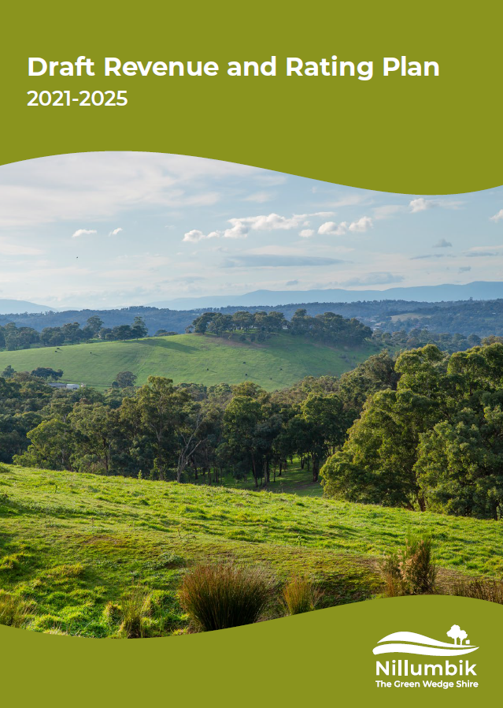

**Contents**

|  |  |
| --- | --- |
|  | ***Page*** |
| Acknowledgement of Country | 2 |
| 1. Purpose | 2 |
| 1. Summary | 2 |
| 1. General Rates Income | 3 |
| 3.1 Valuation Base | 3 |
| 3.2 Differential Rates | 4 |
| 3.3 Proposed Rating System | 5 |
| 3.4 Waste Service Charge | 6 |
| 3.5 Rate Instalment Due Dates | 6 |
| 3.6 Rates – Summary | 6 |
| 1. Fees and Charges | 7 |
| 4.1 Principals | 7 |
| 4.2 Full Service Costing | 7 |
| 4.3 Pricing Policy | 9 |
| 1. Grants | 10 |
| 1. Other Income | 10 |
| 1. Review | 10 |

## **Acknowledgement of Country**

Nillumbik Shire Council acknowledges the Wurundjeri people who are the Traditional Custodians of this Land. We would also like to pay respect to the elders both past and present and extend that respect to other Indigenous Australians.

## **Purpose**

The purpose of the Revenue and Rating Plan is to determine the rating and revenue strategy which, in conjunction with other income sources, will adequately finance the objectives proposed in the Council Plan.

## **Summary**

Nillumbik Shire Council requires sufficient revenue to maintain its service delivery needs and fund its infrastructure needs. The most important sources of these funds are:

* general rates
* government grants
* fees and charges.

General Rates are levied annually, in compliance with the Fair Go Rating System.

Council advocacy is an ongoing priority to obtain external grant funds, particularly for community infrastructure capital works programs.

Council has reviewed all fees and charges and increased/decreased the levels consistent with application of the user pays principle – that is, so far as is possible, the cost of providing a direct service will be met by the fees charged.

A schedule of the current user fees and charges is presented in the annual budget. Also included is a selection of council services and their costs compared to the income received for their provision.

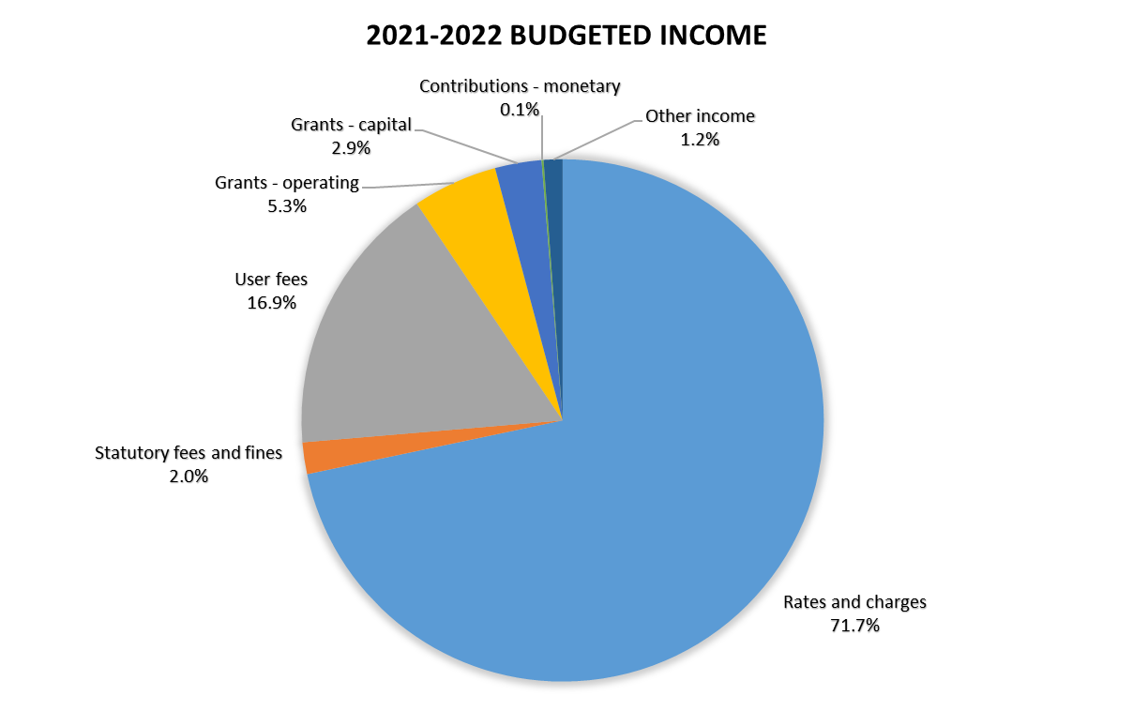

## **General Rates Income**

General Rates are levied annually, in compliance with the Fair Go Rating System and section 158 of the Local Government Act 1989.

The Fair Go Rates System (FGRS) sets out the maximum amount councils may increase rates in a year. The cap applies to general rates and is calculated on the basis of council’s average rates and charges.

The rating system is based on property valuations, which are carried out annually by the Valuer-General Victoria or their nominated representatives. Rates are levied based on these valuations.

Council has several means by which it can vary the amounts which are levied, including:

* a general rate
* a municipal charge
* differential rates
* service rates and charges
* special rates and charges
* rebates, deferments, concessions and exemptions.

Several propositions are considered in developing the most suitable rating system. This entailed giving consideration to a number of factors, such as:

* equity of the system
* efficiency of application
* the link between rate levied and benefit to be derived.
* the valuation base of rates
* A differential rating system with and without a municipal charge
* The use of rebates and deferment schemes
* Policy approaches for exemptions and concessions
* Rating of cultural and recreational land.

## **Valuation Base**

In raising Council rates, Council is required to use the valuation of the rateable property to levy rates, with the valuation updated annually.

The *Local Government Act 2020* (the Act) permits Councils to use three valuation basis; Site Value (SV), Capital Improved Value (CIV) and Net Annual Value (NAV).

Capital Improved Value – the total market value of the land plus buildings and other improvements.

Net Annual Value – the current value of a property’s net annual rent (by law, Net Annual Value must be at least 5% of the Capital Improved Value for commercial property and exactly 5% of Capital Improved Value for residential property).

Site Value – the market value of the land only.

Capital Improved Value (CIV) better reflects capacity to pay than the other two bases as it incorporates the developed value of properties i.e. the total value. Most Victorian councils use the Capital Improved Value to levy rates.

Basis of Valuation

The basis of valuation currently used by Nillumbik is the Capital Improved Value (CIV), in compliance with the Fair Go Rates System and the Act.

* 1. **Differential rates**

Differential rates are where councils set different rates in the dollar for different categories of rateable land. Councils are able to levy either a uniform rate across all properties, or one or more differential rates. Council may, for example, have differential rates for farmland, various categories of residential property or commercial/industrial properties – each paying a higher or lower rate in the dollar.

Differential rates are usually used to achieve greater equity or efficiency.

The highest differential rate cannot be more than four times the lowest differential rate declared by a council.

Details of the objectives of each differential rate, the types of classes of land, which are subject to each differential rate and the uses of each differential rate, are set out below.

***Commercial land -*** any land used for commercial purposes.

Occupied for the principal purpose of carrying out the trade in goods and services or unoccupied but zoned commercial under the State Planning Scheme

***Industrial –*** any land used for industrial purposes

Occupied for the principal purpose of carrying out the manufacture or production of or unoccupied but zoned industrial under the State Planning Scheme.

***Farm land –*** Land not less than two hectares in area; that is used primarily for grazing (including agistment), dairying, pig-farming, poultry-farming, tree farming, bee-keeping, viticulture, horticulture, fruit-growing or the growing of crops of any kind or for any combination of those activities; that is used by a business.

Land that has a significant and substantial commercial purpose or character; and that seeks to make a profit on a continuous or repetitive basis from its activities on the land; and that is making a profit from its activities on the land, or that has a reasonable prospect of making a profit from its activities on the land if it continues to operate in the way that it is operating.

***Farm land with Sustainable Agriculture Rebate land –*** Used by the applicant for a single farm enterprise must comprise and aggregate of a minimum 30 hectares;

The property in respect of which the rebate is sought is classified as Farm Land; the applicant shall satisfy detailed criteria relating to sustainable farming practices and land care principles as developed by Council.

***Other land –*** Unoccupied land which is not farm land, commercial/industrial land or vacant land - residential and specified low density residential zones.

***Vacant Land –*** Residential and Specified Low Density Residential Zones

General Residential / Activity Centre Zone / Neighbourhood Residential Zones and Low Density Residential Zones (LDRZ) to which Development Planning Overlay 4 applies, on which no habitable dwelling exists.

Lots greater than 8,000 square metres in the Plenty LDRZ are excluded.

This is a higher differential to encourage construction of new dwellings in preferred locations across the Shire.

Rateable land under this definition includes Vic Roads land that is not used for transport or for residential properties.

***Cultural and Recreational Land –*** Council is required to determine an amount payable as rates in respect to recreational lands.

Recreational lands are described as lands which are:

* Vested in or occupied by a body-corporate or un-incorporate which exists for the purpose of providing or promoting cultural or sporting recreational facilities or objectives.
* Which applies its profits in promoting its objectives and prohibits the payment of dividend or amount to members used for outdoor sporting recreational or cultural purposes or similar outdoor activities.
  1. **Proposed rating system**

## Rate in the dollar, proposed draft budget 2021-2022

## 

## Rates levied, proposed draft budget 2021-2022

## 

## Past and proposed rate levels

### 

### *\*2021-2022 proposed rates to be levied*

* 1. **Waste Service Charge**

The waste management charge captures all known costs associated with the provision of the service.

Council’s approach to the service charge is compliant with section 162 of the Local Government Act 1989. The Essential Services Commission is capturing the data on the waste management charge.

Currently the charge levied to residents captures the cost of service provision including known costs for the landfill rehabilitation sites.

The waste service charge levied is dependent on the level of service the ratepayer elects to receive.

## Current and proposed waste service charges



* 1. **Rate instalment due dates**

Rates and charges are due on a quarterly instalment basis. The due dates for the 2021-22 financial year will be:

• 30 September 2021,

• 30 November 2021,

• 28 February 2022 and

• 31 May 2022

(if any of these dates fall on a weekend, the due date will be the following Monday).

* 1. **Rates – summary**

### In council’s view the proposed revenue and rating strategy puts due emphasis on equity. The budget projections have been prepared on the basis of a 1.50 percent rate increase in 2021-2022 and 2022-23, 1.80 percent in 2023-24, 2.00 percent in 2024-2025 and 2025-2026, 2.25 percent in 2026-2027 and 2027-2028, followed by increases of 2.50 percent in each of the following years.

## **Fees and Charges**

### Council provides a wide range of services, to the community, often for a fee or charge. The nature of these fees and charges generally depends on whether they relate to compulsory or discretionary services. Some of these, such as statutory planning fees, are set by state government statute and are commonly known as ‘regulatory fees’. In these cases, councils usually have no control over service pricing.

### The *Local Government Act 1989* gives Council the power to set these fees and charges at a level that recovers the full cost of providing the services, unless there is an overriding policy or imperative in favour of subsidisation.

### A schedule of the current user fees and charges is presented in Council’s annual budget. Council periodically reviews all fees and charges and adjusts the levels consistent with application of the user pays principle – the cost of providing a direct service will be met by the fees charged where possible.

* 1. **Principles**

Council has developed a range of principles to determine the level of fees and charges to be applied to each service. These principles are:

* Fees and charges are set in line with other like services through benchmarking.
* Fees and charges are set at a level that is deemed to be fair and equitable to enable the majority of residents to access the services.
* Full cost or direct cost recovery is achieved where possible.
* Fees are charged in line with State or Federal government legislation or Local Laws.
* Fees are charged in line with State or Federal government funding requirements.
* Fees and charges are comparable to private industry.
  1. **Full Service Costing**

## Cost recovery

Setting fees and charges is often determined by a notion that the fee charged for a service should correspond with the cost of providing the service; that is, the costs borne by the council are fully recovered.

## Council operations attracting fees and charges

All council services are reviewed to assess whether they are appropriate to attract user fees and charges. Attributes of a service that can affect the ability for a council to place a fee or charge include whether the operation is a public or private good in nature and if there is any state & federal government legislation or funding conditions prohibiting or setting ceilings for pricing. Examples of such charges are found below:

### Examples of council fees and charges

### 

## Full cost

The full cost of delivering a service or providing a facility include both:

* direct costs – those costs that can be readily and unequivocally attributed to a service or activity because they are incurred exclusively for that particular product/activity
* indirect Costs (often referred to as overheads) – those costs that are not directly attributable to an activity, but support a range of activities across the council.

*Direct Costs*

Council has systems for calculating the direct costs of providing services. These include:

* labour – the wages and salaries of all staff directly working on the service.
* materials and supplies – supplies used in providing the service.
* capital equipment and assets used in providing the service – this may include plant hire or, where a council owns the equipment and assets, allowance for asset replacement and depreciation.

*Indirect Costs*

Every council has a range of back office operations that are not directly tied to any service delivery. Nonetheless, these involve real costs that are incurred in supporting the delivery of direct services. Two widely used methods to allocate indirect costs are:

* activity-based costing – links an organisation’s outputs or goods and services to the activities used to produce them, and then assigns a cost to each output based on the rate of consumption of associated activities
* the pro-rata approach – allocates indirect costs on a proportionate basis by using measures that are easily available, such as staff involved in the activity as a percentage of total staff, or the service unit’s share of total office space.
  1. **Pricing Policy**

After a council has calculated the full costs of a service, another series of questions require answers before prices are decided. These include:

* Do any external constraints apply? Possibilities include:

- either the State or Commonwealth Government sets a statutory price for that service; and if the service has private sector competitors AND is a “significant business activity”, the council needs to check competitive neutrality conditions. How would the service users respond to any price changes?

* Is a price based on the full cost of the service competitive with other suppliers (nearby councils and/or private competitors)?
* Does the council have a specific policy either:

- to subsidise this service (setting prices below full costs)?

- to use the service as a taxation mechanism (setting prices above the full cost level)?

If a competitive neutrality assessment is required, the following steps are recommended by the Victorian Government’s National Competition Policy (the Policy) and Local Government Statement:

* Determine whether the operation is a “significant business activity” and, therefore, subject to the policy
* Assess the full costs of providing the services, including all overheads
* Identify any aspect whereby the operation gains a net commercial benefit from being government owned.

If this analysis shows that a significant business does enjoy a net competitive benefit, the council is expected to set prices that include competitive neutral adjustments. However, under the policy this is not required if the council:

* decides that the costs of applying competitive neutrality outweigh the benefits
* conducts and documents a public interest test, which involves public consultation on costed options, and identifies clear public policy objectives for providing the service at below competitive neutral prices.

The policy aims to identify subsidies, make them transparent to the community, and explain why the council is providing cross-subsidisation. Cross-subsidisation implies that one group may pay higher/lower prices than another group. Cross-subsidisation exists in a number of forms:

* cross-subsidisation between the fees and charges paid by different users for a specific service – a cross subsidy between users
* cross-subsidisation between fees and charges and rates – a cross subsidy between users and ratepayers or from one service to another service
* cross-subsidisation between the amounts of rates paid by various classes of ratepayers.

The final step in a pricing policy is identifying what council services or service areas are “public goods” and therefore most appropriate for funding via general rate revenue. This need not be an exacting exercise, and as often noted, few council services fall exclusively into the public or private goods category. But it is important for a council to make recommendations that as far as possible allow judgements to be made and a rationale for pricing decisions to be expressed in the rating and revenue strategy.

The final step in a pricing policy is identifying what council services or service areas are “public goods” and therefore most appropriate for funding via general rate revenue.

## **Government Grants**

### Council pursues all avenues to obtain external grant funds for prioritised works. A large proportion (39%) of government grants is made up of the Financial Assistance Grants provided by the Commonwealth Government under the Local Government (Financial Assistance) Act 1995 (Commonwealth) and distributed annually to 79 local governing bodies within Victoria.

### The Financial Assistance Grant program consists of two components:

### A general purpose component, which is distributed between the states and territories according to population (i.e., on a per capita basis), and

### An identified local road component, which is distributed between the states and territories according to fixed historical shares.

### Both components of the grant are un-tied, allowing councils to spend the grants according to local priorities. Council applies the local roads component to road rehabilitation projects in its Capital Works Program, and utilises the general purpose component to fund Council operations and Capital works.

## **Other Income**

Council receives income from other sources, including interest on investments, rent received, reimbursements and insurance refunds.

## **Review**

The next review of this document is scheduled for completion by 30 June 2025 as part of the next Council Plan development process.