STATEMENT OF SIGNIFICANCE

WHAT IS SIGNIFICANT?
50 Oatland Road, Plenty, built c1928, is significant.
Elements that contribute to the significance of the place include:
- setback from Oatland Road;
- asymmetric built form with a projecting front room and return verandah;
- weatherboard-clad walls;
- corrugated iron Dutch gable roof that extends down at a lower pitch over the return verandah;
- exposed rafter ends;
- red brick chimney;
- projecting front gable;
- decorative gable end detail, including timber lattice work and small timber brackets;
- corrugated iron clad timber window hood with scalloped trim supported by brackets;
- original pattern of fenestrations on the west, south and north elevations;
- timber double-hung sash windows;
- glazed door under the verandah on the west elevation;
- half-glazed front door set in a moulded timber door frame with sidelights;
- original or early timber flywire screen doors;
- timber garage with pitched roof south of the house;
- extant corrugated iron clad agricultural shed to the rear.
The mature tree in front of the house is not significant in its own right but contributes to the setting of the place.
Other more recent outbuildings are not significant.

HOW IS IT SIGNIFICANT?
50 Oatland Road, Plenty, is of local historical and representative significance to the Shire of Nillumbik.

WHY IS IT SIGNIFICANT?
50 Oatland Road, Plenty, is historically significant for its association with the development of Plenty in the interwar years. As an intact timber bungalow built for William Charles and Priscilla Mary Lierse in c1928, originally on a 30 acre lot, it provides tangible evidence of the interwar subdivision pattern in which large rural landholdings in the Plenty area where divided for sale in allotments of 10 of 30 acres. These allotments were advertised as being equally suited to farming and fruit-growing as they were to residential purposes. In response to an increasing population in the area, this development coincided with and supported a growing Plenty town centre. Established in the 1920s, the town centre included a Primary School (HO213), Methodist Church (HO250), Store and Hall (HO248). The Lierse family were early residents in the Diamond Creek and Plenty area involved in a variety of agricultural and other pursuits. They were heavily involved in the development of community life in Plenty from the mid-1920s (Criterion A).
Arthurs Creek, Doreen, Hurstbridge, Strathewen, Plenty, Diamond Creek, Yarrambat and Research became important centres for a fruit-growing industry that was based at Diamond Creek. Smaller orchardists, however, often struggled to make a living from their trees and often turned to other activities such as raising chickens, selling firewood or even working for other landowners or in goldmines, as well as tending their fruit trees. This was the case for William Charles Lierse, who was an orchardist and sanitary contractor prior to establishing a poultry farm on the property by 1943. 50 Oatland Road provides important tangible evidence of these early agricultural activities in the area. The significance of the place is enhanced by its rural setting, which maintains it street frontage and setback to Oatland Road (Criterion A).
The house at 50 Oatland Road, Plenty, is a largely intact representative example of a timber interwar bungalow. It has had very few changes made to the original or early built fabric across its principal elevations. Key characteristics include its asymmetric built form with projecting front room below a dominant Dutch gable roof, and an extensive wrap-around verandah under the sweep of the main roof line. The extant c1920s garage, poultry shed, and open setting evidence the use of the site as a poultry farm complex (Criterion D).

RECOMMENDATIONS
Recommended for inclusion in the Schedule to the Heritage Overlay of the Nillumbik Planning Scheme as an individually significant place.
Extent of overlay: As per map below:
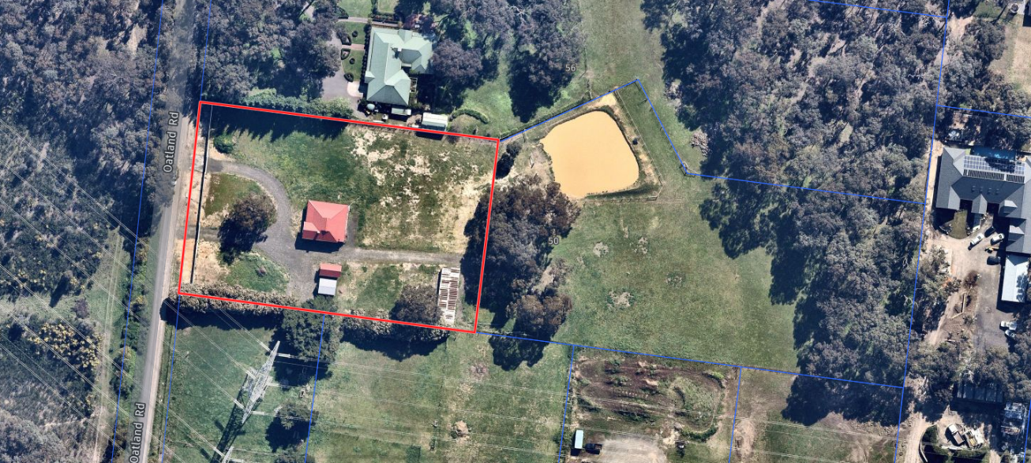
Figure 29. Proposed curtilage for 50 Oatland Road, Plenty, outlined in red. (Source: Nearmap with Context overlay)

