02.04 Strategic framework plans
--/--/----
CXX
The plans contained in Clause 02.04 are to be read in conjunction with the strategic directions in Clause 02.03.

02.04-1 Strategic framework plan
--/--/----
CXX
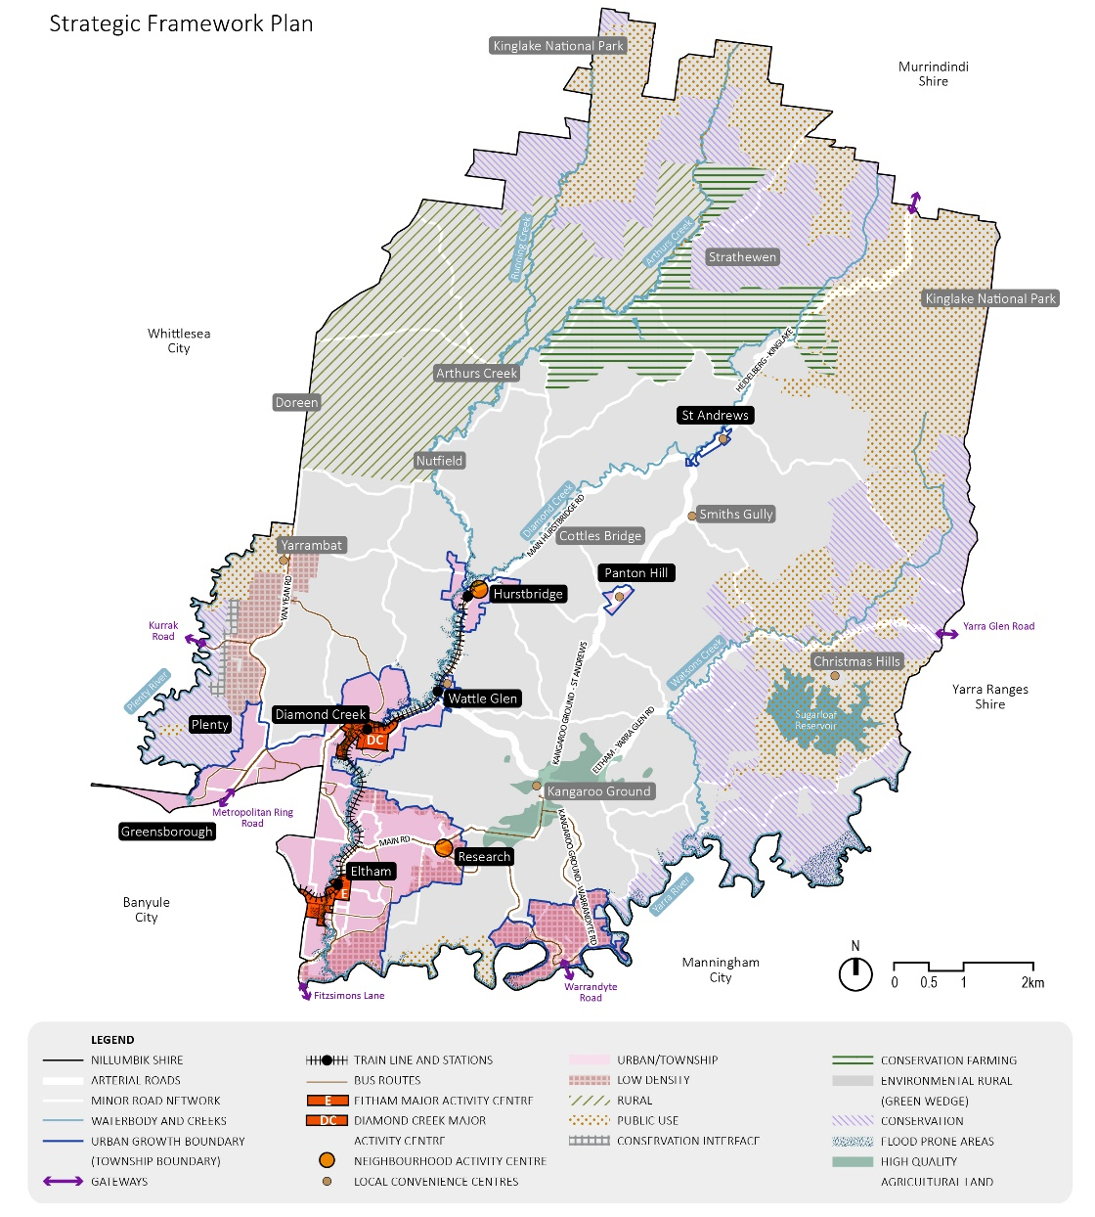

02.04-2 Faunal habitat and remnant vegetation plan
--/--/----
CXX

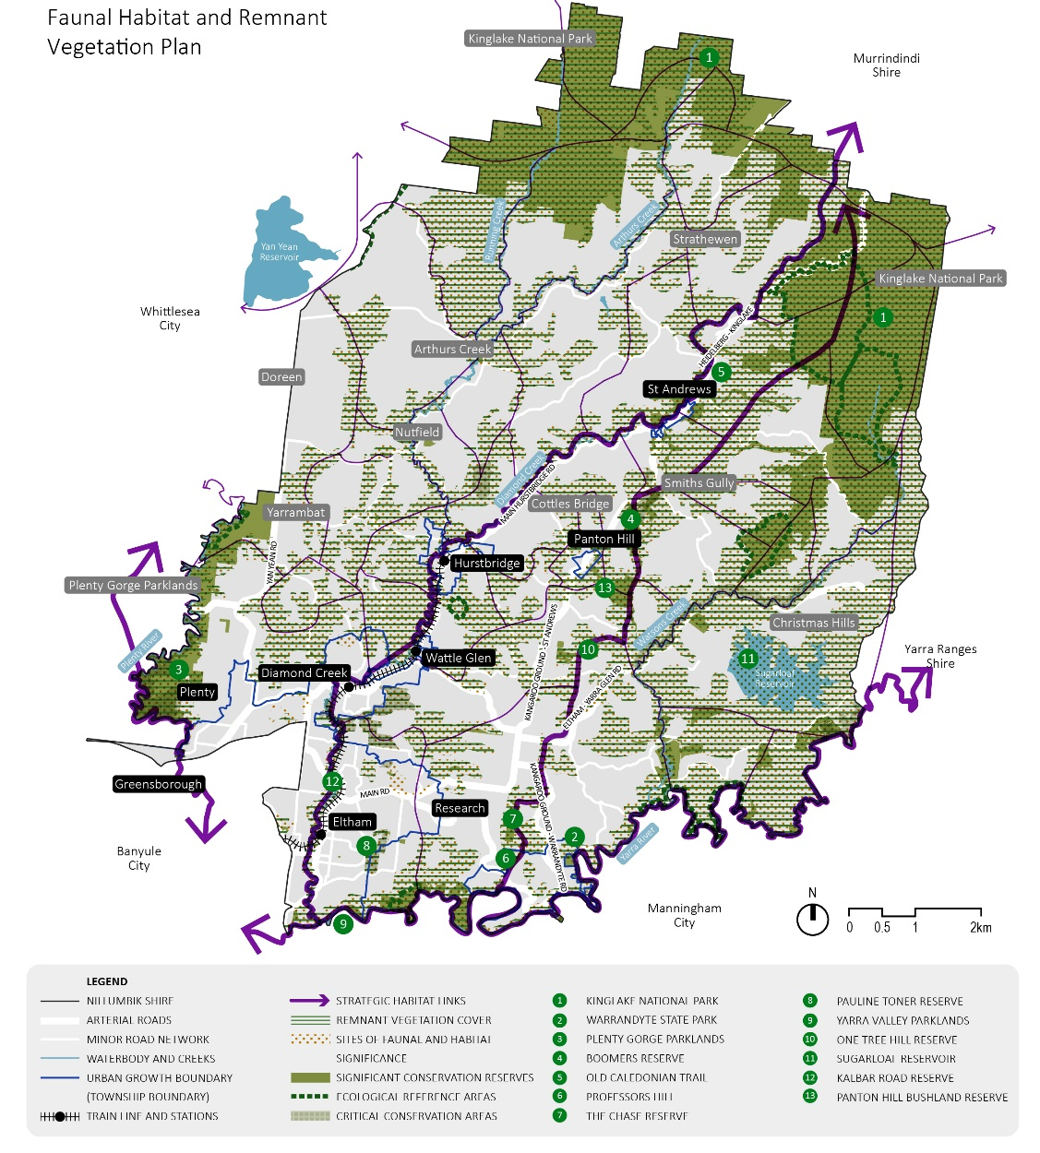

02.04-3 Open space and recreation facilities plan
--/--/----
CXX
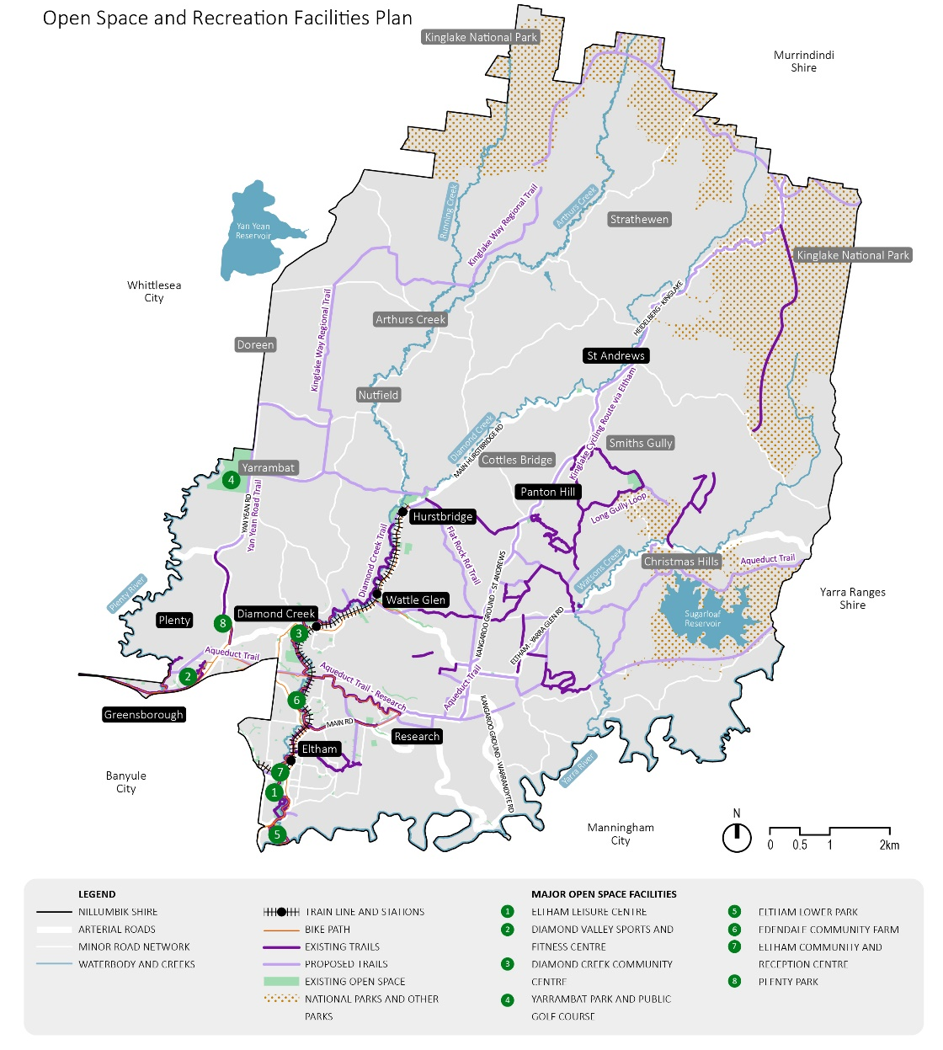

02.04-4 Infrastructure assets plan
--/--/----
CXX
