Title: McPherson’s ‘Yarra Glen’ Station/Estate
Prepared by: Trethowan Architecture

Address: 75 Wendy Way, Christmas Hills
Name: McPherson’s ‘Yarra Glen’ Station/Estate, 75 Wendy Way, Christmas Hills | Survey Date: N/A
Place Type: Individual place | Architect: Unknown
Grading: | Builder: Unknown
Extent of Overlay: | Construction Date: c1870s

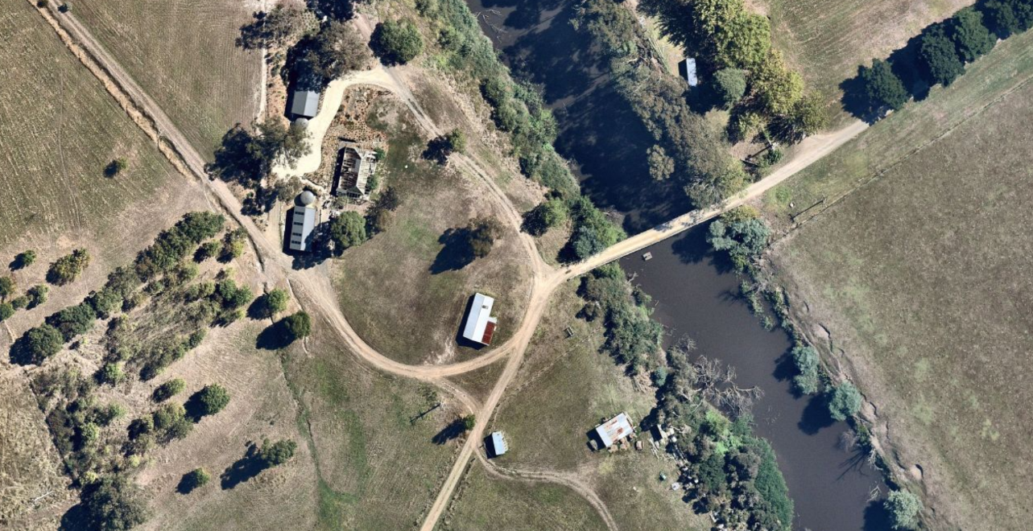
Image Source: Nearmap February 2022.

Historical Context

The first squatters arrived in the area, which would become known as Christmas Hills in the late 1830s. The Ryrie’s established their station near where Chateau Yering now stands. John Gardiner and David Fletcher set up downstream of the Ryrie’s at Moorool Bark station (Woiwod 2010:35-36). The pattern of squatting north of the Yarra from c1840 is more difficult to establish, with historians of the squatting era giving conflicting details. Billis and Kenyon have James Watson in occupation of the Stringybark run located in the country between the Yarra, Watsons Creek and the Nillumbik station, in 1840. Watson had numerous runs elsewhere in Port Phillip and local historian Mick Woiwod concludes that Watson never actually lived on the Stringybark run (Woiwod 2010:36-7, 40-41).

Joseph Stevenson had established a run on the Diamond Creek by 1841. From 1842-45 he also occupied the 9,600-acre run to the north of the Watsons Creek and Yering Stations, which became the Christmas Hill station. Stevenson, like James McPherson who would arrive in the Christmas Hills area ten years later, was a working-class Scottish migrant, a carpenter, in contrast to first wave of squatters generally in the colony, and many of the other contemporary squatters in the district such as Ryrie and Watson (Woiwod 2010:42-43, 52).

The squatting runs in this area close to Melbourne were much smaller than the more typical runs to the west of the Port Phillip district which frequently exceeded 100,000 acres. Woiwod suggests that typically cattle were grazed here because the runs were much closer to the Melbourne markets. Leaseholders of runs located in the settled districts of Port Phillip were not permitted to grow commercial crops (Woiwod 2010:38, 51-52). Notable pastoral runs in the 1840s and 50s included those of Hugh Glass (Spreadborough & Anderson 1983:265) and of Hugh Glass and James Murray (Woiwod 2010:61). The extent of their respective runs remains uncertain. Woiwod was unable to find documentation of an exact location of the Glass/Murray station buildings on the Watsons Creek run. Murray was known to have occupied land north of the Yarra and east of Watsons Creek, and the bridge over Watsons Creek is named Murrays Bridge on old maps. Woiwod concluded that because most of the run was unsuitable for pastoralism, Murray’s station buildings were likely to have been in the position of the later station buildings of the McPhersons (Woiwod 2010:36).

In 1958 there was a severance poll and part of Christmas Hills which had been in the Shire of Eltham was taken over by the Shire of Healesville. The new boundary followed Watsons Creek. This was effectively reversed in the 1994 local government amalgamations when the boundary was moved to the Yarra River and the subject site became part of the new Shire of Nillumbik.

History

McPherson’s Station – ‘Yarra Glen’
The next occupiers of the Watsons Creek run were the McPherson family in the early 1850s. James and Janet (McKenzie) McPherson arrived in Sydney in 1838. The couple were from Kingussie, Scotland. Prior to coming to Watsons Creek, the McPhersons spent six months in Sydney then to Port Phillip where James was soon employed in his trade as a shoemaker (Watson 2006:1-2). They moved to Campbellfield in 1840/41 (Watson 2006:6), then to Morang on the Plenty River where they rented a farm (Watson 2006:7 &10).

In 1855 James McPherson applied for the grant of a Pre-emptive Right block of 640 acres. The letter was addressed to the Commissioner of Crown Land, c/o Hugh Glass. Glass may have retained some connection to the lease or may have been acting as an agent for McPherson (Woiwod 2010:75). The grant was made in 1857 (PROV, VPRS16171/P01/8, Sutton (Psh) LOLmps3513). An c1857 plan drawn for the pre-emptive right grant shows three buildings by the river, including one labelled “dwelling house”. In 1858 James was cultivating only 5 acres of the 640 acres (RB 1858).
Figure 1: James McPherson’s Yarra Glen Run. Source: PROV, VPRS16171/P01/8, Sutton (Psh) LOLmps3513)
The McPhersons continued to make use of grazing leases on Crown land. In 1859 he was rated for 8320 acres of Crown-owned grazing land, indicting he was probably leasing much of the remainder of the original Watsons Creek/Yarra Glen run (Woiwod 2010:77; RB 1859). In 1864 James McPherson advertised 200 dairy cattle for sale at his station Yarra Glen (Argus, 26 July 1864:3). He made a will in 1866 in which his son William was to get the 591 acres Lot 13 in the Parish of Tarrawarra in 1867. While William did not officially become the owner until 1881, he and his new wife soon moved to the property, which they named ‘Huntinglen’ (Watson 2006:21; PROV, VPRS 7591/P2, 15/418).

In the will younger son James was to get the 640-acre Pre-emptive Right lot when he was 21, along with “the building and other erections thereon”. James senior’s wife Janet was to retain a life interest in the property (VPRS 7591/P2, 15/418). Perhaps because he felt secure in this position, from c1869 James McPherson junior set about his own selections around the original Pre-emptive Right block. In 1869 he applied for a Section 42 occupation license for Lot A2 Parish of Sutton, 74 acres south of William Herbert’s 42nd section block, to which he gained freehold in 1873. This land was river flats which flooded in winter. He also selected the 39- acre Lot A3 just to the west under Sections 19 and 20 of the Land Act, and for which he gained freehold in 1876. He cleared, drained and sowed this land to grass (Age 12 May 1869:1; PROV, VPRS5357/P0, 11850/106; PROV, VPRS16171/P01/8, Sutton (Psh) LOLmps3513).

In 1869 James McPherson (presumably senior) advertised for sale his entire dairy herd, with the auction at his homestead at Yarra Glen Station, “in consequence of [his] giving up the run” (Australasian 21 August 1869:3). The reasons for, and the outcome of this sale are not known. In 1873 James Junior selected the heavily timbered 205-acre Lot 47A adjoining the northern boundary of his father’s Pre-emptive Right. Here he cleared and ringbarked, built a dam and planted a small area of orchard. The Lands Department file notes that at this time he was living on the adjoining block with his father. Times must have been tough, as he applied to mortgage the lease in 1878. He would not gain freehold until 1891 (PROV, VPRS625/P0, file 32069; PROV, VPRS16171/P01/8, Sutton (Psh) LOLmps3513).

Tansley and Watson both suggest the existing slab house was built in the early 1870s, though neither detail how they came to this conclusion (Tansley 1978:113, Watson 2006:25). Rate books from 1858 to the late 1870s give no indication of the date of construction. James junior was concurrently clearing land on the adjacent blocks he had selected (see above), and this may have provided the materials for the new residence. Perhaps the condition of the old building had simply become too poor. The new slab house was certainly there by the time James McPherson senior died, in 1876. The inventory in McPherson’s probate papers lists a four-roomed wood residence with shed and stable (VPRS 7591/P2, 15/418).

James McPherson Junior
James junior married Alice Holding in 1879. Alice gave birth to a son, James William, at her father’s residence in Fitzroy in 1880 (Age 17 September 1880:1; Watson 2006:26). Watson writes that James junior continued to farm Yarra Glen during the 1880s, but he appears to have done so with some reluctance. In 1877 he had a clearing out sale of the whole of his farming stock at Yarra Glen because he was giving up dairying (Australasian 3 November 1877:28). In 1889 he offered the Yarra Glen Estate, containing 845 acres, for a three-year lease. It included a comfortable homestead of four rooms (EO&S&EBR 20 September 1889:2). There appear to have been no takers.

The depression of the 1890s had taken hold in Victoria and James junior struggled to maintain the property (Watson 2006:34). In 1890 he advertised for cattle to graze on the Yarra Glen Estate (EO&S&EBR 13 June 1890:2). He advertised grazing paddocks again in 1894 (EO&S&EBR 16 March 1894:2). James senior’s executors William Herbert and William Ross finally transferred ownership of the property to James junior in 1894. He then mortgaged the property to neighbour William Herbert to enable him to carry on with the farm. His brother William had been more successful as a farmer and he also supported James (Watson 2006:34). James junior’s mother Janet McPherson died in 1889 (Watson 2006:33).

When James junior himself died in 1898, he still owned the 640 acres of Pre-emptive Right land, on which was an “old slab house containing four rooms”, along with an old detached building of three rooms (presumably the original residence c1851) and an old barn, stable and cowsheds (PROV, VPRS 28/P0, 67/925). James’ wife Alice remained on the property with the children until 1907. Her oldest son James William died in 1905 and her next son Andrew had little interest in becoming a farmer. The family struggled to run the large property, and Alice sold the property and moved to a much smaller farm closer to the township of Yarra Glen.

David Mitchell and the ‘Henley Estate’
The McPherson land was purchased by David Mitchell, father of Dame Nellie Melba, in 1907/8. Mitchell was a builder, contractor and businessman who constructed several major buildings in the city of Melbourne. He owned a brick-works in Richmond and was a shareholder in a lime and cement manufacturing company. He owned several large pastoral properties round Victoria, including a number of properties around Yarra Glen. He worked limestone deposits at his property Cave Hill at Lilydale, and also produced ham, cheese, butter, bacon and soap there. He owned winegrowing and making properties at Yeringberg, Coldstream and St Huberts. At Yarra Glen he added land on the Yarra flats across the river and renamed the property the ‘Henley’ (Watson 2006:37; Campbell, 1974). The farm was frequently visited by the hunts of the Yarra Glen and Lilydale Hounds (Australasian 24 June 1911:23).

John Herbert Thornton
David Mitchell died in 1916. In 1920 the Henley Estate was sold by the executors of the David Mitchell estate to Mr (John) Herbert Thornton of ‘Mount Myrtoon’ station, Camperdown. The estate was now 1478 acres in extent with 600 acres of Yarra flats (Age 22 April 1920:9). When Thornton died in 1924 the inventory in his probate papers indicated that the property included a “5 roomed slab house, slab stables and outbuildings” (VPRS 28/P3,199/180). This may indicate the addition of another room, possibly the infilling of the verandah on the northern side.

When the estate was put up for sale in 1925 it was described as “a splendid dairying and fattening property, with a double frontage to the River Yarra”. There was a “substantial” bridge over the river. The house on the north side of the river (the subject house) was described as the manager’s cottage, indicating that the owners did not live on the farm (Australasian 14 February 1925:7).

Sharp and Taylor
Messrs Sharp and Taylor of City Road South Melbourne became the owners in 1925 (RB 1925). They were still there in the 1934 floods when they lost several trucks of sheep “at Henley” (H&YGG 8 December 1934:3).

The Hill brothers
The Hill Bros. became the new owner of the Henley Estate, now 1017 acres, in 1937. They planned to run the property as “an up-to-date dairy farm” (Advertiser (Hurstbridge) 16 July 1937:3). It appears that the Hills also raised and grazed horses. In 1937 the estate sold 150 horses and ponies at the Dandenong Horse sale, including “several trucks [of] fresh country horses” (Dandenong Journal 28 January 1937:4).

One of the brothers, Edward Colin Hill, was the owner until he died in 1974 (BDM 24302/1974). His executors Colin Edward Hill, Wendy Oliver, and Ruby Vera Elizabeth Hill became the joint owners of the land including the subject building in 1985. Wendy Oliver was living at Henley at that time (CT: V9594 F108).

The slab barn was removed in c 2010 (Nearmap 2010).

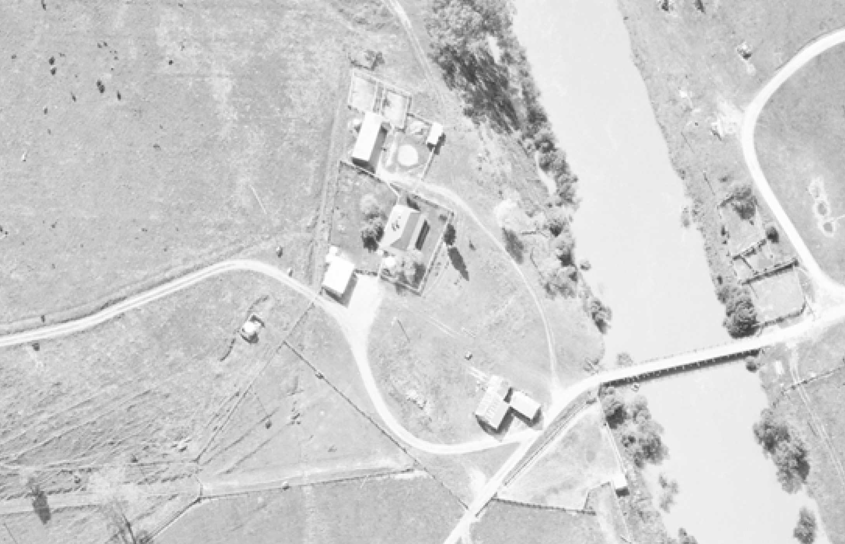
Figure 2: Aerial view of the subject site in 1971. Source: Landata.
Figure 3: Nearmap dated 24 December 2010 shows the subject site. The location of the former slab barn is indicaed with an arrow. Source: Nearmap

1988 Reinvestigation by Upper Yarra Valley and Dandenong Ranges Authority

In 1988 the Upper Yarra Valley and Dandenong Ranges Authority conducted a follow up study of sites and structure of historical and archaeological significance. The condition of currently known sites was reviewed, and a number of sites not identified in the previous study were investigated.

The Yarra Glen slab homestead and stables was again judged to be of State significance and was recommended for inclusion in the State Register of Historic Buildings.

Description & Integrity

This description is limited by reliance on a few photos and plans supplied with the Planning Application and the Tansley citation of 1978.

The building is rectangular in plan. The original enclosed area is approximately 5.5m x 16m, and the verandahs were approximately 2m wide. It appears that it originally had four rooms along its length.

The house has a moderately steep hip roof with bell-cast verandah on three sides. The verandah is supported on simple square-section hardwood posts. If built in 1870, it is possible that shingles may still have been used originally. Tansley stated in 1978 that the iron on the roof had been recently replaced (Tansley 1978, p.113). If so, it has corroded quite rapidly, or second-hand iron was used. The sheets are short, which may support the latter. The narrow strips of un-corroded material at the joints also suggests reuse, with the original lapping pattern not being replicated. Gutters are recent quad section.

The verandahs have been filled in gradually over the years. The earliest ‘extension’ may have been at the back left where a section of the rear slab wall was moved back to form the external wall. The other infills, one on the front right and the other at the rear-right, have either weatherboard of asbestos-cement cladding.

The vertical hardwood slabs are chamfered at the ends and appear to be slotted into mortices in both the top and bottom plates. Most, if not all of the slabs appear to have come from the outside of the log. The inner face may be sawn or split. The bottom-plates or sleepers are on ground where they are visible at the sides and back of the building. It is possible they are supported on shoulders on the posts or on stumps at the front where the ground drops away. Heavy squared corner posts support the top-plates. The quality of the slab finish suggests that the builder was well versed in this form of construction.

The windows are double four-light sashes with slender frames and glazing bars. Tansley states that parts of the interior are pine board lined (Tansley 1978:114). There are two chimneys, one servicing a fireplace in the original interior, which is taller and features a smattering of dark bricks among the red, and a simple corbelling at the top. The other is in a later extension into the rear verandah, and may have serviced a copper.

The main body of the building is in good condition, especially for a slab hut of this age The verandah foundations, posts and roofing are in poorer condition. The building is highly intact for a slab structure. The integrity of the building is moderate to high, with some obscuring of the original form over the years by the verandah infills and some new openings and rearrangement of original walls. There is some loss of original setting, including the relatively recent loss of the slab barn/stables, but new buildings are located at a distance and the original view across the river to the Yarra Flats remains unobscured.

Comparative Analysis

History of slab buildings
Miles Lewis writes that by the mid-1840s the vast majority of squatters’ residences on the eastern side of Australia were of slab construction (Lewis 2000:46). Lewis also states that the majority of these squatter slab buildings were of horizontal slab construction (Lewis Australian Building Sec.2.4). Several of the squatting run stations in this district had slab huts in this period, including the original Haley homestead at Allwood (Marshall 1971:78).

Later slab huts in the district were largely constructed by gold diggers and smallholders and are modest, typically small buildings. A 1927 article in the Advertiser on the coming centenary of settlement (1835-1935) celebrations at Eltham suggested that “in those days most habitations were of crude design, slab and wattle and daub houses being predominant. Traces of these houses may be seen all over the district” (Hurstbridge Advertiser 25 March 1927:2). The Heidelberg Shire valuation book for its Greensborough riding in 1885, a broadly comparable area, detailed nine slab residences among the 181 residences listed. The valuation book also reveals that by this time the great majority of residences were of weatherboard on timber frame, with a few of stone and brick (RB 1885). If one extrapolated over the whole Nillumbik Shire footprint, there might have been dozens of slab residences and a similar number or more again of slab outbuildings extant in this period.

Within the Shire of Nillumbik, comparative examples include:

Drop slab barn Cleir Hills 1394 Heidelberg-Kinglake Rd, Nillumbik Shire HO63
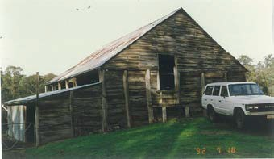
The late 19th/early 20th century barn is of horizontal drop slab construction. It has a steep gable roof. The building is considered significant for its association with pioneering orchardist William Gray of Allwood. It is said to demonstrate the kind of buildings erected by the Shire’s early settlers. It is rare as one of four known surviving slab buildings in Nillumbik Shire.

Miners Timber Slab Cottage 2 Castle Road North Warrandyte, Nillumbik Shire HO22
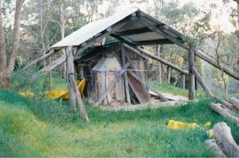

This “pre-1904” cottage is a very small vertical slab building with bark roof. It is in very poor condition. The building is considered technologically and historically significant as a rare surviving slab cottage with bark roof.

Timber slab farm building 365 Wattle Glen-Kangaroo Ground Rd, Nillumbik Shire HO107

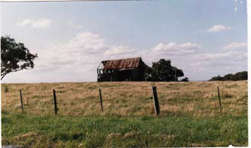
The late 19th/early 20th century barn is of “drop-slab” construction with a corrugated iron clad gable roof. It is in poor condition. The barn is considered significant as a reminder of the importance of agriculture in the development of the area and as a rare example of the use of vernacular building techniques in the late 19th/early 20th century.

‘Willowmist’ drop slab outbuilding, 2315 Heidelberg Kinglake Rd St Andrews, Nillumbik Shire HO64
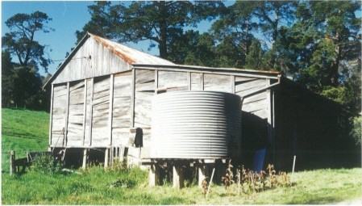
This building is a horizontal drop-slab outbuilding with integrated lean to, constructed in the late 19th/early 20th century. The building is considered significant as a good example of a vernacular technology applied to farm outbuildings.

Bells cottage off Gellibrand Place Lower Plenty, Nillumbik Shire HO59
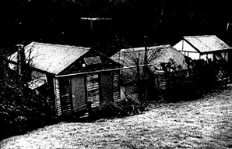
The late nineteenth century central bay has a combination of vertical slab and wattle and daub walls with corrugated iron over an earlier bark hipped roof. Later asbestos-cement additions are located at either end. The cottage is considered significant for its association with pioneering orchardists including Frederick Flintoff and Robert Whatmaugh. It is considered technically significant as an example of a suite of vernacular building methods including vertical slab, wattle and daub and bark roof.

Summary
Among the suite of five slab buildings in the Nillumbik Shire with a heritage overlay, none are earlier than the late nineteenth century. The three outbuildings are of horizontal slab or ‘drop-slab’ construction. The two residences are single room structures and much smaller than the Yarra Glen slab house. They relate in one case to mining, and in the other to small-holding. They are also in poor condition. In all these respects, Yarra Glen is distinctive.

Assessment Against Criteria

Criteria referred to in Practice Note 1: Applying the Heritage Overlay, Department of Planning and Community Development, revised July 2015, modified for the local context.

CRITERION A: Importance to the course or pattern of the Shire of Nillumbik’s cultural or natural history (historical significance).
The Yarra Glen slab residence is of historical significance for its capacity to demonstrate the evolution of a small squatting run in the settled districts through the end of the squatting era and into the era of selection and grazing leases on Crown land.

CRITERION B: Possession of uncommon, rare or endangered aspects of the Shire of Nillumbik’s cultural or natural history (rarity).
the Yarra Glen slab building is significant as a rare surviving vertical slab residence of substantial size, which appears in good condition with a high level of intactness and integrity. It is a vulnerable building type that has been saved by continuous occupation. With its 1870s date of construction, it is an early surviving building in the Shire of Nillumbik.

CRITERION C: Potential to yield information that will contribute to an understanding of the Shire of Nillumbik’s cultural or natural history (research potential).
N/A

CRITERION D: Importance in demonstrating the principal characteristics of a class of cultural or natural places or environments (representativeness).
N/A

CRITERION E: Importance in exhibiting particular aesthetic characteristics (aesthetic significance).
N/A

CRITERION F: Importance in demonstrating a high degree of creative or technical achievement at a particular period (technical significance).

CRITERION G: Strong or special association with a particular community or cultural group for social, cultural or spiritual reasons. This includes the significance of a place to Indigenous peoples as part of their continuing and developing cultural traditions (social significance).
N/A

CRITERION H: Special association with the life or works of a person, or group of persons, of importance in the Shire of Nillumbik’s history (associative significance).
N/A

Grading and Recommendations

Recommended for inclusion in the schedule to the Heritage Overlay of the Nillumbik Planning Scheme.

Recommendations for the Schedule to the Heritage Overlay (Clause 43.01) in the Nillumbik Planning Scheme:

External Paint Controls  Is a permit required to paint an already painted surface? | No
Internal Alteration Controls  Is a permit required for internal alterations? | No
Tree Controls  Is a permit required to remove a tree? | No
Victorian Heritage Register  Is the place included on the Victorian Heritage Register? | No
Incorporated Plan  Does an Incorporated Plan apply to the site? | No
Outbuildings and fences exemptions  Are there outbuildings and fences which are not exempt from notice and review? | No
Prohibited uses may be permitted  Can a permit be granted to use the place for a use which would otherwise be prohibited? | No
Aboriginal Heritage Place  Is the place an Aboriginal heritage place which is subject to the requirements of the Aboriginal Heritage Act 2006? | No

Identified By

Samantha Westbrooke Pty Ltd, Dr Peter Mills and Trethowan Architecture

References

Advertiser (Hurstbridge), as cited.

Australasian (Melbourne), as cited.

Age (Melbourne), as cited.

Argus (Melbourne), as cited.

Billis, R V & Keyon A S, 1932, Pastoral Pioneers of Port Phillip, Macmillan, Melbourne.

Births Deaths and Marriages Victoria (BDM), as cited.

Campbell, Joan 1974, 'Mitchell, David (1829–1916)', Australian Dictionary of Biography, National Centre of Biography, Australian National University, accessed online 24 October 2018.

Certificates of Title (CT), as cited.

Dandenong Journal, as cited.

Campbell, J 1974 'Mitchell, David (1829–1916)', Australian Dictionary of Biography (published first in hardcopy 1974, https://adb.anu.edu.au/biography/mitchell-david-4209/text6779, accessed online 4 April 2022.

Evelyn Observer & Bourke East Record (EO&BER), as cited.

Evelyn Observer & South and East Bourke Record (EO&S&EBR), as cited.

Gippsland Guardian, as cited.

Healesville and Yarra Glen Guardian (H&YGG), as cited.

Landata, 1971, aerial photo No 161 (VIC 2540).

Lewis, M ‘Making do’ in Troy, P (ed.) 2000, A History of European Housing in Australia, Cambridge University Press, Oakleigh (Vic.).

Lewis, M ‘Australian Building a Cultural Investigation’, website, http://www.mileslewis.net/australian- building/#two, accessed 24 October 2018, as cited.

PROV, VA444 Heidelberg, VPRS 3567 Greensborough Riding Valuation Book

PROV, VA538 Department of Crown Lands and Survey, VPRS 625 Land Selection Files, Sections 19 and 20, 1869, File 32069.

PROV, VA 538 Department of Crown Lands and Survey, VPRS 5357 Land Selection Files, Item 11850/106 land Application James McPherson, Sutton.

PROV, VA2428 Eltham, VPRS 9705 Northern, Eastern and Southern Ridings (rate books) (RB), as cited.

PROV, VA 2620 Registrar of Probates, Supreme Court, VPRS 7591 Wills, James McPherson (Senior) File 15/418

PROV, VA 2620 Registrar of Probates, Supreme Court, VPRS 28/P0 Probate and Administrative Files, James McPherson (Junior) item 67/925

PROV, VA 2620 Registrar of Probates, Supreme Court, VPRS 28/P2 Probate and Administrative Files, James McPherson (Junior) item 67/925

PROV, VA 2620 Registrar of Probates, Supreme Court, VPRS 28 /P3 Probate and Administrative Files, John H Thornton File 199/180

Marshall, A 1971, Pioneers & Painters: One hundred years of Eltham & its shire, Thomas Nelson Australia, West Melbourne.

Melbourne Daily News, as cited.

Tansley, MR, 1978, The Conservation of Sites and Structures of Historical and Archaeological Significance in the Upper Yarra Valley and Dandenong Ranges Region, Upper Yarra Valley and Dandenong Ranges Authority, Melbourne.

Spreadborough, R & Anderson, H 1983, Victorian Squatters, Red Rooster Press, Ascot Vale (Vic.).

Upper Yarra Valley and Dandenong Ranges Authority (UYV&DRA), 1988, ‘Technical Report Series (Upper Yarra Valley and Dandenong Ranges Authority) Report No.17: Reinvestigation of Region: Conservation of Sites and Structures of Historical and Architectural Significance’, Upper Yarra Valley and Dandenong Ranges Authority, Melbourne.

Watson, M 2006, ‘Yarra Glen & District Historical Society Publication Series No.5: The McPhersons of Yarra Glen’, Yarra Glen & District Historical Society, Yarra Glen (Vic.).

Woiwod, M 2010, The Christmas Hills Story: Once Around the Sugarloaf II, Andrew Ross Museum, Kangaroo Ground (Vic.).

