Arthurs Creek Methodist Church
Prepared by: Trethowan Architecture

Address: 893 Arthurs Creek Road, Arthurs Creek
Name: Arthurs Creek Methodist Church | Survey Date: 2015
Place Type: Individual Place | Architect:
Grading: Significant | Builder:
Extent of Overlay: To Title Boundaries | Construction Date: 1873-1973

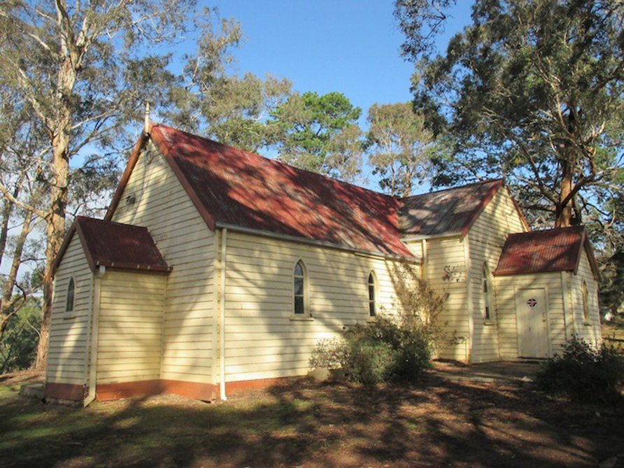

Historical Context

The first squatters arrived in the Arthurs Creek area in 1837. The Reid’s run ‘Hazel Glen’, where the original stone and mud house survives, lay on the southwest. The Bears’ ‘New Leicester’ lay on the northwest, the Macfarlane’s ‘Ard Chattan’ lay between Running Creek and Arthurs Creek, and the Smiths ‘Glen Ard’ lay to the west of Running Creek (Hicks 1988:6). Most of the land west of the Plenty River was sold by the mid-1840s. The land to the east, including the Arthurs Creek area, which was forested and hilly with poor sedimentary soils, was considered ‘cattle country’ and remained under grazing leases for longer (Hicks 1988:13).

The more open undulating country between the Yan Yean Reservoir and Arthurs Creek/Deep Creek was bought at Crown Land sales in the mid-1860s (PROV, VPRS 16171/P1/6, Linton-2). Under the 1860 Land Act, the remaining grazing leases were revoked. The eastern margin of the Parish of Linton, including the Arthurs Creek locality, was surveyed in 1856 but remained unsold. Lots 16, 17 and 24 of this survey were the first to be selected in c1861 by C. Vaughan, M. McLaughlin and W. Watson (Department of Crown Lands and Survey, 1856). The remainder of the Arthurs Creek area became the Upper Plenty Farmers’ Common (later Whittlesea Common) in 1861. An area to the east of Arthurs Creek was proclaimed as the Arthurs Creek Common in 1871 (Vic Gov Gazette, 26 March 1861, No.48:632; PROV, VPRS 0242/P0, file C90869). Most of the European settlers in the area were orchardists and dairy farmers, the most famous of which were the Ryders and Drapers (PROV, VPRS 16171/P1/6, Linton-2). The homesteads of the 1860s such as those of the Ryders and Murphys were typically slab huts (PROV, VPRS 627/ P1, Unit 235, File No 19301). Butter, eggs and poultry were often the first source of income.

A village began to appear in the early 1870s, with the Primitive Methodist church established in 1873, the school opened in 1876 and the Mechanics’ Institute in 1878. The Arthur’s Creek Fruitgrowers’ Association formed in 1890 and held meetings and competitive exhibitions of fruit at the Mechanics’ Institute (Argus, 14 May 1890:6). Daily mail services started in 1889. By 1899 George Murphy had built a post office and store (E&WSA& DCVA, 26 April 1918 :3; Payne 1975:191). The settlement would expand little after this point. In the late 1880s there were 1500 acres under fruit within a three-mile radius of Arthur’s Creek. The extension of the railway to Yan Yean in 1889 made transport to market easier and quicker (Argus, 21 October 1889:9).

Poor prices during the Depression compounded the decline, and by the late 1930s all but the largest and most progressive orchards were unprofitable. Orchards were cleared and the land turned over to sheep. Markets for lamb and wool were variable and while the larger farms survived on sheep, the smaller holdings reverted to dairying and pigs. By the 1970s beef cattle were becoming more profitable. Orcharding continued at Glen Ard, which by 1975 was reputedly the largest orchard in southern Victoria (Five Pear Trees, Apted's Glen Ard Orchard, 120997). The township had about 350 residents at the 1996 census (Hunter-Payne, 2008).

History

The small settlement of Arthurs Creek featured only one church in the nineteenth and early twentieth century, a Primitive Methodist chapel. Methodism as a whole had only around a third of the adherents of Catholics and a sixth of the Church of England in 1857. Primitive Methodists, in turn, were outnumbered by Wesleyan Methodists by around nine to one. Most of the earlier settlements in the area had gained churches for each of the main denominations in early white settlement. The Heidelberg Primitive Methodist Mission, which started in 1854, opened a church in Eltham in 1860 and a first small chapel at Diamond Creek 1861. After quartz mining came to Diamond Creek in 1866, it gained a new church in 1871 (Lesley Alves 2015).

In the settlement of the Arthurs Creek locale, which took place following the squatting era from the early 1860s, a considerable number of the newcomers were Primitive Methodists including the Ryders, Macmillans, McDonalds, Manns (East Linton), Reids, Aireys (Lot 35), Bunkers and the Murphys of both Arthur’s Creek and Streamville. Settlers from other denominations had access to well-established churches within a reasonable distance such as the 1868 Church of England at Queenstown. The Church of England held services in the Arthur’s Creek Mechanics’ Institute hall for a small congregation in the 1890s, possibly to cater for an increased population of orchard workers. It was only in the 1920s that the density of settlement was such that Catholic services were held in the Mechanics’ Institute hall and only in 1928-9 that the short-lived Church of the Irish Martyrs was built (EO&S&EBR, 14 October 1892:2. Advocate (Melbourne), 9 September 1920:31; 27 September 1923:30; Murphy and Draper 2004:304).

By the early 1870s a number of the Primitive Methodist settlers at Arthur’s Creek banded together to arrange local services. According to a 1933 sixtieth anniversary account, the first service was held in 1872 by a preacher from Linton (Hazel Glen), succeeded by Mr Gilbert, a Primitive Methodist from Eltham. By a 1923 fiftieth anniversary account, the first service was arranged by the Ryders and George Gilbert and conducted by Gilbert and another preacher in 1873. A service was held by the Wesleyan Methodists from Yan Yean the following Sunday but as they found that Gilbert had arranged for regular services under the Primitive Methodist banner, they did not return. Subsequently the Arthur’s Creek congregation became connected with the Heidelberg Primitive Methodist mission.

Services during warm weather were said to have been conducted under a “huge” gumtree on the Ryders’ property. In wet weather and perhaps more often, services were held in Mrs MacDonald’s barn and house on the property Glen Donald east of Arthur’s Creek. By 1873, with attendances becoming too large for the accommodation, plans were made for a church. Both the Aireys and Ryders offered land and the Ryders’ one-acre offer was taken up as the most central. Trustees were appointed and the land transferred to the Primitive Methodist Connexion (Advertiser (Hurstbridge), 30 November 1923:4; 13 October 1933:1).

The land was cleared by “the bachelors” [the unmarried men] of the congregation. Mrs “Stuart” [sic actually Stewart] assisted with sawing of “the blocks”. The requisite sawn timber was brought from Melbourne, and the “palings”, “battens” and “ties” were split from a single tree brought from “the mountain” by Thomas Murphy. (Reputedly there are still timber palings under the corrugated iron of the roof). Mr Stuart [sic actually Cornelius John Stewart, soon to marry Mrs MacDonald]’ was contracted to build the church with the aid of volunteer labour, at a cost of £60 (Advertiser (Hurstbridge), 30 November 1923:4; Spectator & Methodist Chronicle, 9 January 1918:32). The first three services were held in a packed church on Sunday 30 November 1873. Some attendees travelled as far as thirteen miles for the occasion. The services were conducted by the Rev. A. Glasson with Mrs Ryder leading the singing. Tea and public meetings were held the following Tuesday with the Reverends Glasson and Gilbert presiding, alongside the Rev. G Grey from Melbourne. A time-capsule enclosed in a bottle was placed under the pulpit. Mrs Stewart was the first to be married in the church, with Mrs Temple following soon after.

A Mr Amos Harrison planted pine trees at the side of the church. The Comers donated towards the purchase of an organ. The first Sunday School superintendent was Mr Airey, followed by Mt Thompson (of Back Creek), Mrs Taylor and Mr Stuart (probably actually Stewart). From 1886 Mr McMillan occupied the position for thirty-seven years. A porch was added in 1899. There were close connections with a succession of teachers at the Arthur’s Creek school, including the Hammetts, the Grennesses and the Pitts (Advertiser (Hurstbridge), 30 November 1923 p.4.).

After the Methodist Union occurred in 1902, the church was referred to as the Arthur’s Creek Methodist Church. The Arthur’s Creek church became part of the Diamond Creek Methodist Home Mission Station, which also had churches at Diamond Creek, Cottles Bridge (built 1894), Hurstbridge and Wattle Glen (Alves 2015). In 1923 the jubilee of the church was held, repairs and alterations were undertaken and a skillion vestry was built at the rear (Advertiser (Hurstbridge), 30 November 1923:4).

In 1933 the sixtieth anniversary was celebrated with a tea meeting and concert in the Mechanics’ Institute. In 1936 a brass plaque was placed in the church to commemorate the jubilee of Sunday School teacher Mr Hugh McMillan (Advertiser (Hurstbridge), 11 September 1936:6). During World War Two a service was held for departing soldiers from the congregation (Eltham and Whittlesea Shires Advertiser, 26 January 1940:4). In 1953 the “historic little Arthurs Creek Methodist Church … glistened with fresh paint for its 80th anniversary”. A set of brick and steel memorial gates were also erected for the occasion (Argus, 29 September 1953:7).

In c1963 the Diamond Creek Methodist Home Mission Station began to build a new church and the old 1871 timber church was moved to Arthur’s Creek to function as a Sunday School hall (Edwards 1997, p.177, Draper 2012, pp.5-6). It was butted up to the rear/south side of the slightly smaller existing building. It appears that the existing vestry structure was moved to the south side of the Sunday School hall.

Primitive Methodism
The Wesleyan Methodists were the first to appear in the colony at Port Phillip in 1838. The Primitive Methodist Connexion was the first of the divisions of Methodism to appear in the colony, with the first services held in Melbourne in 1849 and a church building started in 1850. Another division, the Bible Christians, was almost as large as the Primitive Methodists (Lewis 1991:9). By the end of the nineteenth century the Primitive Methodists were the second largest group of Methodists in Victoria after the Wesleyans, with 125 church buildings in 1901. In 1902 the divisions of Methodism united to form the Methodist Church of Australasia. The 1000 accumulated churches of the various divisions were rationalised down to 829. (Lewis 1991:.10) The flexibility of worship of the Methodists, including the Primitive Methodists, was such that they were among the first to conduct services in goldfields, often in the open or in tents. By the 1860s a number of churches had been built. Those in the larger towns were relatively large masonry buildings often with classical architecture. Those in smaller settlements were typically small rustic timber and brick structures, with hints of Gothic in the doors and windows, barges and roof pitch. While the Methodist churches in the larger towns had some pretensions, the majority of churches were small and simple buildings in line with John Wesley’s prescription that preaching house should be plain and decent (Lewis 1991:10).

Description & Integrity
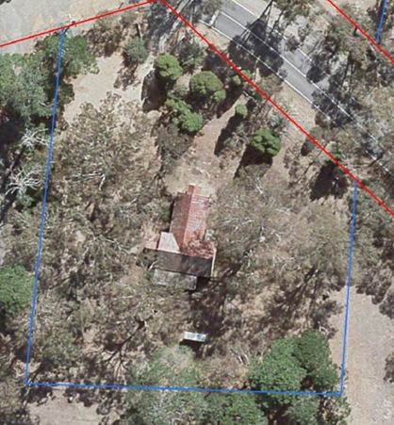

Aerial photograph 2015
Source: Nillumbik Shire Council

The church is set on a rise, above the road. The Arthurs Creek Road entry is framed by the 1953 Memorial Gates, which consist of brick walls clad in crazy slate and double wrought iron gates with a geometric pattern. The walls angle outwards from the gate opening and there are taller pillars either side of the gate. A timber post and rail fence with chain mesh wire panels between the posts sits behind the side walls and extends along the boundary on both sides of the entry.

Arthur’s Creek Methodist Church is a weatherboard building with a gable roofed nave running perpendicular to the road making up the original 1873 section of the church. The side walls of the nave contain two pointed arch and timber framed windows with three panes. There is a small gable roofed porch to the front of the nave with a side single pointed arch entry door.

There is a small pointed arch timber framed window to the front elevation of the porch.

To the rear of the nave is a weatherboard Sunday School wing with a gable roof running perpendicular to the nave and extending either side of the nave. This building is the former Diamond Creek Methodist Church (constructed in 1971) moved to this site in 1963. There is also a gable roofed entry porch to the west end of the vestry with a square door on the north side facing the street. The windows to the vestry are also pointed arches and timber framed; however, the windows to the vestry are larger with pointed arch panes to the top portion.

To the rear of the Sunday School is a skillion roofed, weatherboard clad wing. This is the vestry added to the church in 1923 and moved to this location in 1963 when the Sunday School was added.

All sections of the building have weatherboard clad walls and corrugated galvanised iron roof cladding which has been painted red. There are turned timber finials at the front gable ends of the nave and Sunday School wings.

There is a weatherboard clad single toilet at the rear of the church with a skillion roof. This building does not contribute to the significance of the place.

Comparative Analysis

Churches were an integral part of the social life of communities within the Shire of Nillumbik and were often amongst the first buildings constructed within townships. Not only did these buildings provide places for worship, they are generally modest in scale, and often functioned as places to gather, celebrate and be educated and span periods from the mid nineteenth to early twentieth centuries.

Comparable churches in Nillumbik on the Heritage Overlay include:

- Presbyterian Church, 265 Eltham-Yarra Glen Road, Kangaroo Ground c1878 (HO46)
- St Andrews Anglican Church, 15 Caledonia Street, St Andrews c1868 (HO21)
- Uniting Church (originally Methodist) 810 Main Road, Eltham 1880 (HO118)
- Plenty Methodist, later Uniting Church, built 1924 formerly 171 Yan Yean Road (HO250)

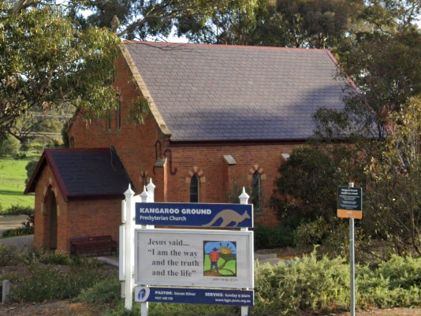  Presbyterian Church, 265 Eltham-Yarra Glen Road, Kangaroo Ground c1878 (HO46) | 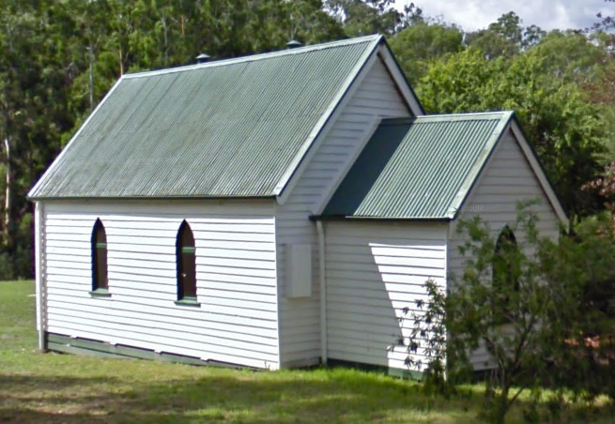  St Andrews Anglican Church, 15 Caledonia Street, St Andrews c1868 (HO21)
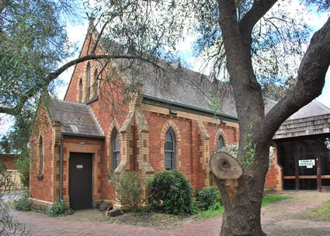  Uniting Church (originally Methodist) 810 Main Road, Eltham 1880 (HO118) | 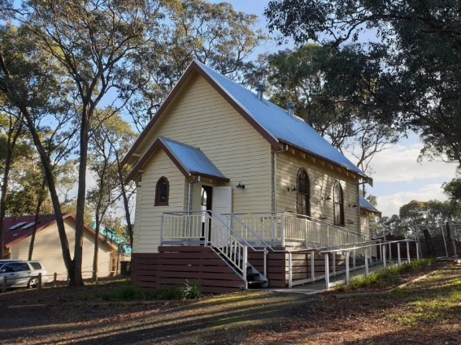  Plenty Methodist, later Uniting Church, built 1924, relocated to this site 2018 (Source: Context June 2021)

The Presbyterian Church at 265 Eltham-Yarra Glen Road, Kangaroo Ground, is a bichromatic brick building with slate roof thought to have been built c.1878, and one of only a few well preserved buildings in the town from that era. The church is historically and socially significant because it has served the local community since construction.

The Anglican church at 15 Caledonia Street, St Andrews is a simple timber building, thought to be erected c1868. The building is significant as one of only four buildings remaining from the town’s goldmining era, and potentially gave its name to the township. The church is also important for the ongoing role it has played in local community life.

The former Methodist Church at 810 Main Road, Eltham, is a bichromatic brick building with slate roof build in 1880. The building is aesthetically significant as a finely detailed example of a rural community church. The place is also significant for its ongoing community role in the region.

The former Plenty Methodist Church was built in 1924 and relocated to its present site in 2018 from the former location at 171 Yan Yean Road.

Like the subject site, each of these examples bear the characteristics of a Gothic Revival style, applied to a simple and modestly sized building form with gable roof. The simple designs of the subject church, and these examples, reflect their rural location and the modest needs of the local congregations at the time when they were built. The subject site is most comparable in terms of materiality to the small timber chapels, St Andrews (HO21) and Plenty Methodist (HO250), however it is earlier in construction than either. It is also distinctive as a Primitive Methodist church in the Shire, while it shares the simple non-pretentious character of the Methodist chapels more broadly. Similar to the comparable examples, the subject site has a demonstrated continual use as a church, servicing the local community as a place of worship and gathering. Overall, the subject site compares favourably against these examples.

Assessment Against Criteria

Criteria referred to in Practice Note 1: Applying the Heritage Overlay, Department of Planning and Community Development, revised July 2015, modified for the local context.

CRITERION A: Importance to the course or pattern of the Shire of Nillumbik’s cultural or natural history (historical significance).
Arthurs Creek Methodist Church is of historical significance for its demonstration of the early development period of the town of Arthurs Creek, particularly the development of spiritual and community life, when a village began to appear following settlement in the area resulting from the 1862 Land Act.
The Sunday School which was originally the Diamond Creek Methodist Church constructed in 1871 and moved to the site for use as a Sunday School in 1963 is also historically significant for its contribution to the history of Diamond Creek as well as for its demonstration of building re-use practice by the church denominations particularly in the rural areas of the municipality

CRITERION B: Possession of uncommon, rare or endangered aspects of the Shire of Nillumbik’s cultural or natural history (rarity).

CRITERION C: Potential to yield information that will contribute to an understanding of the Shire of Nillumbik’s cultural or natural history (research potential).

CRITERION D: Importance in demonstrating the principal characteristics of a class of cultural or natural places or environments (representativeness).
Arthurs Creek Methodist Church is significant as a representative example of a substantially intact Victorian timber church typical of Methodist Churches, which were substantially small and simple in design with minimal pretensions.

CRITERION E: Importance in exhibiting particular aesthetic characteristics (aesthetic significance).
The church demonstrates key features of its type and period including gable roof forms, small entry porch, pointed arch timber framed windows and timber finials. The Sunday School hall is complementary to the Church with its similar form and materials. The building is of aesthetic interest for its integration of a previous church building for use as a Sunday School at the rear of the original building. Despite the integration of the two buildings, the integrity of both individual buildings has been retained.

CRITERION F: Importance in demonstrating a high degree of creative or technical achievement at a particular period (technical significance).

CRITERION G: Strong or special association with a particular community or cultural group for social, cultural or spiritual reasons. This includes the significance of a place to Indigenous peoples as part of their continuing and developing cultural traditions (social significance).

CRITERION H: Special association with the life or works of a person, or group of persons, of importance in the Shire of Nillumbik’s history (associative significance).

Grading and Recommendations

Recommended for inclusion in the schedule to the Heritage Overlay of the Nillumbik Planning Scheme.
Recommendations for the Schedule to the Heritage Overlay (Clause 43.01) in the Nillumbik Planning Scheme:

External Paint Colours  Is a permit required to paint an already painted surface? | No
Internal Alteration Controls  Is a permit required for internal alterations? | No
Tree Controls  Is a permit required to remove a tree? | No
Victorian Heritage Register  Is the place included on the Victorian Heritage Register? | No
Incorporated Plan  Does an Incorporated Plan apply to the site? | No
Outbuildings and fences exemptions  Are there outbuildings and fences which are not exempt from notice and review? | Yes – 1953 Memorial Gates
Prohibited uses may be permitted  Can a permit be granted to use the place for a use which would otherwise be prohibited? | Yes
Aboriginal Heritage Place  Is the place an Aboriginal heritage place which is subject to the requirements of the Aboriginal Heritage Act 2006? | No

Identified By

Identified by Samantha Westbrooke Pty Ltd and Peter Mills 2016

References

Argus, as cited.

Australasian, as cited.
Alves, Lesley, ‘ A brief history of the Diamond Valley Parish’, Diamond Valley Uniting Church website, http://diamondvalley.unitingchurch.org.au/history.html accessed 30 May 2015.

Edwards, Dianne H. 1979. The Diamond Valley Story: Shire of Diamond Valley.

Eltham and Whittlesea Shires Advertiser and Diamond Creek Valley Advocate (E&WSA& DCVA), as cited.

Evelyn Observer and Bourke East Record (EOBER), as cited.

Hermes Records for ‘Five Pear Trees, Apted's Glen Ard Orchard’, Shire of Nillumbik, accessed March 2022, as cited.

Hicks, P1988, Plenty Valley Historical Survey, Ministry for Planning and Environment, Melbourne.

Hunter-Payne, G. 2009, Arthurs Creek, https://www.emelbourne.net.au/biogs/EM00093b.htm, accessed online 23 March 2022.

Murphy, J. T. 1971. Early settlers of Arthurs Creek, Victoria, J. T Murphy, Arthurs Creek.

PROV, VA538 Department of Crown Lands and Survey, VPRS 627 Land Selection Files, Section 31 Land Act 1869, File No 19301.

PROV, VA4554 Department of sustainability and Environment, VPRS 16171 Regional Land Office Parish and Township Plans Digitised Reference Set, Linton-2(Psh)LOImpL3000-2.pdf Linton -2 Parish Plan, Imperial measure L3000-2

PROV, VA 2878 Crown Lands Department, VPRS 0242 Crown Reserve Correspondence, Arthurs Creek Common File C90869.

Payne, J. W1975, The Plenty: A Centenary History of the Whittlesea Shire, Lowden, Kilmore.

Blake, L.J., ed. 1973a. Vision and Realisation: a centenary history of state education in Victoria Vol. 3, Education Dept. of Victoria, Melbourne.

Blake, L.J. 1973f. Vision and Realisation: a centenary history of state education in Victoria Vol.
1 Education, Dept. of Victoria, Melbourne.

Draper, B. G 2012, Arthurs Creek Mechanics' Institute, Arthurs Creek Mechanics' Institute Inc., Victoria.

Education Department of Victoria 1922, A history of state education in Victoria / with an introduction by Sir Alexander J. Peacock, C. Parker for the Education Depart. of Victoria, Melbourne.

Lewis, Miles, ed. 1991. Victorian Churches. Melbourne: National Trust of Australia Victoria.

Payne, J.W. 1975. The Plenty: A Centenary History of the Whittlesea Shire. Kilmore: Lowden.
Victoria. Department of Crown Lands and Survey 1856, Country lands, in the Parish of Linton, East of the Parish of Toorourong, adjoining the Yan Yean Reservoir. Dept. of Lands and Survey, Melbourne

Victorian Government Gazette, as cited.

