Arthurs Creek School Shelter Shed
Prepared by: Trethowan Architecture

Address: 900 Arthurs Creek Road, Arthurs Creek
Name: Shelter Shed | Survey Date: 2015
Place Type: Individual | Architect:
Grading: Significant | Builder:
Extent of Overlay: One Metre around Shed | Construction Date: 1910

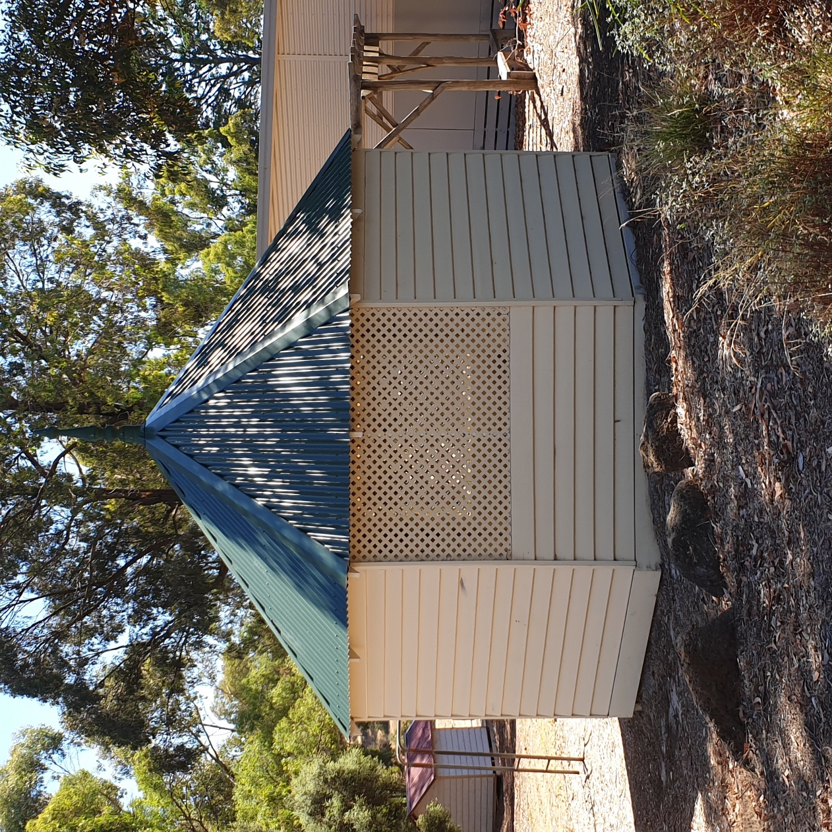

Historical Context

The first squatters arrived in the Arthurs Creek area in 1837. The Reid’s run ‘Hazel Glen’, where the original stone and mud house survives, lay on the southwest. The Bears’ ‘New Leicester’ lay on the northwest, the Macfarlane’s ‘Ard Chattan’ lay between Running Creek and Arthurs Creek, and the Smiths ‘Glen Ard’ lay to the west of Running Creek (Hicks 1988:6). Most of the land west of the Plenty River was sold by the mid-1840s. The land to the east, including the Arthurs Creek area, which was forested and hilly with poor sedimentary soils, was considered ‘cattle country’ and remained under grazing leases for longer (Hicks 1988:13).

The more open undulating country between the Yan Yean Reservoir and Arthurs Creek/Deep Creek was bought at Crown Land sales in the mid-1860s (PROV, VPRS 16171/P1/6, Linton-2). Under the 1860 Land Act, the remaining grazing leases were revoked. The eastern margin of the Parish of Linton, including the Arthurs Creek locality, was surveyed in 1856 but remained unsold. Lots 16, 17 and 24 of this survey were the first to be selected in c1861 by C. Vaughan, M. McLaughlin and W. Watson (Department of Crown Lands and Survey, 1856). The remainder of the Arthurs Creek area became the Upper Plenty Farmers’ Common (later Whittlesea Common) in 1861. An area to the east of Arthurs Creek was proclaimed as the Arthurs Creek Common in 1871 (Vic Gov Gazette, 26 March 1861, No.48:632; PROV, VPRS 0242/P0, file C90869). Most of the European settlers in the area were orchardists and dairy farmers, the most famous of which were the Ryders and Drapers (PROV, VPRS 16171/P1/6, Linton-2). The homesteads of the 1860s such as those of the Ryders and Murphys were typically slab huts (PROV, VPRS 627/ P1, Unit 235, File No 19301). Butter, eggs and poultry were often the first source of income.

A village began to appear in the early 1870s, with the Primitive Methodist church established in 1873, the school opened in 1876 and the Mechanics’ Institute in 1878. The Arthur’s Creek Fruitgrowers’ Association formed in 1890 and held meetings and competitive exhibitions of fruit at the Mechanics’ Institute (Argus, 14 May 1890:6). Daily mail services started in 1889. By 1899 George Murphy had built a post office and store (E&WSA& DCVA, 26 April 1918 :3; Payne 1975:191). The settlement would expand little after this point. In the late 1880s there were 1500 acres under fruit within a three-mile radius of Arthur’s Creek. The extension of the railway to Yan Yean in 1889 made transport to market easier and quicker (Argus, 21 October 1889:9).

Poor prices during the Depression compounded the decline, and by the late 1930s all but the largest and most progressive orchards were unprofitable. Orchards were cleared and the land turned over to sheep. Markets for lamb and wool were variable and while the larger farms survived on sheep, the smaller holdings reverted to dairying and pigs. By the 1970s beef cattle were becoming more profitable. Orcharding continued at Glen Ard, which by 1975 was reputedly the largest orchard in southern Victoria (Five Pear Trees, Apted's Glen Ard Orchard, 120997). The township had about 350 residents at the 1996 census (Hunter-Payne, 2008).

History

A meeting was held in Arthurs Creek in 1870 to seek establishment of a Common School. A committee was appointed consisting of John Ryder, Patrick Green, William Lodge, Pierce Brennan, Dougal McPhee and George Grey. In the application to the Education Department by George Ryder fifty-four eligible children were listed and Ryder offered an acre of his land for the purpose (Payne 1975, p.84). Two acres of Ryder’s land was purchased in 1874 for £10 by the Education Department (School No.1666 Arthurs Creek, 1912-52, VPRS 795, Unit 2307). James Cockburn of Daylesford constructed State School No.1666 by the end of 1875. The school opened on 17 January 1876 (Blake 1973a, p.354). One room was added in 1888 and another in 1909 (Payne 1975, p.84).

On 22 October 1909 a “grand concert” was held at the Arthur’s Creek Mechanics’ Institute to raise funds to build a shelter shed at the school. Admission was 1s for the concert and 2s. 6d for the ball. The funds raised were to supplement the grant already obtained from the government. The concert was given by the school children under the guidance of the head teacher Mr Grenness. The Chairman and members of the Board of Advice attended and at the interval gave prizes for the best attendance at the school. After the concert Mr Grenness was thanked and the hall cleared for the dance, which continued “until a late hour” (Evelyn Observer & Bourke East Record, 8 October 1909 p.2; 5 November 1909:6). The octagonal shelter shed was built in 1910 (Blake 1973a, V.3 p.354).

Over the succeeding years the school committee requested funding for a variety of repairs and maintenance to the shelter shed. The “play house”, presumably the shelter shed, received funds for painting in 1914. In 1925 the committee requested funding for the replacement of the shelter shed floor. The Department subsidised half of this £5 12s 4d cost in 1926 as well as half of the cost of repainting. Photographs from 1938 indicate that the ventilation of the shed took the form of diagonal timber lattice (Draper 2012, p,21). Repairs occurred again in 1950. A fire occurred in the school and residence in 1951.148 The “school shed and fence” were damaged by a tornado in 1959 (Blake 1973a, p.354).

Fire struck again on 23 October 1962. This time the school and residence were destroyed, and only the shelter shed remained. (Blake 1973a, V.3 p.354) It appears that this was an isolated building fire rather than the outcome of a bushfire. The school was held in the Mechanics’ Institute for a few months. A new school building was ready by February 1963 (Payne 1975, p.85, Blake 1973a, p.354). The wall cladding of the shelter was refurbished in 2015 and a concrete floor slab added.

Contextual history of Shelter Sheds
Few schools had shelter sheds in the nineteenth century. School Boards of Advice or parents often requested them, but in only a few cases the Education Department provided small grants in only a few cases, or they were erected by the Public Works Department. Frequently boards or parents requested the cheaper alternative of building verandahs on the existing school building for this purpose (Blake 1973f, p.265).

In the early twentieth century the Department started a major campaign of updating the school buildings of the nineteenth century. Parents were still expected to organise and fund shelter sheds, fences, gates and woodsheds (Blake 1973, p.329). But, from c1905 the Education Department systematically gave pound-for-pound grants towards the cost of various improvements for school yards such as shelter sheds, fences, asphalting and shade trees. In 1910, the year the Arthurs Creek shelter shed was built, the Department had subsidised 100 local contributions to a total of over £900. Parents typically formed themselves into local committees and arranged various means of raising their share of the funds. As far as the Department was concerned, this was a means for the parents to interest themselves in the state schools in which their children were trained. Parents were more inclined to think of these items as essentials that the department should have provided. An Education Department history of Victorian schools published in 1922 wrote of facilities in rural schools in the first decades of the twentieth century that “shady trees are in growth, and the deeper interest in the children is seen in the play pavilions without, and the libraries with books and magazines within” (Education Department of Victoria 1922, p.225).

A survey of advertisements for fundraising events and tender notices in Victorian newspapers indicates that from around 1905 into the 1920s many school communities held concerts, balls, dances, fetes and bazaars, usually at local halls or mechanics’ institutes, to raise money for a shelter shed or sheds in the same period as the efforts of the Arthurs Creek School.

Other schools in the Nillumbik area made use of the pound-for-pound funding. The Eltham North School held a dance in 1929 to augment their grant for a shelter shed from the Education Department (Advertiser (Hurstbridge), 13 December 1929:2). The same year the Diamond Creek State School planned to erect separate boys’ and girls’ sheds following a fundraising ball and Education Department grant (Advertiser (Hurstbridge), 10 May 1929:2) Shelter sheds were an important part of the life and memories of school. School shelter sheds were typically located in the playground at a distance from the classroom. They provided shelter from the elements – without them children might be forced to sit in the classroom in wet clothes after a rainy lunchtime. They also served as places to sit and eat lunch. For a number of larger schools there were separate sheds for boys and girls. They were very well ventilated as part of the push for children to experience fresh air in their playtime.

Description & Integrity

The shelter shed is located in the south west corner of the Arthurs Creek Primary School site behind the front boundary fence. It is clearly visible from Arthurs Creek Road.

The Shelter Shed has an octagonal plan with an octagonal pyramidal roof form. The building is timber framed with substantially weatherboard wall cladding with the exception of timber lattice panels either side of the single door opening and on the wall opposite the door. The weatherboards have a round profile to the bottom edge. There were formerly scalloped boards to the central rows of weatherboards, but these have been replaced with plain weatherboards. The lattice panels are to the upper end of the walls with weatherboards below. The lattice panels extend between two posts being one full angle of the octagon. The roof is clad in corrugated galvanised iron (painted green) with flat galvanised iron strips over the joins and a tall turned timber finial at the apex. The eaves are exposed and there is no guttering or downpipes. The interior of the shelter shed is unlined.

Comparative Analysis

Small timber-framed shelter sheds with radial symmetry, whether hexagonal, octagonal or decagonal, sometimes described as rotundas, were a feature of a many schools in the State. Unfortunately, few existing heritage citations provide details and dates for these structures because most heritage studies and type studies have been focussed on the architects of the school buildings. The radial sheds were probably outnumbered by rectangular sheds, but shared with them features such as ample ventilation through timber lattice at eaves or eaves and floor levels, as well as one open side.

Other examples of school shelter sheds with radial symmetry which have been identified in heritage studies and assessments include:

- An octagonal shelter shed at the Nichols Point Primary School, Mildura, built c1907.
- a decagonal shelter shed at the former Kerrie Primary School No.1290 (VHR H1631),
- a decagonal shelter shed at State School No.2118 at Coleraine, moved from the Coleraine Primary School site in 1960
- an octagonal shelter shed at former State School No.971 Drik Drik,
- a hexagonal shelter (pavilion?) at Glenroy Primary School No.3118 (Moreland City HO382)
- a hexagonal shelter shed at Auburn Primary School No.2948 (Boroondara City HO110),
- a large octagonal shelter shed with tiled roof at Primary School No.484 Coburg (VHR H1709), with umbrella-like internal structure
- an octagonal shelter shed at Heywood State School, built 1912,
- an octagonal shelter shed at ‘Old Gippstown’ collection, moved from the Grey St Primary School Traralgon
- A small hexagonal shelter shed at former Harcourt State School No.299 built c1918

There is a spectrum of scale and sophistication in these sheds, ranging from small rural examples such as at Arthurs Creek, Kerrie, Heywood and Drik Drik, to the larger examples such as at Bell St Coburg primary School, which display more complex and heavier structures and materials. There are also parallels in these simple structures with bandstands and rotundas in parks and cemeteries.

In Nillumbik Shire, Strathewen Primary School No.3947 School Building, Hexagonal Shelter Shed and Exotic Site Planning, 5 School Ridge Road, Strathewen (HO160) contained a comparable hexagonal shelter of around the same period, however it and the complex were destroyed by fire in 2009.

The Strathewen Primary School had historic and social significance as the local school, while the one room schoolroom illustrates a standard design found throughout Victoria. The intact hexagonal shelter shed is a quite rare example of this type of structure in a Victoria-wide context. The three exotic trees are important components in the school grounds and direct links to the school's past. Strathewen School was established by the local community and leased by the Education Department, an unusual arrangement for an early 20th century school (Bick Study 1992).

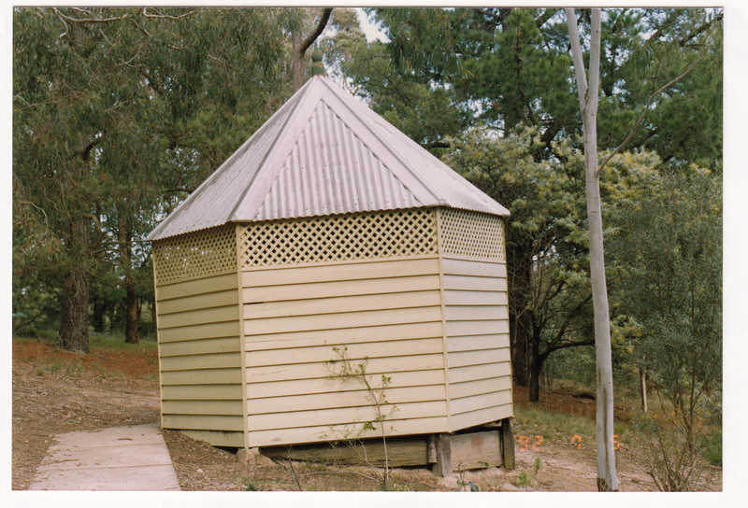
The former shelter shed at Strathewen (destroyed) pictured in 1992.

Assessment Against Criteria

Criteria referred to in Practice Note 1: Applying the Heritage Overlay, Department of Planning and Community Development, revised July 2015, modified for the local context.

CRITERION A: Importance to the course or pattern of the Shire of Nillumbik’s cultural or natural history (historical significance).
The Arthur’s Creek Primary School Shelter Shed is historically significant as the only remaining remnant of the earlier Arthurs Creek Primary School (1876), which burnt down in 1962. Constructed at the school in 1910, the octagonal shelter shed represents a time of growth in the local school community, with funds raised in 1909, around the same time as another new room was added to the school. As a shelter shed it demonstrates the changing requirements and designs of school playground buildings in the early twentieth century, incorporating a lattice for ventilation at a time when the importance of ventilation and fresh air was gaining prominence in public health.

CRITERION B: Possession of uncommon, rare or endangered aspects of the Shire of Nillumbik’s cultural or natural history (rarity).
Shelter sheds were a common feature of state schools during this period, but few seem to have survived, with notable examples attached to schools having been replaced or otherwise lost or destroyed by fire.

CRITERION C: Potential to yield information that will contribute to an understanding of the Shire of Nillumbik’s cultural or natural history (research potential).

CRITERION D: Importance in demonstrating the principal characteristics of a class of cultural or natural places or environments (representativeness).

CRITERION E: Importance in exhibiting particular aesthetic characteristics (aesthetic significance).

CRITERION F: Importance in demonstrating a high degree of creative or technical achievement at a particular period (technical significance).

CRITERION G: Strong or special association with a particular community or cultural group for social, cultural or spiritual reasons. This includes the significance of a place to Indigenous peoples as part of their continuing and developing cultural traditions (social significance).

CRITERION H: Special association with the life or works of a person, or group of persons, of importance in the Shire of Nillumbik’s history (associative significance).

Grading and Recommendations

Recommended for inclusion in the schedule to the Heritage Overlay of the Nillumbik Planning Scheme.
Recommendations for the Schedule to the Heritage Overlay (Clause 43.01) in the Nillumbik Planning Scheme:

External Paint Colours  Is a permit required to paint an already painted surface? | No
Internal Alteration Controls  Is a permit required for internal alterations? | No
Tree Controls  Is a permit required to remove a tree? | No
Victorian Heritage Register  Is the place included on the Victorian Heritage Register? | No
Incorporated Plan  Does an Incorporated Plan apply to the site? | No
Outbuildings and fences exemptions  Are there outbuildings and fences which are not exempt from notice and review? | No
Prohibited uses may be permitted  Can a permit be granted to use the place for a use which would otherwise be prohibited? | No
Aboriginal Heritage Place  Is the place an Aboriginal heritage place which is subject to the requirements of the Aboriginal Heritage Act 2006? | No

Identified By
Samantha Westbrooke
References

Argus, as cited.

Australasian, as cited.

Eltham and Whittlesea Shires Advertiser and Diamond Creek Valley Advocate (E&WSA& DCVA), as cited.

Evelyn Observer and Bourke East Record (EOBER), as cited.

Hermes Records for ‘Five Pear Trees, Apted's Glen Ard Orchard’, Shire of Nillumbik, accessed March 2022, as cited.

Hicks, P1988, Plenty Valley Historical Survey, Ministry for Planning and Environment, Melbourne.

Hunter-Payne, G. 2009, Arthurs Creek, https://www.emelbourne.net.au/biogs/EM00093b.htm, accessed online 23 March 2022.

Murphy, J. T. 1971. Early settlers of Arthurs Creek, Victoria, J. T Murphy, Arthurs Creek.

PROV, VA538 Department of Crown Lands and Survey, VPRS 627 Land Selection Files, Section 31 Land Act 1869, File No 19301.

PROV, VA4554 Department of sustainability and Environment, VPRS 16171 Regional Land Office Parish and Township Plans Digitised Reference Set, Linton-2(Psh)LOImpL3000-2.pdf Linton -2 Parish Plan, Imperial measure L3000-2

PROV, VA 2878 Crown Lands Department, VPRS 0242 Crown Reserve Correspondence, Arthurs Creek Common File C90869.

Payne, J. W1975, The Plenty: A Centenary History of the Whittlesea Shire, Lowden, Kilmore.

Blake, L.J., ed. 1973a. Vision and Realisation: a centenary history of state education in Victoria Vol. 3, Education Dept. of Victoria, Melbourne.

Blake, L.J. 1973f. Vision and Realisation: a centenary history of state education in Victoria Vol.
1 Education, Dept. of Victoria, Melbourne.

Draper, B. G 2012, Arthurs Creek Mechanics' Institute, Arthurs Creek Mechanics' Institute Inc., Victoria.

Education Department of Victoria 1922, A history of state education in Victoria / with an introduction by Sir Alexander J. Peacock, C. Parker for the Education Depart. of Victoria, Melbourne.

Payne, J.W. 1975. The Plenty: A Centenary History of the Whittlesea Shire. Kilmore: Lowden.
Victoria. Department of Crown Lands and Survey 1856, Country lands, in the Parish of Linton, East of the Parish of Toorourong, adjoining the Yan Yean Reservoir. Dept. of Lands and Survey, Melbourne

Victorian Government Gazette, as cited.

See for instance Yarck State School (Yea Chronicle, 24 March 1909 p.2. Alexandra and Yea Standard and Yarck, Gobur, Thornton and Acheron Express, 16 September 1910 p.2), Majors Line School (McIvor Times and Yea Chronicle, 16 June 1910 p.4; 16 September 1910 p.3), Williamstown North State School (Williamstown Chronicle, 26 August 1911 p.3), Glengarry (Traralgon Record, 26 September 1911 p.3), Glenmore School (Bacchus Marsh Express, 23 March 1912 p.2), Axedale School (Bendigo Advertiser, 5 February 1913 p.3), Seal Lake State School (Sea Lake Times and Berriwillock Advertiser, 22 August 1914 p.2).

