Arthur’s Creek Mechanics Institute
Prepared by: Trethowan Architecture

Address: 906 Arthurs Creek Road, Arthurs Creek
Name: Mechanics Institute | Survey Date: 2015
Place Type: Individual | Architect: Edgar J Henderson
Grading: Significant | Builder: D.J. Murphy
Extent of Overlay: To Title Boundaries | Construction Date: 1886

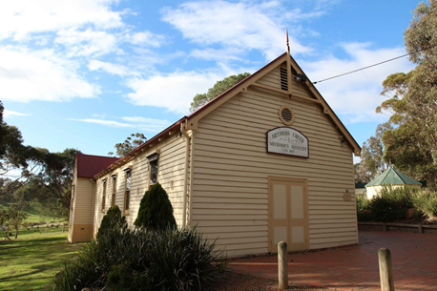
Arthurs Creek Mechanics Institute as viewed from Arthurs Creek Road, Samantha Westbrooke 12.05.2015

Historical Context

The first squatters arrived in the Arthurs Creek area in 1837. The Reid’s run ‘Hazel Glen’, where the original stone and mud house survives, lay on the southwest. The Bears’ ‘New Leicester’ lay on the northwest, the Macfarlane’s ‘Ard Chattan’ lay between Running Creek and Arthurs Creek, and the Smiths ‘Glen Ard’ lay to the west of Running Creek (Hicks 1988:6). Most of the land west of the Plenty River was sold by the mid-1840s. The land to the east, including the Arthurs Creek area, which was forested and hilly with poor sedimentary soils, was considered ‘cattle country’ and remained under grazing leases for longer (Hicks 1988:13).

The more open undulating country between the Yan Yean Reservoir and Arthurs Creek/Deep Creek was bought at Crown Land sales in the mid-1860s (PROV, VPRS 16171/P1/6, Linton-2). Under the 1860 Land Act, the remaining grazing leases were revoked. The eastern margin of the Parish of Linton, including the Arthurs Creek locality, was surveyed in 1856 but remained unsold. Lots 16, 17 and 24 of this survey were the first to be selected in c1861 by C. Vaughan, M. McLaughlin and W. Watson (Department of Crown Lands and Survey, 1856). The remainder of the Arthurs Creek area became the Upper Plenty Farmers’ Common (later Whittlesea Common) in 1861. An area to the east of Arthurs Creek was proclaimed as the Arthurs Creek Common in 1871 (Vic Gov Gazette, 26 March 1861, No.48:632; PROV, VPRS 0242/P0, file C90869). Most of the European settlers in the area were orchardists and dairy farmers, the most famous of which were the Ryders and Drapers (PROV, VPRS 16171/P1/6, Linton-2). The homesteads of the 1860s such as those of the Ryders and Murphys were typically slab huts (PROV, VPRS 627/ P1, Unit 235, File No 19301). Butter, eggs and poultry were often the first source of income.

A village began to appear in the early 1870s, with the Primitive Methodist church established in 1873, the school opened in 1876 and the Mechanics’ Institute in 1878. The Arthur’s Creek Fruitgrowers’ Association formed in 1890 and held meetings and competitive exhibitions of fruit at the Mechanics’ Institute (Argus, 14 May 1890:6). Daily mail services started in 1889. By 1899 George Murphy had built a post office and store (E&WSA& DCVA, 26 April 1918 :3; Payne 1975:191). The settlement would expand little after this point. In the late 1880s there were 1500 acres under fruit within a three-mile radius of Arthur’s Creek. The extension of the railway to Yan Yean in 1889 made transport to market easier and quicker (Argus, 21 October 1889:9).

Poor prices during the Depression compounded the decline, and by the late 1930s all but the largest and most progressive orchards were unprofitable. Orchards were cleared and the land turned over to sheep. Markets for lamb and wool were variable and while the larger farms survived on sheep, the smaller holdings reverted to dairying and pigs. By the 1970s beef cattle were becoming more profitable. Orcharding continued at Glen Ard, which by 1975 was reputedly the largest orchard in southern Victoria (Five Pear Trees, Apted's Glen Ard Orchard, 120997). The township had about 350 residents at the 1996 census (Hunter-Payne, 2008).

History

Moves towards creating a mechanics’ institute and free library at Arthurs Creek started in 1886. By this time most of the surrounding land was settled. Land to the east of Arthurs Creek and Running Creek was typically obtained at land sales in the 1860s, while land on the banks of Arthurs Creek, Running Creek and Deep Creek land was taken up under various clauses of the Land Acts, starting in 1863. The Primitive Methodist Church was built 1873 and the school was established in 1876. By the 1880s Arthurs Creek was a flourishing orcharding area with a number of well-established landholders.

At a public meeting at the school in March 1886 a chairman, secretary and treasurer were appointed and subscriptions were collected (The Australasian, 3 September 1910 p.10; 17 September 1910 p.10). By April William Murphy had offered half an acre of land next to the Primitive Methodist Church. In August trustees and a committee were elected and the local member of Parliament, Mr Cameron, promised to lobby for government support. Murphy made an alternative offer of land adjacent to the school, and this site was accepted at an October meeting (Murphy and Draper 2004, p.299). A Mr Mcfarlane was asked to prepare plans for a hall of 40x20ft with a library of 14x12ft, and arrangements were made for transfer of the land. At a January 1887 meeting Charles Draper encouraged the engagement of Melbourne architect Edgar J Henderson to prepare plans. Draper offered to supervise the works (Murphy and Draper 2004, p.300) and an advertisement for tenders to build the hall appeared in city and local papers in February 1887 (EO&S&EBR, 25 February 1887 p.2). D.J. Murphy, of the Streamville family of Murphys, was the successful tenderer (Murphy and Draper 2004, p.300).

The hall of 40x20ft had a raised dais on the north side, with a library of 17x12ft and a dressing room of 12x11ft at the rear. This £200 build provided only a first stage of Henderson’s design. The opening was held on 2 September 1887. “As this was the first entertainment of the sort ever held at Arthur’s Creek, much speculation was indulged in as to how it would come off, and it is pleasing to record that the result achieved … far exceeded the most genuine expectations of those concerned in its production.” The hall was filled to overflowing and William Reid chaired the meeting. The concert of vocal and instrumental performances by locals was concluded with the national anthem, and the hall was then cleared for a dance. Around forty couples participated in the twenty-one dances, which finished at 5am (Argus, 10 September 1887:7; EO&S&EBR, 16 September 1887:2).

The hall soon proved its value as a focus for almost every aspect of the public life of the Arthur’s Creek community. A public meeting was held in April 1888 to discuss calls for extension of the Heidelberg railway line, a vital matter for the local orchardists (EO&S&EBR, 28 June 1889:3). A committee of the Arthur’s Creek Railway League was appointed, which subsequently used the library room for its meetings. Another public meeting at the hall in June 1889 considered the poor postal services in the district (EO&S&EBR, 28 June 1889:3). Many social events were also held in the hall. The Arthur’s Creek Brass Band started to practice in the hall in 1890 and the Arthur’s Creek Cricket Club also met there as well as a local debating club. The local fruit growers met in May 1890 and formed the Arthurs Creek Fruitgrowers’ Association. The Church of England even held services for a small congregation during the period (EO&S&EBR).

As funds became available the buildings and facilities were gradually improved. Some funds came from rents for the various uses. The Institute also held its own fundraisers, such as the Queen’s Birthday and New Year’s Eve balls (EO&S&EBR, 19 December 1890:2). a picket fence was added in front of the hall and a fireplace in the library in 1889. A six-stall stable was added and the hall painted in 1893 and in 1894 ornamental trees were purchased for the grounds and a curtain added to the stage (Murphy and Draper 2004, p.302).

The adult education role of the Mechanics’ Institute was also being exercised to some extent in the nineteenth century. In late 1891 £35 was spent on books for the library, including a copy of Chamber’s Encyclopaedia and a Map of Victoria. The committee of the circulating library published a catalogue of its “fine collection” and the librarian attended on Tuesday and Saturday nights. It seems the library was tailored to the needs of the local orchardists - in 1893 a £30 purchase of books included “some of the best works on fruit culture” (EO&S&EBR, 10 March 1893:2). The lectures were slanted in a similar vein. In 1892 the government entomologist Mr Hammett read a paper at the hall. A debating club started to meet at the hall in 1893 (Murphy and Draper 2004, p.302).

In first years of the new century, the Mechanics’ Institute mainly provided a venue for meetings of various clubs and associations and a wide variety of benefit events. It is at the turn of the century that use of the alternative moniker ‘Arthurs Creek Hall’ begins to become more prevalent in the newspapers. In April 1900 a concert and ball were held for victims of the bushfires that had recently swept through Arthur’s Creek (EO&S&EBR, 30 March 1900 p.2; 20 April 1900:2). The use of the hall was such that in 1903 plans were made for extensions and a new Kauri Pine floor.205 Fifteen feet were added to the south end of the hall. The Health Department also required an additional door on the east side.206 The work was completed in time for an opening concert and ball in December (Murphy and Draper 2004, P.303).

In 1909 a concert and dance were held at the hall by the school to raise funds for a shelter shed (EO&BER, 8 October 1909 p.2; 5 November 1909:6). During World War I takings from monthly socials were divided between the hall and the Red Cross (Murphy and Draper 2004, p.303). In the interwar period, Sporting clubs continued to use the hall for meetings and events, but with the decline of fruit growing in the district and the onset of the World War II, most of these were disbanded by the early 1940s. The fortunes of the hall continued to wane, despite some repairs in 1949, and between that year and 1952 the hall was used only once a year. The books from the library were donated to the school and the dividing room between library and dressing room removed to make a single meeting room/kitchen (Murphy and Draper 2004, p.304). From 1966-74 the Arthurs Creek Progress Association took over administration of the hall. A new masonry toilet block was constructed in 1982, funded with help from the Shire, local donations and an overdraft (Murphy and Draper 2004, p.305).

The hall’s centenary celebrations took place over a weekend in 1987 and included a dance for young people, an old time ball, an ecumenical church service and a barbecue and game afternoon. The celebrations for the 125th anniversary of the school in 2001 included a dinner for 300 at the hall. A storage shed was added c1997. The hall was used as a relief centre following the 2009 Black Friday fires. After the fires funding was obtained for another storage shed and the upgrade of the hall kitchen (Draper 2012, pp.31-32). A large open sided skillion was added to the east side of the hall c2010. The Hall Committee continues to foster community activity and a number of local groups meet and hold events in the hall, including the Cemetery Trust, local Landcare group and bush fire brigade (Murphy and Draper 2004, p.305).

Description & Integrity

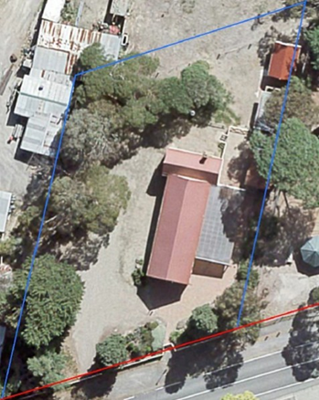
Aerial view of the Mechanics’ Institute
Source: Nillumbik Shire Council

Arthurs Creek Mechanics Institute is a weatherboard building with a main gable roofed hall running perpendicular to the street. At the rear of the hall is smaller gable roofed wing running perpendicular to the hall. There is a decorative bargeboard with hanging beam and finial at the front gable end of the building. The front elevation also contains double doors with a painted sign to the gable end with the wording Arthurs Creek Mechanics Institute AD 1887. On the east side of the hall is a skillion roofed canopy attached to the building and added in 2010. It is possible that the doors on this side of the building were also altered at this time. The timber framed double hung windows to the building appear to be original and in their original locations. Therefore, apart from the changes to the east side, and door openings, the Mechanics’ Institute is substantially intact.

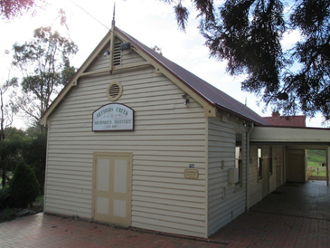 | 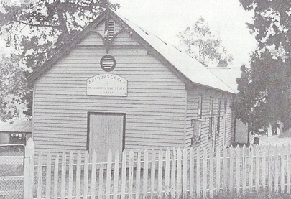
Front view of the Mechanics’ Institute and the same view prior to east side additions
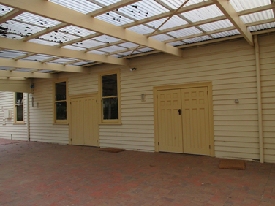 | 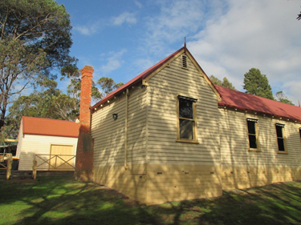
East elevation | Rear, west view

There is a row of three outbuildings buildings on the eastern boundary. The northernmost is a weatherboard shed with a gable roof which may be the 1890 stables. The central outbuilding is a skillion roofed rendered brick toilet block constructed in 1982 and the southernmost one adjacent to the hall, is a replica Edwardian weatherboard shed constructed in 2010. The former 1890s stables contribute to the significance of the place but the two later buildings (1982 and 2010) are non-contributory.

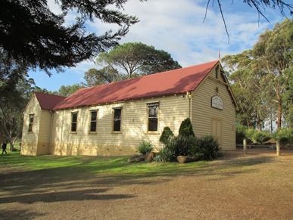 | 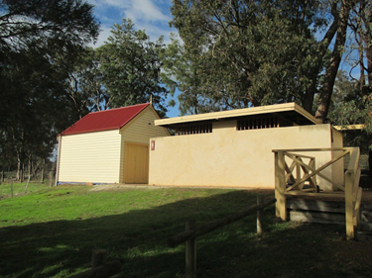
West side view | Former stables and brick toilet block

Comparative Analysis

Not many Mechanics Institutes have survived in the Shire. The earliest halls in the Nillumbik area usually took the form of mechanics’ institutes and free libraries. The mechanics’ institute movement started in Scotland in 1800 with the intention of improving the education of working men (Mills & Westbrooke 2017). Several of these early halls were either destroyed by fire or demolished over time. For example, the Diamond Creek Public Hall and Literary Institute was possibly the earliest hall in the area, opening in 1868. The hall was used to house the infant grades of the state school when there was a rapid increase of pupils in the early 1870s (Mills & Westbrooke 2016:103). A new hall incorporating sections of the old was built in 1905 however this building was destroyed by fire in 1969 (Mills & Westbrooke 2017). At Kangaroo Ground a hall, which became known as Stevenson Hall after its builder, was built in 1885. It did not have a library but did host the typical list of entertainments and meetings and was noted for its good dance floor. The Shire ordered the demolition of the dilapidated hall in 1969. (Mills & Westbrooke 2017)

Surviving community halls in the Shire include:

- Christmas Hills Mechanics Institute, 775 – 787 Ridge Road, Christmas Hills, rebuilt in 2013 (HO243)
- St Andrews Hall, 1 Proctor Street, St Andrews (1925)
- Plenty Hall, Plenty Heritage Park 2-6 Memorial Drive Plenty (1931)
- Gibson Hall, 575 Kangaroo Ground-St Andrews Road, Panton Hill (c1924) (HO96).

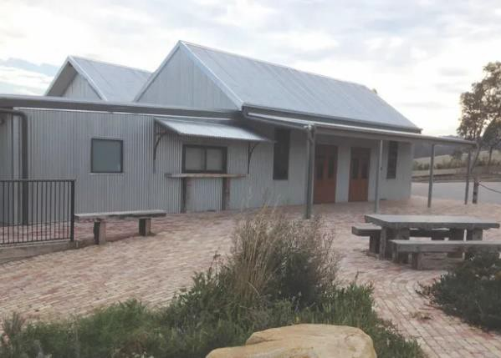  Christmas Hills Mechanics Institute, 775 – 787 Ridge Road, Christmas Hills rebuilt in 2013 (HO243 Shire of Nillumbik). Source: https://christmashillshall.org.au/ | 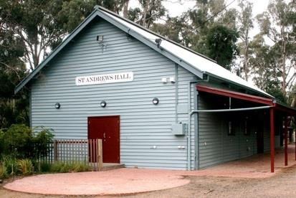  St Andrews Hall, 1 Proctor Street, St Andrews built 1925. Source: https://www.standrewscommunitycentre.org/history-of-st- andrews-hall.html
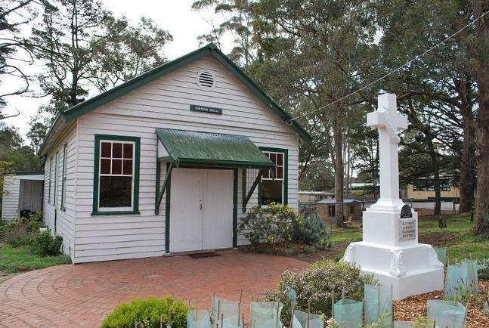  Gibson Hall, 575 Kangaroo Ground-St Andrews Road, Panton Hill built in c1924 (HO96). Source: https://commons.wikimedia.org/wiki/File:PantonHillGibsonH all.JPG | 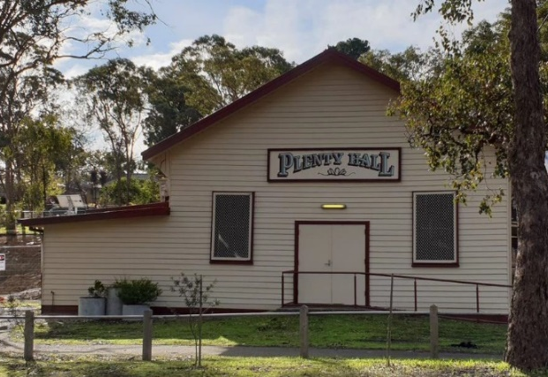  HO248 Plenty Hall, Plenty Heritage Park 2-6 Memorial Drive Plenty. Constructed 1930-31, additions 2010. Image source: Context May 2021.
The Christmas Hills Mechanics Institute, 775 – 787 Ridge Road, Christmas Hills, (HO243) had a similar weatherboard materiality and simple gable form. It opened in 1877, partly funded partly by public donations and partly by a government grant and was located on a temporary Crown land reserve (Mills & Westbrooke 2017). Destroyed by fire in 1894, the hall was rebuilt on its current site in 1895 and again in 2013.

Fundraising for the Queenstown Mechanics’ Institute and Free Library started in 1882 with the building opening in 1883. In 1889 the building was moved to a more central position in the town, as it had been too inaccessible. The institute was reopened in 1899 and was an important part of the community until 1924 when it was destroyed by fire. It was rebuilt in 1925 at its current location and is now known as the St Andrews Hall (Mills & Westbrooke 2017).

There is also a small timber hall building adjacent to the St Matthews Church at 575 Kangaroo Ground-St Andrews Road, Panton Hill. Known as Gibson Hall and built in c1924 the building is within the curtilage of HO96 and is comparable to the Plenty Hall having a similar materiality, form and interwar build date. Like the subject building it has also been in continual use as a hall since built. The Plenty Hall (HO248), in Plenty Heritage Park 2-6 Memorial Drive Plenty was constructed 1930-31, with comparable weatherboard and a simple gable form.

Compared to the above examples Arthurs Creek Mechanics Institute shares similar weatherboard materiality and simple gable forms, but it is distinctive as an earlier (1887) surviving example with more elaborate late nineteenth century features such as the decorative bargeboard with finial, exposed rafter ends. Only Christmas Hills was earlier but has been significantly rebuilt in its entirety.

Assessment Against Criteria

Criteria referred to in Practice Note 1: Applying the Heritage Overlay, Department of Planning and Community Development, revised July 2015, modified for the local context.

CRITERION A: Importance to the course or pattern of the Shire of Nillumbik’s cultural or natural history (historical significance).

Arthurs Creek Mechanics’ Institute is historically significant as an early and important public building in the township of Arthurs Creek since 1887 and as an early surviving example in Nillumbik more broadly. Constructed in 1887, the Mechanics’ Institute demonstrates the heyday of Arthurs Creek in the late 19th century, when there was a much larger population in the area and it played an important role in the townships continuing development. The building is of significance a substantially intact example of a Mechanics’ institute constructed in the Shire during the Victorian period when compared to others that hark mostly to the Interwar period. The Mechanics’ Institute is a visual reminder of the once more populous township of Arthurs Creek. The Mechanics’ Institute has been the venue for meetings of various clubs and associations and a wide variety of benefit events and thus played an important role in the development of local community life. This has included its provision of a library and adult education services focussed on the particular needs of the local area.

CRITERION B: Possession of uncommon, rare or endangered aspects of the Shire of Nillumbik’s cultural or natural history (rarity). N/A

CRITERION C: Potential to yield information that will contribute to an understanding of the Shire of Nillumbik’s cultural or natural history (research potential). N/A

CRITERION D: Importance in demonstrating the principal characteristics of a class of cultural or natural places or environments (representativeness).

CRITERION E: Importance in exhibiting particular aesthetic characteristics (aesthetic significance).
Arthurs Creek Mechanics’ Institute is aesthetically significant as a substantially intact example of a weatherboard Victorian Mechanic’s Institute of the late Victorian period. Key features of the style include the all-encompassing gable roof form, timber framed double hung windows and their placement, double doors to the front, gable end decorative bargeboards and finial, and weatherboard cladding. It compares well to other community halls in Nillumbik, particularly as expressing the late Victorian style compared to many other surviving halls that are Interwar.

CRITERION F: Importance in demonstrating a high degree of creative or technical achievement at a particular period (technical significance). N/A

CRITERION G: Strong or special association with a particular community or cultural group for social, cultural or spiritual reasons. This includes the significance of a place to Indigenous peoples as part of their continuing and developing cultural traditions (social significance). N/A

CRITERION H: Special association with the life or works of a person, or group of persons, of importance in the Shire of Nillumbik’s history (associative significance). N/A

Grading and Recommendations

Recommended for inclusion in the schedule to the Heritage Overlay of the Nillumbik Planning Scheme.
Recommendations for the Schedule to the Heritage Overlay (Clause 43.01) in the Nillumbik Planning Scheme:

External Paint Colours  Is a permit required to paint an already painted surface? | No
Internal Alteration Controls  Is a permit required for internal alterations? | No
Tree Controls  Is a permit required to remove a tree? | No
Victorian Heritage Register  Is the place included on the Victorian Heritage Register? | No
Incorporated Plan  Does an Incorporated Plan apply to the site? | No
Outbuildings and fences exemptions  Are there outbuildings and fences which are not exempt from notice and review? | Yes – former stables
Prohibited uses may be permitted  Can a permit be granted to use the place for a use which would otherwise be prohibited? | Yes
Aboriginal Heritage Place  Is the place an Aboriginal heritage place which is subject to the requirements of the Aboriginal Heritage Act 2006? | No

Identified By

Mills & Westbrooke

Proposed Extent

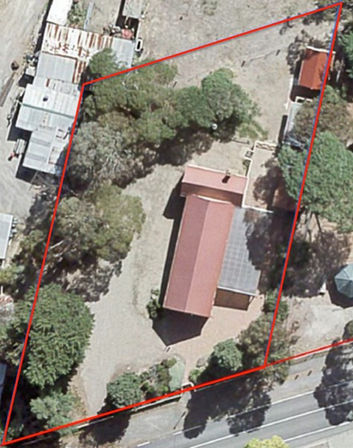

Proposed extent indicated by the red line, which follows the property boundary

References

Argus, as cited.

Australasian, as cited.

Blake, L.J., ed. 1973a. Vision and Realisation: a centenary history of state education in Victoria Vol. 3, Education Dept. of Victoria, Melbourne.

Blake, L.J. 1973f. Vision and Realisation: a centenary history of state education in Victoria Vol.
1 Education, Dept. of Victoria, Melbourne.

Draper, B. G 2012, Arthurs Creek Mechanics' Institute, Arthurs Creek Mechanics' Institute Inc., Victoria.

Education Department of Victoria 1922, A history of state education in Victoria / with an introduction by Sir Alexander J. Peacock, C. Parker for the Education Depart. of Victoria, Melbourne.

Eltham and Whittlesea Shires Advertiser and Diamond Creek Valley Advocate (E&WSA& DCVA), as cited.

Evelyn Observer and Bourke East Record (EOBER), as cited.

Hermes Records for ‘Five Pear Trees, Apted's Glen Ard Orchard’, Shire of Nillumbik, accessed March 2022, as cited.

Hicks, Paul. 1988. Plenty Valley Historical Survey. Melbourne: Ministry for Planning and Environment.

Baragwanath, Pam. 2004. "Mechanics' Institute Libraries in Victoria, 1839-2004." Buildings, Books and Beyond: Mechanics' Institutes Worldwide Conference 2004, Swinburne University Melbourne.

Edwards, Dianne H. 1979. The Diamond Valley Story: Shire of Diamond Valley.

Murphy, James T. 1971. Early settlers of Arthurs Creek, Victoria. Arthurs Creek, Vic.: The Author.

PROV, VA538 Department of Crown Lands and Survey, VPRS 627 Land Selection Files, Section 31 Land Act 1869, File No 19301.

PROV, VA4554 Department of sustainability and Environment, VPRS 16171 Regional Land Office Parish and Township Plans Digitised Reference Set, Linton-2(Psh)LOImpL3000-2.pdf Linton -2 Parish Plan, Imperial measure L3000-2

PROV, VA 2878 Crown Lands Department, VPRS 0242 Crown Reserve Correspondence, Arthurs Creek Common File C90869.

Payne, J.W. 1975. The Plenty: A Centenary History of the Whittlesea Shire. Kilmore: Lowden.

Murphy, Ken, and Bruce Draper. 2004. "Arthurs Creek Mechanics' Institute and Free Library." Buildings, Books and Beyond: Mechanics Worldwide Conference 2004, Swinburne University Melbourne.

Woiwod, Mick. 1995. Kangaroo Ground: the highland taken Maryborough, Vic.: Tarcoola Press.

Graeme Butler & Associates, Nillumbik Shire Heritage Review – Environmental History, 1996
p. 44

Meredith Gould Conservation Consultants, Whittlesea Heritage Study prepared for the City of Whittlesea, 1991. P. 18.03

Victorian Government Gazette, as cited.

