Title: Arthurs Creek Cemetery
Identified by: Dr Peter Mills and Samantha Westbrooke
Prepared and updated by: Trethowan Architecture

Address: 1165 Arthurs Creek Road, Arthurs Creek
Name: Arthurs Creek Cemetery | Survey Date: 2016, 2022
Place Type: Cemetery | Architect:
Grading: Individually Significant | Builder:
Extent of Overlay: To title boundaries | Construction Date: 1847 onwards

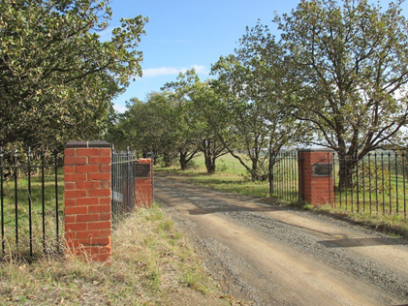

Historical Context

The first squatters arrived in the Arthurs Creek area in 1837. The Reid’s run ‘Hazel Glen’, where the original stone and mud house survives, lay on the southwest. The Bears’ ‘New Leicester’ lay on the northwest, the Macfarlane’s ‘Ard Chattan’ lay between Running Creek and Arthurs Creek, and the Smiths ‘Glen Ard’ lay to the west of Running Creek (Hicks 1988:6). Most of the land west of the Plenty River was sold by the mid-1840s. The land to the east, including the Arthurs Creek area, which was forested and hilly with poor sedimentary soils, was considered ‘cattle country’ and remained under grazing leases for longer (Hicks 1988:13).

The more open undulating country between the Yan Yean Reservoir and Arthurs Creek/Deep Creek was bought at Crown Land sales in the mid-1860s (PROV, VPRS 16171/P1/6, Linton-2). Under the 1860 Land Act, the remaining grazing leases were revoked. The eastern margin of the Parish of Linton, including the Arthurs Creek locality, was surveyed in 1856 but remained unsold. Lots 16, 17 and 24 of this survey were the first to be selected in c1861 by C. Vaughan, M. McLaughlin and W. Watson (Department of Crown Lands and Survey, 1856). The remainder of the Arthurs Creek area became the Upper Plenty Farmers’ Common (later Whittlesea Common) in 1861. An area to the east of Arthurs Creek was proclaimed as the Arthurs Creek Common in 1871 (Vic Gov Gazette, 26 March 1861, No.48:632; PROV, VPRS 0242/P0, file C90869). Most of the European settlers in the area were orchardists and dairy farmers, the most famous of which were the Ryders and Drapers (PROV, VPRS 16171/P1/6, Linton-2). The homesteads of the 1860s such as those of the Ryders and Murphys were typically slab huts (PROV, VPRS 627/ P1, Unit 235, File No 19301). Butter, eggs and poultry were often the first source of income.

A village began to appear in the early 1870s, with the Primitive Methodist church established in 1873, the school opened in 1876 and the Mechanics’ Institute in 1878. The Arthur’s Creek Fruitgrowers’ Association formed in 1890 and held meetings and competitive exhibitions of fruit at the Mechanics’ Institute (Argus, 14 May 1890:6). Daily mail services started in 1889. By 1899 George Murphy had built a post office and store (E&WSA& DCVA, 26 April 1918 :3; Payne 1975:191). The settlement would expand little after this point. In the late 1880s there were 1500 acres under fruit within a three-mile radius of Arthur’s Creek. The extension of the railway to Yan Yean in 1889 made transport to market easier and quicker (Argus, 21 October 1889:9).

Poor prices during the Depression compounded the decline, and by the late 1930s all but the largest and most progressive orchards were unprofitable. Orchards were cleared and the land turned over to sheep. Markets for lamb and wool were variable and while the larger farms survived on sheep, the smaller holdings reverted to dairying and pigs. By the 1970s beef cattle were becoming more profitable. Orcharding continued at Glen Ard, which by 1975 was reputedly the largest orchard in southern Victoria (Five Pear Trees, Apted's Glen Ard Orchard, 120997). The township had about 350 residents at the 1996 census (Hunter-Payne, 2008).

History

The cemetery was gazetted in 1867 however the land on which it sits was previously part of the property, Hazel Glen owned by the Reid family. A private cemetery was established when Agnes Reid died in 1847 and was buried on a hill on the property that provided views of the ranges. The cemetery was later to be gazetted on this hilltop location.

Description & Integrity

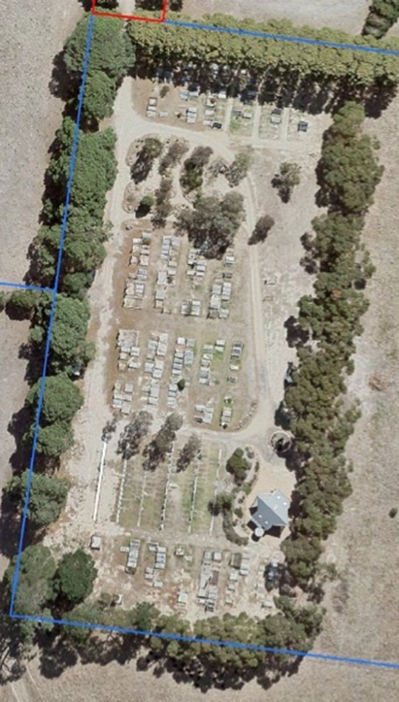

Arthurs Creek Cemetery is a rectangular cemetery accessed by a tree lined road off Arthurs Creek Road. The layout of the cemetery plots is such that the plots sit on the rise, overlooking rolling hills of farmland and towards the Arthurs Creek township to the east. There are plantings around the boundary of the cemetery reserve with Cypresses to the west boundary and natives to the south and east boundary. There is tall hedge type planting to the north boundary.

 | 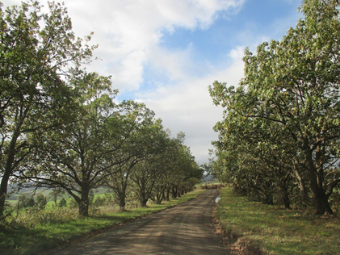
Arthurs Creek Road entry gates | Oaks at the Arthurs Creek Road end

There are double iron gates with four red brick pillars and glazed brown brick capping at the Arthurs Creek Road entry to the Cemetery Road and another set of iron gates with red brick pillars at the entry onto the cemetery reserve.

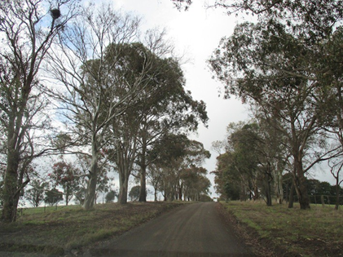 | 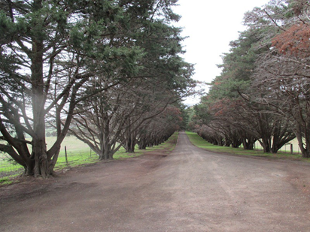
Sugar Gums to central section of avenue  Source: Sam Westbrooke 2016 | Cypress Avenue  Source: Sam Westbrooke 2016

The avenue of trees along the Cemetery Road consists of Cypress trees directly below the reserve gate, which were planted in 1959. There are Sugar Gums on the mid-section of the approach road, planted in 1963, with Oaks on the first straight from the Arthurs Creek Road entry, also planted in 1963.

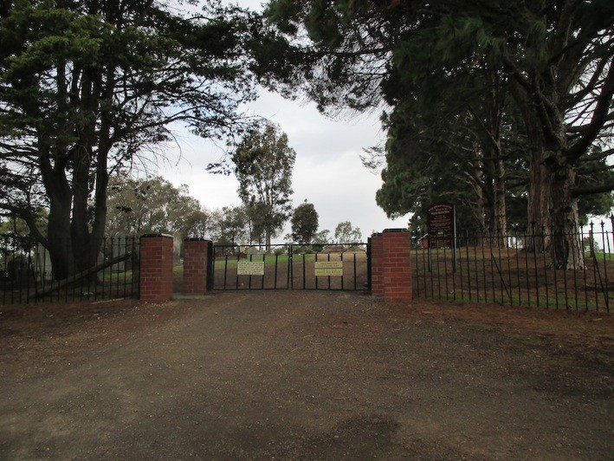 | 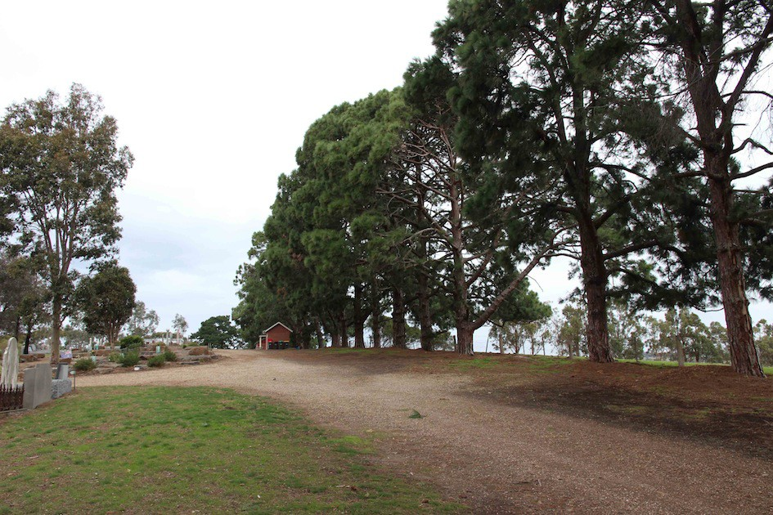
Cemetery Reserve Entry Gates  Source: Sam Westbrooke 2016 | View from entry along west boundary  Source: Sam Westbrooke 2016

The cemetery is divided into denominations with a mixture of early and later headstones in these sections. There are a number of elaborate early headstones with some cast iron fences around some of the plots. There are six bays of plots with an east west path running between each bay and a path at the north and south boundaries linking the east west paths.

A new non-denominational section (formerly the ‘independent denominational section’) was created in 1978, with concrete beams to carry headstones added in 1982. This forms the fourth bay in the cemetery layout. Ground niches were created for internment of ashes in 1980.
Toward the end of the twentieth century the non-denominational section became the ‘lawn section’ and further concrete beams for headstones were installed.

The red-brick store was erected on the rear (west) boundary in 1970. It has a gable roof. A similar brick building with a gable roof was erected, also on the west boundary as a toilet block in 1976.

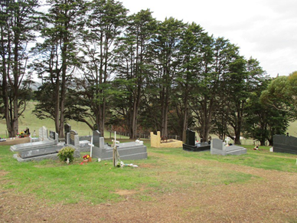 | 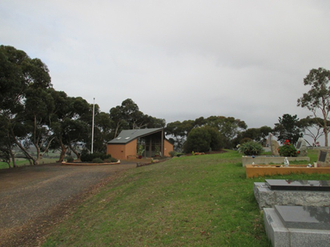
Northern boundary  Source: Sam Westbrooke 2016 | Chapel to the south east corner  Source: Sam Westbrooke 2016

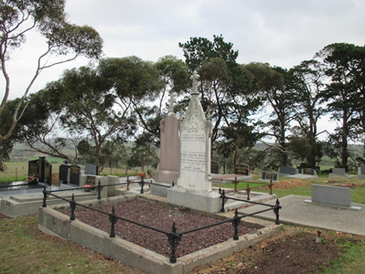 | 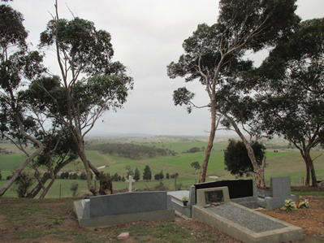
Early headstones  Source: Sam Westbrooke 2016 | View towards east  Source: Sam Westbrooke 2016

On Australia Day 1994 a plaque was unveiled to commemorate 150 years of the Reid family’s occupation of Hazel Glen. The plaque was mounted on a cairn and housed in a gazebo at the cemetery.

The second bay of the cemetery consists of a bush garden with Australian plantings and boulders, which contain plaques. A bluestone niche wall sits at the east end of this garden and is used for reception of cremated ashes. This section was added to the cemetery in 1997.

The red brick Pioneers Memorial Chapel, which was completed in 2004, is located to the north east corner of the site with glazing to the east elevation allowing views over the hills and farmland to the east. The chapel is red brick with a tapered gable roof following the essentially diamond shaped footprint of the building. The taper on the west (entry) side forms a canopy over the entry, which is glazed. The north and south bays have brick walls with the central, taller chapel with glazing to the east and west elevations.

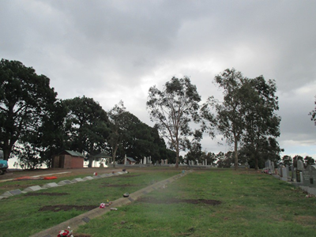 | 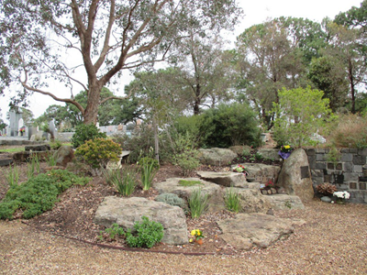
Non-denominational Lawn area  Source: Sam Westbrooke 2016 | Native garden Section of cemetery  Source: Sam Westbrooke 2016

The Arthur’s Creek cemetery remains in use today. Prominent families represented include Bassetts, Christian, Draper, Murphy, Reid, Sutherland and Smith.

Comparative Analysis

Other cemeteries currently on the Heritage Overlay include the following:

- Hurst Family Cemetery, at Hurstbridge Pre-School, 4-8 Greysharps Road, Hurstbridge - HO57
- Queenstown Cemetery, 70 Smiths Gully Road, Smiths Gully - HO163
- Ellis Gateway at Nillumbik Cemetery, 35 Main Street, Diamond Creek - HO226

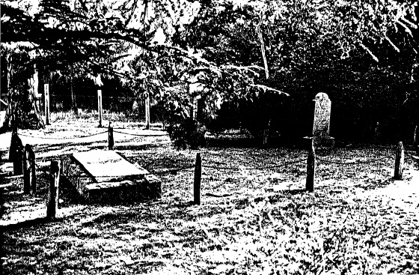  Hurst Family Cemetery. Image source: Victorian Heritage Directory. | 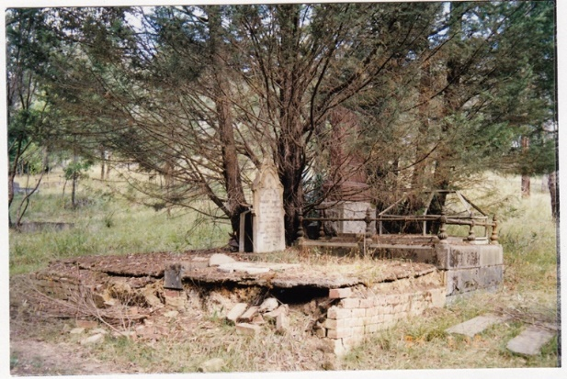  Queenstown Cemetery. Image source: Victorian Heritage Database
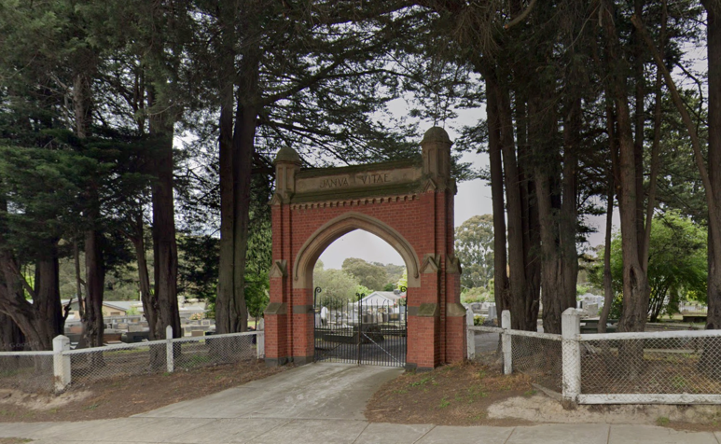
Gateway to the Nillumbik Cemetery. Source: Nillumbik Cemetery Trust.

The Hurst family cemetery includes tombstones and remains, mature exotic planting, Significant trees include an Atlas Cedar tree, Canary Island Pine tree, Peppercorn tree and Stone Pine tree. The cemetery is historically significant because it is associated with the Hurst family, who were amongst the first settlers at Hurstbridge and because it is a rare example (in Melbourne) of a private burial ground established by a district's early settlers

The Queenstown Cemetery is a c1866 cemetery and the mature planting within the cemetery and the surrounding site is historically, aesthetically and socially significant to the Shire of Nillumbik. The cemetery is historically significant as a rare example (in Melbourne) of a private burial ground established by a district's early settlers - many of the early burials in the cemetery are those of diggers who worked on the nearby Caledonia (St Andrews) goldfields. A study of the graves and associated records tells the story of the difficulties faced by early miners and settlers in the area, and in particular the high child mortality rate (Criterion A). The cemetery is also historically significant as the resting place of several prominent local citizens, including Charlotte Ness and Kathleen Donaldson (Criterion H).

The Nillumbik Cemetery (established c.1860s) is significant for its association with the early history and a record of the pioneering families of the district. It includes significant plantings including boundary cypress rows and various structures, with ornamental gateway.

The Arthurs Creek Cemetery is comparable to these in terms of age, dating to the mid nineteenth century, and associated with Victorian era colonists in the area. It contains comparable trees and structures. While its gates are less ornamental than the Nillumbik Cemetery, its historical significance is comparable, and its spectacular landscape setting on the hill is distinctive and uniquely associated with the first private burial at the site.

Assessment Against Criteria

Criteria referred to in Practice Note 1: Applying the Heritage Overlay, Department of Planning and Community Development, revised July 2015, modified for the local context.

CRITERION A: Importance to the course or pattern of the Shire of Nillumbik’s cultural or natural history (historical significance).
Arthurs Creek Cemetery is historically significant for demonstration of the early settlement of the Arthurs Creek area as well as providing documentary history of the families living in the district from its beginnings until the present day.

CRITERION B: Possession of uncommon, rare or endangered aspects of the Shire of Nillumbik’s cultural or natural history (rarity).

CRITERION C: Potential to yield information that will contribute to an understanding of the Shire of Nillumbik’s cultural or natural history (research potential).

CRITERION D: Importance in demonstrating the principal characteristics of a class of cultural or natural places or environments (representativeness).

CRITERION E: Importance in exhibiting particular aesthetic characteristics (aesthetic significance).
Arthurs Creek Cemetery is aesthetically significant as a representative example of a rural cemetery established in the mid 1800s. It provides examples of late Victorian headstones and cast iron cemetery surrounds as well as demonstrating the early denominational layout of a cemetery. The bush garden section for cremated ashes is of aesthetic interest and links to the history of native landscaping in the Shire. The two sets of entry gates, pine boundary planting, entry avenue with Cypress, Sugar Gums and Oaks and picturesque hillside setting contribute to the aesthetic significance of the place.

CRITERION F: Importance in demonstrating a high degree of creative or technical achievement at a particular period (technical significance).

CRITERION G: Strong or special association with a particular community or cultural group for social, cultural or spiritual reasons. This includes the significance of a place to Indigenous peoples as part of their continuing and developing cultural traditions (social significance).
Arthurs Creek Cemetery is of social significance as an important commemorative site valued by the Arthurs Creek district community

CRITERION H: Special association with the life or works of a person, or group of persons, of importance in the Shire of Nillumbik’s history (associative significance).
The Arthurs Creek Cemetery contains graves of prominent families who have had a long association with the district, including the Bassett, Christian, Draper, Murphy, Reid, Sutherland and Smith families.

Grading and Recommendations

Recommended for inclusion in the schedule to the Heritage Overlay of the Nillumbik Planning Scheme.
Recommendations for the Schedule to the Heritage Overlay (Clause 43.01) in the Nillumbik Planning Scheme:

External Paint Colours  Is a permit required to paint an already painted surface? | No
Internal Alteration Controls  Is a permit required for internal alterations? | No
Tree Controls  Is a permit required to remove a tree? | Yes – sugar gums, cypresses, oaks, avenue of trees.
Victorian Heritage Register  Is the place included on the Victorian Heritage Register? | No
Incorporated Plan  Does an Incorporated Plan apply to the site? | No
Outbuildings and fences exemptions  Are there outbuildings and fences which are not exempt from notice and review? | Yes - Gates
Prohibited uses may be permitted  Can a permit be granted to use the place for a use which would otherwise be prohibited? | No
Aboriginal Heritage Place  Is the place an Aboriginal heritage place which is subject to the requirements of the Aboriginal Heritage Act 2006? | No

Identified By

Samantha Westbrooke

Proposed Extent

The proposed extent includes the original cemetery reserve area and the Cemetery Road avenue entry and gates.

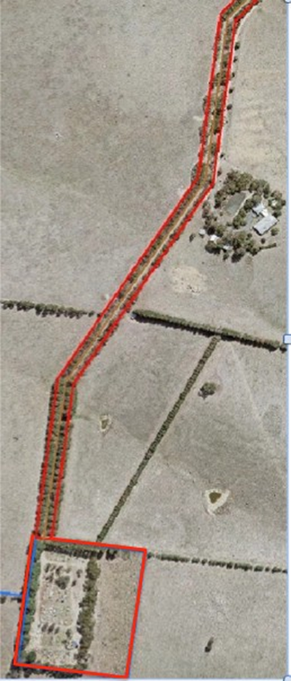

References

Argus, as cited.

Australasian, as cited.

Eltham and Whittlesea Shires Advertiser and Diamond Creek Valley Advocate (E&WSA& DCVA), as cited.

Evelyn Observer and Bourke East Record (EOBER), as cited.

Hermes Records for ‘Five Pear Trees, Apted's Glen Ard Orchard’, Shire of Nillumbik, accessed March 2022, as cited.

Hicks, P1988, Plenty Valley Historical Survey, Ministry for Planning and Environment, Melbourne.

Hunter-Payne, G. 2009, Arthurs Creek, https://www.emelbourne.net.au/biogs/EM00093b.htm, accessed online 23 March 2022.

Murphy, J. T. 1971. Early settlers of Arthurs Creek, Victoria, J. T Murphy, Arthurs Creek.

PROV, VA538 Department of Crown Lands and Survey, VPRS 627 Land Selection Files, Section 31 Land Act 1869, File No 19301.

PROV, VA4554 Department of sustainability and Environment, VPRS 16171 Regional Land Office Parish and Township Plans Digitised Reference Set, Linton-2(Psh)LOImpL3000-2.pdf Linton -2 Parish Plan, Imperial measure L3000-2

PROV, VA 2878 Crown Lands Department, VPRS 0242 Crown Reserve Correspondence, Arthurs Creek Common File C90869.

Payne, J.W1975, The Plenty: A Centenary History of the Whittlesea Shire, Lowden, Kilmore.

Blake, L.J., ed. 1973a. Vision and Realisation: a centenary history of state education in Victoria Vol. 3, Education Dept. of Victoria, Melbourne.

Blake, L.J. 1973f. Vision and Realisation: a centenary history of state education in Victoria Vol.
1 Education, Dept. of Victoria, Melbourne.

Draper, B. G 2012, Arthurs Creek Mechanics' Institute, Arthurs Creek Mechanics' Institute Inc., Victoria.

Education Department of Victoria 1922, A history of state education in Victoria / with an introduction by Sir Alexander J. Peacock, C. Parker for the Education Depart. of Victoria, Melbourne.

Payne, J.W. 1975. The Plenty: A Centenary History of the Whittlesea Shire. Kilmore: Lowden.
Victoria. Department of Crown Lands and Survey 1856, Country lands, in the Parish of Linton, East of the Parish of Toorourong, adjoining the Yan Yean Reservoir. Dept. of Lands and Survey, Melbourne

Victorian Government Gazette, as cited.

