Sherwood
Proposed by: Samantha Westbrooke Pty Ltd in association with Dr Peter Mills
Prepared and updated by: Trethowan Architecture.

Address: 110 Deep Creek Road, Arthurs Creek
Name: Sherwood | Survey Date: 2015 and 2022
Place Type: Individual | Architect: Unknown
Grading: Significant | Builder: Unknown
Extent of Overlay: To property boundary | Construction Date: c1865

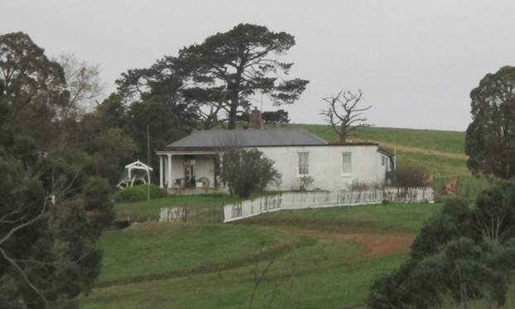
Sherwood, view from Deep Creek Road,
Source: Samantha Westbrooke, dated May 2015

Historical Context

The first squatters arrived in the Arthurs Creek area in 1837. The Reid’s run ‘Hazel Glen’, where the original stone and mud house survives, lay on the southwest. The Bears’ ‘New Leicester’ lay on the northwest, the Macfarlane’s ‘Ard Chattan’ lay between Running Creek and Arthurs Creek, and the Smiths ‘Glen Ard’ lay to the west of Running Creek (Hicks 1988:6). Most of the land west of the Plenty River was sold by the mid-1840s. The land to the east, including the Arthurs Creek area, which was forested and hilly with poor sedimentary soils, was considered ‘cattle country’ and remained under grazing leases for longer (Hicks 1988:13).

The more open undulating country between the Yan Yean Reservoir and Arthurs Creek/Deep Creek was bought at Crown Land sales in the mid-1860s (PROV, VPRS 16171/P1/6, Linton-2). Under the 1860 Land Act, the remaining grazing leases were revoked. The eastern margin of the Parish of Linton, including the Arthurs Creek locality, was surveyed in 1856 but remained unsold. Lots 16, 17 and 24 of this survey were the first to be selected in c1861 by C. Vaughan, M. McLaughlin and W. Watson (Department of Crown Lands and Survey, 1856). The remainder of the Arthurs Creek area became the Upper Plenty Farmers’ Common (later Whittlesea Common) in 1861. An area to the east of Arthurs Creek was proclaimed as the Arthurs Creek Common in 1871 (Vic Gov Gazette, 26 March 1861, No.48:632; PROV, VPRS 0242/P0, file C90869). Most of the European settlers in the area were orchardists and dairy farmers, the most famous of which were the Ryders and Drapers (PROV, VPRS 16171/P1/6, Linton-2). The homesteads of the 1860s such as those of the Ryders and Murphys were typically slab huts (PROV, VPRS 627/ P1, Unit 235, File No 19301). Butter, eggs and poultry were often the first source of income.

A village began to appear in the early 1870s, with the Primitive Methodist church established in 1873, the school opened in 1876 and the Mechanics’ Institute in 1878. The Arthur’s Creek Fruitgrowers’ Association formed in 1890 and held meetings and competitive exhibitions of fruit at the Mechanics’ Institute (Argus, 14 May 1890:6). Daily mail services started in 1889. By 1899 George Murphy had built a post office and store (E&WSA& DCVA, 26 April 1918 :3; Payne 1975:191). The settlement would expand little after this point. In the late 1880s there were 1500 acres under fruit within a three-mile radius of Arthur’s Creek. The extension of the railway to Yan Yean in 1889 made transport to market easier and quicker (Argus, 21 October 1889:9).

Poor prices during the Depression compounded the decline, and by the late 1930s all but the largest and most progressive orchards were unprofitable. Orchards were cleared and the land turned over to sheep. Markets for lamb and wool were variable and while the larger farms survived on sheep, the smaller holdings reverted to dairying and pigs. By the 1970s beef cattle were becoming more profitable. Orcharding continued at Glen Ard, which by 1975 was reputedly the largest orchard in southern Victoria (Five Pear Trees, Apted's Glen Ard Orchard, 120997). The township had about 350 residents at the 1996 census (Hunter-Payne, 2008).

History

The subject site (Lot 27F, Parish of Linton) was taken up by William Phillips in 1869 under an occupation license granted under Section 42 of the 1865 Land Act. It is likely that the Phillips built the house around this time. Freehold was later obtained in November 1875 under Section 31 of the 1869 Land Act (Linton Parish Plan Pt.2; CT: V852 F255).

James Bradford, who had married the Phillips’ daughter Mary, bought Lot 27F from Mary’s parents in April 1882 (CT: V1348 F443). From 1886 the Bradford’s leased part of their Lot 27F to C J Stewart and Angus McDonald (CT: V1348 F443).

John Edward Steer, Ernest Steer and Anna Maria Steer purchased Lot 27F from Bradford in 1888, and the lease to Stewart and McDonald was still active at this time (CT V2021 F166). John Edward Steer later took single ownership of Lot 27F in 1903. A 1917 article implies that the house in which Steer lived had been built during the period of occupation by the Phillips (EOBER 30 March 1917:3). Steers’ only daughter Winifred was married in 1920, and an account of this occasion was the earliest use of the name Sherwood found in local newspapers (E&WSA&DCVA 19 November 1920:3).

John Edward Steer died in 1922 and was survived by his wife Clementina (E&WSA&DCVA 24 February 1922:3). Steer’s probate indicates the family had a six-roomed brick house on the subject site at that time, with a value of £960 (Probate papers for John Steer, VPRS 28, Consignment P3, Unit 1222).

Clementina Steer died in 1931, at which point the property went to her son Edward Allison Steer (CT: V2021 F846). At her death the property still included an “old six- roomed brick house”. There were 15 acres of orchard, 8 of crops, with the rest grass and lightly timbered (Probate Papers for Clementina Steer 1932, VPRS 28, Consignment P3, Unit 2286, Item 246/471).

Edward Steer took over the property, with his wife Ilma joining him in 1935 shortly after their marriage (Advertiser (Hurstbridge) 5 July 1935:5). Edward and Ilma Steer had a son at the property in 1938 (Argus 5 November 1938:6). The family did not remain at the site for long, selling it in 1942. The property later changed hands multiple times between 1942 and 1966 (CT: V2021 F846; V2929 F709).

Description & Integrity

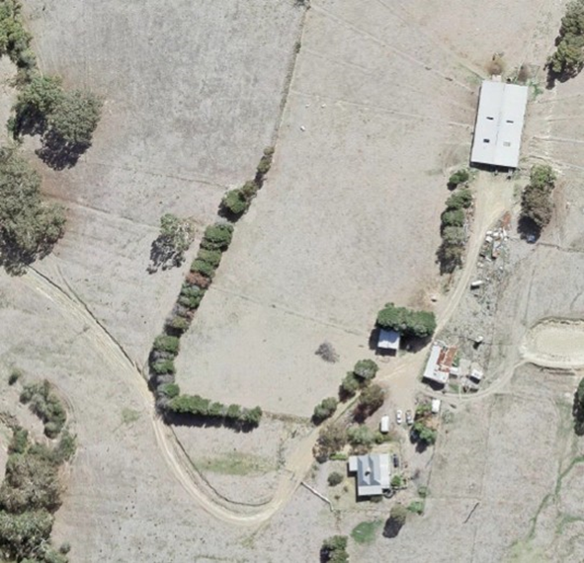
Aerial view of Sherwood 2015 Source: Nillumbik Shire Council

Sherwood, 110 Deep Creek Road, is located on the 80-acre Lot 27F, Parish of Linton. This Lot is bordered on the west by the Arthurs Creek Road, and Deep Creek flows from north to south on the western side of the property.

Sherwood contains a Victorian brick farmhouse with an M-shaped double hip roof and later skillion additions to the south and east elevations. The original six roomed homestead would be contained under the double hip roof. The verandah on the west side has cast iron verandah posts. Surviving original windows are timber framed and double hung and there is a central brick chimney. There appear to be large mature cedars on the site, possibly early plantings, including a row along the boundary.

Comparative Analysis

Farmhouses have been present in the Shire of Nillumbik since the 1840s, when rudimentary dwellings were erected by settlers as the land was opened up for agricultural use. The earliest farmhouses were usually modest constructions that made use of readily available materials, evident in examples such as the 1843 sections of Hazel Glen Homestead (HO234).

As more settlers arrived in the district, and became more prosperous, later examples began to display popular stylistic details such as veranda fretwork and detailed chimneys. Despite this, many farmhouses continued to be built as simple vernacular forms that prioritised function.

Comparable examples of farms currently on the Nillumbik Shire Heritage Overlay include:

- Nillumbik Farm, 50 Challenger Street, Diamond Creek (HO24)
- Tregowan Farm Complex, 310 Doctors Gully Road, Doreen (HO193)
- Pigeon Bank, 450 Kangaroo Ground-Warrandyte Road, Kangaroo Ground (HO102)

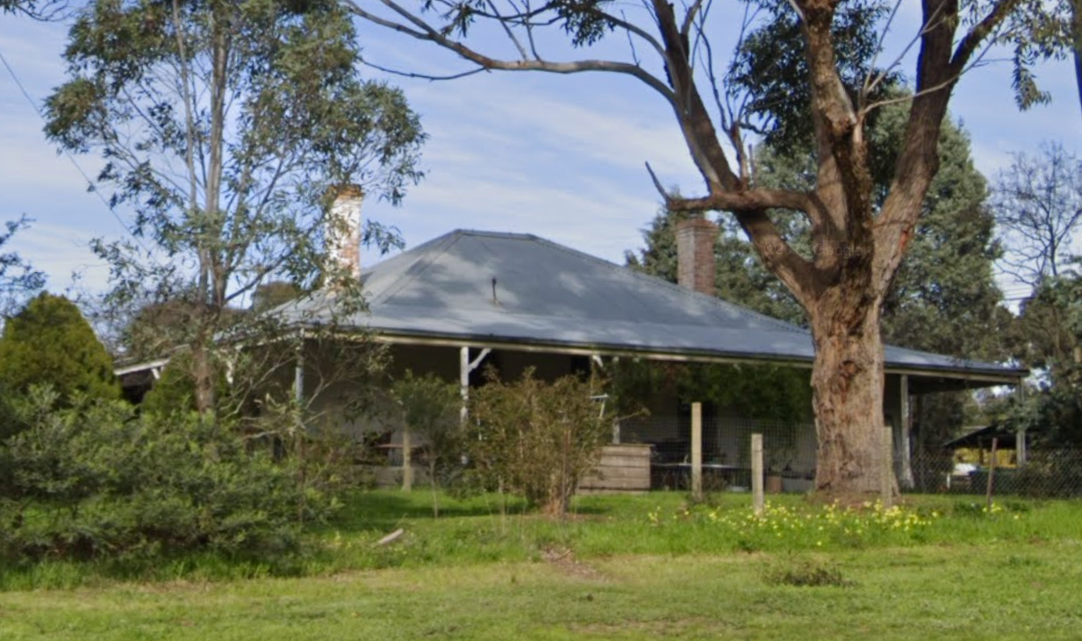  Nillumbik Farm, 50 Challenger Street, Diamond Creek (HO24) | 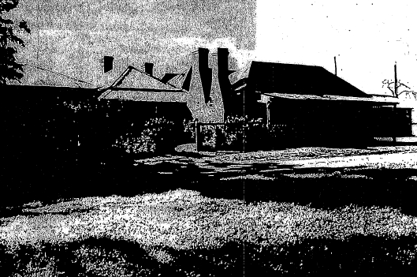  Tregowan Farm Complex, 310 Doctors Gully Road, Doreen (HO193)
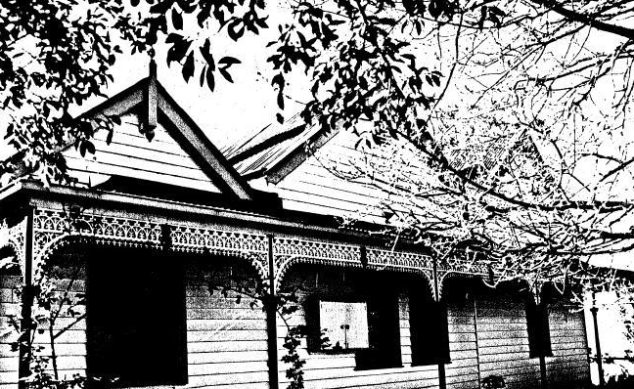
Pigeon Bank, 450 Kangaroo Ground-Warrandyte Road, Kangaroo Ground (HO102)

Nillumbik Farm is a c1850s farmhouse that is significant as a rare surviving example of a house from that era in the Shire. The house is contained under a large, hipped roof with surrounding veranda. The house is also historically significant for its association with important early settlers in Victoria.

The Tregowan Farm Complex is a collection of farm buildings, with the earliest sections dating to the 1860s. The buildings demonstrate vernacular forms demonstrating their use as both a home and the centre of a working orchard. The site is historically significant to the Shire of Nillumbik for its early role in orcharding in the area, and as an excellent example of remote building techniques in the 1860s in Victoria.

Pigeon Bank is a timber farmhouse commenced in the 1860s, with sections added to meet changing needs in following years. The house features various parallel gable roofed sections that demonstrate this development and highlight the vernacular approach to farmhouse building in the Shire. Pigeon Bank is historically significant for its associations with prominent settlers in the Shire, and aesthetically significant for tis remnant exotic gardens.

Although each of these examples is distinct from the subject site in terms of overall form, they each demonstrate a similar vernacular approach to farmhouse construction in the earliest decades of settlement in the Shire. Each building demonstrates a primary response to function, with stylistic elements being a secondary consideration. The sites also demonstrate the often piecemeal development patterns of early farmhouses in the area. Overall, the subject site compares well as an early example of a vernacular farmhouse in the Shire of Nillumbik.

Assessment Against Criteria

Criteria referred to in Practice Note 1: Applying the Heritage Overlay, Department of Planning and Community Development, revised July 2015, modified for the local context.

CRITERION A: Importance to the course or pattern of the Shire of Nillumbik’s cultural or natural history (historical significance).

Sherwood is historically significant as an example of a farming property settled in the district in the 1860s, as a result of the 1865 Land Act. The uptake of land during this period brought many families to the district and brought about the establishment of the Arthurs Creek township. The property’s association with early prominent citizens of Arthurs Creek, including the Phillips and Steer families, is of historical interest for the township. Sherwood is also historically significant for its associations with the history of orcharding in the area, which peaked in the 1890s and underwent a renewal in the early 20th century.

CRITERION B: Possession of uncommon, rare or endangered aspects of the Shire of Nillumbik’s cultural or natural history (rarity).

CRITERION C: Potential to yield information that will contribute to an understanding of the Shire of Nillumbik’s cultural or natural history (research potential).

CRITERION D: Importance in demonstrating the principal characteristics of a class of cultural or natural places or environments (representativeness).

Sherwood is representative of the type of modest farmhouses that were being erected during the 1860s in the Shire of Nillumbik. The house demonstrates the vernacular nature of rural properties built in that era, evidenced by its modest size, double parallel hipped roof form, and skillion additions. The verandah and timber framed double hung windows are more generally characteristic of housing in the Victorian era. The house’s siting on a rise overlooking farmland contributes to the setting of the place. The cool store and other early outbuildings contribute to the legibility of the place as an orcharding property in the Shire.

CRITERION E: Importance in exhibiting particular aesthetic characteristics (aesthetic significance).

CRITERION F: Importance in demonstrating a high degree of creative or technical achievement at a particular period (technical significance).

CRITERION G: Strong or special association with a particular community or cultural group for social, cultural or spiritual reasons. This includes the significance of a place to Indigenous peoples as part of their continuing and developing cultural traditions (social significance).

CRITERION H: Special association with the life or works of a person, or group of persons, of importance in the Shire of Nillumbik’s history (associative significance).

Grading and Recommendations

Recommended for inclusion in the schedule to the Heritage Overlay of the Nillumbik Planning Scheme.
Recommendations for the Schedule to the Heritage Overlay (Clause 43.01) in the Nillumbik Planning Scheme:

External Paint Colours  Is a permit required to paint an already painted surface? | No
Internal Alteration Controls  Is a permit required for internal alterations? | No
Tree Controls  Is a permit required to remove a tree? | Yes – mature Cedars
Victorian Heritage Register  Is the place included on the Victorian Heritage Register? | No
Incorporated Plan  Does an Incorporated Plan apply to the site? | No
Outbuildings and fences exemptions  Are there outbuildings and fences which are not exempt from notice and review? | No
Prohibited uses may be permitted  Can a permit be granted to use the place for a use which would otherwise be prohibited? | No
Aboriginal Heritage Place  Is the place an Aboriginal heritage place which is subject to the requirements of the Aboriginal Heritage Act 2006? | No

Identified By

Westbrooke & Mills

Proposed Extent
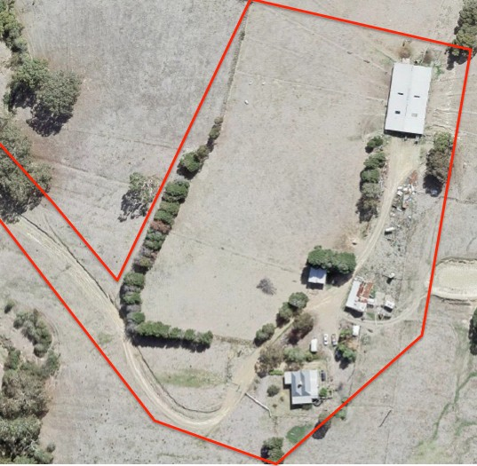

The proposed extent to the property boundary.

References

Advertiser (Hurstbridge), as cited.

Argus, as cited.

Eltham and Whittlesea Shires Advertiser and Diamond Creek Valley Advocate (E&WSA&DCVA), as cited.

Evelyn Observer & Bourke East Record (EOBER), as cited.

Hicks, Paul. 1988. Plenty Valley Historical Survey. Melbourne: Ministry for Planning and Environment.

Land Victoria, Certificates of Title (CT), as cited.

Linton Parish Plan

Murphy, James T. 1971. Early settlers of Arthurs Creek, Victoria. Arthurs Creek, Vic.: The Author.

Payne, J.W. 1975. The Plenty: A Centenary History of the Whittlesea Shire. Kilmore: Lowden.

Probate Papers for Clementina Steer 1932, VPRS 28, Consignment P3, Unit 2286, Item 246/471

Probate papers for John Steer, VPRS 28, Consignment P3, Unit 1222

