Former Church of the Sacred Heart
Prepared by: Trethowan Architecture

Address: 49-55 Main Street, Diamond Creek
Name: Former Church of the Sacred Heart | Survey Date:
Place Type: Religious | Architect: JB Denny
Grading: Individually Significant | Builder: T Dakin
Extent of Overlay: To Property Boundaries | Construction Date: 1872-1874

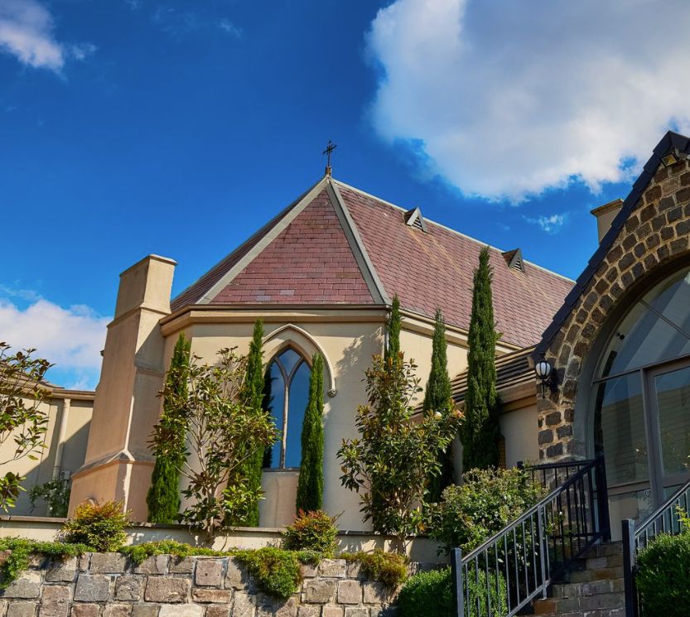
Figure 1: Source: Tobin Brothers Funerals 2022.

Historical Context

Although Crown Land in Nillumbik Parish was offered for sale in 1852 there were few buyers. A government township was reserved on the west of the Diamond Creek at this time but it was neither subdivided nor sold until 1866. In 1863 the Diamond Reef was discovered on land located to the east of the creek, which was purchased by Dr John Blakemore Phipps in 1854. The rush to Diamond Creek began and soon Phipps was renting sections of his land, which he later subdivided to miners. In effect the development of Phipps land for gold mining was the beginnings of Diamond Creek, which was soon bustling with gold seekers. In 1866 the government proclaimed Diamond Creek as a township. Many of the important community buildings were established by the late 1860s and early 1870s. These included a post office, a Methodist church and school and three hotels (Barnard, 2008). In 1870, a national school was established (Edwards, 1979:118).

By the second half of the 1880s the locality was being carved up rapidly into a dominant pattern of numerous small lots of around 20 acres. These were taken up under occupation licenses, first under Section 49 of the Land Act 1869 and later under Section 65 of the Land Act 1884. Diamond Creek's population peaked around the turn of the century then seemed to fall away again in the early twentieth century (Graeme Butler & Associates 1996:36). From 1885 onwards, the rural landscape of the area also inspired many artists to work in Diamond Creek and its surrounds, and the scenery of the area was captured in the works of the Heidelberg School painters (Edwards, 1979:143).

In 1912, the Eltham Railway Line was extended to Hurstbridge through Diamond Creek, bringing tourists to this area. Despite this, Diamond Creek remained a rural township concentrating on the orchard industry throughout the first half of the twentieth century, without much new industries to offer alternative employment opportunities. As such, the area entered a period of population decline (Edwards, 1979:177). This began to change in the 1960s and 70s, as, affordable land on subdivided orchards and accessibility to railway networks attracted young families to build their homes in the area, prompting further population growth in Diamond Creek (Barnard, 2008).

History

The corner stone of the church was laid on 14 July by the then Bishop (later Archbishop) of Melbourne, James Goold (Advocate 6 July 1872:6). An article published at the time stated the architect as being JB Denny, while T Dakin was the builder. The total cost of construction was £2500. The newspaper article further noted that branches of the Hibernian Australasian Catholic Benefit Society (HACBS) would be in attendance at the stone laying, in ‘full regalia’, indicating that the congregation was likely to have been substantially populated by Irish families at the time (Advocate 6 July 1872:6). The new Church was dedicated on the 11 October 1874 (IANFHR 4 November 1874:179). An image published in 1925 indicates that the building had a small side porch on the southeast side (Figure 1).

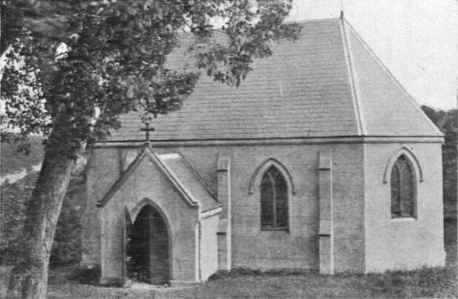
Figure 2: c1925 image of the church, showing the original side porch to the southeast. Source: Barker 1925:17

John Bunn (JB) Denny (1810-1892) was a prolific church architect in Victoria. Prior to his arrival in Australia, Denny was Master of Works for the renowned architect Augustus Pugin on works at Alton Towers (Staffordshire, England) (Pugin Foundation 2013-2014:7). Denny was also involved with other Pugin projects, including churches, and it was in this time that he worked alongside William Wilkinson Wardell.

Wardell was responsible for Denny’s arrival in Australia, hiring him to be the Clerk of Works on the construction of St John’s College, Sydney. Although this position fell through, he was quickly hired by Wardell superintendent of the newly designed St Patrick’s Cathedral. Both Wardell and Pugin had an enduring influence on Denny’s own work (Pugin Foundation 2013-2014:8). Buildings designed by Denny include the Mortuary Chapel at Melbourne General Cemetery; sections of St Patrick’s Cathedral, Ballarat; St John’s, Clifton Hill; the hall at St Augustine’s, Melbourne; Infant Jesus Church, Koroit; and St Finbar’s, Brighton.

By 1965, the original Church building had become too small for the purposes of the congregation. The site was sold, and the property was sub-divided. Shortly afterwards, the congregation moved to a temporary building (which later became the parish hall following the opening of a new church building) next to the Sacred Heart Primary School in Gipson Street, Diamond Creek (Archdiocese of Melbourne 2022).

A restaurant named ‘The Abbey’ opened at the site in May 1978 (Australian Jewish News 2 November 1979:16). It appears that alterations were undertaken to the building at this time, including the addition of a chimney to the chancel, in a similar style as that evident to the original vestry. A castellated extension to the southwest, since removed also appeared to be constructed at this time. These additions, undertaken between 1963 and 1982, can be seen in Figure 2 and Figure 3.

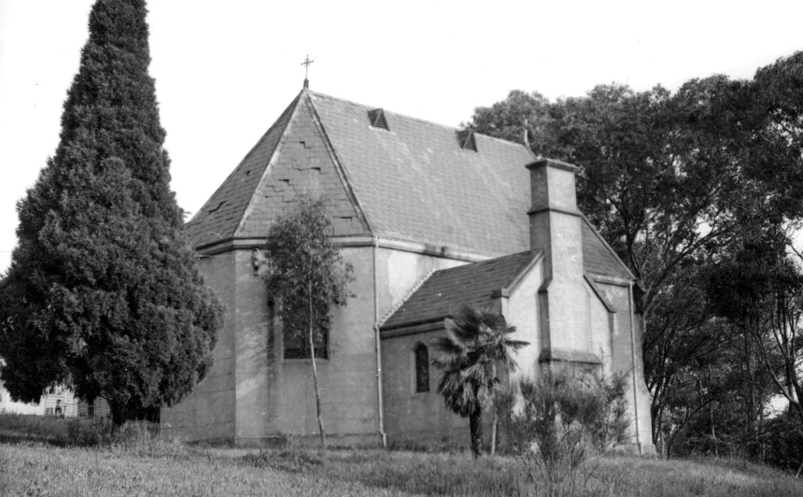
Figure 3: A 1963 image of the church, showing the northwest side of the church. The small vestry with chimney is evident. Source: Collins 1963, SLV.

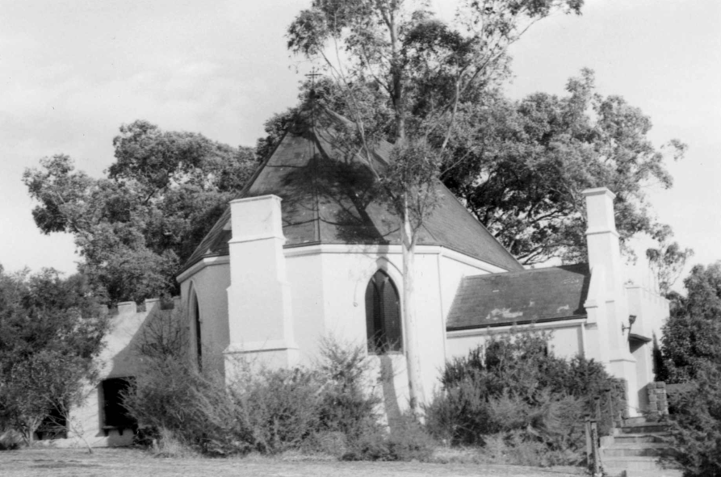
Figure 4: A 1982 image of the church, taken from the north, showing the later chimney to the chancel, and castellated additions. Source: Collins 1982, SLV.

The church was later used as a reception centre, during which extensive additions were undertaken. This included the construction of a large reception hall and associated rooms. The site is now used as a funeral home.

Description & Integrity

The former Church of the Sacred Heart at 49-55 Main Street, Diamond Creek, is a single storey building constructed in brick with concrete render, constructed on a northeast-southwest axis. Although broadly rectangular in form, the building’s northeast chancel end features chamfered sides, creating the effect of a canted bay. The steeply pitched slate roof bears a gable end to the southwest, and is hipped above the chamfered northeast end. A small iron cross is affixed to the ridgeline a the northeast, and small roof vents are evident along the ridgeline.

The church has a small vestry room to the northwest, which has a gable running perpendicular to the main roof. This room is lower than the main body of the church, and thus its ridgeline sits below the gutter of the main church roof. A substantial tapering chimney is placed centrally on the gable end of this room.

The church bears gothic-style pointed windows, with rendered drip moulds above the windows. Theses drip moulds terminate in rosettes. Examples of these windows are located on the chamfered sides of the chancel. A c1970s chimney, replicating the detailing of the vestry chimney, is located centrally on the chancel end.

The building has been substantially enveloped by later development, and appears to have lost its original southeast side porch. Despite this, the original church form appears legible.

Comparative Analysis

Churches were an integral part of the social life of communities within the Shire of Nillumbik and were often amongst the first buildings constructed within townships. Not only did these buildings provide places for worship, they often functioned as places to gather, celebrate and receive religious education.

Despite JB Denny’s prolific work on churches in Victoria, no other examples in the Shire of Nillumbik have been identified. Because of this, the church is best compared against other modestly sized churches within the Shire. Comparable churches in Nillimbik on the Heritage Overlay are as follows:

- Presbyterian Church, 265 Eltham-Yarra Glen Road, Kangaroo Ground (HO46)
- Uniting Church (originally Methodist) 810 Main Road, Eltham (HO118)
- St Margaret’s Anglican Church, 10-12 John Street, Eltham (HO154; VHD H0459)
- St John’s Anglican Church, 61 Main Street, Diamond Creek (HO132)

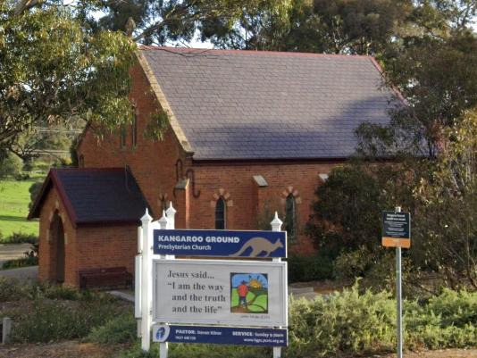  Presbyterian Church, 265 Eltham-Yarra Glen Road, Kangaroo Ground (HO46) | 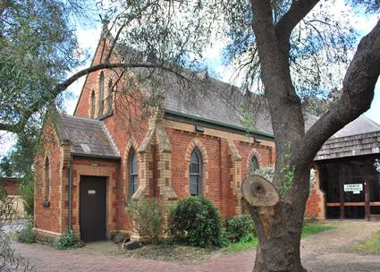  Uniting Church (originally Methodist) 810 Main Road, Eltham (HO118)
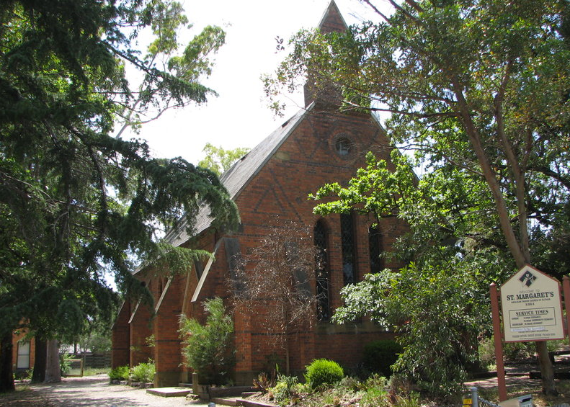  St Margaret’s Anglican Church, 10-12 John Street, Eltham (HO154; VHD H0459) | 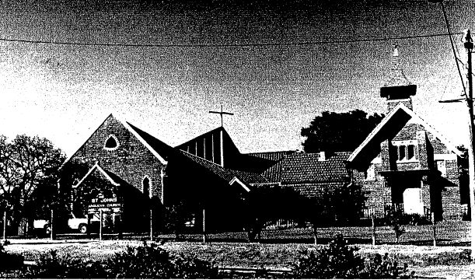  St John’s Anglican Church, 61 Main Street, Diamond Creek (HO132)

The Presbyterian Church at 265 Eltham-Yarra Glen Road, Kangaroo Ground, is a bichromatic brick building with slate roof thought to have been built c1878, and one of only a few well preserved buildings in the town from that era. The church is historically and socially significant because it has served the local community since construction.

The former Methodist Church at 810 Main Road, Eltham, is a bichromatic brick building with slate roof build in 1880. The building is aesthetically significant as a finely detailed example of a rural community church. The place is also significant for its ongoing community role in the region.

St Margaret’s Church at 10-12 John Street, Eltham, is a polychromatic brick building with slate roof constructed in 1861. Designed by the architect Nathaniel Billings, the church is built in the Gothic style and features extensive brick decoration, steep buttresses and a notable bellcote surmounting the gable end. The site is also significant for its historical connections with the early settlement of Eltham.

St John’s Church at 61 Main Street, Diamond Creek, is a red brick building with metal roof, constructed in 1867. The church has side buttresses and a front porch, with the primary detailing provided by cream brick detailing to window and door openings. The church has had significant alterations to the rear to accommodate its ongoing use however remains legible from the front.

Like the subject site, each of these examples are modestly sized church buildings bearing the characteristics of the Gothic Revival style. Like the subject site, the size and relatively modest detailing of these examples reflect the modest needs of early congregations in rural areas. The subject site is set apart from these examples by its rendered materialist, as opposed to decorative polychromatic or bichromatic brick work. The subject site is also distinguished by its chamfered chancel end, which introduces a picturesque quality and more complexity than a standard gable roof. The inclusion of a small vestry room with substantial chimney is unusual in the shire, and further enhances the picturesque nature of the site. Like the other examples, in particular the next-door St John’s Anglican Church, the subject site has been altered and added to through its history, however this does not detract from its legibility as a church building.

Although the subject site does not have a demonstrated continual use as a church, the building has continued a social aspect through its use as a restaurant, reception centre and funeral home. Overall, the subject site compares favourably against these examples in terms of historical associations and architectural expression of the Gothic Revival style in the modest rural context.
Assessment Against Criteria

Criteria referred to in Practice Note 1: Applying the Heritage Overlay, Department of Planning and Community Development, revised July 2015, modified for the local context.

CRITERION A: Importance to the course or pattern of the Shire of Nillumbik’s cultural or natural history (historical significance).

The subject site, constructed between 1872 and 1874, is an early building in Diamond Creek and thus serves as a reminder of the historical development of the township. Alongside the neighbouring Anglican Church, the prominent position on a hill near the centre of town demonstrates the importance of churches in town life in the nineteenth century. The subject site is also of historical interest for its associations with the prolific church architect JB Denny, who was greatly influenced through his direct work with the prominent architects Augustus Pugin and William Wardell.

CRITERION B: Possession of uncommon, rare or endangered aspects of the Shire of Nillumbik’s cultural or natural history (rarity).

CRITERION C: Potential to yield information that will contribute to an understanding of the Shire of Nillumbik’s cultural or natural history (research potential).

CRITERION D: Importance in demonstrating the principal characteristics of a class of cultural or natural places or environments (representativeness).

CRITERION E: Importance in exhibiting particular aesthetic characteristics (aesthetic significance).

The subject site is a finely designed, modestly sized Gothic Revival church. Although most churches constructed in the nineteenth century in the Shire adopt the Gothic Revival style, the subject site exhibits a particularly skilful application. The site is a particularly picturesque example, which is enhanced by its steep combination hip and gable roof, chamfered corners, and small vestry with substantial chimney. Additional details that contribute to the aesthetic qualities of the site include the window drip moulds, roof vents and metal cross on the ridgeline.

CRITERION F: Importance in demonstrating a high degree of creative or technical achievement at a particular period (technical significance).

CRITERION G: Strong or special association with a particular community or cultural group for social, cultural or spiritual reasons. This includes the significance of a place to Indigenous peoples as part of their continuing and developing cultural traditions (social significance).

CRITERION H: Special association with the life or works of a person, or group of persons, of importance in the Shire of Nillumbik’s history (associative significance).

Grading and Recommendations

Recommended for inclusion in the schedule to the Heritage Overlay of the Nillumbik Planning Scheme.
Scheme.
Recommendations for the Schedule to the Heritage Overlay (Clause 43.01) in the Nillumbik Planning Scheme:

External Paint Colours  Is a permit required to paint an already painted surface? | Yes
Internal Alteration Controls  Is a permit required for internal alterations? | No
Tree Controls  Is a permit required to remove a tree? | No
Victorian Heritage Register  Is the place included on the Victorian Heritage Register? | No
Incorporated Plan  Does an Incorporated Plan apply to the site? | No
Outbuildings and fences exemptions  Are there outbuildings and fences which are not exempt from notice and review? | No
Prohibited uses may be permitted  Can a permit be granted to use the place for a use which would otherwise be prohibited? | Yes
Aboriginal Heritage Place  Is the place an Aboriginal heritage place which is subject to the requirements of the Aboriginal Heritage Act 2006? | No

Identified By

Trethowan

References

Advocate, as cited.

Archdiocese of Melbourne, Sacred Heart, Diamond Creek and St. Peter's, Hurstbridge – History, www.pol.org.au, accessed online March 2022.

Australian Jewish News, as cited.

Barker 1925, Diamond Creek, profusely pictured, Barker, Melbourne.

Collins, JT 1963, ‘Diamond Creek Church’, State Library Victoria (SLV) JT Collins collection, accessed online March 2022.

Collins, JT 1963, ‘Diamond Creek, Former Catholic Church now The Abbey Restaurant Main St’, State Library Victoria (SLV) JT Collins collection, accessed online March 2022.

Illustrated Australian News for Home Readers (IANFHR), as cited.

Pugin Foundation 2013-2014, ‘John Bunn Denny in Australia’, Pugin Foundation Newsletter, no.84, pp. 7-14.

