Title: Former Felton House, 12 Broad Gully Road
Identified by: Dr Peter Mills and Samantha Westbrooke
Prepared and updated by: Trethowan Architecture

Address: 12 Broad Gully Road, Diamond Creek
Name: Former Felton House | Survey Date: 20/1/2022
Place Type: Residential | Architect: Unknown
Grading: Locally significant | Builder: Unknown
Extent of Overlay: Title boundaries | Construction Date: c.1870

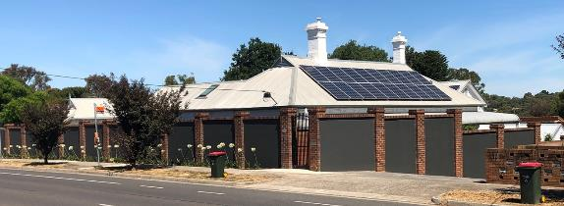
View of property from Broad Gully Road showing limited views of facade. Source: Trethowan Architecture, January 2021.

Historical Context

Early History of Diamond Creek
Although Crown Land in Nillumbik Parish was offered for sale in 1852 there were few buyers. A government township was reserved on the west of the Diamond Creek at this time but it was neither subdivided nor sold until 1866. In 1863 the Diamond Reef was discovered on land purchased by Dr John Blakemore Phipps in 1854 east of the creek. The rush to Diamond Creek began and soon Phipps was renting sections of his land, which he later subdivided to miners. In effect the development of Phipps land for gold mining was the beginnings of Diamond Creek, which was soon bustling with gold seekers. In 1866 the government proclaimed Diamond Creek as a township. Many of the important community buildings were established by the early 1870s. By the second half of the 1880s the locality was being carved up rapidly into a dominant pattern of numerous small lots of around 20 acres. These were taken up under occupation licenses, first under Section 49 of the Land Act 1869 and later under Section 65 of the Land Act 1884. Diamond Creek's population peaked around the turn of the century then seemed to fall away again in the early twentieth century (Graeme Butler & Associates 1996:36).

History

Thomas Huntley
Thomas Huntley originally owned the land on which the current house sits at 12 Broad Gully Road and was responsible for construction of the current house on the site. Thomas Huntley took up a miner’s right residential area within the 5½-acre Lot 13, comprising the northern half of Section 16 Parish of Nillumbik in August 1872 (PROV, VPRS5357/P0, 18378/ 47.49). This land was just outside the original Diamond Creek Township area and adjacent to Lots 1 to 12, which were offered as “town lots” for sale at a Crown land auction in March 1872. Thomas Huntley’s first appearance in the rate book is in 1872, when he is rated for house and land in Diamond Creek with and NAV of £7 (RB 1872-74).

Mary Ann Ferguson and Thomas Huntley came to Victoria on the same ship in 1860. Thomas came to work on the goldfields (Ryan 1972:47). Mary Ann and Thomas married in 1864 (BDM 1275/1864). First son John was born at Greensborough in 1865, Jeanette in 1867, Eleanor in 1869, Thomas (Jun.) in 1871, Mary Ann in 1873, Alexander in 1875, Elizabeth in 1878 and Isabella in 1880 (BDM 8853/1865; 4152/1867; 2675/1869; 18826/1871; 16029/1873; 22306/1875; 22144/1878; 15035/1880).

An 1874 plan of Section 16 on the Lands Department file for Thomas’s occupation license shows a fenced garden on the south side of Lot 13 (at a distance from and separate from the position of the current building), of about 1/5 acre in area, with a building (probably a dwelling) on the northern fence-line of this small enclosure (PROV VPRS 7357/P0 Unit 3790 File 7/49). This existing paddock probably marked Thomas Huntley’s miner’s right residential right area.

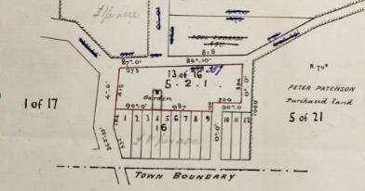
1874 Plan of Section 16 Parish of Nillumbik showing a large Lot 13

The new Diamond Reef goldfield was opened up in 1863 on private land on the east side of Diamond Creek. In order to avoid purchasing land, or paying costly rent, miners took up a number of Miner’s Right residential right areas on the as-yet-unsold Nillumbik township area, on the opposite bank of Diamond Creek (Argus, 9 May 1865:6). This concentration of residence areas is visible on an 1867 survey map of the Nillumbik Township, with around twenty small fenced areas outlined in amongst the as-yet-unsold township subdivision. Thomas’ residence area was probably a continuation of this activity.

In August 1873 Thomas acquired an occupation license on auriferous land under Section 49 of the Land Act 1869 for the 5½-acre Lot 13 of Section 16 (Argus, 2 August 1873:1). The 1874 rate book reflects the change, with an NAV increased to £12 (RB 1872-74).

In the 1878 rate book entry the NAV has been raised to £15, and since the land area had not changed, this perhaps indicated improvements to the accommodation (RB, 1878). In June 1879 when Thomas Huntley applied for a reduction in rent for this occupation license, there was a dwelling of four rooms and outbuildings on the land. This was probably a new house on Broad Gully Road (the current house), replacing the house in the middle of the block from the miner’s-right period of occupation. A 3-acre garden was enclosed with a three-rail fence, with 1¾ acres under cultivation, ¾ of an acre of which was under fruit trees. Thomas obtained freehold to Lot 13 Section 16 in 1882 (PROV VPRS 7357/P0 Unit 3790 File 7/49).

The 1885 Greensborough Riding valuation book shows Thomas Huntley, miner, occupying Lot 13 Section 16, which was graced with a three-room weatherboard house (RB 1885).

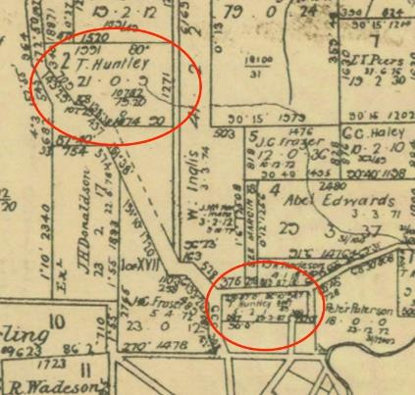
1888 Nillumbik Parish Plan showing Huntley’s ownership of land. The subject site is located on the southern land holding.

By 1891 Lot 13 had a Net Annual Value (NAV) of £22 (RB 1892). Thomas died in 1891, at the age of 72 (Leader (Melbourne), 21 November 1891:43.). His probate papers reveal that the property at Lot 13 was enclosed partly with three-rail timber fence, partly with wire and partly with paling. By this time the weatherboard house contained 6 rooms, accompanied by a one-stall stable and a cart shed, all valued at £650 (PROV VPRS 28/P2 Unit 345 File 49/921).

Continuing association with the Huntly family
The 1907-8 rate book shows Mary Ann Huntley, widow, as owner occupier of house and land, Lot 13 Section 16 (RB: Oct 1907- Sept 1908; PROV VPRS 2870/P0 Unit 167). Ryan writes that Mary Ann was a nurse in the district over many years (Ryan 1972:47). Mary Ann died at Diamond Creek in 1919, at the age of 78 (Advertiser (Hurstbridge), 17 April 1919:1, BDM 6396/1919).

While the 1907 rate book still had Mary Ann owning the Lot, in fact Mary Ann and the other executor of Thomas’s will, John Campbell Fraser, had subdivided the block into three. The central section of 1¼ acres and house went to the first daughter, Jeanette, in 1906. The remaining portion, made up of two blocks one on either side of the house block, was not passed on from the estate until well after Mary Ann senior had died in 1929 (CT: V1407 F303).

Youngest daughters Elizabeth and Isabella gained ownership of the central part of Lot 13 on which the house stood from Jeanette, now Campbell, in 1914 (CT: V3101 F030. RB 1910, PROV VPRS 2870/P0 Unit 170). It appears that they had taken up their mother’s profession and planned to open their own hospital. From late 1914 and during 1915 Misses E. and I. Huntley, certified nurses, advertised nursing home services at the “Felton House Private Nursing Home” (EO&BER, 18 June 1915:2). ‘Felton House’ appears to have been the old family home.

The sisters may only have run the home together for a couple of years. It appears that Isabella had opened the “St Elmo Private Hospital” at Yarram by May 1917 (FM&SGSA, 20 September 1917:3. GS&ASR, 30 May 1917:2)

The 1919 rate book shows Elizabeth and Isabella as owners and occupiers, replaced as occupiers during the year by Dr. Ted Cordner (RB 1919).

Bates writes that at the end of World War I Dr. Ted Cordner opened Diamond Creek’s second hospital in “the original homestead of the pioneer family Huntley” on Broad Gully Road just past Grassy Flat Road. In c1930 Dr. Cordner built a new house and surgery in Diamond Creek (Bates 2006:103) and it is assumed no longer operated from the Broad Gully Road building. In 1925 Isabelle and Elizabeth are the owners and occupiers. The NAV is £50, indicating some improvements (RB 1925).

In 1929 the remaining executor of Thomas’s estate, John Campbell Fraser, allocated the two blocks flanking the house lot to Elizabeth, now Culliford. She immediately transferred to joint ownership by herself and her sister Isabella Huntley (CT: V1407 F303).

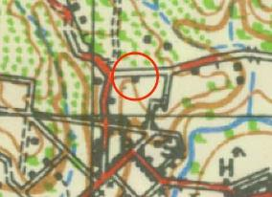
1930 Topographical map showing a building in the same location as the current house

In 1932 the house was occupied by Elizabeth (Huntley) Culliford. The NAV was £40 (RB 1932). Elizabeth, “late of Felton House”, died in 1935 and probate of her will went to Isabella, who was still in Gippsland (Argus, 16 August 1935:1). The St Elmo nursing home (in Yarram) was still operating in 1935, although it is not known whether Isabella was still involved by then (Argus, 16 August 1935:1. Gippsland Times, 23 May 1935 p.7). Isabella gained sole ownership of the house lot in Broad Gully Road in 1939.

Owners after the Huntly family
The land and house went out of Huntley family hands when it was sold to Ernest and Orpah Bryning in 1942 (CT V3814 F644). Patrick and Jane Murphy became the owners of the land encompassing the house in 1956. Filtgar Nominees became the owners in 1985 (CT V8171 F823). Bates writes that the Twigg family purchased the house in the 1980s and “restored it to its original splendour” (Bates 2006:103).

Description & Integrity

The site comprises a weatherboard Victorian style residence with a hipped roof. The front of the early residence faces west, rather than fronting Broad Gully Road indicating it was once on a much larger site taking advantage of views into the valley to the west. A tall picket fence and hedge surrounded the property in 2017 but these have since been removed and replaced with a high masonry and brick wall interspersed with metal rod gates. The two Victorian chimneys are landmark features in views to the top of the Diamond Creek hill. Although this main house section has had alterations, the main hipped roof is extant with two tall brick chimneys with corbelling and the central front door on the front elevation with side and highlight windows.

A gable roofed wing on the south side of the main wing running east west contains early features including roof finials, gable roof vent and scalloped boards to the gable ends. The west end of this wing appears to be original but it has been extended to the east end. This indicates that it may have been an early outbuilding on the site (the stable and cart shed noted in 1891). This wing is now connected to the south of the house via a weatherboard clad link.

The additions to the rear (east) of the main wing do not contribute to the significance of the place.

Note that some elements are described based on the views of the house before the masonry fence was erected.

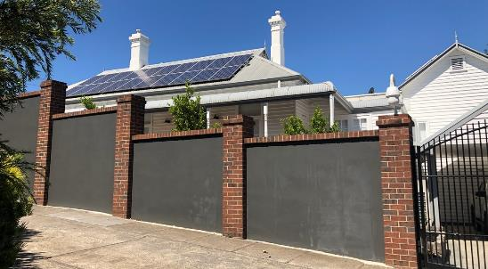
The front facade of 12 Broad Gully Road viewed from access road, off Broad Gully Road. Source: Trethowan Architecture, January 2022.

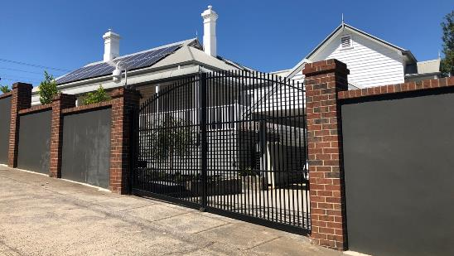
View front facade of 12 Broad Gully Road through vehicle gate on access road, off Broad Gully Road. Source: Trethowan Architecture, January 2022.

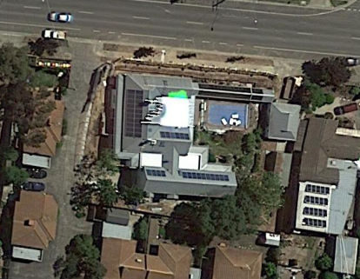
Recommended HO Extent.

Comparative Analysis

The residence at 12 Broad Gully Road was constructed in c. 1870 on land adjacent to a subdivision undertaken in 1872. It is an early surviving residence in the Diamond Creek township indicating the early expansion of the town on the boundaries of the township proclaimed in 1866. Other surviving early residences in the Diamond Creek township demonstrating the establishment of Diamond Creek and included in the Heritage Overlay are as follows:

- HO187 Windermere, former Leach House, 24 Collins Street, Victorian and Edwardian residence.
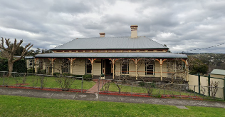

- HO188 25 Collins Street, Victorian weatherboard house.
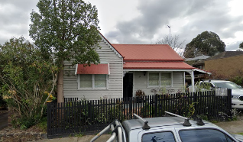

- HO244 Wadeson House, 9 Risdale Close, Italianate Victorian residence.
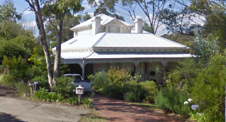

These are all surviving examples from the early development of Diamond Creek and as a collection create a picture of the makeup of the gold mining town. The property at 12 Broad Gully Road is distinctive for its retention of original detailing such as the two Victorian style corbelled chimneys and front door. It is also distinguished for its landmark qualities at the ridge of the Diamond Creek hill and for its retention of an early outbuilding with original detailing including the scalloped weatherboards to the gable end.

The property at 12 Broad Gully Road is also distinguished by its use (albeit short) as the Felton House Private Nursing Home in the residence at least during 1914 and 1915 but maybe for a longer period. In addition, it is documented that Dr. Ted Cordner opened Diamond Creek’s second hospital in “the original homestead of the pioneer family Huntley” on Broad Gully Road just past Grassy Flat Road after c1919 and possibly up to the end of the 1920s when he built a new home and surgery in the town.

Assessment Against Criteria

Criteria referred to in Practice Note 1: Applying the Heritage Overlay, Department of Planning and Community Development, revised July 2015, modified for the local context.

Criterion A:
Importance to the course, or pattern, of Victoria’s cultural history.

The residence at 12 Broad Gully Road, Diamond Creek is significant as an early residence in the township of Diamond Creek demonstrating its establishment as a result of the gold rush in the area. It is one of a small number of houses of a similar quality which represent this theme. It has important associations with the Huntly family who moved to the area as a result of the gold rush and Thomas Huntly junior who was a prominent miner. This site is a good example of the wider phenomenon in the Nillumbik area of how gold miners and those of low income more generally made use of the provisions in the Mines and Land Acts for cheap rent of small-holdings on Crown Land.

This site demonstrates a slow but constant improvement over years and through generations.

The property is also of historical significance for its use (albeit short) as the Felton House Private Nursing Home run by sisters Isabella and Elizabeth Huntly during 1914 and 1915 but maybe for a longer period. In addition, it is documented that Dr. Ted Cordner opened Diamond Creek’s second hospital in “the original homestead of the pioneer family Huntley” on Broad Gully Road just past Grassy Flat Road after c1919 and possibly up to the end of the 1920s when he built a new home and surgery in the town.

Criterion B:
Possession of uncommon, rare or endangered aspects of Victoria’s cultural history.

Criterion C:
Potential to yield information that will contribute to an understanding of Victoria’s cultural history.

Criterion D:
Importance in demonstrating the principal characteristics of a class of cultural places and objects.

Criterion E:
Importance in exhibiting particular aesthetic characteristics.

The residence and former outbuilding retain original features demonstrating the Victorian period of residential architecture. Features of note on the residence include the front door with sidelights and highlight windows, the tall brick chimneys with corbelling, the hipped roof form with timber corbelling under the eaves and the scalloped weatherboards and timber finial on the west gable end of the former outbuilding

Criterion F:
Importance in demonstrating a high degree of creative or technical achievement at a particular period.

Criterion G:
Strong or special association with a particular community or cultural group for social, cultural or spiritual reasons. This includes the significance of a place to Indigenous peoples as part of their continuing and developing cultural traditions.

Criterion H:
Special association with the life or works of a person, or group of persons, of importance in Shire of Nillumbik’s history.

Grading and Recommendations

Recommended for inclusion in the schedule to the Heritage Overlay of the Nillumbik Planning Scheme.

Recommendations for the Schedule to the Heritage Overlay (Clause 43.01) in the Nillumbik Planning Scheme:

External Paint Controls  Is a permit required to paint an already painted surface? | No
Internal Alteration Controls  Is a permit required for internal alterations? | No
Tree Controls  Is a permit required to remove a tree? | No
Victorian Heritage Register  Is the place included on the Victorian Heritage Register? | No
Incorporated Plan  Does an Incorporated Plan apply to the site? | No
Outbuildings and fences exemptions  Are there outbuildings and fences which are not exempt from notice and review? | No
Prohibited uses may be permitted  Can a permit be granted to use the place for a use which would otherwise be prohibited? | Yes
Aboriginal Heritage Place  Is the place an Aboriginal heritage place which is subject to the requirements of the Aboriginal Heritage Act 2006? | No

References

PROV, VA 538 Department of Crown Lands and Survey, VPRS 5357 Land Selection and Correspondence files. 18378/47.49 Thomas Huntley John Campbell Fraser Mary Ann Huntley; Nillumbik; 21; 8-2-34. 1888-1907.

‘Thomas Huntley John Campbell’, Lands Department file, VPRS 5357/P0 Unit 3550.

‘Thomas Huntley John Campbell’, Lands Department file, VPRS 5357/P0 Unit 3550. Thomas Huntley will and probate papers File 227/018, VPRS 28/P3 unit 1961; VPRS 7951/P2 Unit 796.

‘Township of Nillumbik at Diamond Creek Parish of Nillumbik County of Evelyn’, surveyed by Edward Bage, Contract Surveyor; photo-lithographed at the Department of Lands and Survey, Melbourne by J. Noone, 1867, SLV, http://handle.slv.vic.gov.au/10381/99554, accessed 23 August 2013

Advertiser (Hurstbridge), as cited.

Argus, as cited.

Bates, Laurie, 2006, Capturing the Essence of Diamond Creek, Laurie Bates, Diamond Creek.

Bendigo Independent, as cited.

Births Deaths and Marriages Victoria (BDM) Victoria Events, as cited.

Evelyn Observer and Bourke East Record (EO&BER), as cited.

Foster Mirror and South Gippsland Shire Advocate (FM&SGSA), as cited.

Gippsland Standard and Alberton Shire Representative (GS&ASR), as cited.
Gippsland Times, as cited.

Graeme Butler & Associates, 1996, 'Nillumbik Shire Heritage Study Stage 1, Review, Heritage Survey and Environmental History', prepared for the Shire of Nillumbik.

Heidelberg Shire District of Greensborough Municipal Rate Book (later Shire of Heidelberg Greensborough Riding Rate Books) (RB), as cited.

Land Victoria, Certificates of Title, as cited.

Lands Department file Thomas Huntly, Section 49 Occupation License, VPRS 7357/P0 Unit 3790 File 7/49.

Leader (Melbourne), as cited.

Mercury & Weekly Courier, as cited.

Nillumbik Parish Plan

Ryan, J L, 1972, Before You Came: Mines, Myths and Memories of Diamond Creek, New Life Publications, Surrey Hills (Vic).

Thomas Huntley Probate Papers File 214/978, VPRS 28/P3 Unit 1758.

