Title: House and Palm, 34 Clyde Street
Identified by: Samantha Westbrooke with Dr Peter Mills
Prepared and Updated by: Trethowan Architecture

Address: 34 Clyde Street, Diamond Creek
Name: Weatherboard House and Palm | Survey Date: 20/1/2022
Place Type: House | Architect:
Grading: Locally significant | Builder:
Extent of Overlay: Title Boundaries | Construction Date: 1907-1910

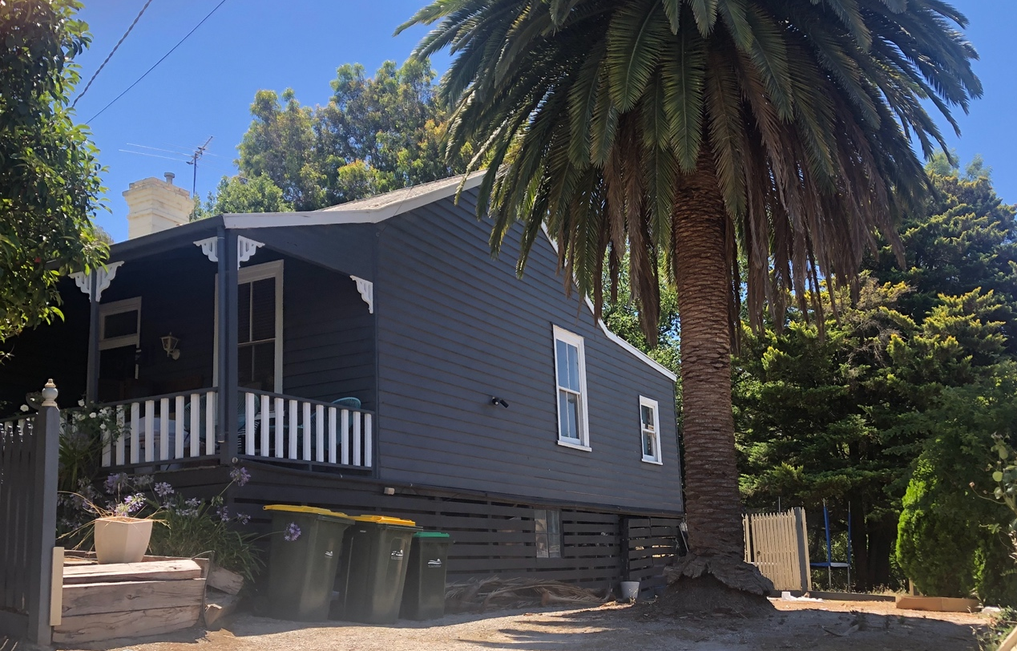

House and Palm at 34 Clyde Street, viewed from driveway at southeast. Source: Trethowan Architecture, January 2022

Historical Context

Early History of Diamond Creek
Although Crown Land in Nillumbik Parish was offered for sale in 1852 there were few buyers. A government township was reserved on the west of the Diamond Creek at this time but it was neither subdivided nor sold until 1866. In 1863 the Diamond Reef was discovered on land purchased by Dr John Blakemore Phipps in 1854 east of the creek. The rush to Diamond Creek began and soon Phipps was renting sections of his land, which he later subdivided to miners. In effect the development of Phipps land for gold mining was the beginnings of Diamond Creek, which was soon bustling with gold seekers. In 1866 the government proclaimed Diamond Creek as a township. Many of the important community buildings were established by the early 1870s. By the second half of the 1880s the locality was being carved up rapidly into a dominant pattern of numerous small lots of around 20 acres. These were taken up under occupation licenses, first under Section 49 of the Land Act 1869 and later under Section 65 of the Land Act 1884. Diamond Creek's population peaked around the turn of the century then seemed to fall away again in the early twentieth century (Graeme Butler & Associates 1996:36).

History

34 Clyde Street

Section 16 Parish of Nillumbik
Section 16 Parish of Nillumbik sits just outside the gazetted Diamond Creek Township boundary. Most of the smaller lots in the Township had sold from 1867-1870. The Crown land sale of Lots 1-12 Section 16 took place in March 1872. The upset price was £3 per acre, with most lots of ½ an acre in area. They were described in the advertisement as “town lots” (Argus 1 March 1872:3). Only two lots, 6 and 11, were sold at the auction (Argus 1 March 1872:3; Argus 13 March 1872:4; PROV, VPRS 16171/P0001/9, Nillumbik-1(Psh)LOImpN3310-1.pdf). The subject site, Lot 4, was sold to Thomas Warner Steedman of Melbourne in June 1875 (PROV, VPRS 16171/P0001/9, Nillumbik-1(Psh)LOImpN3310-1.pdf; CT V814 F701).

Steedman does not appear in the rate books for 1876, 78, 80 and 83, however there were no other owners before William Farmer, storekeeper of Nillumbik, purchased it in 1885 (RB 1876; 1878; 1880; 1883; CT: V814F701; CT: V1687F247). In 1885 Farmer was rated for a store, and for land without a house and with a Net Annual Value (NAV) of £5 (RB 1885). Farmer died in 1893 (Will and probate papers William Farmer, File 52/913, VPRS 28/P2 Unit 368).

When Farmer died in 1893 he still owned Lot 4 Section 16, which was also still vacant and valued at £20 (Will and probate papers William Farmer, File 52/913, VPRS 28/P2 Unit 368. Township of Diamond Creek Plan). Lot 4 Section 16 then went first to Maria Catherine Farmer, who died in 1893, then to her sister Harriet Anne Boston in 1897. It was purchased by Henry Smith Elliot of Greensborough, butcher, in 1898. The lot was still vacant in 1901 (RB 1901-2).

Development of Lot 4 - Augustus Flower Edmonds
Augustus Flower (Gus) Edmonds, miner of Diamond Creek, purchased the subject site Lot 4 (now 34 Clyde Street) in 1905 (CT: V1687 F247). He was part of the large Diamond Creek family of Thomas Frederick Laurence Edmonds and Frances (Gast), and in 1916 he was caretaker and librarian of the Free Library and Literary Institute (EO&BER 30 June 1916:3). Augustus was born in Diamond Creek in 1878 and married Edith Collins in 1904 (BDM 15162/1878 & 565/1904). In 1907 A.F. Edmonds owned Lot 5 with a house (NAV of £10), and the subject site Lot 4 with no house and with a NAV of £2. Edmonds built a house on Lot 4 between 1907 and 1910, which was soon rented out (RB 1907-08) In the 1910-11 rate book A.F. Edmonds was renting a house on Lot 4 to Mr Garrett, a miner, and the NAV of the property was up to £15. The house was accommodating 4 people (RB 1910-11). This and subsequent rate books, which are ordered by Sections, show Section 16 as part of the Township of Diamond Creek rather than the Parish of Nillumbik.

Lot 4 was purchased by Bruce Heddle, fruit packer of Diamond Creek, in 1928. Heddle was Augustus Edmonds’ half-brother. His father was William Heddle and mother Frances (Gast). He retained ownership of the property until he died in 1974 (CT: V1687 F247. Advertiser Hurstbridge 11 August 1939:7. BDM 8656/1974.). The 1936-37 rate book shows Heddle on Lot 4 with a house and an NAV of £18, the small rise indicating the building was unchanged.

Description & Integrity

The site contains a substantially intact c.1907 Edwardian weatherboard residence with main gable roof and a projecting gable wing to the front with a skillion roofed verandah. There is a skillion wing to the rear that also appears to be early. The verandah has timber posts with corner brackets and a timber balustrade across the front and sides. The original timber framed double hung windows to the front and sides appear to be intact. The front door is also intact.

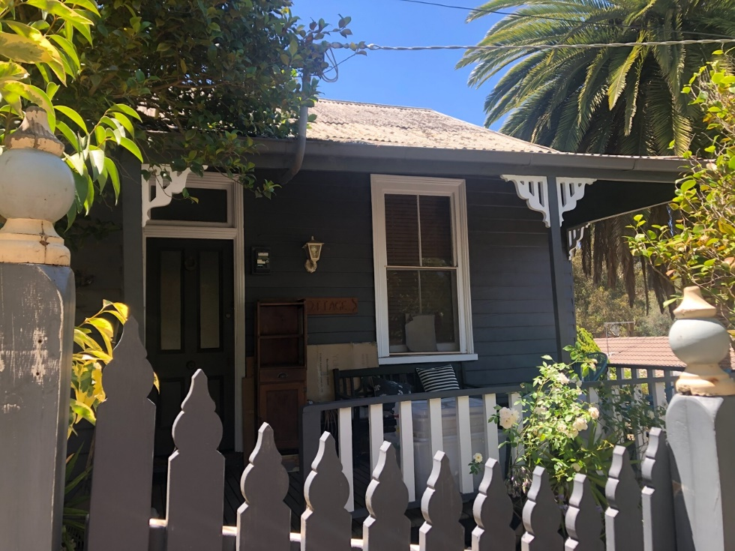
Facade detail. Source: Trethowan Architecture, January 2022

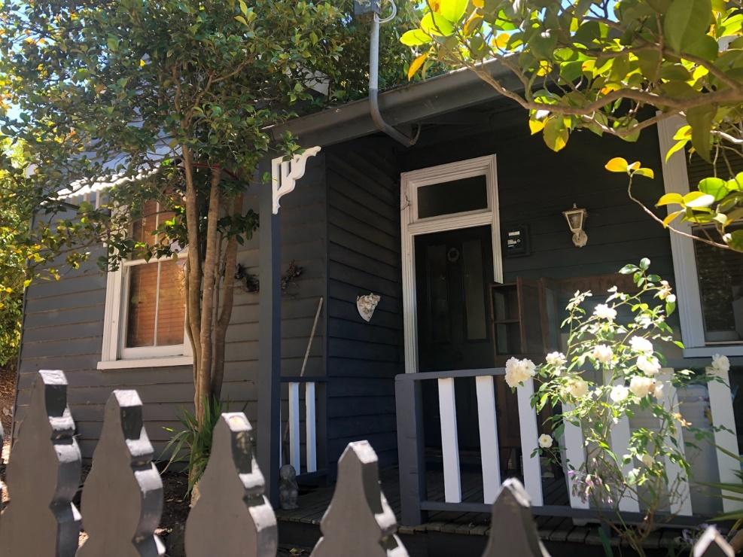
Facade detail, showing south-facing gable end at left. Source: Trethowan Architecture, January 2022

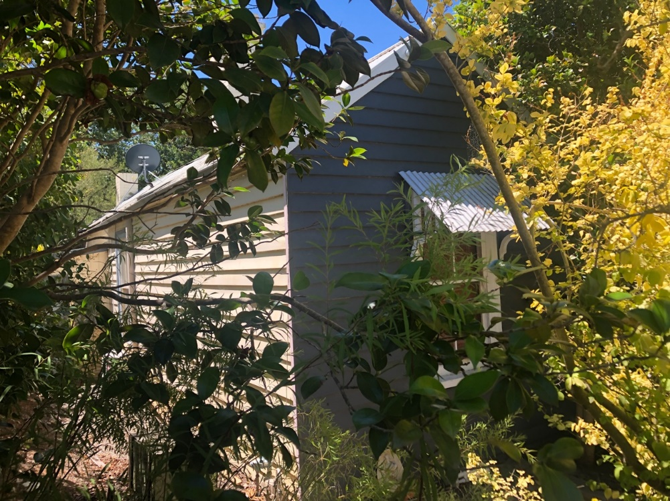
Detail of south facing gable and west wall. Source: Trethowan Architecture, January 2022

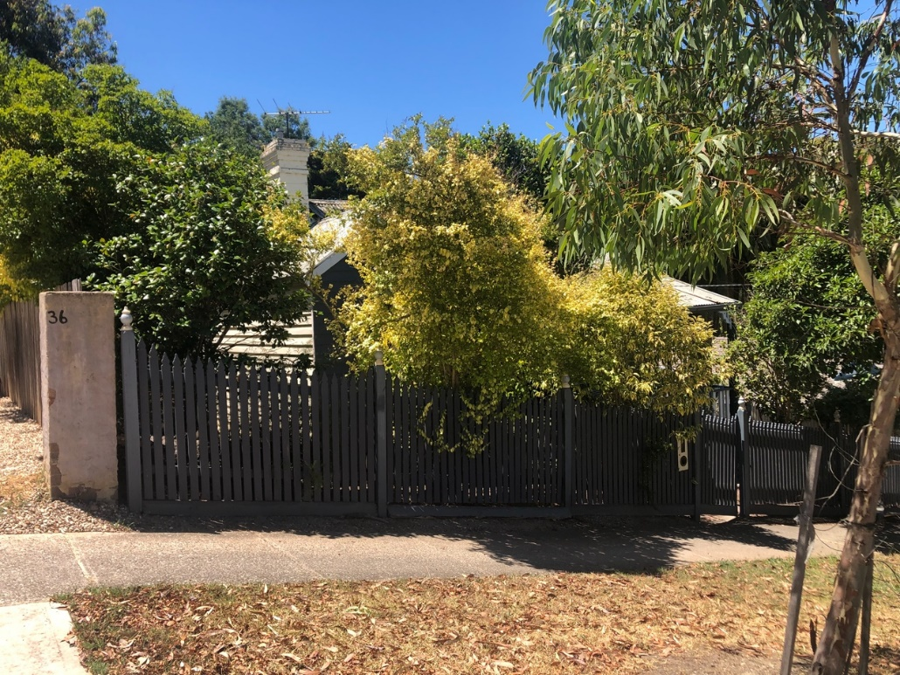
The house’s presentation to the street, from southwest. Source: Trethowan Architecture, January 2022

Comparative Analysis

Other surviving early residences in the Diamond Creek township demonstrating the establishment of Diamond Creek as a result of the gold rush and its appearance around c1900 are as follows:

- HO186 Kyah, Bourke House, 1/15 Collins Street, Edwardian House
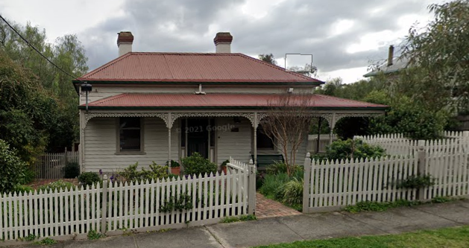

- HO187 Windermere, former Leach House, 24 Collins Street, Victorian and Edwardian residence.
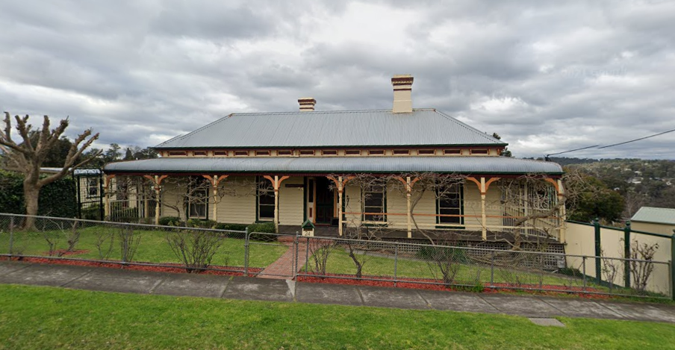

- HO188 25 Collins Street, Victorian weatherboard house.
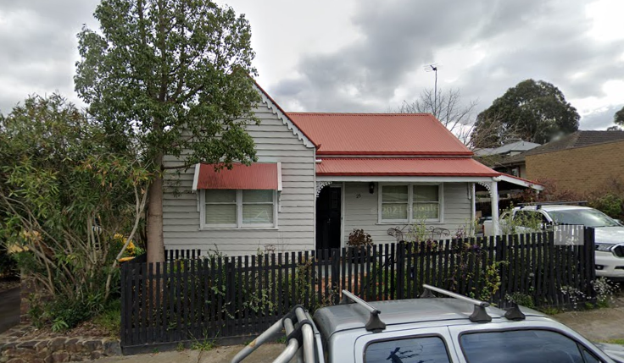

- HO203 Peers House, 15 Galatea Street, Edwardian House
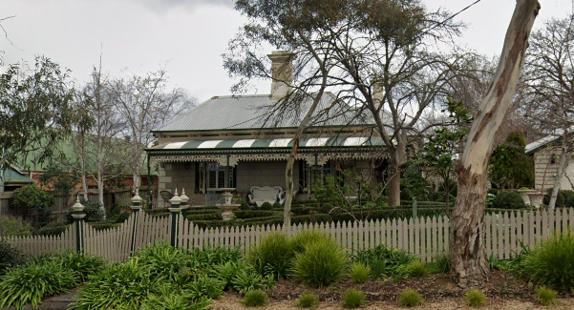

- HO217 Edwin Peters, later Henry Ryan house, 5 Hyde Street, Edwardian residence
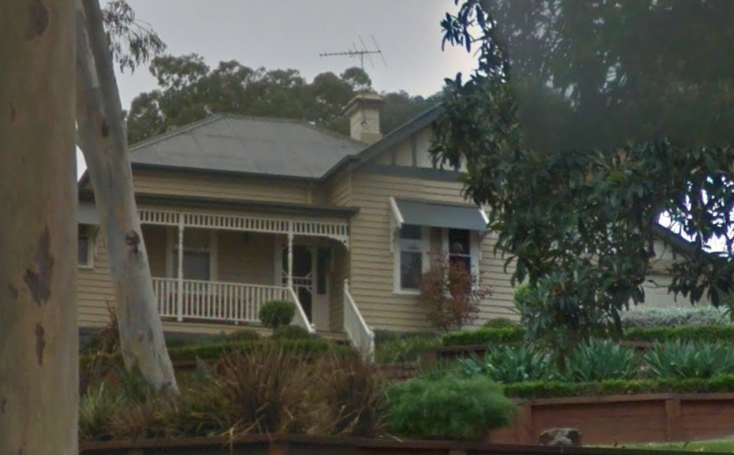

- HO244 Wadeson House, 9 Risdale Close, Italianate Victorian residence.
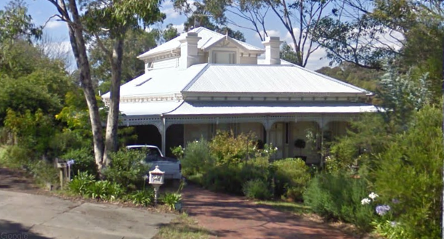

These are all surviving examples from the early development of Diamond Creek and as a collection create a picture of the makeup of the gold mining town. This site demonstrates a typical humble home and is substantially intact demonstrating the appearance of Diamond Creek at the turn of the 20th century.

Assessment Against Criteria

Criteria referred to in Practice Note 1: Applying the Heritage Overlay, Department of Planning and Community Development, revised July 2015, modified for the local context.

CRITERION A: Importance to the course or pattern of the Shire of Nillumbik’s cultural or natural history (historical significance).
The residence is important as an early residence in the Diamond Creek township. This site demonstrates a typical humble home and is substantially intact demonstrating the appearance of Diamond Creek at the turn of the century and during its heyday. The residence is one of a small collection of Victorian and Edwardian houses surviving in the Diamond Creek township to demonstrate its early establishment.

CRITERION B: Possession of uncommon, rare or endangered aspects of the Shire of Nillumbik’s cultural or natural history (rarity).

CRITERION C: Potential to yield information that will contribute to an understanding of the Shire of Nillumbik’s cultural or natural history (research potential).

CRITERION D: Importance in demonstrating the principal characteristics of a class of cultural or natural places or environments (representativeness).
The residence is of aesthetic significance for demonstrating typical characteristics of a humble Edwardian dwelling and retaining original features and detailing including the gable roofed form with rear skillion and projecting gable roofed room to the front skillion roofed verandah, timber framed double hung windows, weatherboard cladding and original front door.

CRITERION E: Importance in exhibiting particular aesthetic characteristics (aesthetic significance).
The mature palm tree at the front of the property contributes to the setting of the place and provides a landmark to the early residence.

CRITERION F: Importance in demonstrating a high degree of creative or technical achievement at a particular period (technical significance).

CRITERION G: Strong or special association with a particular community or cultural group for social, cultural or spiritual reasons. This includes the significance of a place to Indigenous peoples as part of their continuing and developing cultural traditions (social significance).

CRITERION H: Special association with the life or works of a person, or group of persons, of importance in the Shire of Nillumbik’s history (associative significance).

Grading and Recommendations

Recommended HO Extent

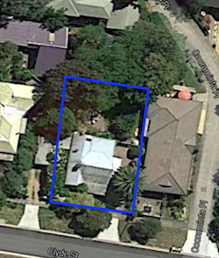
Proposed Extent for 34 Clyde Street, Diamond Creek

Recommended for inclusion in the schedule to the Heritage Overlay of the Nillumbik Planning Scheme.
Recommendations for the Schedule to the Heritage Overlay (Clause 43.01) in the Nillumbik Planning Scheme:

External Paint Colours  Is a permit required to paint an already painted surface? | No
Internal Alteration Controls  Is a permit required for internal alterations? | No
Tree Controls  Is a permit required to remove a tree? | Yes - Palm
Victorian Heritage Register  Is the place included on the Victorian Heritage Register? | No
Incorporated Plan  Does an Incorporated Plan apply to the site? | No
Outbuildings and fences exemptions  Are there outbuildings and fences which are not exempt from notice and review? | No
Prohibited uses may be permitted  Can a permit be granted to use the place for a use which would otherwise be prohibited? | No
Aboriginal Heritage Place  Is the place an Aboriginal heritage place which is subject to the requirements of the Aboriginal Heritage Act 2006? | No

References

Advertiser Hurstbridge, as cited.

Argus, as cited.

Births Deaths and Marriages (BDM) Victoria, as cited.

Evelyn Observer and Bourke East Record (EO&BER), as cited.

Graeme Butler & Associates 1996, 'Nillumbik Shire Heritage Study Stage 1, Review, Heritage Survey and Environmental History', prepared for Shire of Nillumbik.

Heidelberg Greensborough Municipal Rate Books (RB), as cited.

Land Victoria, Certificates of Title (CT), as cited.

PROV, VA4554 Department of Sustainability and Environment, VPRS 16171 Regional Land Office Parish and Township Plans Digitised Reference Set, Nillumbik- 1 Parish Plan, Imperial measure N3310-1.

