Title: War Memorial
Identified by: Peter Mills and Samantha Westbrooke
Updated and Prepared by: Trethowan Architecture

Address: Reserve Circuit, Main Hurstbridge Road Diamond Creek
Name: Diamond Creek War Memorial | Survey Date: January 2022
Place Type: Memorial | Architect: Unknown
Grading: Locally Significant | Builder: Unknown
Extent of Overlay: | Construction Date: 1921, additions 1970

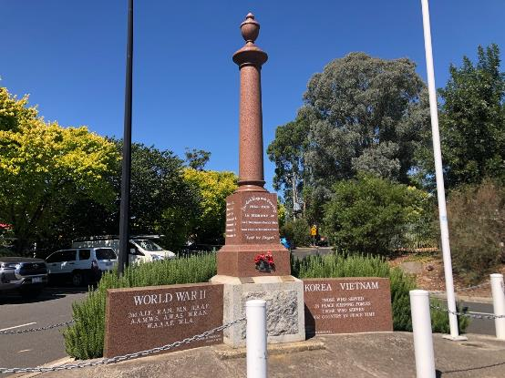
The War Memorial in context, Reserve Circuit. Source: Trethowan Architecture, January 2022.

Historical Context

Early History of Diamond Creek
Although Crown Land in Nillumbik Parish was offered for sale in 1852 there were few buyers. A government township was reserved on the west of the Diamond Creek at this time but it was neither subdivided nor sold until 1866. In 1863 the Diamond Reef was discovered on land purchased by Dr John Blakemore Phipps in 1854 east of the creek. The rush to Diamond Creek began and soon Phipps was renting sections of his land, which he later subdivided to miners. In effect the development of Phipps' land for gold mining was the beginnings of Diamond Creek, which was soon bustling with gold seekers. In 1866 the government proclaimed Diamond Creek as a township. Many of the important community buildings were established by the early 1870s. By the second half of the 1880s the locality was being carved up rapidly into a dominant pattern of numerous small lots of around 20 acres. These were taken up under occupation licenses, first under Section 49 of the Land Act 1869 and later under Section 65 of the Land Act 1884. Diamond Creek's population peaked around the turn of the century then seemed to fall away again in the early twentieth century (Graeme Butler & Associates 1996, p.36).

History

Diamond Creek War Memorial
In November 1919 the Diamond Creek ‘Girls Blue Triangle Club’, which was formed in the town during the war, began to collect funds to erect a monument at Diamond Creek as a memorial to local men who had lost their lives during the war (E&WSA&DCVA 7 November 1919:2, Advertiser (Hurstbridge) 13 March 1925:3). The term ‘Blue Triangle Club’ developed during the war to describe activities of the Young Women’s’ Christian Association, initially directed towards providing women war workers with hostels, canteens and “healthy recreation”. After the war efforts were directed towards providing for country women working in the city. In 1921 the ‘Blue Triangle Girls Club’ had 420 members fundraising in Victoria for various causes (Argus 14 October 1921:8).

The memorial committee in Diamond Creek consisted of Miss Faith Smith, the secretary, Messrs J. Lorimer, W. Cook and B. Rose, Mesdames Fineran and Sinclair, and Misses Corwin, Dora Wadeson and Lily Rose (E&WSA&DCVA, 24 June 1921:3). The site chosen was opposite the Public Hall, on the west side of the intersection of Collins Street with Main Street.

The unveiling ceremony was held on 19 June 1921. Ceremonies began with the large crowd singing the national anthem and a series of speeches by local notables. The Governor, Lord Stradbroke, accompanied by Lieutenant Commander Haggard D.S.C., unveiled the cenotaph, which was draped with bunting, the Union Jack, and “our own beloved six-star banner”. A minute’s silence followed, medals were presented to local returned men and the ceremony concluded with the playing of the last post and another rendition of the national anthem (E&WSA&DCVA, 24 June 1921:3, Argus 20 June 1921:8).

The names of the fallen inscribed on the monument were E. Mills, J. Mills, D. Scott, W. Starling, S. Wadeson, R. Whicker, C. Williams, B. Allen, N. Coventry, G. Fineran, J. Gosstray, W. Hill and R. Laurie. The column was topped with an urn and was made of English red granite and Harcourt grey granite, at a cost of £200 (E&WSA&DCVA 24 June 1921:3). The German heavy machine gun mounted at the base of the column had been captured by the 24th Battalion A.I.F. in the attack on Lamotte Farm, south of Beaurevoir, France, on the 3rd of October 1918 (E&WSA&DCVA 24 June 1921:2).

The memorial became an established part of Anzac Day celebrations. In 1926 a commemoration at the Diamond Creek school involved songs and recitations, the reading of the honour roll and a minute’s silence, followed by a march to the public memorial and placing of wreaths (Advertiser (Hurstbridge) 30 April 1926:3, 3 May 1929:3).

In the lead-up to Anzac Day 1932 it was thought that the monument had taken on a “very neglected appearance”, and the local branch of the Returned Soldiers Association requested assistance of the Heidelberg Council, resulting in the supply of paint by the council. It appears the memorial was surrounded by a post and rail fence, as several loads of rubbish were removed from inside its perimeter by local returned soldiers, before the fence was painted. The ground was dug, flowers planted and a small lawn laid down (Advertiser (Hurstbridge) 15 April 1932:1). Before Anzac Day 1940 the Heidelberg Council stepped in to clean up the memorial, which was “badly in need of attention”. Water was laid on to help in future maintenance (EWSA, 19 April 1940:2).

The memorial was transferred to the grounds of the Diamond Creek Kindergarten in the 1970s (Edwards 1979:46). In 1996 the memorial was relocated to Main Street next to the Diamond Creek Community Centre and re-dedicated to cover the loss of lives in conflicts since the Great War (Advertiser (Hurstbridge) 16 January 1931:1, Monument Australia 2022b).

Description & Integrity

The Diamond Creek War Memorial consists of an English red granite column on a red granite plinth with a square Harcourt grey granite base. The column is surmounted with an urn. There are rectangular red granite panels either side of the column, which have been added at a later date. The left hand panel is dedicated to those who fought in World War Two and the right hand side panel is dedicated to those who fought in Korea and in the Vietnam War.

The following inscriptions are included on the memorial.

Front Inscription
For God King and Country
1914 - 1919
IN MEMORY OF THE DIAMOND CREEK MEN WHO FELL IN THE GREAT WAR.
"Lest We Forget"

Rectangular section of column
Names of the fallen soldiers from World War One are inscribed on the rectangular section of the column, on the left and right faces.

Plaque 1:
THIS MEMORIAL WAS REDEDICATED ON THE 6TH OCTOBER 1996 IN CONJUNCTION WITH THE ROTARY CLUB OF DIAMOND CREEK AND THE RETURNED AND SERVICES LEAGUE OF VICTORIA INC.

Plaque 2:
THIS PLAQUE IS TO COMMEMORATE THE LOSS OF LIVES IN ALL CONFLICTS SINCE
THE GREAT WAR OF 1914 - 1918.
REST IN PEACE

Lower Right Side Panel Inscription
Korea Vietnam
Those who served in peace keeping forces
Those who served our country in peace time
Des. F. Vincent
R.A.A.F. WWII
Founder Diamond Creek R.S.L.

Lower Left Side Panel Inscription
World War II
2nd A.I.F. R.A.N. M.N. R.A.A.F
A.A.M.W.S A.W.A.S. W.R.A.N.
W.A.A.A.F. W.L.A.
VX 136506 B . Wadeson
2nd A.I.F. WWII

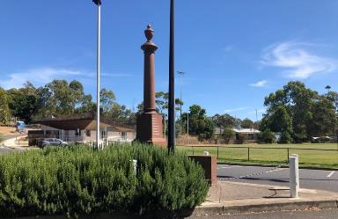
Placement of Memorial in relation to local open space. Source: Trethowan Architecture, January 2022.

Comparative Analysis

There are two other war memorial monuments located in the Shire:

- HO126 Eltham War Memorial – an obelisk erected in 1919 which has been relocated twice since its original unveiling (now located at 903-907 Main Road, Eltham). The monument contains the names of the 27 local men who died in the First World War and following the Second World War the names of the eleven local men who died in that war were added.
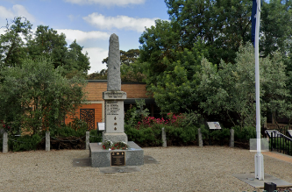
Image Source: Google Street View 2022

- Christmas Hills War Memorial, Eltham & Yarra Glen Roads, Memorial Park, Christmas Hills. Rendered concrete obelisk unveiled December 1921.
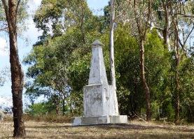
Image Source: Monument Australia 2022a

The Diamond Creek War Memorial is unusual for its form and its use of red granite, and it has particular social value to the Diamond Creek area.

Assessment Against Criteria

Criteria referred to in Practice Note 1: Applying the Heritage Overlay, Department of Planning and Community Development, revised July 2015, modified for the local context.

CRITERION A: Importance to the course or pattern of the Shire of Nillumbik’s cultural or natural history (historical significance).

The Diamond Creek War Memorial is historically significant for its role in civic commemoration in the township of Diamond Creek. The Diamond Creek War Memorial was unveiled on the west side of the intersection of Collins and Main Street, opposite the Diamond Creek Hall on 19 June, 1921. The memorial was transferred to the grounds of the Diamond Creek kindergarten in the 1970s and again relocated to Main Street next to Diamond Creek Community Centre. At this time, it was rededicated and panels included commemorating the loss of lives in conflicts since World War One. The Memorial is historically significant for demonstrating the type of monumental memorialisation that occurred in townships following the end of the First World War.

CRITERION B: Possession of uncommon, rare or endangered aspects of the Shire of Nillumbik’s cultural or natural history (rarity).

CRITERION C: Potential to yield information that will contribute to an understanding of the Shire of Nillumbik’s cultural or natural history (research potential).

CRITERION D: Importance in demonstrating the principal characteristics of a class of cultural or natural places or environments (representativeness).

The Diamond Creek War Memorial is aesthetically significant as an intact representative example of a First World War Memorial.

CRITERION E: Importance in exhibiting particular aesthetic characteristics (aesthetic significance).

The memorial is more unusual being constructed substantially of red granite and with a column rather than obelisk form, which was more common for the period.

CRITERION F: Importance in demonstrating a high degree of creative or technical achievement at a particular period (technical significance).

CRITERION G: Strong or special association with a particular community or cultural group for social, cultural or spiritual reasons. This includes the significance of a place to Indigenous peoples as part of their continuing and developing cultural traditions (social significance).

The Diamond Creek War Memorial is of social significance as a community focus for the commemoration of war in the Diamond Creek district since it was unveiled in 1921. The Memorial has special associations with the local RSL group.

CRITERION H: Special association with the life or works of a person, or group of persons, of importance in the Shire of Nillumbik’s history (associative significance).

Grading and Recommendations

Recommended for inclusion in the schedule to the Heritage Overlay of the Nillumbik Planning Scheme.

Recommended HO Extent
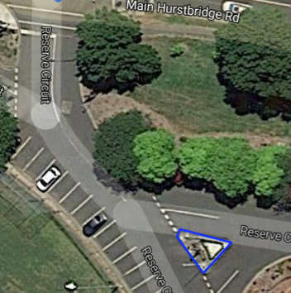
Proposed Extent for Diamond Creek War Memorial

Recommendations for the Schedule to the Heritage Overlay (Clause 43.01) in the Nillumbik Planning Scheme:

External Paint Controls  Is a permit required to paint an already painted surface? | No
Internal Alteration Controls  Is a permit required for internal alterations? | No
Tree Controls  Is a permit required to remove a tree? | No
Victorian Heritage Register  Is the place included on the Victorian Heritage Register? | No
Incorporated Plan  Does an Incorporated Plan apply to the site? | No
Outbuildings and fences exemptions  Are there outbuildings and fences which are not exempt from notice and review? | No
Prohibited uses may be permitted  Can a permit be granted to use the place for a use which would otherwise be prohibited? | No
Aboriginal Heritage Place  Is the place an Aboriginal heritage place which is subject to the requirements of the Aboriginal Heritage Act 2006? | No

References

Advertiser (Hurstbridge), as cited.

Edwards, Dianne H. 1979. The Diamond Valley Story: Shire of Diamond Valley.

Eltham and Whittlesea Shires Advertiser and Diamond Creek Valley Advocate (E&WSA&DCVA), as cited.

Eltham and Whittlesea Shires Advertiser (EWSA), as cited.

Graeme Butler & Associates 1996 'Nillumbik Shire Heritage Study Stage 1, Review, Heritage Survey and Environmental History', prepared for Nillumbik Shire Council.

Monument Australia 2022a, Christmas Hills War Memorial, https://monumentaustralia.org.au/display/30806-christmas-hills-war-memorial, accessed 1 March 2022.

Monument Australia 2022b, Diamond Creek War Memorial, http://monumentaustralia.org.au/themes/conflict/multiple/display/31011-diamond-creek-war-memorial, accessed 20 April 2017 and 3 February 2022.

Argus, as cited.

