Title: Ghirrawheen Farmhouse, Outbuildings and Orchard, 349-361 Diamond Creek Road
Prepared by: Trethowan Architecture

Address: 349-361 Diamond Creek Road, Diamond Creek
Name: Ghirrawheen Farmhouse, Outbuildings and Orchard | Survey Date: 20/1/2022
Place Type: Individual Place | Architect:
Grading: Significant | Builder:
Extent of Overlay: | Construction Date: 1925-28 (outbuilding dates uncertain)
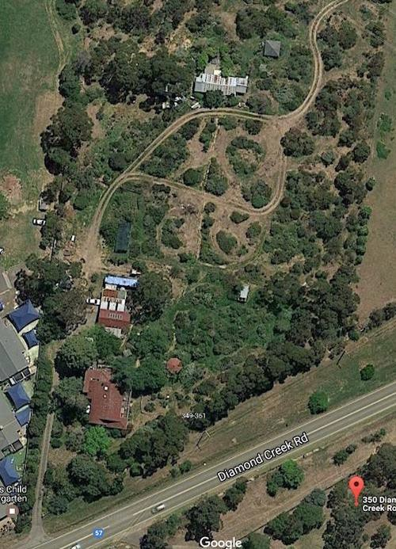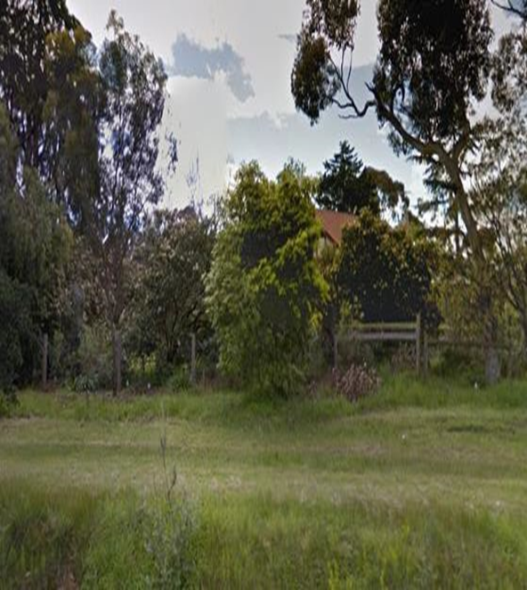

Historical Context

Early History of Diamond Creek
Although Crown Land in Nillumbik Parish was offered for sale in 1852 there were few buyers. A government township was reserved on the west of the Diamond Creek at this time but it was neither subdivided nor sold until 1866. In 1863 the Diamond Reef was discovered on land purchased by Dr John Blakemore Phipps in 1854 east of the creek. The rush to Diamond Creek began and soon Phipps was renting sections of his land, which he later subdivided to

miners. In effect the development of Phipps land for gold mining was the beginnings of Diamond Creek, which was soon bustling with gold seekers. In 1866 the government proclaimed Diamond Creek as a township. Many of the important community buildings were established by the early 1870s. By the second half of the 1880s the locality was being carved up rapidly into a dominant pattern of numerous small lots of around 20 acres. These were taken up under occupation licenses, first under Section 49 of the Land Act 1869 and later under Section 65 of the Land Act 1884. Diamond Creek's population peaked around the turn of the century then seemed to fall away again in the early twentieth century (Graeme Butler & Associates 1996, p.36).

History

349-361 Diamond Creek Road
The subject property was originally part of Lot 7 Section 22, Parish of Nillumbik. H.M. Bell obtained freehold for 80 acres Lot 7 Section 22 Parish of Nillumbik in 1872. Bell had taken up the land under an occupation license on auriferous land under Section 42 of the Amending Land Act 1865 and purchased under Section 13 of the same Act (Nillumbik Parish).

James Cole obtained title to western half of Lot 7, (west of the easement for Larch Crescent) in 1888. This was an irregular polygonal block of 34 acres. Cole sold the land to William Harwood Finlay, gardener of Diamond Creek, in 1895 (CT: V2094 F772). In 1902, part of Lot 7 was purchased by Anne Finlay (nee Leach), widow of William’s brother, Robert Mitchell Finlay (d 1885) (CT: V2094 F772). In 1906, her son Robert Mitchell Finlay (junior), fruit grower of Diamond Creek, obtained the land (CT: V2094 F772).

Finlay orchardists
The subject site formed part of Finlay’s 33-acre orchard throughout Finlay’s ownership. The first mention of a building occurred in 1922, when the rate book records that Finlay had built a “fruit house”, possibly referring to a packing shed (RB 1922). By 1928 the property had a house and the rate was increased to £75.122 from £42.120 of the previous year (RB 1925, 1926, 1927 and 1928). This implies the house was built between 1925 and 1928. The1930 map shows extensive orchards to the east of the house (Great Britain War Office, 1920).

Robert Finlay was part of a new generation of orchardists open to new techniques and fruit varieties, which was replacing the old guard of the district established in the nineteenth century. He had already become the secretary of Diamond Creek Horticultural Society by 1907, suggesting he was already established as a fruit grower (Leader, 5 January 1907: 3). In 1911 a demonstration of “subsoiling by the use of explosives” was given at his orchard.114 By 1913 he was the president of the Society, and a toast at a Society luncheon proposed that “the success of the Society was in great measure due to his exertions (Age, 11 September 1913: 12; EOBER, 28 March 1913: 3). In 1913 he was carrying out extensive drainage work on his young orchard. “The plantation is reported to be making great headway” (Australasian, 30 August 1913: 11). In 1914 he won first prize at the Diamond Creek Show for Beurre Bosc pears from his “young orchard” (Australasian, 28 March, 1914: 10). In 1917 he exhibited pears from his “young orchard” at the Diamond Creek Show (Australasian, 17 March 1917: 9).

Robert Mitchell Finlay was an active and respected figure in the fruit-growing community, and held positions in the Fruit-Grower’s’ Cool Stores Association of Victoria store (Hurstbridge Advertiser¸5 September 1924:2) and the Diamond Creek Co-operative Cool Store (Weekly Times, 23 February 1929: 28). Upon his death in 1949, his probate papers described the Diamond Creek property as “31 acres of neglected orchard country with a six-roomed weatherboard house”. The fruit trees were described as “old” (PROV, VPRS 28/P3,424/708). When the property, known by this time as ‘Girrahwheen’, was put up for sale in April 1950, it was described as a “Gentleman’s out-of-town home”. The residence was of weatherboard, “well built” with 5 large rooms and a wide return verandah. Outbuildings included a double garage, laundry, packing sheds and stables (Age, 22 April 1950: 23). Following the sale of the property, there was a clearing sale of furniture and farm implements at ‘Girrahwheen’ in May 1950 (Argus, 23 May 1950: 11).

Charles James Fox Peckover of ‘Ghirrawheen’ [sic] Diamond Creek, radio announcer, became the owner in 1950. The block was subdivided into 5 lots in 1953. The subject house was on the westernmost t7.5-acrs Lot 1 of this subdivision (CT: V2094 F772).

Description & Integrity

The farm house is located on the south west corner of a large vegetated site. The house is a large 1920s weatherboard bungalow with a large main hipped roof with a gable to the front end facing the road. The roof is clad in corrugated galvanised iron painted red. There is a wide front verandah, which returns on one side.

There are outbuildings directly to the rear of the residence and further back on the site. These may date from the 1920s and 30s when the property was in use as a successful orchard.

When ‘Girrahwheen’ was put up for sale in April 1950, it was described as a “Gentleman’s out- of-town home”. The residence was of weatherboard, “well built” with 5 large rooms and a wide return verandah. Outbuildings included a double garage, laundry, packing sheds and stables.

Comparative Analysis

Other orchard properties in Diamond Creek:
Larch Hill Farm, 2 Hillmartin Lane (recommended for the Heritage Overlay) is historically significant for the grand 1920s bungalow residence constructed as a comfortable retirement home and a large orchard site. The property also has associations with the orcharding industry in the area. The property is significant as a rare intact example of a grand country residence constructed in the inter-war period. Such grand houses of the period, constructed for wealthy owners, are rare in the Nillumbik Shire.

HO166 Trenowin House, 83 Lambert Street, Diamond Creek is an orchard site established by the first wave of orchardists in the Nillumbik Shire. The house is historically and aesthetically significant as a good and early representation of an orchard house within the Shire, as it is situated within a well preserved farm setting and serves as a reminder of the importance of agriculture to the early growth of the Shire. It is only other orchard of this scale or recognition in Diamond Creek

Figure 1: Image dated c2022 showing the front elevation of Trenowen House. Source: realestate.com.au
Other successful orchard properties in the Shire from the second wave of orchardists and included in the Heritage Overlay are as follows:

HO29 Californian Bungalow, 830 Cottlesbridge-Strathewen Road, Arthurs Creek. The Apted family have operated their orchard at Arthurs Creek for over a century. The orchard was, in 1916, the largest in southern Victoria and is a reminder of the importance of orcharding in the former Shire of Eltham. The Californian bungalow is historically significant as a rare surviving example of its type in the Shire.

The property at 349-361 Diamond Creek Road is distinguished from the above examples by the scale of the farmhouse and the retention of a number of outbuildings. The site is also associated with a prominent orchardist in the Shire, Robert Mitchell Finlay who obtained a high level of success and participated in promoting and bettering the fruit industry in the area. The significance lies in Finlay as representing the second generation, more modern, fruit growers of the district. The house dating 1926-28 was built during Finlay’s ascendancy in this field.

Assessment Against Criteria

Criteria referred to in Practice Note 1: Applying the Heritage Overlay, Department of Planning and Community Development, revised July 2015, modified for the local context.

CRITERION A: Importance to the course or pattern of the Shire of Nillumbik’s cultural or natural history (historical significance).
The property is of historical significance for its demonstration of the successful orchard farming carried out in the area. This property demonstrates the second generation of orchard farmers in the area and the size of the house demonstrates the success of Robert Mitchell Finlay as an orchardist. The house dating 1926-28 was built during Finlay’s ascendancy as a successful orchardist.

CRITERION B: Possession of uncommon, rare or endangered aspects of the Shire of Nillumbik’s cultural or natural history (rarity).
The outbuildings associated with the orchard use of the property are significant as rare surviving examples of their types – particularly the fruit packing sheds.

CRITERION C: Potential to yield information that will contribute to an understanding of the Shire of Nillumbik’s cultural or natural history (research potential).

CRITERION D: Importance in demonstrating the principal characteristics of a class of cultural or natural places or environments (representativeness).

CRITERION E: Importance in exhibiting particular aesthetic characteristics (aesthetic significance).
The farmhouse on the property is of aesthetic significance as a large 1920s bungalow with its expansive and dominant main hipped roof and wide return verandah.

CRITERION F: Importance in demonstrating a high degree of creative or technical achievement at a particular period (technical significance).

CRITERION G: Strong or special association with a particular community or cultural group for social, cultural or spiritual reasons. This includes the significance of a place to Indigenous peoples as part of their continuing and developing cultural traditions (social significance).

CRITERION H: Special association with the life or works of a person, or group of persons, of importance in the Shire of Nillumbik’s history (associative significance).

Grading and Recommendations

Recommended for inclusion in the schedule to the Heritage Overlay of the Nillumbik Planning Scheme.

Recommended HO Extent

Proposed Extent (indicated with red) for 349-361 Diamond Creek Road, Diamond Creek

Recommendations for the Schedule to the Heritage Overlay (Clause 43.01) in the Nillumbik Planning Scheme:

External Paint Controls  Is a permit required to paint an already painted surface? | No
Internal Alteration Controls  Is a permit required for internal alterations? | No
Tree Controls  Is a permit required to remove a tree? | Yes (remnant orchard)
Victorian Heritage Register  Is the place included on the Victorian Heritage Register? | No
Incorporated Plan  Does an Incorporated Plan apply to the site? | No
Outbuildings and fences exemptions  Are there outbuildings and fences which are not exempt from notice and review? | Yes - garage, stables, packing sheds
Prohibited uses may be permitted  Can a permit be granted to use the place for a use which would otherwise be prohibited? | Yes
Aboriginal Heritage Place  Is the place an Aboriginal heritage place which is subject to the requirements of the Aboriginal Heritage Act 2006? | No

Identified By

Samantha Westbrooke Pty Ltd, Dr Peter Mills and Trethowan Architecture

References

Birth Death Marriages (BDM), as cited.

Certificate of Title, as cited.

The Age, as cited.

The Argus, as cited.

The Australasian as cited.

Evelyn Observer and Bourke East Record (EOBER), as cited.

Graeme Butler & Associates. 1996. Nillumbik Shire Heritage Study Stage 1, Review, Heritage Survey and Environmental History. Greensborough: Shire of Nillumbik.

Great Britain. War Office. General Staff. Commonwealth Section & Australia. Department of Defence 1920, 'Yan Yean, Victoria / prepared by Commonwealth Section, Imperial General Staff' Yan Yean, Victoria [cartographic material]

Land Victoria, Certificates of Title (CT), as cited.

Leader, as cited.

PROV, VA 2620 Registrar of Probates, Supreme Court, VPRS 28 Probate and Administration Files, file 424/708 Robert M Finlay, Grant of probate

Shire of Heidelberg Greensborough Riding Rate Books (later Heidelberg Riding Rate Books), as cited.

Weekly Times, as cited.

