Title: Larch Hill, 2 Hillmartin Lane
Prepared by: Trethowan Architecture

Address: 2 Hillmartin Lane, Diamond Creek
Name: Larch Hill Residence and Remnant Orchard | Survey Date: 20/1/2022
Place Type: Individual Place | Architect: Unknown
Grading: Significant | Builder: Unknown
Extent of Overlay: to the title boundary | Construction Date: 1920-22

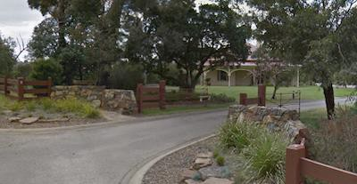

Historical Context

Early History of Diamond Creek
Although Crown Land in Nillumbik Parish was offered for sale in 1852 there were few buyers. A government township was reserved on the west of the Diamond Creek at this time but it was neither subdivided nor sold until 1866. In 1863 the Diamond Reef was discovered on land purchased by Dr John Blakemore Phipps in 1854 east of the creek. The rush to Diamond Creek began and soon Phipps was renting sections of his land, which he later subdivided to miners. In effect the development of Phipps land for gold mining was the beginnings of Diamond Creek, which was soon bustling with gold seekers. In 1866 the government proclaimed Diamond Creek as a township. Many of the important community buildings were established by the early 1870s. By the second half of the 1880s the locality was being carved up rapidly into a dominant pattern of numerous small lots of around 20 acres. These were taken up under occupation licenses, first under Section 49 of the Land Act 1869 and later under Section 65 of the Land Act 1884. Diamond Creek's population peaked around the turn of the century then seemed to fall away again in the early twentieth century (Graeme Butler & Associates 1996, p.36).

History

2 Hillmartin Lane

William Gardiner
William Gardiner took up Lot 12 Section 22, 20 acres Parish of Nillumbik under Section 31 of the Land Act 1869. He obtained freehold in 1873. This lot is amongst a large grouping of Section 31 occupation license areas to the north and west of the township of Diamond Creek. Characteristically they were either 20 acres or multiples thereof. Most were converted to freehold during the 1870s (Nillumbik Parish Plan sheet 1). The land that contained the subject site was occupied by Sarah Gardiner, who was recorded to have owned ‘house and land’ in Parish of Nillumbik (RB 1872, 1873 & 1874).

The 1876-77 rate book shows Sarah Gardiner owning house and land in Parish of Nillumbik (RB 1876 & 1877). The land was purchased by Charlotte De Frederick in 1884 (CT: V1606). In 1885 Henry de Frederick was rated for house and land in the Parish of Nillumbik with an NAV of £10. In 1895 Lot 12 was purchased by Constance Fitzgibbon, wife of Major Maurice Fitzgibbon, engineer of the 18th Royal Scots regiment, then based in Calcutta India (CT: V2562F379). The de Fredericks, however, continued to occupy the site, and were recorded to be the owner/ occupier of the property until 1910 (RB, 1910). In 1911, the Fitzgibbons came to Diamond Creek and settled in the property, establishing an additional 10 acres of orchards, presumably on top of what the de Fredericks had already cultivated (The Australasian, 2 December 1911:13). The 1920 topographic map, which probably reflects the state of development a couple of years before it was published, shows a house on the north end of the property but no house is identified within the subject site.
Figure 1: Extract of the plan of Yan Yean shows the locality of Diamond Creek in 1920. The subject site (indicated with red) was an empty paddock at that time. Source: National Library of Australia.

In 1920, the subject site (Lot 12) was purchased by Rose and Henry P Thomson, formerly of Mildura. Henry P Thomson, who was a merchant, had also been chairman of the First Mildura Irrigation Trust (Mildura Telegraph & Darling & Lower Murray Advocate, 15 October 1918: 4). The subject site, which the Thomson’s named ‘Larch Hill’, was to be used as their retirement home. The property was described as “a beautifully situated property of some twenty-six acres – fine woods, no dust, no sand, no mosquitoes, and glorious wattle in every direction.” (Mildura Cultivator, 28 August 1920:12). A new house was constructed within Lot 12 in c1920-22. The 1921- 22 rate book shows Harry Thomson as the occupier and Rose Thomson as the owner of Lot 12, comprising 20 acres with a house. This considerable increase in value indicates that a substantial new house had been built. Rose also owned 6 acres’ part of a subdivision of Lot 18A, just to the west (RB 1922, 1923).

The Thomson’s kept the orchard and it appears they employed others to run it. In 1923 they advertised for an orchard hand (Age, 10 February 1923:7). The Thomson’s advertised for someone to plough 23 acres of orchard in 1931 (Hurstbridge Advertiser, 31 July 1931:.5). In 1933 part of the property was advertised to let, with a house of 6 rooms and a cottage of 3 rooms adjoining, and land of 1-4 acres (The Age, 27 July 1933:14.) By early 1934 the Thomson’s had moved to Caulfield (Table Talk, 25 January 1934:44).

In August 1936 James Murphy purchased the land. He died in October 1953, and probate went to Harriet Charlotte Murphy in 1954 (Age, 14 August, 1943:4). In 1959 the property was sold to Charles Eric and Rae Constance Holland. Rae became the sole owner in 1967. The land was subdivided in 1971(CT: V4196 F139).

Description & Integrity

The site is a large block and is marked by a combination of timber and stone fencing. A circular driveway, which is access via Hillmartin Lane, is located on the southern section of the property, leading to a c1920s weatherboard bungalow and an outbuilding. Mature trees and vegetation spread across the property.

The bungalow comprises a rectangular plan form with a narrower west extension. The bungalow is dominated by a tall hipped roof form (with later cladding). The north and south falls are each featured by a simple brick chimney, with a gabled section projects forward on its southwest elevation. The bungalow features a wide encircling verandah with timber posts and fretworks. On the west elevation, the verandah shelters a pair of French windows on the southern section, and a prominent sash window with sidelights.

A later swimming pool is located to the north of the bungalow.

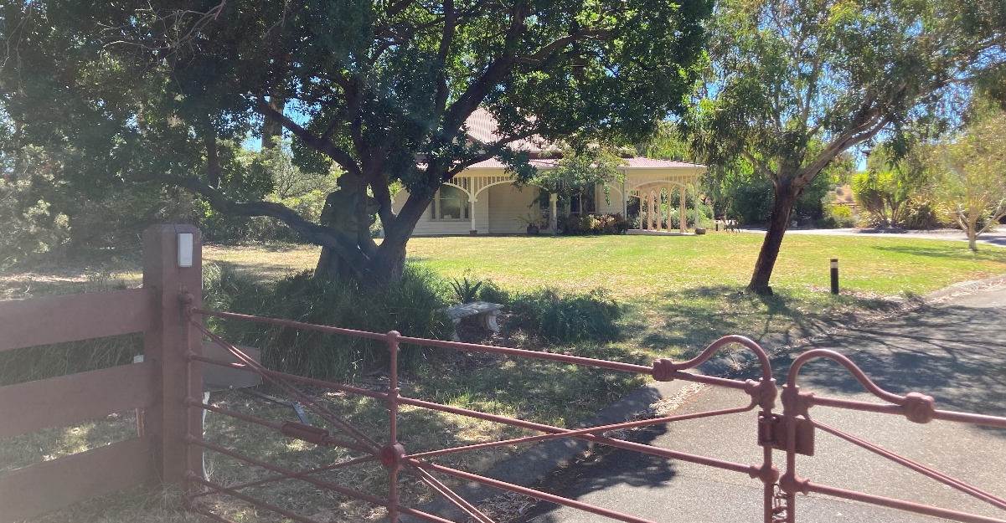
Figure 2:The front elevation of the built form. the projecting gabled section is located on central left and is partially concealed by a mature tree. Source: Trethowan Architecture, 2022.
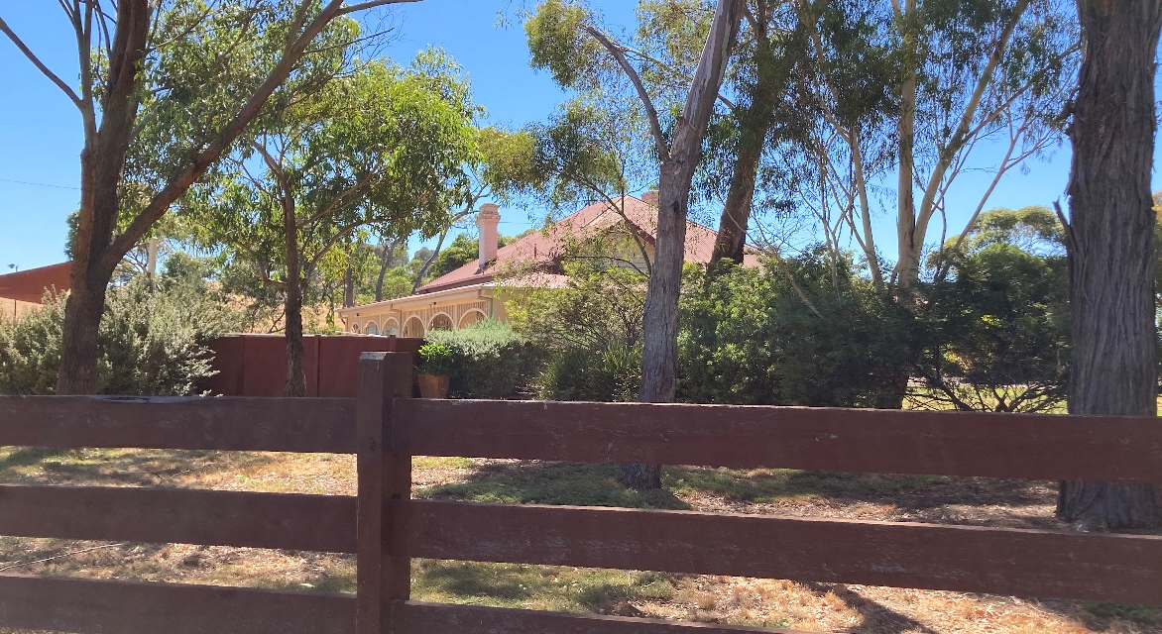
Figure 3: The rear (north) elevation of the built form. Note the continuation of the verandah. Source: Trethowan Architecture, 2022.

Comparative Analysis

The house is one of only a few grand country residences constructed in the Shire. Although built on an existing orchard, this was more of an upper-class country residence constructed specifically as a retirement home for a wealthy former merchant. The house was built 1920-22 for the Thomson’s who were retiring from Mildura. The significance of this property relies on its intactness as a grand bungalow residence from the 1920s. This intactness can only be confirmed from a site inspection. The interest is as a substantial retirement house/hobby farm of a wealthy family.

There are only a limited number of known examples of substantial country residences built for wealthy owners in the earlier period of the Shire (1880s – 1930s). Compared to these, the subject property displays similar dominant hipped roof forms, deep verandahs and bay windows.

Linton Grange, 55 Chapel Lane, Doreen (recommended for the HO) is historically a rare and unusual site in the Nillumbik Shire as it is the only known example of a ‘country seat’ property of a wealthy Melbourne family who lived between the city and country. It is also a rare example of a wealthy estate dating from the Victorian period and operating a successful cattle stud.
Figure 4: Extract of an image (dated June 2016) shows the built form of 55 Linton Grange, Doreen. Source: domain.com.au

Villa Beraguardo, 32-36 Perversi Lane, Diamond Creek (recommended for the HO). Constructed in 1924, the property was initially used as a weekender up until 1929 and is an uncommon example of country residence constructed for a wealthy Melbourne family who were not dependent on living off the land.

Figure 5: Image dating 2021 shows the front view of Villa Beraguardo. Source: domain.com.au

Assessment Against Criteria

Criteria referred to in Practice Note 1: Applying the Heritage Overlay, Department of Planning and Community Development, revised July 2015, modified for the local context.

CRITERION A: Importance to the course or pattern of the Shire of Nillumbik’s cultural or natural history (historical significance).

The property is of historical significance for the grand 1920s bungalow residence constructed as a comfortable retirement home. Rose and H.P Thomson purchased the property in 1920 and built the house as a retirement home. H.P was originally a merchant of Melbourne and by 1918 he was the chairman of the First Mildura Irrigation Trust. The property also has associations with the orcharding industry in the area. Maurice Fitzgibbon with his wife Constance, established substantial orchards on the property between 1911 and 1913.

CRITERION B: Possession of uncommon, rare or endangered aspects of the Shire of Nillumbik’s cultural or natural history (rarity).
N/A

CRITERION C: Potential to yield information that will contribute to an understanding of the Shire of Nillumbik’s cultural or natural history (research potential).
N/A

CRITERION D: Importance in demonstrating the principal characteristics of a class of cultural or natural places or environments (representativeness).
N/A

CRITERION E: Importance in exhibiting particular aesthetic characteristics (aesthetic significance).

The house on the property is of aesthetic significance as an elegant 1920s weatherboard bungalow with dominant main hipped roof and surrounding deep verandah with delicate arched fretwork valence and bay windows.

CRITERION F: Importance in demonstrating a high degree of creative or technical achievement at a particular period (technical significance).
N/A

CRITERION G: Strong or special association with a particular community or cultural group for social, cultural or spiritual reasons. This includes the significance of a place to Indigenous peoples as part of their continuing and developing cultural traditions (social significance).
N/A

CRITERION H: Special association with the life or works of a person, or group of persons, of importance in the Shire of Nillumbik’s history (associative significance).
N/A

Grading and Recommendations

Recommended for inclusion in the schedule to the Heritage Overlay of the Nillumbik Planning Scheme.

Recommended HO Extent

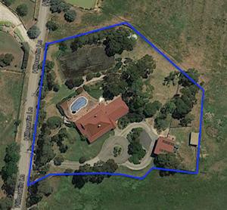
Proposed Extent for 2 Hillmartin Lane, Diamond Creek

Recommendations for the Schedule to the Heritage Overlay (Clause 43.01) in the Nillumbik Planning Scheme:

External Paint Controls  Is a permit required to paint an already painted surface? | No
Internal Alteration Controls  Is a permit required for internal alterations? | No
Tree Controls  Is a permit required to remove a tree? | No
Victorian Heritage Register  Is the place included on the Victorian Heritage Register? | No
Incorporated Plan  Does an Incorporated Plan apply to the site? | No
Outbuildings and fences exemptions  Are there outbuildings and fences which are not exempt from notice and review? | No
Prohibited uses may be permitted  Can a permit be granted to use the place for a use which would otherwise be prohibited? | Yes
Aboriginal Heritage Place  Is the place an Aboriginal heritage place which is subject to the requirements of the Aboriginal Heritage Act 2006? | No

Identified By

Samantha Westbrooke Pty Ltd, Dr Peter Mills and Trethowan architecture

References

Age, as cited.

Australasian, as cited.

Great Britain. War Office. General Staff. Commonwealth Section & Australia. Department of Defence 1920, 'Yan Yean, Victoria / prepared by Commonwealth Section, Imperial General Staff' Yan Yean, Victoria [cartographic material]

Graeme Butler & Associates. 1996. Nillumbik Shire Heritage Study Stage 1, Review, Heritage Survey and Environmental History. Greensborough: Shire of Nillumbik.

Hurstbridge Advertiser, as cited.

Land Victoria, Certificates of Title (CT), as cited.

Mildura Cultivator, as cited.

Shire of Heidelberg Greensborough Riding Rate Books (RB), as cited.

Table Talk (Melbourne), as cited.

