Greet
Prepared by: Trethowan Architecture

Address: 162 Murray Road, Diamond Creek
Name: Greet | Survey Date: February 2022
Place Type: Residential; Farming | Architect: NA
Grading: Significant | Builder: Unknown
Extent of Overlay: To title boundaries | Construction Date: c.1890-1926

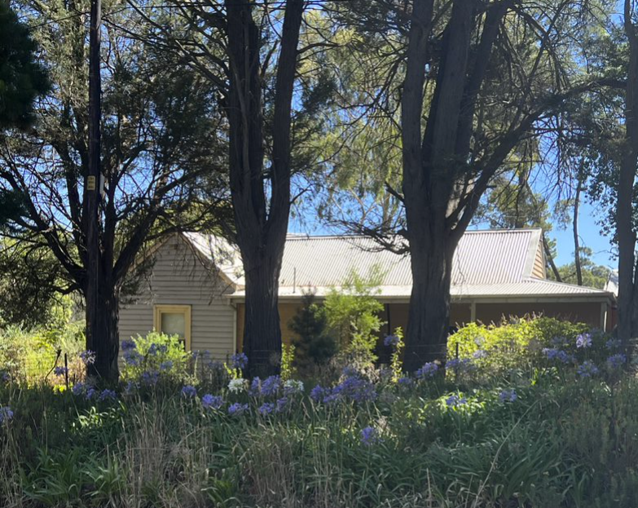

Historical Context

Although Crown Land in Nillumbik Parish was offered for sale in 1852 there were few buyers. A government township was reserved on the west of the Diamond Creek at this time but it was neither subdivided nor sold until 1866. In 1863 the Diamond Reef was discovered on land located to the east of the creek, which was purchased by Dr John Blakemore Phipps in 1854. The rush to Diamond Creek began and soon Phipps was renting sections of his land, which he later subdivided to miners. In effect the development of Phipps land for gold mining was the beginnings of Diamond Creek, which was soon bustling with gold seekers. In 1866 the government proclaimed Diamond Creek as a township. Many of the important community buildings were established by the late 1860s and early 1870s. These included a post office, a Methodist church and school and three hotels (Barnard, 2008). In 1870, a national school was established (Edwards, 1979:118).

By the second half of the 1880s the locality was being carved up rapidly into a dominant pattern of numerous small lots of around 20 acres. These were taken up under occupation licenses, first under Section 49 of the Land Act 1869 and later under Section 65 of the Land Act 1884. Diamond Creek's population peaked around the turn of the century then seemed to fall away again in the early twentieth century (Graeme Butler & Associates 1996:36). From 1885 onwards, the rural landscape of the area also inspired many artists to work in Diamond Creek and its surrounds, and the scenery of the area was captured in the works of the Heidelberg School painters (Edwards, 1979:143).

In 1912, the Eltham Railway Line was extended to Hurstbridge through Diamond Creek, bringing tourists to this area. Despite this, Diamond Creek remained a rural township concentrating on the orchard industry throughout the first half of the twentieth century, without much new industries to offer alternative employment opportunities. As such, the area entered a period of population decline (Edwards, 1979:177). This began to change in the 1960s and 70s, as, affordable land on subdivided orchards and accessibility to railway networks attracted young families to build their homes in the area, prompting further population growth in Diamond Creek (Barnard, 2008).

History

The property now known as 162 Murray Road, Diamond Creek is made up of two lots known as Lot 46J and Lot 46C.

An 1893 plan of Greensborough Parish shows a 20-acre Lot 46C. The owner is not shown on the 1893 plan, but was presumably the W. Pearl shown on a 1905 parish plan (‘Greensborough, County of Evelyn’, T.F. McGauran, 1893, Department of Lands and Survey Melbourne, SLV Map Collection. Nillumbik, County of Evelyn, 1888, J. Noone, Department of Lands and Survey, Melbourne, SLV map collection).
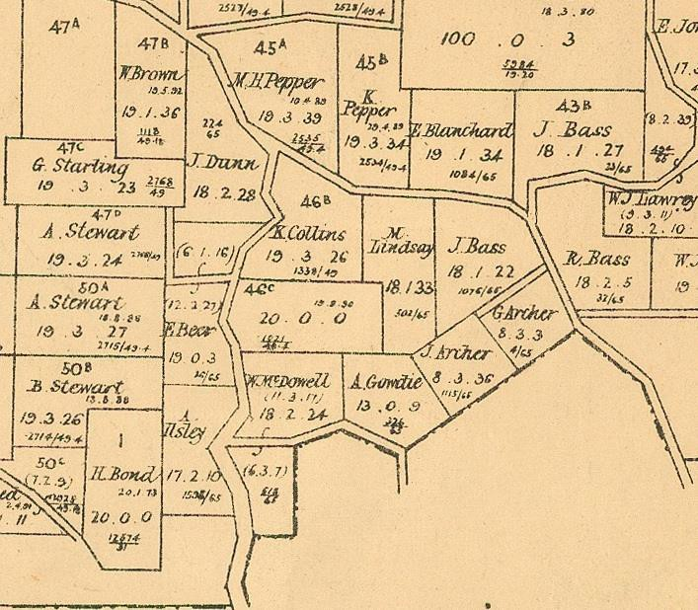
Figure 1: 1893 Greensborough Parish Plan
Lot 46J covering 13 acres was taken up in 1888 by Adam Gowdie (Greensborough, County of Evelyn’, T.F. McGauran, 1893, Department of Lands and Survey Melbourne, SLV Map Collection). Adam Gowdie was a boot-maker with a house and shop in Diamond Creek township from the mid-1880s (EO&S&EBR 24 April 1885:2; 2 October 1885:2; 23 September 1898:2). The original weatherboard cottage at 162 Murray Road was possibly constructed in the 1890s under Gowdie’s ownership.

In 1917 a discharged soldier, Herbert Tait, applied for the purchase of the 13- acre Lot 46J. The land included 11 acres that had been cleared, 8 of which were “orchard bearing”. By this stage it was noted that a house of 6 rooms with enclosed veranda, stables and sheds was on the site and in poor condition, “having been built of old material & rooms put on at different times”. This indicates that some of the house was likely to date to Gowdie’s ownership. The Board decided in January 1918 that the property did not meet its requirements (Department of Crown Lands and Survey File LS28166, VPRS 5714, Consignment P0, Unit 2516).

In the same year another returned soldier, Ernest Albert Johns, applied for a qualification certificate in order to acquire land under Section 20 of the Closer Settlement Act 1915 as varied by the Discharged Soldier Settlement Act 1917. Johns expressed an interest in acquiring an orchard holding of 15 to 20 acres (Department of Crown Lands and Survey File LS28166, VPRS 5714, Consignment P0, Unit 2516). Under the scheme, many soldier settlers were settled on estates opened or acquired specifically for the purpose, and others were accommodated within existing closer settlement estates.

However, a returned soldier with a certificate could also apply for a farm in a district he chose, perhaps near relatives or friends, which the Closer Settlement Board could then purchase on his behalf subject to an assessment of the land’s viability (Nelson and Alves 2009:302-3). Private Johns, now 30, had served in Egypt and at Gallipoli in the 8th Light Horse Regiment and was discharged in 1916. Prior to the war he had worked for 12 years in orchards in the Quantong area (Department of Crown Lands and Survey File LS28166, VPRS 5714, Consignment P0, Unit 2516; AIF Project 2022).

Ernest Johns married Muriel Kate Manners in 1917 (BDM Ernest Johns). In March 1918 Ernest’s mother-in-law Nina Manners purchased Lot 46J, evidently with a view to Ernest applying to purchase it from her through the scheme. Johns immediately set to work on the existing orchard there, and also planted new trees and tomatoes. He was keeping chickens and had acquired a horse and farm equipment. On this basis Johns and Manners asked the Board to reconsider the viability of the property. The Board stipulated that the adjoining forested 20-acre Lot 46C needed to be purchased and combined for it to be viable. The Closer Settlement Board authorised the purchase of both lots in April 1919, and by 1920 they were purchased for the Crown. The 33 acre combined lot was re-labelled Lot 46C (Department of Crown Lands and Survey File LS28166, VPRS 5714, Consignment P0, Unit 2516).

In 1923 the Board’s inspector found Johns’ land was unoccupied. Winter work in the orchard had not been done and the house was empty. Conditions of the lease required that the land be occupied for 8 months of the year, however Johns claimed that he was planning to move his family to the land when the house was repaired. A sheet of architectural drawings on the Lands Department file details repairs and renovations to the 6-roomed weatherboard house, which it appears, took place before 1926.

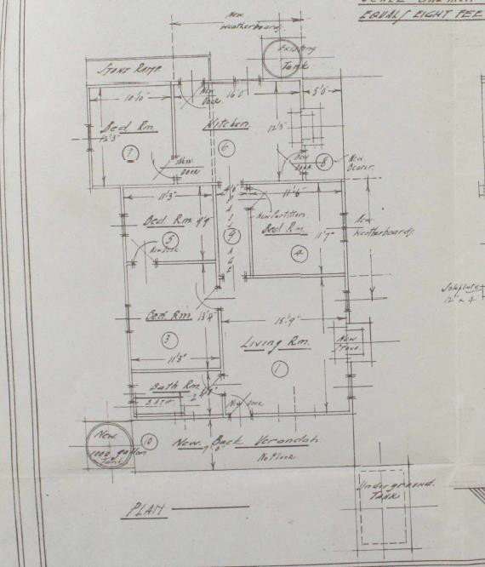
Figure 2: Architectural plans of changes to the existing residence at 162 Murray Road for Ernest Johns from the Lands Department file.

Things must not have improved, for in 1926 the lease was declared void (Department of Crown Lands and Survey File LS28166, VPRS 5714, Consignment P0, Unit 2516). By 1927 the fruit trees had been dug out, and the Closer Settlement Board decided the land was unsuitable for Closer Settlement purposes. The property was put up for sale and was described in the advertisement as “ten acres of orchard in poor condition, [weatherboard] house (good) 6 rooms, bathroom, back verandah and underground tank, two sheds, two 1000-gallon tanks, small dam. Balance of land partly cleared. Timber suitable for firewood.” The land was purchased on a lease arrangement from the Crown by Richard John Larking (Advertiser (Hurstbridge) 29 April 1927:2; Department of Crown Lands and Survey File LS28166, VPRS 5714, Consignment P0, Unit 2516. Greensborough Parish plan).

Shortly afterwards it was transferred to Alma Rose Murray (CT V5948 F471). Alma Murray named her property ‘Greet’ (Advertiser (Hurstbridge) 1 September 1939:3; Argus 28 May 1940:4). Alma Murray died in 1940, after which her estate was administered by her elder son Leslie St. Quinton Murray (CT V5948 F471; Argus 26 June 1940:12). The land was purchased by the Scott family in 1944, and was later subdivided in 1973 (CT V5948 F471; CT V8972 F453).

Description & Integrity

This site contains a timber framed and weatherboard clad residence that has been extended to the rear a number of times. What appears to be the earliest section, built c1890 is clearly distinguishable at the front of the residence and appears to be substantially intact. It has a main hipped wing running east west and a perpendicular gable wing at the west end. The west end gable roomed wing has a central door and double hung window either side on the west elevation. This side entry was a later change made for Soldier Settler Ernest Johns. A verandah runs across the front and terminates at the west wing and has been partially filled in.

There are timber additions to the rear and east of the residence. Each new addition appears to have a new roof form, therefore providing separation from the original building.

There are sheds at the east end of the property. These are likely to be the stables and sheds described in 1917. They are of rudimentary timber pole construction with corrugated iron cladding.

Comparative Analysis

The erection of houses outside the main town areas of Nillumbik appeared to be slow in the late nineteenth and early twentieth century, as dwellings were usually only required when land was taken up for farming or other agricultural pursuits. Reflecting the nature of the small-scale farm holdings that characterised the agricultural economy of Nillumbik at this time, houses often demonstrated frugality in their construction. In many cases, farmhouses were modest timber structures that reflected vernacular styles and placed less focus on stylistic elements. Some farmhouses demonstrate incremental development as rooms were added or altered over time. This vernacular style was not limited just to farmhouses in Nillumbik. Smaller workers’ houses in the town areas were often erected in a similar style, similarly reflecting the more modest economic status of many residents of the area. As such, this style of housing is evident in both the suburban and rural areas of the Shire.

This property is also a well-documented example of soldier settlement activity in the area following World War I. The fact that this soldier did not make good on the land is highly representative of the scheme as a whole in terms of failure. The amalgamation of small lots is representative of how a proportion of soldier settler farms were created in this region in particular.

Similar comparative examples of simple timber homes in the Shire include the following:

- Pizzey House, 29 Main Street, Diamond Creek (HO225)
- Farm and Orchard Complex, 265 Ninks Road, St Andrews (HO237)
- Yarra Vale, 188 Mount Pleasant Road, Eltham (HO137)
- Hillside, 23 Glen Park Road, Eltham North (Recommended as individually significant in Shire of Nillumbik Advisory Consultant Services: Nillumbik Shire Stage A 2021)

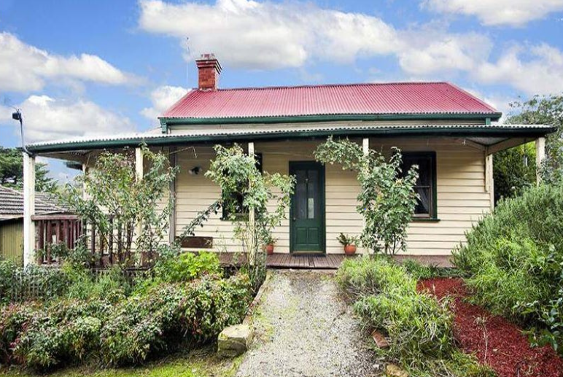  Figure 3. Pizzey House, 29 Main Street, Diamond Creek (HO225) | 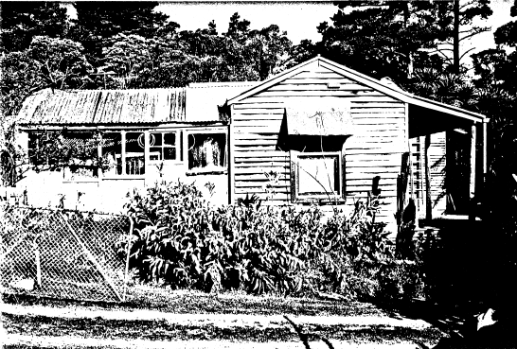  Figure 4. Farm and Orchard Complex, 265 Ninks Road, St Andrews (HO237)
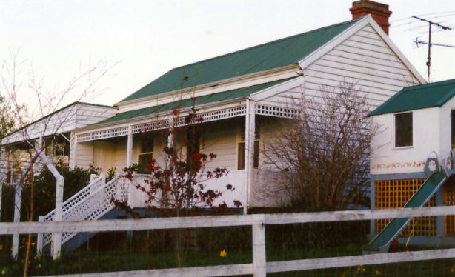  Figure 5. Yarra Vale, 188 Mount Pleasant Road, Eltham (HO137) | 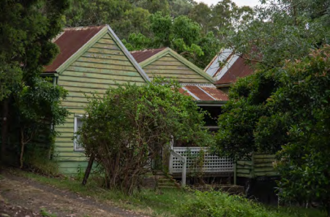  Figure 6. Hillside, 23 Glen Park Road, Eltham North (Recommended as individually significant in Shire of Nillumbik Advisory Consultant Services: Nillumbik Shire Stage A 2021)

The c1904 house at 29 Main Street is considered to be one of the earliest in the Diamond Creek township. While primarily associated with Alfred Pizzey, a locally important industrialist, the house demonstrates the simple vernacular timber buildings erected in the Shire during the nineteenth and early twentieth centuries.

The farm complex at 265 Ninks Road comprises a group of pre-1940 buildings and exotic planting. The place is noted for its historical and associative significance with the Nink family, who had been locally prominent. The buildings display various changes over time and demonstrate the practical nature of construction on agricultural properties in the Shire before WWII. Remnants of a substantial ornamental garden also remain on the site.

Yarra Vale at 188 Mount Pleasant Road, Eltham, is a c1894 timber cottage with gable roof and rear skillion wing. This form aligns with the type of modest vernacular cottages that were erected across Victoria in the nineteenth and early twentieth centuries. The house is notes as being historically and aesthetically significant as a rare surviving example of this style of housing within the Shire.

Hillside at 23 Glen Park Road is a c1914 timber house that demonstrates the simple vernacular style of construction prevalent in the Shire during the period. The house features three parallel gable roofs and a distinct lack of ornamentation or detailing usually associated with houses constructed at a similar time.

Similar to these examples, the subject site shows how residents of modest means in the Shire relied on simple vernacular building forms that were easily constructed using readily available materials. Key characteristics that unite these examples include the timber construction, use of simple gable roof forms, and an absence of unnecessary ornamentation. Although similar to the houses at 29 Main Street and 188 Mount Pleasant Road due to their modest size and construction, both of these houses use a more traditional cottage form of a gable roof with rear skillion section rather than the irregular form of the subject site. In that sense, the subject site is more similar to the homes at 265 Ninks Road and 23 Glen Park Road. Overall, the subject site demonstrates the main characteristics of modest housing erected in the Shire during the nineteenth and early twentieth centuries.
Assessment Against Criteria

Criteria referred to in Practice Note 1: Applying the Heritage Overlay, Department of Planning and Community Development, revised July 2015, modified for the local context.

CRITERION A: Importance to the course or pattern of the Shire of Nillumbik’s cultural or natural history (historical significance).

The house at 162 Murray Road Diamond Creek is significant as an early modest farm property that remains legible in its form and setting. The house is also significant for its historical association with the Soldier Settlement Scheme, with alterations carried out by the unsuccessful soldier settler evident in the c.1923-6 extension and alterations.

CRITERION B: Possession of uncommon, rare or endangered aspects of the Shire of Nillumbik’s cultural or natural history (rarity).

CRITERION C: Potential to yield information that will contribute to an understanding of the Shire of Nillumbik’s cultural or natural history (research potential).

CRITERION D: Importance in demonstrating the principal characteristics of a class of cultural or natural places or environments (representativeness).

The house at 162 Murray Road Diamond Creek is significant for its ability to demonstrate the type of modest, easily constructed vernacular homes that were erected in the Shire of Nillumbik during the nineteenth and early twentieth centuries. Key characteristics of this type of housing evident at the site include the timber construction, simple gable roof forms, and lack of ornamentation.

CRITERION E: Importance in exhibiting particular aesthetic characteristics (aesthetic significance).

CRITERION F: Importance in demonstrating a high degree of creative or technical achievement at a particular period (technical significance).

CRITERION G: Strong or special association with a particular community or cultural group for social, cultural or spiritual reasons. This includes the significance of a place to Indigenous peoples as part of their continuing and developing cultural traditions (social significance).

CRITERION H: Special association with the life or works of a person, or group of persons, of importance in the Shire of Nillumbik’s history (associative significance).

Grading and Recommendations

Recommended for inclusion in the schedule to the Heritage Overlay of the Nillumbik Planning Scheme.
Recommendations for the Schedule to the Heritage Overlay (Clause 43.01) in the Nillumbik Planning Scheme:

External Paint Colours  Is a permit required to paint an already painted surface? | No
Internal Alteration Controls  Is a permit required for internal alterations? | No
Tree Controls  Is a permit required to remove a tree? | No
Victorian Heritage Register  Is the place included on the Victorian Heritage Register? | No
Incorporated Plan  Does an Incorporated Plan apply to the site? | No
Outbuildings and fences exemptions  Are there outbuildings and fences which are not exempt from notice and review? | No
Prohibited uses may be permitted  Can a permit be granted to use the place for a use which would otherwise be prohibited? | No
Aboriginal Heritage Place  Is the place an Aboriginal heritage place which is subject to the requirements of the Aboriginal Heritage Act 2006? | No

Identified By

Peter Mills and Samantha Westbrooke, Trethowan

References

Advertiser (Hurstbridge), as cited.

Age, as cited.

AIF Project, Ernest Albert John[s], www.aif.adfa.edu.au, UNSW Canberra at the Australian Defence Force Academy, accessed online 22 February 2022.

Argus, as cited.

Barnard, J 2008, Diamond Creek, https://www.emelbourne.net.au/biogs/EM00464b.htm, accessed online 03 February 2022.

Births Deaths Marriages (BDM) Victoria events, as cited.

Butler, Graeme & Associates. (1996). Nillumbik Shire Heritage Study Stage 1, Review, Heritage Survey and Environmental History. Greensborough: Shire of Nillumbik.

Edwards, D 1979, The Diamond Valley Story, The Shire of Diamond Valley, Victoria.

Evelyn Observer, and South and East Bourke Record (EO&S&EBR), as cited.

Lake, M 1987, The Limits of Hope: Soldier Settlement in Victoria 1915-38, Oxford University Press, Melbourne.

Nelson, P, and Alves, L 2009, Lands Guide: A guide to finding records of Crown land at Public Record Office Victoria, Public Records Office of Victoria, Melbourne.

Woiwod, M 1995, Kangaroo Ground: The Highland Taken Maryborough, Tarcoola Press, Victoria.

