Windmill House
Prepared by: Trethowan Architecture

Address: 25 Nicole Crescent, Diamond Creek
Name: Windmill House | Survey Date:
Place Type: Residential | Architect: Robin Greenwood
Grading: Individually Significant | Builder: Bill Bruinsma
Extent of Overlay: To title boundaries | Construction Date: 1973

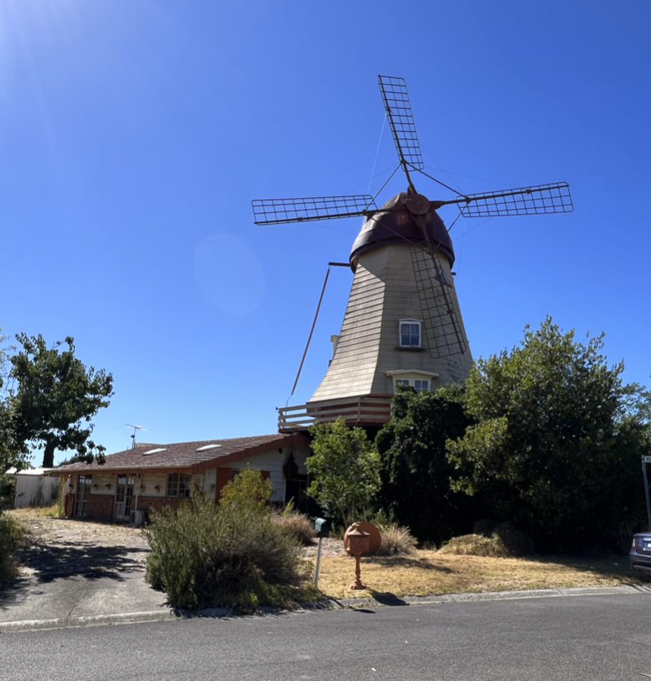

Historical Context

Although Crown Land in Nillumbik Parish was offered for sale in 1852 there were few buyers. A government township was reserved on the west of the Diamond Creek at this time but it was neither subdivided nor sold until 1866. In 1863 the Diamond Reef was discovered on land located to the east of the creek, which was purchased by Dr John Blakemore Phipps in 1854. The rush to Diamond Creek began and soon Phipps was renting sections of his land, which he later subdivided to miners. In effect the development of Phipps land for gold mining was the beginnings of Diamond Creek, which was soon bustling with gold seekers. In 1866 the government proclaimed Diamond Creek as a township. Many of the important community buildings were established by the late 1860s and early 1870s. These included a post office, a Methodist church and school and three hotels (Barnard, 2008). In 1870, a national school was established (Edwards, 1979:118).

By the second half of the 1880s the locality was being carved up rapidly into a dominant pattern of numerous small lots of around 20 acres. These were taken up under occupation licenses, first under Section 49 of the Land Act 1869 and later under Section 65 of the Land Act 1884. Diamond Creek's population peaked around the turn of the century then seemed to fall away again in the early twentieth century (Graeme Butler & Associates 1996:36). From 1885 onwards, the rural landscape of the area also inspired many artists to work in Diamond Creek and its surrounds, and the scenery of the area was captured in the works of the Heidelberg School painters (Edwards, 1979:143).

In 1912, the Eltham Railway Line was extended to Hurstbridge through Diamond Creek, bringing tourists to this area. Despite this, Diamond Creek remained a rural township concentrating on the orchard industry throughout the first half of the twentieth century, without much new industries to offer alternative employment opportunities. As such, the area entered a period of population decline (Edwards, 1979:177). This began to change in the 1960s and 70s, as, affordable land on subdivided orchards and accessibility to railway networks attracted young families to build their homes in the area, prompting further population growth in Diamond Creek (Barnard, 2008).

History

Construction of the Windmill house started in 1973. Peter van Wunnik, who was Dutch, and his Australian wife Kathleen conceived the idea after staying in a windmill in Holland. Noting that the house may not be practical, Kathleen van Wunnik agreed to the building due to her husband’s sentimental reasons (Canberra Times 19 June 1974:14). The van Wunniks later stated that the house was designed by architect Robin Greenwood and erected by builder Bill Bruinsma. The house took nearly four years to complete (Leader – Diamond Valley News, 27 June 2007:303).

A newspaper article from 1984 noted that the house contained a family room and kitchen on the ground level, with another large lounge contained within the base of the windmill. Timber trusses created the windmill form, enclosing a gallery, master-bedroom and two bedrooms above. A linked one-storey structure accommodated a surgery for their chiropractic practice (Age 21 February 1984:22)

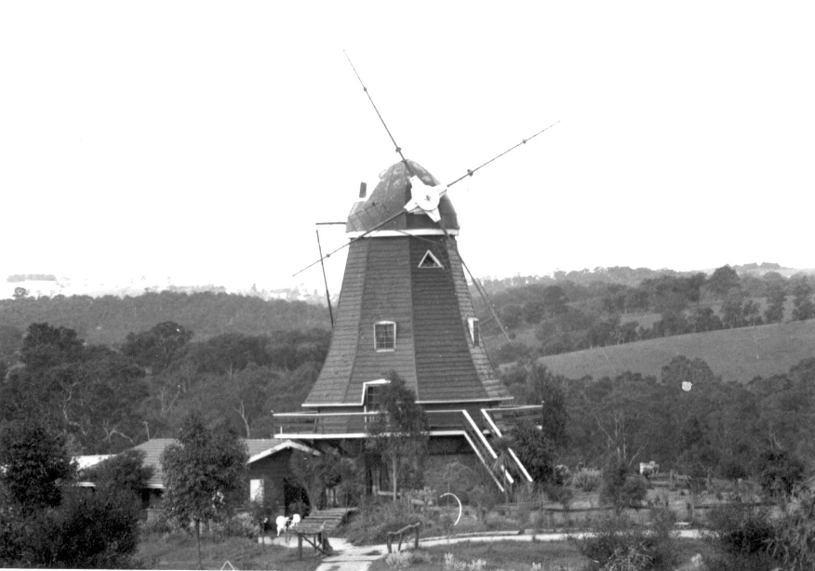
Figure 1: A 1979 image of the windmill house, showing its original open, rural setting. Source: Collins 1979.

The Windmill House initially stood in a largely open rural setting, as can be seen in the 1979 John T. Collins photograph (Figure 1). The Windmill house featured soon after its completion in a book by John Belot named Our Glorious Home, which was a study of a newly described architectural phenomenon “domestic featurism” (Belot 1978:25). Belot wrote that “… in a young country, many of its inhabitant’s pine for the visual traditions of other ages and places. … Sometimes the pull of the old country is overwhelming … The windmill is a frequent motif, presumably having various national origins and suggesting the cooler breezes of more temperate lands”. The three other suburban windmills Belot illustrated were large garden features (Belot 1978:vi). In a 2009 article in the Sydney Morning Herald on ‘Wild and wonderful dwellings’, architect Simon Thornton categorised buildings such as the Windmill house as “representational architecture” (Sydney Morning Herald 2009).

The Windmill house has attracted local affection. In a 2012 article on his childhood in Diamond Creek, Liam Carter mentioned as a landmark “the iconic windmill” (Carter 2012). The house has also become a go-to place for articles on unusual residences and buildings. A 2013 article in the online magazine The Stylist Splash, titled ‘Australia’s most unusual houses’, includes the Windmill house among a group of much more recent residences, describing it as a “local landmark” (Stylist Splash 2013). A 2015 article in The Age titled ‘13 weird and wonderful things you can see out your train window’ includes the windmill in Diamond Creek among “some of the city’s more unusual, even mysterious sights’ (Age 2015).

Description & Integrity

The Windmill House consists of the main windmill form, a single-storey wing to the north, and a single-storey wing to the rear (east).

The windmill section, which is approximately 15 metres high, is octagonal in plan. The ground floor is clad in brick, which continues to sill height on the first floor. Above this, the body of the windmill gradually tapers inwards and is clad in weatherboard. The windmill is capped in metal cladding. The arms of the four sails are stout tubular steel, and in place of traditional cloth webbing to encourage wind to turn the sails there is a lattice of strong steel strap (Figure 2). A balcony with horizontal timber balustrade returns around the windmill at the first floor. This is accessed by a set of French doors, or a staircase to the south of the building. Shallow dormer windows are evident on the second and third floors of the windmill.

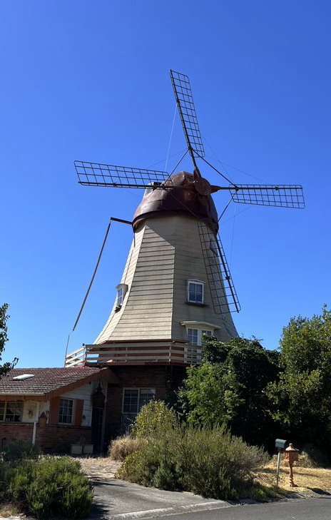
Figure 2: A view of the main windmill section, showing how it tapers inwards towards the apex. Source: Trethowan 2022.

The single-storey wing to the north is rectangular in form, with a low-slung, tile-clad gable roof. This building has brick to the height of the windowsills, with irregularly edged weatherboards above. Windows across this wing of the building are multi-paned. The fascia of this wing is completed in irregular shingles (Figure 3). Clogs are attached across the walls and used as flowerpots. The wing to the rear, which is not visible from the street, appears irregular in shape and has an octagonal sunroom attached.

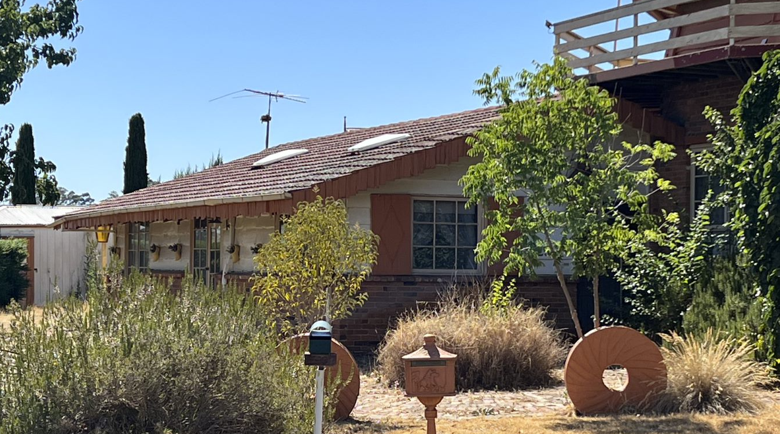
Figure 3: The single-storey wing to the north of the main windmill section. Note the brick to sill height and irregular shingle fascia.

Comparative Analysis

The Windmill House is undoubtedly a rare building form within the Shire of Nillumbik. Although windmills have been part of farm infrastructure in the Shire, no other known examples of windmills built in the Dutch style, or for use as a residence, have been identified. Further, few other buildings within the Shire exhibit the same ‘landmark’ quality.

Apperly et al. outline the phenomenon of ‘Late Twentieth-Century Immigrants’ Nostalgic’ architecture in A Pictorial Guide to Identifying Australian Architecture. The broadly defined style, which was multi-faceted by its very nature, explores how many migrant families either consciously or subconsciously chose to express new-found prosperity with references to their heritage. In many examples, families chose to express this through applying motifs to otherwise standard suburban homes, however others took a more literal approach to the replication of vernacular forms from their home countries (Apperly et al. 1994:270-271).

Perhaps as a side-effect of the Post-Modern turn, judgement of expressions such as the Windmill house transitioned from dismissal as mere kitsch to acceptance as a valid vernacular expression. The Windmill house was included in the 2008 ‘Survey of Post-War Built Heritage in Victoria’ by Heritage Alliance (prepared for Heritage Victoria) where it was described as being of aesthetic significance. Heritage Alliance noted the following of the site:

“This extraordinary house, featured in John Belot’s study of Australian ‘Domestic Featurism’ has been described as the only residential windmill in Australia. Although now edged by subsequent residential development, it remains as a prominent and much-loved local landmark.” (Heritage Alliance 2008:190)

There are other examples of replica Dutch windmills in Australia, although they remain a rare building form. A similar windmill was constructed c1980s at 533-539 Leakes Rd, Bonnie Brook, Victoria, however this example has been used exclusively as a reception centre. A stone example was constructed by a Dutch-born family between 1991 and 1997 in Amelup, Western Australia. While similar in form, this building has the distinction of being an operational mill. The subject site is distinguished from these as an early example of the style, and for its exclusive use as a residence.

Although located outside the municipality, another example of ‘domestic featurism’ included in the same study was the Stamoulis House in Templestowe. Built in the form of a castle in 1978 for the late Spiros Stamoulis, a prominent Greek-born property developer and philanthropist, this house also featured in the John Belot book. The 2008 study described it as “an outstanding example of the kitsch mansions erected in this part of Melbourne in the 1970s by wealth émigré businessmen”, and like the Windmill House, it has become a well-known landmark. The reference to the originator as émigré implies that this was a nostalgic vision deriving from the country or continent of origin.

No other residential buildings in the form of Windmills exist in the Shire, and examples of buildings exhibiting characteristics of the Immigrants’ Nostalgic style seem to be absent from the Heritage Overlay. Based on this, subject site is instead most comparable to the following buildings, as examples of unusual sites with ‘landmark’ qualities in Nillumbik:

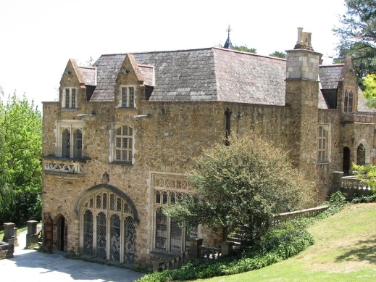
Montsalvat, 7-15 Hillcrest Avenue, Eltham (HO82; VHR H0716)

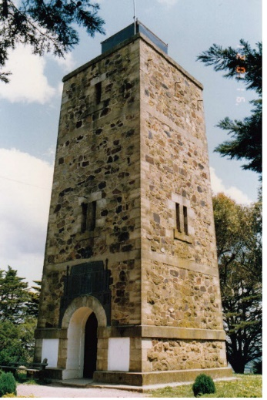
War Memorial Tower, 385 Eltham-Yarra Glen Road, Kangaroo Ground (HO49)

Montsalvat is a complex of buildings started in 1934-1935 by Justus Jorgensen, for use as an artists’ colony. Many of the buildings were designed by Jorgensen in Gothic and/or vernacular styles using mud brick and recycled materials, which had a profound influence on the development of the ‘Eltham Style’. The site is open to the public, and commonly hosts celebrations such as weddings. The site is perhaps one of the most notable landmarks of the Shire.

The War Memorial Tower, constructed c1925-26 out of local stone, is historically and architecturally significant due to its design by Stephenson and Meldrum, based upon a sketch by artist Harold Herbert. The site also has ties to prominent local figures. Although significant as a war memorial, the building’s significant presence and siting has made it a landmark within the municipality.

Although fundamentally different in form and function to the above examples, the subject site compares favourably as an instantly recognisable building and local landmark within the Shire.

Assessment Against Criteria

Criteria referred to in Practice Note 1: Applying the Heritage Overlay, Department of Planning and Community Development, revised July 2015, modified for the local context.

CRITERION A: Importance to the course or pattern of the Shire of Nillumbik’s cultural or natural history (historical significance).
NA

CRITERION B: Possession of uncommon, rare or endangered aspects of the Shire of Nillumbik’s cultural or natural history (rarity).

The house is of historical significance as a rare example of a nostalgic style of construction commissioned by immigrant Victorians. Peter van Wunnik, who was Dutch by birth, conceived the idea as a tribute to his Dutch heritage and after him and his wife Kathleen stayed in a windmill while visiting Holland. The house, which featured in John Belot’s study of Australian ‘Domestic Featurism’, has been described as the only residential windmill in Australia.

CRITERION C: Potential to yield information that will contribute to an understanding of the Shire of Nillumbik’s cultural or natural history (research potential).
NA

CRITERION D: Importance in demonstrating the principal characteristics of a class of cultural or natural places or environments (representativeness).
NA

CRITERION E: Importance in exhibiting particular aesthetic characteristics (aesthetic significance).

Although now edged by subsequent residential development, the Windmill House remains as a prominent and much-loved local landmark because of its scale and form as a Dutch styled windmill. The physical prominence and unusual nature of the building form has made the Windmill House a well-regarded local landmark. The building is considered a rare example of ‘Domestic Featurism’ and was featured in a book on the topic not long after its construction. The house is highly intact to its 1970s construction, retaining key details such as the windmill sails, distinctive shape, dormer windows, shingled fascia boards, irregular edged weatherboards, and decorative features such as clogs fixed to the walls as flower pots. The house is an extreme example of a nostalgic style that derives from the first owner’s home country, including idiosyncratic decorative details such as the clog flowerpots. The building is intact from its 1970s construction.

CRITERION F: Importance in demonstrating a high degree of creative or technical achievement at a particular period (technical significance).
NA

CRITERION G: Strong or special association with a particular community or cultural group for social, cultural or spiritual reasons. This includes the significance of a place to Indigenous peoples as part of their continuing and developing cultural traditions (social significance).
NA

CRITERION H: Special association with the life or works of a person, or group of persons, of importance in the Shire of Nillumbik’s history (associative significance).
NA
Statement of Significance

What is Significant?

The Windmill House located at 25 Nicole Crescent, Diamond Creek, is significant.

Elements that contribute to the significance of the place include:

- The original form of the windmill with steel sails, projecting dormer-style windows and wrap around balcony
- The original form of the adjacent wings
- The original materials, including weatherboards (with sections of regular and irregular edging) and brick
- key detailing including the shingled fascia boards

Outbuildings on the site are not of significance.

How is it significant?

The Windmill House is of local aesthetic significance to the Shire of Nillumbik. The house is also significant for its rarity within the Shire.

Why is it significant?

The Windmill House is historically significant as a highly unusual example of a nostalgic style of house design, commissioned by a migrant family as a tribute to their homeland. Construction of the house started 1973, after Dutch-born owner Peter van Wunnik and his Australian-born wife Kathleen conceived the idea as a tribute to his heritage following a return trip to Holland. The primary building, which takes the form of a traditional Dutch windmill, is the only known example within the Shire and likely the only example built as a residence in Australia. Such literal examples of nostalgic architecture associated with immigrant identity are rare within the Shire. (Criterion B)

The Windmill House is aesthetically significant as a rare, legible and intact example of nostalgic architecture in the Shire of Nillumbik. The house, which is prominently sited in Diamond Creek, retains its dominant presence despite being hemmed in my residential development. The physical prominence and unusual nature of the building form has made the Windmill House a well-regarded local landmark. The building is considered a rare example of ‘Domestic Featurism’ and was featured in a book on the topic not long after its construction. The house is highly intact to its 1970s construction, retaining key details such as the windmill sails, distinctive shape, dormer windows, shingled fascia boards, irregular edged weatherboards, and decorative features such as clogs fixed to the walls as flower pots. (Criterion E)

Grading and Recommendations

Recommended for inclusion in the schedule to the Heritage Overlay of the Nillumbik Planning Scheme.
Recommendations for the Schedule to the Heritage Overlay (Clause 43.01) in the Nillumbik Planning Scheme:

External Paint Colours  Is a permit required to paint an already painted surface? | No
Internal Alteration Controls  Is a permit required for internal alterations? | No
Tree Controls  Is a permit required to remove a tree? | No
Victorian Heritage Register  Is the place included on the Victorian Heritage Register? | No
Incorporated Plan  Does an Incorporated Plan apply to the site? | No
Outbuildings and fences exemptions  Are there outbuildings and fences which are not exempt from notice and review? | No
Prohibited uses may be permitted  Can a permit be granted to use the place for a use which would otherwise be prohibited? | Yes
Aboriginal Heritage Place  Is the place an Aboriginal heritage place which is subject to the requirements of the Aboriginal Heritage Act 2006? | No

Identified By

Mills and Westbrooke, Trethowan

References

Age, as cited.

Age 2015, 13 weird and wonderful things you can see out your train window, www.theage.com.au, accessed online 17 February 2022.

Canberra Times, as cited.

Carter, L 2012, Ode to my suburb of Diamond Creek, The Weekly Review, https://www.theweeklyreview.com.au/, accessed February 2022.

Collins, John T 1979, ‘Diamond Creek “Windmill” 384-394 Ryans Rd.’, State Library Victoria (SLV) JT Collins collection, accessed online 17 February 2022.

Belot, J 1978, Our Glorious Home, Sun Books, South Melbourne.

Graeme Butler & Associates 1996, ‘Nillumbik Shire Heritage Study Stage 1, Review, Heritage Survey and Environmental History’, prepared for the Shire of Nillumbik.

Herald Sun 2016, Magic price for Elwood’s ‘Gryphon House’, www.heraldsun.com.au, accessed online 17 February 2022.

Heritage Alliance 2008, ‘Survey of Post-War Built Heritage in Victoria: Stage One’, prepared for Heritage Victoria.

Leader – Diamond Valley News, as cited.

Stylist Splash 2015, Australia’s most unusual houses, http://thestylistsplash.com.au/, accessed online February 2022.

Sydney Morning Herald 2009, Wild and wonderful dwellings, www.smh.com.au, accessed online 17 February 2022.

