Harton Hill Farmhouse and Outbuildings, Monterey Cypress Drive
Prepared by: Trethowan Architecture

Address: 405 Ryans Road, Diamond Creek
Name: Harton Hill Farmhouse and Outbuildings, Monterey Cypress Drive | Survey Date:
Place Type: Residential, Farming | Architect: Not known
Grading: Significant | Builder: Not known
Extent of Overlay: To title boundaries | Construction Date: c1930s

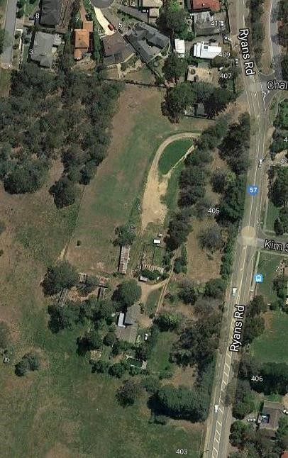
Historical Context

Although Crown Land in Nillumbik Parish was offered for sale in 1852 there were few buyers. A government township was reserved on the west of the Diamond Creek at this time but it was neither subdivided nor sold until 1866. In 1863 the Diamond Reef was discovered on land purchased by Dr John Blakemore Phipps in 1854 east of the creek. The rush to Diamond Creek began and soon Phipps was renting sections of his land, which he later subdivided to miners. In effect the development of Phipps land for gold mining was the beginnings of Diamond Creek, which was soon bustling with gold seekers. In 1866 the government proclaimed Diamond Creek as a township. Many of the important community buildings were established by the early 1870s. By the second half of the 1880s the locality was being carved up rapidly into a dominant pattern of numerous small lots of around 20 acres. These were taken up under occupation licenses, first under Section 49 of the Land Act 1869 and later under Section 65 of the Land Act 1884. Diamond Creek's population peaked around the turn of the century then seemed to fall away again in the early twentieth century (Graeme Butler & Associates 1996, p.36).

In 1912, the Eltham Railway Line was extended to Hurstbridge through Diamond Creek, bringing tourists to this area. Despite this, Diamond Creek remained a rural township throughout the first half of the twentieth century/ From the 1960s onwards, affordable land on subdivided orchards and accessibility to railway networks attracted young families to build their homes in the area, prompting the population growth in Diamond Creek (Jill Barnard, 2008).

History

Lot 1 and 2 Section 15 Parish of Nillumbik, 320 acres, were sold by the Crown to W.R. Belcher in 1857 (Nillumbik Parish Plan sheet 3). It appears that George D’Arley Boursiquot (later Bourcicault) had acquired Lots 1 and 2 Section 15 Parish of Nillumbik at some stage. In 1904 320 acres of “first class orchard land”, being Lots 1 and 2 of Section 15, were offered for sale by the estate of G.D. Bourcicault, in lots from 6 to 16 acres. The land was subdivided into 27 lots, all of which were sold by 1907 (CT V2992 F205; Age 4 June 1904:2).

Lots 4 and 5 of this 1904 subdivision, totalling 20 acres, were purchased by Henry Coventry of Diamond Creek, carter, in 1906 (CT V2992 F205; V3141 F016). The 1907-8 rate book notes that Henry Coventry owned the land with a house that had a NAV of £15 (RB 1907-08). This indicates a house was built on the property between 1906 and 1907.

By 1916 the property was known as ‘Gracedale’ (Argus 27 January 1917:1). In the rate book of 1919-20 the house and land had a NAV of £19, indicating little had changed (RB 1919-20). By 1922/23 the NAV had risen to £30, indicating investment in either a new house or extension, and/or in the orchards (RB 1922-1923). The 1925-26 rate book shows another rise, to £37, indicating further improvements (RB 1925-26). A house is shown in the position of the current house on a 1920 topographic map, while extensive orchards are shown at the site on a 1935 topographic map (Commonwealth of Australia 1920; 1935).

In 1935 Henry Coventry’s property was offered for sale. The property included a five-roomed dwelling, seven acres of orchard, six acres of cultivation and seven acres of grass and timber. Farming implements were also sold, indicating the Coventry family were leaving the district (Advertiser (Hurstbridge) 18 January 1935:8).

Alison Stewart Davis of Kew purchased the property in 1935 (CT V3141 F016). Alison had married Harold Carmichael Davis in 1930, who had previously been a soldier settler on a sheep property in the Glenorchy area (BDM 425/1930; Battle to Farm 2022). The Davises made the subject site their residence and renamed it ‘Harton Hills’, possibly after a Western District estate of the same name.

The Davis family bred both Jersey stud cattle (a herd of about 20) and poultry (over 1000 head) on the property, and Alison Davis was a recognised dog breeder by 1939 (Argus 17 January 1938:10; 7 October 1939:23). The current two-storey brick home was most likely built during their occupation. In 1949, due to sale of ‘Harton Hills’ they held a “complete dispersal sale” of their stud Friesian and Guernsey cattle (Argus 9 March 1949:11). It appears they had also been leasing another 72 acres of grazing land in the Diamond Creek area owned by the railways department, indicating the extent of their agricultural pursuits (Age 25 June 1952:10).

Arthur Coutts, grazier of Diamond Creek, purchased the property by 1951 and renamed it ‘Sunny Hills’ (CT V3141 F016). In 1952 ‘Sunny Hills’, was offered again for sale. The property was noted as including a “modern” two-storey solid-brick home of 11 rooms. There was also a three-roomed cottage, which may have been an earlier residence. Outbuildings catered for a wide variety of livestock, with fowl pens for 2000 birds, brick pigsties, a milking shed and dairy, and breeding kennels. The advertisement described the property as suiting “the discriminating buyer seeking an outer suburban home with sufficient land to create that country atmosphere”, further stating that “it is rarely such a place with such delightful views, garden and ornamental trees so handily situated is offered for sale” (Age 29 March 1952:24).

Peter Salmon (editor) and Vivian Betty Colclough purchased the site in 1957. The State Electricity Commission compulsorily acquired easements over parts of Lot 4 in 1964, 1967 and 1969. The Country Roads Board acquired the property in 1973 (CT V3141 F016). The property appears to have returned to private use since.

Description & Integrity

The property contains a combined single and double storey brick residence constructed in the 1930s. The house has two main gable roofed wings, clad with terracotta tiles, on north-south axes. The wings are placed end to end, but slightly offset from each other; the north wing is two-storey, while the south is single-storey. A terracotta roofed veranda is evident on the western side of the house, indicating the location of the primary entryway. Further single-storey wings appear to have been added to the house on the eastern side.

There is an extensive collection of tin roofed farm buildings to the east and north of the house. A swimming pool is located to the south. There is a Monterey cypress drive that skirts Ryans Road as it approaches the house.

It is possible that the earlier house on the site built around 1907 could be located on the northeast corner of the site, however this has not been confirmed by a site inspection at the time of writing.

Comparative Analysis

Interwar development in the Shire of Nillumbik appeared to be slow, possibly due to its distance from the city and continuing agricultural setting. A majority of houses within the shire built in the interwar era are illustrative of the demand for low-cost housing, likely due to a combination of material shortages and rural economy. Many houses built in the Shire during this period are modest, weatherboard structures with little architectural pretence.

Substantial examples of interwar housing are uncommon within the Shire and are underrepresented on the Heritage Overlay. Although substantial interwar homes were more common in neighbouring municipalities (such as Manningham and Banyule), the Shire of Nillumbik has fewer examples. Two-storey houses of this era are even less common in the Shire, where most homes of the era were single storey, likely in order to capitalise on the abundance of land.

There are no other identified substantial two-storey farmhouses or farm properties from the mid to late 1930s currently included in the Heritage Overlay, however there are examples of other homes dating to the Interwar period, as follows:

- Brinkkotter House, 32 Lindon Strike Court, Research (HO114)
- Worlingworth, 10-26 Banoon Road, Eltham (HO7)
- Orchard House, 25 Cottles Bridge-Strathewen Road, Cottles Bridge (HO190).

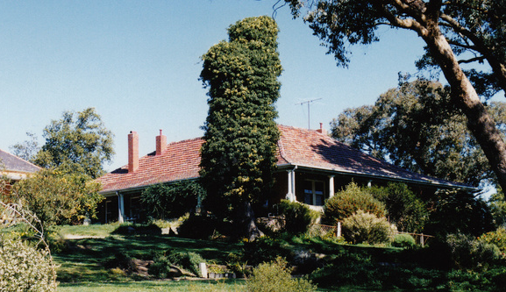  Figure 4. Brinkkotter House, 32 Lindon Strike Court, Research (HO114). | 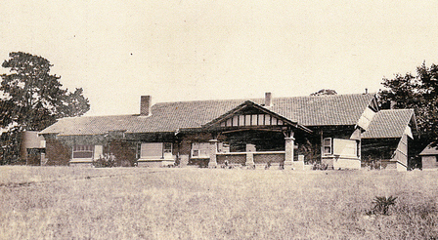  Figure 5. Worlingworth, 10-26 Banoon Road, Eltham (HO7).
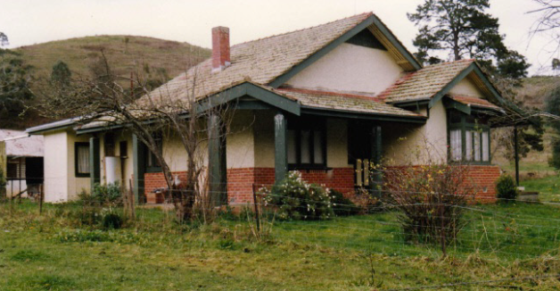
Figure 6. Orchard House, 25 Cottles Bridge-Strathewen Road, Cottles Bridge (HO190).

The Brinkotter House at 32 Lindon Strike Court was built c1935, and is significant for its associations with the Brinkkotter family, who were well-known farmers and orchardists in the region. It is also aesthetically significant for its unusual design. An earlier significant house exists on the same site, and the presence of two adjacent farmhouses on one property is uncommon.

Worlingworth at 10-26 Banoon Road, built c1922, is historically significant for its associations with the notable anthropologist Donald Thomson, who lived there from the mid-1930s and because it is one of a few substantial homes erected in the Shire during
the interwar period.

The Orchard House at 25 Cottles Bridge-Strathewen Road, is significant as one of few brick houses built prior to 1930 in the Shire. The house is considered significant due to its transitional style, which demonstrates elements of both federation and interwar bungalow styles.

The subject site is similar to the above examples due to its age, siting, and substantial brick construction. Despite this, the subject site is set apart from the houses at 25 Cottles Bridge-Strathewen Road and 10-26 Banoon Road, which both exhibit the more recognisable characteristics of interwar bungalows with their prominent gable roofs and projecting bay windows. Although similar in age and materiality, the subject site is set apart from the Brinkotter House at 32 Lindon Strike Court, which is more alike a traditional homestead with its simple rectangular form and surrounding veranda contained underneath a single hipped roof. Should the original c1907 farmhouse be present at the subject site, it would be a similar to the Brinkotter House as an example of two farmhouses coexisting on the same site.

The subject site demonstrates an unusual use of a two-storey form within the Shire, which further elevates its significance as a substantial interwar farmhouse in the municipality. Overall, the subject site compares favourably against these examples.

Assessment Against Criteria

Criteria referred to in Practice Note 1: Applying the Heritage Overlay, Department of Planning and Community Development, revised July 2015, modified for the local context.

CRITERION A: Importance to the course or pattern of the Shire of Nillumbik’s cultural or natural history (historical significance).
The Harton Hills farm complex at 405 Ryans Road, Diamond Creek is historically significant for its illustration of farming in the Diamond Creek district since the early 1900s. The most significant occupation of the property was by Alison and Harold Davis from 1935 until 1949 when the current c1930s residence was constructed, and dog breeding was undertaken at the property as well as it being a Jersey stud. The site also has associations with orchard farming in the area, which was undertaken by the Coventry family.

CRITERION B: Possession of uncommon, rare or endangered aspects of the Shire of Nillumbik’s cultural or natural history (rarity).

CRITERION C: Potential to yield information that will contribute to an understanding of the Shire of Nillumbik’s cultural or natural history (research potential).

CRITERION D: Importance in demonstrating the principal characteristics of a class of cultural or natural places or environments (representativeness).

CRITERION E: Importance in exhibiting particular aesthetic characteristics (aesthetic significance).

The 1930s farmhouse is aesthetically significant as a distinctive example of a substantial inter-war brick farmhouse. The two-storey nature of the building is unusual and makes this example stand out in the Shire. The outbuildings on the site demonstrate the operation of the farm during the 1930s and 1940s. The Monterey cypress drive contributes to the setting of the place and emphasises its grandeur.

CRITERION F: Importance in demonstrating a high degree of creative or technical achievement at a particular period (technical significance).

CRITERION G: Strong or special association with a particular community or cultural group for social, cultural or spiritual reasons. This includes the significance of a place to Indigenous peoples as part of their continuing and developing cultural traditions (social significance).

CRITERION H: Special association with the life or works of a person, or group of persons, of importance in the Shire of Nillumbik’s history (associative significance).

Statement of Significance

What is Significant?

The Harton Hills farm complex at 405 Ryans Road, Diamond Creek. The original form, materials and detailing of the c1907 farmhouse, 1930s farmhouse and outbuildings and the Monterey cypress drive and their setting contribute to the significance of the place.

How is it significant?

The Harton Hills farm complex at 405 Ryans Road, Diamond Creek is of local historic and aesthetic significance to the Shire of Nillumbik.

Why is it significant?

The Harton Hills farm complex at 405 Ryans Road, Diamond Creek is historically significant for its illustration of farming in the Diamond Creek district, which remained an integral part of the economic life of the district through the Interwar period. The most significant occupation of the property was by Alison Stewart Davis and Harold Carmichael Davis from 1935 until 1949, when the current c1930s two-storey brick residence was constructed and dog breeding was undertaken at the site. It is also during this period that the Davises operated a Jersey stud at the site. The site also has historic associations with orchard farming in the area which was undertaken during the Coventry family’s occupation of the site. (Criterion A)

The farm complex at 405 Ryans Road, Diamond Creek is aesthetically significant as an uncommon example of a substantial Interwar brick farmhouse. The two-storey nature of the building is also distinctive in the Shire, where most substantial houses were single-storey. The outbuildings on the site demonstrate the operation of the farm during the 1930s and 1940s. The Monterey cypress drive contributes to the setting of the place and emphasises its grandeur. (Criterion E)

Grading and Recommendations

Recommended for inclusion in the schedule to the Heritage Overlay of the Nillumbik Planning Scheme.
Recommendations for the Schedule to the Heritage Overlay (Clause 43.01) in the Nillumbik Planning Scheme:

External Paint Colours  Is a permit required to paint an already painted surface? | No
Internal Alteration Controls  Is a permit required for internal alterations? | No
Tree Controls  Is a permit required to remove a tree? | Yes – Monterey Cypresses
Victorian Heritage Register  Is the place included on the Victorian Heritage Register? | No
Incorporated Plan  Does an Incorporated Plan apply to the site? | No
Outbuildings and fences exemptions  Are there outbuildings and fences which are not exempt from notice and review? | Yes
Prohibited uses may be permitted  Can a permit be granted to use the place for a use which would otherwise be prohibited? | Yes
Aboriginal Heritage Place  Is the place an Aboriginal heritage place which is subject to the requirements of the Aboriginal Heritage Act 2006? | No

Identified By

Samantha Westbrook and Peter Mills

References

Advertiser (Hurstbridge), as cited.

Age, as cited.

Argus, as cited.

Battle to Farm 2022, Harold Carmichael Prescott Davis, Public Records Office of Victoria, http://soldiersettlement.prov.vic.gov.au/, accessed online 21 February 2022.

Bernard, J 2008, Diamond Creek, https://www.emelbourne.net.au/biogs/EM00464b.htm, accessed online 03 February 2022.

Births Death Marriages (BDM) Victoria events, as cited.

Butler, Graeme & Associates. (1996). Nillumbik Shire Heritage Study Stage 1, Review, Heritage Survey and Environmental History. Greensborough: Shire of Nillumbik.

Edwards, D 1979, The Diamond Valley Story, The Shire of Diamond Valley, Victoria.

Great Britain. War Office. General Staff. Commonwealth Section & Australia. Department of Defence 1920, 'Yan Yean, Victoria / prepared by Commonwealth Section, Imperial General Staff' Yan Yean, Victoria [cartographic material].

Great Britain. War Office. General Staff. Australian Section, cartographer. & Australia. Army. Survey Corps. 1935, Yan Yean, Victoria / prepared by Australian Section, Imperial General Staff.

Land Victoria, Certificates of Title (CT), as cited.

Shire of Heidelberg Rate Books (RB), as cited.

Graeme Butler & Associates 1996, ‘Nillumbik Shire Heritage Study Stage 1 Review, Heritage Survey and Environmental History,’ prepared for the Shire of Nillumbik.

