Villa Bereguardo
Prepared by: Trethowan Architecture

Address: 32-36 Perversi Avenue
Name: Villa Bereguardo | Survey Date: February 2022
Place Type: Residential | Architect: FW Thomas
Grading: Significant | Builder: FJ Jennings
Extent of Overlay: To title boundaries | Construction Date: 1924

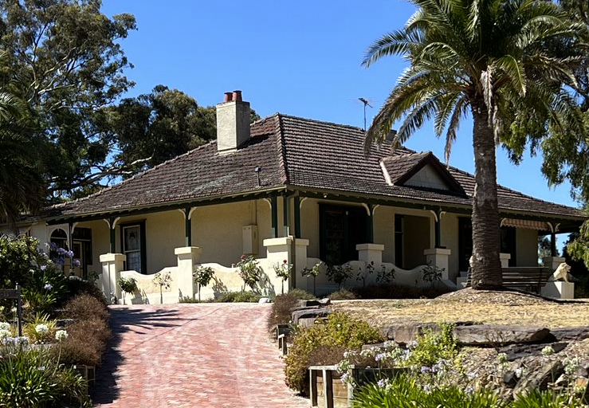

Historical Context

Although Crown Land in Nillumbik Parish was offered for sale in 1852 there were few buyers. A government township was reserved on the west of the Diamond Creek at this time but it was neither subdivided nor sold until 1866. In 1863 the Diamond Reef was discovered on land purchased by Dr John Blakemore Phipps in 1854 east of the creek. The rush to Diamond Creek began and soon Phipps was renting sections of his land, which he later subdivided to miners. In effect the development of Phipps land for gold mining was the beginnings of Diamond Creek, which was soon bustling with gold seekers. In 1866 the government proclaimed Diamond Creek as a township. Many of the important community buildings were established by the early 1870s. By the second half of the 1880s the locality was being carved up rapidly into a dominant pattern of numerous small lots of around 20 acres. These were taken up under occupation licenses, first under Section 49 of the Land Act 1869 and later under Section 65 of the Land Act 1884. Diamond Creek's population peaked around the turn of the century then seemed to fall away again in the early twentieth century (Graeme Butler & Associates 1996, p.36).

In 1912, the Eltham Railway Line was extended to Hurstbridge through Diamond Creek, bringing tourists to this area. Despite this, Diamond Creek remained a rural township throughout the first half of the twentieth century/ From the 1960s onwards, affordable land on subdivided orchards and accessibility to railway networks attracted young families to build their homes in the area, prompting the population growth in Diamond Creek (Jill Barnard, 2008).

History

Adolph Frederick Seelenmeyer acquired 158 acres of Portions 2 and 3 Parish of Nillumbik, in 1915, before subdividing the land into smaller lots for sale. Sicilia Perversi acquired 12 acres of the subdivision (Lots 11-15 and 22-23) in February 1924. Guiseppi Perversi acquired another adjoining two acres to the east (lots 16 and 17) in October 1924 (CT: V3899 F780; V4808 F539).

Guiseppe Perversi was born in Bereguardo, near Milan, in 1884, before arriving in Melbourne in 1914 and being naturalised as a citizen in 1914 (Perversi 2002:12; NAA: A1, 1914/6188). It appears that he was first employed as a wine merchant on Chapel Street in Prahran by Azzo Ongarello, before taking over Ongarello’s wine license and premises by 1918 (Vigilante 1 September 1918:1). Sicilia (Scolari) Perversi was born in East Melbourne in 1895, and was the younger sister of Azzo Ongarello’s wife (BDM 5264). Guiseppe Perversi and Sicilia Scolari were married at St Joseph’s Catholic Church in Northcote in 1919. (BDM 939; Table Talk 6 February 1919:25; 12 May 1927:56). By 1923 Guiseppi Perversi had a wine and spirits store at 295 Hoddle St Abbotsford; Sicilia obtained the wine licence for the business the following year (Argus 7 November 1923:13; Age 23 December 1924:13).

In March 1924 FW Thomas, architect of 60 Queen St Melbourne, invited tenders for construction of a reinforced concrete bungalow in Diamond Creek (Argus 29 March 1924:1). By July building, noted as being constructed for Mr G Perversi, was under way. In July 1924 a newspaper reported that “Mr (F.J.) Jennings, builder, is at present erecting £1500 reinforced concrete house of 7 rooms with verandas on three sides in a commanding position at Diamond Creek”. According to the architect, the house was to feature the “Dutch style”, which may have been a reference to the curved balustrades (Advertiser (Hurstbridge) 25 July 1924:4; Figure 1).

FW Thomas does not appear to have been a prominent architect, and much of his work was based around Prahran. These works include a brick stable in 1906, additions to ‘The Colosseum’ (a large drapery store on Chapel Street) in 1911, and a warehouse in 1925 (Age 22 September 1906:4; Prahran Telegraph 22 December 1911:15; Argus 17 January 1925:5). In 1927, he designed the Prahran Meat Markets in conjunction with F.L. and K. Klingender (Age 5 November 1927:1). FJ Jennings was active as a builder in the district during the 1920s, advertising his services in the Hurstbridge Advertiser between 1924 and 1928 (Advertiser (Hurstbridge) 23 May 1924:3; 7 December 1928:3). In 1925 he constructed the replacement Queenstown (St Andrews) public hall (Advertiser (Hurstbridge) 17 April 1925:2).

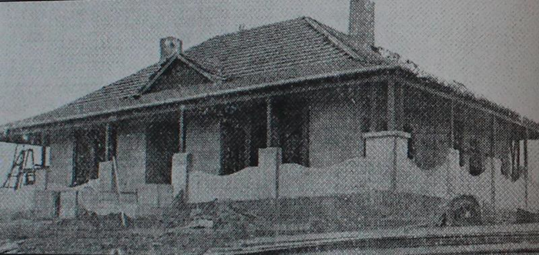
Figure 1:A view of the principal facade of the Perversi house under construction c1924, taken from the southwest. Note the chimneys, curved balustrade and small gable. Source: Bates 2006:36.

It appears that the house at Diamond Creek was initially used by the Perversi family as a weekend residence. The Perversi’s were still residing in Collingwood up until 1929, travelling to Diamond Creek by car (Advertiser (Hurstbridge) 5 July 1929:2). The Perversi’s had evidently planted an orchard on the property by this stage, as they were fined for failing to eradicate codlin moth on their trees (Advertiser (Hurstbridge) 22 February 1929:4). By 1930, when their daughter Iolanda was born, they were described as residing at Diamond Creek permanently (Argus 9 December 1930:1).

The house performed an important role in the Perversi’s involvement in the community life of Diamond Creek. A report on a fund-raiser for an organ for the Sacred Heart church hosted by the Perversi’s at their ‘charming residence, Villa Bereguardo’, reveals details of the house and garden. The verandah was converted into ‘an attractive bazaar’ for the occasion, with stands against the walls. A flower stall was located in a ‘charming bush house’ on the lawn, and a lucky dip was located in the ‘large fernery.’ Afternoon tea was served in the ‘spacious dining room,’ and music came from a piano and assorted instruments played in the lounge (Advertiser (Hurstbridge) 1 December 1933:2-4). In 1939 the house hosted sixty players at a euchre party in aid of the church, and in 1941 the family entertained soldiers from the Heidelberg Military Hospital on behalf of the Diamond Creek Red Cross (Advertiser (Hurstbridge) 26 May 1939:5; Eltham and Whittlesea Shires Advertiser 20 June 1941:4).

Guiseppe died in Melbourne in 1961 (BDM 14434/1961). The Perversi family sold Lots 22 and 23 in 1967, Lot 15 in 1968, Lot 14 in 1973 and Lot 11 in 1974
(CT: V4808 F539; CT: V9034 F399). Sicilia died in 1973, and bequeathed her land to the Sisters of Mercy in Rosanna (BDM 3544; PROV, VPRS7591/P4 Unit 332, Sicilia Perversi File 752/180,). The land changed ownership multiple times in the following years (CT: V9030 F772).

Description & Integrity

The subject site is a rectangular residence with a veranda to three sides, contained under a single tile-clad hipped roof. The walls of the building are rendered concrete. The veranda is supported by timber posts with brick pillar bases and is enclosed by a scalloped brick balustrade. The timber posts have corner timber brackets, and the roof features exposed timber rafters.

The entry to the residence faces west and the principal elevation has a central door with large leadlight windows either side. There is a small, central gable in the roof facing west that is clad with painted shingles. There are two symmetrically arranged rendered chimneys with terra cotta pots at each end of the ridge line of the roof.

To the rear are two small projecting wings at each end of the return verandah, both of which are also contained under the main sweep of the roof (Figure 2. Between these two side wings is a gable roofed wing that is slightly shallower. The side wings have timber framed double hung windows and hoods with brackets over the windows.

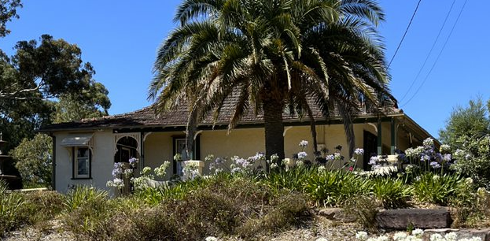
Figure 2: A view of the house from the north, showing one of the rear wings highlighted in red. Source: Trethowan.

There is a small out building on the northeast corner of the site. The building has a tile clad gable roof with exposed rafters, and appears to be built of rendered masonry. The gable ends are clad in painted shingles (Figure 2). Alterations have been undertaken to this building, with the installation of new glazing. This appears to be early and is possibly contemporary with the residence. There is also another gable roofed shed on the southwest side of the site, which is used as a double garage and is not original to the house.
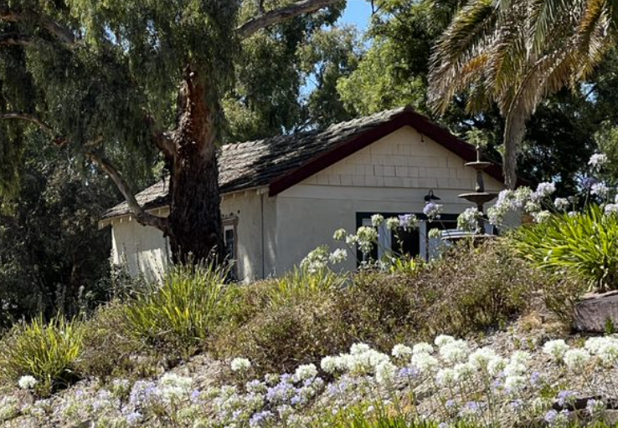
Figure 3: A view of the small gabled outbuilding in the northeast corner of the site. Source: Trethowan.

Comparative Analysis

Interwar Bungalows

Following the financial and social upheaval and general devastation of WWI, Australian housing ideals were significantly altered. Although the aspiration of an individual house on its own block had driven earlier suburban development, the ideal was ‘carried into a new dimension’ in the interwar period (Cuffley 1989:14). As a mark of the renewed optimism of a society emerging from war, garden suburbs, model villages, War Service Loan and Bank houses facilitated major Australian residential growth. The new bungalow form came to dominate, deviating from the established Victorian and Federation styles, and architectural applications drew from diverse stylistic origins.

A majority of houses of the era were illustrative of the demand for low-cost housing. Schemes such as those of the State Savings Bank provided customers of lesser means readily available finance to purchase land and construct modest houses using pre-prepared designs (Cuffley 1989:17). Many used new cost-efficient materials, especially those in outer suburbs and regional areas. The bungalow was also popular amongst the wealthier classes, who expressed the form in more substantial dimensions and materials. These houses were often architect-designed and individually treated and featured comparatively elaborate design details.

Interwar development in the Shire of Nillumbik appeared to be slow, possibly due to its distance from the city and continuing agricultural setting. The conservatism often associated with sleepier rural areas may also have contributed to a slow up-take of new architecture (Cuffley 1989:22). Many houses built in the Shire during this period appear to be modest, weatherboard structures with little architectural pretence.

Although interwar dwellings are under-represented on the Heritage Overlay, the number of substantial residences built during the Interwar period in the Shire is further limited. The following places are comparable to the subject site, as a more substantial interwar home designed for a prosperous family.

- Brinkkotter House, 32 Lindon Strike Court, Research (HO114)
- Worlingworth, 10-26 Banoon Road, Eltham (HO7)
- Orchard House, 25 Cottles Bridge-Strathewen Road, Cottles Bridge (HO190).

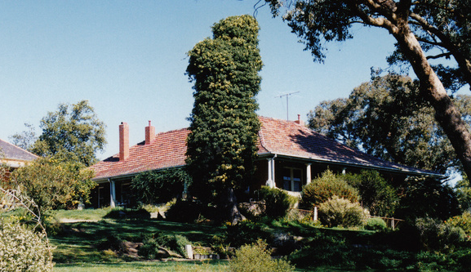  Figure 4. Brinkkotter House, 32 Lindon Strike Court, Research (HO114). | 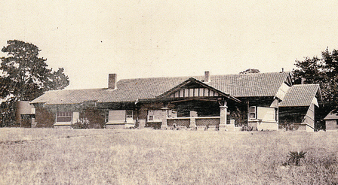  Figure 5. Worlingworth, 10-26 Banoon Road, Eltham (HO7).
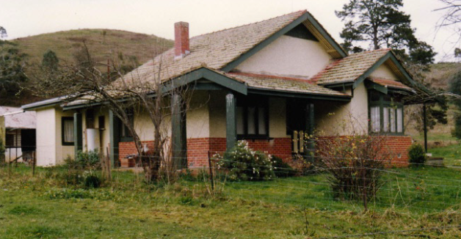
Figure 6. Orchard House, 25 Cottles Bridge-Strathewen Road, Cottles Bridge (HO190).

The Brinkotter House at 32 Lindon Strike Court was built c1935, and is significant for its associations with the Brinkkotter family, who were well-known farmers and orchardists in the region. It is also aesthetically significant for its unusual design. An earlier significant house exists on the same site, and the presence of two adjacent farmhouses on one property is uncommon.

Worlingworth at 10-26 Banoon Road, built c1922, is historically significant for its associations with the notable anthropologist Donald Thomson, who lived there from the mid-1930s and because it is one of a few substantial homes erected in the Shire during
the interwar period.

The Orchard House at 25 Cottles Bridge-Strathewen Road, is significant as one of few brick houses built prior to 1930 in the Shire. The house is considered significant due to its transitional style, which demonstrates elements of both federation and interwar bungalow styles.

Although of similar substantial construction, the subject site is set apart from the houses at 25 Cottles Bridge-Strathewen Road and 10-26 Banoon Road, which both exhibit the more recognisable characteristics of interwar bungalows with their prominent gable roofs and projecting bay windows. The subject site is most similar to the house at 32 Lindon Strike Court, as both are rectangular form houses with surrounding verandas contained completely under the sweep of one hipped roof. Both houses are also positioned to take advantage of views to valleys. Although they are similar in their form and substantial nature, the subject site demonstrates an unusual use of curved solid balustrading and concrete construction. Overall, the subject site compares favourably against these examples.

Concrete Construction

Domestic concrete construction prior the post-war period is uncommon in the Shire of Nillumbik.

Before 1900 concrete building was virtually unknown in Victoria, with only a few examples in monolithic construction (without steel reinforcement). Concrete construction progressed faster for commercial buildings where the structural benefits were greater. Some concrete houses appeared in the suburbs of Melbourne after 1900, and a group were built in Sunshine for the workers of the Mackay Sunshine Works in 1910 (VHD Place ID 45843, ‘Concrete Housing Estate Precinct’).

The demand for affordable construction and a shortage in housing following WWI encouraged architects to explore new building methods. In a time where timber and bricks were expensive or in scarce supply, concrete was recognised as a cheaper and readily available alternative. Adoption increased from around 1919, when six reinforced concrete houses were built in Melbourne to designs by architect and proponent of concrete construction Leslie Perrot (Perrott 1919). Various other homes were built in concrete to designs by Walter Burley Griffin at a similar time.

The mid-to late 1920s and 1930s saw a flurry of concrete house building activity in Victoria, and particularly Melbourne (Lewis 2013:4). ‘Park View’ in Racecourse Road Flemington was constructed in 1924, unusually using tram cables and horseshoes for reinforcement as a measure of economy (VHR Place ID 4430, ‘Park View’). In the same year, another group of concrete houses was built to designs by architect GB Leith in Sunshine for workers at the Sunshine Harvester Works, with backing from the State Savings Bank (VHD Place ID 45843, ‘Concrete Housing Estate Precinct’). Concrete houses were built to Leslie Perrott’s designs in Northcote in 1924, Kew and Wattle Valley Rd Camberwell in c1925, and in Portsea in c1926 (Argus 17 May 1924:20; Roser 2002:13). Despite the 1920s peak, the technology was not widely considered a common material for houses, and it was noted that in 1927 only 82 of 7,500 building housing permits issued within a twenty-mile radius of Melbourne were of concrete (Roser 2002).

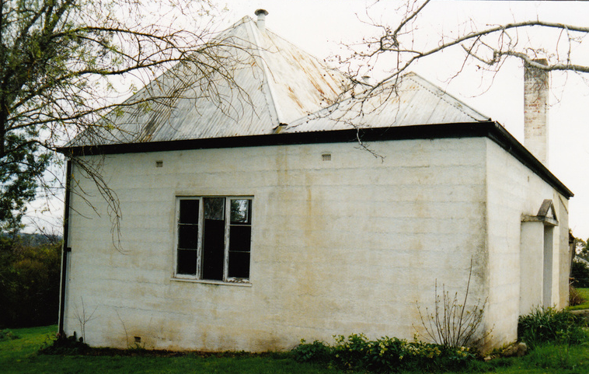
Figure 7. Rear Concrete Studio, 60 Lavender Park Road, Eltham (HO113)

The only domestic interwar concrete construction on the Heritage Overlay identified for comparison is the Rear Concrete Studio at 60 Lavender Park Road. Although likely dating from a similar period, this building is differentiated from the subject site by its use as an ancillary building to a larger masonry house, rather than being a house itself. No other examples of concrete houses built prior to the post-war period were identified in the Shire, highlighting the subject site’s rarity.
Assessment Against Criteria

Criteria referred to in Practice Note 1: Applying the Heritage Overlay, Department of Planning and Community Development, revised July 2015, modified for the local context.

CRITERION A: Importance to the course or pattern of the Shire of Nillumbik’s cultural or natural history (historical significance).

The property is historically significant as a substantially intact example of a 1920s residence demonstrating the early use of reinforced concrete walls. Constructed in 1924, the property is also an example of a residence initially constructed for weekend use by a prosperous Italian family based in Melbourne. The family’s presence also demonstrates pre-WW2 Italian migration in Victoria and in the Nillumbik area.

CRITERION B: Possession of uncommon, rare or endangered aspects of the Shire of Nillumbik’s cultural or natural history (rarity).

Known surviving examples of early reinforced concrete houses such as this one are rare in the Shire of Nillumbik.

CRITERION C: Potential to yield information that will contribute to an understanding of the Shire of Nillumbik’s cultural or natural history (research potential).

CRITERION D: Importance in demonstrating the principal characteristics of a class of cultural or natural places or environments (representativeness).

CRITERION E: Importance in exhibiting particular aesthetic characteristics (aesthetic significance).

The residence is a substantially intact 1920s architect designed concrete house that retains many of its original features including its overall original form with hipped roof, verandah around three sides and corner pavilions to the rear. The pavilion form of the house with its rear corner wings, the decorative verandah balustrade with timber fretwork and the chimneys and gables to the roof make it a particularly attractive building evocative of the 1920s period of design. The location of the house on the hill and the two palm trees at the front contribute to the aesthetic significance of the site.

CRITERION F: Importance in demonstrating a high degree of creative or technical achievement at a particular period (technical significance).

CRITERION G: Strong or special association with a particular community or cultural group for social, cultural or spiritual reasons. This includes the significance of a place to Indigenous peoples as part of their continuing and developing cultural traditions (social significance).

CRITERION H: Special association with the life or works of a person, or group of persons, of importance in the Shire of Nillumbik’s history (associative significance).

Grading and Recommendations

Recommended for inclusion in the schedule to the Heritage Overlay of the Nillumbik Planning Scheme.
Recommendations for the Schedule to the Heritage Overlay (Clause 43.01) in the Nillumbik Planning Scheme:

External Paint Colours  Is a permit required to paint an already painted surface? | No
Internal Alteration Controls  Is a permit required for internal alterations? | No
Tree Controls  Is a permit required to remove a tree? | Yes – Palm Trees
Victorian Heritage Register  Is the place included on the Victorian Heritage Register? | No
Incorporated Plan  Does an Incorporated Plan apply to the site? | No
Outbuildings and fences exemptions  Are there outbuildings and fences which are not exempt from notice and review? | Yes – front outbuilding
Prohibited uses may be permitted  Can a permit be granted to use the place for a use which would otherwise be prohibited? | Yes
Aboriginal Heritage Place  Is the place an Aboriginal heritage place which is subject to the requirements of the Aboriginal Heritage Act 2006? | No

Identified By

Samantha Westbrook and Peter Mills, Trethowan

References

Advertiser (Hurstbridge), as cited.

Age, as cited.

Argus, as cited.

Bacchus Marsh Express, as cited.
Bernard, Jill,2008, Diamond Creek, https://www.emelbourne.net.au/biogs/EM00464b.htm, accessed online 03 February 2022.

Bates, L 2006, Capturing the Essence of Diamond Creek, Laurie Bates, Diamond Creek.

Births Death Marriages (BDM) Victoria events, as cited.

Camberwell and Hawthorn Advertiser, as cited.

Eltham and Whittlesea Shires Advertiser, as cited.

Essendon Gazette and Keilor, Bulla and Broadmeadows Reporter, as cited.

Graeme Butler & Associates. 1996. Nillumbik Shire Heritage Study Stage 1, Review, Heritage Survey and Environmental History. Greensborough: Shire of Nillumbik.

Land Victoria, Certificates of Title (CT), as cited.

Lewis, M 2013. ‘Australian Building: A cultural investigation.’ Chapter 7.08 Cement & Concrete: Forms and Systems, http://www.mileslewis.net/australian-building/.

National Archives of Australia: Correspondence files, annual single number series A1; 1914/6188, Certificate of Naturalization No.18262, 1914.

Perrott, L 1919, ‘Concrete for Construction: Its use in home building considered,’ Real Property Annual Vol.8, pp 25-29.

Perversi, F 2002, From Tobruk to Borneo: memoirs of an Italian-Aussie volunteer, Rosenburg Publishing, Kenthurst.

Prahran Telegraph, as cited.

PROV, VA2620, Registrar of Probates, Supreme Court, VPRS7591 Wills File 752/180, Sicilia Perversi will.

Roser, P 2002, ‘Concrete Houses in Victoria 1900-1940’, unpublished paper, University of Melbourne.

Table Talk, as cited.

Vigilante, as cited.

Victorian Heritage Database (VHD) Place ID 45843, ‘Concrete Housing Estate’, Victorian Heritage Database, accessed online 22 February 2022.

Victorian Heritage Register (VHR) Place ID 4430, ‘Park View’, Victorian Heritage Database, accessed online 22 February 2022.

