Farmhouse and Outbuildings
Prepared by: Trethowan Architecture

Address: 75-99 Phipps Crescent, Diamond Creek
Name: Farmhouse and Outbuildings | Survey Date:
Place Type: Residential, Farming | Architect: Not known
Grading: Individually significant | Builder: Not known
Extent of Overlay: | Construction Date: 1929

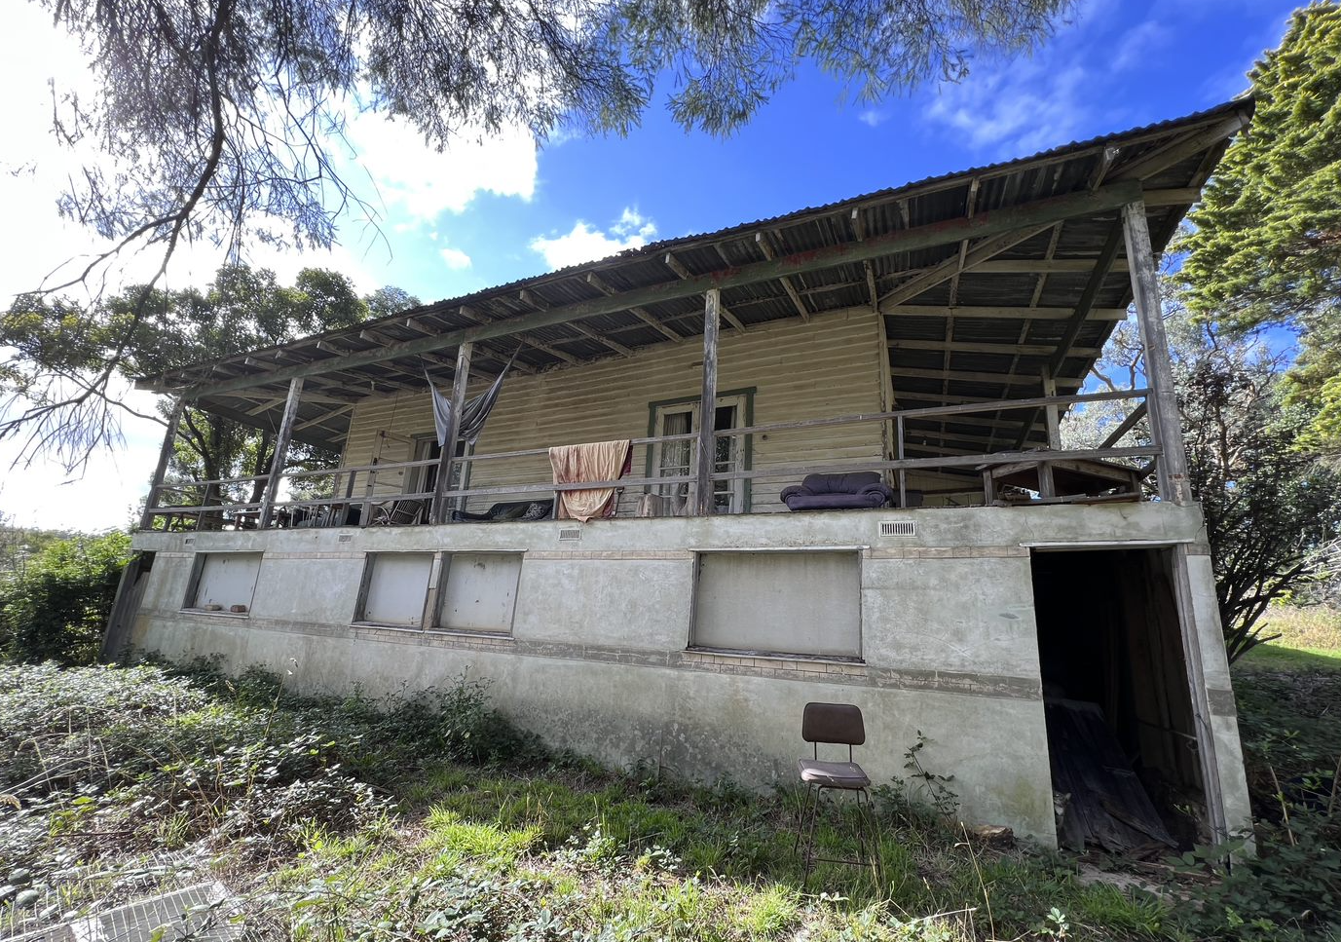

Historical Context

Although Crown Land in Nillumbik Parish was offered for sale in 1852 there were few buyers. A government township was reserved on the west of the Diamond Creek at this time but it was neither subdivided nor sold until 1866. In 1863 the Diamond Reef was discovered on land located to the east of the creek, which was purchased by Dr. John Blakemore Phipps in 1854. The rush to Diamond Creek began and soon Phipps was renting sections of his land, which he later subdivided to miners. In effect the development of Phipps land for gold mining was the beginnings of Diamond Creek, which was soon bustling with gold seekers. In 1866 the government proclaimed Diamond Creek as a township. Many of the important community buildings were established by the late 1860s and early 1870s. These included a post office, a Methodist church and school and three hotels (Barnard, 2008). In 1870, a national school was established (Edwards, 1979:118).

By the second half of the 1880s the locality was being carved up rapidly into a dominant pattern of numerous small lots of around 20 acres. These were taken up under occupation licenses, first under Section 49 of the Land Act 1869 and later under Section 65 of the Land Act 1884. Diamond Creek's population peaked around the turn of the century then seemed to fall away again in the early twentieth century (Graeme Butler & Associates 1996:36). From 1885 onwards, the rural landscape of the area also inspired many artists to work in Diamond Creek and its surrounds, and the scenery of the area was captured in the works of the Heidelberg School painters (Edwards, 1979:143).

In 1912, the Eltham Railway Line was extended to Hurstbridge through Diamond Creek, bringing tourists to this area. Despite this, Diamond Creek remained a rural township concentrating on the orchard industry throughout the first half of the twentieth century, without much new industries to offer alternative employment opportunities. As such, the area entered a period of population decline (Edwards, 1979:177). This began to change in the 1960s and 70s, as, affordable land on subdivided orchards and accessibility to railway networks attracted young families to build their homes in the area, prompting further population growth in Diamond Creek (Barnard, 2008).

History

Although Crown Land in Nillumbik Parish was offered for sale in 1852, there were few buyers. A government township was reserved on the west of the Diamond Creek at this time, however it was neither subdivided nor sold until 1866. In 1863 the Diamond Reef was discovered on land east of the creek that Dr John Blakemore Phipps had purchased in 1854. The rush to Diamond Creek began and soon Phipps was renting sections of his land, which he later subdivided to miners. The development of Phipps’ land for gold mining was effectually the beginnings of Diamond Creek, which was soon bustling with gold seekers.

J. Rosier purchased Portion 1 No Section Parish of Nillumbik, 265 acres, from the Crown in 1852. Dr John Blakemore Phipps acquired Portion 1 and part of Portion 2 no section Parish of Nillumbik, purportedly with the assistance of Humphrey Peers and Cornelius Haley, who had purchased Portions 2 and 3 Parish of Nillumbik respectively in Crown land sales in 1852 (Nillumbik Parish Plans Sheets 1 and 3). Phipps arrived from England in 1854 and stayed in the area at first for 5 or 6 years. During this period, he also acquired Lots 1 and 2 Section 17 Parish of Nillumbik, just to the south of Portion 1. When the gold rush in the Caledonian field started in 1864 Phipps returned to his land, where much of the mining activity was occurring, and rented land to miners to live on (Edwards 1979:49-50).

Phipps first tried to sell all of his land in the district in 1873 (Argus 21 June 1873:2). His later subdivision of 1897 included 60 lots of from 2 to 70 acres. The subject site was vacant (Figure 1). Phipps re-advertised the small blocks near the railway station as the ‘Station Estate” in 1902, and the ‘Phipps Estate’ in 1905 (Argus 24 February 1902:16; 13 March 1905:2). Christine Lorrimer purchased the northern parts of Lots 52 and 53 of the 1897 subdivision in 1918 (CT V4143 F522). The 1921-22 rate book does not list a house on the property (RB).

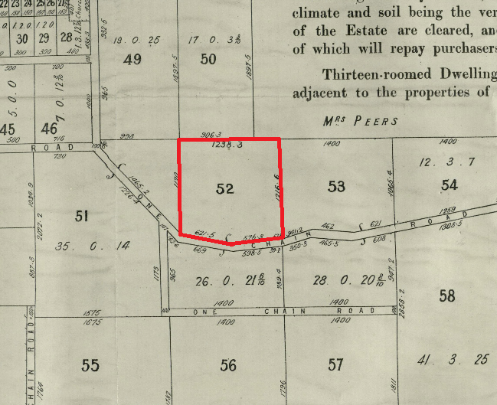
Figure 1: An excerpt of the 1897 subdivision plan. Source: John Vale & Sons 1897.

Ivy Gleeson and Henry Frederick Gleeson of North Melbourne purchased 15 acres of Lot 52 from Christine Lorrimer in July 1929 (CT V5567 F261). This is the northern part of the original 26-acre block of the sub-division, with the southern part becoming 52A. Ivy Billet and Henry Gleeson had married in 1922 (BDM Victoria Event 8613/1922). The 1926 rate book shows the Gleeson’s owned the land with no house, with an NAV of £12 (RB).

The Gleeson’s house was built in 1929. In May of that year, the local paper recorded that construction had commenced on a seven-roomed ‘up to date’ house for the Gleeson’s in the ‘eastern part’ of town, following delays caused by a building strike (Advertiser (Hurstbridge), 17 May 1929:3). A house was marked in an appropriate position on the 1930 topographic map (‘Victoria, Yan Yean’ prepared by Australian Section, Imperial General Staff, Great Britain, War Office General Staff Australian Section, c1930, 1:63,360 topo series. SLV map collection). The 1931 rate book listed a house on the property with the NAV now £50 (RB).

Poultry farmers Walter and Gloria Belot purchased the property in 1959, and it appears that they used the property for that purpose. The property has changed in ownership since (CT V5567 F261).

Description & Integrity

75-99 Phipps Crescent, Diamond Creek, is a single-storey weatherboard farmhouse with hipped, corrugated metal clad roof. Rectangular in shape, the building is constructed on a northwest-southeast axis. A veranda, contained under the main sweep of the roof, returns around the northwest, northeast and southwest elevations. The roof is low-slung and has exposed rafters. A simple brick chimney with soldier brick detailing is evident on the southwest side of the roof. The house is built into the slope of the land and takes advantage of views into the valley to the northwest.

The primary façade with front entry to the house faces the southwest and is accessed by an original or early set of steps with pebble balustrade detailing. Part of the veranda on this elevation has been infilled to form a kitchen, with solid weather boards to sill height and glazing above. Some of this glazing includes original casement windows that likely came off the wall of the house since enclosed within the room (Figure 2). This alteration is likely to have been undertaken in the 1950s, as a concrete chimney is evident. An interwar brick chimney indicates the location of the original kitchen in the southern corner of the house, behind this infilled veranda (Figure 3).

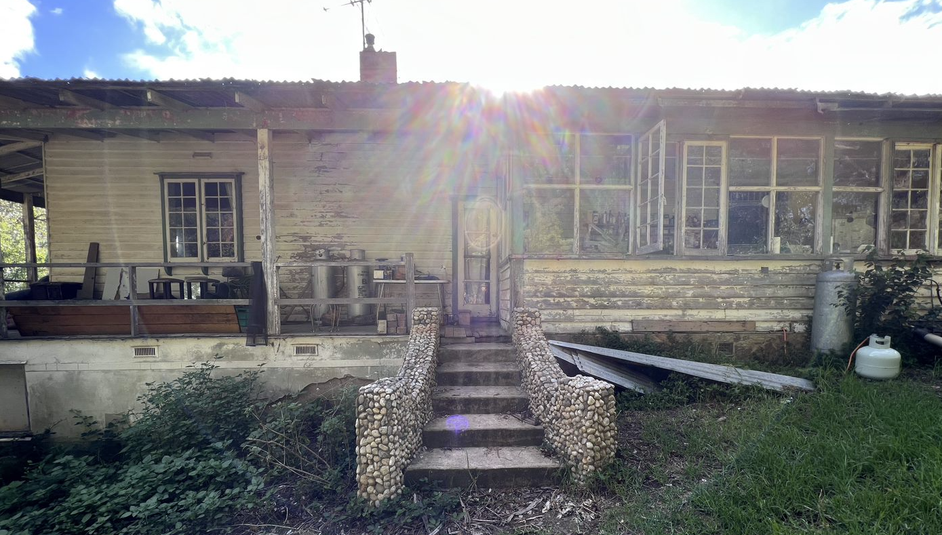
Figure 2: A view of the southwest of the house. The infilled veranda is visible to the right, and original or early pebble-detailed stairs central. Source: Trethowan 2022.
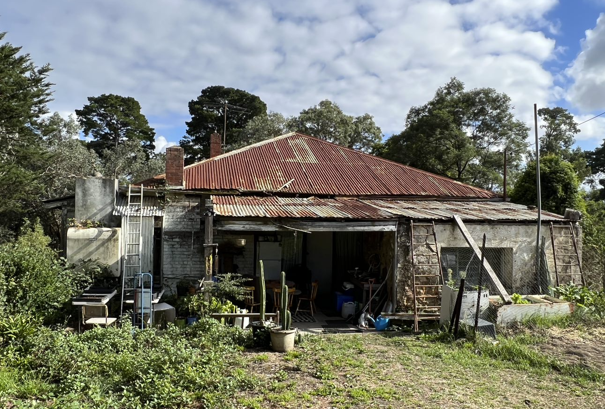
Figure 3: A view of the southeast of the house. The c1950s concrete chimney to the infill veranda room is highlighted in red; the original interwar kitchen chimney in yellow. The later stone rear addition is highlighted in blue. Source: Trethowan 2022.

The remainder of the building’s facades that are contained under the veranda feature original sets of French doors and boxed casement windows (Figure 4). The veranda balustrade is comprised of simple timber posts and rails and does not appear to be original. A stone addition to the southeast is contained under a skillion roof. This addition appears to date from the late interwar or post-war period.
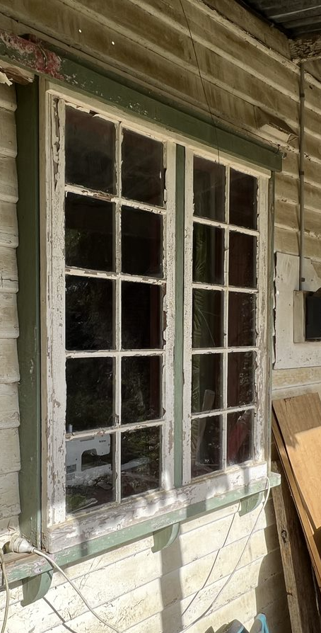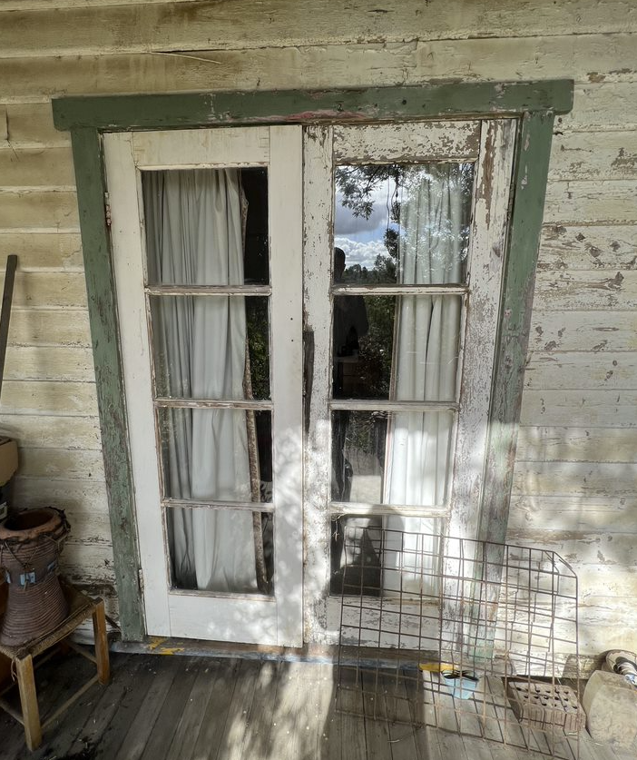
Figure 4: Examples of the casement windows (left) and French doors (right) with timber surrounds evident across the building. Source: Trethowan 2022.
There are outbuildings to the east of the residence adjacent to the current entry drive. What appears to have been a former poultry shed is a simple rectangular building with gable roof, constructed out of asbestos sheeting with corrugated metal roof (Figure 5). This building has a concrete gangway along its northwest elevation, where door openings retain their original sliding mechanisms (the sliding doors have since been replaced with hinged versions). This building was likely constructed in the interwar period or after. Another outbuilding is completed in concrete and features an irregular arrangement of rooms. A signature on the concrete slab indicates that it was constructed in 1955. Original louvred windows are evident, however the roof has since been removed (Figure 6).

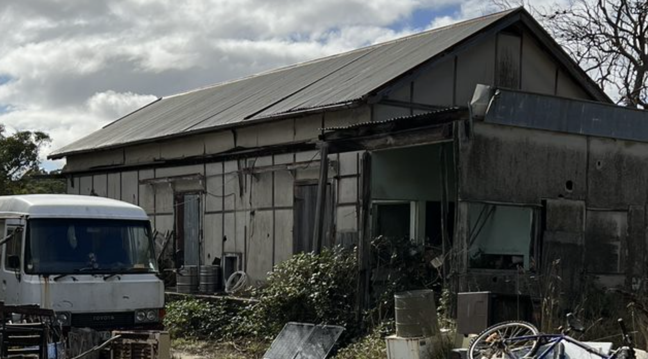
Figure 5: The building that is likely a former poultry shed. Source: Trethowan 2022.

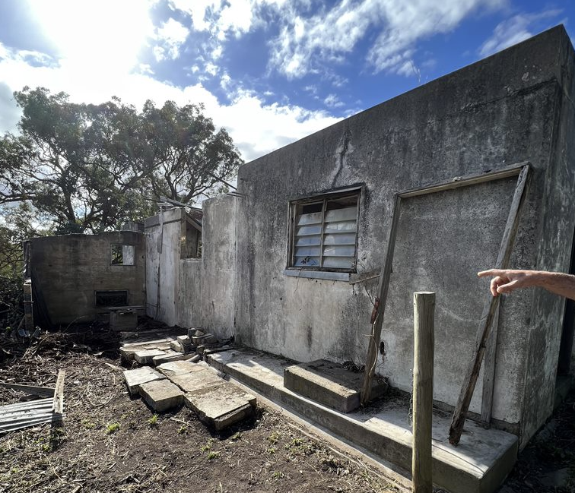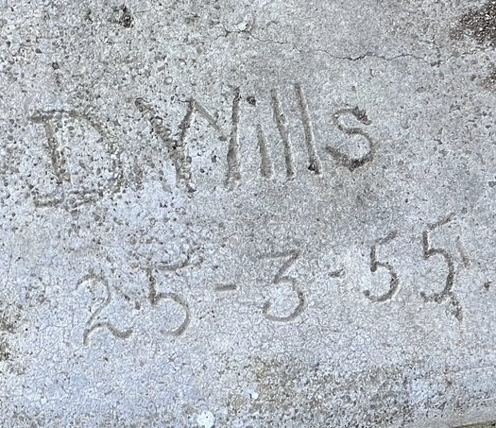
Figure 6: A view of the concrete outbuilding (left) and the signature indicating when it was built (right). Source: Trethowan 2022.

Comparative Analysis

Farmhouses have been present in the Shire of Nillumbik since the 1840s, when rudimentary dwellings were erected by settlers as the land was opened up for agricultural use. The earliest farmhouses were usually modest constructions that made use of readily available materials, evident in examples such as the 1843 sections of Hazel Glen Homestead (HO234). As farmers in the district became more prosperous, their homes were erected according to contemporary tastes. In this way, many farmhouses came to conform to the styles, detailing and materiality of suburban houses evident across the Greater Melbourne.

Interwar development in the Shire of Nillumbik appeared to be slow, possibly due to its distance from the city and continuing agricultural setting. Dwellings from this era are currently under-represented on the Nillumbik Heritage Overlay, however the following places are comparable to the subject site due to their age and construction as farmhouses:

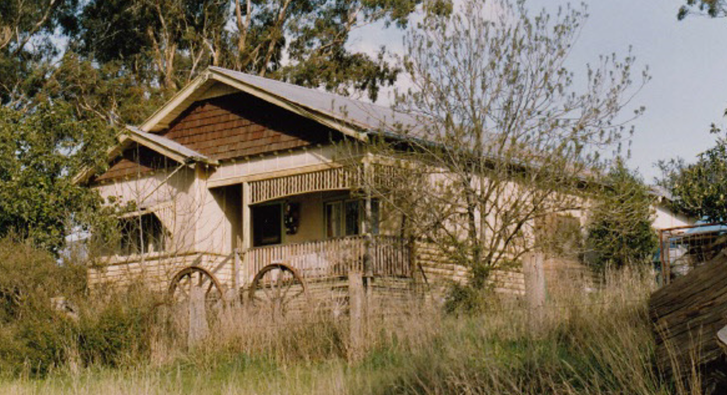
830 Cottles Bridge - Strathewan Road, Arthurs Creek (HO29)

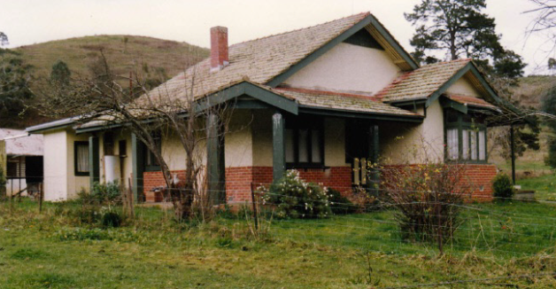
Orchard House, 25 Cottles Bridge-Strathewen Road, Cottles Bridge (HO190)

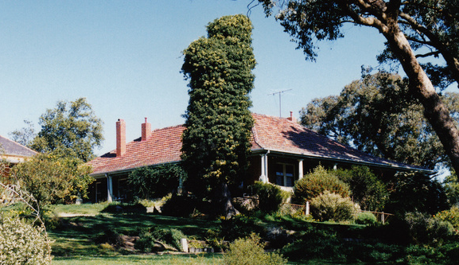
Old Brinkkotter House, 32 Lindon Strike Court, Research (HO114).

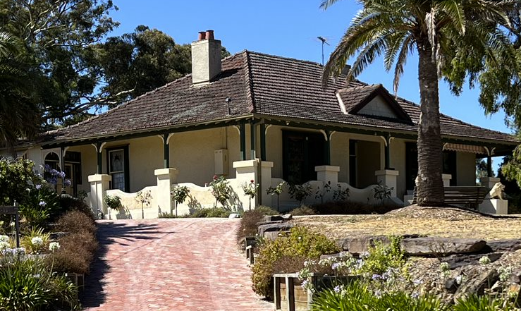
Villa Bereguardo, 32-36 Perversi Avenue, Diamond Creek (Recommended as individually significant)
830 Cottles Bridge-Strathewen Road, Arthurs Creek, was built for the Apted family who have operated an orchard in Arthurs Creek for over a century. The orchard was, in 1916, the largest in southern Victoria and is a reminder of the importance of orcharding in the former Shire of Eltham. The Californian bungalow farmhouse is historically significant as a rare surviving example of its type in the Shire.

The Orchard House at 25 Cottles Bridge-Strathewen Road, is significant as one of few brick houses built prior to 1930 in the Shire. The house is considered significant due to its transitional style, which demonstrates elements of both federation and interwar bungalow styles.

The Brinkotter House at 32 Lindon Strike Court was built c1935 and is significant for its associations with the Brinkkotter family, who were well-known farmers and orchardists in the region. It is also aesthetically significant for its unusual design. An earlier significant house exists on the same site, and the presence of two adjacent farmhouses on one property is uncommon.

32-36 Perversi Avenue, Diamond Creek was built in 1924 as a weekend property and orchard for a family who eventually took up permanent residence at the site. The house is notable for its simple form with return veranda, with interwar detailing. The house is rare in the shire as an example of concrete construction before the post-war period.

Although similar in age to the houses at 25 and 830 Cottles Bridge-Strathewen Road, these houses present as more conventional examples of Interwar bungalows that were being erected across Victoria at the time. Both examples demonstrate the common characteristics of Interwar bungalows, such as the large, nested gable roofs with detailed ends. The subject site is distinguished from these for its use of a more traditional homestead form with return veranda.

The subject site is similar to the houses at 32 Lindon Strike Court and 32-36 Perversi Avenue due to their age and similar form. These examples all employ a more traditional homestead form with simple rectangular plan with return veranda to three sides, with interwar style features. All are sited in a considered manner to take in views. Although not as substantially constructed or detailed as 32 Lindon Strike Court and 32-36 Perversi Avenue, which are brick and concrete respectively, the subject house demonstrates how the same form and siting was applied to more modest versions across the Shire.

Assessment Against Criteria

Criteria referred to in Practice Note 1: Applying the Heritage Overlay, Department of Planning and Community Development, revised July 2015, modified for the local context.

CRITERION A: Importance to the course or pattern of the Shire of Nillumbik’s cultural or natural history (historical significance).

The property has associations with the 1897 subdivision of the Phipps land. Phipps arrived from England in 1854 and stayed in the area at first for 5 or 6 years. During this period, he also acquired Lots 1 and 2 Section 17 Parish of Nillumbik, just to the south of Portion 1. When the gold rush in the Caledonian field started in 1864 Phipps returned to his land, where much of the mining activity was occurring, and rented land to miners to live on. The site was part of the 1897 subdivision of Phipps’ land. It demonstrates settlement in the area following the gold rush.

CRITERION B: Possession of uncommon, rare or endangered aspects of the Shire of Nillumbik’s cultural or natural history (rarity).

CRITERION C: Potential to yield information that will contribute to an understanding of the Shire of Nillumbik’s cultural or natural history (research potential).

CRITERION D: Importance in demonstrating the principal characteristics of a class of cultural or natural places or environments (representativeness).

The house at 75-99 Phipps Crescent, Diamond Creek, is representative of interwar farmhouses built in the Shire. The house bears interwar detailing including the original French doors and casement windows with timber surrounds and chimneys. The building form is similar to a traditional homestead, with rectangular body and wraparound veranda contained under the sweep of a hipped roof, which aligns with other examples built in the Shire during that era.

CRITERION E: Importance in exhibiting particular aesthetic characteristics (aesthetic significance).

CRITERION F: Importance in demonstrating a high degree of creative or technical achievement at a particular period (technical significance).

CRITERION G: Strong or special association with a particular community or cultural group for social, cultural or spiritual reasons. This includes the significance of a place to Indigenous peoples as part of their continuing and developing cultural traditions (social significance).

CRITERION H: Special association with the life or works of a person, or group of persons, of importance in the Shire of Nillumbik’s history (associative significance).

Grading and Recommendations

Recommended for inclusion in the schedule to the Heritage Overlay of the Nillumbik Planning Scheme.
Recommendations for the Schedule to the Heritage Overlay (Clause 43.01) in the Nillumbik Planning Scheme:

External Paint Colours  Is a permit required to paint an already painted surface? | No
Internal Alteration Controls  Is a permit required for internal alterations? | No
Tree Controls  Is a permit required to remove a tree? | No
Victorian Heritage Register  Is the place included on the Victorian Heritage Register? | No
Incorporated Plan  Does an Incorporated Plan apply to the site? | No
Outbuildings and fences exemptions  Are there outbuildings and fences which are not exempt from notice and review? | No
Prohibited uses may be permitted  Can a permit be granted to use the place for a use which would otherwise be prohibited? | No
Aboriginal Heritage Place  Is the place an Aboriginal heritage place which is subject to the requirements of the Aboriginal Heritage Act 2006? | No

Identified By

Samantha Westbrooke and Peter Mills, Trethowan

References

Advertiser (Hurstbridge), as cited.

Argus, as cited.

‘Victoria, Yan Yean’ prepared by Australian Section, Imperial General Staff, Great Britain, War Office General Staff Australian Section, c1930, 1:63,360 topo series. SLV map collection

Edwards, D 1979, The Diamond Valley Story: Shire of Diamond Valley, Shire of Diamond Valley, Greensborough.

Graeme Butler & Associates 1996, ‘Nillumbik Shire Heritage Study Stage 1, Review, Heritage Survey and Environmental History’, prepared for the Shire of Nillumbik.

John Vale & Sons 1897, ‘Diamond Creek, in areas of from 2 to 70 acres, orchards, gardens and farms, and township allotments’, State Library Victoria Haughton collection, accessed online 17 February 2022.

Land Victoria, Certificates of title (CT), as cited.

Shire of Heidelberg Greensborough Riding Rate Books (later Heidelberg Riding Rate Books) (RB), as cited.

