Title: Oak, 477 Broad Gully Road Diamond Creek
Identified by: Peter Mills and Samantha Westbrooke
Prepared by: Trethowan Architecture

Address: 477 Broad Gully Road Diamond Creek
Name: Oak, former Sylvadale homestead | Survey Date:
Place Type: Tree | Architect:
Grading: Locally Significant | Builder:
Extent of Overlay: Tree Protection Zone TBC by arborist | Construction Date: c.1898

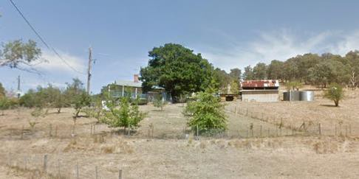

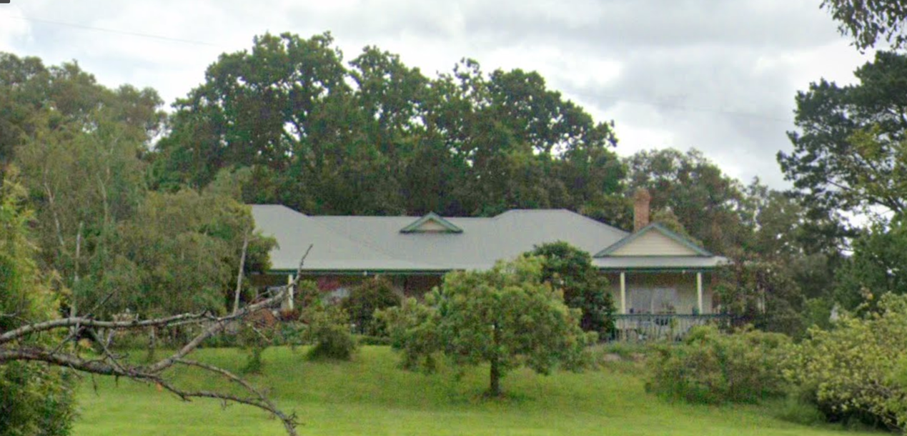
The former homestead, much altered, with oak indicated.

Historical Context

Early History of Diamond Creek
Although Crown Land in Nillumbik Parish was offered for sale in 1852 there were few buyers. A government township was reserved on the west of the Diamond Creek at this time but it was neither subdivided nor sold until 1866. In 1863 the Diamond Reef was discovered on land purchased by Dr John Blakemore Phipps in 1854 east of the creek. The rush to Diamond Creek began and soon Phipps was renting sections of his land, which he later subdivided to miners. In effect the development of Phipps land for gold mining was the beginnings of Diamond Creek, which was soon bustling with gold seekers. In 1866 the government proclaimed Diamond Creek as a township. Many of the important community buildings were established by the early 1870s. By the second half of the 1880s the locality was being carved up rapidly into a dominant pattern of numerous small lots of around 20 acres. These were taken up under occupation licenses, first under Section 49 of the Land Act 1869 and later under Section 65 of the Land Act 1884. Diamond Creek's population peaked around the turn of the century then seemed to fall away again in the early twentieth century (Graeme Butler & Associates 1996, p.36).

Site History

477 Broad Gully Road

An 1882 plan of the Greensborough Parish shows the subject site as part of Lot 37 Section A, 128 acres. Milthorpe and Larson Roads are not yet formed (‘Greensborough County of Evelyn’, J. Folwarczny, 20 March 1882, Department of Lands and Survey Melbourne, SLV map collection). By 1893 the northern part of the lot defined by the formation of Milthorpe Road on the west and Larson Road on the south was divided from west to east into three Section 65 occupation license holdings. These were held by C. Norman, I. (Isabelle) W. Apted and G.J. Apted. They appear to be early Section 65 licenses, with the Apted’s having Lands Department file numbers 5 and 7 (‘Greensborough, County of Evelyn’, T.F. McGauran, 1893, Department of Lands and Survey Melbourne, SLV Map Collection). G.J. Apted’s license, which encompassed the subject site, commenced in 1888. By 1893 he was having difficulties paying the rent and this was compounded by damage by the big bushfire, which hit Diamond Creek in 1894. In 1894 G.J. Apted was living at Arthur’s Creek and there was no residence on the land (Thomas Jackson Wadeson File No.5954/42.44, VPRS 5357/P0 Unit 3308).

In 1895 G.J Apted and his wife Isabelle W. Apted applied to transfer their licenses (by this time described as occupying Lots 37c and 37d Section A) to R. Wadeson. The land was fenced but there were no buildings on either lot. The land was reclassified as not auriferous and suitable for selection, and Thomas Jackson Wadeson applied to select the 38 acres under Section 42 of the Land Act 1890 in 1898. It appears that at first Thomas Wadeson leased Lot 37d and his wife Priscilla Wadeson leased Lot 37c (Thomas Jackson Wadeson File No.5954/42.44, VPRS 5357/P0 Unit 3308).

Priscilla Lean and Thomas Jackson Wadeson, both of Diamond Creek, married in 1891, and their child Lancelot was born in Diamond Creek in 1894 (BDM Victoria Events 6851/1891, 19989/1894. The Age, 5 December 1891:5). Priscilla was born in 1872 at Diamond Creek to William John Lean and Mary Ann (Edwards). Thomas Jackson Wadeson’s father Thomas and mother Ann (Jackson) had selected Lot 11 Section 22 Parish of Nillumbik, 25 acres, on the northwest edge of the Township of Diamond Creek, and obtained freehold in 1874 (Nillumbik Parish Plan sheet 1). At Thomas Wadeson senior’s death in 1891 Thomas Jackson Wadeson’s brother Edward Dawson Wadeson inherited Lot 11 Section 22 (Thomas Wadeson will File 47/836, VPRS 7591/P2 Unit 189).

The 1901-2 Heidelberg Shire rate book shows Priscilla on Lot 37c with a house, and Thomas on 37d with no house. Thomas also occupied lot 39b, 19 acres immediately to the south, which he may have purchased (Heidelberg Shire Greensborough Riding rate book 1901-2, VPRS 2870/P0 Unit 14). In 1904 T.J. Wadeson applied for another lease for the consolidated lot of 37c and 37d. The Wadeson’s had now occupied the block for 6 years and had built a 4- roomed weatherboard house with attached kitchen, as well as stable, chaff house in paling, and hay shed and wagon shed in dab (probably sapling and dab) with iron roof. 11 acres had been cleared and planted with orchard. The remaining 28 acres had been ringbarked and “scrubbed” (Thomas Jackson Wadeson File No.5954/42.44, VPRS 5357/P0 Unit 3308). It thus appears that the oak was most likely planted once the Wadeson’s occupied the block in c1898 (Thomas Jackson Wadeson File No.5954/42.44, VPRS 5357/P0 Unit 3308).

The Wadeson’s obtained freehold to the land, now described as Lot 45 Section A, in 1910. The description of the house at this point remains the same as in 1904, and the orchard had increased to 13 acres (Greensborough Parish Plan. Selected under Sections 42 and 44, Lands Dept. File No. 5954). In 1910 Thomas also selected Lot 39, 16 acres just across Broad Gully Road, and he obtained freehold in 1915.

The property was known as ‘Sylvadale’ by 1914 (Evelyn Observer &Bourke East Record, 6 November 1914:3). By 1919 Thomas had also acquired Lot 39c, 19 acres to the south of Lot 39b (Heidelberg Shire Greensborough Riding rate book 1919-20, VPRS 2870/P0 Unit 179). The homestead was now at the centre of an orchard property of 95 acres, built up out of 5 former Section 65 holdings.

Description & Integrity

The large oak, appearing to be over a century old, stands near to the former homestead. The house contains a substantially altered weatherboard c.1900 residence facing east to Broad Gully Road. There is also a large pine nearby. There are two large outbuildings on either side of the rear drive behind the house and what may be remnant orchard plantings to the north east and south of the residence. The site demonstrates the seizing of opportunity of Section 65 blocks, with the successful accumulation of close to 100 acres over 30 years. The old chimney emerging from surrounding later house indicates old dwelling was likely incorporated into the new homestead, but it has been extensively redone. The age of the outbuildings is not known, but they do not appear to be original and are utilitarian in design and of predominantly corrugated iron construction.

Comparative Analysis
Comparators are provided for the oak tree, which is the only extant intact heritage item on the site.

The Oak

The Oak canopy spread is approximately 13m radius as measures from Google Earth, which seems comparable with a small group of the largest oaks already included in the Heritage Overlay, and healthier than others of the scale. This tree is the only one associated with theme of small lot settlement. The tree appears to be around the same age/size as other oaks on the Heritage Overlay. Other comparable oak trees on the HO include:

- The 13m radius is similar to the radius of the oak at ‘Trenowin’ 83 Lambert Road, Diamond Creek (HO166). The tree is individually listed HO176 and historically associated with Laurey family.

- Wippel’s Oak HO99 c1880 Large example but in declining health 14m canopy spread. As per Donaldson’s Oak, seed collected in England.

- Donaldson’s Oak HO39 c1880 English Oak, of provenance supposedly from acorn collected from Great Windsor Park 1878 by the “pioneer settler” Donaldson and “one of the largest in the shire” (VHD). The radius measured at 11.5m.

- HO241 includes English oaks at the rugby field end of Pitt St Eltham. One tree here appears on Google Earth to have a 14m radius.

- Two English Oaks (3 on citation) are included in HO235 270 Mt Pleasant Rd. These are about 10m radius and are noted as “typical plantings for early farms in the area which now are uncommon at this maturity” (VHD)

- HO171 Mrs. Meglin’s House and Special School 3 contains oaks only about 8m radius.

- HO102 Pigeon Bank – residence 450 Kangaroo Ground –Warrandyte Rd, Kangaroo Ground Only about 10m radius

Assessment Against Criteria

Criteria referred to in Practice Note 1: Applying the Heritage Overlay, Department of Planning and Community Development, revised July 2015, modified for the local context.

CRITERION A: Importance to the course or pattern of the Shire of Nillumbik’s cultural or natural history (historical significance).

The site is of historical importance for its association with the prominent Wadeson and Apted families who were prominent orchardists. It is of historical importance for its demonstration of the orcharding industry in the area, which was a common source of livelihood around the 1900s in the Shire. The house has been enveloped by new structures, with only the old chimney visible. The age of the outbuildings is not known, but they do not appear to be original and are utilitarian in design and of predominantly corrugated iron construction. For these reasons only the oak is notable as an extant reminder of the former homestead and its historical associations. The size of the oak close to the residence demonstrates the settlement on the land in the late 1890s, and the exotic planting represents the favour at the time given to European species in domestic settings.

CRITERION B: Possession of uncommon, rare or endangered aspects of the Shire of Nillumbik’s cultural or natural history (rarity).

CRITERION C: Potential to yield information that will contribute to an understanding of the Shire of Nillumbik’s cultural or natural history (research potential).

CRITERION D: Importance in demonstrating the principal characteristics of a class of cultural or natural places or environments (representativeness).

CRITERION E: Importance in exhibiting particular aesthetic characteristics (aesthetic significance).
The oak tree located adjacent to the house is of aesthetic significance for its scale and span and is a landmark demonstrating the early settlement of the area.

CRITERION F: Importance in demonstrating a high degree of creative or technical achievement at a particular period (technical significance).

CRITERION G: Strong or special association with a particular community or cultural group for social, cultural or spiritual reasons. This includes the significance of a place to Indigenous peoples as part of their continuing and developing cultural traditions (social significance).

CRITERION H: Special association with the life or works of a person, or group of persons, of importance in the Shire of Nillumbik’s history (associative significance).

Grading and Recommendations

Recommended for inclusion in the schedule to the Heritage Overlay of the Nillumbik Planning Scheme.

Recommendations for the Schedule to the Heritage Overlay (Clause 43.01) in the Nillumbik Planning Scheme:

External Paint Colours  Is a permit required to paint an already painted surface? | No
Internal Alteration Controls  Is a permit required for internal alterations? | No
Tree Controls  Is a permit required to remove a tree? | Yes – mature Oak tree
Victorian Heritage Register  Is the place included on the Victorian Heritage Register? | No
Incorporated Plan  Does an Incorporated Plan apply to the site? | No
Outbuildings and fences exemptions  Are there outbuildings and fences which are not exempt from notice and review? | No
Prohibited uses may be permitted  Can a permit be granted to use the place for a use which would otherwise be prohibited? | No
Aboriginal Heritage Place  Is the place an Aboriginal heritage place which is subject to the requirements of the Aboriginal Heritage Act 2006? | No

Identified By

Mills & Westbrooke

References

Butler, Graeme & Associates. (1996). Nillumbik Shire Heritage Study Stage 1, Review, Heritage Survey and Environmental History. Greensborough: Shire of Nillumbik.

Evelyn Observer &Bourke East Record, as cited.

Heidelberg Shire Greensborough Riding rate book, as cited.

Public Records Office of Victoria

Victorian Heritage Directory.

