Post Office and General Store
Prepared by: Trethowan Architecture

Address: 920 Yan Yean Road, Doreen
Name: Post Office and General Store | Survey Date: February 2022
Place Type: Commercial | Architect: Not known.
Grading: | Builder: Not known.
Extent of Overlay: | Construction Date: 1932-33

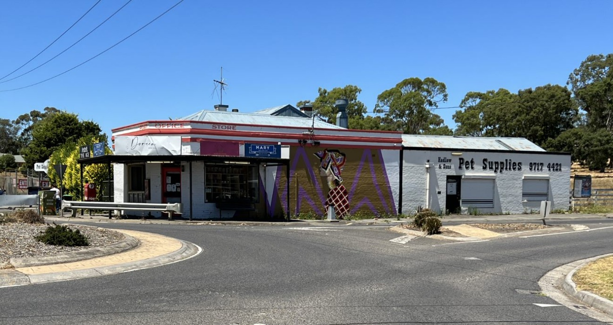

Historical Context

Doreen was established as an orchard district in the mid to late nineteenth century and was originally known as Linton as it was within the Parish of Linton. Several families have been associated with the district from the mid-nineteenth century: the Reids, the Bassetts, Herbert Brocks, Lobbs and Creightons are among them.

The first Linton (Hazel Glen) Wesleyan Chapel and Sunday School was built in 1863, located across Chapel Lane from the site of the existing church (Draper 2012). In 1867, Doreen’s first school, a non-vested Common School, was established on the south side of Chapel Lane. The school also became the location of Doreen’s first Postal Office, which operated from a room in the teacher’s residence until as late as 1894 (Payne 1989:3). The school became Common School No 945 in 1868 and was purchased by the Colonial Government in 1873, turning it into a State School (Payne, 1989:7). The school was moved to the current site on the north side of Doctor’s Gully Road in 1895 (Doreen Primary School, accessed 2015). From the 1870s onwards, the crossroads of Bridge Inn Road and Yan Yean Road has been the town centre of the district. In 1895, despite the opposition of the local community, the Post Master General had renamed the area ‘Doreen’ (Age, 15 June, 1895:7).

Doreen was becoming a more substantial locality by 1908, with greater emphasis being placed on the corner where the stores were located and a new recreation reserve and hall diagonally opposite to the stores. In 1909 when the hall was opened the local paper announced that “a few years ago the place was scarcely known; now it blossoms out as a leading place of the Shire” (EO&BER, 19 November 1909:2).41 In 1908 arrangements were being made for a telephone connection between Yan Yean and Doreen (EO&BER, 17 April 1908:2).

During the 1920s Doreen was a frequent stopping place for excursionists and the cross roads remained the centre of social activities for the predominantly fruit growing district.

History

In 1873 John Cornell purchased 10 acres, being the eastern half of Lot 4 Section A Parish of Greensborough, from Helen Cook(e). John Cornell’s father William, who had obtained the adjoining 20-acre lot to the east (Lot 5) in 1871 through an occupation license, purchased the other 10 acres (the western half), which adjoined land he already owned (CT V517 F371; Greensborough Parish Plan)

Early references indicate that John Cornell may have opened a store on the south-east corner of the crossroads in the 1880s: In 1882 and 1883 the Whittlesea Shire discussed road works near “Cornell’s store” (EO&S&EBR 16 December 1892:2; 18 May 1883:3). By 1897 the term ‘Cornell’s corner’ was in use (EO&S&EBR 27 August 1897:2). In July 1901 John Cornell advertised a store of four rooms and six acres of land to let at seven shillings per week (Age 19 July 1901:3). At his death in September 1901, John Cornell was living with his sister Elizabeth and brother-in-law William Christian in Doreen (EO&BER 27 September 1901:2).

The post office was transferred from the school residence to the store in 1902. In the same year, as a result of Cornell’s death, ownership of the 10-acre property with store went to Cornell’s sister Elizabeth Christian (CT V587 F331). John Adams was the postmaster from 1903-5, and John Davis followed until 1908. During Davis’ tenure the store was destroyed by fire and rebuilt (Payne 1989:34). It is possible that the existing residence adjacent to the current store was built at this time as it appears to date from this period.

The next long-term storekeepers, Mr Robert William Atkinson and his wife Georgina (Patterson), appear in the record around 1909 (EO&BER 14 May 1909:2). By March 1917, when the Atkinson’s announced they were retiring from the business, the store had become a stopping point for excursionists from the city. The Atkinson’s were described as “an agreeable and willing authority on the most accessible routes to the sylvan beauty spots located for many miles around for pleasure seekers.” The local paper reported on the widespread local expressions of regret from customers and the public at their departure, stating that “Mr and Mrs Atkinson…will be greatly missed in their public capacity at this centre, which is a convenient calling place for many.” During the war they had also been active workers for the local Red Cross Society, and the store had been made available as the receiving depot for donated articles (EO&BER 16 March 1917:2).

The next few years saw another succession of short-lived occupations of the store at the corner. In 1917 Mr Henry Gilbert Gentry, late of Clarinda Post Office, purchased the general store business “consisting of Groceries, Crockery, Ironmongery, Produce, Drapery, Haberdashery, etc.” The post office, telegraph and telegram services were also conducted from the store (E&WSA&DCVA 6 April 1917:3; EO&BER 9 March 1917:3; 30 March 1917:2).

Elizabeth Christian’s oldest daughter Mary and her husband Evan Owens took over the store next, as Owens was described as the postmaster and storekeeper in 1924 (Payne 1989:34; Advertiser (Hurstbridge) 16 May 1924:2). Telephone poles were installed between the store and ‘Reid’s Land’ in 1924/5 (Argus 9 December 1924:11). The increasing number of excursionists from the city was indicated by calls in 1927 for a “fingerpost” at the post-office corner; it was also noted that “every Sunday many motorists stop to inquire the destination of each of the four roads radiating from there” (Advertiser (Hurstbridge), 7 October 1927:2).

In 1931 Elizabeth Christian subdivided the 10-acre lot she had inherited from John Cornell. Evan Owens purchased a quarter-acre portion on the corner, including the store (CT V5756 F049; V5756 F050). Owen’s ownership of the freehold coincides with the rebuilding of the current post office store in 1932/3. The adjacent storeroom was likely part of this new building. During construction of the new brick store, a wall collapsed and crashed onto the road (Age 23 December 1932:10; Advertiser (Hurstbridge), 6 January 1933:4).

In 1934 Mary Owens died at the age of 37 (Advertiser (Hurstbridge) 5 January 1934:1). In the same year Evan Owens became a councillor for the Morang riding of the Whittlesea Shire (Advertiser (Hurstbridge) 14 September 1934:6; 5 October 1934:3). He also secured the contract for carting mail between Mernda and the Doreen post office (Advertiser (Hurstbridge) 29 June 1934:4).

When the Doreen Bush Fire Brigade was formed in 1942, Mr Owens was the first president, and equipment was stored at the Post Office store (E&WSA 16 January 1942:2; 6 February 1942:4). By 1941 a Mrs Mitchell was running the post office (E&WSA 31 October 1941:1). Between 1945 and 1991, the property changed ownership numerous times (CT V5756 F050; CT V7594 F166).

Description & Integrity

The Doreen General Store and Post Office consists of a corner brick shop building, a brick storeroom constructed in 1932-33 to the south, and a weatherboard residence attached on the east side. The residence dates from the early 20th century (c1908). The site is located on the south east of the intersection of Yan Yean Road and Doctors Gully Road.

The shop and residence are contained under one large, low-slung Dutch-gabled roof that runs on an east-west plane. The shop projects further north from the façade of the house to meet the corner of the intersection (Figure 1). This front projection is contained under a hipped roof. The roof form indicates that part of the store actually dates to the earlier period, and the front corner section and brick walls form the part of the building erected in 1932-33.

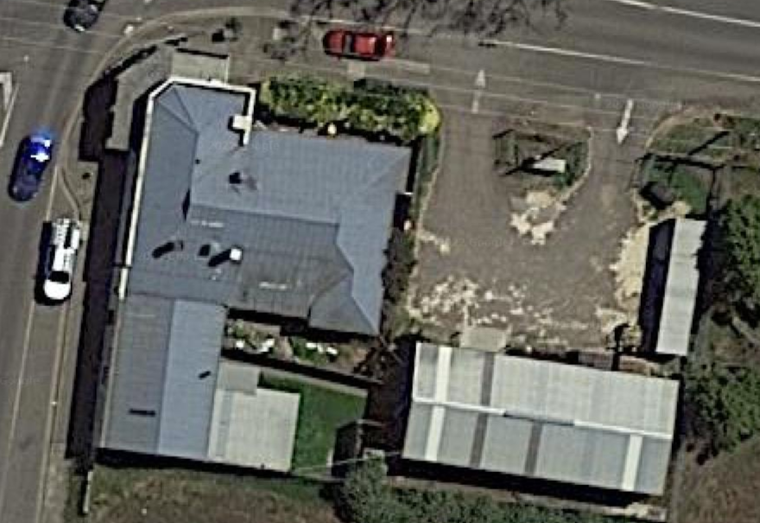
Figure 1: An aerial view of the site. The front projecting section of the corner store is highlighted in green; residence in yellow; and storeroom in red. Source: Google Maps.

The shop has a splayed corner and the entry door is located on this splay. Above the door is a small window (Figure 2). On each road elevation is a large shop window of the same size. The shop building has simple brick parapet with projecting brick courses on both elevations; original lettering is evident on this parapet as well.

Figure 2: A view of the small window above the doorway on the corner splay. Source: Google Maps.

The brick wall continues further south for the store building, however the parapet is lower along this section. The storeroom is contained under a gable roof that runs north-south. The storeroom has a single door on Yan Yean Road closest to the corner store, with two windows to the south.

The timber residence with weatherboard cladding has a frontage to Doctors Gully Road. The roof has deep eaves around the residence, with exposed rafters. There is a small, central recessed veranda on the front façade, with a later bay window to the side. A simple chimney is also evident (Figure 2).

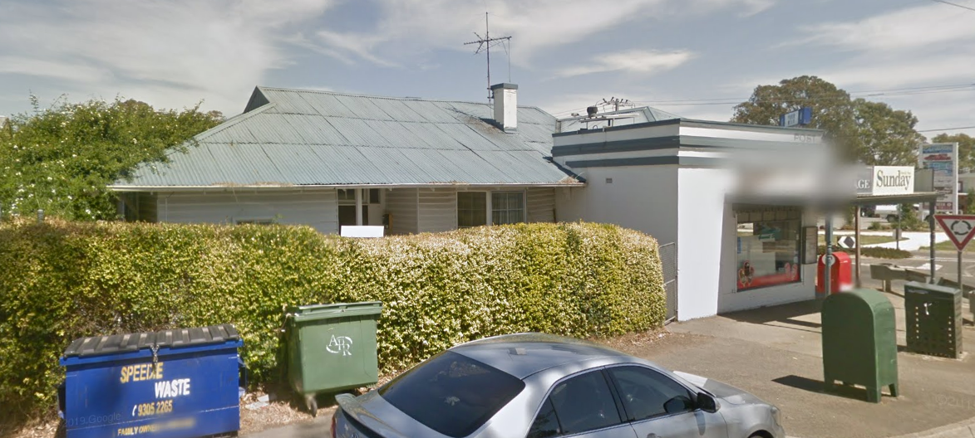
Figure 3: A view of the residence. Source: Google Maps.

Comparative Analysis

Post offices were integral to rural communities, as the primary method of communication for many. In rural settings such as the small towns in the Shire of Nillumbik, post offices were often combined with another integral commercial function, such as a general store. It was common for a residence to be attached for the postmaster and storekeeper.

This site is a rare surviving building on the central crossroads of Doreen, and demonstrates the early social, commercial and civic centre of the Doreen township. At its height, the intersection was home to was a blacksmith to the east of the general store and residence, another store across the road that closed around c.1910 and a public hall and recreation reserve on the diagonally opposite corner.

The subject site is an important surviving example of a Post Office and General Store located in what was the social centre of the town. Other examples within Nillumbik of early commercial buildings with a Post Office function that are in the Heritage Overlay are as follows:

- Kangaroo Ground General Store & Post Office, 280 Eltham-Yarra Glen Road, Kangaroo Ground (HO48)
- Hurstbridge Post Office-Evelyn Observer Office, 794 Heidelberg-Kinglake Road, Hurstbridge (HO68)
- Old Store and Post Office, 910 Arthurs Creek Road, Arthurs Creek (HO179)

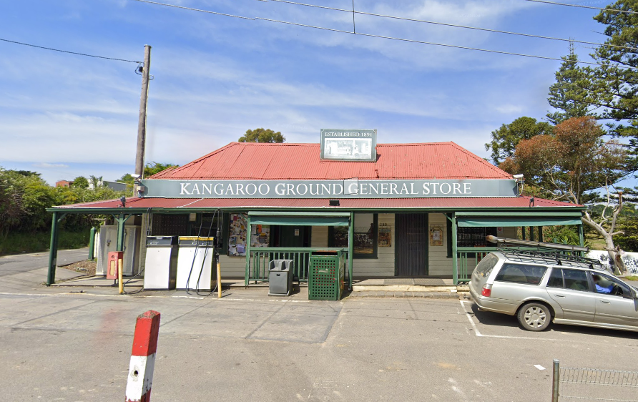  Figure 4. Kangaroo Ground General Store & Post Office, 280 Eltham-Yarra Glen Road, Kangaroo Ground (HO48) | 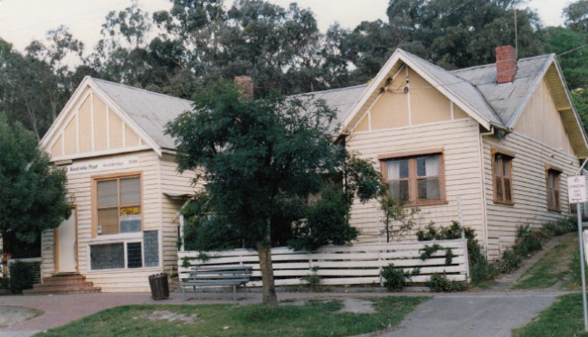  Figure 5. Hurstbridge Post Office-Evelyn Observer Office, 794 Heidelberg-Kinglake Road, Hurstbridge (HO68)
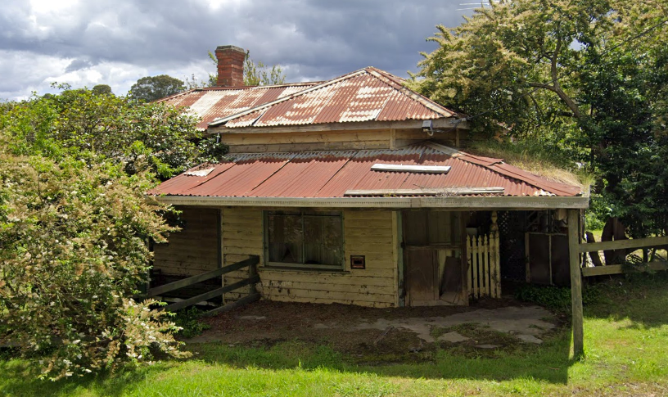
Figure 6. Old Store and Post Office, 910 Arthurs Creek Road, Arthurs Creek (HO179)

The General Store and Post Office at 280 Eltham-Yarra Glen Road is historically significant as a centre of community life since c1900, including its use for Council meetings which were conducted in the front room of the store. The building is also aesthetically significant as one of a group of three well preserved public buildings in the Kangaroo Ground hamlet.

The post office and former newspaper office at 794 Heidelberg-Kinglake Road is historically significant because it was constructed for the local newspaper, the Evelyn Observer. The office is historically and socially significant because it has served as a post office since 1930 and is an important component of a group of pre-1950s structures in this part of the town.

The former store and post office at 910 Arthurs Creek Road is significant as a well-preserved building and early within Arthurs Creek, and for its rare shopfront detailing. The building is considered as contributing to the significant historic landscape of the town.

Although united by their similar functions as post offices with secondary commercial functions, the subject site is distinctive among these examples for its prominent corner siting and brick construction. The subject site is similar to the Arthurs Creek example for its attached residence.

All three comparative example are constructed in timber, which is reflective of the modest town development that occurred in the Victorian and Edwardian periods. The choice to erect a prominent brick store front indicates a level of prosperity for the locality and the site’s prominence in the town setting. Aesthetically, the subject site is also set apart from the comparative examples by its restrained design with Moderne influences, evident in the parapet brick courses and lettering.
Assessment Against Criteria

Criteria referred to in Practice Note 1: Applying the Heritage Overlay, Department of Planning and Community Development, revised July 2015, modified for the local context.

CRITERION A: Importance to the course or pattern of the Shire of Nillumbik’s cultural or natural history (historical significance).

The Doreen Post Office and General Store is historically significant as an early social centre for the township of Doreen. The site has functioned as the Post Office since 1902, however the current shopfront dates to the 1932-33. The building also has associations with the tourism history of the Shire, as from the late nineteenth the General Store facilitated excursionists from the city on their way to points of interest in the district. It is one of only a few surviving premises that evidence the early township of Doreen at this key intersection, with other early buildings having been demolished.

CRITERION B: Possession of uncommon, rare or endangered aspects of the Shire of Nillumbik’s cultural or natural history (rarity).

CRITERION C: Potential to yield information that will contribute to an understanding of the Shire of Nillumbik’s cultural or natural history (research potential).

CRITERION D: Importance in demonstrating the principal characteristics of a class of cultural or natural places or environments (representativeness).

The Doreen Post Office and General Store is significant as an example of an interwar brick corner commercial building with earlier attached residence. The prominent corner location on an important intersection demonstrates the Post Office and Store’s role in the life of the town. The shopfront shows elements of the Moderne style, and retains details including the original brick walls, parapet with cornice, corner entry and shop windows. The residence retains its original roof form, weatherboard walls and front veranda.

CRITERION E: Importance in exhibiting particular aesthetic characteristics (aesthetic significance).

CRITERION F: Importance in demonstrating a high degree of creative or technical achievement at a particular period (technical significance).

CRITERION G: Strong or special association with a particular community or cultural group for social, cultural or spiritual reasons. This includes the significance of a place to Indigenous peoples as part of their continuing and developing cultural traditions (social significance).

CRITERION H: Special association with the life or works of a person, or group of persons, of importance in the Shire of Nillumbik’s history (associative significance).

Grading and Recommendations

Recommended for inclusion in the schedule to the Heritage Overlay of the Nillumbik Planning Scheme.
Scheme.
Recommendations for the Schedule to the Heritage Overlay (Clause 43.01) in the Nillumbik Planning Scheme:

External Paint Colours  Is a permit required to paint an already painted surface? | No
Internal Alteration Controls  Is a permit required for internal alterations? | No
Tree Controls  Is a permit required to remove a tree? | No
Victorian Heritage Register  Is the place included on the Victorian Heritage Register? | No
Incorporated Plan  Does an Incorporated Plan apply to the site? | No
Outbuildings and fences exemptions  Are there outbuildings and fences which are not exempt from notice and review? | No
Prohibited uses may be permitted  Can a permit be granted to use the place for a use which would otherwise be prohibited? | Yes
Aboriginal Heritage Place  Is the place an Aboriginal heritage place which is subject to the requirements of the Aboriginal Heritage Act 2006? | No

Identified By

Mills & Westbrooke

References

Age, as cited.

Advertiser (Hurstbridge), as cited.

Argus, as cited.

Doreen Primary School History (archived webpage), https://webarchive.nla.gov.au/awa/20170218044436/http://www.doreenps.vic.edu.au/general_history.htm accessed 25 March 2022

Draper, 2012, Arthurs Creek Mechanics' Institute, Mechanics' Institute Inc., Arthurs Creek.

Eltham and Whittlesea Shires Advertiser and Diamond Creek Valley Advocate, as cited.

Evelyn Observer and Bourke East Record (EO&BER), as cited.

Evelyn Observer and South and Bourke East Record (EO&S&EBR), as cited.

Land Victoria, Certificates of Title (CT), as cited.

Mornington Standard, as cited.

Payne, J.W. 1989, The Quiet Hills Doreen (Vic.), J.W. Payne.

