Hazel Glen Uniting Church
Prepared by: Trethowan Architecture

Address: 1070 Yan Yean Road, Doreen
Name: Hazel Glen Uniting Church | Survey Date:
Place Type: Religious | Designer: CH Robinson
Grading: Religious | Builder: Nelson and Young
Extent of Overlay: To title boundaries | Construction Date: 1872

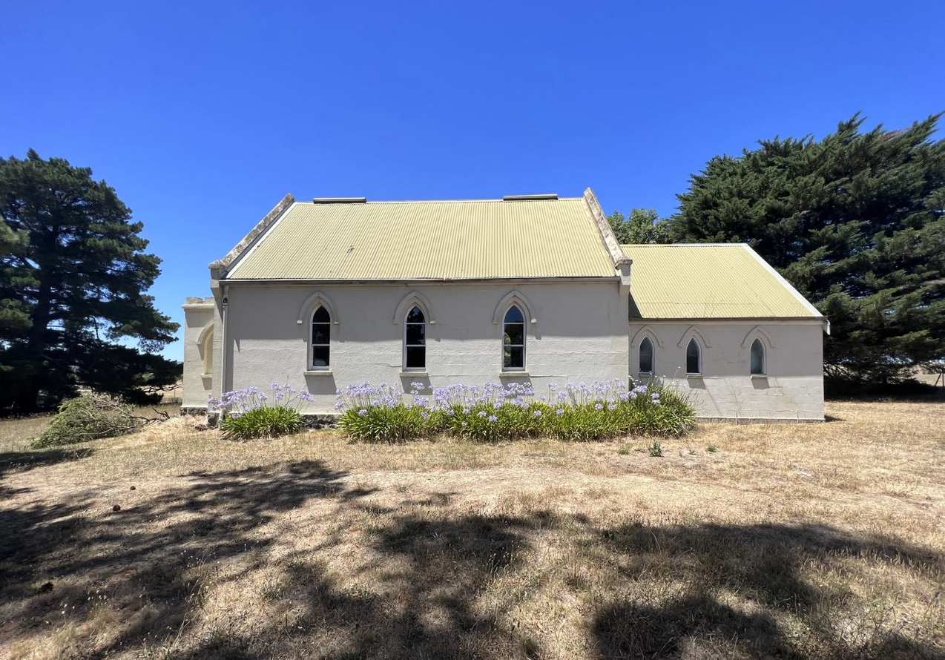

Historical Context

Doreen was established as an orchard district in the mid to late nineteenth century and was originally known as Linton as it was within the Parish of Linton. Several families have been associated with the district from the mid-nineteenth century: the Reids, the Bassetts, Herbert Brocks, Lobbs and Creightons are among them.

The first Linton (Hazel Glen) Wesleyan Chapel and Sunday School was built in 1863, located across Chapel Lane from the site of the existing church (Draper 2012). In 1867, Doreen’s first school, a non-vested Common School, was established on the south side of Chapel Lane. The school also became the location of Doreen’s first Postal Office, which operated from a room in the teacher’s residence until as late as 1894 (Payne 1989:3). The school became Common School No 945 in 1868 and was purchased by the Colonial Government in 1873, turning it into a State School (Payne, 1989:7). The school was moved to the current site on the north side of Doctor’s Gully Road in 1895 (Doreen Primary School, accessed 2015). From the 1870s onwards, the crossroads of Bridge Inn Road and Yan Yean Road has been the town centre of the district. In 1895, despite the opposition of the local community, the Post Master General had renamed the area ‘Doreen’ (Age, 15 June, 1895:7).

Doreen was becoming a more substantial locality by 1908, with greater emphasis being placed on the corner where the stores were located and a new recreation reserve and hall diagonally opposite to the stores. In 1909 when the hall was opened the local paper announced that “a few years ago the place was scarcely known; now it blossoms out as a leading place of the Shire” (EO&BER, 19 November 1909:2).41 In 1908 arrangements were being made for a telephone connection between Yan Yean and Doreen (EO&BER, 17 April 1908:2).

During the 1920s Doreen was a frequent stopping place for excursionists and the cross roads remained the centre of social activities for the predominantly fruit growing district.

History

The first Linton (Hazel Glen) Wesleyan Chapel was built in 1863 on land acquired from Thomas Stockdale. The timber slab-walled and bark-roofed building stood on a site across Chapel Lane from the site of the existing church (Draper 2012).

The Wesleyan Chronicle of June 1863 reported on the ‘Wesleyan Sunday-school Anniversary’ celebration on 31 May 1863, indicating that the congregation had formed in May of 1862. Thomas Stockdale became the first Sunday School Superintendent, and subsequent anniversaries of the Sunday School would be based on this founding year (Advertiser (Hurstbridge) 24 March 1933:3).

The first church was still standing, though in poor condition, when moves were made to build a new and larger church in 1872 (Wesleyan Chronicle March 1872). A contemporary article in the Age states that Melbourne soap and candle manufacturer and Mayor of Collingwood Henry Walker gifted approximately an acre of his land across Chapel Lane (part of Lot 30D Parish of Morang) for the purposes of erecting a new church (Age 20 March 1873:3).

C.H. Robinson of Heidelberg prepared plans and specifications free of charge. Robinson was involved with the Wesleyan church in Heidelberg and was the Heidelberg shire auditor. No evidence has been found that he was as architect. (Age, 28 November 1873:3; 1 August 1878:3.) The builders were Messrs. Nelson and Young (Age, 20 March 1873:3).

The church was of rendered masonry construction on a bluestone plinth and footings, and it was roofed with hardwood shingles (Draper 2012). The new Linton Wesleyan Church was opened on Sunday 16 March 1873 with the Rev. C. Dubourg giving two sermons (Age 20 March 1873:3). Dubourg was responsible for the building of three other local Wesleyan churches during his ministry from 1871-1874 – Whittlesea, Wollert and Thomastown (Payne 1989:28).

Slabs from the original church were used to build a stable in the new grounds, but this was destroyed by fire in 1930 and was replaced by an “iron” structure (Payne 1989?28). The name was changed to Hazel Glen Wesleyan Church in 1886, following the change of name of the locality (Draper 2012).

The church and Sunday school played an important part in the community life of the locality, marked by regular services, weddings and funerals and a number of annual celebrations. The first “Methodist social” was held at Hazel Glen in 1927 (Advertiser (Hurstbridge), 12 August 1927:3). From the late 1920s harvest thanksgiving services or harvest festivals were held at the church (Advertiser (Hurstbridge) 18 March 1927:3; 1 March 1929:2; 28 March 1930:2; 16 March 1934:7).

A working bee installed a “fine cyclone fence” around the church in 1939 (Advertiser (Hurstbridge) 7 July 1939:3). In 1940 the Yan Yean circuit of the Methodist Church, which included Whittlesea, Yan Yean, Hazel Glen, Mernda, Doreen, Yarrambat, South Morang, Wollert, Woodstock and Beveridge, was altered from an Independent Ministerial Circuit to a Home Mission Station, as a result of dwindling attendance (Eltham and Whittlesea Shires Advertiser 21 March 1940:2).

A 1960 plan shows a single room vestry 10x15 ft. with a fireplace and chimney, and small entrance porch on the east, with no side windows. The porch at this stage was 6x6ft. Pit toilets were located at the southeast corner of the church land (Department of Health Public Building File No.11960, VPRS 7882, Consignment P1, Unit 1401). An early photo and a 1980 photo show the old small rendered masonry porch with castellated parapet and door on one side and window on the other (Payne 1989?:28; Figure 1). The centenary of the church building was held in 1972 (Payne 1989?:28). In 1977 the Hazel Glen Church, now in the Parish of Mernda, became part of the Uniting Church in Australia, when the majority of the Methodist, Presbyterian and Congregationalist congregations opted to merge.

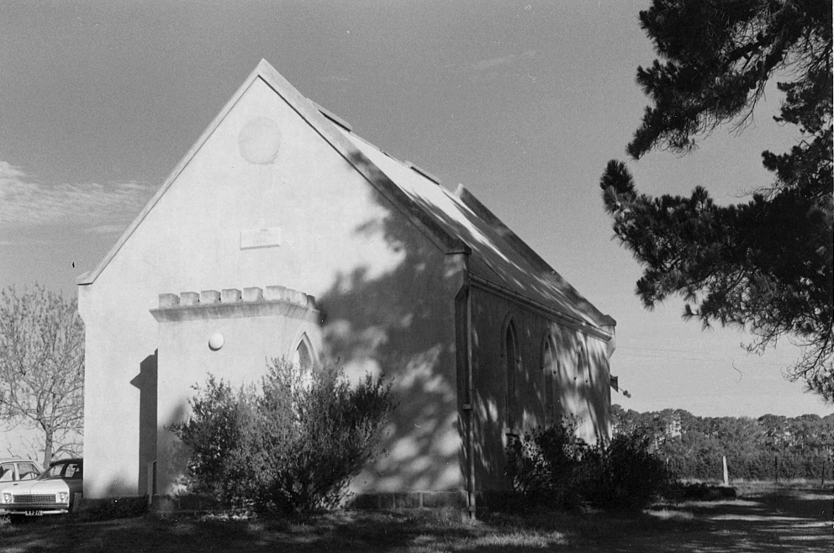
Figure 1: A view of the north of the subject building dated to 1980, showing the original castellated front porch with west facing door. Source: Collins 1980.

In the 1990s Church Elder Jim Barr was instrumental in the replacement of the “southern
extension” of the church (the vestry) to provide a building more in keeping with the main body of the church, and provide modern toilets. The scrollwork above the Communion Table was repainted by notable artist Kenneth Jack. In 1993 the porch was enlarged to around 8x12ft with a rendered castellated parapet, presumably based on the old porch. It included a northern mosaic window of stained glass by notable mural and mosaic artist David Jack (Draper 2012). At the 125th anniversary in 1997 new entrance gates were dedicated in memory of Mr Jack Bassett of ‘Tregowan’, Doreen, “who worked tirelessly and enthusiastically for Hazel Glen Church throughout his life” (Draper 2012).

Description & Integrity

Hazel Glen Uniting Church is a single-storey building constructed of rendered brick on a bluestone plinth. The building has a gable roof running north south. The roof, originally clad in shingles, is now clad in corrugated metal. A smaller gable section also clad in corrugated metal is located to the south. There is a low parapet moulding following the line of the roof at the gable ends of the nave. The side walls of the nave contain three evenly spaced Gothic arch windows with rendered drip moulds around the arch (Figure 2). A small plaque bearing ‘Wesleyan Chapel 1872’ is located on the north gable end (Figure 3). Round openings, likely originally vents, are located in the apexes of both gable ends to the original section of the church. They have since been filled in (Figure 4).

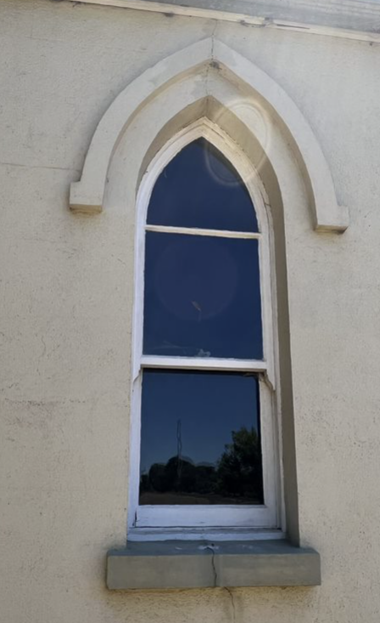
Figure 2: An example of an original side window with drip mould.
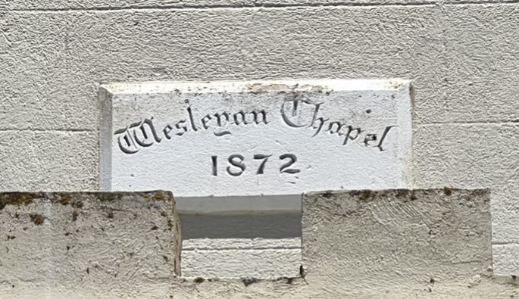
Figure 3: The date plaque. Source: Trethowan 2022.

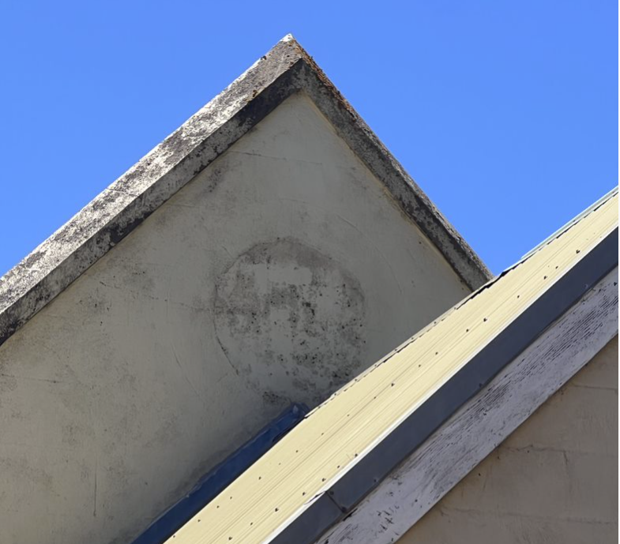
Figure 4: A view of the former round opening to the south gable end. Source: Trethowan 2022.

There is a front porch at the north end with a castellated parapet. This replaced an original smaller porch, which also had a castellated parapet. The new porch includes a northern mosaic window of stained glass by notable mural and mosaic artist David Jack. The gable roofed nave to the rear (south) was also erected in the 1990s. It replaced an earlier nave in this location. The 1990s nave has pointed arch windows to the west and south walls and an entry door and rectangular window on the east wall.

The church sits at the southern end of the corner block with pine boundary plantings on both road elevations. There are double iron entry gates at the south west corner off Yan Yean Road (Figure 5). These were erected in 1997. In the south east corner of the site are skillion roofed corrugated iron clad toilet buildings.

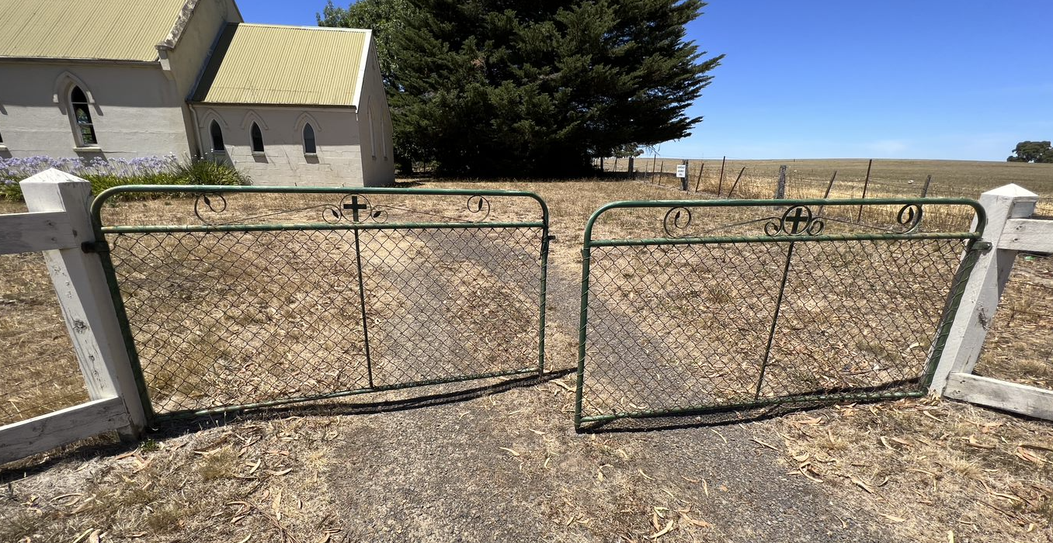
Figure 5: A view of the gates fronting Yan Yean Road. Source: Trethowan 2022
Comparative Analysis

Churches were an integral part of the social life of communities within the Shire of Nillumbik and were often amongst the first buildings constructed within townships. Not only did these buildings provide places for worship, they often functioned as places to gather, celebrate and be educated.

Apart from the Doreen Store and Post Office, this is the only other surviving public building to demonstrate the township of Hazel Glen, which was later to become Doreen. It importantly represents the establishment of a community in the area in the Victorian period. There are no other sites in Doreen that can demonstrate this community establishment.

Comparable churches in Nillumbik on the Heritage Overlay are as follows:

- Presbyterian Church, 265 Eltham-Yarra Glen Road, Kangaroo Ground c1878 (HO46)
- St Andrews Anglican Church, 15 Caledonia Street, St Andrews c1868 (HO21)
- Uniting Church (originally Methodist) 810 Main Road, Eltham 1880 (HO118)

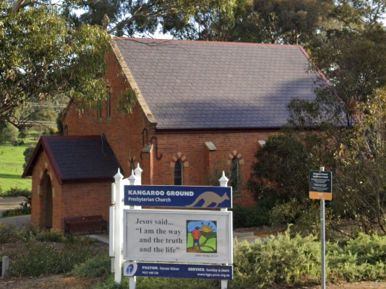  Figure 5. Presbyterian Church, 265 Eltham-Yarra Glen Road, Kangaroo Ground c1878 (HO46) | 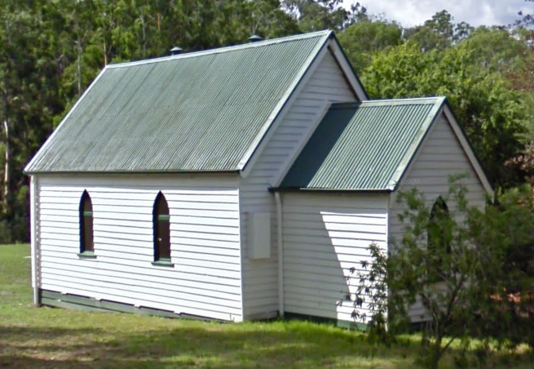  Figure 6. St Andrews Anglican Church, 15 Caledonia Street, St Andrews c1868 (HO21)
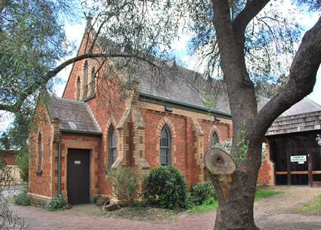
Figure 7. Uniting Church (originally Methodist) 810 Main Road, Eltham 1880 (HO118)

The Presbyterian Church at 265 Eltham-Yarra Glen Road, Kangaroo Ground, is a bichromatic brick building with slate roof thought to have been built c1878, and one of only a few well preserved buildings in the town from that era. The church is historically and socially significant because it has served the local community since construction.

The Anglican church at 15 Caledonia Street, St Andrews is a simple timber building, thought to be erected c1868. The building is significant as one of only four buildings remaining from the town’s goldmining era, and potentially gave its name to the township. The church is also important for the ongoing role it has played in local community life.

The former Methodist Church at 810 Main Road, Eltham, is a bichromatic brick building with slate roof build in 1880. The building is aesthetically significant as a finely detailed example of a rural community church. The place is also significant for its ongoing community role in the region.

Like the subject site, each of these examples bear the characteristics of the Gothic Revival style, applied to a simple and modestly sized building form with gable roof. The simple designs of the subject church, and these examples, reflect their rural location and the modest needs of the local congregations at the time when they were built. The subject site is set apart from these examples by its rendered surfaces, as opposed to timber or bichromatic brick work. Further, similar to the comparable examples, the subject site has a demonstrated continual use as a church, servicing the local community as a place of worship and gathering. Overall, the subject site compares favourably against these examples.

Assessment Against Criteria

Criteria referred to in Practice Note 1: Applying the Heritage Overlay, Department of Planning and Community Development, revised July 2015, modified for the local context.

CRITERION A: Importance to the course or pattern of the Shire of Nillumbik’s cultural or natural history (historical significance).

Hazel Glen Uniting Church is historically significant as one of the only remaining early community buildings in the Hazel Glen (later Doreen) area. Constructed in 1872, the brick church replaced an earlier timber slab building that had been erected nearby in 1863. The construction of a more substantial brick church at that time indicates the surrounding farming community had grown relatively prosperous. The building also highlights the importance of religious buildings in spiritual and community life during the Victorian period. The Church is also significant for its ongoing use by the same congregation, and historical associations are celebrated though elements including memorial gates.

CRITERION B: Possession of uncommon, rare or endangered aspects of the Shire of Nillumbik’s cultural or natural history (rarity).

CRITERION C: Potential to yield information that will contribute to an understanding of the Shire of Nillumbik’s cultural or natural history (research potential).

CRITERION D: Importance in demonstrating the principal characteristics of a class of cultural or natural places or environments (representativeness).

Hazel Glen Uniting Church is significant as a representative example of a rural Victorian church, conforming to the simple forms and Gothic Revival style that many churches adopted in the region from the 1860s up to the interwar period. The use of bluestone and rendered brick is uncommon in the more rural townships in the Shire, where many religious buildings were timber. The original section of the church retains key original features including Gothic arch windows with drip moulds. The location of the church on a rise with a clear land around on the site and border pine plantings contributes to the significant setting of the place.

CRITERION E: Importance in exhibiting particular aesthetic characteristics (aesthetic significance).

CRITERION F: Importance in demonstrating a high degree of creative or technical achievement at a particular period (technical significance).

CRITERION G: Strong or special association with a particular community or cultural group for social, cultural or spiritual reasons. This includes the significance of a place to Indigenous peoples as part of their continuing and developing cultural traditions (social significance).

Hazel Glen Uniting Church is of social significance as it has been a primary place of worship and community gathering in the district since 1872 to the present day. The building continues to be used for these purposes by the congregation.

CRITERION H: Special association with the life or works of a person, or group of persons, of importance in the Shire of Nillumbik’s history (associative significance).
Grading and Recommendations

Recommended for inclusion in the schedule to the Heritage Overlay of the Nillumbik Planning Scheme.
Recommendations for the Schedule to the Heritage Overlay (Clause 43.01) in the Nillumbik Planning Scheme:

External Paint Colours  Is a permit required to paint an already painted surface? | No
Internal Alteration Controls  Is a permit required for internal alterations? | No
Tree Controls  Is a permit required to remove a tree? | Yes – Pine trees
Victorian Heritage Register  Is the place included on the Victorian Heritage Register? | No
Incorporated Plan  Does an Incorporated Plan apply to the site? | No
Outbuildings and fences exemptions  Are there outbuildings and fences which are not exempt from notice and review? | Yes – gates facing Yan Yean Road
Prohibited uses may be permitted  Can a permit be granted to use the place for a use which would otherwise be prohibited? | Yes
Aboriginal Heritage Place  Is the place an Aboriginal heritage place which is subject to the requirements of the Aboriginal Heritage Act 2006? | No

Identified By

Mills and Westbrooke

References

Advertiser (Hurstbridge), as cited.

Age, as cited.

Collins, John T 1980, ‘Hazel Glen, Uniting Church, former Methodist, Yan Yean Rd’, State Library of Victoria (SLV) JT Collins collection, accessed online 16 February 2022.

Department of Health Public Building File No.11960, VPRS 7882, Consignment P1, Unit 1401

Doreen Primary School History (archived webpage), https://webarchive.nla.gov.au/awa/20170218044436/http://www.doreenps.vic.edu.au/general_history.htm accessed 25 March 2022

Draper, B. 2012, Hazel Glen Wesleyan Church, Bruce Draper.

Eltham and Whittlesea Shires Advertiser, as cited.

Evelyn Observer & Bourke East Record (EO&BER), as cited.

Lewis, Miles, ed. 1991. Victorian Churches. Melbourne: National Trust of Australia Victoria.

Payne, J.W 1989, The Quiet Hills Doreen (Vic.), J.W. Payne.

Spectator and Methodist Chronicle, as cited.

Wesleyan Chronicle, as cited.

