Laughing Water
Prepared by: Trethowan Architecture

Address: 220 Laughing Waters Road, Eltham
Name: Laughing Water | Survey Date:
Place Type: Residential | Designer: Alistair Knox
Grading: Significant | Builder: Alistair Knox
Extent of Overlay: To title boundaries | Construction Date: 1969

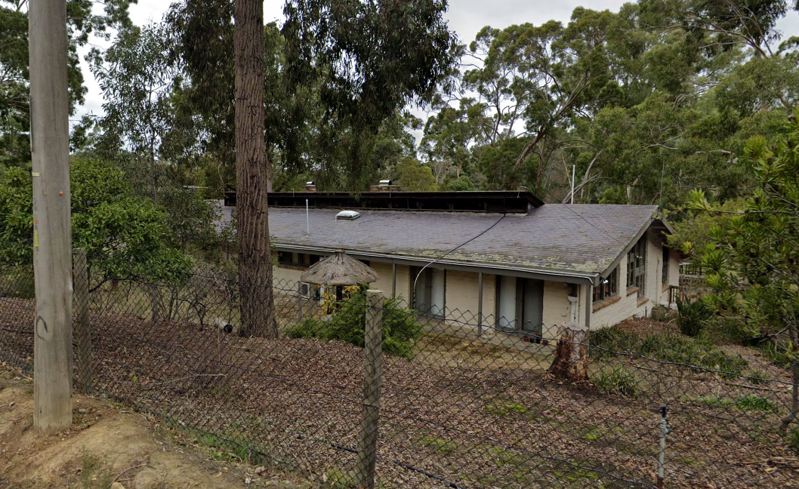
Figure 1: Source: Google Maps.

Historical Context

Eltham, situated in hilly country northeast of Melbourne, is located on the country of the Wurundjeriwillam clan of the Woi wurrung, one of the five tribes of the Kulin Nation. A plan for fifty allotments in the Township of Eltham, Parish of Nillumbik, was announced in 1848, with the name officially gazetted in 1851. The township, near the junction of the Diamond Creek and the Yarra River, was laid out an area bounded by Baxter Street, Diamond Creek, Dalton Street and Bolton Street. This area is known today as Eltham South. Present-day Eltham, however, was not established on the township reserve, where land proved difficult to sell. Instead, the town grew from allotments in Section IV of the Parish of Nillumbik located on Main Road, to the north of Dalton Street and the township reserve (Butler 1996:32). The township grew during the 1850s around a cluster of buildings at the corner of Pitt Street and Main Road within the Little Eltham subdivision. Located on the road to the Caledonian Diggings, this small township became a service centre for the surrounding mining areas, and by 1854 supported a population of 282. In this period Eltham had two hotels, a brewery and tannery on Diamond Creek. Several public buildings and institutions, including a police station, Wesleyan chapel, a Church of England School and a National School, were established in the 1850s -70s (Context, 2020:1).

Between the 1860s and the 1880s, Eltham supplied food and produce for the gold-mining communities of the Caledonian Diggings at Queenstown (St Andrews) and Panton Hill. It also became a stopping place on route to the Woods Point diggings. Eltham’s population grew in response. In 1871, the town’s population was 165 and by 1881 this had increased to 388 (Victorian Places 2015). Several large properties surrounding the township had absentee owners, who subdivided their properties into smaller farms either for lease or sale. The smaller properties, especially in the Little Eltham township, were run by farmers who often made a modest living as wage labourers. Like many later Eltham residents, they were attracted by cheap land and the country life (Butler 1996:33).

The railway was extended to Eltham opened in 1902, which brought excursionists from Melbourne, many of whom picked wattle during the flowering season, and focused development of the Eltham township around the railway station. Eltham was a picturesque village with the advantage of its proximity to metropolitan Melbourne as well as to attractive countryside with farms and uncleared stringybark forest (Victorian Places 2015). The attractive bush scenery attracted artists, writers and nature-lovers. The landscape painter Walter Withers (1854-1914) moved to Eltham in 1902 when the railway opened; others artists, including members of the Heidelberg School, painted in the area in the open air. Clara Southern and May Vale, landscape painters and students of Frederick McCubbin, settled in the region. Vale resided at Diamond Creek and Southern at Warrandyte (Bartolomei 2008). The war artist Will Longstaff also lived in Eltham for a period. Artist Justus Jorgensen established the notable Montsalvat artist’s colony buildings, on land he purchased in 1934. Seeking a closer engagement with the natural environment, the establishment of Montsalvat, with its adobe and rammed earth buildings, influenced future mud brick construction in the area. Several local architects and designers, including Alistair Knox, specialised in mud brick housing in the post-war period (Victorian Places 2015). Others who have been inspired by Eltham and have made the region their home include landscape architect Edna Walling, authors Alan Marshall and Carolyn Van Langenberg, artists Clifton Pugh and Danila Vassilieff; composers and musicians Graeme and Roger Bell; jewellers and sculptors Michael Wilson, Simon Icarus Baigent and Matcham Skipper; writer CB Christensen; poet Chris Wallace-Crabbe; and actress Kerry Armstrong (Bartolomei 2008; Pierce 1987:354).

Eltham experienced significant post-war development with a number of residential estates subdivided and put up for sale. The population of the town increased from 927 in 1933, to 1278 in 1947, to 7177 in 1971. As a result, Eltham High School opened in 1950 and the Catholic Ladies College was relocated to Eltham in 1971 (Victorian Places 2015). The Eltham War Memorial Trust Baby Health Centre opened in 1951. New shire offices opened in 1965, and Eltham College commenced classes in 1974 (Eltham District Historical Society 2000:np).

A distinctive style in local building emerged in Eltham in the post-war period, with a strong use of natural materials, low form structures, and an integration with the natural environment and the preference for bush gardens, especially after the 1970s. The Eltham Library, designed by architect Greg Burgess, was constructed in mud brick and recycled timbers and received the RAIA Institutional Architecture Award in 1995 (Bartolomei 2008).

The Shire of Eltham became part of the Shire of Nillumbik in 1994, with a small area becoming part of the City of Banyule.

History

The original Laughing Water house was built at the subject site in 1912-1913 for Dr Sidney Valentine Sewell. Sewell sold the house in 1922 to the O’Connor family, who moved to the property from the Gippsland (Woollard 2016:99). The O’Connor’s were relatives of the Barlee family, who were residents of the notable house Worlingworth on Banoon Road in Eltham (Woollard 2016:107). The street name is believed to be derived from the property.

The property was later purchased by Gosta Petre, the Swedish Consul. Using Laughing Water as his weekend residence, Petre commissioned the renowned landscape designer Edna Walling to lay out the garden (Woollard 2016:111; Figure 2). Edna Walling (1895-1973) was a designer and conservationist, who became well known for the gardens she created for wealthy clientele in the first half of the twentieth century. Known for her use of garden elements such stone walls, pergolas, stairs, parterres, pools and colonnades, she became a ‘household name’ in Australia by the 1940s. Many of her gardens remain around Australia, although most are in Victoria (Watts 2002).

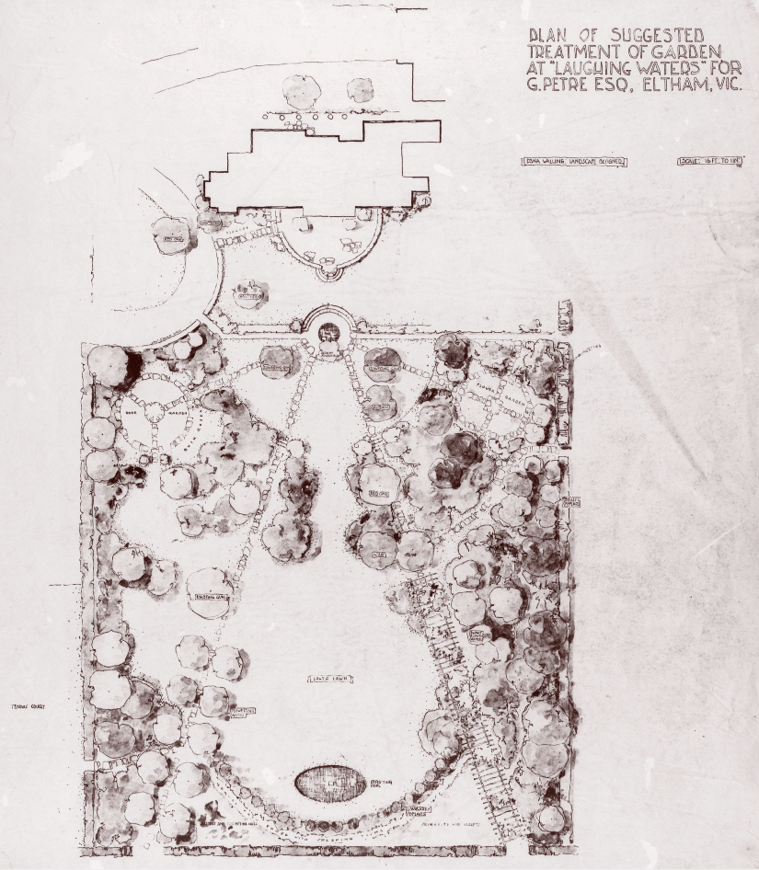
Figure 2: The garden plan prepared by Edna Walling for Laughing Water c1930s. Source: Walling c1930.

The house was purchased by Ken and Kath Guest c1941, following Petre’s death. The Guests owned the house when a bushfire destroyed much of Laughing Waters Road in 1965, including the houses on the site (Woollard 2016:111, 118). In 1969, Kath Guest’s daughter Susie and her husband Malcolm Hastie commissioned Alistair Knox to construct a new mudbrick house at the property, sited almost exactly where the former house had stood. When constructed, the Hastie family moved permanently to the house from Toorak (Woollard 1016:118). The landscape designer Gordon Ford was commissioned to undertake work on Walling’s original garden, and his changes included making the pond larger and planting native trees.

The Hastie family remained at the house for almost four decades, until Parks Victoria acquired the property in 2006. In the same year, the house became a retreat for families with children who were seriously ill or disabled. This program, known as ‘Caitlin’s Retreat’, still operates at the site (Woollard 2016: 122-123).

Description & Integrity

220 Laughing Waters Road is a substantial, single-storey mudbrick house. The building is rectangular in form, on an east-west axis. The house in contained under one large, low-slung slate-clad gable roof. The central section of the southern gable plane extends over the ridgeline to accommodate a clerestory window.

The southern façade features a central recessed section. Substantial bluestone piers divide bays of windows in this recess (Figure 3). Timber framed windows and doors are evident across the building, as are stained timber fascia boards.

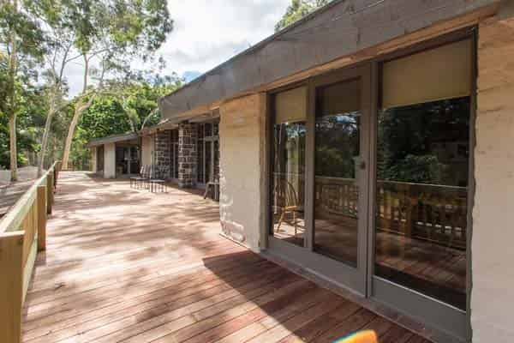
Figure 3: A view of the southern façade, showing the central recessed section with bluestone piers. Source: Tony Knox, Alistair Knox Foundation.

On the northern façade, timber rafters originally extended past the eave line to connect with timber posts to create an open trellis (Figure 4). These have since been removed and shortened to the eave line. This façade features rhythmically placed sets of French doors.

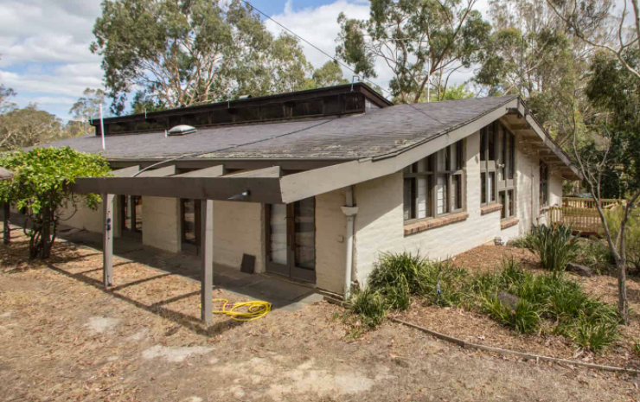
Figure 4: A view of the north east of the house. The original rafters extending to create the trellis on the north are still evident in this photo but have been removed. Note the clerestory windows. Source: Tony Knox, Alistair Knox Foundation.

Elements of Edna Walling’s garden plan are still legible, including the general layout with splayed view lines radiating from the central round pond, with large pond located as a focal point at the end of the garden. These ponds still exist, along with stone walls, the tennis court, and possibly early tree planting (Figure 5).
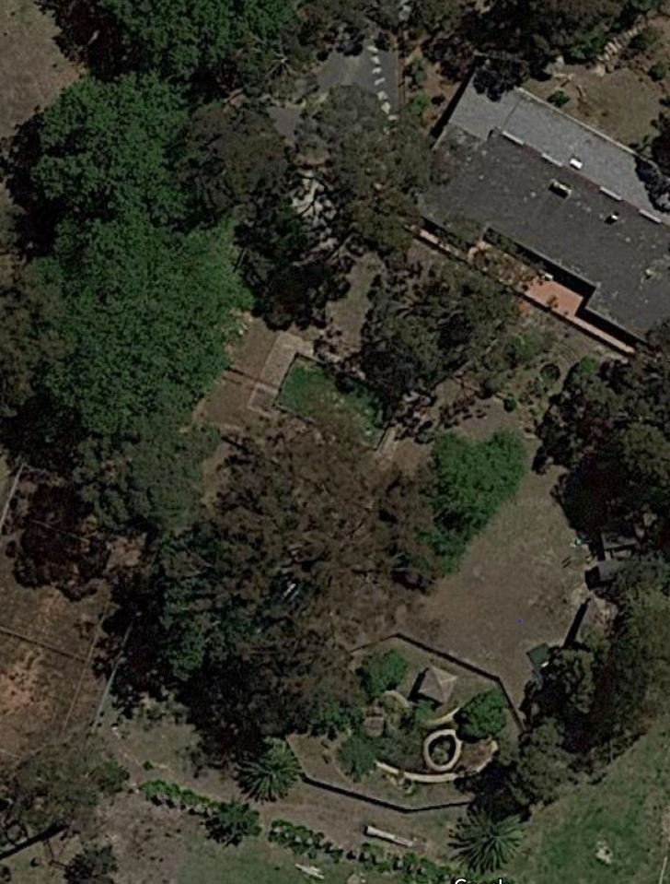
A
B
C
Figure 5: An aerial of the site, showing elements of the garden that remain intact to Walling’s plan (with later additions by Gordon Ford). These include the ponds (A&B) and tennis court (C). Source: Google Maps.

Comparative Analysis
Although Post-war modernism had taken off across the suburbs of Melbourne, the Eltham and Warrandyte areas saw an alternative form of architectural experimentation. Mills and Westbrooke write that

the trend was characterised by an acceptance of the characteristics of the site, including the local bush, topography and geology and an attempt to blend and adapt to these conditions through building form and siting, choice of materials and landscape approach. The best-known spokesperson for this trend, Alistair Knox, gave it the label ‘Australian environmental building’ (Mills and Westbrooke 2016: 78)

The style that developed, often referred to as ‘the Eltham Style’ or ‘the Warrandyte Rustic’, was characterised by its use of honest, natural materials including mud bricks, local stone and expressed structural timber. Recycled materials were often utilised in construction (Mills and Westbrooke 2016: 78).

Alistair Knox was a prolific builder and designer who is widely associated with developing the style, and for his contribution to the built environment in the Shire of Nillumbik. Mills and Westbrooke further note that

inspired by his visits to Montsalvat in the early 1940s and, after the war, he studied building at the Melbourne Technical College. Knox’s early work in Eltham falls into two main categories: simple rectilinear forms, which were the basis for most of his work up to the 1970s, and a first flush of complex exploratory designs …

By the mid-1960s Knox had become something of an industry in his own right. A 1966 article indicates he had already built over one hundred houses since 1946. In this period, he was increasingly mining a rich vein of high quality materials from the nineteenth century buildings then being demolished in the city. His Glover house in Eltham was built by Dutch immigrant builder Pieter Hellemons using recycled bricks and timber. The property was also graced with a ‘natural rock and bush’ garden design by Gordon Ford (Mills and Westbrooke 2016:79-80).

The subject site, designed by Alistair Knox, bears key characteristics of his work. Although Knox was a prolific builder and designer in the Shire, only a handful of examples of his work are represented on the Heritage Overlay. Comparative examples completed by Alistair Knox include:

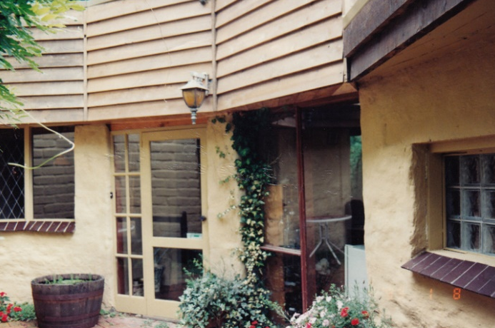
The Periwinkle House, 54 Batman Road, Eltham (HO11)

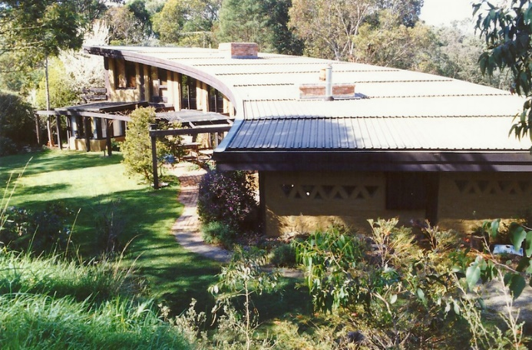
The Pittard House, 430 Mount Pleasant Road, Research (HO139)

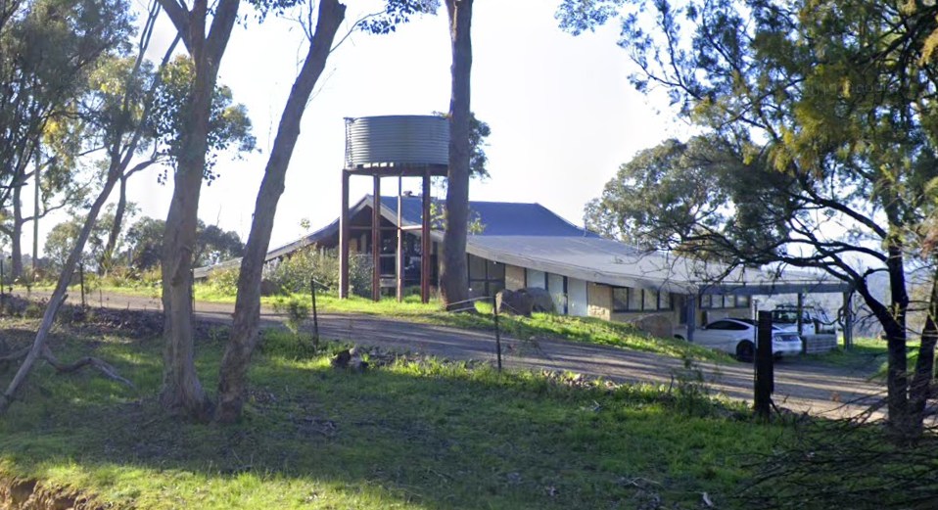
160 Henley Road, Kangaroo Ground (Recommended as individually significant in Nillumbik Shire Heritage Review Stage A, 2021).

The Periwinkle House at 54 Batman Road, Eltham, is a curved mudbrick house built in 1948 to a design by Alistair Knox. The house is significant as one of the first mudbrick houses constructed in Eltham, and the first curved wall house designed by Knox. The modest size is characteristic of Post-war development in the Shire.

The Pittard House at 430 Mount Pleasant Road, Research, is a substantial mudbrick home built between 1978-1979. The house features a large sweeping curved wall, and many recycled materials. The house is considered a good example of Knox’s later work.

160 Henley Road, Kangaroo Ground, is a substantial mudbrick house built c1973 to a design by Alistair Knox. The house is dominated by a large, simple gable roof. An example of the ‘Eltham Style’, the house bears characteristics of Knox’s work including exposed timbers and recycled bricks internally.

Like the comparative examples, the subject site demonstrates key characteristics of Alistair Knox’s work including mudbrick walls and recycled materials. Although comparable to the Periwinkle House, the subject site is more aligned with the Pittard House and 160 Henley Road as substantial examples of Knox’s work in the early 1970s. It appears that by this time, Knox was experimenting with large homes that had expansive internal volumes, evident at the subject site and these two homes. Similar to the house at 160 Henley Road, the house is also contained under a large gable roof. The house compares well as an example of Knox’s mudbrick work from this era. The house is also distinguished by its historic landscape setting.
Assessment Against Criteria

Criteria referred to in Practice Note 1: Applying the Heritage Overlay, Department of Planning and Community Development, revised July 2015, modified for the local context.

CRITERION A: Importance to the course or pattern of the Shire of Nillumbik’s cultural or natural history (historical significance).

The house is historically significant for its layered development and associations with prominent designers. Originally an early weekend residence for wealthy families, the site has been occupied by a house since 1912. The site was later enhanced by a garden to Edna Walling’s design, further demonstrating the wealth of the residents. Following its destruction by a bushfire in the 1960s, the house was replaced with a design by the notable Alistair Knox with garden additions by Gordon Ford. The street name is believed to be derived from the property.

CRITERION B: Possession of uncommon, rare or endangered aspects of the Shire of Nillumbik’s cultural or natural history (rarity).

CRITERION C: Potential to yield information that will contribute to an understanding of the Shire of Nillumbik’s cultural or natural history (research potential).

CRITERION D: Importance in demonstrating the principal characteristics of a class of cultural or natural places or environments (representativeness).

CRITERION E: Importance in exhibiting particular aesthetic characteristics (aesthetic significance).

The house is aesthetically significant as a good example of a substantial house built in the Shire during the 1970s. Built to a design by Alistair Knox, the house exhibits key characteristics of his work and the architecture being promulgated in the Shire at that time, including use of mudbrick and recycled materials. The garden setting, created by Edna Walling and reworked by Gordon Ford, greatly enhances the aesthetic significance of the place.

CRITERION F: Importance in demonstrating a high degree of creative or technical achievement at a particular period (technical significance).

CRITERION G: Strong or special association with a particular community or cultural group for social, cultural or spiritual reasons. This includes the significance of a place to Indigenous peoples as part of their continuing and developing cultural traditions (social significance).

CRITERION H: Special association with the life or works of a person, or group of persons, of importance in the Shire of Nillumbik’s history (associative significance).

Grading and Recommendations

Recommended for inclusion in the schedule to the Heritage Overlay of the Nillumbik Planning Scheme.
Recommendations for the Schedule to the Heritage Overlay (Clause 43.01) in the Nillumbik Planning Scheme:

External Paint Colours  Is a permit required to paint an already painted surface? | No
Internal Alteration Controls  Is a permit required for internal alterations? | No
Tree Controls  Is a permit required to remove a tree? | No
Victorian Heritage Register  Is the place included on the Victorian Heritage Register? | No
Incorporated Plan  Does an Incorporated Plan apply to the site? | No
Outbuildings and fences exemptions  Are there outbuildings and fences which are not exempt from notice and review? | No
Prohibited uses may be permitted  Can a permit be granted to use the place for a use which would otherwise be prohibited? | No
Aboriginal Heritage Place  Is the place an Aboriginal heritage place which is subject to the requirements of the Aboriginal Heritage Act 2006? | No

Identified By

Trethowan

References

Argus, as cited.

Bartolomei, D 2008, ‘Eltham’, eMelbourne, School of Historical and Philosophical Studies, The University of Melbourne, https://www.emelbourne.net.au/biogs/EM00516b.htm.

Butler, Graeme and Associates 1996, ‘Nillumbik Shire Heritage Review – Environmental History’, Prepared for the Shire of Nillumbik.

Eltham District Historical Society 2000, A Chronology of Known Local Events 1835-early 2000 including
those in the Shire of Nillumbik and the former shires of Eltham and Diamond Valley, Eltham District
Historical Society Incorporated.

Context Pty Ltd 2020, ‘War Memorial Building Complex, 903-907 Main Road’ Eltham, draft citation, prepared for Nillumbik Shire Council.

Mills, Peter and Westbrooke, Samantha 2017, ‘Nillumbik Shire Thematic Environmental History – Revision 2016’, prepared for Nillumbik Shire Council.

Nillumbik Parish Plan 1951, Department of Lands and Survey, Melbourne.

‘Parish of Nillumbik’ 2002, VPRS 16171, Public Record Office Victoria.

Victorian Places 2015, ‘Christmas Hills’, Monash University and The University of Queensland, https://www.victorianplaces.com.au/, accessed online 06 April. 2022

Mills, P and Westbrooke, S 2016, ‘Nillumbik Shire Thematic Environmental History Revision’, prepared for the Shire of Nillumbik.

Walling, E c1930s, ‘Plan of Suggested Treatment of Garden at Laughing Waters For G. Petre Esq, Eltham, Vic’, State Library Victoria (SLV) Edna Walling Collection, accessed online March 2022.

Watts, P 2002, ‘Walling, Edna Margaret (1895-1973)’, Australian Dictionary of Biography, National Centre for Biography, Australian National University, originally published 1996.

Woollard, J 2016, Laughing Waters Road: Art, Landscape & Memory in Eltham, Shire of Nillumbik, Eltham.

