Title: Mitchell House
Identified by: Bick (1992)
Prepared by: Trethowan Architecture

Address: 19 Fordhams Road Eltham
Name: Mitchell House | Survey Date:
Place Type: House | Architect:
Grading: Significant | Builder:
Extent of Overlay: Title Boundaries | Construction Date: 1985

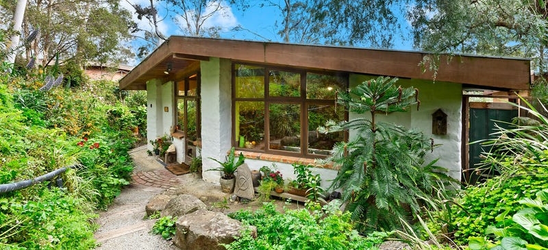
Front facade of 19 Fordhams Road. Source: realestate.com.au

Historical Context

Eltham, situated in hilly country northeast of Melbourne, is located on the country of the Wurundjeriwillam clan of the Woi wurrung, one of the five tribes of the Kulin Nation. A plan for fifty allotments in the Township of Eltham, Parish of Nillumbik, was announced in 1848, with the name officially gazetted in 1851. The township, near the junction of the Diamond Creek and the Yarra River, was laid out an area bounded by Baxter Street, Diamond Creek, Dalton Street and Bolton

Street. This area is known today as Eltham South. Present-day Eltham, however, was not established on the township reserve, where land proved difficult to sell. Instead, the town grew from allotments in Section IV of the Parish of Nillumbik located on Main Road, to the north of Dalton Street and the township reserve (Butler 1996:32). The township grew during the 1850s around a cluster of buildings at the corner of Pitt Street and Main Road within the Little Eltham subdivision. Located on the road to the Caledonian Diggings, this small township became a service centre for the surrounding mining areas, and by 1854 supported a population of 282. In this period Eltham had two hotels, a brewery and tannery on Diamond Creek. Several public buildings and institutions, including a police station, Wesleyan chapel, a Church of England School and a National School, were established in the 1850s -70s (Context, 2020:1).

Between the 1860s and the 1880s, Eltham supplied food and produce for the gold-mining communities of the Caledonian Diggings at Queenstown (St Andrews) and Panton Hill. It also became a stopping place on route to the Woods Point diggings. Eltham’s population grew in response. In 1871, the town’s population was 165 and by 1881 this had increased to 388 (Victorian Places 2015). Several large properties surrounding the township had absentee owners, who subdivided their properties into smaller farms either for lease or sale. The smaller properties, especially in the Little Eltham township, were run by farmers who often made a modest living as wage labourers. Like many later Eltham residents, they were attracted by cheap land and the country life (Butler 1996:33).

The railway was extended to Eltham opened in 1902, which brought excursionists from Melbourne, many of whom picked wattle during the flowering season, and focused development of the Eltham township around the railway station. Eltham was a picturesque village with the advantage of its proximity to metropolitan Melbourne as well as to attractive countryside with farms and uncleared stringybark forest (Victorian Places 2015). The attractive bush scenery attracted artists, writers and nature-lovers. The landscape painter Walter Withers (1854-1914) moved to Eltham in 1902 when the railway opened; others artists, including members of the Heidelberg School, painted in the area in the open air. Clara Southern and May Vale, landscape painters and students of Frederick McCubbin, settled in the region. Vale resided at Diamond Creek and Southern at Warrandyte (Bartolomei 2008). The war artist Will Longstaff also lived in Eltham for a period. Artist Justus Jorgensen established the notable Montsalvat artist’s colony buildings, on land he purchased in 1934. Seeking a closer engagement with the natural environment, the establishment of Montsalvat, with its adobe and rammed earth buildings, influenced future mud brick construction in the area. Several local architects and designers, including Alistair Knox, specialised in mud brick housing in the post-war period (Victorian Places 2015). Others who have been inspired by Eltham and have made the region their home include landscape architect Edna Walling, authors Alan Marshall and Carolyn Van Langenberg, artists Clifton Pugh and Danila Vassilieff; composers and musicians Graeme and Roger Bell; jewellers and sculptors Michael Wilson, Simon Icarus Baigent and Matcham Skipper; writer CB Christensen; poet Chris Wallace-Crabbe; and actress Kerry Armstrong (Bartolomei 2008; Pierce 1987:354).

Eltham experienced significant post-war development with a number of residential estates subdivided and put up for sale. The population of the town increased from 927 in 1933, to 1278 in 1947, to 7177 in 1971. As a result, Eltham High School opened in 1950 and the Catholic Ladies College was relocated to Eltham in 1971 (Victorian Places 2015). The Eltham War Memorial Trust Baby Health Centre opened in 1951. New shire offices opened in 1965, and Eltham College commenced classes in 1974 (Eltham District Historical Society 2000:np).

A distinctive style in local building emerged in Eltham in the post-war period, with a strong use of natural materials, low form structures, and an integration with the natural environment and the preference for bush gardens, especially after the 1970s. The Eltham Library, designed by architect Greg Burgess, was constructed in mud brick and recycled timbers and received the RAIA Institutional Architecture Award in 1995 (Bartolomei 2008).

The Shire of Eltham became part of the Shire of Nillumbik in 1994, with a small area becoming part of the City of Banyule.

History

The house at 19 Fordhams Road was commissioned by Jenni Mitchell, a local artist, conservationist and former Eltham Shire Councillor. It stands on the site of her parents Grace and Arthur's former home. Bick (1992) relies on personal communications with the original owner Jenni Mitchell, and writes:

In 1985, Alistair Knox drew up plans for an extension to an old cottage in Fordhams Road, the first Eltham home of Jenni Mitchell's parents, Grace and Arthur, in the early 1950s. The old cottage which Jenni inherited was eventually pulled down. In its place stands the present house and studio designed in 1985 by Alistair Knox and the 1988 extension to the detached studio.¹

Plans for the current house exist and are shown below. The provenance of the studio is not established by these plans.

Bick (1992): The adobe Jenni Mitchell house is an excellent example of a small house environmentally designed by Melbourne's leading mud brick designer and builder, Alistair Knox, at the end of his career of nearly forty years in Eltham. The one-bedroom dwelling is well detailed and shows the refinement of Knox's. design during this period, combined with the basic construction which has its roots in his early buildings of the 1940s and 1950s. A distinctive detail is the brick paved floor laid directly on the ground, rather than on a concrete slab. Knox is known for his substantial dwellings such as the Collar and Pittard residences, rather than smaller buildings of this sort.

Alistair Knox

Alistair Knox is one of a small number of architects and building designers in Victoria who are recognised by the general public as identities and whose architecture gave rise to a regional style. (Peterson & Kuzyk RMIT Design Archives 2014). Alistair Samuel Knox (1912 - 1986), architect, was largely self-taught. He advocated for using available resources for building construction, allowing the buildings to be in harmony with its environment. These ideals were influenced by shortages of building materials in the aftermath of WWII, by his artistic friends and by his own view of the world. His unique ‘Eltham Style’, which typically comprises a residence with mud brick and recycled materials in a bushland setting, marks the post-war built environment of Eltham and the surrounding areas (Alistair Knox Foundation c2018).

His stylistic periods were divided into the following:

The first Mud Brick (or earth building) Period (1947-53)
In the early period of his architecture career, Knox mainly designed residences for his friends from the artistic circle, including landscape architect Gordon Ford and filmmaker Tim Burstall. His houses are often sited on a slope with their foundation cut into the hillsides. He also used concrete slab for domestic architecture, a practice that only began to emerge during the post-war era (Alistair Knox Foundation c2018). Due to the shortage of building materials in the immediate aftermath of WWII, Knox began using the cheap mud brick as building material, hence marking Knox’s first mud brick period. Notable work at this time includes the residence for Philip Busst at 71 Silver St, Eltham, and the Downing Le Galliene House at 12 Yarra Braes Road, Eltham (Alistair Knox Foundation c 2018).

Modular Houses (1955-c1961)
Following the easing of building materials and loan credit in the 1950s, Knox’s design career entered a new height, as the demand of new houses had now surged. There were numerous houses produced in this period all based on the prototype he built for himself on the corner of the Pine Trees property, allowing for quick construction. These houses were rectangular with a large central beam that supported a gently pitched Stramit roof finished with a skin of Malthoid, bitumen and creek gravel. The walls were primarily glazed with timber or brick infills. The joinery produced the window frames that made up 60 per cent of the external walls (Alistair Knox Foundation c2018).

The Second Mud brick stage (1964-72)
The credit squeeze of 1961 had a deleterious effect on the Knox building enterprise. Financial restrictions forced him to return to mud brick. It was during this period that Knox’s style solidified. Houses in this period retain the simplicity of his first mud brick stage, but many of them were now in a grander scale. The design in this time is also noted for windows and doors extended from floor to ceiling, puncturing the elevations with a predominantly vertical pattern. Clerestory windows, which let in natural lights, also became universal. He continued to build split-level houses on sloping sites, allowing the built forms to follow the contours of the land. Notable works in this period include the Pittard Residence at 430 Mount Pleasant Road, Research (HO139) (Alistair Knox Foundation c2018).

Apart from his architectural career, Knox served as an Eltham Shire councillor from 1972-1975 and its President in 1975. He was a founding member of the Australian Institute of Landscape Architects, becoming a fellow in 1983. In 1982, four years before he died, the University of Melbourne awarded him an honorary Doctorate. Knox continued to design houses until his death in 1986 (Alistair Knox Foundation c2018).

Peterson and Kuzyk (RMIT Design Archives 2014) sum up Knox’s style thus:

In general, Knox’s approach was modernist in its embrace of light, space, proportion, unadorned minimalism, modularity and orientation. His buildings sit empathetically within the natural landscape and his materials were nearly always those he perceived as ‘rustic, and reclaimed’; he sought to build homes for people, not monuments to their architect.

Description & Integrity

The main dwelling, fronting Fordhams Road uphill to the south, is a single storey adobe and timber building. It has a low-pitched metal roof with central ridge running north-south.
Its plan is an irregular hexagon footprint with chevron shaped gable ends. The house plan is oriented north-south, on an angle to the rectangular site, presumably to maximise the entry of light into the northern aspect. It has mud brick walls and columns. Timber framed floor to ceiling windows on the rear (north) elevation opening onto the garden, and timber framed windows at the front (south) with brick sills. The tops of the windows are raised to the roof level. Timber barge-boards to the gable ends, and timber-lined eaves. The house interior features brick floors, exposed timber beams under the roof and ceiling lining boards.

The garden setting includes what appears to be intact elements of original design such as the brick elements, curved front garden paths and rockery that enhance the natural bush setting.

The studio is said to have been designed and built by Knox, but has not been inspected. It is unknown whether it has any relationship to the April 1985 extension plans. The provenance of the 3x5m shed a with loft is also unknown. Knox died in 1986, making this one of Knox’s final designs.

The house appears substantially intact to the original 1985 design.

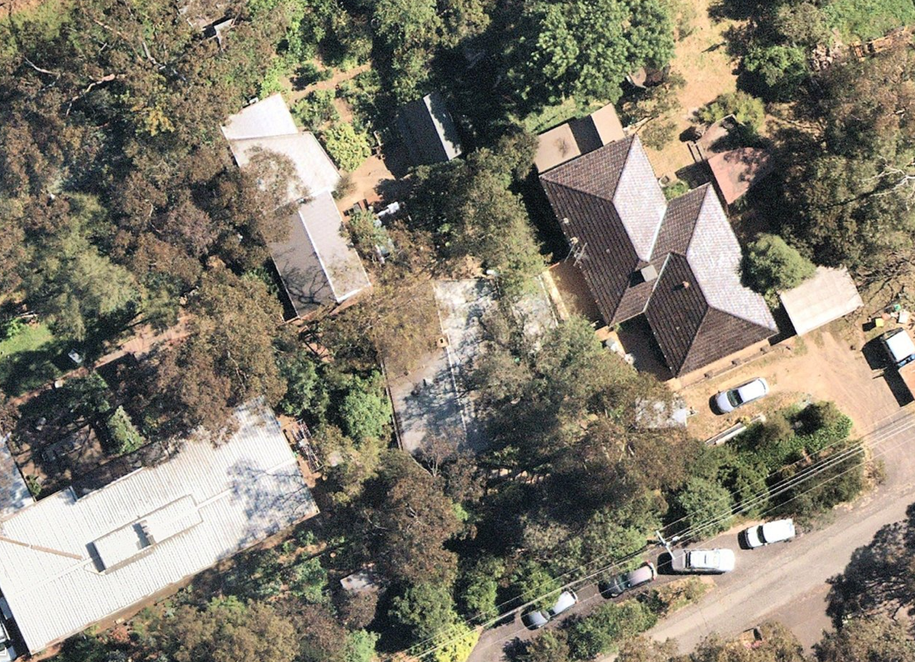
19 Fordhams Road Eltham, showing position of main house, studio and shed. Red line indicates property boundary. Source: NearMap 2022.
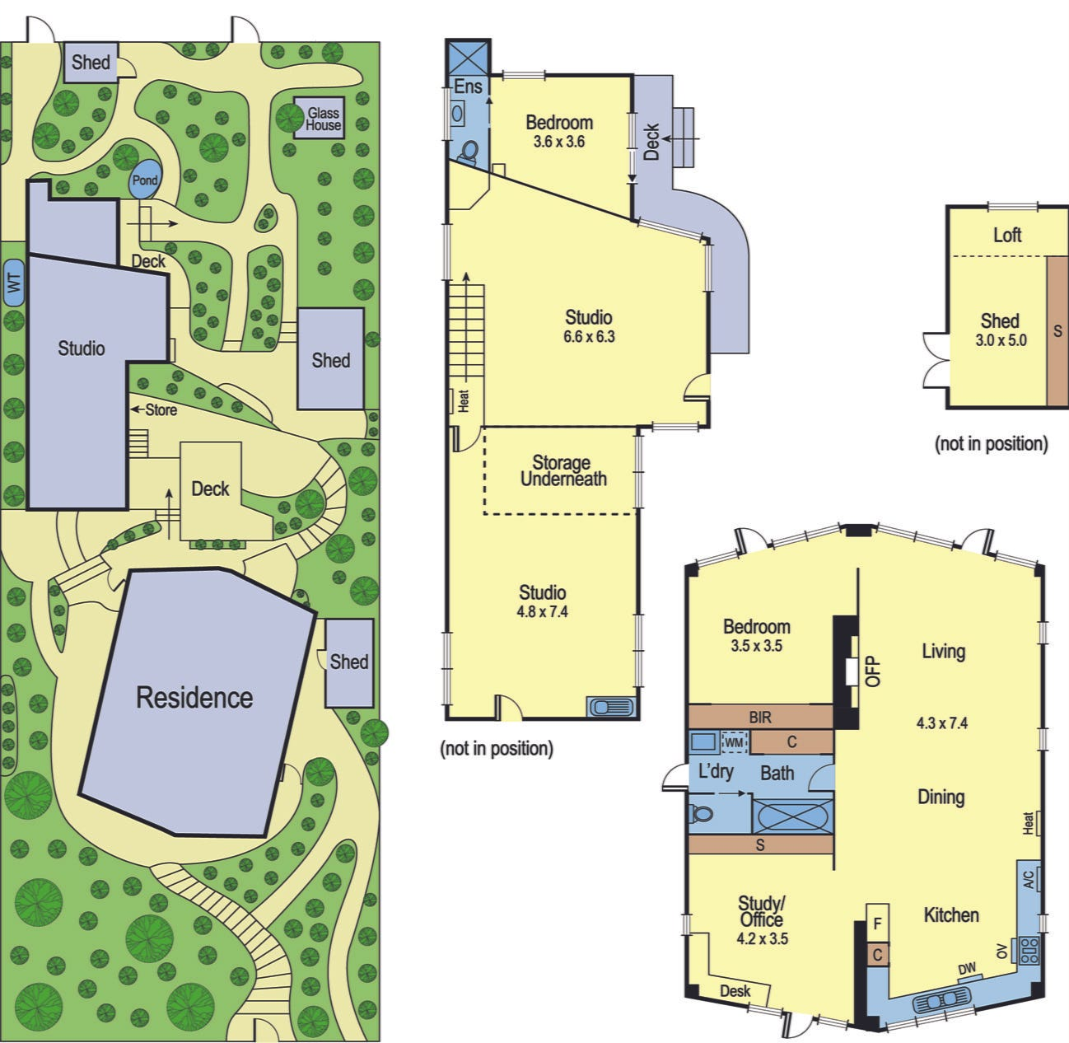
19 Fordhams Road, indicative layout of buildings on the site, and floorplans of house, studio and shed.
Source: realestate.com.au accessed 2022 (2016 image).
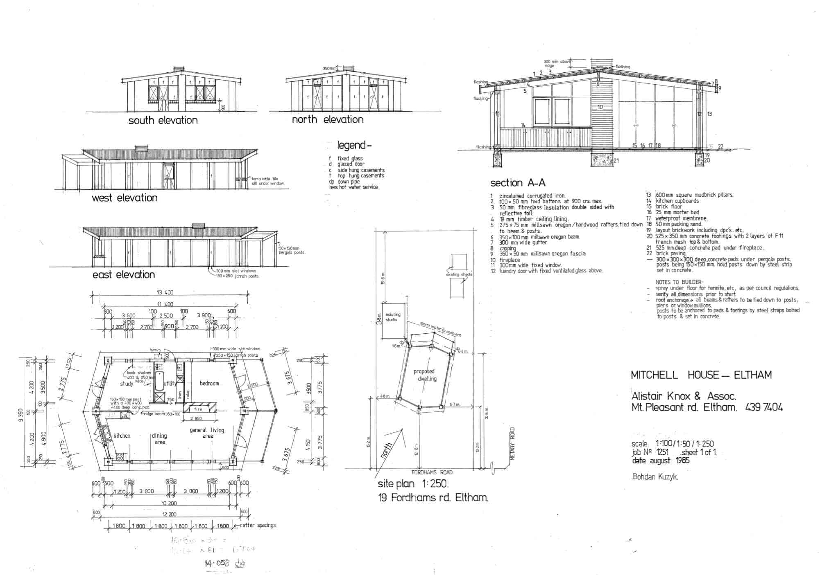
'Mitchell House Eltham, April 85, Job No 1234'. 550:1: Plan, Bohdan Kuzyk. Dated August 1985. Note there is no existing structure on the street frontage. There is however an 'existing studio' to the northwest of the proposed house. Source: http://alistairknox.org/plans/550

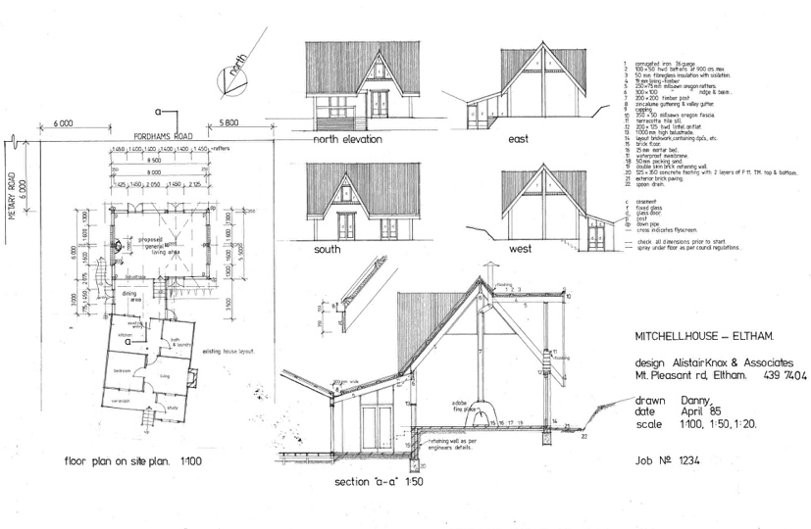
Mitchell House Eltham, April 85 Job No 1234. Address: 19 Fordhams Rd, Eltham. 3095 VIC. 551 : 2: Plan Alistair Knox August 1985. Source: http://alistairknox.org/plans/551. This is an unrealised plan for the 'extension to the old cottage at 19 Fordhams Road', as described by Bick 1992 p.730, dated April 1985. The old cottage shown at the base of the plan (north) was demolished and the current chevron shaped dwelling was built in this position on the lot. It is unknown whether this plan informed the present detached Studio at the north of the site in any way, but the roof form does not resemble it.

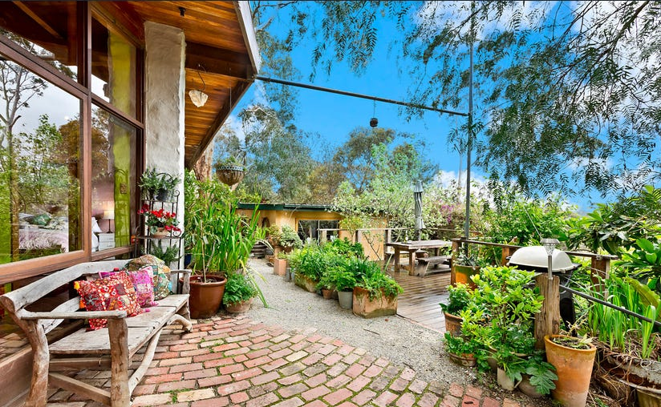
Rear (north) aspect of the main house, with view to the Studio down the hill to the north. Note the timber framed windows, mud brick walls, timber eaves and stylistically typical external brick paving. Source: realestate.com.au accessed 2022 (2016 image).

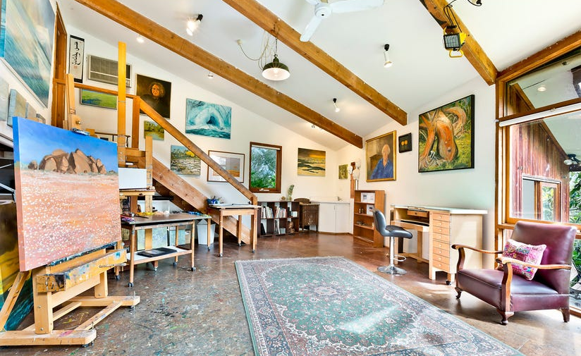
Interior of lower level studio, with bedroom beyond to the right (north) and upper level studio to the left (south). Source. Realestate.com.au 2022 (2016 image).

North view of main house showing extensive glazing, later shed addition at left (east). Source: Realestate.com.au 2022 (2016 image).
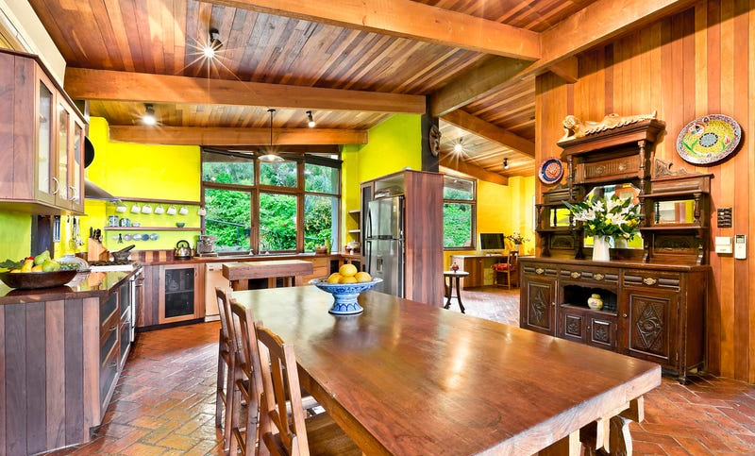
Interior view of main house showing stylistically typical brick floor and exposed timber ceiling and beams. Source: Realestate.com.au 2022 (2016 image).

Comparative Analysis

There are a number of houses in the HO that were designed by Alistair Knox. Some comparable examples are the following:

- Former Lim Joon House, 618 Main Road Eltham (HO119)
- The Coller House (HO136) at 185 Mount Pleasant Road, Eltham
- Pittard Residence (HO139) at 430 Mount Pleasant Road, Research
- Alistair Knox’s House and Office (HO109), 2 King Street, Eltham

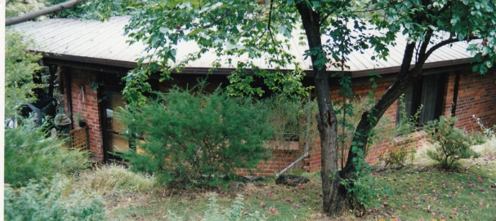  Former Lim Joon House, 618 Main Road Eltham. Source: Heritage Victoria. | The elevation of Coller House. Source: Bick, 1992.
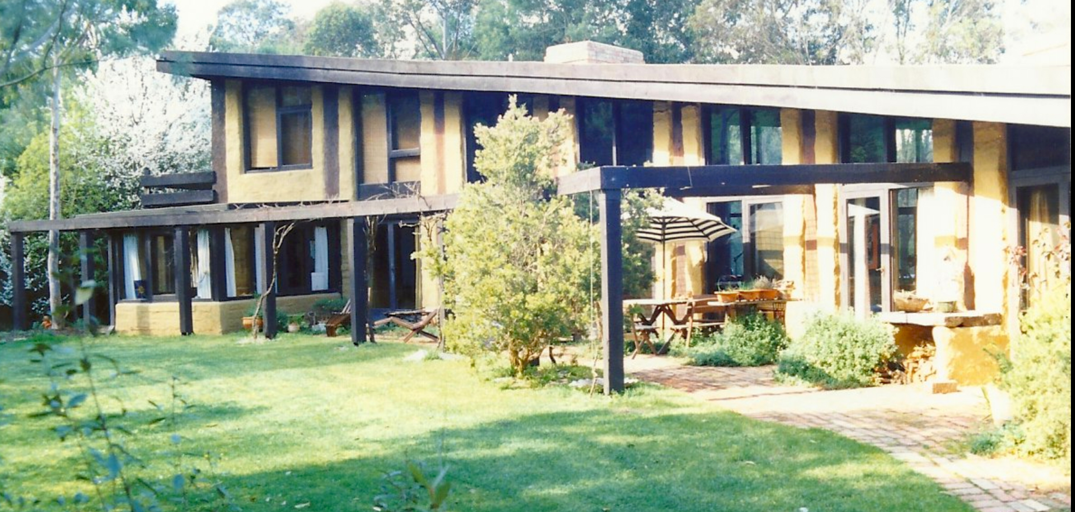  Figure 18: Pittard Residence in 1992. Source: Bick, 1992 | Image dated c 2010s shows the windowed wall of the Knox Residence. Source: realestate.com.au.

The former Lim Joon house at 618 Main Road Eltham (HO119)
The former Lim Joon house (c.1950s) is architecturally significant as an excellent example of a small, polygonal dwelling that also illustrates other advanced architectural features, of the time: floor to ceiling window walls, a single living area containing the kitchen at one end, a stone fireplace wall, a flat roof, and an integral carport.

The Coller House (HO136) at 185 Mount Pleasant Road, Eltham
In design and construction, the Coller House exemplifies the Eltham mud brick residence of the 1970s and is an important work by the Architect Alistair Knox. Built in stages, the large main interior spaces with their subdued natural light, adzed timber beams and posts, timber board lined ceilings and internal walls, brick paved floors, timber floor to ceiling windows and doors, clerestory windows, all combined with the exterior mud brick walls, wide eaves and exposed timber framing are all the basic components of the Knox design idiom. This low-cost building was built largely with amateur labour and is a definitive example of the houses Knox regarded as most suitable for the Eltham environment. It also demonstrates his' theories for integration into a natural or man-planted bushland setting, as well as that environmental fathers produced environmental sons, his son Hamish being one of the builders (VHD).

Pittard Residence (HO139) at 430 Mount Pleasant Road, Research
The Pittard residence constructed in 1978, is a later and more substantial example of Knox’s Eltham Style architecture, using mudbrick and recycled materials. The curved plan shape and single plane roof rising up over the living area to the double storey end section are of particular note.

Alistair Knox’s House and Office (HO109), 2 King Street, Eltham
The house and office, constructed in 1962-63, are historically significant as the purpose-built and final home and office of renowned Eltham architect Alistair Knox, who was so influential in creating Eltham's distinctive residential environment (Criterion H). Architecturally, they are excellent examples of Knox's innovative work, and exemplify his use of mud brick and recycled building materials within a complementary bush landscape. Apart from the materials, the house features large scale window openings, extending from floor to ceiling, and clerestory windows, a feature that is shared by the subject site and many of Knox’s subsequent designs.

By comparison to these properties already on the HO, the subject property is much later. Given that Knox died in 1986, it is perhaps one of his last designs and belongs to his most mature period when he had been widely acclaimed for his stylistic approach and experience. It is notable that this house was executed for a Shire councillor, given Knox’s association with the Shire as a former councillor and president, representing the wide recognition, status and local popularity of his style. The house demonstrates key elements of his style, notably the emphasis on plan orientation to natural features and light on the site, the low pitched roof, the natural brick, adobe and timber materiality. It also demonstrates strongly elements of the mature style such as the floor to ceiling windows and the experimentation with irregular plan shape, in this case a hexagonal or chevron-ended rectangular plan. The effect of the timber framed windows opening onto the bush or garden setting is reminiscent of Knoz’s own house and office, but in a chevron rather than rounded window wall. While more modest in scale than Coller House or the Pittard Residence, the subject property is designed for its smaller site and represents the maturity of his style applied to the more modest context., with greater emphasis on large scale window openings. It is polygonal like Jim Loon house, but again much later, with the adobe columns as a supporting or framing feature rather than the dominant material. The subject property thus compares well in terms of demonstrating the hallmark elements of Knox’s mature design, while demonstrating also a distinctive form adapted to its particular site and client.

In the Bick (1992) Study it was noted in relation to the subject property that:

The adobe Jenni Mitchell house is an excellent example of a small house environmentally designed by Melbourne's leading mud brick designer and builder, Alistair Knox, at the end of his career of nearly forty years in Eltham. The one-bedroom dwelling is well detailed and shows the refinement of Knox's. design during this period, combined with the basic construction which has its roots in his early buildings of the 1940s and 1950s. A distinctive detail is the brick paved floor laid directly on the ground, rather than on a concrete slab. Knox is known for his substantial dwellings such as the Collar and Pittard residences, rather than smaller buildings of this sort.

Assessment Against Criteria

Criteria referred to in Practice Note 1: Applying the Heritage Overlay, Department of Planning and Community Development, revised July 2015, modified for the local context.

CRITERION A: Importance to the course or pattern of the Shire of Nillumbik’s cultural or natural history (historical significance).
The house at 19 Fordhams Road Eltham is one of Alistair Knox’s last designs. The house is associated with the environmental design movement pioneered by Knox. The movement was often associated with the artistic and intellectual milieu that grew up in the Shire in the post-war period and gained increasingly formalised influence into the late twentieth century as practitioners like Knox and artists like Jenni Mitchell were elected to the Eltham Council. The house represents this fusion and maturity of the movement well through its design, commission and period of execution.

CRITERION B: Possession of uncommon, rare or endangered aspects of the Shire of Nillumbik’s cultural or natural history (rarity).

CRITERION C: Potential to yield information that will contribute to an understanding of the Shire of Nillumbik’s cultural or natural history (research potential).

CRITERION D: Importance in demonstrating the principal characteristics of a class of cultural or natural places or environments (representativeness).

CRITERION E: Importance in exhibiting particular aesthetic characteristics (aesthetic significance).
The house at 19 Fordhams Road Eltham is of aesthetic and architectural significance to the Shire of Nillumbik as a mature design of Alistair Knox, the renowned architect. Located in a bush garden setting, the house demonstrates Knox’s ideals on how a residence should be in harmony with its surroundings through its orientation to the site and integration of indoor and outdoor through the large-scale windows. With the notable Knox architectural elements such as use of natural materials such as adobe, brick floors, exposed timber beams. It has a low pitch roof with broad timber eaves, and an unusual hexagonal plan. Mitchell House serves as a fine example of Knox’s more mature design.

CRITERION F: Importance in demonstrating a high degree of creative or technical achievement at a particular period (technical significance).

CRITERION G: Strong or special association with a particular community or cultural group for social, cultural or spiritual reasons. This includes the significance of a place to Indigenous peoples as part of their continuing and developing cultural traditions (social significance).

CRITERION H: Special association with the life or works of a person, or group of persons, of importance in the Shire of Nillumbik’s history (associative significance).
The house has historical associations with local artist, former Shire Councillor, Australian artist and conservationist Jenni Mitchell, who was intimately involved in its construction as the owner/ builder. This association is of local interest.

Grading and Recommendations

Recommended for inclusion in the schedule to the Heritage Overlay of the Nillumbik Planning Scheme.

Recommendations for the Schedule to the Heritage Overlay (Clause 43.01) in the Nillumbik Planning Scheme:

External Paint Colours  Is a permit required to paint an already painted surface? | No
Internal Alteration Controls  Is a permit required for internal alterations? | No
Tree Controls  Is a permit required to remove a tree? | No
Victorian Heritage Register  Is the place included on the Victorian Heritage Register? | No
Incorporated Plan  Does an Incorporated Plan apply to the site? | No
Outbuildings and fences exemptions  Are there outbuildings and fences which are not exempt from notice and review? | No
Prohibited uses may be permitted  Can a permit be granted to use the place for a use which would otherwise be prohibited? | No
Aboriginal Heritage Place  Is the place an Aboriginal heritage place which is subject to the requirements of the Aboriginal Heritage Act 2006? | No

Identified By

Bick 1992

References

Apperly, R, Irving, R, and Reynolds, P 1995, A Pictorial Guide to Identifying Australian Architecture, Angus & Robertson, Sydney.

Argus, as cited.

Bartolomei, D 2008, ‘Eltham’, eMelbourne, School of Historical and Philosophical Studies, The
University of Melbourne, https://www.emelbourne.net.au/biogs/EM00516b.htm.

Butler, Graeme and Associates 1996, ‘Nillumbik Shire Heritage Review – Environmental History’, Prepared for the Shire of Nillumbik.

Eltham District Historical Society 2000, A Chronology of Known Local Events 1835-early 2000 including those in the Shire of Nillumbik and the former shires of Eltham and Diamond Valley, Eltham District Historical Society Incorporated.

Context Pty Ltd 2020, ‘War Memorial Building Complex, 903-907 Main Road’ Eltham, draft citation, prepared for Nillumbik Shire Council.

Mills, Peter and Westbrooke, Samantha 2017, ‘Nillumbik Shire Thematic Environmental History –
Revision 2016’, prepared for Nillumbik Shire Council.

Nillumbik Parish Plan 1951, Department of Lands and Survey, Melbourne.

‘Parish of Nillumbik’ 2002, VPRS 16171, Public Record Office Victoria.

Victorian Places 2015, ‘Christmas Hills’, Monash University and The University of Queensland,
https://www.victorianplaces.com.au/, accessed online 06 April. 2022

