130 Laughing Waters Road, Eltham
Prepared by: Trethowan Architecture

Address: 130 Laughing Waters Road, Eltham
Name: Riverbend, formerly Tilwinda | Survey Date: 11 March 2022
Place Type: Residential | Designer: Alistair Knox
Grading: Individually Significant | Builder: Alistair Knox
Extent of Overlay: To title boundaries | Construction Date: 1968

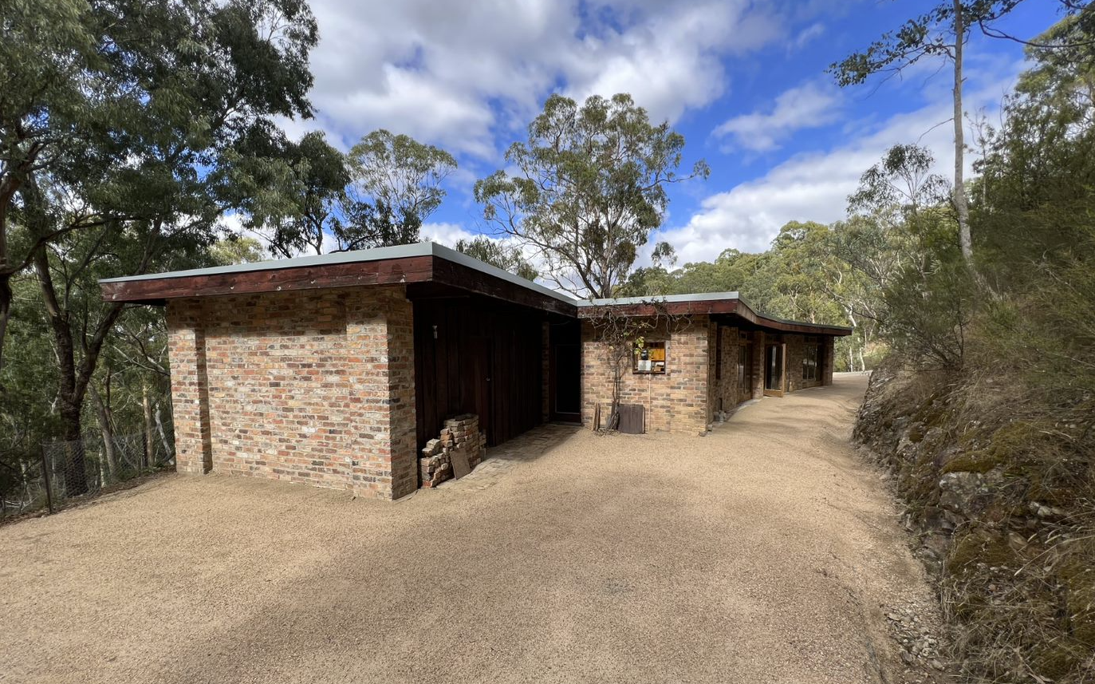

Historical Context

Eltham, situated in hilly country northeast of Melbourne, is located on the country of the Wurundjeriwillam clan of the Woi wurrung, one of the five tribes of the Kulin Nation. A plan for fifty allotments in the Township of Eltham, Parish of Nillumbik, was announced in 1848, with the name officially gazetted in 1851. The township, near the junction of the Diamond Creek and the Yarra River, was laid out an area bounded by Baxter Street, Diamond Creek, Dalton Street and Bolton Street. This area is known today as Eltham South. Present-day Eltham, however, was not established on the township reserve, where land proved difficult to sell. Instead, the town grew from allotments in Section IV of the Parish of Nillumbik located on Main Road, to the north of Dalton Street and the township reserve (Butler 1996:32). The township grew during the 1850s around a cluster of buildings at the corner of Pitt Street and Main Road within the Little Eltham subdivision. Located on the road to the Caledonian Diggings, this small township became a service centre for the surrounding mining areas, and by 1854 supported a population of 282. In this period Eltham had two hotels, a brewery and tannery on Diamond Creek. Several public buildings and institutions, including a police station, Wesleyan chapel, a Church of England School and a National School, were established in the 1850s -70s (Context, 2020:1).

Between the 1860s and the 1880s, Eltham supplied food and produce for the gold-mining communities of the Caledonian Diggings at Queenstown (St Andrews) and Panton Hill. It also became a stopping place on route to the Woods Point diggings. Eltham’s population grew in response. In 1871, the town’s population was 165 and by 1881 this had increased to 388 (Victorian Places 2015). Several large properties surrounding the township had absentee owners, who subdivided their properties into smaller farms either for lease or sale. The smaller properties, especially in the Little Eltham township, were run by farmers who often made a modest living as wage labourers. Like many later Eltham residents, they were attracted by cheap land and the country life (Butler 1996:33).

The railway was extended to Eltham opened in 1902, which brought excursionists from Melbourne, many of whom picked wattle during the flowering season, and focused development of the Eltham township around the railway station. Eltham was a picturesque village with the advantage of its proximity to metropolitan Melbourne as well as to attractive countryside with farms and uncleared stringybark forest (Victorian Places 2015). The attractive bush scenery attracted artists, writers and nature-lovers. The landscape painter Walter Withers (1854-1914) moved to Eltham in 1902 when the railway opened; others artists, including members of the Heidelberg School, painted in the area in the open air. Clara Southern and May Vale, landscape painters and students of Frederick McCubbin, settled in the region. Vale resided at Diamond Creek and Southern at Warrandyte (Bartolomei 2008). The war artist Will Longstaff also lived in Eltham for a period. Artist Justus Jorgensen established the notable Montsalvat artist’s colony buildings, on land he purchased in 1934. Seeking a closer engagement with the natural environment, the establishment of Montsalvat, with its adobe and rammed earth buildings, influenced future mud brick construction in the area. Several local architects and designers, including Alistair Knox, specialised in mud brick housing in the post-war period (Victorian Places 2015). Others who have been inspired by Eltham and have made the region their home include landscape architect Edna Walling, authors Alan Marshall and Carolyn Van Langenberg, artists Clifton Pugh and Danila Vassilieff; composers and musicians Graeme and Roger Bell; jewellers and sculptors Michael Wilson, Simon Icarus Baigent and Matcham Skipper; writer CB Christensen; poet Chris Wallace-Crabbe; and actress Kerry Armstrong (Bartolomei 2008; Pierce 1987:354).

Eltham experienced significant post-war development with a number of residential estates subdivided and put up for sale. The population of the town increased from 927 in 1933, to 1278 in 1947, to 7177 in 1971. As a result, Eltham High School opened in 1950 and the Catholic Ladies College was relocated to Eltham in 1971 (Victorian Places 2015). The Eltham War Memorial Trust Baby Health Centre opened in 1951. New shire offices opened in 1965, and Eltham College commenced classes in 1974 (Eltham District Historical Society 2000:np).

A distinctive style in local building emerged in Eltham in the post-war period, with a strong use of natural materials, low form structures, and an integration with the natural environment and the preference for bush gardens, especially after the 1970s. The Eltham Library, designed by architect Greg Burgess, was constructed in mud brick and recycled timbers and received the RAIA Institutional Architecture Award in 1995 (Bartolomei 2008).

The Shire of Eltham became part of the Shire of Nillumbik in 1994, with a small area becoming part of the City of Banyule.

History

Riverbend was designed in 1968 by Alistair Knox, for Rosemary and Bill Cuming, who had purchased the land not long before (Woollard 2016:226; Figure 1). Bill Cuming was an engineer, whose work had earlier taken him, Rosemary and their young family to Colmar in France. Following the construction of the home, Rosemary Cuming hand laid the brick paving in a distinctive shell pattern based on paving she had seen in Colmar (Woollard 2016:226). Other landscaping elements, including the stone bench and stairs, evidently made from salvaged building parts, date to the Cuming’s time. The cast iron stove in the kitchen was brought to the site from Rosemary’s sister’s home in Wattletree Road, Armadale (Woollard 2016:226). Bill and Rosemary later sold the site due their relocation to America.

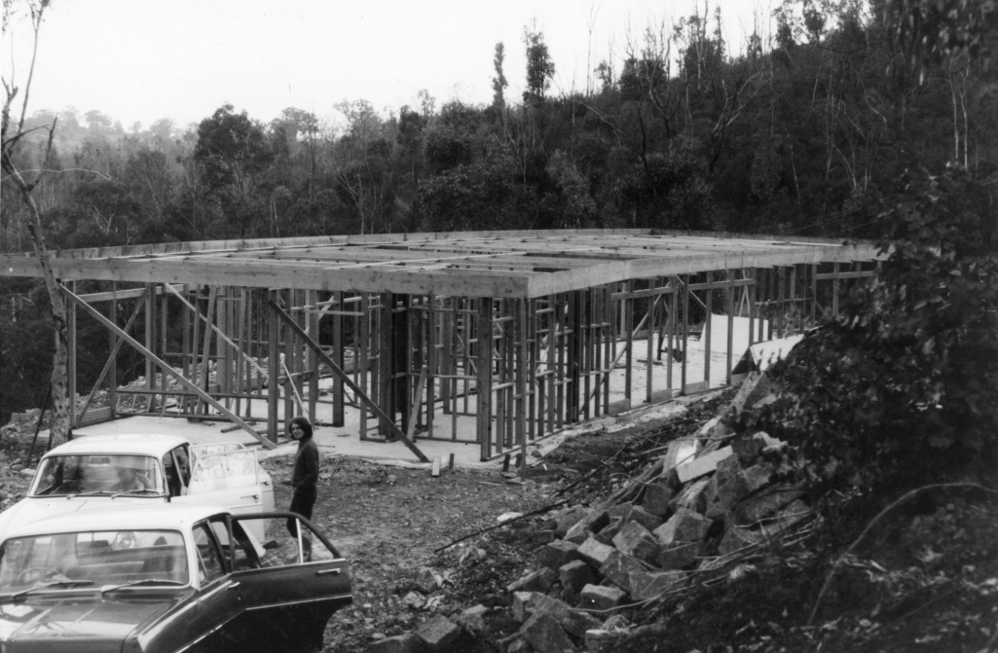
Figure 1: The house during construction c1968, showing its timber framing. Source: Cuming family, pers. Comm., January 2022.

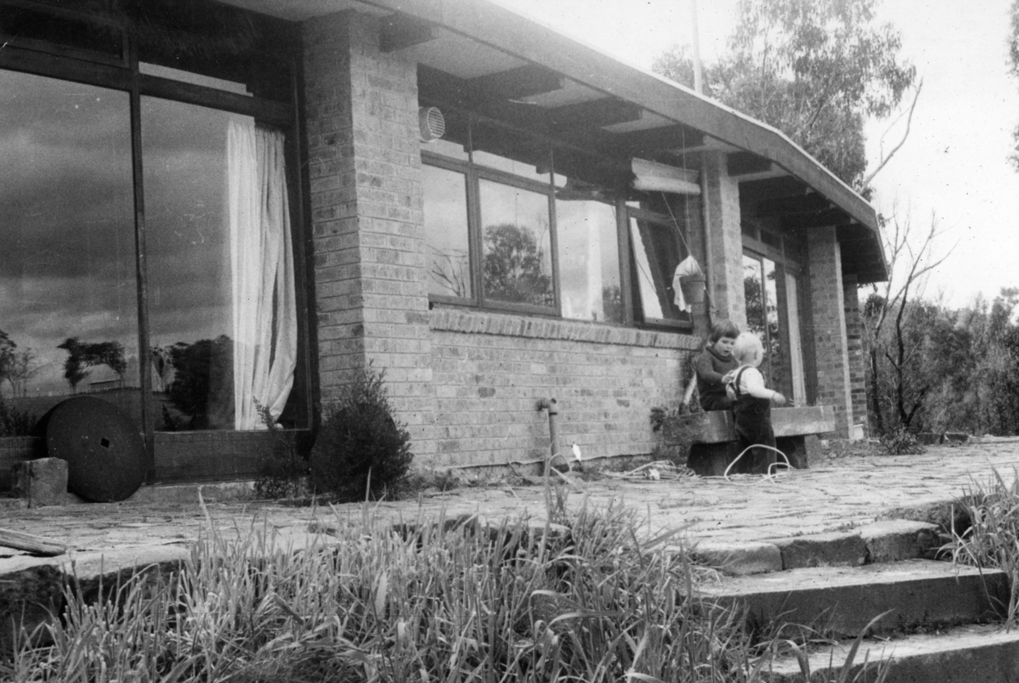
Figure 2: The house, c1970, during the Cuming’s ownership. Note the stairs, paving and stone bench. Source: Cuming family, pers. Comm., January 2022.

Max and Tini Huygens, who had migrated with their family from The Netherlands following WWII, purchased the home in 1975. The family named the site Tilwinda, which was thought to have been derived from an Aboriginal word translated as ‘hole in a rock’ (Woollard 2016:227). Tini Huygens had been an Olympic high jumper and discus thrower for The Netherlands in 1936, while Max was an importer who brought, amongst other things, Sirena Tuna, La Gina tomatoes and Bisleri soft drinks to Australia through his business (Woollard 2016:227). The Huygens were responsible for further work on the house, including the construction of an open carport to the west, and a workshop to the east (Woollard 2016:228). Tini Huygens died in 1981, however Max stayed at the property until 2000 (Woollard 2016:230).

The house was later sold to Parks Victoria. In 2008, the Laughing Waters Artist in Residency program began using the site as a retreat. The open carport was removed in late 2021 following damage, and the house was restored at the same time to further accommodate use by an artists’ residency program.

Description & Integrity

130 Laughing Waters Road is located on the south side of the street, directly adjacent to the Yarra River. The site slopes down towards the river, with the house placed on a clearing in the land that provides an expansive view over the river and valley. The block is otherwise heavily vegetated.

The house at 130 Laughing Waters Road, Eltham, is a modestly sized single storey brick veneer building with flat, metal clad roof. The floorplan is arranged on an east-west axis, however follows a slight curve, with the concave of the curve to the north (Figure 3). This allows the convex of the curve to face the river to the south. The mid-toned bricks are recycled from other sites in Melbourne.

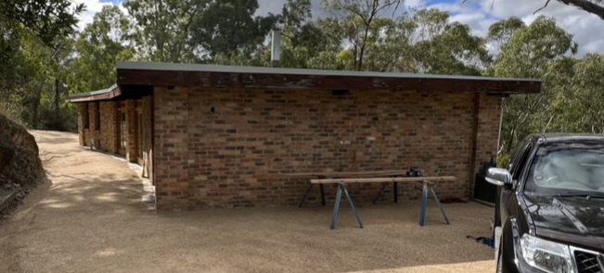
Figure 3. A view of the house from the west, showing the curve of the house. Source: Trethowan Architecture 2022.
The building is simply detailed. To accommodate the curve of the building, the north and south facades are broken into bays that are separated by engaged brick columns. Between these columns are arrangements of timber doors and windows (Figure 3). Some windows, such as those to the kitchen, are set higher above sections of brick walls. The roof is supported by exposed dark-stained timber rafters, with similarly stained timber fascia boards.

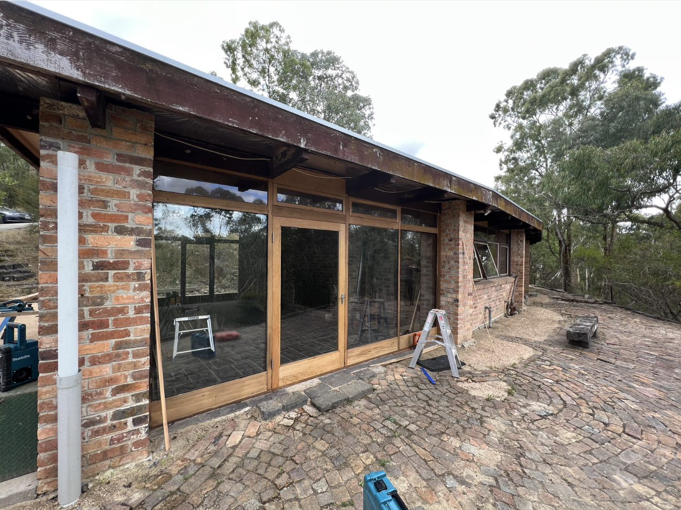
Figure 4: The south of the house, showing how the sets of doors and windows are set between brick columns. Note the stained fascia, shell pattern brick paving and bluestone bench (highlighted in red). Source: Trethowan Architecture 2022.
A further single storey storeroom is built adjacent to the house on the eastern side. This section uses similar recycled bricks to the main body of the house and continues the exposed rafters. The north wall of this room is finished in vertical stained timber boards.

An expansive terrace to the south of the house has brick paving in a shell pattern. A set of bluestone stairs lead down from this terrace to the river, with the treads made from bluestone blocks with dressed edges which appear to be former windowsills or door thresholds/lintels from a Victorian era building(s) (Figure 5). A simple stone bench on the terrace is made from similar bluestone. Bluestone sills and lintels are evident in the landscaping elsewhere around the site.

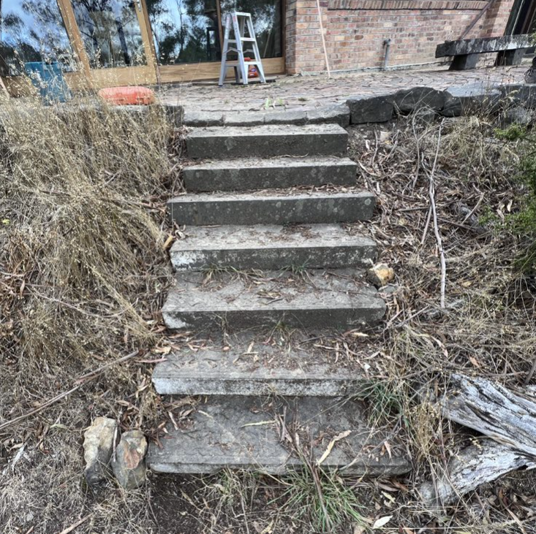
Figure 5: A view of the bluestone garden stairs. Source: Trethowan Architecture 2022.

Comparative Analysis

Although Post-war modernism had taken off across the suburbs of Melbourne, the Eltham and Warrandyte areas saw an alternative form of architectural experimentation. Mills and Westbrooke write that

the trend was characterised by an acceptance of the characteristics of the site, including the local bush, topography and geology and an attempt to blend and adapt to these conditions through building form and siting, choice of materials and landscape approach. The best-known spokesperson for this trend, Alistair Knox, gave it the label ‘Australian environmental building’ (Mills and Westbrooke 2016: 78)

The style that developed, often referred to as ‘the Eltham Style’ or ‘the Warrandyte Rustic’, was characterised by its use of honest, natural materials including mud bricks, local stone and expressed structural timber. Recycled materials were often utilised in construction (Mills and Westbrooke 2016: 78).

Alistair Knox was a prolific builder and designer who is widely associated with developing the style, and for his contribution to the built environment in the Shire of Nillumbik. Mills and Westbrooke further note that

inspired by his visits to Montsalvat in the early 1940s and, after the war, he studied building at the Melbourne Technical College. Knox’s early work in Eltham falls into two main categories: simple rectilinear forms, which were the basis for most of his work up to the 1970s, and a first flush of complex exploratory designs …

By the mid-1960s Knox had become something of an industry in his own right. A 1966 article indicates he had already built over one hundred houses since 1946. In this period, he was increasingly mining a rich vein of high quality materials from the nineteenth century buildings then being demolished in the city. His Glover house in Eltham was built by Dutch immigrant builder Pieter Hellemons using recycled bricks and timber. The property was also graced with a ‘natural rock and bush’ garden design by Gordon Ford (Mills and Westbrooke 2016:79-80).

The subject site, designed by Alistair Knox, bears key characteristics of his work. Although Knox was a prolific builder and designer in the Shire, only a handful of examples of his work are represented on the Heritage Overlay. Comparative examples completed by Alistair Knox include:
- The Periwinkle House, 54 Batman Road, Eltham (HO11)
- The Pittard House, 430 Mount Pleasant Road, Research (HO139)

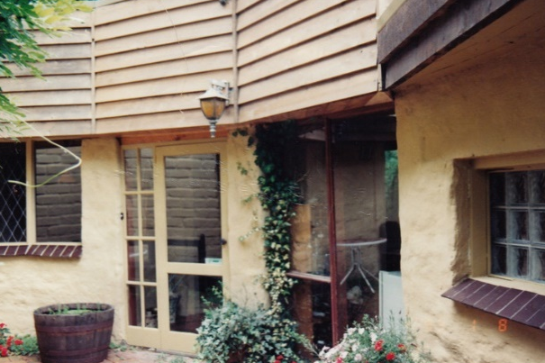  The Periwinkle House, 54 Batman Road, Eltham (HO11) Source: VHD | 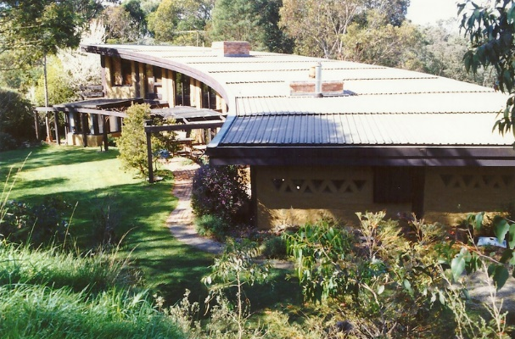  The Pittard House, 430 Mount Pleasant Road, Research (HO139) Source: VHD
The Periwinkle House at 54 Batman Road, Eltham, is a curved mudbrick house built in 1948 to a design by Alistair Knox. The house is significant as one of the first mudbrick houses constructed in Eltham, and the first curved wall house designed by Knox. The modest size is characteristic of Post-war development in the Shire.

The Pittard House at 430 Mount Pleasant Road, Research, is a substantial mudbrick home built between 1978-1979. The house features a large sweeping curved wall, and many recycled materials. The house is considered a good example of Knox’s later work.

While the subject site does not use mudbrick construction like these examples, it compares well for its use of a curved wall that dominates the floor plan. As the subject site was built in 1968, it sits between the two examples (1948 and 1978-9, respectively), and demonstrates Knox’s continued interest in curved forms throughout his body of work. Like the comparative examples, the site bears characteristics of Knox’s work including the use of recycled materials and carefully selected bush settings. The subject site is distinguished from these examples by its use of recycled brick materials. Overall, the site compares well as a well-designed, modest example of Knox’s work during the 1960s. The house is also distinguished by its expert positioning on a dramatic, vegetated block above the Yarra River, which expresses the ideals of the Eltham Style.
Assessment Against Criteria

Criteria referred to in Practice Note 1: Applying the Heritage Overlay, Department of Planning and Community Development, revised July 2015, modified for the local context.

CRITERION A: Importance to the course or pattern of the Shire of Nillumbik’s cultural or natural history (historical significance).
The house at 130 Laughing Waters Road is associated with the historical period of post-war growth and experimentation in the Shire that occurred as post-war subdivisions were taken up and attracted Modernist architects and designers such as Alistair Knox to the area. It demonstrates the ‘environmental building’ style of Knox as part of this movement.

CRITERION B: Possession of uncommon, rare or endangered aspects of the Shire of Nillumbik’s cultural or natural history (rarity).

CRITERION C: Potential to yield information that will contribute to an understanding of the Shire of Nillumbik’s cultural or natural history (research potential).

CRITERION D: Importance in demonstrating the principal characteristics of a class of cultural or natural places or environments (representativeness).

CRITERION E: Importance in exhibiting particular aesthetic characteristics (aesthetic significance).

The house at 130 Laughing Waters Road is a significant example of a well-designed, modestly sized house constructed in the Shire during the late 1960s and designed by Alistair Knox. The house’s curved floorplan and use of recycled materials, in this case brick, are characteristics of Alistair Knox’s work, and the type of architecture being promulgated in Nillumbik at the time. The house’s expert positioning on a dramatic, heavily vegetated sloping block above the Yarra River substantially enhances the aesthetic quality of the place.

CRITERION F: Importance in demonstrating a high degree of creative or technical achievement at a particular period (technical significance).

CRITERION G: Strong or special association with a particular community or cultural group for social, cultural or spiritual reasons. This includes the significance of a place to Indigenous peoples as part of their continuing and developing cultural traditions (social significance).

CRITERION H: Special association with the life or works of a person, or group of persons, of importance in the Shire of Nillumbik’s history (associative significance).

Grading and Recommendations

Recommended for inclusion in the schedule to the Heritage Overlay of the Nillumbik Planning Scheme.
Recommendations for the Schedule to the Heritage Overlay (Clause 43.01) in the Nillumbik Planning Scheme:

External Paint Colours  Is a permit required to paint an already painted surface? | No
Internal Alteration Controls  Is a permit required for internal alterations? | No
Tree Controls  Is a permit required to remove a tree? | No
Victorian Heritage Register  Is the place included on the Victorian Heritage Register? | No
Incorporated Plan  Does an Incorporated Plan apply to the site? | No
Outbuildings and fences exemptions  Are there outbuildings and fences which are not exempt from notice and review? | No
Prohibited uses may be permitted  Can a permit be granted to use the place for a use which would otherwise be prohibited? | No
Aboriginal Heritage Place  Is the place an Aboriginal heritage place which is subject to the requirements of the Aboriginal Heritage Act 2006? | No

Identified By
Trethowan

References

Apperly, R, Irving, R, and Reynolds, P 1995, A Pictorial Guide to Identifying Australian Architecture, Angus & Robertson, Sydney.

Bartolomei, D 2008, ‘Eltham’, eMelbourne, School of Historical and Philosophical Studies, The
University of Melbourne, https://www.emelbourne.net.au/biogs/EM00516b.htm.

Butler, Graeme and Associates 1996, ‘Nillumbik Shire Heritage Review – Environmental History’, Prepared for the Shire of Nillumbik.

Cuming family, original owners of 130 Laughing Waters Road, personal communication, January 2022.

Eltham District Historical Society 2000, A Chronology of Known Local Events 1835-early 2000 including
those in the Shire of Nillumbik and the former shires of Eltham and Diamond Valley, Eltham District
Historical Society Incorporated.

Context Pty Ltd 2020, ‘War Memorial Building Complex, 903-907 Main Road’ Eltham, draft citation, prepared for Nillumbik Shire Council.

Mills, Peter and Westbrooke, Samantha 2017, ‘Nillumbik Shire Thematic Environmental History – Revision 2016’, prepared for Nillumbik Shire Council.

Nillumbik Parish Plan 1951, Department of Lands and Survey, Melbourne.

‘Parish of Nillumbik’ 2002, VPRS 16171, Public Record Office Victoria.

Victorian Places 2015, ‘Christmas Hills’, Monash University and The University of Queensland,
https://www.victorianplaces.com.au/, accessed online 06 April. 2022

Woollard, J 2016, Laughing Waters Road: Art, Landscape & Memory in Eltham, Shire of Nillumbik, Eltham.

