Title: Former Nichols House
Identified by: Context PL
Prepared by: Trethowan Architecture

Address: 17 Haldane Road Eltham
Name: Former Nichols House, 17 Haldane Road Eltham | Survey Date: 11 March 2022
Place Type: House | Architect: Kevin Borland
Grading: Significant | Builder: J and LM Leaford
Extent of Overlay: Property boundaries | Construction Date: 1973

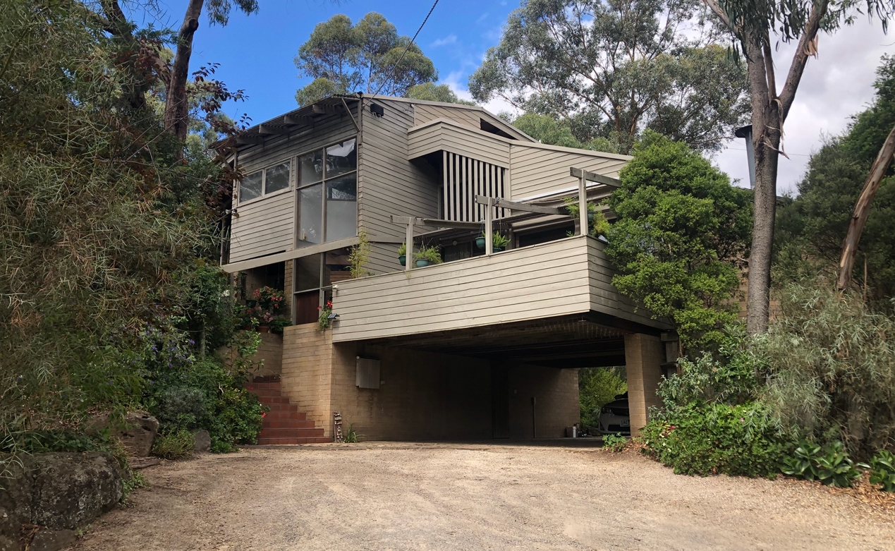
North facade and carport, 17 Haldane Road Eltham. Source: Trethowan Architecture 2022

Historical Context

The following history is extracted from ‘War Memorial Building Complex, 903-907 Main Road’ Eltham, draft citation, prepared for Nillumbik Shire Council by Context Pty ltd in 2020.

Eltham, situated in hilly country northeast of Melbourne, is located on the country of the Wurundjeriwillam clan of the Woi wurrung, one of the five tribes of the Kulin Nation. A plan for fifty allotments in the Township of Eltham, Parish of Nillumbik, was announced in 1848, with the name officially gazetted in 1851. The township, near the junction of the Diamond Creek and the Yarra River, was laid out an area bounded by Baxter Street, Diamond Creek, Dalton Street and Bolton Street. This area is known today as Eltham South. Present-day Eltham, however, was not established on the township reserve, where land proved difficult to sell. Instead, the town grew from allotments in Section IV of the Parish of Nillumbik located on Main Road, to the north of Dalton Street and the township reserve (Butler 1996:32). The township grew during the 1850s around a cluster of buildings at the corner of Pitt Street and Main Road within the Little Eltham subdivision. Located on the road to the Caledonian Diggings, this small township became a service centre for the surrounding mining areas, and by 1854 supported a population of 282. In this period Eltham had two hotels, a brewery and tannery on Diamond Creek. Several public buildings and institutions, including a police station, Wesleyan chapel, a Church of England School and a National School, were established in the 1850s -70s (Context, 2020:1).

Between the 1860s and the 1880s, Eltham supplied food and produce for the gold-mining communities of the Caledonian Diggings at Queenstown (St Andrews) and Panton Hill. It also became a stopping place on route to the Woods Point diggings. Eltham’s population grew in response. In 1871, the town’s population was 165 and by 1881 this had increased to 388 (Victorian Places 2015). Several large properties surrounding the township had absentee owners, who subdivided their properties into smaller farms either for lease or sale. The smaller properties, especially in the Little Eltham township, were run by farmers who often made a modest living as wage labourers. Like many later Eltham residents, they were attracted by cheap land and the country life (Butler 1996:33).

The railway was extended to Eltham opened in 1902, which brought excursionists from Melbourne, many of whom picked wattle during the flowering season, and focused development of the Eltham township around the railway station. Eltham was a picturesque village with the advantage of its proximity to metropolitan Melbourne as well as to attractive countryside with farms and uncleared stringybark forest (Victorian Places 2015). The attractive bush scenery attracted artists, writers and nature-lovers. The landscape painter Walter Withers (1854-1914) moved to Eltham in 1902 when the railway opened; others artists, including members of the Heidelberg School, painted in the area in the open air. Clara Southern and May Vale, landscape painters and students of Frederick McCubbin, settled in the region. Vale resided at Diamond Creek and Southern at Warrandyte (Bartolomei 2008). The war artist Will Longstaff also lived in Eltham for a period. Artist Justus Jorgensen established the notable Montsalvat artist’s colony buildings, on land he purchased in 1934. Seeking a closer engagement with the natural environment, the establishment of Montsalvat, with its adobe and rammed earth buildings, influenced future mud brick construction in the area. Several local architects and designers, including Alistair Knox, specialised in mud brick housing in the post-war period (Victorian Places 2015). Others who have been inspired by Eltham and have made the region their home include landscape architect Edna Walling, authors Alan Marshall and Carolyn Van Langenberg, artists Clifton Pugh and Danila Vassilieff; composers and musicians Graeme and Roger Bell; jewellers and sculptors Michael Wilson, Simon Icarus Baigent and Matcham Skipper; writer CB Christensen; poet Chris Wallace-Crabbe; and actress Kerry Armstrong (Bartolomei 2008; Pierce 1987:354).

Eltham experienced significant post-war development with a number of residential estates subdivided and put up for sale. The population of the town increased from 927 in 1933, to 1278 in 1947, to 7177 in 1971. As a result, Eltham High School opened in 1950 and the Catholic Ladies College was relocated to Eltham in 1971 (Victorian Places 2015). The Eltham War Memorial Trust Baby Health Centre opened in 1951. New shire offices opened in 1965, and Eltham College commenced classes in 1974 (Eltham District Historical Society 2000:np).

A distinctive style in local building emerged in Eltham in the post-war period, with a strong use of natural materials, low form structures, and an integration with the natural environment and the preference for bush gardens, especially after the 1970s. The Eltham Library, designed by architect Greg Burgess, was constructed in mud brick and recycled timbers and received the RAIA Institutional Architecture Award in 1995 (Bartolomei 2008).

A group of young Modernist architects, later described by Robin Boyd as the Melbourne Moderns, made a small but significant contribution to the experimental activity occurring in the Nillumbik area and in adjoining suburbs such as Warrandyte and Lower Plenty. The greatest concentration of their work was along the Kangaroo Ground–Warrandyte Road in North Warrandyte. Apperly et al. would later describe their style as ‘Post-war Melbourne Regional’ (Apperly, Irving & Reynolds 1995, p. 220–1). The Melbourne Moderns experimented with unusual structural systems and materials including steel frames, concrete block and strawboard panels (Heritage Alliance 2008, p. 22).). Robin Boyd designed a house in North Warrandyte for artists Doris and Ken Nichol (1949–50) (HO103). This is one of Boyd’s earliest surviving works; it is also an example of his penchant for the structural expression of timber, most visible here in the sloping timber-framed window walls. The young architect, Kevin Borland’s Rice house in Eltham (HO254) built for Harrie and Lorna Rice, was another clear example of the structuralist bent in the Nillumbik area (Nillumbik Thematic Environmental History 2016:77).

The Shire of Eltham became part of the Shire of Nillumbik in 1994, with a small area becoming part of the City of Banyule.

Architect: Kevin Borland (1926-2000)

A brief history has been extracted from ‘Kevin Borland’ in Encyclopaedia of Australian Architecture (Evans 2012) and Kevin Borland: Architecture from the heart (Evans, Borland & Hamann 2006).

Employed by architect Best Overend in his youth, Borland studied at the Melbourne Technical College before he commenced architecture at the University of Melbourne in 1944. Enlisting during the war, he finished studies in 1951 with honours and with a Diploma in Town and Regional Planning. Immediately following university, he along with Peter McIntyre rented the basement of Mockridge, Stahle and Mitchell’s office, while working with Robin Boyd and Neil Clerehan at the RVIA Small Homes Service. In 1952, they combined with John and Phyllis Murphy and engineer Bill Irwin to put forward the winning design for the Olympic Swimming Stadium (VHR H1977).

At the same time, he was undertaking his first residential commission for the Rice family at Eltham, using the experimental Ctesiphon construction system of intersecting catenary concrete arches (VHR H0123). This period also saw the construction of the Klepner House (1955), the Stein House (1956) and the Mollar House (1959), as well as Borland commencing teaching in 1955, a career that would last three decades and influence generations of architects in Melbourne.

In 1962, Borland also began his relationship with the Preshil School in Kew (VHR H0072), with the following decade producing a number of commissions including the octagonal hall (Kevin Borland Hall, 1962), classrooms (‘treehouse’, 1964) and home rooms (1972).

In conjunction with Daryl Jackson, he designed the seminal Brutalist building, the Harold Holt Swim Centre, in Malvern, in 1968-69 (VHR H0069). It was also in 1969-1970 that he would design the rugged timber Paton House, a project that was to influence his future output strongly, and win house of the year in 1972 (RAIA Victorian Chapter). Subsequent designs in this geometric style included the Nichols house in Eltham (1973), the Crossman flats at Launching Place (1973), the Colvin house in Warrandyte (1974), the McCaughey house in Tallarook (1975), and the Marshall house in Somers (1975).

In 1973, he founded the Architects Group, as a means to accommodate large projects into his growing practice and invited architects Max May, Osric Spence and Philip Cohen to the firm, with the venture lasting until 1977 and completing ‘New Gordon House’ in 1974-76 and the Clyde Cameron College in Wodonga in 1975-77 (VHR H2192).

During a time when industry awards weren’t as widespread as today, Borland’s designs won 11 awards and citations from the Royal Australian Institute of Architects Victorian Chapter, and his lasting impact to Victoria is acknowledged further with the recognition of five projects on the State Heritage Register.

History

On 19 January 1966 Donald Finlay Fergusson Thomson of Worlingworth, Eltham South (Anthropologist) became the first owner of Lot 4, Plan of Subdivision 71415, Parish of Nillumbik, County of Evelyn (the subject site). He died on 12 May 1970 and the property was inherited by Dorita Maria Thomson, widow, with probate granted 1 October 1971. On 14 February 1972 Roy Bruce Nichols, (Company Director) and Jennifer Ann Nichols (married woman) both of 19 Silverdale Road Ivanhoe, became joint proprietors and later commissioned the house to be designed by Kevin Borland. The house won the Age-RAIA House of the Year Award jointly with Max May's Rattle house at Harkaway. Hard landscaping was by landscape designer Gordon Ford (pers.comm).

Ronald and Jennifer Gowan bought the property on 31 October 1996 and are the current owners.
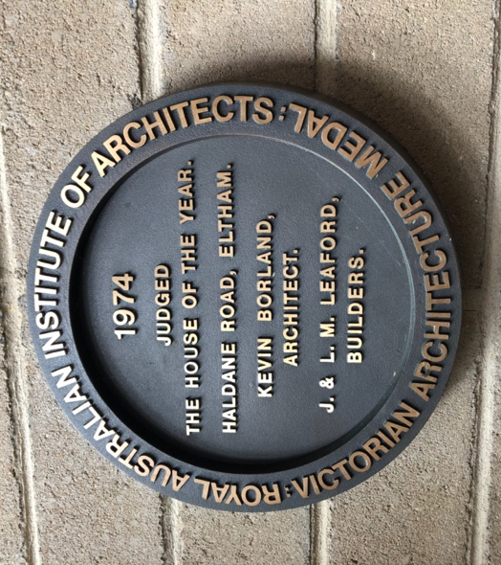
RAIA award plaque, front entry hall. Source: Trethowan Architecture 2022.
Below: Age announcement of the winning designs. Source: Age, 17 October 1974.
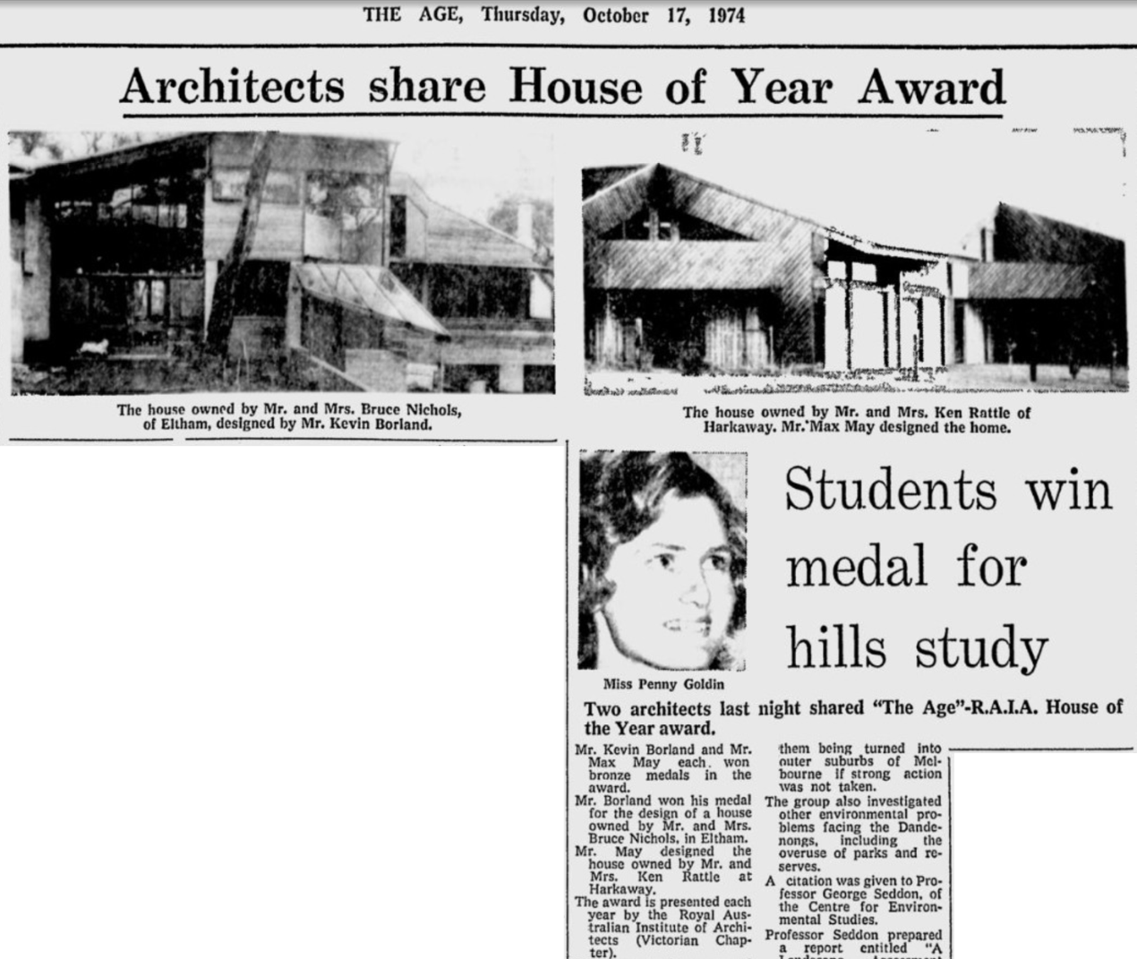

Description & Integrity

The subject site of some 5700sqm of sloping land is located down Haldane Road, a single track unsealed road. The house is centrally placed, set in bushland and not visible from the street. The unsealed driveway leads to the lower end of the house incorporating the carport, workshop and habitable levels above, with the rest of the house stepping up the hill toward the east. The house is a complex form which cascades down the hill, incorporating varied elements extending over four levels plus a mezzanine. It incorporates sections of butterfly roof and other angular, pitched roof sections in corrugated and standing seam metal; recessed and projecting walls; highlight windows, floor to ceiling windows; and deck and pergola areas. Eaves and verandahs are used intermittently with sheer walls.

External walls are of large, tinted modular concrete bricks (possibly Besser 'Beslite') with matching mortar; and also of timber. Timber walls are horizontal shiplap, with window frames also in timber. Exterior timber is painted.

The main butterfly roof, positioned to the east, features a protruding stormwater channel draining to a concrete cylinder on the terrace below, beside the formal entry.

Intersections in brickwork on the front steps and the southwest corner employ a distinctive interlocking pattern which repeats inside the building. The southwest corner also exhibits two dramatic sections of corbelled brickwork.

Evidence of the designed hard landscaping by Gordon Ford exists, comprising naturalistic positioning of large boulders and reclaimed bridge timbers as steps and paths. Other paving such as in the carport and outside the formal entry is of standard size, possibly second-hand or rolled cream brick. The steps from the carport to the everyday entry are of smooth, rectangular terracotta tiles, a material which repeats in the interior of the house.

The house is in its second ownership since being designed and built for the Nichols family in 1973. The first owners added the tennis court extension and pergola at the northeast in the mid-1980s (pers.comm.). The current owners bought the property in 1995 and have undertaken some alterations to the exterior including extending the carport deck by approximately 1m in the early 2000s, and painting the external timber to slow its deterioration. The interior of the house including timber finish is substantially intact, with some minor alterations and repairs.

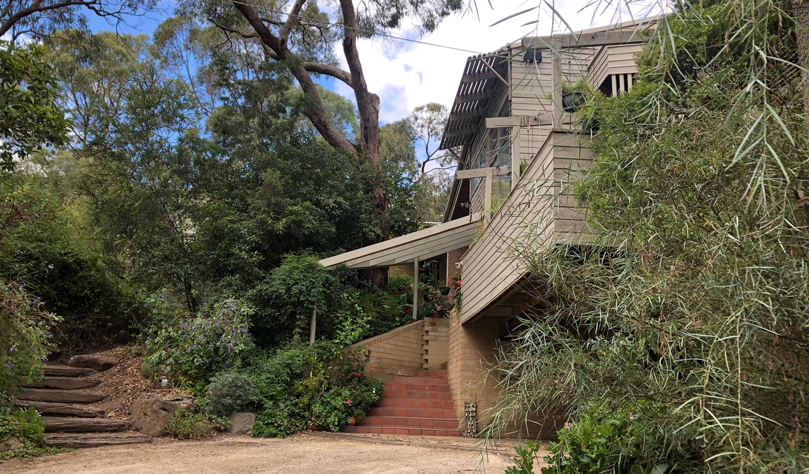
Two sets of steps lead up from the unsealed driveway. At left, timber bridge beam steps lead to the front terrace and formal entry, and at left terracotta tile steps lead to the informal, everyday entry. Source; Trethowan Architecture 2022.

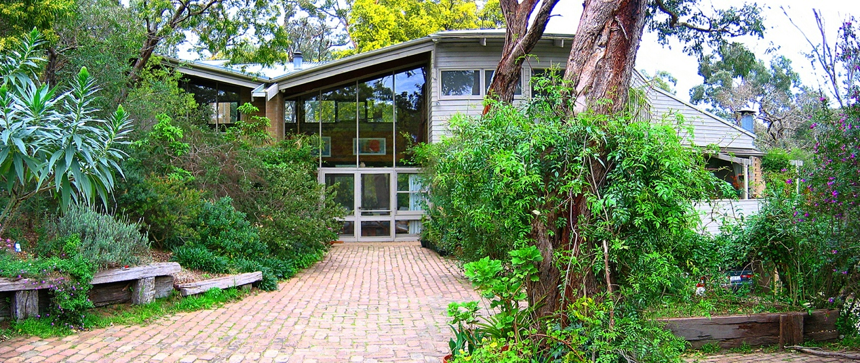
North facade and formal entry. The protruding stormwater channel is to the upper left of the entrance. Source: Ron Gowan 2004.
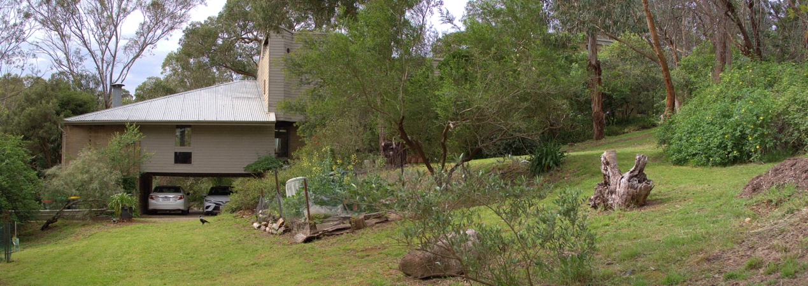
South (rear) facade. Source: Ron Gowan 2020.
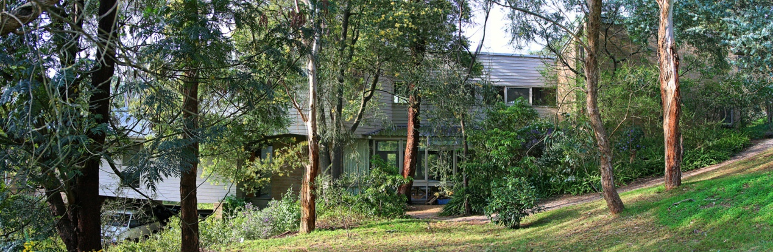
South (rear) facade from southeast. Source: Ron Gowan 2020.

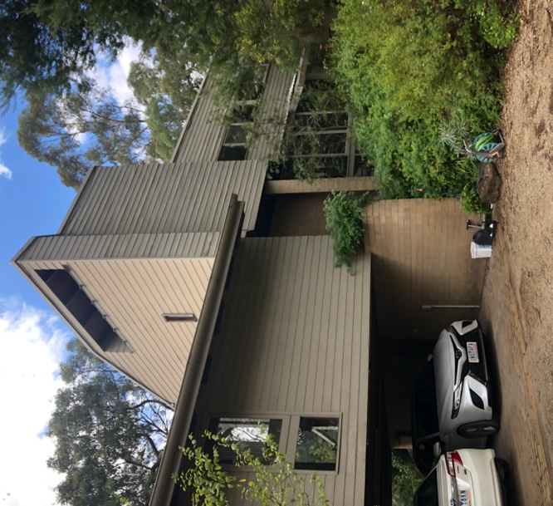 | 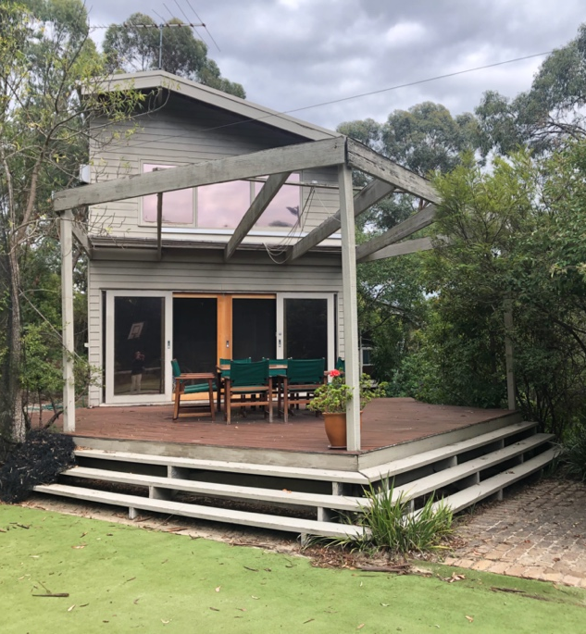
Rear view of house from carport showing the lower three levels. Source: Trethowan Architecture 2022 | Two level addition at northeast. Source: Trethowan Architecture 2022

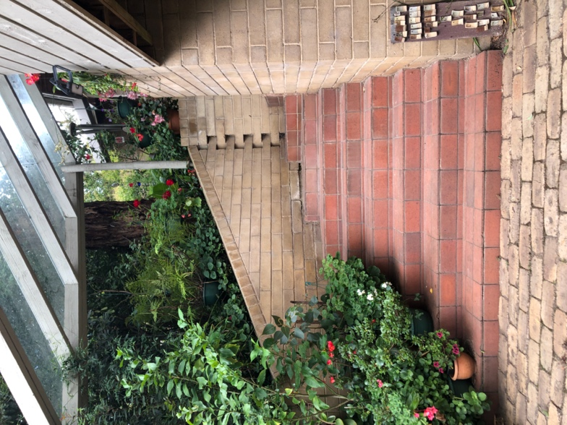 | 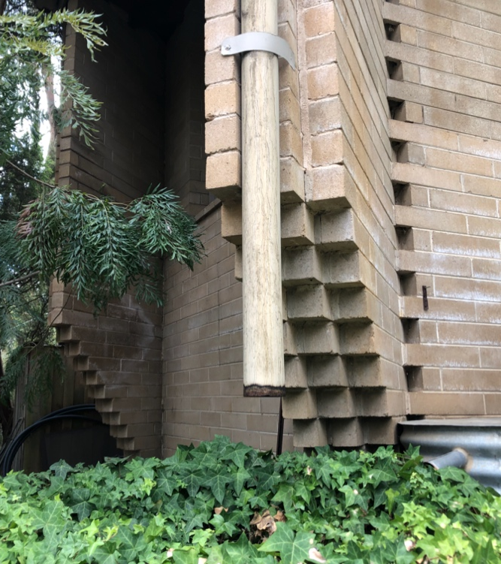
Steps from carport to secondary front entry, showing brickwork, tiled steps and brick paving. Source: Trethowan Architecture 2022 | Detail of brickwork at southwest corner of house, workshop area. Source: Trethowan Architecture 2022

 | 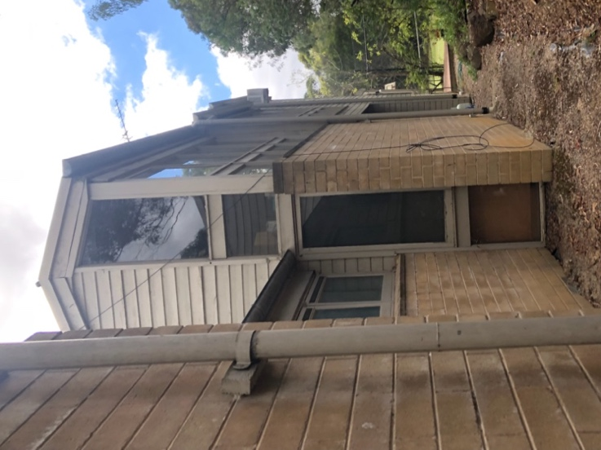
Southeast corner of house, bedroom with loft. Source: Trethowan Architecture 2022 | Looking toward northeast corner of house, showing mirroring two-level rooms, and later addition beyond. Source: Trethowan Architecture 2022

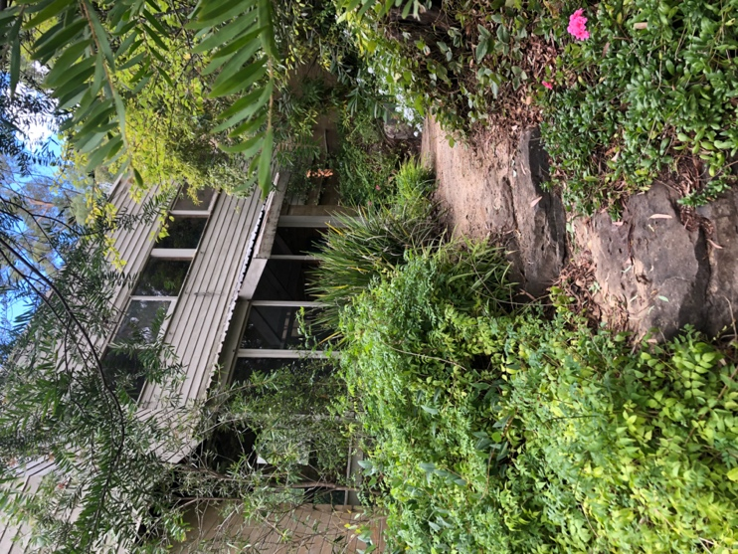 | 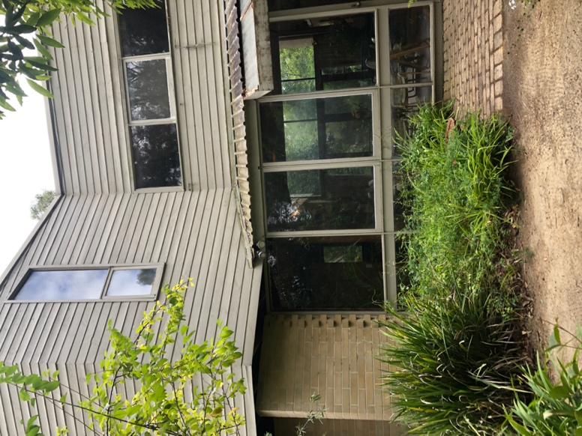
Rough stone steps looking tioward rear terrace. Source: Trethowan Architecture 2022 | Rear terrace to living area, showing decorative brickwork at left. Source: Trethowan Architecture 2022

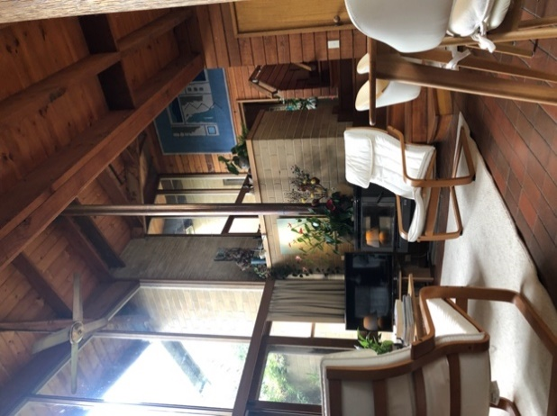 | 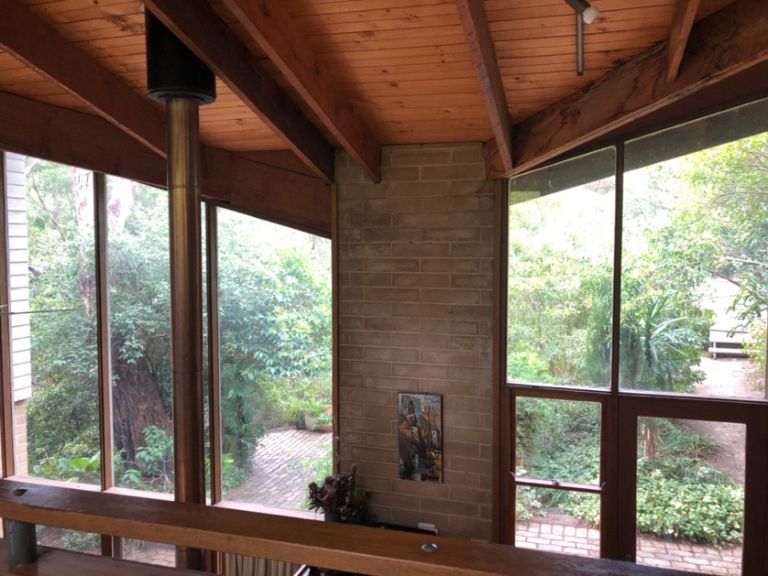
View of central living area showing cathedral ceiling and floor to ceiling windows. Source: Trethowan Architecture 2022. | View to front terrace from third floor gallery, nadir of butterfly roof above. Source: Trethowan Architecture 2022.

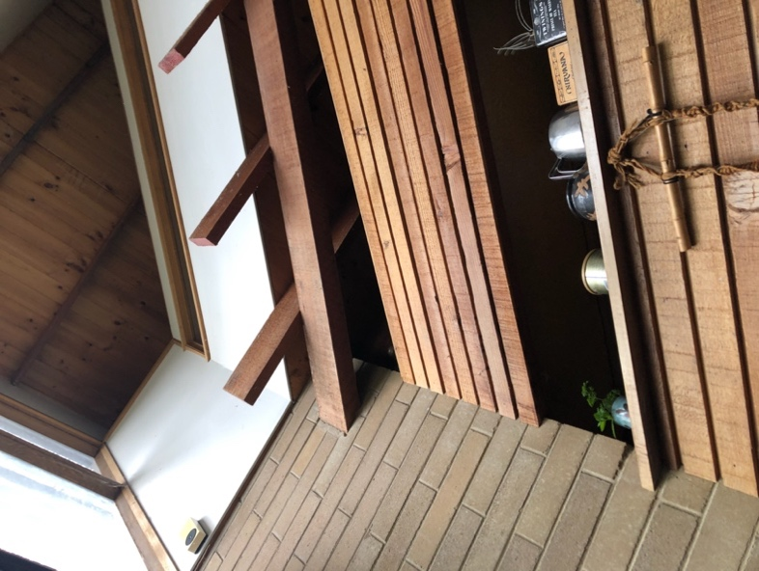 | 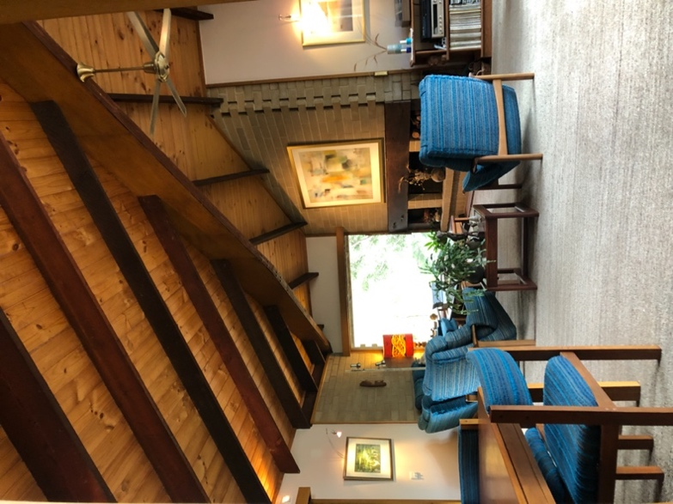
View from front entry looking up two further levels. Source: Trethowan Architecture 2022. | Living room over carport. Source: Trethowan Architecture 2022.

Condition and Integrity

There is evidence of deterioration in external timber at various points around the house. Exterior timber has been painted and some sections replaced with new material over time. Brickwork looks intact. There is aging of roofing at the rear terrace entrance. However apart from the deck extension over the carport, the wing added to the northeast of the house, and the painting of external timber, the house as a whole is substantially intact and true to its original design.

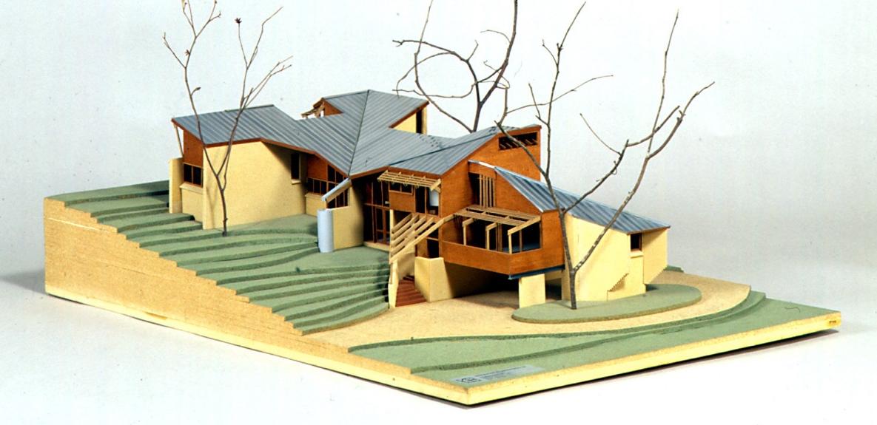
Architectural model of 17 Haldane Road by Huan Chen, donated to Museums Victoria for its exhibition 'Home Sweet Home: Changes in Victorian Domestic Architecture, 1839 - 1989'. The model shows the original design before deck extension at northwest, and addition at northeast. Also note timber finish on external walls, which was the original scheme before it was painted.
Source: Museums Victoria collection https://collections.museumsvictoria.com.au/items/255676

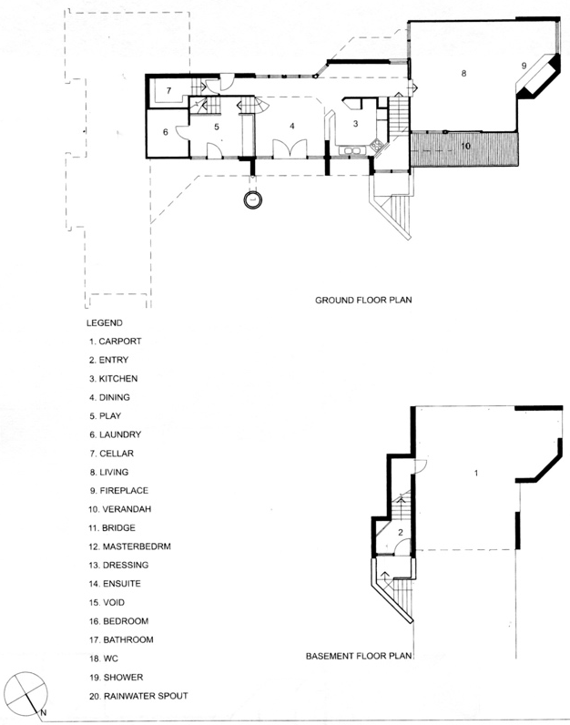 | 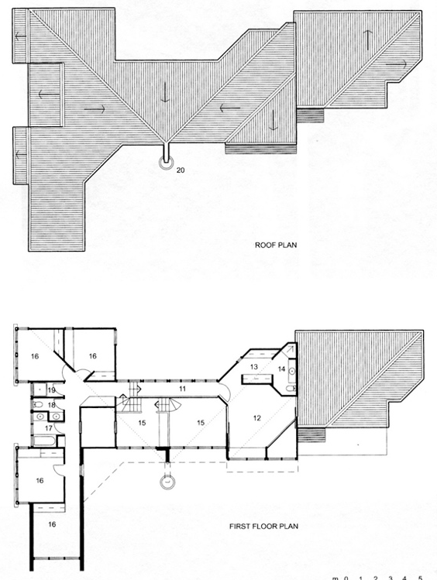
Plans of the Nichols House 1973. Source: D Evans Kevin Borland: Architecture form the Heart pp.194-195

Comparative Analysis

Architect designed houses in the 1960s-70s

The 1960s led the reassessment of the aesthetic ideals of post-war Modernism, and what followed was a return to the compartmentalised plan, natural materials and vernacular methods of construction in a search for traditional symbolic references to home and truth in structure and expression of materials (Goad 1992). This move away from the concept of uninterrupted space, towards an exploration of enclosed volume saw a rigorous investigation of the section and a return to primitive notion of space and shelter with the avoidance of the hierarchical notions of space. Key practitioners were David Saunders, Neville Quarry, Judith and John Brine, Graeme Gunn, Daryl Jackson and Kevin Borland and it was here the emergence of Brutalism in Melbourne was tentatively fostered. (London 2012; Goad 1992)

The Nichols House at 17 Haldane Road is distinctive as an individual design, and a later but similarly idiosyncratic and expressive example of Borland's work.

The following examples have been chosen to illustrate the rise of the architect designed house in the Shire of Nillumbik.

- Rice House, 69 Ryan's Road Eltham - HO123 - Victorian Heritage Register
Designed by Kevin Borland in 1951 and constructed in 1953-4, this was Borland's first commissioned house design and was a boldly experimental post-war project. It is architecturally and historically significant. The house was constructed using the 'ctesiphon system', an innovative construction method developed in 1947. This system used 'cement containing a non-porite waterproofing agent [...] applied in layers to a form of regularly spaced catenary timber arches tightly covered by hessian'.

Rice house is of historical significance for its association with architect Kevin Borland whose innovative designs in both domestic and public architecture make him notable amongst the Melbourne architects of the second half of the twentieth century (SoS HO123).
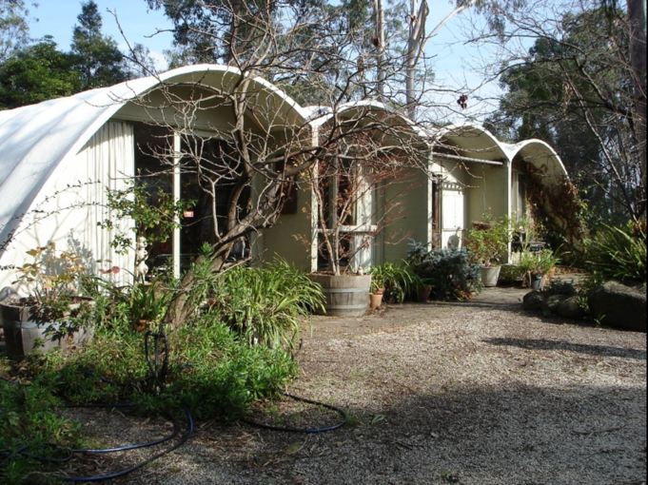
Image source: Victorian Heritage Database.

- Wright House 8 Kangaroo Ground-Warrandyte Road, North Warrandyte - HO105
A post-war modernist house from 1964 designed by Robin Boyd, one of six in the area by this renowned architect. A two level building featuring exposed oregon beams and bagged brick walls, evoking the Eltham mud brick era.

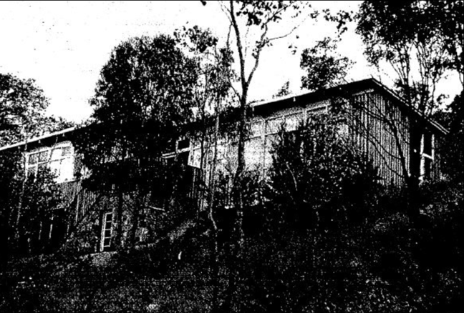
Wright House HO105. Image source: Context 2010

- Pittard Residence, 430 Mount Pleasant Road Research - HO139
Designed by Alastair Knox and built in 1978-1979, this mud brick and timber two level house makes use of recycled materials and has a curved plan and expansive sloping roof. The house is architecturally and historically significant and is an innovative example of Knox's later work.

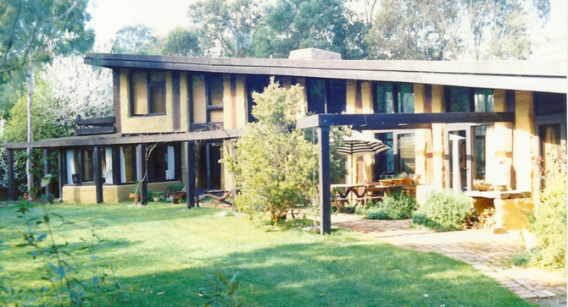
Image source: SoS

- 14-16 Warringah Crescent Eltham
A concrete block and timber house designed by architect Peter Carmichael of Cocks Carmichael, built in c. 1975. Recommended for HO in 'Nillumbik Shire Heritage Review Stage A'.
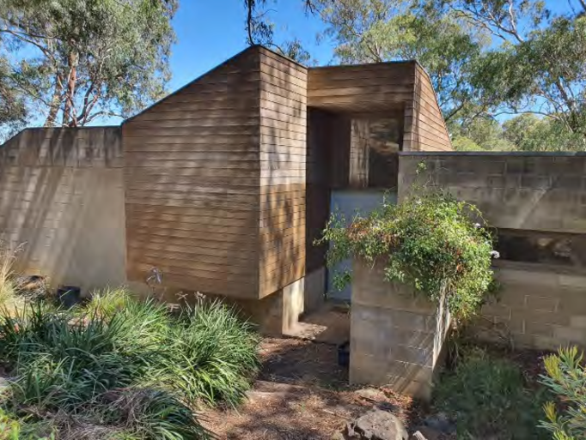
Image source: Nillumbik Shire Council Heritage Review Stage A, Context PL. p.185.

- Colvin House, 3 Lawrence Court Warrandyte North
This house, recommended for investigation and assessment, was designed by Kevin Borland and built in 1976. It was cited as an Age-RAIA House of the Week on 6 December 1976. The timber house steps down a steep hill under a triangular skillion roof, with floor levels adapting to the slope. (Age 6 December 1976 p.16; Mills and Westbrooke 2016 p.89; Day 1976 p.68)
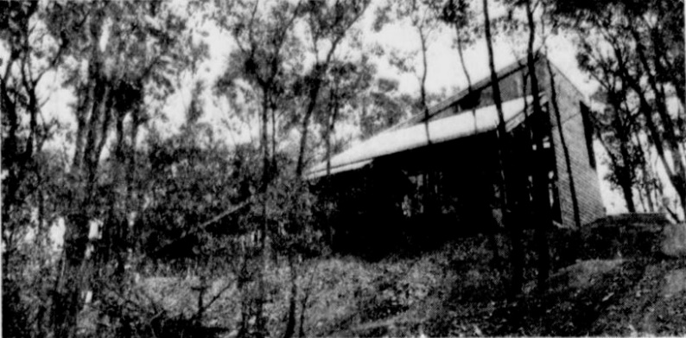
Colvin House, Warrandyte North. Image source: Age, 6 December 1976, p. 16
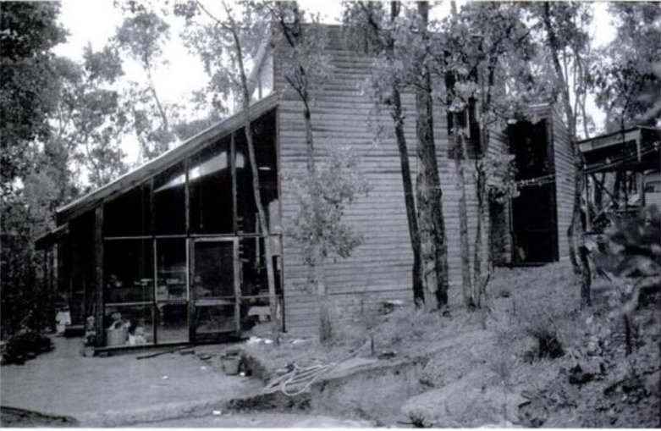
Colvin House, Warrandyte North. Image source: Evans, D., Borland, H.C. and Hamann C. 2006, p.69

Assessment Against Criteria

Criteria referred to in Practice Note 1: Applying the Heritage Overlay, Department of Planning and Community Development, revised July 2015, modified for the local context.

CRITERION A: Importance to the course or pattern of the Shire of Nillumbik’s cultural or natural history (historical significance).
The house at 17 Haldane Road Eltham is associated with the later period of ‘Melbourne Modern’ architects’ involvement in the Shire, in this case Kevin Borland, who was among the prominent architects and designers experimenting with design in the Shire from the post-war period through to the late twentieth century.

CRITERION B: Possession of uncommon, rare or endangered aspects of the Shire of Nillumbik’s cultural or natural history (rarity).

CRITERION C: Potential to yield information that will contribute to an understanding of the Shire of Nillumbik’s cultural or natural history (research potential).

CRITERION D: Importance in demonstrating the principal characteristics of a class of cultural or natural places or environments (representativeness).

CRITERION E: Importance in exhibiting particular aesthetic characteristics (aesthetic significance).
The house at 17 Haldane Road Eltham is aesthetically significant as a mature example of architect Kevin Borland's residential work, recognised by the RAIA Victoria House of the Year award in 1974. It represents the evolution of domestic architecture from the light, open spaces and simplicity of the modernist ideal, through the rugged 'Eltham Style' of solid shapes and reclaimed and handmade materials, toward the more ´structuralist’ complexity of forms and interrelated planes and spaces responding to their landform setting which characterise Kevin Borland's work of this period. The landscaping is of aesthetic significance as an archetypal naturalistic design by landscape designer Gordon Ford.

CRITERION F: Importance in demonstrating a high degree of creative or technical achievement at a particular period (technical significance).

CRITERION G: Strong or special association with a particular community or cultural group for social, cultural or spiritual reasons. This includes the significance of a place to Indigenous peoples as part of their continuing and developing cultural traditions (social significance).

CRITERION H: Special association with the life or works of a person, or group of persons, of importance in the Shire of Nillumbik’s history (associative significance).

Statement of Significance

What is Significant?
How is it significant?
Why is it significant?
Grading and Recommendations

Recommended for inclusion in the schedule to the Heritage Overlay of the Nillumbik Planning Scheme.

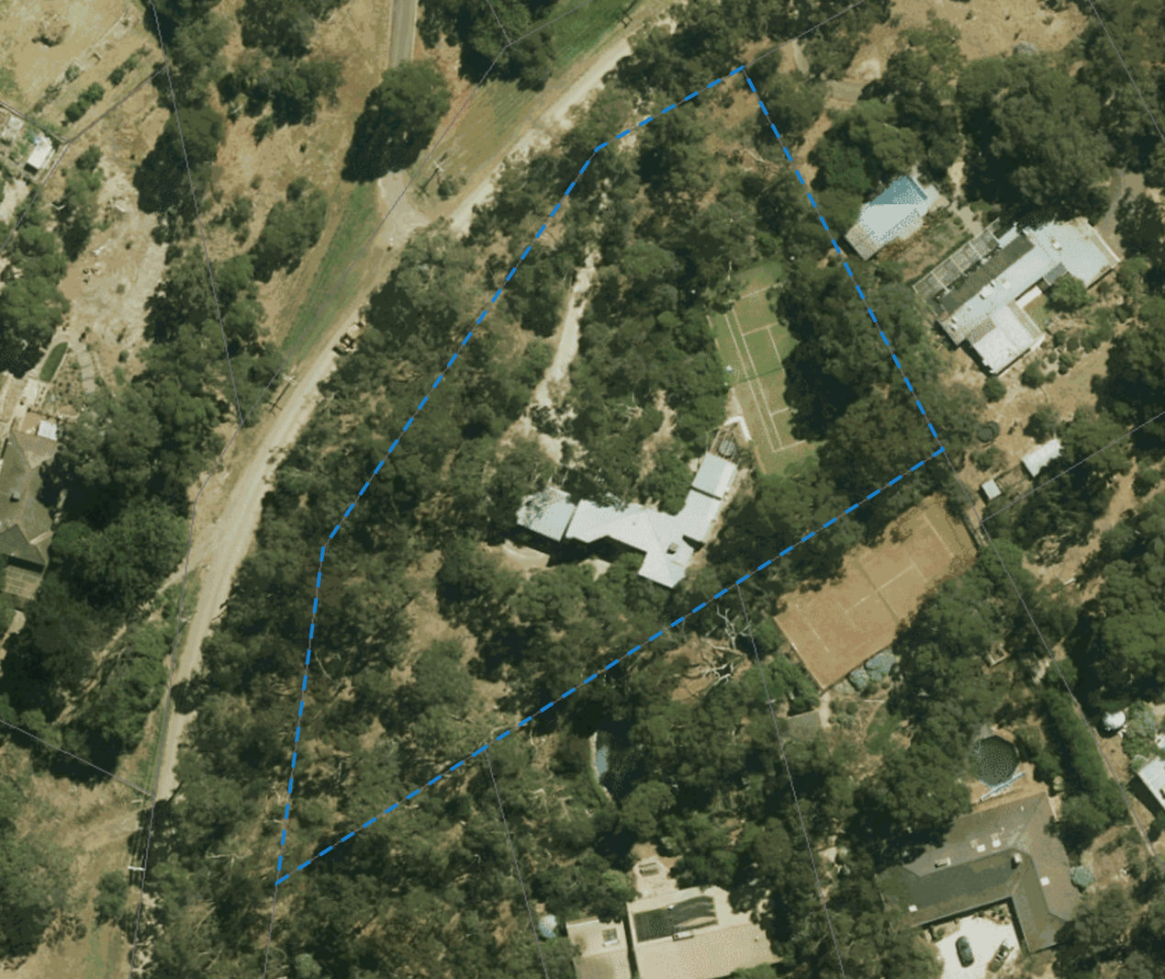
Recommended extent of HO.

Recommendations for the Schedule to the Heritage Overlay (Clause 43.01) in the Nillumbik Planning Scheme:

External Paint Colours  Is a permit required to paint an already painted surface? | No
Internal Alteration Controls  Is a permit required for internal alterations? | No
Tree Controls  Is a permit required to remove a tree? | No
Victorian Heritage Register  Is the place included on the Victorian Heritage Register? | No
Incorporated Plan  Does an Incorporated Plan apply to the site? | No
Outbuildings and fences exemptions  Are there outbuildings and fences which are not exempt from notice and review? | No
Prohibited uses may be permitted  Can a permit be granted to use the place for a use which would otherwise be prohibited? | No
Aboriginal Heritage Place  Is the place an Aboriginal heritage place which is subject to the requirements of the Aboriginal Heritage Act 2006? | No

References

Age, as cited.

Context PL 2021, Nillumbik Shire Council Heritage Review Stage A, prepared for Nillumbik Shire Council.

Day, N. 1976 Modern Houses Melbourne Brian Zouch Publications, Armadale Vic.

Evans, D. 2012 'Borland, Kevin' in Goad, P. and Willis, J. The Encyclopaedia of Australian Architecture Cambridge University Press, New York

Evans, D., Borland H.C. and Hamann C. 2006, Kevin Borland: Architecture from the Heart, RMIT Publishing, Melbourne

Goad, Philip 1992, The Modern House in Melbourne, 1945-1975. PhD Thesis, Faculty of Architecture Building and Planning, University of Melbourne.

London, Geoffrey 2012, ‘Brutalism’ in The Encyclopaedia of Australian Architecture, Cambridge University Press.

Mills, P. and Westbrooke, S. 2016, Nillumbik Shire Thematic Environmental History, Prepared for the Shire of Nillumbik.

