Title: Zadnic House, 7 Banoon Road Eltham
Identified by: Peter Mills and Samantha Westbrooke
Prepared by: Trethowan Architecture

Address: 7 Banoon Road Eltham
Name: Zadnic House | Survey Date: NA
Place Type: House | Architect: Ken Robinson
Grading: Locally significant | Builder: G Stewart
Extent of Overlay: Property boundaries | Construction Date: 1975

The house at 7 Banoon Road in c.1976. Source: Day 1976 p.185.

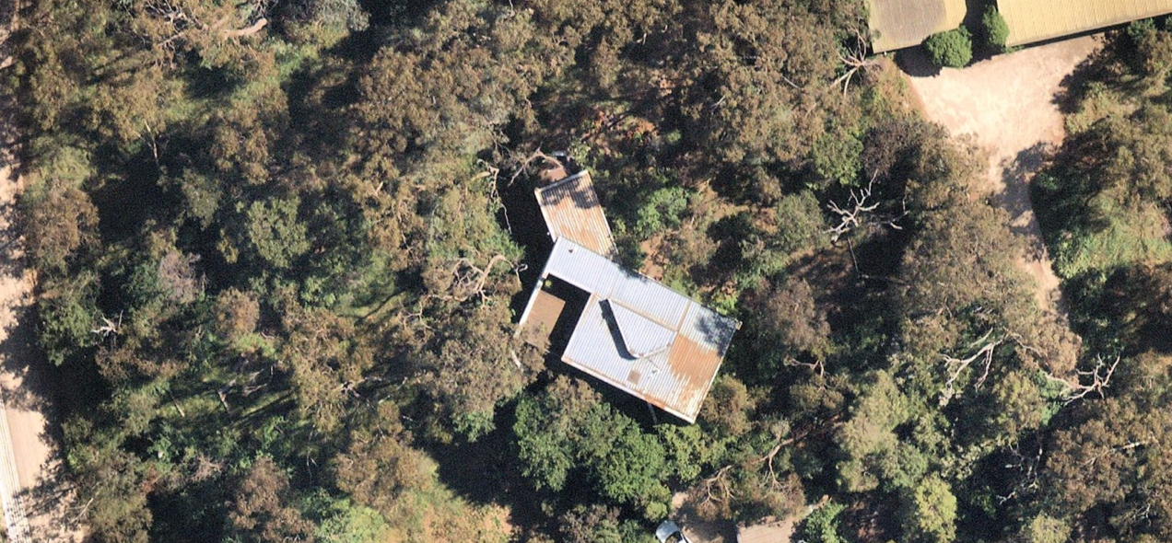
Contemporary aerial of house at 7 Banoon Road Eltham. Image source: Nearmap 2021.

Historical Context

The following history is extracted from ‘War Memorial Building Complex, 903-907 Main Road’ Eltham, draft citation, prepared for Nillumbik Shire Council by Context Pty Ltd in 2020.

Eltham, situated in hilly country northeast of Melbourne, is located on the country of the Wurundjeriwillam clan of the Woi wurrung, one of the five tribes of the Kulin Nation. A plan for fifty allotments in the Township of Eltham, Parish of Nillumbik, was announced in 1848, with the name officially gazetted in 1851. The township, near the junction of the Diamond Creek and the Yarra River, was laid out an area bounded by Baxter Street, Diamond Creek, Dalton Street and Bolton Street. This area is known today as Eltham South. Present-day Eltham, however, was not established on the township reserve, where land proved difficult to sell. Instead, the town grew from allotments in Section IV of the Parish of Nillumbik located on Main Road, to the north of Dalton Street and the township reserve (Butler 1996:32). The township grew during the 1850s around a cluster of buildings at the corner of Pitt Street and Main Road within the Little Eltham subdivision. Located on the road to the Caledonian Diggings, this small township became a service centre for the surrounding mining areas, and by 1854 supported a population of 282. In this period Eltham had two hotels, a brewery and tannery on Diamond Creek. Several public buildings and institutions, including a police station, Wesleyan chapel, a Church of England School and a National School, were established in the 1850s -70s (Context, 2020:1).

Between the 1860s and the 1880s, Eltham supplied food and produce for the gold-mining communities of the Caledonian Diggings at Queenstown (St Andrews) and Panton Hill. It also became a stopping place on route to the Woods Point diggings. Eltham’s population grew in response. In 1871, the town’s population was 165 and by 1881 this had increased to 388 (Victorian Places 2015). Several large properties surrounding the township had absentee owners, who subdivided their properties into smaller farms either for lease or sale. The smaller properties, especially in the Little Eltham township, were run by farmers who often made a modest living as wage labourers. Like many later Eltham residents, they were attracted by cheap land and the country life (Butler 1996:33).

The railway was extended to Eltham opened in 1902, which brought excursionists from Melbourne, many of whom picked wattle during the flowering season, and focused development of the Eltham township around the railway station. Eltham was a picturesque village with the advantage of its proximity to metropolitan Melbourne as well as to attractive countryside with farms and uncleared stringybark forest (Victorian Places 2015). The attractive bush scenery attracted artists, writers and nature-lovers. The landscape painter Walter Withers (1854-1914) moved to Eltham in 1902 when the railway opened; others artists, including members of the Heidelberg School, painted in the area in the open air. Clara Southern and May Vale, landscape painters and students of Frederick McCubbin, settled in the region. Vale resided at Diamond Creek and Southern at Warrandyte (Bartolomei 2008). The war artist Will Longstaff also lived in Eltham for a period. Artist Justus Jorgensen established the notable Montsalvat artist’s colony buildings, on land he purchased in 1934. Seeking a closer engagement with the natural environment, the establishment of Montsalvat, with its adobe and rammed earth buildings, influenced future mud brick construction in the area. Several local architects and designers, including Alistair Knox, specialised in mud brick housing in the post-war period (Victorian Places 2015). Others who have been inspired by Eltham and have made the region their home include landscape architect Edna Walling, authors Alan Marshall and Carolyn Van Langenberg, artists Clifton Pugh and Danila Vassilieff; composers and musicians Graeme and Roger Bell; jewellers and sculptors Michael Wilson, Simon Icarus Baigent and Matcham Skipper; writer CB Christensen; poet Chris Wallace-Crabbe; and actress Kerry Armstrong (Bartolomei 2008; Pierce 1987:354).

Eltham experienced significant post-war development with a number of residential estates subdivided and put up for sale. The population of the town increased from 927 in 1933, to 1278 in 1947, to 7177 in 1971. As a result, Eltham High School opened in 1950 and the Catholic Ladies College was relocated to Eltham in 1971 (Victorian Places 2015). The Eltham War Memorial Trust Baby Health Centre opened in 1951. New shire offices opened in 1965, and Eltham College commenced classes in 1974 (Eltham District Historical Society 2000:np).

A distinctive style in local building emerged in Eltham in the post-war period, with a strong use of natural materials, low form structures, and an integration with the natural environment and the preference for bush gardens, especially after the 1970s. The Eltham Library, designed by architect Greg Burgess, was constructed in mud brick and recycled timbers and received the RAIA Institutional Architecture Award in 1995 (Bartolomei 2008).

The Shire of Eltham became part of the Shire of Nillumbik in 1994, with a small area becoming part of the City of Banyule.

Ken Robinson - Architect

Born in 1944 in East Melbourne, Ken Robinson grew up in Alphington and began Architecture at the University of Melbourne in 1962, studying under Brian Lewis. He describes the School of Architecture as 'a wonderful experience - colourful and exciting, a whole new world of art and interaction with interesting people' (pers.comm.). After graduating in 1967 he completed an internship with Peter McIntyre and was involved with the design of some of McIntyre's earlier 'Modern Houses'.

Robinson became a sole practitioner in 1968, collaborating with other enthusiastic recent graduates of the University of Melbourne School of Architecture. He worked closely with Dennis Carter and together they started Robinson Carter Architects in South Melbourne.

It was during this time Robinson was approached by Alex and Megan Zadnic, who commissioned the house at 7 Banoon Road Eltham. The design was partially a product of Robinson's interest in the Art Deco period, utilising curves, 45 degree angles, flat rooms and pitched ceilings.

In the mid-1970s, Ken Robinson left Robinson Carter Architects to pursue a heritage reconstruction project near Kyneton Victoria, immersing himself in working with brick, stone and slate. During this time, he continued work as a sole practitioner, designing the Cave house at Wye River, and Brocklebank at Kyneton, both in Victoria.

In the early 1980s he moved to the Noosa hinterland in Queensland, where he designed buildings to suit the subtropical environment, utilising lightweight materials such as metal and timber. In 1990 his Spargo House in Noosa was awarded an HIA Queensland award for House of the Year.

History

On 19 January 1966 Donald Finlay Fergusson Thomson of Worlingworth, Eltham South (Anthropologist) became the first owner of Lot 1, Plan of Subdivision 71415, Parish of Nillumbik, County of Evelyn (the subject site). He died on 12 May 1970 and the property was inherited by Dorita Maria Thomson, widow, with probate granted 1 October 1971. The land was purchased by Alexander Zadnic (Engineer) and Dorothea Megan Zadnic (married woman) of 10 Cypress Avenue Lower Templestowe on 28 July 1972. Dorothea became sole proprietor on 4 December 1992.

The house was commissioned by the Zadnic’s to be designed by architect Ken Robinson and was the Age-RAIA House of the Week on 9 June 1975 (p.8).

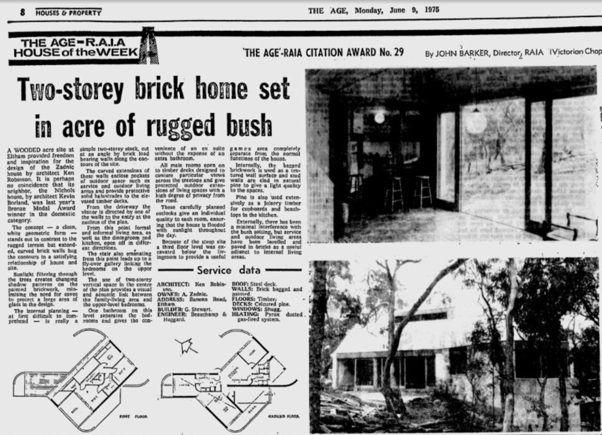
Source: Age, 9 June 1975 p.8.

Description & Integrity

The house is set on a sloping, treed corner site of approximately 4400sqm. The building is of masonry construction with an exterior of bagged and painted brick, a metal roof, and timber window frames, decks and floors. Double tubular metal rails run horizontally beside balconies and decks. The form of the house is of simple rectangular shapes, over two distinct levels, and features curving brick arms at ground level.

In contrast to the earthy 'Eltham Style' of the 60s and 70s which express the bush environment through their materials such as mud brick, handmade brick, reclaimed and new timber, the materials of this house stand apart from their natural bushland setting:
The clean white geometrical form of Ken Robinson’s Zadnik house, located on a steeply sloping wooded site in Banoon Road, Eltham, was similarly intended to stand out ‘in contrast to the rugged terrain’. The walls were of painted bagged brick and the roof of metal deck. (Mills and Westbrooke 2016 p.90)
First Floor and Ground Floor plans. Image source: Day 1976 p.185.

Exterior showing bagged brick walls.  Image source: Day 1976 p.184. | Timber lined interior.  Image source: Day 1976 p.186.

The house at 7 Banoon Road in c.1976. Source: Day 1976 p.185.

Comparative Analysis

The Zadnic house moves away from the 'Eltham Style' of timber and mud brick, and neither does it follow the complex, detailed timber-rich forms of Ken Borland which step in stages down their sloping bushland sites. The house stands apart from its setting, bright and bold, and is stylistically unique for the period in this municipality. Robinson noted his interest at this point was in art deco architecture of the 1930s which is evident in the curving brick 'arms' and horizontal tubular rails, but the incorporation of other ideas particular to the time of the house's design such as the 45 degree angles on sections of roof with near flat roof elsewhere, sheer walls, voids, clerestory windows, floor to ceiling glazing, and interior timber lining is apparent, and these combine to produce an innovative and unusual building.

Other houses of the period notable for their unique design include the following:

- Richards House, 80 Dodd Street St Andrews - HO194
- Eltham South Preschool, 35 Fordhams Road Eltham - HO202
- 17 Haldane Road Eltham - Proposed for HO
- 14-16 Warringah Crescent Eltham - Proposed for HO

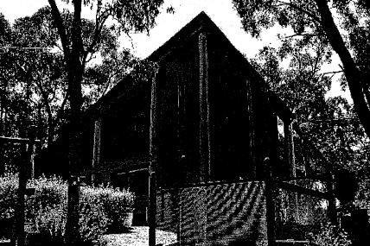  Richards House, 80 Dodd Street St Andrews - HO194 | 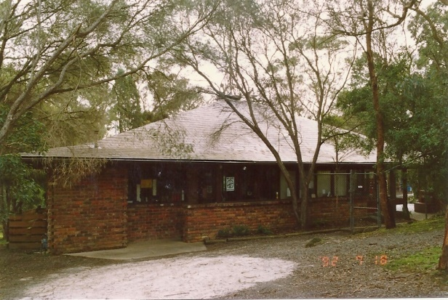  Eltham South Preschool, 35 Fordhams Road Eltham - HO202
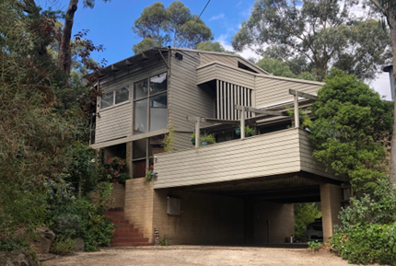  17 Haldane Road Eltham - Proposed for HO. | 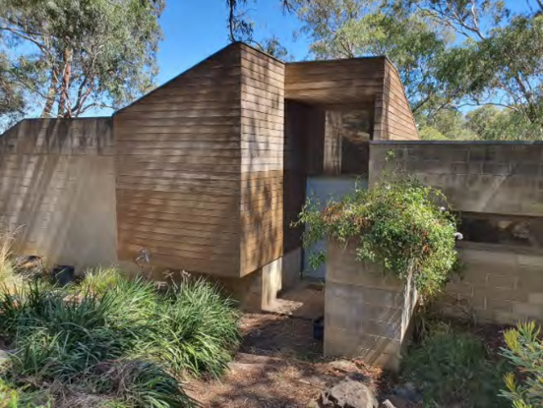  14-16 Warringah Crescent Eltham – Proposed for HO.

The Richards House at 80 Dodd Street St Andrews (HO194) was one of a group of often irregularly shaped houses in the area built on sloping sites in the 1970s and 1980s, with angled walls and roof forms, on multiple levels.

The Eltham South Preschool, 35 Fordhams Road Eltham (HO202) was designed by architect Charles Duncan in c.1970s. The form of this building is noticeably unusual amongst 'Eltham Style' buildings of the time, with triangular floor plan.
The house at 17 Haldane Road Eltham – (Proposed for HO) is located immediately to the north of the subject site, this house was designed by Kevin Borland won the RAIA Victoria House of the Year award in 1974, and also adopts an unusual range of interlocking forms and irregular plan.
The house at 14-16 Warringah Crescent Eltham (Proposed for HO) is a concrete block and timber house designed by architect Peter Carmichael of Cocks Carmichael, built in c. 1975.
Ken Robinson’s house at 7 Banoon Road compares favourably to these examples in terms of its architectural distinction, using an unusual plan and combination of forms that rise from the landscape, quite different to the more integrative approach of the ‘Eltham Style’. In this respect it is most comparable to 14-16 Warringah Crescent, also built around the same time. The combination of Art Deco forms with more Modernist design, combining an angle plan with attached drum form, is distinctive, and the emphasis on sheer walls and expressed materiality tends towards a more Brutalist style.

Assessment Against Criteria

Criteria referred to in Practice Note 1: Applying the Heritage Overlay, Department of Planning and Community Development, revised July 2015, modified for the local context.

CRITERION A: Importance to the course or pattern of the Shire of Nillumbik’s cultural or natural history (historical significance).

CRITERION B: Possession of uncommon, rare or endangered aspects of the Shire of Nillumbik’s cultural or natural history (rarity).

CRITERION C: Potential to yield information that will contribute to an understanding of the Shire of Nillumbik’s cultural or natural history (research potential).

CRITERION D: Importance in demonstrating the principal characteristics of a class of cultural or natural places or environments (representativeness).

CRITERION E: Importance in exhibiting particular aesthetic characteristics (aesthetic significance).
The house at 7 Banoon Road is of aesthetic significance to the Shire of Nillumbik. Designed by architect Ken Robinson and recipient of an Age-RAIA house of the Week award in 1975, it was distinctive and notable for the time, exhibiting a new scheme for contemporary architecture in a bush setting which remains unique today. The body of the house is based around a rectangle with a protruding wing, and features bagged brick walls with curving 'arms', horizontal tubular rails, 45 degree angles on parts of the roof and near horizontal on others, sheer walls, voids, clerestory windows and floor to ceiling glazing. he combination of Art Deco forms with more Modernist design, combining an angle plan with attached drum form, is distinctive in Nillumbik, and the emphasis on sheer walls and expressed materiality using brick rather than concrete tends towards a more Brutalist style and a very different architectural approach to what was more popular at the time.

CRITERION F: Importance in demonstrating a high degree of creative or technical achievement at a particular period (technical significance).

CRITERION G: Strong or special association with a particular community or cultural group for social, cultural or spiritual reasons. This includes the significance of a place to Indigenous peoples as part of their continuing and developing cultural traditions (social significance).

CRITERION H: Special association with the life or works of a person, or group of persons, of importance in the Shire of Nillumbik’s history (associative significance).

Grading and Recommendations

Recommended for inclusion in the schedule to the Heritage Overlay of the Nillumbik Planning Scheme.

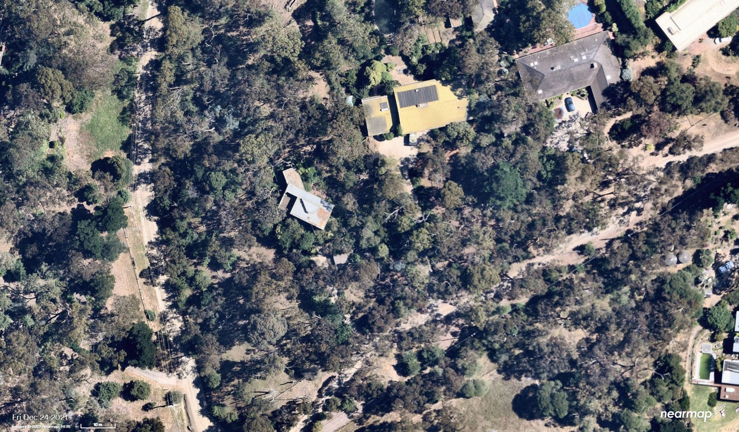
Recommended extent for subject site. Image source: Nearmap 2021.

Recommendations for the Schedule to the Heritage Overlay (Clause 43.01) in the Nillumbik Planning Scheme:

External Paint Colours  Is a permit required to paint an already painted surface? | No
Internal Alteration Controls  Is a permit required for internal alterations? | No
Tree Controls  Is a permit required to remove a tree? | No
Victorian Heritage Register  Is the place included on the Victorian Heritage Register? | No
Incorporated Plan  Does an Incorporated Plan apply to the site? | No
Outbuildings and fences exemptions  Are there outbuildings and fences which are not exempt from notice and review? | No
Prohibited uses may be permitted  Can a permit be granted to use the place for a use which would otherwise be prohibited? | No
Aboriginal Heritage Place  Is the place an Aboriginal heritage place which is subject to the requirements of the Aboriginal Heritage Act 2006? | No

References

Age, as cited.

Argus, as cited.

Day, Norman 1976 Modern Houses Melbourne, Brian Zouch publications, Armadale.

Mills, P. and Westbrooke, S. 2016, Nillumbik Shire Thematic Environmental History, prepared for Nillumbik Shire Council.

Bartolomei, D 2008, ‘Eltham’, eMelbourne, School of Historical and Philosophical Studies, The
University of Melbourne, https://www.emelbourne.net.au/biogs/EM00516b.htm.

Butler, Graeme and Associates 1996, ‘Nillumbik Shire Heritage Review – Environmental History’, Prepared for the Shire of Nillumbik.

Eltham District Historical Society 2000, A Chronology of Known Local Events 1835-early 2000 including those in the Shire of Nillumbik and the former shires of Eltham and Diamond Valley, Eltham District Historical Society Incorporated.

Context Pty Ltd 2020, ‘War Memorial Building Complex, 903-907 Main Road’ Eltham, draft citation, prepared for Nillumbik Shire Council.

Mills, Peter and Westbrooke, Samantha 2017, ‘Nillumbik Shire Thematic Environmental History – Revision 2016’, prepared for Nillumbik Shire Council.

Nillumbik Parish Plan 1951, Department of Lands and Survey, Melbourne.

‘Parish of Nillumbik’ 2002, VPRS 16171, Public Record Office Victoria.

Personal Communication, Ken Robinson, April 2022.

Victorian Places 2015, ‘Christmas Hills’, Monash University and The University of Queensland,
https://www.victorianplaces.com.au/, accessed online 06 April. 2022

