2 Batman Road, Eltham

‘Bell Vue’
Prepared by: Context | Survey date: December 2020
Place type: Residential | Designer: -
Significance level: Significant | Builder: Not known
Extent of overlay: To title boundaries | Major construction: c1929-30
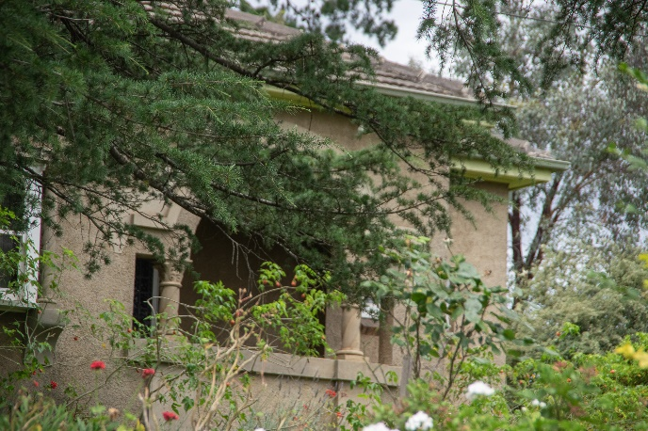
Figure 1. 2 Batman Road, Eltham, detail of the primary elevation with Mediterranean detailing. (Source: Context 2020)
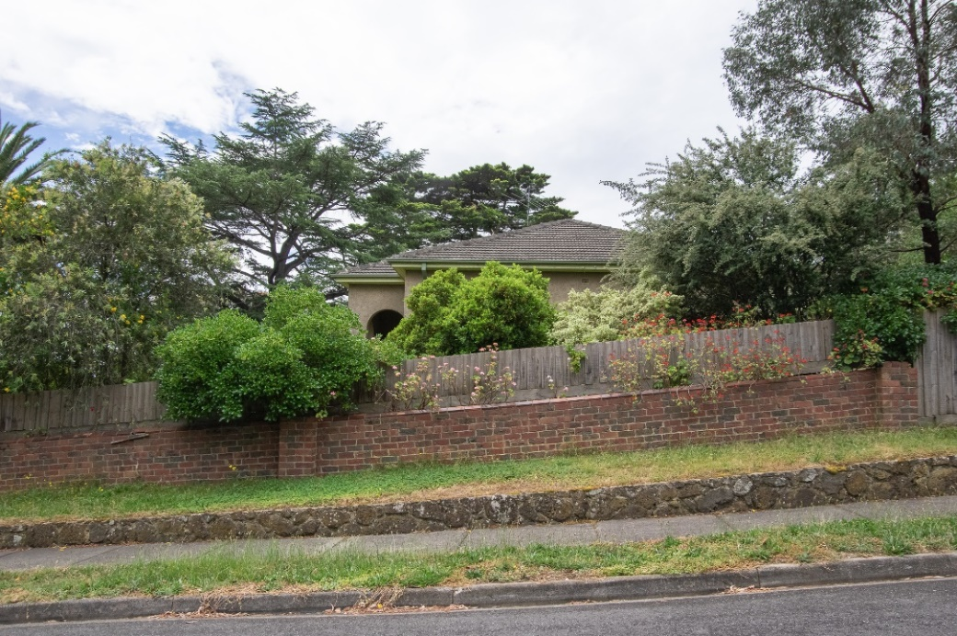
Figure 2. 2 Batman Road, Eltham, secondary elevation from Livingstone Road. (Source: Context 2020)

HISTORICAL CONTEXT
This place is associated with the following historic themes taken from the Nillumbik Shire Thematic Environmental History (2016):
6 BUILDING TOWNS AND SHAPING SUBURBS
6.3 Interwar subdivisions and estates
In the interwar period there were numerous speculative subdivisions throughout the Nillumbik area. These were often marketed as combining possibilities for escape from the city and immersion in the natural values of the area. The introduction of the railway made such speculations possible and they were spurred on by the promise of its electrification. This meant greater frequency of services and therefore greater viability for commuting workers and weekenders. (Mills & Westbrooke 2016:71)
The suburban fringe of the metropolis was advancing towards the southern and south-eastern edges of Eltham Shire. With the advancing of the metropolitan fringe towards Eltham, and the closer subdivision in the main towns of the Shire, both the suburban dream and an alternative in the form of a weekend getaway from the city were on offer. (Mills & Westbrooke 2016:71)
The electrification of the railway to Eltham in 1923 eliminated the changeover to steam trains at Heidelberg allowing faster through-trains and so reducing commuting time. It was generally expected that this would soon convert Eltham into a suburban area. Certainly, there was a proliferation of subdivided new estates for the next few years. At first there was some infilling of Holloway’s early Little Eltham subdivision. The 130 blocks of Sydney Haynes’ Bellevue estate, situated on both sides of Main Road and the railway line to the north of Eltham station, were advertised from 1920. By 1923 prospective buyers were advised to take advantage of the cheap blocks before prices inevitably rose. Forty lots in the estate were sold in April 1923. (Mills & Westbrooke 2016:71)
Other subdivisions were carved from rural land, often starting with deceased estates. The local name for the estate often reflected the former rural landowners. In 1922 the View Hill estate was advertised as the ‘highest point in the district, quite handy to [Eltham] station’. Twenty-three building blocks in the Mona Vale estate and two in Browne’s subdivision were advertised in 1924. In 1925 the owners of the View Hill estate submitted a plan for roads on the estate to the shire council for approval. The following year an owner in the estate disposed of his two lots at a ‘very satisfactory figure’ to Messrs J. & H. Rowe, electrical engineers from the city who were planning to build two ‘concrete villas’. (Mills & Westbrooke 2016:71)
In 1924 a ‘leading Melbourne land agent’ acquired a large tract of land in Eltham for subdivision purposes. This may have been the Eltham Electric Station Estate (known locally as the Pryor estate) opposite the station, where lots were auctioned in 1925. The estate included 11 shop sites in Main Street and 29 ‘beautiful elevated residential allotments’. Local reports found that Eltham was on the ‘up grade’. ‘The railway has given the necessary acceleration towards advancement and not only is Eltham becoming popular as an outer suburban residential area, but also as an easily accessible tourist resort.’ (Mills & Westbrooke 2016:72)
In the late 1920s the developer’s tone remained optimistic. The Advertiser described the commencement of five new buildings in Eltham as a ‘mini boom’. ‘New buildings are springing up all round the district, which a progressive council has supplied with water and for which far-sighted residents have obtained the electric current from the Electricity Commission. For some time agents have been seeking out and securing the beauty spots around Eltham, for which there is a good demand, and there is every indication that, in the near future, a substantial increase in settlement will take place.’ (Mills & Westbrooke 2016:72)

LOCALITY HISTORY
Eltham, situated in hilly country northeast of Melbourne, is located on the country of the Wurundjeri-willam clan of the Woi wurrung, one of the five tribes of the Kulin Nation. A small, short-lived reservation south of Eltham on the Yarra River was set aside for Aboriginal people in 1852. The area is situated near the junction of the Yarra River and its tributary, Diamond Creek.
Pastoral settlers moved into the area from around 1840 and took up pastoral leases (Bartolomei 2008). It was located proximate to the track used by the Ryrie brothers to provide access between their ‘Yering’ run, near Yarra Glen, and the Heidelberg village (Victorian Places 2015). In 1841, William Bell and Thomas Armstrong occupied land for a squatting run east of Diamond Creek in what was to become the Eltham district (Eltham District Historical Society 2000: np).
A plan for 50 allotments in the Township of Eltham, Parish of Nillumbik, was announced in 1848, with the name officially gazetted in 1851. The township, near the junction of Diamond Creek and the Yarra River, was laid out in an area bounded by Baxter Street, Diamond Creek, Dalton Street and Bolton Street. The township plan shows that a track to a bridge across Diamond Creek and Main Road was noted as the ‘Track from Melbourne’ (Butler 1996:32). This area is known today as Eltham South.
Present-day Eltham, however, was not established on the township reserve, where land proved difficult to sell. Instead, the town grew from allotments in Section IV of the Parish of Nillumbik located on Main Road, to the north of Dalton Street and the township reserve (Butler 1996:32). In 1851, Melbourne property developer Josiah Holloway purchased one square mile (or 5120 acres) of this land, which he subdivided immediately, calling the subdivision Little Eltham. The central area of current-day Eltham is contained within the Little Eltham subdivision. A number of large farming properties around the township were purchased from the early 1850s (Nillumbik Parish Plan 1951).
Eltham township grew during the 1850s around a cluster of buildings at the corner of Pitt Street and Main Road within the Little Eltham subdivision. Located on the road to the Caledonia goldfields, this small township became a service centre for the surrounding mining areas, and by 1854 supported a population of 282. In this period Eltham had two hotels, a brewery, and a scattering of shops along Main Road (known in the 1850s as Maria Street). The town had a steam flour mill operated by Henry Dendy, and a tannery was located on the Diamond Creek. The Little Eltham School, opened by the Church of England, was built in 1853 near Swan Street and closed in 1872. A second school, a national school (later Eltham Common School No. 209) opened in Dalton Street in 1856. A Wesleyan chapel opened in 1858. Public buildings constructed at this time included a courthouse and a police station in Main Road in 1860. The ‘flat land’, which is now the Eltham Lower Park, near the Yarra, was used as a racecourse (Kellaway cited in Butler 1996:32-33; Eltham District Historical Society 2000:np). A cemetery was established in 1858. The township and wider area was administered by the Shire of Eltham, established in 1856.
Between the 1860s and the 1880s, Eltham supplied food and produce for the goldmining communities of the Caledonia goldfields at Queenstown (St Andrews) and Panton Hill. It also became a stopping place on the route to the Woods Point diggings. Eltham’s population grew in response (Victorian Places 2015).
A Primitive Methodist chapel was built in 1860. The following year St Margaret's Anglican Church, designed by the notable Melbourne architect Nathaniel Billing, was built. In 1881, a Wesleyan church was constructed by George Stebbing to the design of Melbourne architects Crouch and Wilson (Butler 1996:33). A new state school, constructed of local sandstone, opened in 1876.
Several large properties surrounding the township had absentee owners, who subdivided their properties into smaller farms either for lease or for sale. The smaller properties, especially in the Little Eltham township, were run by farmers who often made a modest living as wage labourers. Like many later Eltham residents, they were attracted by cheap land and the country life (Butler 1996:33).
In 1884 Eltham was described as:
… a pretty little township on the Yarra Flats road ... It has a population of nearly 400 inhabitants, but in addition it is the centre of a large district extending over 208 square miles, having a population of 2344. The land in the district is mostly used for grazing purposes, although as a rule the small farms grow a good deal of wheat, oats and other agricultural produce. A large quantity of fruit, especially raspberries and strawberries, is also produced (Illustrated Australian News 20 December 1884, cited by Carlotta Kellaway in Butler 1996:33).
The Australian News noted that gold had been found in the vicinity of the township, ‘but not in remunerative quantities’ (cited by Carlotta Kellaway in Butler 1996:33).
In the 1880s agitation began for the extension of the railway line from Melbourne to Heidelberg to serve Eltham and districts further afield such as Kangaroo Ground. The railway station in Eltham opened in 1902, however the line was never extended to Kangaroo Ground. The railway brought excursionists from Melbourne, many of whom picked wattle during the flowering season, and focused development of the Eltham township around the railway station. Eltham was a picturesque village with the advantage of its proximity to metropolitan Melbourne and to attractive countryside with farms and uncleared stringybark forest (Victorian Places 2015). The bush scenery attracted artists, writers and nature-lovers.
In 1903 the Australian Handbook described Eltham as part of an orcharding and grazing district. In 1901, 4289 acres were under cultivation, of which 2506 acres were planted with orchards and market gardens. The township, with a population of 377, included a state school, a branch of the Commercial Bank, and Catholic, Anglican, Wesleyan Methodist and Primitive Methodist places of worship (cited in Victorian Places 2015). From 1909, rural properties were increasingly subdivided to create residential estates on the outskirts of the Eltham township (Mills & Westbrooke 2017:69).
The electrification of the railway line was extended to Eltham in 1923, eliminating the need to change to steam train at Heidelberg and allowing faster through-trains and shorter commuting times. The establishment of new residential estates in Eltham followed (Mills & Westbrooke 2017:71). Reflecting the town’s growth, a higher elementary school was opened in 1926 (Victorian Places 2015).
Eltham was described in 1940 as ‘residential, horticultural, dairying and grazing ... a beauty spot for artists and picnickers’. By this time, the town had three recreation reserves, swimming baths, tennis courts and a fire brigade (Victorian Places 2015).
Eltham has attracted a number of writers and artists over the years. The landscape painter Walter Withers (1854-1914) moved to Eltham in 1902 when the railway opened; other artists, including members of the Heidelberg School, painted in the area in the open air. Clara Southern and May Vale, landscape painters and students of Frederick McCubbin, settled in the region. Vale resided at Diamond Creek and Southern at Warrandyte (Bartolomei 2008). The war artist Will Longstaff also lived in Eltham for a period. From 1910, painter William ‘Jock’ Frater and cartoonist Percy Leason often camped and painted in the area. Artist Justus Jorgensen established the notable Montsalvat artists’ colony buildings, on land he purchased in 1934. Seeking a closer engagement with the natural environment, the establishment of Montsalvat, with its adobe and rammed earth buildings, influenced future mudbrick construction in the area. Several local designers, including Alistair Knox, specialised in mudbrick housing in the postwar period (Victorian Places 2015). Others who have been inspired by Eltham and have made the Nillumbik region their home include landscape architect Edna Walling; authors Alan Marshall and Carolyn Van Langenberg; artists Clifton Pugh and Danila Vassilieff; composers and musicians Graeme and Roger Bell; jewellers and sculptors Michael Wilson, Simon Icarus Baigent and Matcham Skipper; writer CB Christensen; poet Chris Wallace-Crabbe; and actor Kerry Armstrong (Bartolomei 2008; Pierce 1987:354).
Eltham experienced significant postwar development with a number of residential estates subdivided and put up for sale. The population of the town increased steadily as a result. In 1933, only 927 residents were recorded in the town in 1933; this had increased to 7177 residents in 1971. As a result, Eltham High School opened in 1950 and the Catholic Ladies College was relocated to Eltham in 1971 (Victorian Places 2015). The Eltham War Memorial Trust Baby Health Centre opened in 1951. New shire offices opened in 1965, and Eltham College commenced classes in 1974 (Eltham District Historical Society 2000:np).
A distinctive style in local building emerged in Eltham in the postwar period, with a strong use of natural materials, low form structures, and an integration with the natural environment. Houses were often sited in bush gardens, especially after the 1970s. This style was also adapted to community buildings in the area, with the Eltham Library being constructed in mudbrick and recycled timbers in 1994 (Eltham District Historical Society 2019).
The Shire of Eltham became part of the Shire of Nillumbik in 1994, with a small area becoming part of the City of Banyule.

PLACE HISTORY
‘Bell Vue’ at 2 Batman Road, Eltham, is located on Crown Allotment 1, Section 11, Parish of Nillumbik, 91 acres purchased by H Stooke in 1852 (Nillumbik Parish Plan 1951).
By 1914, parts of Crown Allotment 1 and adjoining Crown Allotment F, a total of 92 acres, were owned by farmers William and Mary Ann Williams (CT:V3805 F900).
In c1920, the 92-acre land parcel was subdivided into approximately 137 residential lots and came to be known as the Bellvue Estate. These lots were sold between 1920 and 1925 (CT:V3805 F900). The streets of the subdivision included Hillside Road, today’s Batman Road, and Bellevue Road, today’s Livingstone Road.
Civil engineers Robert Woodcock and Charles McCormack of Melbourne purchased a number of the subdivision lots, subsequently selling them between 1925 and 1927 (CT:V4847 F238).
Lot 79 of the subdivision, which incorporated the subject site, was sold to Eltham grazier Charles Henry Felix Butler in 1925. Butler also purchased a number of other neighbouring lots bounded by Bellevue Road, Hillside Road and Stanley Avenue - a total of approximately nine acres (CT:V4847 F238; CT:V5070 F911).
The subject residence, ‘Bell Vue’, was subsequently built for C F (Felix) Butler, and his wife, Margaret (nee Swanton), who were married in 1910 (Ancestry 2021). The building was in the planning stage in September 1929, when Butler requested that Eltham Shire Council extend the water supply to the property so that he could proceed with the erection of his house. An application to Council for the construction of a brick residence at the corner of Hillside and Bellevue roads was made by Butler in December of the same year (Advertiser 6 September 1929:4 and 6 December 1929:4). In January 1930, Butler applied to Council for permission to install a septic tank at the property (Advertiser 10 January 1930:4).
Butler undertook a 33-lot subdivision of the nine acres on which his residence was located, with all blocks selling between 1928 and 1950. As part of the subdivision, Lot 79 was surveyed into five blocks: Lot 1, 2, 3, 32 and 33, all retained by Butler (CT:V5070 F911).
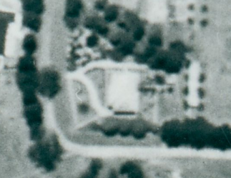  Figure 3. Aerial imagery of the site in 1945 showing original forked driveway. (Source: CPO, ‘MELBOURNE AND METROPOLITAN AREA PROJECT’ 1945, via Landata) | 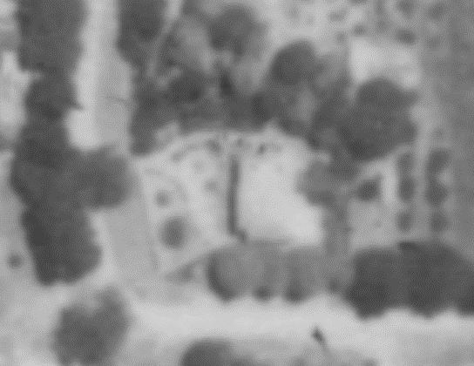  Figure 4. Aerial imagery of the site in 1951, the lean-to at the rear appears to be visible (Source: CPO, ‘MELBOURNE AND METROPOLITAN PROJECT NO.2’ 1951, via Landata)
The five Lot 79 blocks were purchased in 1947 by widow Esther Cooke of East Malvern. Cooke sold a portion of the property in the same year, retaining Lot 1 (the subject property) and Lot 2 (CT:V6995 F923). Lots 1 and 2 were sold in 1957. By 1957, Hillside Road had been renamed Batman Road and Bellevue Road renamed Livingstone Road (CT:V8143 F160). The two lots were subdivided in 1971 (CT:V6995 F923). The subject site, Lot 1, was sold as a separate property in 1971 (CT:V8143 F160), with Lot 2 selling the following year
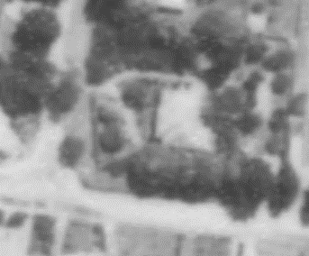  Figure 5. Aerial imagery in 1962, the outbuilding in the southeastern corner is visible. (Source: CPO, ‘MELBOURNE-GEELONG PROJECT’, via Landata) | 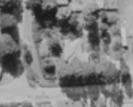  Figure 6. Aerial imagery of the site in 1968, the southern fork of the driveway appears to have been lost (Source: CPO, MELBOURNE 1968 PROJECT, via Landata)
Comparison of historical aerial photographs indicates that the skillion weatherboard lean-to at the rear (east) of the house was built between 1945 and 1951, and the gable-roofed outbuilding at the south-eastern property boundary is visible by 1962 (Figure 4, Figure 5 and Figure 6). It appears that the southern part of the original forked driveway was removed between 1962 and 1968 (Figure 5 and Figure 6). An established canopy, comparable to that of the extant mature Canary Island Date Palm tree in the front garden, is visible in the 1945 aerial indicating that the tree is contemporary with the construction of the subject house (Figure 3). The same can be said for the mature Monterey Pine tree at the property’s southern edge, which appears to be quite established in the 1945 aerial.
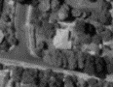  Figure 7. Aerial imagery of the subject site in 1987 (Source: CPO, ‘WESTERN PORT FORESHORES’, via Landata) | 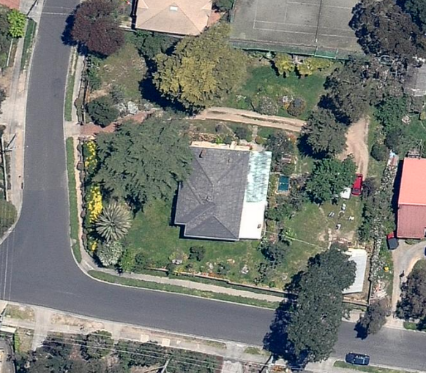  Figure 8. Aerial imagery of the subject site in 2009 showing the polycarbonate translucent roofing to the rear. (Source: Nearmap 2009)

Felix Butler, owner 1930-47
Charles Felix Butler was born in 1875 in Newstead, Victoria. Butler served in South Africa during the Boer War of 1899-1902. He married Margaret Swanton in 1910 and the couple had six children, all born before the subject house was built for the family in 1930 (Ancestry 2021).
Before undertaking the subdivision of the land on which the subject residence stands, Butler developed the Bellevue Estate in Eltham. This estate comprised 137 building allotments located on Main Road close to the Eltham Railway Station, with lots sold from 1920 (Argus 21 February 1920:2; Eltham and Whittlesea Shires Advertiser and Diamond Creek Valley Advocate 10 March 1922:3).
In 1923, Butler was a director of the Melbourne company M B Rail Anchor Pty Ltd. In January 1947, as an executor of the will of Mary Ann Williams, Butler was described as a retired farmer who lived in Bellevue Road, Eltham. By July of that year, he was living in East Malvern (Herald 27 April 1923:14; Argus 14 January 1947:16 and 16 July 1947:14).
On his death in 1955, a newspaper notice stated that Butler was survived by his wife Margaret, and children Gwen, Jack, Dorothea, Noel, Lesley, and Muriel (Argus 5 January 1955:14).

DESCRIPTION
‘Bell Vue’ at 2 Batman Road, Eltham, is an interwar brick bungalow with Mediterranean detailing designed in c1929 for Charles Felix Butler, and his wife Margaret (nee Swanton).
The dwelling sits on a large block at the northeast corner of Batman Road and Livingstone Road within a residential area. The block has two street frontages with the principal elevation facing Batman Road. The eastern side of Batman Road is elevated; the land falls away to the west, providing views from the dwelling across to treed ridges beyond the Diamond River. The single-storey dwelling is in the centre of the block and is surrounded by mature plantings. It has a deep setback from Batman Road that is greater than that of neighbouring properties. There is a lesser setback to Livingstone Road.
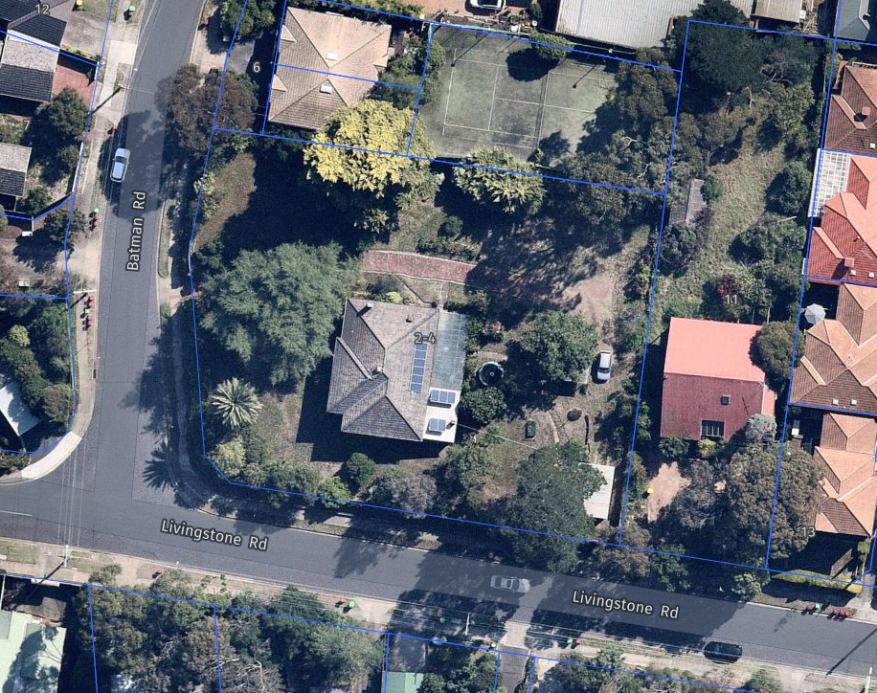
Figure 9. Aerial view of the site showing footprint and rear extension, and garage in the southeast corner. (Source: Nearmap 2021)

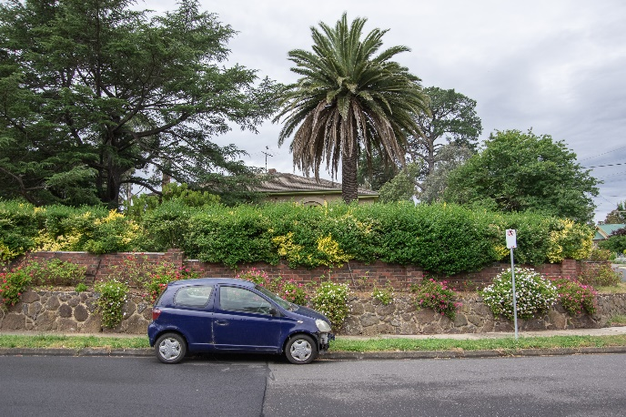  Figure 10. Batman Road (west) frontage with stone retaining wall and brick fence behind and Canary Island Date Palm. (Source: Context 2020) | 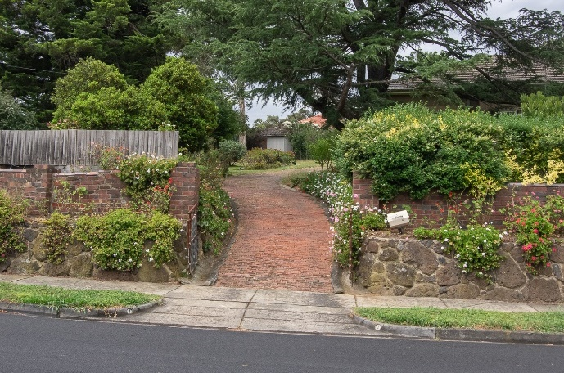  Figure 11. Red brick driveway from Batman Road with timber topped brick fence to the left. (Source: Context 2020)

The dwelling has a hipped roof and is largely rectangular in plan. It has projecting bays to the west and east, creating a slightly asymmetrical form. The main hipped roof is clad in concrete tiles. Eaves are boxed. Lightly textured rendered walls, with contrasting smooth rendered details, sit atop a red clinker brick base. A weatherboard lean-to extension to the rear (east) with a skillion roof of corrugated iron is an early (c1945-51) addition. An adjoining section of translucent polycarbonate to the same depth as the lean-to, added c1987-2009, completes the expanded footprint.
The projecting bay to the principal (west) elevation contains the entrance porch. The porch incorporates a semi-circular arch with smooth rendered detailing. The arch is supported on short barley twist columns with Corinthian capitals. The rendered porch balustrade is capped in smooth render. To the north of the porch are three double-hung timber-framed windows separated by barley twist mullions atop smooth rendered corbels. A smooth rendered lintel extends across all three windows supporting a decorative arched panel. Set back from the projecting bay to the north of this elevation are a further three timber-framed double-hung windows with stepped clinker brick sills. At the south, there is a small highlight window with diamond detailing and angled clinker brick sill on the wall adjacent to the porch.
Figure 12. Porch arch with loose barley twist columns and smooth capped balustrade. (Source: Context 2020) | 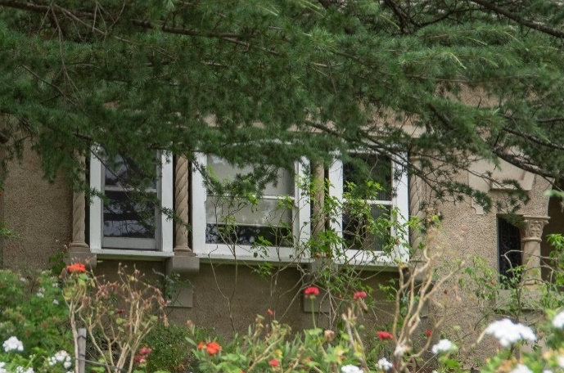  Figure 13. Windows separated by barley twist mullions atop smooth corbels. (Source: Context 2020)
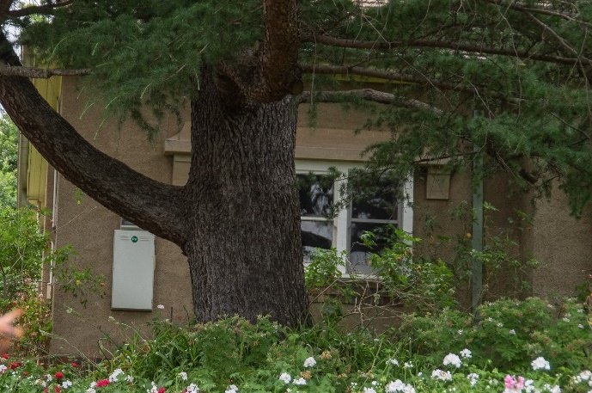  Figure 14. Second tier window detailing, with stepped brick sills and broad smooth rendered lintel supported by corbels. (Source: Context 2020) | 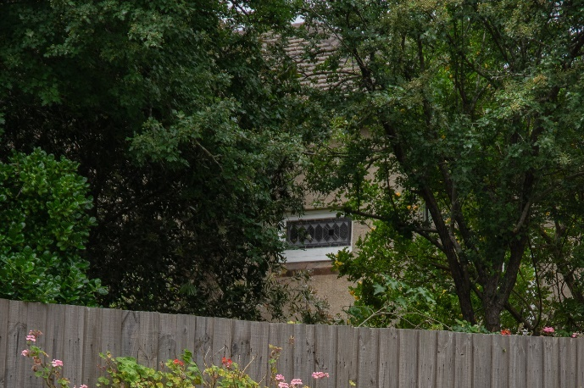  Figure 15. Highlight window with diamond detailing. (Source: Context 2020)

The secondary elevation (south) features a lesser level of detailing and includes double-hung timber-framed sash windows with angled brick sills; one to the east and a pair to the west. A tripartite double-hung timber-framed sash window is visible at the southern elevation of the weatherboard lean-to.
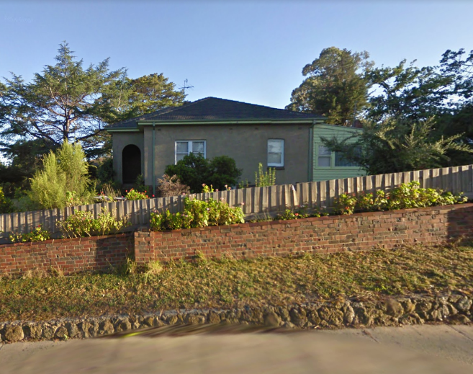  Figure 16. Secondary elevation facing Livingstone Road showing porch entrance arch, simple window detailing, and weatherboard rear extension. (Source: Google Streetview 2010) | 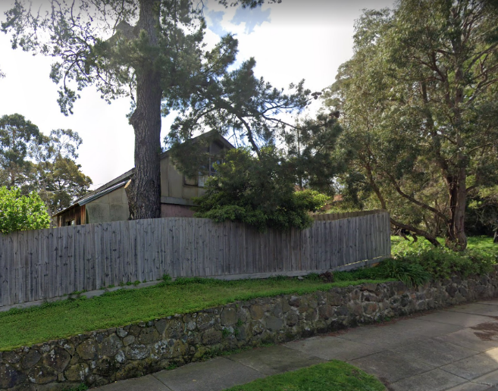  Figure 17. Gable roofed garage visible at the Livingstone Road frontage. (Source: Google Streetview 2019).

A tall face brick chimney sits in the northwest corner of the roof and there is another chimney just visible towards the centre. Photovoltaic cells occupy the part of rear (east plane) of the original roof and part of the skillion roof.
Stone retaining walls line both street frontages, behind which sits a low red clinker brick fence. The brick fence extends from the Batman Street frontage and continues around the corner to halfway along the Livingstone Road frontage. The timber fencing extends above the brick fence along Livingstone Road, and continues at full height from the termination of the brick fence to the property boundary. A driveway laid with red brick (frogs up) and concrete channelling curves uphill on the northern side of the building and provides access to the property from Batman Road before terminating abruptly at the rear of the property. A gable-roofed outbuilding sits in the southeast corner of the block slightly set back from the boundary. There are several other small outbuildings behind the dwelling toward the rear (east) of the allotment.
An established garden surrounds the dwelling with mature trees including a Canary Island Date Palm (Phoenix canariensis) and Himalayan Cedar (Cedrus deodara) at the Batman Road frontage, and a Monterey Pine (Pinus radiata) at the Livingstone Road boundary next to the garage.

INTEGRITY
‘Bell Vue’ at 2 Batman Road, Eltham, is largely intact with very few changes visible to original or early fabric. The building retains its original single-storey built form, concrete tiled roof, entrance porch and fenestrations. The rear weatherboard lean-to appears to be an early addition dating from c1945-1951. A rear verandah of translucent polycarbonate roofing was added c1987-2009, however this is not visible from the public domain.
The integrity of the house is greatly enhanced by highly intact main built form elements and materials including the lightly textured rendered walls, contrasting with smooth render detailing and double-hung timber-framed sash windows. Intact decorative details include the arched porch, and decorative arched panel above the windows to the principal elevation, barley twist columns and corbels which reflect the Interwar Mediterranean style.
The integrity of the place is enhanced by the retention of original and early landscape elements including the original low clinker brick fence, stone retaining walls and the layout of the remaining portion of the driveway that curves to the north of the house. The mature Canary Island Date Palm and Monterey Pine tree that appear to be contemporary with the construction of the house similarly enhance integrity. Overall, the place has high integrity.

COMPARATIVE ANALYSIS
The Interwar Mediterranean style is also referred to as Mediterranean Revival and Mediterranean Villa style. The style appeared in Australia in the late 1910s in response to the temperate climate and bright sunlight, which were conducive to ’an architecture of simple shapes, light and shade, bleached pastel colours and accents of classical detail’, according to Leslie Wilkinson, Professor of Architecture at the University of Sydney, who is credited with popularising the style in Australia (Apperly et al. 1989:172). The style gained popularity in the 1920s (Cuffley 1989:74-5). It was originally applied to domestic architecture in upper and upper middle-class suburbs, and later to modest-sized commercial and institutional buildings (Apperly et al. 1989:172).
The Interwar Mediterranean style is related to the Interwar Spanish Mission style, but is intentionally designed with simpler and less elaborate features. Details take on an austere classical or Renaissance mode, which subtly evokes a Mediterranean feel. In particular, Interwar Mediterranean domestic architecture incorporates features including pergolas, balconies, arcaded loggias and formal entrances, with sidelights and highlights, while Tuscan columns typically appear in verandahs and porches. The exterior is lightly bagged or cement-rendered (Apperly et al. 1989:172-4; Cuffley 1989:75-76).
There is only one place on the Heritage Overlay that exhibits elements of the Mediterranean style: the former Sutherland Homes orphanage administration block (HO171) at 2 Yan Yean Road, Diamond Creek. Built in 1929, the building comprises a central pavilion wing in a parapeted stuccoed Spanish Revival style, with porch and arched windows.
Despite the growth that was experienced in Eltham in the interwar years, this period of development is generally under-represented on the Heritage Overlay.
The interwar period was characteristic of a range of diverse architectural styles. The following Individually Significant examples are comparable with 2 Batman Road, Eltham:
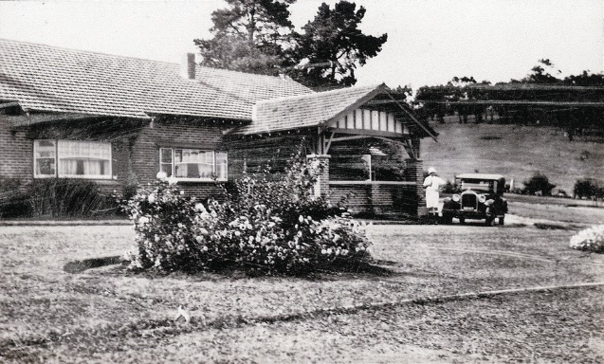  Worlingworth, 10-26 Banoon Road, Eltham (HO7). (Source: VHD) | The property at 10-26 Banoon Road, Eltham, is historically significant for its associations with the notable anthropologist Donald Thomson, who lived there from the mid-1930s. Built c 1922, it is also important as one of a few substantial homes erected in the Shire during the interwar period, illustrating Eltham's development into a desirable residential locality. It survives as one of few properties to retain its intact farm setting (VHD).
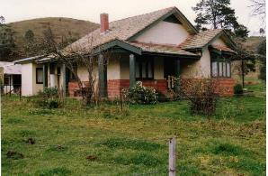  Orchard House, 25 Cottles Bridge-Strathewen Road, Cottles Bridge (HO190). (Source: VHD) | The property at 25 Cottles Bridge-Strathewen Road, Cottles Bridge, is significant as one of few brick houses built prior to 1930 in Nillumbik. It is unique in the municipality as an example of the transitional bungalow style, exhibiting elements of both the interwar and Federation eras. It is also significant for its association with Thomas Cottle, the namesake of the Cottles Bridge area, the Cooke orcharding family and the probable builder of the house, ‘Caffin’ (VHD).
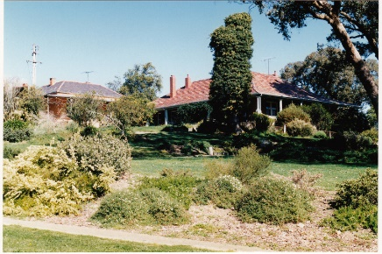  Old Brinkkotter House, 32 Lindon Strike Court, Research (HO114). (Source: VHD) | The substantial brick house built c1935 at 32 Lindon Strike Court, Research, is significant together with the c1913 timber house also on the site, for its associations with the Brinkkotter family, well-known Research farmers and orchardists. The existence of two adjacent farmhouses on the one property is rare in the former Shire of Eltham, and the design of the c1935 house is aesthetically significant for its unusual design (VHD).
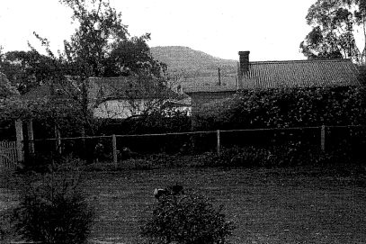  California Bungalow, 830 Cottlesbridge-Strathewen Road, Arthurs Creek (HO29). (Source: VHD) | The California Bungalow at 830 Cottlesbridge-Strathewen Road, Arthurs Creek, built c1930 is historically significant for its connection with the Apted family, who operated an orchard in Arthurs Creek for over a century. It is also significant as a rare surviving example of a Californian Bungalow in the former Shire of Eltham (VHD).
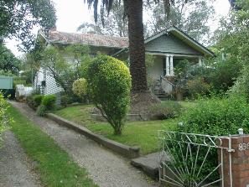  Residence, 836 Heidelberg-Kinglake Road, Hurstbridge (HO264). (Source: VHD) | The property at 836 Heidelberg-Kinglake Road, Hurstbridge, is aesthetically significant as a substantially intact example of an interwar bungalow constructed c1923. Its aesthetic value is enhanced by the intact front garden and fence, including the two Canary Island Date Palm trees framing the entry to the residence. The residence is demonstrative of the township’s dominant period of development which was stimulated by the orchard industry and introduction of the railway line in 1912 (VHD).
Discussion
‘Bell Vue’ at 2 Batman Road, Eltham, compares well to the above examples. It demonstrates key design elements of interwar-era domestic architecture, and in particular, the Interwar Mediterranean style. The house displays key characteristics associated with the style including the rendered brick walls with smooth render detailing, arched porch, and barley twist column details to the porch and windows.
Though there are several interwar residences on the Nillumbik Heritage Overlay as demonstrated above, the subject place is distinguished from these examples for two reasons. Firstly, it exhibits elements of the Interwar Mediterranean style, a style that appears to be uncommon within the shire, notwithstanding the former Sutherland Homes orphanage administration block (HO171). ‘Bell Vue’ therefore adds an important additional place type to the above group of interwar houses in Nillumbik, since there are no other examples of houses designed in the Interwar Mediterranean or Spanish Mission style on the Shire of Nillumbik Heritage Overlay. Secondly, most of the above examples are farmhouses or orcharding properties, whereas ‘Bell Vue’ demonstrates the residential subdivision of land and transition towards suburban living in Eltham during the interwar years.

STATEMENT OF SIGNIFICANCE

WHAT IS SIGNIFICANT?
‘Bell Vue’ at 2 Batman Road, Eltham, constructed c1929-30 for Charles Felix Butler, is significant.
Elements that contribute to the significance of the place include the:
- original single-storey built form, hipped-roof form and original fenestrations;
- rendered brick walls and roof clad with concrete tile;
- decorative details including barley twist columns, decorative corbels, arched porch with smooth render detailing, decorative arched panel above the window to the projecting bay of the west elevation and other applied Interwar Mediterranean style detailing;
- original timber window and door joinery; and
- low clinker brick fence, stone retaining walls and the layout of the remaining portion of the driveway; and
- intact garden setting and mature trees including the Canary Island Date Palm and Monterey Pine.

HOW IS IT SIGNIFICANT?
‘Bell Vue’ at 2 Batman Road, Eltham is of local historic and representative significance to the Shire of Nillumbik.

WHY IS IT SIGNIFICANT?
‘Bell Vue’ at 2 Batman Road, Eltham is representative of the subdivision of land for residential use and transition towards suburban living in Eltham during the interwar years. The electrification of the Hurstbridge railway line in 1926 which reduced travel time to the city, saw Eltham become a commuter town and development flourished along the railway. (Criterion A)
‘Bell Vue’ at 2 Batman Road, Eltham is a fine representative, and largely externally intact, example of interwar-era domestic architecture. It exhibits key elements of the Interwar Mediterranean style - a style closely related to the Interwar Spanish Mission style, but more rational and subtle in form and detailing. Key characteristics demonstrated include the lightly textured rendered walls with contrasting smooth render detailing, arched entrance porch, and medium-pitched hipped roof of concrete tile, as well as decorative features including barley twist column detail to the porch and windows, ornamental arched window panel, and decorative corbels. The property is enhanced by the retention of the substantial garden setting, within which sit a mature Canary Island Date Palm and Monterey Pine tree, as well as part of the original driveway layout, the front and side clinker brick fence, and stone retaining walls. (Criterion D)

RECOMMENDATIONS
Recommended for inclusion in the Schedule to the Heritage Overlay of the Nillumbik Planning Scheme as an Individually Significant place.
Extent of overlay: To title boundaries
Recommendations for the Schedule to the Heritage Overlay (Clause 43.01) in the Nillumbik Planning Scheme:

Nillumbik Planning Scheme
External paint controls | No
Internal alteration controls | No
Tree controls | Yes - Canary Island Date Palm (Phoenix canariensis) and Monterey Pine (Pinus radiata)
Outbuildings or fences | Yes - front fence
To be included on the Victorian Heritage Register | No
Prohibited uses may be permitted | No
Aboriginal heritage place | No

Other
N/A

REFERENCES
Advertiser, as cited.
Ancestry 2021, ‘Family Trees’, https://www.ancestry.com.au/, accessed online 15 April 2021.
Apperly, R., Irving, R. & Reynolds, P. 1989, A pictorial guide to identifying Australian architecture. Styles and terms from 1788 to the present, Angus & Robertson, Sydney.
Argus, as cited.
Bartolomei, Deborah 2008, ‘Eltham’, eMelbourne, School of Historical and Philosophical Studies, The University of Melbourne, https://www.emelbourne.net.au/biogs/EM00516b.htm.
Built Heritage Pty Ltd 2010. ‘Survey of Post-War Built Heritage in Victoria: Stage 2’. Prepared for Heritage Victoria.
Butler, Graeme, and Associates 1996, ‘Nillumbik Shire Heritage Review - Environmental History’, Prepared for the Shire of Nillumbik.
Central Plan Office (CPO), Historic Aerial Photography: 1930s to 1990s, as cited, via Landata, https://www.landata.vic.gov.au/, accessed online March-April 2021.
Cuffley, Peter 2007, Australian houses of the twenties and thirties, (2nd edition), Five Mile Press, Fitzroy, VIC.
Eltham and Whittlesea Shires Advertiser and Diamond Creek Valley Advocate, as cited.
Eltham District Historical Society 2000, A Chronology of Known Local Events 1835-early 2000 including those in the Shire of Nillumbik and the former shires of Eltham and Diamond Valley, Eltham District Historical Society Incorporated.
Eltham District Historical Society 2019, ‘OTD: Opening of the new Eltham Library, 22 May 1994’, www.elthamhistory.org.au.
Gowrie Victoria 2019, Our History, www.gowrievictoria.com.au.
Herald, as cited.
Land Victoria, Certificates of Title (CT), as cited.
Central Plan Office (CPO), Historic Aerial Photography: 1930s to 1990s, as cited, via Landata, https://www.landata.vic.gov.au/, accessed online March-April 2021.
Mills, Peter & Westbrooke, Samantha 2010, ‘War Memorial Building Complex, 903-907 Main Road, Eltham, Cultural Heritage Significance Assessment’, prepared for Nillumbik Shire Council.
Mills, Peter & Westbrooke, Samantha 2017, ‘Nillumbik Shire Thematic Environmental History - Revision 2016’, prepared for Nillumbik Shire Council.
Nearmap, as cited.
Nillumbik Parish Plan 1951, Melbourne, Department of Lands and Survey.
Pierce, Peter (ed.) 1987, The Literary Guide to Australia, Oxford University Press, Melbourne.
Raworth, Bryce 1993, ‘A question of style: inter-war domestic architecture in Victoria’, Thesis (M.Arch) University of Melbourne.
Victorian Heritage Database (VHD), https://vhd.heritagecouncil.vic.gov.au/, accessed online April-May 2021.
Victorian Places 2015, ‘Christmas Hills’, Monash University and The University of Queensland, https://www.victorianplaces.com.au/.
Victorian Year Book 1973. Government Printer, Melbourne.
Yeoman, Russell, Pinn, Richards, and Connor, Jim 2020, Sign of the Times: Eltham street names with history, Eltham District Historical Society, www.elthamhistory.org.au.

