Part of 570 Main Road, Eltham

Diamond Valley Miniature Railway
Prepared by: Context | Survey date: December 2020
Place type: Recreational | Designer: -
Significance level: Significant | Builder: Members of the Diamond Valley Miniature Railway
Extent of overlay: Refer to map | Major construction: 1961-1974
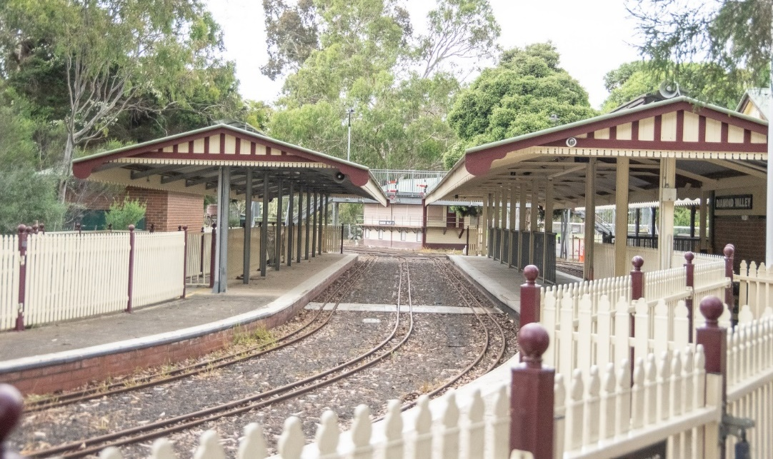
Figure 1. Photograph of the main railway station. (Source: Context 2020)
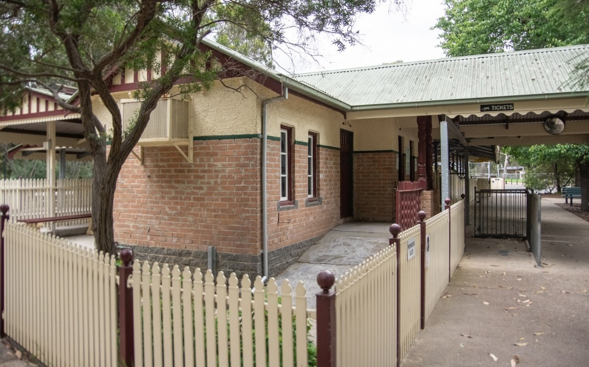
Figure 2. Main railway station building of the Diamond Valley Miniature Railway. (Source: Context 2020)

HISTORICAL CONTEXT
This place is associated with the following historic themes taken from the Nillumbik Shire Thematic Environmental History (2016):
5 BUILDING NILLUMBIK’S WORKFORCE
5.1 Catering for tourists
In the 1920s Mack Clinton initiated an unusual effort to attract tourism to Christmas Hills when he established a ‘pleasure ground’ named Rob Roy on his property at Watsons Creek. Clinton kept a Shetland pony stud and offered picnic facilities for those who motored up from the city during the day. Seeing further possibilities for visitors, in 1935 he invited the Light Car Club of Australia to use the property for hill climbs. By 1939, the rally track was sealed with bitumen and, with the exception of the war years, the club continued to hold meets there until 1962, when a bushfire destroyed many of the facilities (Mills & Westbrooke 2016:64).
The Diamond Valley Miniature Railway Club was founded in 1960 with equipment relocated from the closed Chelsworth Park Railway (located in Ivanhoe, Melbourne). The original main line at Eltham was completed on August 17, 1961 at 0.52 kilometres (0.32 miles) long. Numerous developments, extensions and improvements took place in the years that followed. In the in mid-1960s the original 1" x 1/2" steel rail was replaced with 14 lb per yard rail recovered from disused quarries, railways and tramways. The main line was significantly expanded in the 1980s down to the edge of Eltham Lower Park (called the outer circle) within sight of Main Road and of passing motor traffic. The full main line is now 1.92 kilometres (1.21 miles) long and takes about nine minutes to complete a journey, passing through two tunnels and over a number of bridges. The line runs over, under and beside itself in a twisted and folded loop. There are the equivalent of 111 points and crossings in the track work. In the 10 years after it opened, the railway carried 250,000 passengers. By 12 June 2011, after almost 50 years of operation, it had carried 3,000,000 passengers (Mills & Westbrooke 2016:64).

LOCALITY HISTORY
Eltham, situated in hilly country northeast of Melbourne, is located on the country of the Wurundjeri-willam clan of the Woi wurrung, one of the five tribes of the Kulin Nation. A small, short-lived reservation south of Eltham on the Yarra River was set aside for Aboriginal people in 1852. The area is situated near the junction of the Yarra River and its tributary, Diamond Creek.
Pastoral settlers moved into the area from around 1840 and took up pastoral leases (Bartolomei 2008). It was located proximate to the track used by the Ryrie brothers to provide access between their ‘Yering’ run, near Yarra Glen, and the Heidelberg village (Victorian Places 2015). In 1841, William Bell and Thomas Armstrong occupied land for a squatting run east of Diamond Creek in what was to become the Eltham district (Eltham District Historical Society 2000: np).
A plan for 50 allotments in the Township of Eltham, Parish of Nillumbik, was announced in 1848, with the name officially gazetted in 1851. The township, near the junction of Diamond Creek and the Yarra River, was laid out in an area bounded by Baxter Street, Diamond Creek, Dalton Street and Bolton Street. The township plan shows that a track to a bridge across Diamond Creek and Main Road was noted as the ‘Track from Melbourne’ (Butler 1996:32). This area is known today as Eltham South.
Present-day Eltham, however, was not established on the township reserve, where land proved difficult to sell. Instead, the town grew from allotments in Section IV of the Parish of Nillumbik located on Main Road, to the north of Dalton Street and the township reserve (Butler 1996:32). In 1851, Melbourne property developer Josiah Holloway purchased one square mile (or 5120 acres) of this land, which he subdivided immediately, calling the subdivision Little Eltham. The central area of current-day Eltham is contained within the Little Eltham subdivision. A number of large farming properties around the township were purchased from the early 1850s (Nillumbik Parish Plan 1951).
Eltham township grew during the 1850s around a cluster of buildings at the corner of Pitt Street and Main Road within the Little Eltham subdivision. Located on the road to the Caledonia goldfields, this small township became a service centre for the surrounding mining areas, and by 1854 supported a population of 282. In this period Eltham had two hotels, a brewery, and a scattering of shops along Main Road (known in the 1850s as Maria Street). The town had a steam flour mill operated by Henry Dendy, and a tannery was located on the Diamond Creek. The Little Eltham School, opened by the Church of England, was built in 1853 near Swan Street and closed in 1872. A second school, a national school (later Eltham Common School No. 209) opened in Dalton Street in 1856. A Wesleyan chapel opened in 1858. Public buildings constructed at this time included a courthouse and a police station in Main Road in 1860. The ‘flat land’, which is now the Eltham Lower Park, near the Yarra, was used as a racecourse (Kellaway cited in Butler 1996:32-33; Eltham District Historical Society 2000:np). A cemetery was established in 1858. The township and wider area was administered by the Shire of Eltham, established in 1856.
Between the 1860s and the 1880s, Eltham supplied food and produce for the goldmining communities of the Caledonia goldfields at Queenstown (St Andrews) and Panton Hill. It also became a stopping place on the route to the Woods Point diggings. Eltham’s population grew in response (Victorian Places 2015).
A Primitive Methodist chapel was built in 1860. The following year St Margaret's Anglican Church, designed by the notable Melbourne architect Nathaniel Billing, was built. In 1881, a Wesleyan church was constructed by George Stebbing to the design of Melbourne architects Crouch and Wilson (Butler 1996:33). A new state school, constructed of local sandstone, opened in 1876.
Several large properties surrounding the township had absentee owners, who subdivided their properties into smaller farms either for lease or for sale. The smaller properties, especially in the Little Eltham township, were run by farmers who often made a modest living as wage labourers. Like many later Eltham residents, they were attracted by cheap land and the country life (Butler 1996:33).
In 1884 Eltham was described as:
… a pretty little township on the Yarra Flats road ... It has a population of nearly 400 inhabitants, but in addition it is the centre of a large district extending over 208 square miles, having a population of 2344. The land in the district is mostly used for grazing purposes, although as a rule the small farms grow a good deal of wheat, oats and other agricultural produce. A large quantity of fruit, especially raspberries and strawberries, is also produced (Illustrated Australian News, 20 December 1884, cited by Carlotta Kellaway in Butler 1996:33).
The Australian News noted that gold had been found in the vicinity of the township, ‘but not in remunerative quantities’ (cited by Carlotta Kellaway in Butler 1996:33).
In the 1880s agitation began for the extension of the railway line from Melbourne to Heidelberg to serve Eltham and districts further afield such as Kangaroo Ground. The railway station in Eltham opened in 1902, however the line was never extended to Kangaroo Ground. The railway brought excursionists from Melbourne, many of whom picked wattle during the flowering season, and focused development of the Eltham township around the railway station. Eltham was a picturesque village with the advantage of its proximity to metropolitan Melbourne and to attractive countryside with farms and uncleared stringybark forest (Victorian Places 2015). The bush scenery attracted artists, writers and nature-lovers.
In 1903 the Australian Handbook described Eltham as part of an orcharding and grazing district. In 1901, 4289 acres were under cultivation, of which 2506 acres were planted with orchards and market gardens. The township, with a population of 377, included a state school, a branch of the Commercial Bank, and Catholic, Anglican, Wesleyan Methodist and Primitive Methodist places of worship (cited in Victorian Places 2015). From 1909, rural properties were increasingly subdivided to create residential estates on the outskirts of the Eltham township (Mills & Westbrooke 2017:69).
The electrification of the railway line was extended to Eltham in 1923, eliminating the need to change to steam train at Heidelberg and allowing faster through-trains and shorter commuting times. The establishment of new residential estates in Eltham followed (Mills & Westbrooke 2017:71). Reflecting the town’s growth, a higher elementary school was opened in 1926 (Victorian Places 2015).
Eltham was described in 1940 as ‘residential, horticultural, dairying and grazing ... a beauty spot for artists and picnickers’. By this time, the town had three recreation reserves, swimming baths, tennis courts and a fire brigade (Victorian Places 2015).
Eltham has attracted a number of writers and artists over the years. The landscape painter Walter Withers (1854-1914) moved to Eltham in 1902 when the railway opened; other artists, including members of the Heidelberg School, painted in the area in the open air. Clara Southern and May Vale, landscape painters and students of Frederick McCubbin, settled in the region. Vale resided at Diamond Creek and Southern at Warrandyte (Bartolomei 2008). The war artist Will Longstaff also lived in Eltham for a period. From 1910, painter William ‘Jock’ Frater and cartoonist Percy Leason often camped and painted in the area. Artist Justus Jorgensen established the notable Montsalvat artists’ colony buildings, on land he purchased in 1934. Seeking a closer engagement with the natural environment, the establishment of Montsalvat, with its adobe and rammed earth buildings, influenced future mudbrick construction in the area. Several local designers, including Alistair Knox, specialised in mudbrick housing in the postwar period (Victorian Places 2015). Others who have been inspired by Eltham and have made the Nillumbik region their home include landscape architect Edna Walling; authors Alan Marshall and Carolyn Van Langenberg; artists Clifton Pugh and Danila Vassilieff; composers and musicians Graeme and Roger Bell; jewellers and sculptors Michael Wilson, Simon Icarus Baigent and Matcham Skipper; writer CB Christensen; poet Chris Wallace-Crabbe; and actor Kerry Armstrong (Bartolomei 2008; Pierce 1987:354).
Eltham experienced significant postwar development with a number of residential estates subdivided and put up for sale. The population of the town increased steadily as a result. In 1933, only 927 residents were recorded in the town in 1933; this had increased to 7177 residents in 1971. As a result, Eltham High School opened in 1950 and the Catholic Ladies College was relocated to Eltham in 1971 (Victorian Places 2015). The Eltham War Memorial Trust Baby Health Centre opened in 1951. New shire offices opened in 1965, and Eltham College commenced classes in 1974 (Eltham District Historical Society 2000:np).
A distinctive style in local building emerged in Eltham in the postwar period, with a strong use of natural materials, low form structures, and an integration with the natural environment. Houses were often sited in bush gardens, especially after the 1970s. This style was also adapted to community buildings in the area, with the Eltham Library being constructed in mudbrick and recycled timbers in 1994 (Eltham District Historical Society 2019).
The Shire of Eltham became part of the Shire of Nillumbik in 1994, with a small area becoming part of the City of Banyule.

PLACE HISTORY
The Diamond Valley Miniature Railway (DVR) is located on the Recreation Reserve, gazetted in 1913 on Crown Allotment 6G of the Eltham Township (Eltham Township Plan 1968).
The history below, derived mainly from The Diamond Valley Railway Story (1985), highlights only the main events in the development of the DVR.
The DVRis a 184 mm (7¼") gauge railway located in parkland close to Diamond Creek in Eltham. The aim of the DVR is to provide visitors the opportunity of building and running a real passenger carrying railway system in miniature. The railway operation and construction are based on, or as near as possible, that of the Victorian Railways, using scales of 1/6 full size for rolling stock; ¼ full size for signals and half full size for buildings. (May et al 1985:np).
The DVR was established at Eltham in 1960, after the closure of the Chelsworth Park Railway. The brainchild of Clem Meadmore, it operated for many years at Chelsworth Park, Ivanhoe, before flooding caused its closure in 1959. Infrastructure and rolling stock were later transferred to the Eltham site (May et al 1985:np).
A meeting, attended by Clem Meadmore, Ray Savage, Syd Gillies, Alan Calder, Jim Willcox, John Murdoch, Ron May and Olive Savage, was called in 1960 to discuss plans for the new site (May et al 1985:np).
The Diamond Valley Miniature Railway Club was formed in 1961 to take over the running of the railway. Members contributed funds to help the shed construction and the purchase of materials and equipment to keep the DVR running. The first club meeting was held on the 23 July 1961 at Ray Savage's flat. The first Committee was elected and consisted of: Clem Meadmore, chairman; Ray Savage, secretary; and Arthur Cowan, treasurer (May et al 1985:np).
The Progress Engineering Company was commissioned to erect the railway's first substantial building after a loan was obtained from Alan Calder. It was a large, garage type building, measuring some 20 ft wide by 30 ft long and 8 ft high, clad in formed galvanised iron sheeting. Entry was gained by opening two sets of large swing doors. The 'shed', as it was known, was the railway's combined workshop, lunchroom, change room, kitchen, storeroom, clubhouse and Way & Works factory. Using voluntary labour, the shed floor was levelled, and work commenced on the laying of the original yards and sidings in front of the building. The permanent way earthworks were also formed (May et al 1985:np).
The original track was 3/4" x 3/8" mild steel, welded to plates which in turn were nailed down to 2" x 2" x 14" hardwood sleepers spaced at 10" intervals. Some of the track was laid on the old Chelsworth Park Railway's 2" x 1" redgum sleepers and rails. On 17 August 1961, the last section of the Mainline was laid. Wear and tear on the wheels caused by the narrow rail meant the track needed to be completely re-laid with 14 lb/yd rail in 1964-71 (May et al 1985:np).
The Chelsworth Bridge was lifted into position on the 10 August 1961 and work proceeded on the old station platform, construction of the wire fence and gates around the platform area, and packing and ballasting of the track (May et al 1985:np).
The first train journey open to the public took place on 29 October 1961.
The steep incline of the long bank and rear curve proved difficult for all locomotives, and it was decided to run trains in the opposite direction (anticlockwise). Extensive alterations and realignments were made to the track in 1961-62 and successful anticlockwise running was achieved. The railway has been run in that direction since. At the same time, a signal lever frame was erected at the arrival end of the station platform and oversized, three position, upper quadrant signals were installed to protect the workshops branch line stub point (May et al 1985:np).
In 1963, the red, green and blue box-and-plank passenger carriage rolling stock was repainted kerrin blue with gold trim and grey inside. The box seats were removed, and new core-stock sides were strengthened with angle iron and bars fitted to the footboards. Each carriage (or coffin car, as they were later known) was fitted with an upholstered seat across the middle to provide extra side support. A new driving car was built for locomotive S300 and another carriage was converted to a passenger/guards’ van (May et al 1985:np).
In 1963 new signal frames were introduced and a new pipe and chain wire fence was erected around the workshop yards (May et al 1985:np).
The first tunnel, approximately 16 ft of 6 ft diameter reinforced concrete pipe, was installed in 1965 and the viaduct bridge was built in 1966. In the same year, new signals were constructed for the old station area and the main line point was converted to hydraulic operation (May et al 1985:np).
By 1968, work had commenced on the new station and platform. Signal boxes were erected in 1969-71 and in 1969 the tunnel was extended in length from 16 ft to 88 ft. The tunnel ends were finished off with framing portals (May et al 1985:np).
Work on a new ticket office commenced in 1971 and in the same year a level crossing was constructed, and the Outer Circle main line was commenced from near 'B' Signal Box. In 1971, it was noted that a quarter million passengers had been carried since October 1961. In late 1971, the Victorian Health Department threatened to close the Railway because the tunnel was not installed in accordance with the regulations. The track was subsequently rerouted to avoid the tunnel (May et al 1985:np).
The new Diamond Valley Railway station was roofed in 1972, with completion of the building reached in c1974. In 1972, the DVR acquired most of the rolling stock from the defunct Valley Railway, Noojee, and conversion to 7" gauge was undertaken. In 1973, a special train run was conducted for the children from Allambie Homes and charity runs were held for the Royal Children’s Hospital, the Salvation Army, the Araluen Day Training Centre and the Eltham Community Youth Club (May et al 1985:np).
On the 19 March 1974, the DVR was incorporated as a public company, limited by guarantee (May et al 1985:np).
Since this time, volunteers at the DVR have maintained a program of updating and installing new infrastructure and facilities, and, except for some periods of 2020 and early 2021, when COVID-19 restrictions applied, have operated the railway continuously over this time. The DVR continues today as a popular tourist attraction, especially with families, attracting close to 3000 passengers on an average Sunday. It was voted the top tourist attraction in Metropolis Research’s 2018 Annual Community survey of 500 randomly selected households in the Nillumbik Shire (Nillumbik Shire 2018).
In 2018, Nillumbik Shire entered into a new 21-year lease agreement with the railway. A small parcel of land from the corner of the Eltham Lower Park was added into the lease. The club, run by 180 volunteers in 2020, plans to work with community groups to revegetate the area with native plants (Nillumbik Shire 2018).
For the year 2018-19 financial year, 151,779 passengers bought tickets (Gillett 2020:6). All ticket sales go back into maintaining the railway and upgrading facilities as well as contributing to local charities, with the club giving annually to various concerns (Nillumbik Shire 2018). In 2019, the DVR established an under 25’s member group, which is the first of its kind in the sector and seeks to address an aging volunteer demographic (Gillett 2020:9).
Because of high visitor numbers, the Diamond Valley Railway would like to build a new railway circuit in the southern part of Eltham Lower Park (Diamond Valley Railway Inc 2021).
Heath Gillett, Manager Recreation and Leisure at Nillumbik Shire council, provides a summary of the important features of the DVR:
The railway carries approx. 150,00 passengers per year and has achieved year-on-year 4% growth rate over the last 20 years with a total of over 4,230,000 passengers since inception. This is a strong visitation number for an attraction that only operates approximately 70 days a year and would be the envy of many other experiences chasing similar numbers if extrapolated. Given its historical operation and popularity there is high awareness and support from the community…The Railway is the top ranked 7 ¼” miniature railway in the southern hemisphere and is now identified as one of the World’s top five miniature railways…The members of the Railway are a professional and skilled volunteer workforce who bring a variety of existing qualifications and/or previous workplace experience into the organisation. This allows for a high standard of planning, maintenance and operations…The Railway hard infrastructure which includes buildings, tracks, platforms, signals, fencing and signage, is extensive within the leased footprint and is a dominant feature of the Park. The rolling stock, including the privately-owned sets, is significant, well maintained and historically relevant…The Railway has been a consistent presence in the Park and is due to celebrate its 60th Birthday in 2021. It enjoys strong relationships with local service clubs, schools, charities, sporting teams and business groups. They contribute to the community by conducting special fund-raising operational days as well as providing a location for supplementary fund-raising activities by charities and service groups to take advantage of (Gillett 2020:8-9).

DESCRIPTION
Diamond Valley Miniature Railway (DVR), Eltham Lower Park, part of 570 Main Road, Eltham, is a miniature railway built from 1961 by members of the Diamond Valley Railway Club (the club, DVRC), an organisation which was incorporated, becoming the Diamond Valley Miniature Railway Incorporated (DVRI), in 1974.
The Diamond Valley Miniature Railway sits within the northeast corner of Eltham Lower Park, bounded by Main Road to the northwest and Diamond Creek to the east. It wraps around a portion of the Eltham Lower Park Oval Number 1 to the south (Figure 32). The kidney shaped site is largely level but falls away towards Diamond Creek to the east. The Melbourne and Metropolitan Board of Works (MMBW) drain, Blowfly Creek, traverses the northern portion of the site.
The substantial miniature railway complex comprises a number of buildings and hard infrastructure elements spread across the site. These elements are connected by railway track and various pedestrian pathways that lead across the site. The railway complex is embedded within a bush landscape setting which also includes exotic deciduous trees. The main entrance is centrally located in the bend of the playing field perimeter road which extends from the Main Road Park entrance (Figure 3 and Figure 4). The track plan (Figure 5) shows the key elements of the complex.

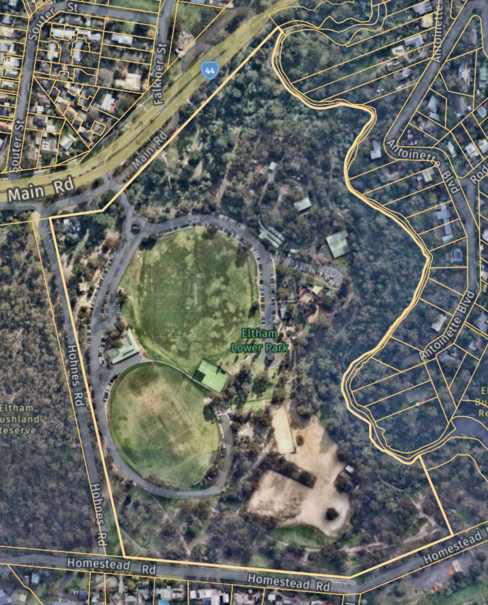
Figure 3. 570 Main Road Eltham with the approximate boundary of the Miniature railway outlined in red. The main entrance is indicated with a red arrow. (Source: Nearmap 2021)

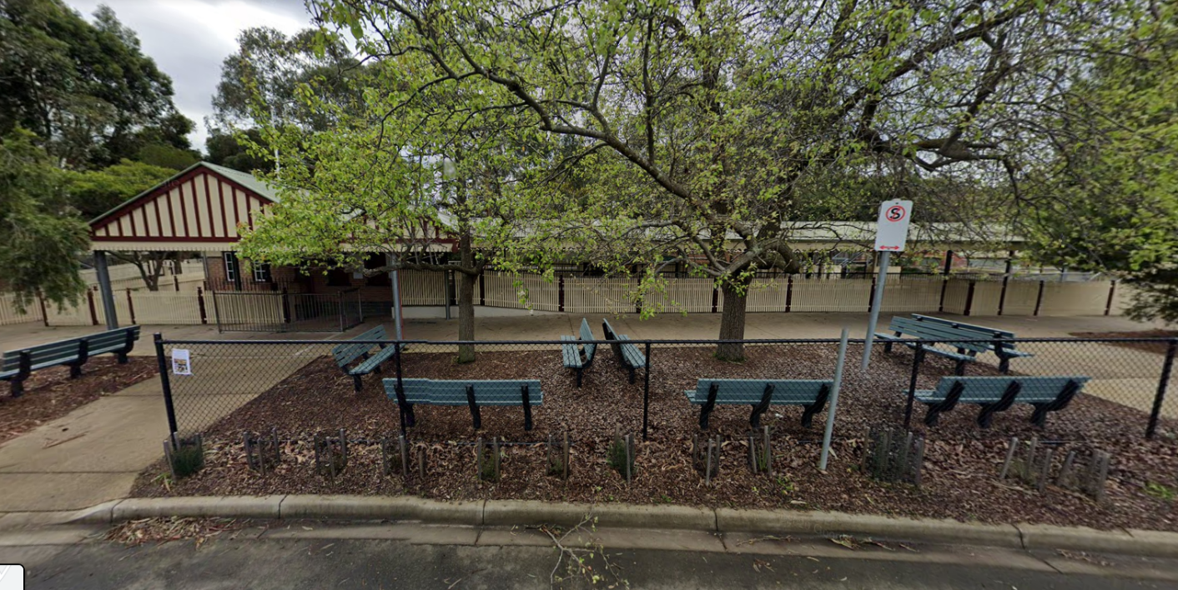
Figure 4. Primary entrance to the Main Station building (southwest elevation). (Source: Google Streetview 2019)
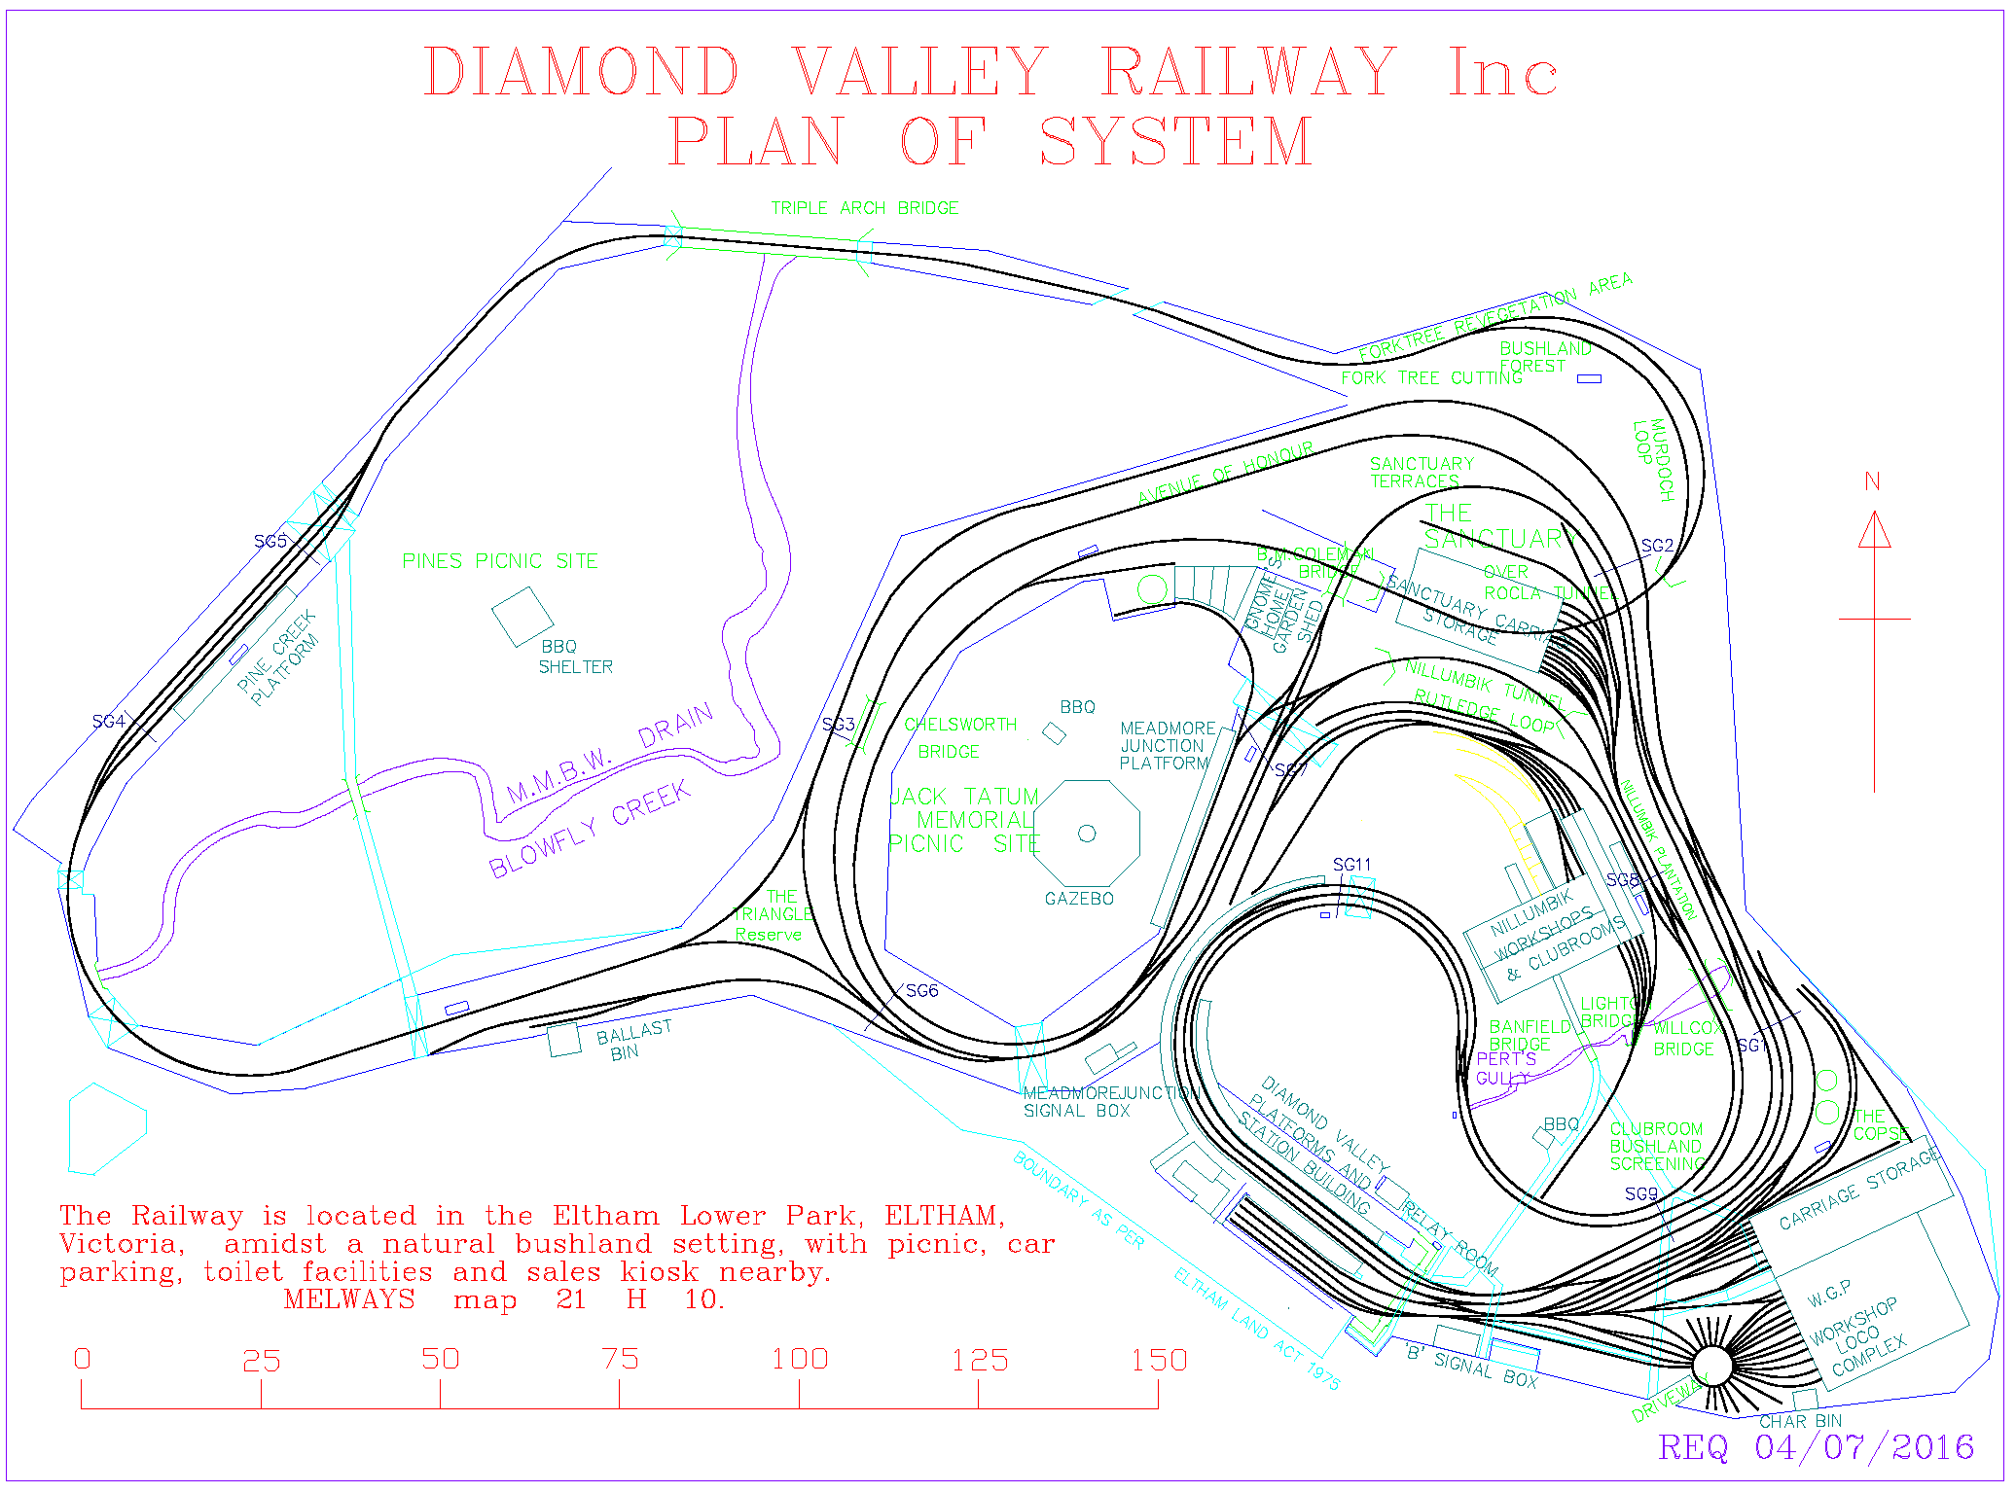
Figure 5. Track plan of the Diamond Valley Railway in 2016. (Source: Diamond Valley Railway)

Key built elements include the following:

Diamond Valley Station (c1969)
The Diamond Valley Station is a replica of Edwardian-era station building design. The Station building has a gabled roof clad in corrugated iron and top third rendered red brick walls on grey stone foundations. Gable ends feature timber battening. Windows are six paned and timber framed, with decorative grey stone flush sills. The ticket window is of similar proportions to the other station building windows.
The station includes three platforms with steel-framed gable roofed canopies supported by square section steel columns. The platform canopies feature battened gable ends to match the main building. The sales kiosk runs perpendicular to the platforms with asymmetrical twin gabled canopy extending across the front entrance supported by I-shaped steel columns. Decorative scalloped timber fascia boards line the station canopies and entrance canopy. Picket fencing surrounds the station.
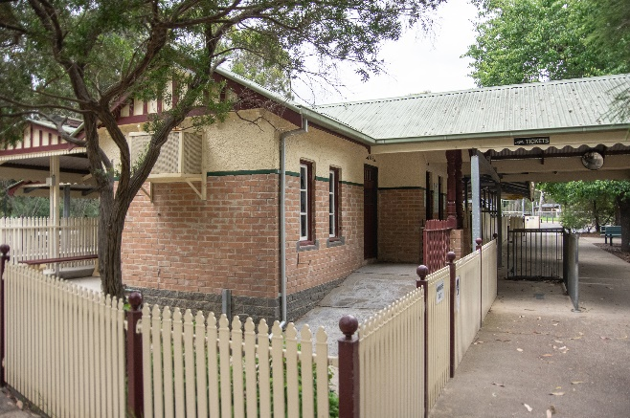  Figure 6. Station building with scalloped fascia. (Context 2020) | 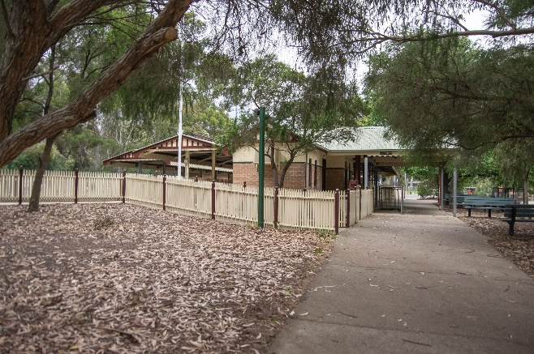  Figure 7. View of the station from the northwest. (Source: Context 2020)
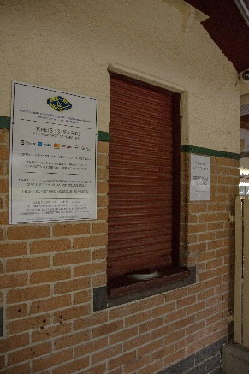  Figure 8. Ticket window. (Source: Context 2020) | 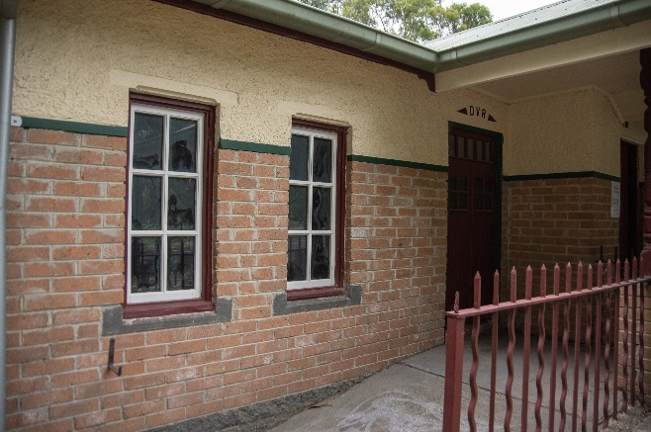  Figure 9. Six paned timber framed windows and decorative fence. (Source: Context 2020)
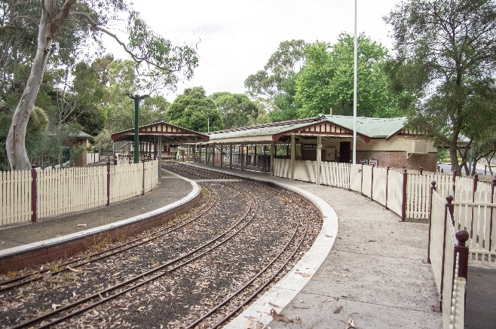  Figure 10. Main station platform. (Source: Context 2020) | 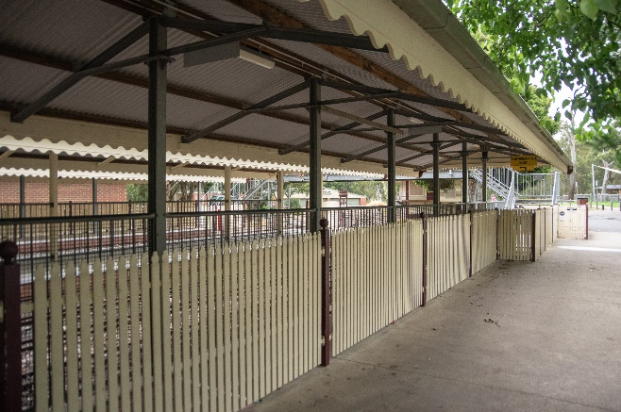  Figure 11. Picket fence and station canopy. (Source: Context 2020)

William (Bill) Pert railway workshop, with turntable
The William (Bill) Pert railway workshop building, located in the southeast corner of the site, is a broad medium-pitched gable roofed shed structure with an almost square footprint. The roof is clad in corrugated iron and walls are brown brick. Four wide metal roller doors are located across the eastern elevation allowing train access, two smaller, centrally placed, roller doors allow pedestrian access to the building. Train lines 9 to 20 lead into the building, through the large roller doors. The turntable immediately east of the workshop is surrounded by track lines and red brick paving on the southern side (Figure 12 and Figure 13)
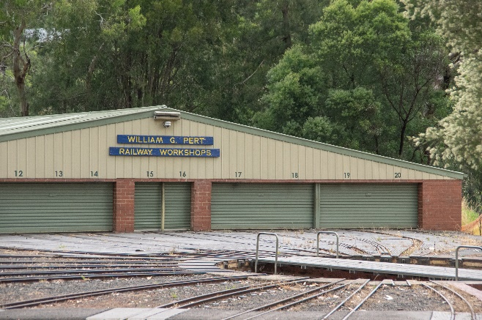  Figure 12. William G Pert railway workshops with turntable in the foreground. (Source: Context 2020) | 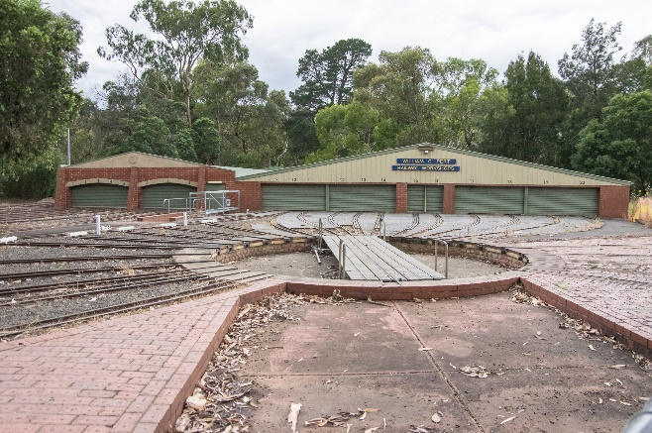  Figure 13. The turntable in the foreground. (Source: Context 2020)

Carriage shed
The Carriage shed building abuts the William G Pert railway workshop to the north. It is rectangular in plan with corrugated iron clad gabled roofing. Walls are of red brick construction. The eastern elevation contains two arched openings with metal roller doors, allowing access for the train lines into the sheds. Number labels indicating the train lines are located on the arch above each line.
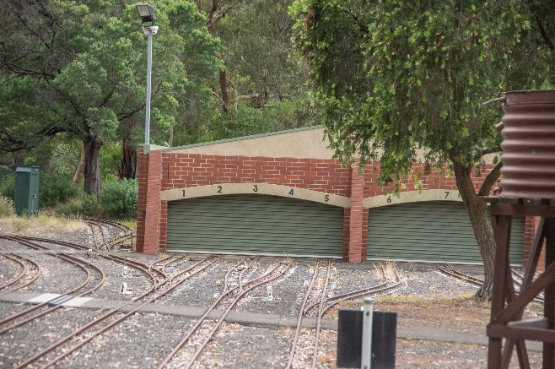
Figure 14. The carriage shed (west). (Source: Context 2020)

Kidney shaped track
The kidney-shaped main track wraps around the complex and connects the key structures. The Diamond Valley Railways website notes:
The track consists of 14 lb/yd rail and is laid to a minimum radius of 18 metres. The track gauge is 184mm (7¼ inches) and the main route length is 2km plus 0.6 km of alternative paths. Some of the line side features are: the 65 metre long main station with three platforms, part of which is covered by a canopy roof; another two wayside stations; various bridges; two separate carriage shed/workshop complexes; two tunnels; two signal boxes; and extensive sidings totalling some 1.2km in length (Diamond Valley Railway).
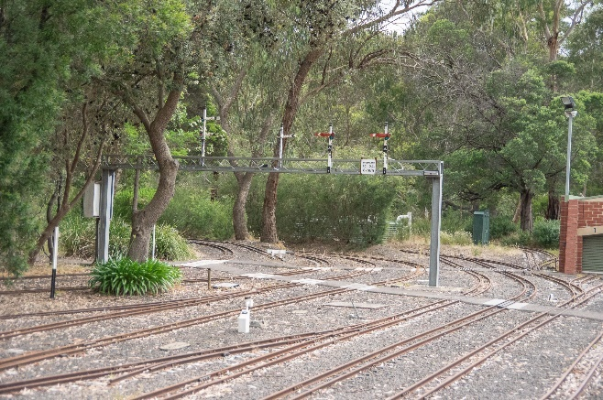
Figure 15. A portion of track. (Source: Context 2020)

B Signal Box
The B Signal box sits to the south of the main station abutting the southwestern site boundary. It has a simple rectangular form with hipped roof clad in corrugated iron and surrounded by a rigid wire fence (Figure 16).
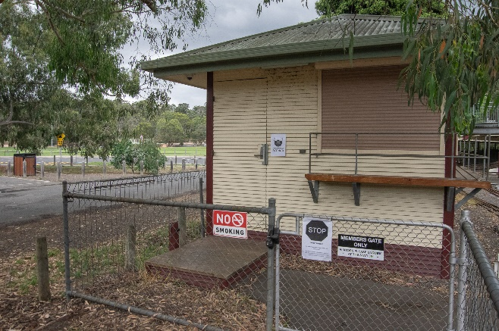
Figure 16. B Signal Box to the south of the main station abutting the southwestern site boundary. (Source: Context 2020)

Steel-framed overhead pedestrian bridge
The Steel-framed overhead pedestrian bridge allows access across the track at the southern end of the Station and platforms (Figure 17).
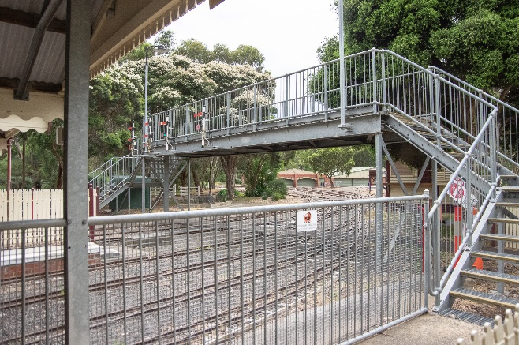
Figure 17. Steel-framed pedestrian bridge. (Source: Context 2020)

Other built elements across the site include:
- reinforced concrete pipe tunnels;
- bridges;
- triple arched, viaduct bridge;
- Chelsworth Bridge;
- other platforms;
- Meadmore Junction platform;
- Pine Creek platform;
- other sheds;
- Gnome’s Home Garden Shed;
- Nillumbik workshop and clubrooms;
- sanctuary carriage storage;
- leisure infrastructure;
- gazebo; and
- BBQ facilities.
These other built elements are well integrated within the site’s landscape setting. The landscape setting is broadly characterised by natural bushland, but also includes mature, deciduous exotic trees and certain well-maintained gardens, tended and curated by the Diamond Valley Railway members. This includes an Avenue of Honour located on the Inner Circle which is a tribute to deceased past members.

INTEGRITY
The Diamond Valley Miniature Railway, Lower Eltham Park, at part of 570 Main Road, Eltham, is largely intact with some later changes to original or early fabric. The complex retains early significant infrastructure and built elements such as the station and platforms, Carriage shed, William Pert workshop with turntable. The layout of the site and tracks has undergone some changes since the opening of the Railway in 1961, in line with its original use and intention as an operating miniature railway complex.
As an operational facility, the track and associated components require regular maintenance and ongoing renewal and upgrades. Additions are an important to the history of the place as a site of ongoing development. The integrity of the place is enhanced by the ongoing use of the site as a miniature railway and integration of the built elements within the landscape setting.
Whilst the complex contains additions and variations, overall, it has high integrity and expresses the vision of original club members for a miniature railway.

COMPARATIVE ANALYSIS
Miniature railways are a form of recreation and entertainment that emerged across Australia in the postwar period. In 1948, the introduction of the Forty Hour week gave Victorians increased leisure time which led to a boom in recreational activities. Many traditional forms of recreation underwent radical transformation and new ones emerged, of which the Diamond Valley Miniature Railway is an example (Heritage Alliance 2008:27).
Several other miniature railways exist across Victoria, however none appear to be listed in the Heritage Overlays of their respective planning schemes. The miniature railway complexes often include replica railway stations, miniature locomotives for public running and other auxiliary structures such as engine shed and signal boxes. Picnic facilities and kiosks are also often provided in the larger scale miniature railways, reflecting their recreational use.
The following examples outside the Shire of Nillumbik are comparable with the subject site in terms of scale and use.

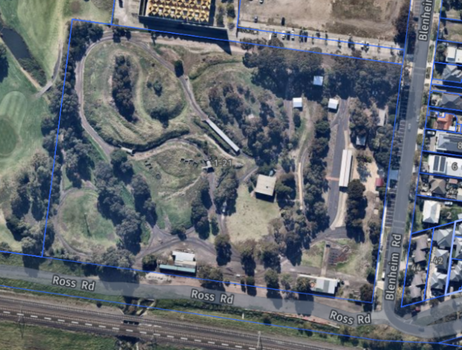  Altona Miniature Railway Inc (No HO). (Source: Nearmap 2021) | The Altona & South Western Railroad was established in 1976 with the expressed objective to build and operate a passenger carrying miniature railway in the Western suburbs area, of Melbourne, Australia. The first official train ran on the Paisley Park site in 1985. Construction of a carriage shed/workshop commenced in 1988 (Altona Miniature Railway).
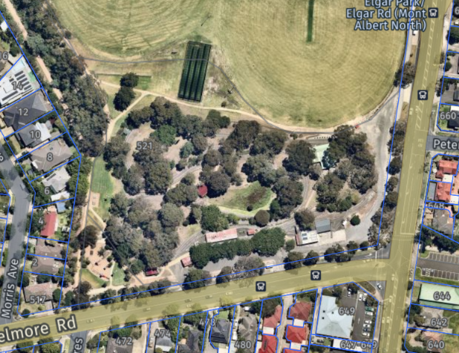  Box Hill Miniature Steam Railway (No HO). (Source: Nearmap 2021) | The Box Hill Miniature Steam Railway was established c1983 by the Box Hill Miniature Steam Railway Society, is a group of miniature steam railway and model engineering enthusiasts. The clubroom and engine shed were opened in 1983, with tracks completed for public running in 1985 (Box hill Miniature Steam Railway Society).
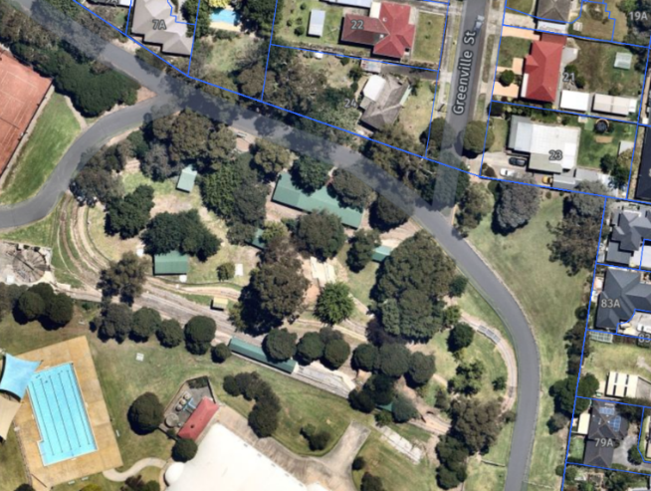  Figure 20. Mooroolbark & District Miniature Railway & Steam Club Inc (No HO). (Source: Nearmap 2021) | Mooroolbark & District Miniature Railway & Steam Club Inc was established in 1980, opening to the public in 1983 (Mooroolbark Miniature Railway). The complex is one of the relatively smaller miniature railways operating today.
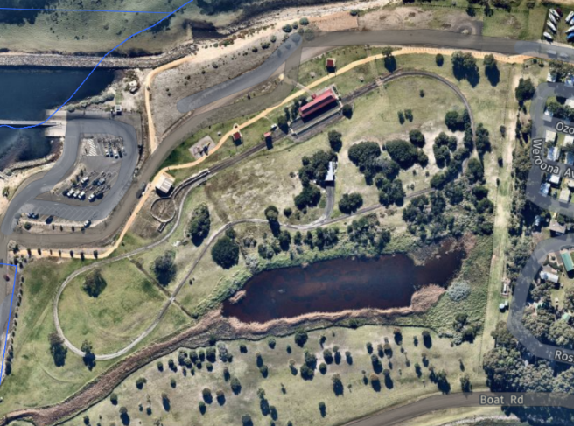  Portarlington Bayside Miniature Railway (No HO). (Source: Nearmap 2021) | Portarlington Bayside Miniature Railway was opened in 1999 for public running. Located on eight hectares of parklands, Portarlington Bayside Miniature Railway is Australia’s only railway located on a foreshore (Portarlington Bayside Miniature Railway).
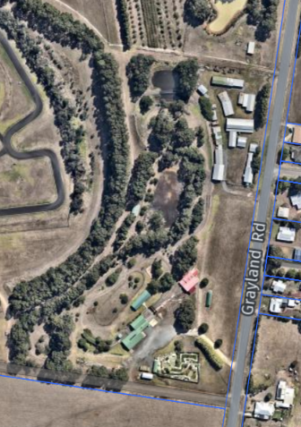  Figure 22. Cobden Miniature Railway, Graylands Road, Cobden (No HO). (Source: Nearmap 2018) | South Western Model Engineers, Cobden, was established in February 1994 opening in June 1994. It is located on the Cobden Racecourse reserve, which have been developed with other public facilities including mini gold park, dairy park, the Cobden Go-Kart Club and the Cobden Historical Society (https://www.cobdenminiaturerail.org.au/).
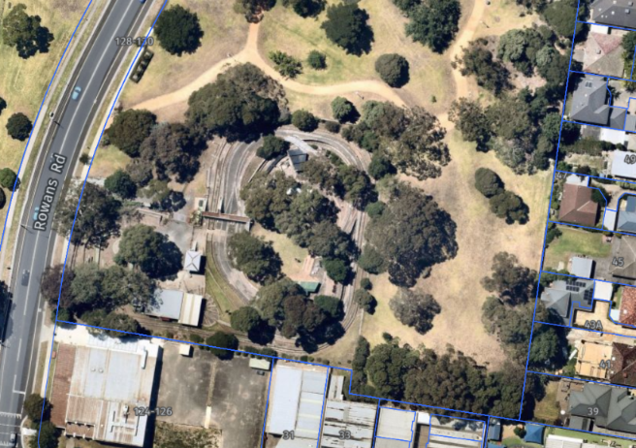  Figure 23. Steam Locomotive Society of Victoria, 128 Rowans Road, Moorabbin (No HO). (Source: Nearmap 2021) | Steam Locomotive Society of Victoria Inc, Moorabbin was opened in 1970 with a single loop. The track has been extended to about 700 meters in length. There is also a brick clubhouse seating about 50 members (http://www.slsv.com.au/about-us/)
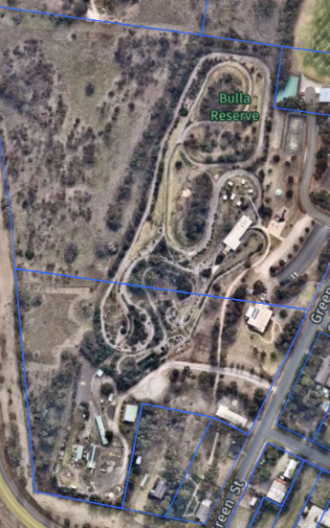  Figure 24. Bulla Hill Railway, 15 Green Street, Bulla (No HO). (Source: Nearmap 2021) | Tullamarine Live Steam Society was established in 1974 and relocated 1997. It was re-opened in 2000 as Bulla Hill Railway. It has two ground-level dual gauge tracks (Bulla Hill Railway).

Examples of miniature railways in Victoria listed below are of a smaller scale or are no longer in operation. These examples are less directly comparable.

- Ballarat Society of Model Engineers Inc (established 1985);
- Campbelltown Miniature Railway (c1983, ceased operation 2018);
- Euroa Miniature Railway Inc.;
- Geelong Society of Model & Experimental Engineers;
- Gippsland Model Engineering Society (1978);
- Loddon Miniature Steam Locomotive Society; and
- Mooroopna-Shepparton Miniature Railway Society.

In comparison to the above examples outside Nillumbik, Diamond Valley Miniature Railway is distinguished as an early and unusually substantial miniature railway complex that demonstrates people's fascination with railways and their components. In previous assessments this miniature railway was considered likely to a rare and fine example in an Australia-wide context (Bick 1992). Compared to the examples listed above, the Diamond Valley Miniature Railway is far more substantial in scale, including more finely detailed replica buildings. Its design is more holistic and contains numerous buildings and landscape elements which enhance the experiential qualities of the recreational complex.
The Diamond Valley Miniature Railway at part of 570 Main Road, Eltham, is notable for the comprehensive nature of the complex compared to other miniature railways, and as an early example of the type. It is also notable as a recreational complex, serving the Diamond Valley community and rail enthusiasts since 1961.

STATEMENT OF SIGNIFICANCE

WHAT IS SIGNIFICANT?
The Diamond Valley Miniature Railway, Eltham Lower Park, at part of 570 Main Road, Eltham, a miniature railway complex constructed from 1961, is significant.
Elements that contribute to the significance of the place include:
- the original scale and form of the complex within the natural bush landscape setting;
- Edwardian-style train stations and platforms, workshop and picket fencing;
- other railway elements reflecting the use such as the signal box, turntable and tracks and signage; and
- the rolling stock, which includes privately-owned assets.
Other elements that support the general recreational use of the place contribute to the use of the place but should be open to alteration.

HOW IS IT SIGNIFICANT?
The Diamond Valley Miniature Railway Eltham Lower Park, at part of 570 Main Road, Eltham, is of local historic and representative significance to the Shire of Nillumbik.

WHY IS IT SIGNIFICANT?
The Diamond Valley Miniature Railway, Eltham Lower Park, at part of 570 Main Road, Eltham is historically significant as an early miniature railway complex built in Victoria. Operating at its current site since 1961, it is important as a popular long-term recreational facility within Nillumbik. It is evidence of the ongoing fascination with railways and their components. It provides physical evidence of a form of leisure activity, and tourism, that emerged during the postwar period and has remained popular as a community recreational complex. (Criterion A)
Constructed from 1961, the Diamond Valley Miniature Railway is significant as an early and detailed representative example of a miniature railway complex built in Victoria. It is distinguished as a substantial example that includes a comprehensive complex of buildings and infrastructure elements which are designed to be convincing replicas of an Edwardian railway system and its components. It contains numerous buildings and landscape elements which enhance the experiential qualities of the place. The incorporation of picnic facilities encouraging use, and gatherings, by the public and broader community for events and recreation is also significant. (Criterion D)

RECOMMENDATIONS
Recommended for inclusion in the Schedule to the Heritage Overlay of the Nillumbik Planning Scheme as an Individually Significant place.
Extent of overlay: Extent of Heritage Overlay is recommended as below, to cover the Diamond Valley Miniature Railway area, and extending to Diamond Creek to the east, within the Eltham Lower Park. Refer to the map below.
Recommendations for the Schedule to the Heritage Overlay (Clause 43.01) in the Nillumbik Planning Scheme:

Nillumbik Planning Scheme
External paint controls | No
Internal alteration controls | No
Tree controls | No
Outbuildings or fences | Yes
To be included on the Victorian Heritage Register | No
Prohibited uses may be permitted | No
Aboriginal heritage place | No

Other
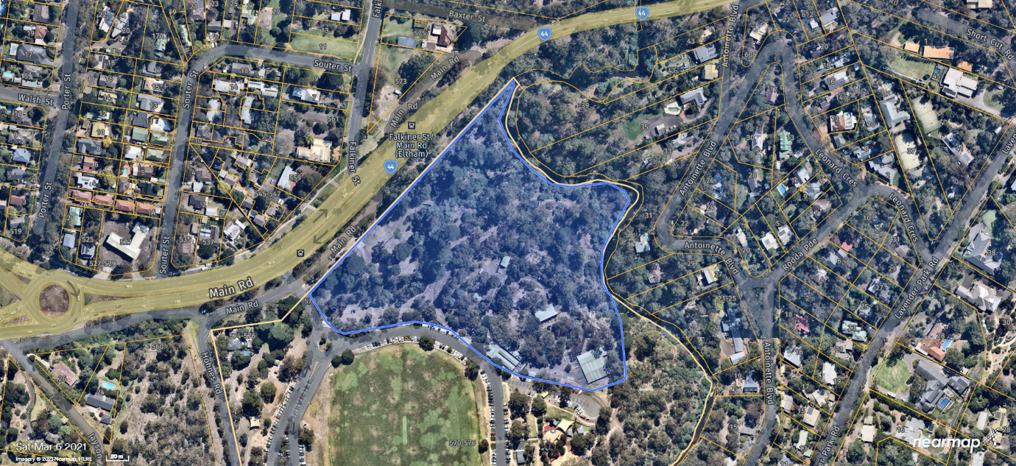
Figure 25. The extent of Heritage Overlay is recommended to cover the Diamond Valley Miniature Railway area, and extend to Diamond Creek to the east, within the Eltham Lower Park. The approximate area is highlighted in blue. (Source: Nearmap 2021)

REFERENCES
Altona Miniature Railway, ‘History’, https://altonaminiaturerailway.com.au/history-2/, accessed May 2021.
Argus, as cited.
Bartolomei, Deborah 2008, ‘Eltham’, eMelbourne, School of Historical and Philosophical Studies, The University of Melbourne, https://www.emelbourne.net.au/, accessed online May 2021.
Bick, David 1992, Shire of Eltham Heritage Study, prepared for the Shire of Nillumbik.
Box hill Miniature Steam Railway Society, ‘Our History’, https://bhmsrs.org.au/, accessed online May 2021.
Built Heritage 2008, Survey of Post-War Built Heritage in Victoria: Stage 1, prepared for Heritage Victoria.
Butler, Graeme, & Associates 1996, ‘Nillumbik Shire Heritage Review - Environmental History’, Prepared for the Shire of Nillumbik.
Bulla Hill Railway, ‘Our History’, https://bullahillrailway.org.au/, accessed online May 2021.
Cobden Miniature Railway & Mini Golf Park, https://www.cobdenminiaturerail.org.au/, accessed online May 2021.
Diamond Valley Railway Inc 2021, ‘All about us’, https://dvr.com.au/, accessed online 20 April 2021.
Eltham District Historical Society 2000, A Chronology of Known Local Events 1835-early 2000 including those in the Shire of Nillumbik and the former shires of Eltham and Diamond Valley, Eltham District Historical Society Incorporated.
Eltham District Historical Society 2019, ‘OTD: Opening of the new Eltham Library, 22 May 1994’, www.elthamhistory.org.au, accessed online April 2021.
Eltham Township Plan 1968, Melbourne, Department of Lands and Survey.
Gillett, Heath 2020, ‘Eltham Lower Park Desktop Review’, Prepared for the Nillumbik Shire.
Gowrie Victoria 2019, Our History, www.gowrievictoria.com.au, accessed online April 2021.
May R, Coleman, B, Cleland, S, and Quaife, R 1985, The Diamond Valley Railway Story, Eltham, The Diamond Valley Railway Ltd.
Mills, Peter & Westbrooke, Samantha 2010, ‘War Memorial Building Complex, 903-907 Main Road, Eltham, Cultural Heritage Significance Assessment’, prepared for Nillumbik Shire Council.
Mills, Peter & Westbrooke, Samantha 2017, ‘Nillumbik Shire Thematic Environmental History - Revision 2016’, prepared for Nillumbik Shire Council.
Mooroolbark Miniature Railway, ‘History’, https://mmr.org.au/, accessed May 2021.
Nillumbik Parish Plan 1951, Department of Lands and Survey, Melbourne.
Nillumbik Shire 2018, ‘Full steam ahead for popular miniature railway’, 2 March 2018, https://www.nillumbik.vic.gov.au, accessed online 20 March 2021.
Pierce, Peter (ed.) 1987, The Literary Guide to Australia, Oxford University Press, Melbourne.
Portarlington Bayside Miniature Railway, ‘About Us’, https://miniaturerailway.com.au/, accessed online May 2021.
Steam Locomotive Society of Victoria, ‘About Us’, http://www.slsv.com.au/about-us/, accessed online May 2021.
Victorian Places 2015, ‘Christmas Hills’, Monash University and The University of Queensland, https://www.victorianplaces.com.au/, accessed online April 2021.
Victorian Year Book 1973. Government Printer, Melbourne.
Yeoman, Russell, Pinn, Richards, and Connor, Jim 2020, Sign of the Times: Eltham street names with history, Eltham District Historical Society, www.elthamhistory.org.au.

