856 Main Road, Eltham

Former house
Prepared by: Context | Survey date: December 2020
Place type: Residential | Designer: State Savings Bank of Victoria (G Burridge Leith)
Significance level: Significant | Builder: Not known
Extent of overlay: To title boundaries | Major construction: 1927
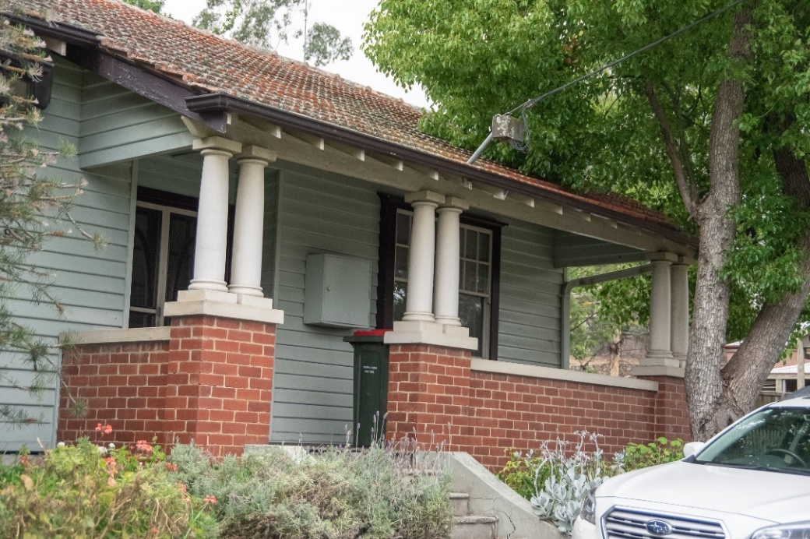
Figure 1. Primary (west) elevation of 856 Main Road, Eltham, with projecting verandah. (Source: Context December 2020)
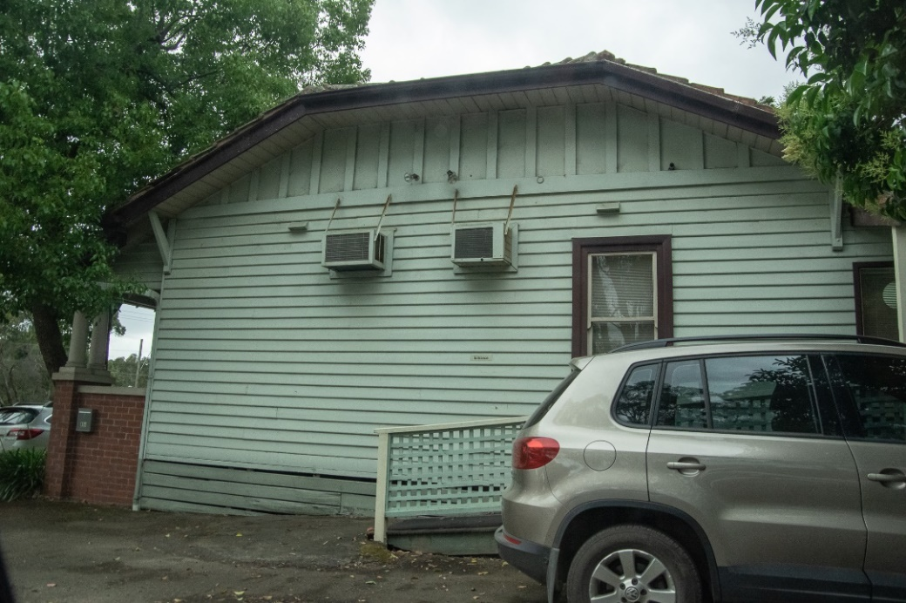
Figure 2. Side (south) elevation of 856 Main Road, Eltham, from the carpark. (Source: Context December 2020)

HISTORICAL CONTEXT
This place is associated with the following historic themes taken from the Nillumbik Shire Thematic Environmental History (2016):
6 BUILDING TOWNS AND SHAPING SUBURBS
6.3 Interwar subdivisions and estates
In the interwar period there were numerous speculative subdivisions throughout the Nillumbik area. These were often marketed as combining possibilities for escape from the city and immersion in the natural values of the area. The introduction of the railway made such speculations possible and they were spurred on by the promise of its electrification. This meant greater frequency of services and therefore greater viability for commuting workers and weekenders. (Mills & Westbrooke 2016:71)
The suburban fringe of the metropolis was advancing towards the southern and south-eastern edges of Eltham Shire. With the advancing of the metropolitan fringe towards Eltham, and the closer subdivision in the main towns of the Shire, both the suburban dream and an alternative in the form of a weekend getaway from the city were on offer. (Mills & Westbrooke 2016:71)
The electrification of the railway to Eltham in 1923 eliminated the changeover to steam trains at Heidelberg allowing faster through-trains and so reducing commuting time. It was generally expected that this would soon convert Eltham into a suburban area. Certainly, there was a proliferation of subdivided new estates for the next few years. At first there was some infilling of Holloway’s early Little Eltham subdivision. The 130 blocks of Sydney Haynes’ Bellevue estate, situated on both sides of Main Road and the railway line to the north of Eltham station, were advertised from 1920. By 1923 prospective buyers were advised to take advantage of the cheap blocks before prices inevitably rose. Forty lots in the estate were sold in April 1923. (Mills & Westbrooke 2016:71)
Other subdivisions were carved from rural land, often starting with deceased estates. The local name for the estate often reflected the former rural landowners. In 1922 the View Hill estate was advertised as the ‘highest point in the district, quite handy to [Eltham] station’. Twenty-three building blocks in the Mona Vale estate and two in Browne’s subdivision were advertised in 1924. In 1925 the owners of the View Hill estate submitted a plan for roads on the estate to the shire council for approval. The following year an owner in the estate disposed of his two lots at a ‘very satisfactory figure’ to Messrs J. & H. Rowe, electrical engineers from the city who were planning to build two ‘concrete villas’. (Mills & Westbrooke 2016:71)
In 1924 a ‘leading Melbourne land agent’ acquired a large tract of land in Eltham for subdivision purposes. This may have been the Eltham Electric Station Estate (known locally as the Pryor estate) opposite the station, where lots were auctioned in 1925. The estate included 11 shop sites in Main Street and 29 ‘beautiful elevated residential allotments’. Local reports found that Eltham was on the ‘up grade’. ‘The railway has given the necessary acceleration towards advancement and not only is Eltham becoming popular as an outer suburban residential area, but also as an easily accessible tourist resort.’ (Mills & Westbrooke 2016:72)
In the late 1920s the developer’s tone remained optimistic. The Advertiser described the commencement of five new buildings in Eltham as a ‘mini boom’. ‘New buildings are springing up all round the district, which a progressive council has supplied with water and for which far-sighted residents have obtained the electric current from the Electricity Commission. For some time agents have been seeking out and securing the beauty spots around Eltham, for which there is a good demand, and there is every indication that, in the near future, a substantial increase in settlement will take place.’ (Mills & Westbrooke 2016:72)

LOCALITY HISTORY
Eltham, situated in hilly country northeast of Melbourne, is located on the country of the Wurundjeri-willam clan of the Woi wurrung, one of the five tribes of the Kulin Nation. A small, short-lived reservation south of Eltham on the Yarra River was set aside for Aboriginal people in 1852. The area is situated near the junction of the Yarra River and its tributary, Diamond Creek.
Pastoral settlers moved into the area from around 1840 and took up pastoral leases (Bartolomei 2008). It was located proximate to the track used by the Ryrie brothers to provide access between their ‘Yering’ run, near Yarra Glen, and the Heidelberg village (Victorian Places 2015). In 1841, William Bell and Thomas Armstrong occupied land for a squatting run east of Diamond Creek in what was to become the Eltham district (Eltham District Historical Society 2000: np).
A plan for 50 allotments in the Township of Eltham, Parish of Nillumbik, was announced in 1848, with the name officially gazetted in 1851. The township, near the junction of Diamond Creek and the Yarra River, was laid out in an area bounded by Baxter Street, Diamond Creek, Dalton Street and Bolton Street. The township plan shows that a track to a bridge across Diamond Creek and Main Road was noted as the ‘Track from Melbourne’ (Butler 1996:32). This area is known today as Eltham South.
Present-day Eltham, however, was not established on the township reserve, where land proved difficult to sell. Instead, the town grew from allotments in Section IV of the Parish of Nillumbik located on Main Road, to the north of Dalton Street and the township reserve (Butler 1996:32). In 1851, Melbourne property developer Josiah Holloway purchased one square mile (or 5120 acres) of this land, which he subdivided immediately, calling the subdivision Little Eltham. The central area of current-day Eltham is contained within the Little Eltham subdivision. A number of large farming properties around the township were purchased from the early 1850s (Nillumbik Parish Plan 1951).
Eltham township grew during the 1850s around a cluster of buildings at the corner of Pitt Street and Main Road within the Little Eltham subdivision. Located on the road to the Caledonia goldfields, this small township became a service centre for the surrounding mining areas, and by 1854 supported a population of 282. In this period Eltham had two hotels, a brewery, and a scattering of shops along Main Road (known in the 1850s as Maria Street). The town had a steam flour mill operated by Henry Dendy, and a tannery was located on the Diamond Creek. The Little Eltham School, opened by the Church of England, was built in 1853 near Swan Street and closed in 1872. A second school, a national school (later Eltham Common School No. 209) opened in Dalton Street in 1856. A Wesleyan chapel opened in 1858. Public buildings constructed at this time included a courthouse and a police station in Main Road in 1860. The ‘flat land’, which is now the Eltham Lower Park, near the Yarra, was used as a racecourse (Kellaway cited in Butler 1996:32-33; Eltham District Historical Society 2000:np). A cemetery was established in 1858. The township and wider area was administered by the Shire of Eltham, established in 1856.
Between the 1860s and the 1880s, Eltham supplied food and produce for the goldmining communities of the Caledonia goldfields at Queenstown (St Andrews) and Panton Hill. It also became a stopping place on the route to the Woods Point diggings. Eltham’s population grew in response (Victorian Places 2015).
A Primitive Methodist chapel was built in 1860. The following year St Margaret's Anglican Church, designed by the notable Melbourne architect Nathaniel Billing, was built. In 1881, a Wesleyan church was constructed by George Stebbing to the design of Melbourne architects Crouch and Wilson (Butler 1996:33). A new state school, constructed of local sandstone, opened in 1876.
Several large properties surrounding the township had absentee owners, who subdivided their properties into smaller farms either for lease or for sale. The smaller properties, especially in the Little Eltham township, were run by farmers who often made a modest living as wage labourers. Like many later Eltham residents, they were attracted by cheap land and the country life (Butler 1996:33).
In 1884 Eltham was described as:
… a pretty little township on the Yarra Flats road ... It has a population of nearly 400 inhabitants, but in addition it is the centre of a large district extending over 208 square miles, having a population of 2344. The land in the district is mostly used for grazing purposes, although as a rule the small farms grow a good deal of wheat, oats and other agricultural produce. A large quantity of fruit, especially raspberries and strawberries, is also produced (Illustrated Australian News 20 December 1884, cited by Carlotta Kellaway in Butler 1996:33).
The Australian News noted that gold had been found in the vicinity of the township, ‘but not in remunerative quantities’ (cited by Carlotta Kellaway in Butler 1996:33).
In the 1880s agitation began for the extension of the railway line from Melbourne to Heidelberg to serve Eltham and districts further afield such as Kangaroo Ground. The railway station in Eltham opened in 1902, however the line was never extended to Kangaroo Ground. The railway brought excursionists from Melbourne, many of whom picked wattle during the flowering season, and focused development of the Eltham township around the railway station. Eltham was a picturesque village with the advantage of its proximity to metropolitan Melbourne and to attractive countryside with farms and uncleared stringybark forest (Victorian Places 2015). The bush scenery attracted artists, writers and nature-lovers.
In 1903 the Australian Handbook described Eltham as part of an orcharding and grazing district. In 1901, 4289 acres were under cultivation, of which 2506 acres were planted with orchards and market gardens. The township, with a population of 377, included a state school, a branch of the Commercial Bank, and Catholic, Anglican, Wesleyan Methodist and Primitive Methodist places of worship (cited in Victorian Places 2015). From 1909, rural properties were increasingly subdivided to create residential estates on the outskirts of the Eltham township (Mills & Westbrooke 2017:69).
The electrification of the railway line was extended to Eltham in 1923, eliminating the need to change to steam train at Heidelberg and allowing faster through-trains and shorter commuting times. The establishment of new residential estates in Eltham followed (Mills & Westbrooke 2017:71). Reflecting the town’s growth, a higher elementary school was opened in 1926 (Victorian Places 2015).
Eltham was described in 1940 as ‘residential, horticultural, dairying and grazing ... a beauty spot for artists and picnickers’. By this time, the town had three recreation reserves, swimming baths, tennis courts and a fire brigade (Victorian Places 2015).
Eltham has attracted a number of writers and artists over the years. The landscape painter Walter Withers (1854-1914) moved to Eltham in 1902 when the railway opened; other artists, including members of the Heidelberg School, painted in the area in the open air. Clara Southern and May Vale, landscape painters and students of Frederick McCubbin, settled in the region. Vale resided at Diamond Creek and Southern at Warrandyte (Bartolomei 2008). The war artist Will Longstaff also lived in Eltham for a period. From 1910, painter William ‘Jock’ Frater and cartoonist Percy Leason often camped and painted in the area. Artist Justus Jorgensen established the notable Montsalvat artists’ colony buildings, on land he purchased in 1934. Seeking a closer engagement with the natural environment, the establishment of Montsalvat, with its adobe and rammed earth buildings, influenced future mudbrick construction in the area. Several local designers, including Alistair Knox, specialised in mudbrick housing in the postwar period (Victorian Places 2015). Others who have been inspired by Eltham and have made the Nillumbik region their home include landscape architect Edna Walling; authors Alan Marshall and Carolyn Van Langenberg; artists Clifton Pugh and Danila Vassilieff; composers and musicians Graeme and Roger Bell; jewellers and sculptors Michael Wilson, Simon Icarus Baigent and Matcham Skipper; writer CB Christensen; poet Chris Wallace-Crabbe; and actor Kerry Armstrong (Bartolomei 2008; Pierce 1987:354).
Eltham experienced significant postwar development with a number of residential estates subdivided and put up for sale. The population of the town increased steadily as a result. In 1933, only 927 residents were recorded in the town in 1933; this had increased to 7177 residents in 1971. As a result, Eltham High School opened in 1950 and the Catholic Ladies College was relocated to Eltham in 1971 (Victorian Places 2015). The Eltham War Memorial Trust Baby Health Centre opened in 1951. New shire offices opened in 1965, and Eltham College commenced classes in 1974 (Eltham District Historical Society 2000:np).
A distinctive style in local building emerged in Eltham in the postwar period, with a strong use of natural materials, low form structures, and an integration with the natural environment. Houses were often sited in bush gardens, especially after the 1970s. This style was also adapted to community buildings in the area, with the Eltham Library being constructed in mudbrick and recycled timbers in 1994 (Eltham District Historical Society 2019).
The Shire of Eltham became part of the Shire of Nillumbik in 1994, with a small area becoming part of the City of Banyule.

PLACE HISTORY
The 1929 former house at 856 Main Road, Eltham, is located on Crown Allotment 12, Section 4, Parish of Nillumbik, 316 acres purchased by J M Holloway in 1853 (Nillumbik Parish Plan 1951).
By 1879, the allotment had been subdivided and streets formed as part of the survey of Eltham township. Postmistress Anne Hunniford purchased approximately four acres of the subdivision in that year, including land associated with the subject site. The majority of the four acres, fronting York Street, Bridge Street and Main Road, was transferred to farmer John James Burgoyne in 1886 (CT:V1118 F583; CT:V1982 F376).
Under Burgoyne’s ownership, a portion of land (approximately one acre) was subdivided and sold in 1912. Burgoyne retained the rest of the land comprising approximately two acres at the corner of Main Road (also known as Maria Road) and York Street (CT:V1982 F376). When Burgoyne died in 1918, his probate listed his real estate assets as comprising two properties in Holmes Street, East Brunswick and the land associated with the subject site in Main Road, Eltham. The extant buildings on the land at the time included a weather board shop (bakehouse) and dwelling fronting Main Road, a brick bakery at the rear fronting York Street and stables (PROV 1918).
In April 1920, John Neville Burgoyne, son of John James Burgoyne subdivided his father’s estate into two allotments. John was hay and corn merchant, and owned a store at today’s 820 Main Road, Eltham (CT:V4328 F509). In 1922, mechanics David Andrew and John Lyon purchased one of the subdivided allotments, which contained land associated with the subject site (CT:V4607 F306). David Andrew and John Lyon built and established Eltham’s first motor garage in the 1920s. The Lyon Brothers Garage, which was the second RACV station in Victoria, was situated on the west side of Main Road opposite Arthur Street.
Under the Lyons’ ownership, the subject site was further subdivided into three allotments in 1928. David Lyon retained one allotment, including the subject site, selling the other two allotments in 1949 and 1952 (CT:V4607 F306).
The subject building was built in 1929, when it was reported in the Advertiser that ‘Mr D A Lyon’ made an application to Eltham Shire council for the construction of a residence in Eltham (Advertiser 15 February 1929:4). In that year, the Commissioners of the State Savings Bank of Victoria took over ownership of the subject land, indicating that Lyon built the house through a loan financed by the State Savings Bank of Victoria. Lyon paid off the loan in 1934, when the ownership reverted to him (CT:5474 F727). The subject building was built to a 1927 State Savings Bank of Victoria standard plan, Type Number 42, supervised by the chief architect G Burridge Leith (Figure 3).

Figure 3. Showing the 1927 State Savings Bank Type No 42 standard plan, the design of the subject building, which was built in the period 1929-34. (Source: State Savings Bank of Victoria 1927:45)

David Lyon retained ownership of the property until 1957, when the ownership transferred to John and Elizabeth Scotland. Elizabeth was the daughter of David Lyon and his wife and Ada. The Scotlands sold the subject property in 1970 (CT:5474 F727; Advertiser 1 September 1951:22).
The land was subdivided again into two allotments in 1984. The subject residence was included in Lot 1 of the subdivision, forming the land today known as 856 Main Road (CT:V9554 F358). The subject building currently houses a medical practice.

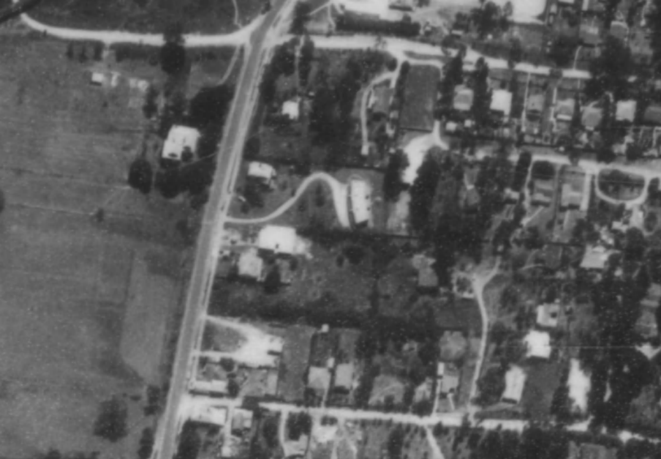
Figure 4. Aerial imagery of the subject building in 1963, outlined in red. (Source: CPO, ‘MELBOURNE (1963) PROJECT’ 1963, Landata)

State Savings Bank of Victoria (G Burridge Leith, chief architect), designer
Following the First World War, Victoria faced housing shortages associated with an influx of returning soldiers and an increase in population. As a response to this situation, from 1920, the Victorian government offered workers on low incomes long-term loans at low interest to enable them to buy a home of their own. The State Savings Bank of Victoria managed the scheme, providing house plans and supervising the selection of contractors.
Under its credit foncier scheme, the State Savings Bank built thousands of homes in Melbourne's suburbs from 1921, particularly in suburbs serviced by newly electrified trains and trams. The Housing and Reclamation Act 1920 and, from 1922, the War Services Home Act 1918-20, authorised the lending of funds for housing to approved persons and ex-servicemen at concessionary rates. Under the supervision of the bank’s architect, G Burridge Leith, the bank initially built mainly detached stripped back Californian Bungalow styles, with designs regularly updated to incorporate emerging fashions and trends. The Housing and Reclamation Act authorised the bank to purchase land and build a house, or alternatively, to purchase land with a house already built and to sell it on hire purchase. The total cost of the house and land was limited to £800 (O’Hanlon 2008; Murray & White 1992:208).
In the northern and western suburbs, smaller weatherboard houses were popular, while larger brick and weatherboard styles were more often found in eastern and southern suburbs. Size, fittings and finishes reflected price, with the smallest houses having two bedrooms, and the larger ones three. More expensive models featured separate dining and breakfast rooms and other 'modern' features (O’Hanlon 2008). Some of the middle-class suburbs attempted to maintain their status and values by declaring ‘brick-only’ areas (Murray & White 1992:213).
Most of the houses built up to the mid-1920s were small timber residences constructed within the £800 limit imposed by the Housing and Reclamation Act loans. Timber homes were chosen from the bank’s pattern books of standard designs, the most popular being the ‘cottage’ and the ‘bungalow’. The bungalow usually had five rooms (kitchen, dining or breakfast room, lounge room and two bedrooms) with a wide central passageway, and an internal bathroom and external toilet (Murray & White 1992:213).
The scheme was phased out in the 1960s, but even today the 'State Bank Home' remains an indicator of quality housing (O’Hanlon 2008).

DESCRIPTION
The former house at 856 Main Road, Eltham, is a single-storey weatherboard former house built in 1929, to a 1927 design by the State Savings Bank of Victoria. Located on the eastern side of Main Road, the site is positioned between York Street and Henry Street opposite the Alistair Knox Park.
856 Main Road is set on an irregular L-shaped block gently rising to the east, with the primary (west) elevation facing Main Road. The house occupies the northern half of the parcel, and an asphalt carpark covers the southern half. The property in unfenced along Main Road. There is a deep setback to the house with open mown lawn and small garden beds. The carpark is accessed from both Main Road and the private driveway on the southern boundary. A driveway to the new townhouse complex at 852 Main Road (Lot 2 of the 1984 subdivision) adjoins the southern boundary.
The former house has a broadly rectangular plan with a forward-facing porch containing the main entry to the southern end of the west façade (Figure 1 and Figure 5). It is clad in timber weatherboards and has a jerkinhead roof clad in terracotta tiles. Eaves are timber-lined and have exposed rafters. A skillion corrugated iron extension has been added to the rear (Figure 4).
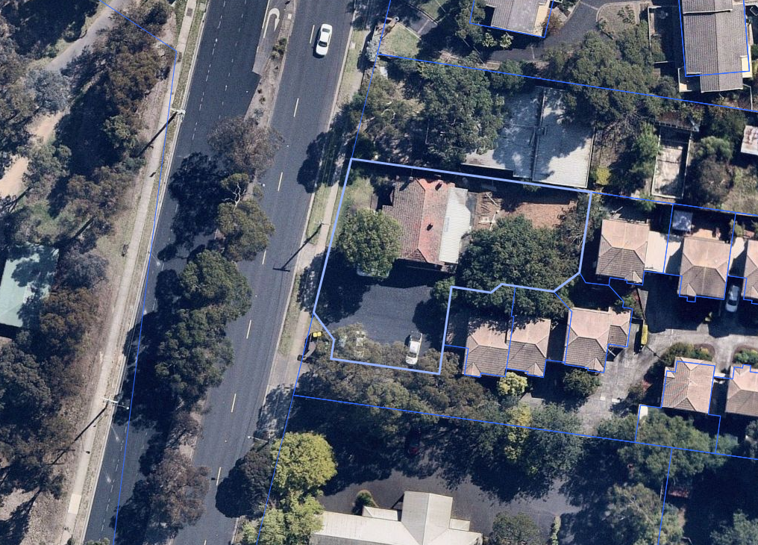
Figure 5. Aerial imagery showing the original roof and corrugated iron skillion roof addition to the rear. (Source: Nearmap 2021)

The entry porch has brick balustrading with integrated piers with rendered capping. The brick piers support Double columns that carry the projecting terracotta-tiled roof. The west façade features a central double door, flanked by a pair of timber-framed double-hung sash windows (to the south) and a bow window (to the north). The bow window has a flat projecting canopy and is clad in square-edged timber shingles (Figure 6). Three unadorned simple red brick chimneys penetrate the roof (Figure 7).
The side (north and south) elevations have weatherboard cladding with vertical batten detailing to the jerkinhead gable ends. The south elevation features a ramp leading to an entrance portico and doorway in the southeast corner on the building. Terracotta tiled roofing supported by simple timber posts extends over the doorway. A timber lattice balustrade lining the ramp appears to be later addition, likely dating from the post-1970 conversion (Figure 8).
An extension with corrugated iron roof cladding is located to the rear of the building, but this is not readily visible from the public domain.

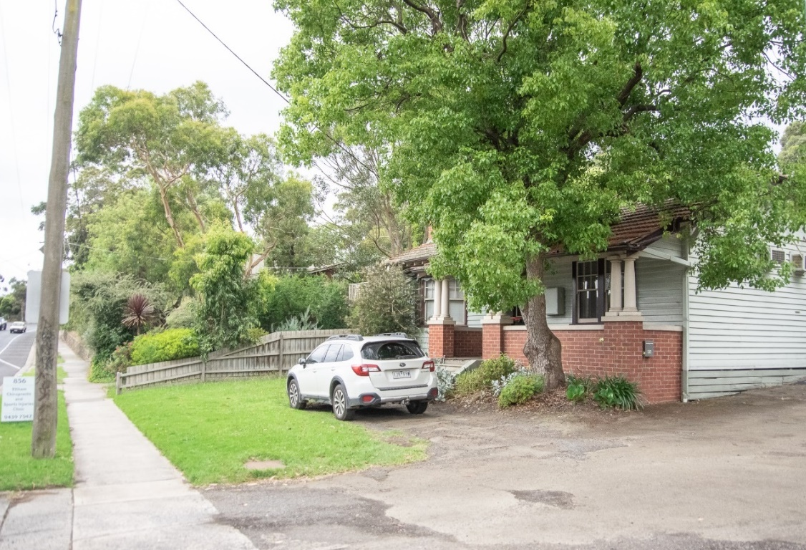
Figure 6. View of the main elevation from the entrance driveway on Main Road (Source: Context 2020).

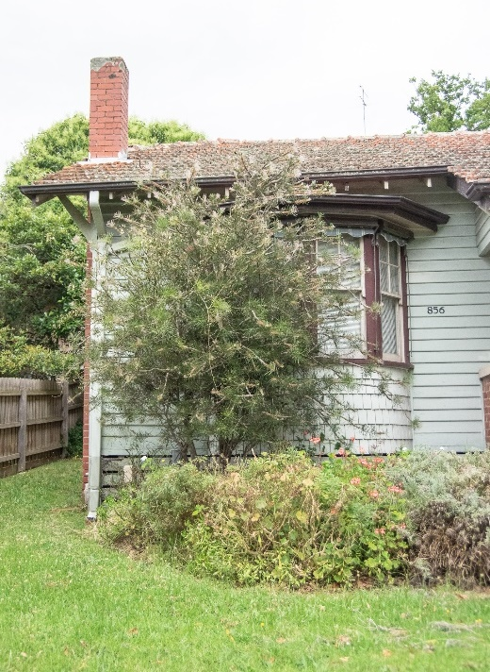
Figure 7. Bow window with canopy on the northern side of the main elevation with shingles. (Source: Context 2020)
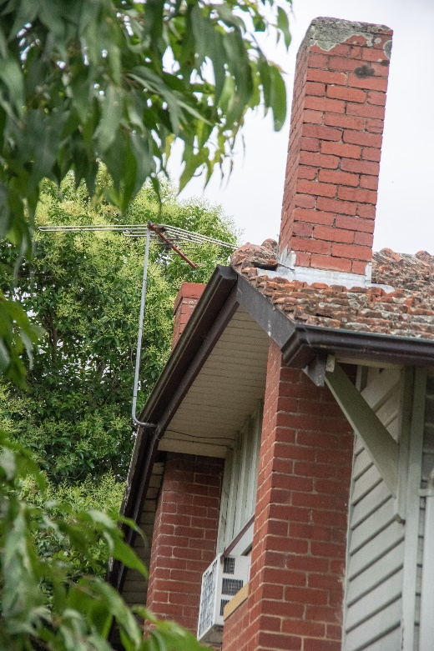
Figure 8. Two red brick chimneys on the northern elevation penetrate the jerkinhead gable. (Source: Context 2020)

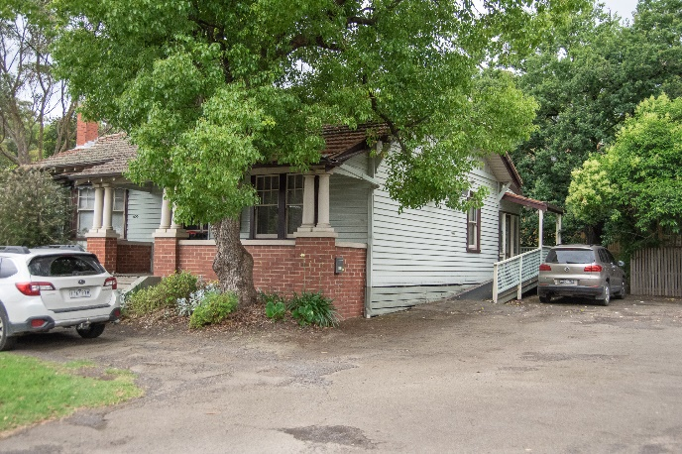
Figure 9. View of 856 Main Road from the southwestern corner. (Source: Context 2020)

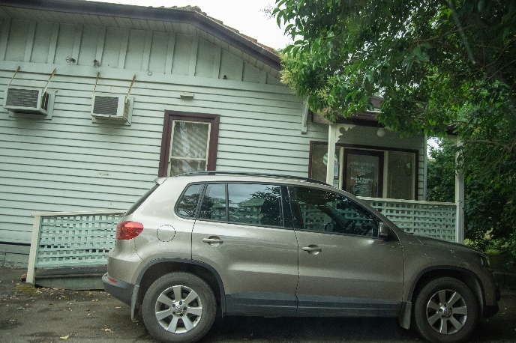
Figure 10. Secondary elevation showing weatherboard cladding with vertical batten detailing to the jerkinhead gable end, ramp and rear extension. (Source: Context 2020)

INTEGRITY
856 Main Road, Eltham, is largely intact with a few changes visible to original or early fabric. The building mostly retains its original built form and detailing, including the transverse jerkinhead roof clad in terracotta tiles, weatherboard cladding, projecting brick porch, pattern of early fenestrations, shingled bow window with projecting canopy, and brick chimneys. The rear extension does not distract the overall legibility of the original design. Overall, the building has high integrity.

COMPARATIVE ANALYSIS
From the 1890s, the defined area of Greater Melbourne had been expanded to include Eltham and the surrounding district for the purpose of censuses. Despite being included within these boundaries, the area continued to be predominantly rural. The interwar period, however, saw an increase in development and suburbanisation of within the broader Nillumbik area. Following World War I, the ideal of small detached houses set within gardens became increasingly popular, causing a ‘dramatic expansion’ of the greater metropolitan areas of cities (Raworth 1991:9). This preferred housing form, along with the introduction of regular railway services, affordable land and the promise of electrification, encouraged many to come to the Nillumbik area and build homes in the interwar period.
Likely due to a combination of continuing agricultural land use and lack of suburban utilities, development in areas outside the main streets of townships in Nillumbik was still slow. Most houses that appeared in new subdivisional estates in the early twentieth century were modest weatherboard, timber framed structures.
Reflecting the popular architecture of the time, many chose to build ‘bungalows’. The early bungalows from the 1920s were commonly associated with the Californian Bungalow style, which usually featured a high level of detailing. Many houses built in the same period or later, however, conformed to a broader interwar bungalow type, especially those in outer suburban and semi-rural areas. These houses were generally small, single-storey, double-fronted dwellings with dominant verandahs with exposed rafters and beams (Raworth 1991:11).
Houses designed by the State Savings Bank of Victoria proliferated across Melbourne from 1921. The State Savings Bank scheme saw that customers would be lent money to build their own home, with the plans of which would be provided by the bank. This scheme made housing affordable for many in the interwar period.
Early State Savings Bank houses designed in the 1920s were simple ‘bungalows’, with roofs clad in corrugated iron or terracotta tiles. The chief architect G Burridge Leith designed around 50 types in Victoria, initially mostly of timber and generally of five main rooms (Butler 2010:42-43). In the northern and western suburbs of Melbourne, smaller-scaled standard weatherboard houses were more popular, while larger houses of brick or weatherboard constructions were more often found in eastern and southern suburbs. Despite their popularity across Melbourne, there are limited examples of State Savings Bank of Victoria designed houses covered by the Heritage Overlay outside the metropolitan Melbourne area.
Although Eltham and the broader Shire of Nillumbik experienced a rapid growth in the interwar years, there are no State Savings Bank-designed houses currently listed on the Heritage Overlay. This type of house is less common in Nillumbik, as they were predominantly constructed in suburbs serviced by newly electrified trains and trams. There were also only few State Savings Bank branches in the area. State School No. 2105 at 275 Eltham-Yarra Glen Road, Kangaroo Ground (HO47), had a small room built on the front verandah of the residence in c1920s that served as a State Savings Bank agency until c1934.
The following examples in the Shire of Nillumbik are comparable with 856 Main Road, Eltham.
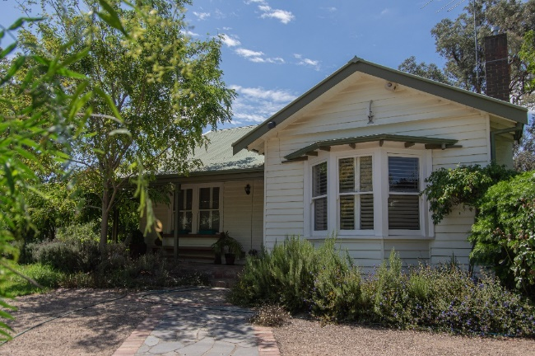  200 Ryans Road, Eltham North (recommended as Individually Significant in this study). (Source: Context 2021) | The property at 200 Ryans Road, Eltham North, is a 1933 single-storey asymmetrical timber house that has a main gabled roof form with an intersecting transverse gable to the principal façade. The house demonstrates the uptake of land in the area during the interwar period.
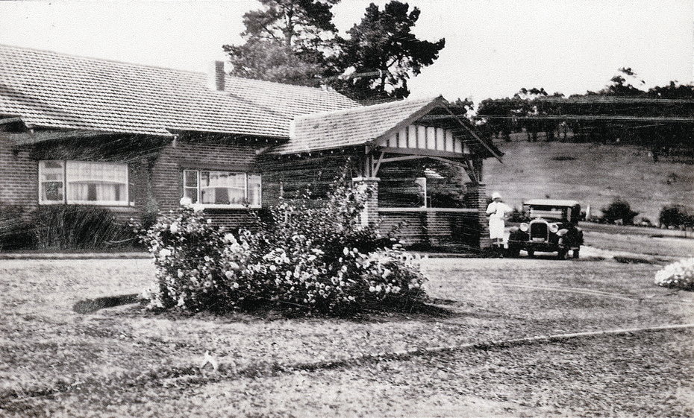  Worlingworth, 10-26 Banoon Road, Eltham (HO7). (Source: VHD) | The property at 10-26 Banoon Road, Eltham, is historically significant for its associations with the notable anthropologist Donald Thomson, who lived there from the mid-1930s. Built c1922, it is also important as one of a few substantial homes erected in the Shire during the interwar period, illustrating Eltham's development into a desirable residential locality. It survives as one of few properties to retain its intact farm setting (VHD).
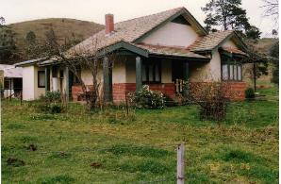  Orchard House, 25 Cottles Bridge-Strathewen Road, Cottles Bridge (HO190). (Source: VHD) | The property at 25 Cottles Bridge-Strathewen Road, Cottles Bridge, is significant as one of few brick houses built prior to 1930 in Nillumbik. It is unique in the municipality as an example of the transitional bungalow style, exhibiting elements of both the interwar and Federation eras. It is also significant for its association with Thomas Cottle, the namesake of the Cottles Bridge area, the Cooke orcharding family and the probable builder of the house, ‘Caffin’ (VHD).
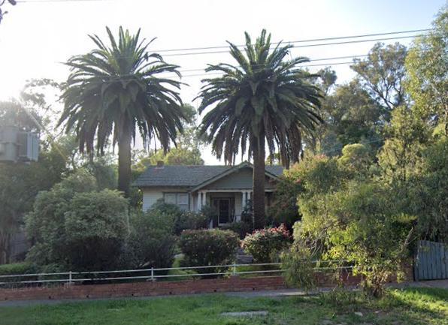  836 Heidelberg-Kinglake Road, Hurstbridge (HO264). (Source: VHD) | The property at 836 Heidelberg-Kinglake Road, Hurstbridge, is aesthetically significant as a substantially intact example of an interwar bungalow constructed c1923. Its aesthetic value is enhanced by the intact front garden and fence, including the two Canary Island Palm trees framing the entry to the residence. The residence is demonstrative of the township’s dominant period of development which was stimulated by the orchard industry and introduction of the railway line in 1912 (VHD).

Outside the Shire of Nillumbik, there are a few comparative examples of the typical State Savings Bank-designed houses included on the Heritage Overlay. The following examples are located in other surrounding municipalities that experienced similar transition towards suburban development during the interwar period.
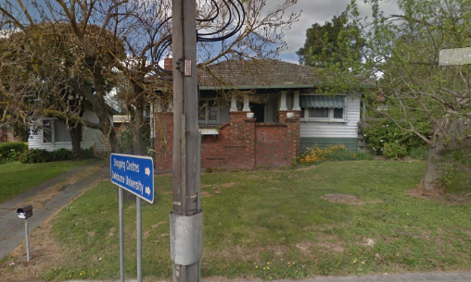  Lilydale Interwar House Types, 30 Anderson Street, Lilydale (Significant within HO412, Yarra Ranges Shire). (Source: Google 2019) | 30 Anderson Street, Lilydale is a modest suburban interwar house. It is one of a group of similar houses in Lilydale built in the 1920s and 1930s that illustrate the shift from rural living to a more suburban mode of development during the interwar era with housing types that reflected popular typologies and style used in other built-up areas of Melbourne (VHD).
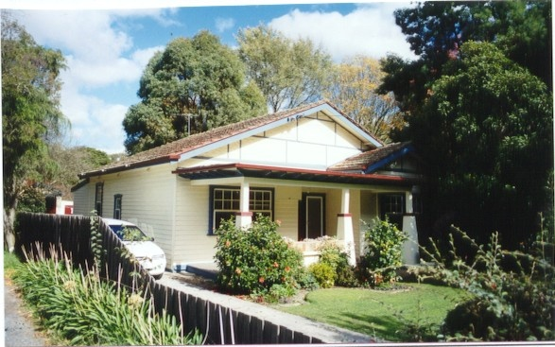  272 Mt Dandenong Road, Croydon (HO110, Maroondah City). (Source: VHD) | 272 Mt Dandenong Road, Croydon, is a timber Californian Bungalow, built c1925, probably to a State Savings Bank of Victoria design. It is historically significant locally as embodying family life in Croydon between the wars and of the housing initiatives of the bank. It is architecturally significant as an intact example of this domestic type enhanced by its grouping with 274, 276, 280 (HO110), 284, 290, 294, 296, 298 (HO111), 315-317 (HO112) and 316 (HO113) Mount Dandenong Road (VHD).
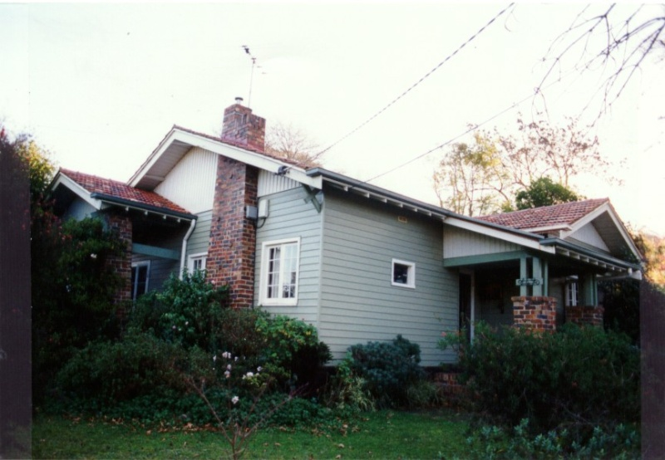  149 Mt Dandenong Road, Croydon (HO105, Maroondah City). (Source: VHD) | 149 Mt Dandenong Road, Croydon is a timber Californian Bungalow built c1929, likely to a State Savings Bank of Victoria design. The house is historically significant as it represents the way in which housing was provided in the predominantly rural area of Croydon during the late 1920s. The property is significant as a highly intact and representative example of a State Savings Bank house in the area, which features two linked groups of similar houses (VHD).
Discussion
Established in a more suburban setting than the above earlier local bungalow examples, 856 Main Road, Eltham, is distinguished from the local examples for its use of a State Savings Bank of Victoria’s standard design, a type that was prevalent throughout Melbourne but that appears to be less common in the Shire than other suburban municipalities.
856 Main Road, Eltham, demonstrates the interwar development of residential subdivisions of larger land parcels that had been evident in the Victorian period township. It reflects the transition towards suburban living in Eltham during this period. 10-26 Banoon Road, Eltham, and 25 Cottles Bridge-Strathewen Road, Cottles Bridge, were erected on more substantial blocks of land with bush setting. Like 856 Main Road, Eltham, 836 Heidelberg-Kinglake Road, Hurstbridge, is located within the more suburban areas of the municipality and is more closely comparable.
The house at 200 Ryans Road, Eltham North, is an example of a slightly later timber residence that was erected on a subdivision that had been created out of a larger allotment. This subdivision, known as the ‘Glen Park Estate,’ sits outside the original township area, however, still characterises the uptake of smaller allotments for residential purposes in the shire during the interwar period.
Designed to a 1927 State Savings Bank Type No 42 plan, the subject building retains key stylistic features of the interwar bungalow type and is largely intact to its State Savings Bank of Victoria design. The shingled bow window with a flat projecting roof, terracotta tiled jerkinhead roof, exposed rafters and brick entry porch characteristic elements of this plan type exhibited by the building.
856 Main Road, Eltham, compares well to the above examples of modest interwar State Savings Bank of Victoria bungalows listed on the Heritage Overlay in surrounding municipalities (30 Anderson Street, Lilydale, 149 and 272 Mt Dandenong Road, Croydon), in terms of scale, design elements, materials and setting. Both the subject building and the above examples have a generous setback fronting a main arterial road with a dual carriageway.
Overall, 856 Main Road, Eltham is differentiated from the interwar dwellings already listed on the Nillumbik Shire Heritage Overlay as a somewhat rare example of a State Savings Bank of Victoria house design. Its simple form, modest detailing, suburban character, and high level of intactness to the original State Savings Bank of Victoria design is an example of a bungalow typology and corresponding period of development that is underrepresented in the Schedule to the Heritage Overlay.

STATEMENT OF SIGNIFICANCE

WHAT IS SIGNIFICANT?
The former house at 856 Main Road, Eltham, built in 1929 to a design by the State Savings Bank of Victoria, is significant.
Elements that contribute to the significance of the place include:
- original single-storey built form, scale and jerkinhead roof form;
- original pattern of openings;
- materiality including weatherboard cladding, vertical batten jerkinhead gable-end detailing, face brick entry porch and timber column roof supports, brick chimneys, terracotta tiled roof cladding; its design to the State Saving Bank of Victoria (Type No 42);
- other characteristic features of the State Saving Bank of Victoria bungalow style including the bow window with projecting flat roof canopy and shingle cladding, timber-lined eaves with exposed rafters, and double-hung timber framed sash windows; and
- the deep front setback from Main Road.
Later changes including the rear extension and new side entrance (post-1970) are not significant.

HOW IS IT SIGNIFICANT?
The former house at 856 Main Road, Eltham, is of local historic and representative significance to the Shire of Nillumbik.

WHY IS IT SIGNIFICANT?
The former house at 856 Main Road, Eltham is historically significant for its association with the residential development of Eltham in the late 1920s and early 1930s. As a timber interwar bungalow situated on a suburban block it represents the consolidation of Eltham into a commuter suburb, following the electrification of the railway line, which reduced the journey into the city. The subject building was erected in 1929 for mechanic David Andrew Lyon, through a loan financed by the State Savings Bank of Victoria. David Andrew Lyon and his brother John established Eltham’s first motor garage in the 1920s. The Lyon Brothers Garage was the second RACV station in Victoria, situated on the west side of Main Road opposite Arthur Street. The former house is also significant as a somewhat rare example of this type in Eltham, financed and built to a standard design by the State Savings Bank of Victoria. (Criterion A)
The former house at 856 Main Road, Eltham is of representative significance as a fine, highly intact, representative example of a standard State Savings Bank bungalow built in the mid-1920s. The former house is an intact example of the 1927 Type No 42 design, created under the supervision of the bank’s chief architect, G Burridge Leith, who designed around 50 types in Victoria. The building showcases characteristic features of the State Savings Bank bungalow type including weatherboard cladding, roof clad with terracotta tiles, vertical timber batted detailing to the jerkinhead gable-ends, bow window with flat roof canopy and shingle cladding, and face brick porch and timber column roof supports. (Criterion D)
The former house at 856 Main Road, Eltham is also representative of the type of housing being built in formerly rural areas surrounding Melbourne, as they rapidly suburbanised during the interwar period. Although State Savings Bank houses were rarer in these outer districts, 856 Main Road fits with the general type of modest timber housing that appeared in these areas during the interwar period. (Criterion D)

RECOMMENDATIONS
Recommended for inclusion in the Schedule to the Heritage Overlay of the Nillumbik Planning Scheme as an Individually Significant place.
Extent of overlay: To title boundaries
Recommendations for the Schedule to the Heritage Overlay (Clause 43.01) in the Nillumbik Planning Scheme:

Nillumbik Planning Scheme
External paint controls | No
Internal alteration controls | No
Tree controls | No
Outbuildings or fences | No
To be included on the Victorian Heritage Register | No
Prohibited uses may be permitted | No
Aboriginal heritage place | No

Other
N/A

REFERENCES
Advertiser, as cited.
Ancestry 2021, ‘Family Trees’, https://www.ancestry.com.au/, accessed online 15 April 2021.
Argus, as cited.
Bartolomei, Deborah 2008, ‘Eltham’, eMelbourne, School of Historical and Philosophical Studies, The University of Melbourne, https://www.emelbourne.net.au/biogs/EM00516b.htm.
Built Heritage Pty Ltd 2010. ‘Survey of Post-War Built Heritage in Victoria: Stage 2’. Prepared for Heritage Victoria.
Butler, Graeme, & Associates 1996, ‘Nillumbik Shire Heritage Review - Environmental History’, Prepared for the Shire of Nillumbik.
Central Plan Office (CPO), Historic Aerial Photography: 1930s to 1990s, as cited, via Landata, https://www.landata.vic.gov.au/, accessed online March-April 2021.
Eltham Cemetery Trust 2017, Our Eltham Artistic Recollections, Eltham, Eltham Cemetery Trust, https://www.imags.com.au, accessed online 12 April 2021.
Eltham District Historical Society 2000, A Chronology of Known Local Events 1835-early 2000 including those in the Shire of Nillumbik and the former shires of Eltham and Diamond Valley, Eltham District Historical Society Incorporated.
Eltham District Historical Society 2021, newspaper article: ‘Murder mystery at bakery, history comes to life for old building’, 4 November 1979, https://elthamhistory.wordpress.com, accessed online 12 April 2021.
Eltham District Historical Society 2019, ‘OTD: Opening of the new Eltham Library, 22 May 1994’, www.elthamhistory.org.au.
Gowrie Victoria 2019, Our History, www.gowrievictoria.com.au.
Land Victoria, Certificates of Title (CT), as cited.
Mills, Peter & Westbrooke, Samantha 2010, ‘War Memorial Building Complex, 903-907 Main Road, Eltham, Cultural Heritage Significance Assessment’, prepared for Nillumbik Shire Council.
Mills, Peter & Westbrooke, Samantha 2017, ‘Nillumbik Shire Thematic Environmental History - Revision 2016’, prepared for Nillumbik Shire Council.
Murray, Robert & White, Kate 1992, A bank for the people: a history of the State Bank of Victoria, Hargreen Publishing, North Melbourne.
Nillumbik Parish Plan 1951, Melbourne, Department of Lands and Survey.
O’Hanlon, Seamus 2008, ‘State Bank Homes’, eMelbourne, School of Historical and Philosophical Studies, The University of Melbourne, http://www.emelbourne.net.au, accessed online 13 April 2021.
Pierce, Peter (ed.) 1987, The Literary Guide to Australia, Oxford University Press, Melbourne.
Public Record Office of Victoria (PROV) 1918, Probate and Administration Files VPRS 28/ P3, unit 850, item 159/484.
State Savings Bank of Victoria 1927, Types of Timber-framed Dwelling Houses available for selection under the Provisions of the Housing and Reclamation Act 1920, July 1927.
Victorian Heritage Database (VHD), https://vhd.heritagecouncil.vic.gov.au/, accessed online April-May 2021.
Victorian Places 2015, ‘Christmas Hills’, Monash University and The University of Queensland, https://www.victorianplaces.com.au/.
Victorian Year Book 1973. Government Printer, Melbourne.
Yeoman, Russell, Pinn, Richards, and Connor, Jim 2020, Sign of the Times: Eltham street names with history, Eltham District Historical Society, www.elthamhistory.org.au.

