42 and 1/44 Park Road West, Eltham

Alan Martin House and Studio
Prepared by: Context | Survey date: April 2021
Place type: Residential | Designer: Not known
Significance level: Significant | Builder: Not known
Extent of overlay: To title boundaries | Major construction: 1946-47; 1952; 1954; 1956 and 1977 (house), 1964 (painting studio), 1971-72 (pottery studio)
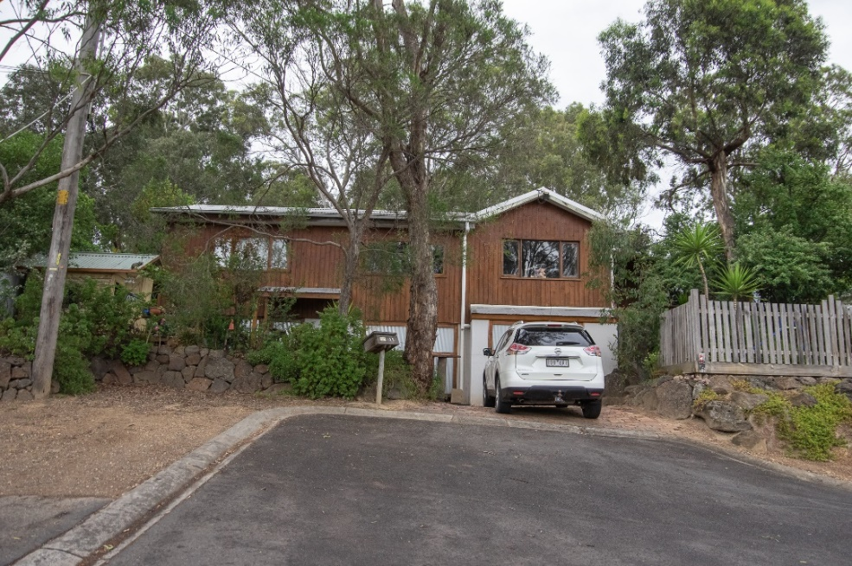
Figure 1. 42 Park West Road, Eltham. (Source: Context 2020)
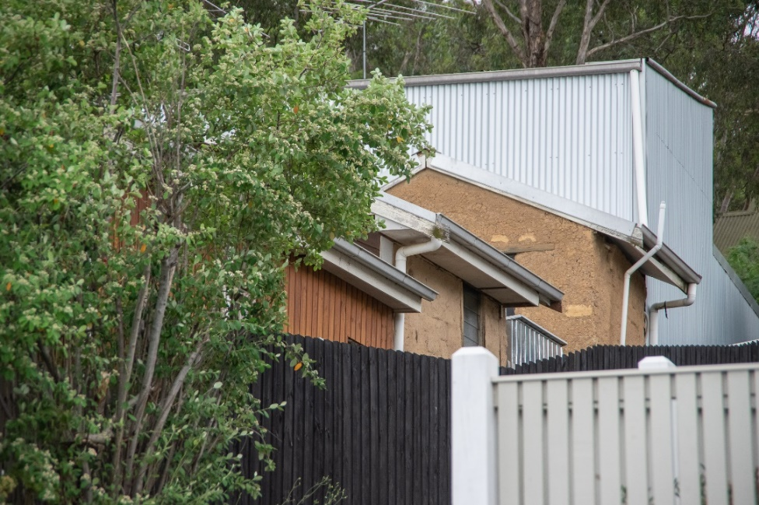
Figure 2. 42 Park West Road (front) and 1/44 Park West Road (rear), Eltham. (Source: Context 2020)

HISTORICAL CONTEXT
This place is associated with the following historic themes taken from the Nillumbik Shire Thematic Environmental History (2016):
6 BUILDING TOWNS AND SHAPING SUBURBS
6.4 Postwar growth and experimentation
At the end of World War II there was a severe housing shortage in Melbourne, which had been escalating since the Depression and was made worse by wartime conditions. Davison and Dingle describe how in Melbourne ‘thousands of families were living in sleepouts, boarding houses, garages and other makeshift dwellings’. It would be a decade before the worst of the shortage was overcome. (Mills & Westbrooke 2016:75)
The shortage in the city was exacerbated by the lack of readily available land on which to build. In the inner suburbs rental controls deterred owners from rebuilding at greater density. Most of the rest of the suburbs were built out, with some space available to fill up in the east in areas such as Kew, Studley Park and Ivanhoe. These conditions propelled a rush to the city fringe. The Nillumbik area provided an abundance of cheap blocks in thinly developed estates. (Mills & Westbrooke 2016:75)
The difficulty of providing new housing was increased by the scarcity of building materials resulting in very high prices. Some materials were still subject to government restrictions introduced during the war. Finally, there were insufficient builders to service the demand resulting in a great increase in owner building. By the early 1950s around 40 per cent of houses completed were constructed by owner-builders. The distribution in the Nillumbik area was probably in line with these figures. (Mills & Westbrooke 2016:75)
On the city fringe owner-builders often sought permission to put temporary housing such as old caravans on their land, rather than travel long distances to work on their houses. In the Nillumbik area the low density of development, the large bush-covered blocks originally intended for weekenders and the flexible rural council favoured this approach. The prewar weekenders were being replaced by a set of more permanent residents, including people working in the district, workers commuting to the city and retirees. (Mills & Westbrooke 2016:75-76)
The artistic and intellectual milieu that had existed since the nineteenth century drew a new generation of artists and thinkers. Philip Goad found that ‘… at Warrandyte and Eltham artists and intellectuals returned to the earth and savoured the bush’. Filmmaker Tim Burstall, who was among a number of newcomers who bought very cheap blocks at ‘The Hill’ around Napier Street in the Panorama estate, would describe the Eltham of the 1940s and 50s as ‘the socio-aesthetic centre of Melbourne’ and ‘a rural Bloomsbury’. At the same time, the same qualities of the Nillumbik area bushland, which had drawn generations of picnickers and weekenders now drew a new wave of settlers. (Mills & Westbrooke 2016:76)

- SHAPING CULTURAL AND CREATIVE LIFE
  - Achieving distinction in the arts
Artists, writers and intellectuals continued to be among those who were attracted to the area in the decades after the Second World War. At Warrandyte, potters began to outnumber painters. In 1958 five local potters, Phyl Dunn, Arthur Halpern, Gus McLaren, Reg Preston and Charles Wilton, along with John Hipwell, established a ‘Potters Cottage’ in Moonlight Cottage selling their wares and demonstrating their craft. Soon the Potters Cottage was moved to a new location south of the river, but other young potters continued to live and work in North Warrandyte. Similarly, Eltham continued to attract artists of all types. (Mills & Westbrooke 2016:116)
Two postwar artists attracted to the area, and concerned to protect and maintain its unique environmental characteristics, were Clifton Pugh, who built Dunmoochin at Cottles Bridge (HO8) in the 1950s and Neil Douglas, largely responsible for the Environmental Living Zone at the Bend of Islands in the 1970s. Pugh attracted a number of other artists to join him in an artists’ colony at Dunmoochin. Several of them also built mudbrick homes at Cottles Bridge. (Mills & Westbrooke 2016:116)
Pugh developed Dunmoochin into Dunmoochin Artist’s Community and it still provides artist residencies today. Among those who lived in the Cottles Bridge community were the artists Frank Werther (HO40), John Howley, John Olsen and Mirka Mora; potters Alma Shanahan (HO9), Peter and Helen Laycock (HO148) and Peter and Chris Wiseman, and the sculptor/engraver Kevin Nolan and his wife. The architect, Maurice Shaw, built a house close to Dunmoochin for Leon Saper (HO41), who became a successful potter. Other artists have lived in the Dunmoochin area since, including Rick Amor, Heja Chong (HO10) and Geoffrey Davidson. A number of important artists were friends of Clifton Pugh and frequent visitors to the property during the 1960s and 1970s. These include Fred Williams and Albert Tucker. Clifton Pugh’s home at Dunmoochin burned down in 2001 but early studio buildings and other original features remain. (Mills & Westbrooke 2016:117)
A new generation of artists in the Shire of Nillumbik upholds this strong artistic tradition. Montsalvat is still a centre for the arts. Dunmoochin continues to be a place for artists to work and live and maintains an artist-in-residence program. The tradition of artists opening their homes and studios to the public, which began in the 1960s, is maintained as part of the Nillumbik Shire Artists Open Studio program. (Mills & Westbrooke 2016:117)

LOCALITY HISTORY
Eltham, situated in hilly country northeast of Melbourne, is located on the country of the Wurundjeri-willam clan of the Woi wurrung, one of the five tribes of the Kulin Nation. A small, short-lived reservation south of Eltham on the Yarra River was set aside for Aboriginal people in 1852. The area is situated near the junction of the Yarra River and its tributary, Diamond Creek.
Pastoral settlers moved into the area from around 1840 and took up pastoral leases (Bartolomei 2008). It was located proximate to the track used by the Ryrie brothers to provide access between their ‘Yering’ run, near Yarra Glen, and the Heidelberg village (Victorian Places 2015). In 1841, William Bell and Thomas Armstrong occupied land for a squatting run east of Diamond Creek in what was to become the Eltham district (Eltham District Historical Society 2000: np).
A plan for 50 allotments in the Township of Eltham, Parish of Nillumbik, was announced in 1848, with the name officially gazetted in 1851. The township, near the junction of Diamond Creek and the Yarra River, was laid out in an area bounded by Baxter Street, Diamond Creek, Dalton Street and Bolton Street. The township plan shows that a track to a bridge across Diamond Creek and Main Road was noted as the ‘Track from Melbourne’ (Butler 1996:32). This area is known today as Eltham South.
Present-day Eltham, however, was not established on the township reserve, where land proved difficult to sell. Instead, the town grew from allotments in Section IV of the Parish of Nillumbik located on Main Road, to the north of Dalton Street and the township reserve (Butler 1996:32). In 1851, Melbourne property developer Josiah Holloway purchased one square mile (or 5120 acres) of this land, which he subdivided immediately, calling the subdivision Little Eltham. The central area of current-day Eltham is contained within the Little Eltham subdivision. A number of large farming properties around the township were purchased from the early 1850s (Nillumbik Parish Plan 1951).
Eltham township grew during the 1850s around a cluster of buildings at the corner of Pitt Street and Main Road within the Little Eltham subdivision. Located on the road to the Caledonia goldfields, this small township became a service centre for the surrounding mining areas, and by 1854 supported a population of 282. In this period Eltham had two hotels, a brewery, and a scattering of shops along Main Road (known in the 1850s as Maria Street). The town had a steam flour mill operated by Henry Dendy, and a tannery was located on the Diamond Creek. The Little Eltham School, opened by the Church of England, was built in 1853 near Swan Street and closed in 1872. A second school, a national school (later Eltham Common School No. 209) opened in Dalton Street in 1856. A Wesleyan chapel opened in 1858. Public buildings constructed at this time included a courthouse and a police station in Main Road in 1860. The ‘flat land’, which is now the Eltham Lower Park, near the Yarra, was used as a racecourse (Kellaway cited in Butler 1996:32-33; Eltham District Historical Society 2000:np). A cemetery was established in 1858. The township and wider area was administered by the Shire of Eltham, established in 1856.
Between the 1860s and the 1880s, Eltham supplied food and produce for the goldmining communities of the Caledonia goldfields at Queenstown (St Andrews) and Panton Hill. It also became a stopping place on the route to the Woods Point diggings. Eltham’s population grew in response (Victorian Places 2015).
A Primitive Methodist chapel was built in 1860. The following year St Margaret's Anglican Church, designed by the notable Melbourne architect Nathaniel Billing, was built. In 1881, a Wesleyan church was constructed by George Stebbing to the design of Melbourne architects Crouch and Wilson (Butler 1996:33). A new state school, constructed of local sandstone, opened in 1876.
Several large properties surrounding the township had absentee owners, who subdivided their properties into smaller farms either for lease or for sale. The smaller properties, especially in the Little Eltham township, were run by farmers who often made a modest living as wage labourers. Like many later Eltham residents, they were attracted by cheap land and the country life (Butler 1996:33).
In 1884 Eltham was described as:
… a pretty little township on the Yarra Flats road ... It has a population of nearly 400 inhabitants, but in addition it is the centre of a large district extending over 208 square miles, having a population of 2344. The land in the district is mostly used for grazing purposes, although as a rule the small farms grow a good deal of wheat, oats and other agricultural produce. A large quantity of fruit, especially raspberries and strawberries, is also produced (Illustrated Australian News, 20 December 1884, cited by Carlotta Kellaway in Butler 1996:33).
The Australian News noted that gold had been found in the vicinity of the township, ‘but not in remunerative quantities’ (cited by Carlotta Kellaway in Butler 1996:33).
In the 1880s agitation began for the extension of the railway line from Melbourne to Heidelberg to serve Eltham and districts further afield such as Kangaroo Ground. The railway station in Eltham opened in 1902, however the line was never extended to Kangaroo Ground. The railway brought excursionists from Melbourne, many of whom picked wattle during the flowering season, and focused development of the Eltham township around the railway station. Eltham was a picturesque village with the advantage of its proximity to metropolitan Melbourne and to attractive countryside with farms and uncleared stringybark forest (Victorian Places 2015). The bush scenery attracted artists, writers and nature-lovers.
In 1903 the Australian Handbook described Eltham as part of an orcharding and grazing district. In 1901, 4289 acres were under cultivation, of which 2506 acres were planted with orchards and market gardens. The township, with a population of 377, included a state school, a branch of the Commercial Bank, and Catholic, Anglican, Wesleyan Methodist and Primitive Methodist places of worship (cited in Victorian Places 2015). From 1909, rural properties were increasingly subdivided to create residential estates on the outskirts of the Eltham township (Mills & Westbrooke 2017:69).
The electrification of the railway line was extended to Eltham in 1923, eliminating the need to change to steam train at Heidelberg and allowing faster through-trains and shorter commuting times. The establishment of new residential estates in Eltham followed (Mills & Westbrooke 2017:71). Reflecting the town’s growth, a higher elementary school was opened in 1926 (Victorian Places 2015).
Eltham was described in 1940 as ‘residential, horticultural, dairying and grazing ... a beauty spot for artists and picnickers’. By this time, the town had three recreation reserves, swimming baths, tennis courts and a fire brigade (Victorian Places 2015).
Eltham has attracted a number of writers and artists over the years. The landscape painter Walter Withers (1854-1914) moved to Eltham in 1902 when the railway opened; other artists, including members of the Heidelberg School, painted in the area in the open air. Clara Southern and May Vale, landscape painters and students of Frederick McCubbin, settled in the region. Vale resided at Diamond Creek and Southern at Warrandyte (Bartolomei 2008). The war artist Will Longstaff also lived in Eltham for a period. From 1910, painter William ‘Jock’ Frater and cartoonist Percy Leason often camped and painted in the area. Artist Justus Jorgensen established the notable Montsalvat artists’ colony buildings, on land he purchased in 1934. Seeking a closer engagement with the natural environment, the establishment of Montsalvat, with its adobe and rammed earth buildings, influenced future mudbrick construction in the area. Several local designers, including Alistair Knox, specialised in mudbrick housing in the postwar period (Victorian Places 2015). Others who have been inspired by Eltham and have made the Nillumbik region their home include landscape architect Edna Walling; authors Alan Marshall and Carolyn Van Langenberg; artists Clifton Pugh and Danila Vassilieff; composers and musicians Graeme and Roger Bell; jewellers and sculptors Michael Wilson, Simon Icarus Baigent and Matcham Skipper; writer CB Christensen; poet Chris Wallace-Crabbe; and actor Kerry Armstrong (Bartolomei 2008; Pierce 1987:354).
Eltham experienced significant postwar development with a number of residential estates subdivided and put up for sale. The population of the town increased steadily as a result. In 1933, only 927 residents were recorded in the town in 1933; this had increased to 7177 residents in 1971. As a result, Eltham High School opened in 1950 and the Catholic Ladies College was relocated to Eltham in 1971 (Victorian Places 2015). The Eltham War Memorial Trust Baby Health Centre opened in 1951. New shire offices opened in 1965, and Eltham College commenced classes in 1974 (Eltham District Historical Society 2000:np).
A distinctive style in local building emerged in Eltham in the postwar period, with a strong use of natural materials, low form structures, and an integration with the natural environment. Houses were often sited in bush gardens, especially after the 1970s. This style was also adapted to community buildings in the area, with the Eltham Library being constructed in mudbrick and recycled timbers in 1994 (Eltham District Historical Society 2019).
The Shire of Eltham became part of the Shire of Nillumbik in 1994, with a small area becoming part of the City of Banyule.

PLACE HISTORY
The residence at 42 Park West Road is located on Crown Allotment 6, Section 10, Parish of Nillumbik, 146 acres purchased by J Frank in 1855 (Nillumbik Parish Plan 1951).
By 1924, the allotment had been subdivided, with Robert Woodcock owning 54 acres of the land (CT:V4871 F001). Under Woodcock’s ownership, the 54 acres were subdivided into a number of residential allotments and sold in the period 1925-29 (CT:V4871 F001).
Investor John Quinn purchased land on the subdivision in 1929, and undertook further subdivision, selling lots from 1929 to 1957 (CT:V5549 F724). Dorothy Kenderdine purchased Lot 73 (the subject land) and Lot 74 of this subdivision in 1948 (CT:V7159 F656).
Student Alan Martin from Reservoir subsequently purchased Lot 73, the subject site, in 1948. In 1963, the property was owned by dental mechanic Alan Albert Martin and his wife, Lesly Dorothy Martin (CT:V7196 F050).
In 1966, Alan and Lesly Martin of 42 Park Road, Eltham, purchased neighbouring Lot 74. By this year, Alan Martin was listed on the certificate of title as an artist and teacher (CT:V8054 F249). In 1976, the Martins amalgamated both lots under the one title (CT:V8054 F249).
According to information provided by Lesly Martin in 1992, the couple came to Eltham in 1946 and moved the first part of the subject house onto the current site in 1947, a room which eventually became the kitchen. This construction pre-dates Alan Martin’s ownership of the land in 1948. As finances became available, additions to the house, mostly timber, were built by the Martins in stages. These additions occurred in 1946-47; 1952; 1954; 1956 and 1977, with a painting studio built in 1964 and a pottery studio in 1971-72 (Bick and Kellaway 1992:1398-1402).
In 1972, Alan Martin advertised an exhibition of his early paintings at 42 Park Road, Eltham (Age 4 November 1972:16). Martin advertised other shows, ‘Paintings from Europe and Centre’ and ‘Week of Landscape Painting’, at the same address in 1978 (Age 12 August 1978:20). The site comprising the house, studio and pottery was shown on a 1978 aerial photograph (Figure 2).
Alan Martin lived at 42 Park West Road until his death in 1989, with Lesly Martin continuing to live at the property. The two blocks were subdivided into three lots in 2007, and addressed as 42, 1/44 and 2/44 Park West Road, Eltham (CT:V11031 F137).
Alan and Lesly Martin’s timber residence is located at 42 Park West Road and Alan Martin’s split level timber studio is located at 1/44 Park West Road. A small bungalow building at 2/44 Park West Road is believed to have been built by the Martins during their ownership to accommodate visiting artists and friends. This building was in evidence by 1978 (Figure 2).

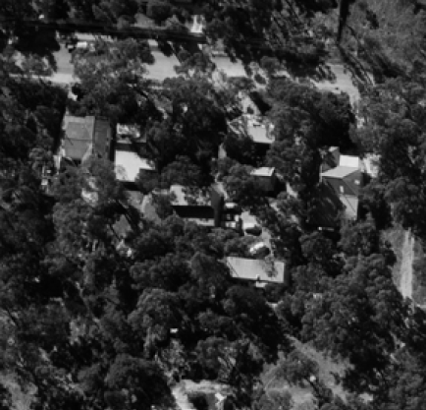
Figure 2. An aerial view of the site from 1978. The house is circled in red; the art studio in yellow and the since removed pottery studio in green. The rear bungalow building at 2/44 Park West Road is circled in blue. (Source: CPO, ‘DIAMOND CREEK (4/1978)’, 1978, via Landata)

Alan Martin, artist and owner c1948-1989
Alan Martin was born in Melbourne in 1923. Martin studied under Max Meldrum at the National Gallery School and at the Royal Melbourne Institute of Technology. He later established his own art school, the Alan Martin Painting School, with lessons held in Eltham at the subject property, and Kew. A painter in oils, he favoured landscapes, still life, and portraits, and was a finalist in the Art Gallery of New South Wales Archibald Prize in 1959. Martin won several prizes in provincial art shows and entered work in the prestigious Archibald Prize in 1962 (Furphy nd; AGNSW 2021). Martin was known to have found the Eltham district conducive to painting, and was one of the earliest artists to arrive in the immediate postwar period (Marshall 1971:123).
One of Martin’s students, Don James, in writing about Martin’s career recalled that Martin started as a student of painting with Meldrum in 1938 at the age of 15, remaining with him for the next 15 years. Meldrum told Martin that he needed to have a job to support his studies and early years, and arranged for Alan to work with John Heath, a Melbourne dentist, as a dental mechanic. This position not only enabled him to attend classes but also gave him the skills for one of his enduring sidelines, that of mould making and casting. Martin also studied design at the Working Men’s College (now RMIT University), and later with Sir William Dargie at the National Gallery School in Melbourne (James 2020).
In 1979, Martin was noted as being a ‘very busy teacher’ with a large number of pupils in his art classes, held in his studio at home (Marshall 1971:123). Don James, a painter who had been taught by Martin at the home studio, was later invited to teach classes in the same studio by Lesly Martin following Alan’s death (Montsalvat 2021).
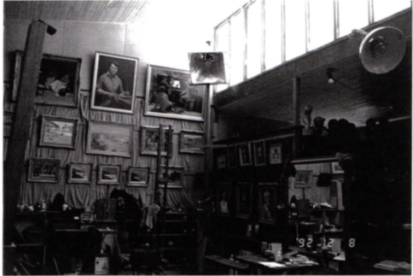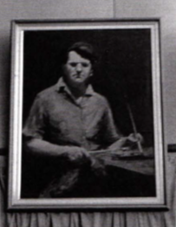
Figure 3. A view of the interior of the studio, built and used by Alan Martin. To the right is a closer image of Martin's self-portrait on the wall. (Source: Bick 1992)

DESCRIPTION
42 Park West Road, Eltham, is an elevated single storey timber house with corrugated iron gable roof built in stages between 1946 and 1977, with a painting studio built in 1964 (now at 1/44 Park West Road). The house sits on the south side of Park West Road, with the land falling towards the street.
Built over 30 years the house now consists of two connected L-shaped wings with the eastern wing sitting forward on the block. Both wings present a gable to the street at their western end, while a transverse gable runs east.
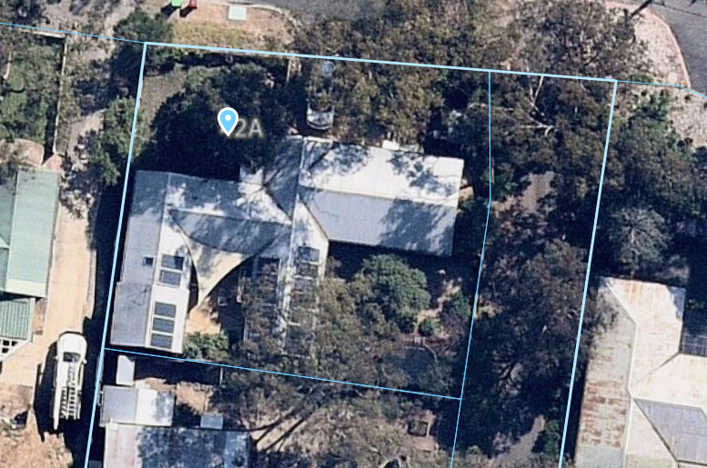
Figure 4. Aerial imagery of the site. (Source: Nearmap)

The upper walls of the house are clad with stained vertical timber boards while at street level the walls are clad in plywood sheets with timber framed corrugated iron doors. A small skillion roofed porch is located midway along the street facing elevation Widows across the front of the house at the upper level are timber framed with a large, fixed centre panes and awning sashes either side. An exception to this is the window in the street facing gable of the recessed wing which comprises a large picture window with three small overlights.
The rear section of the western wing of the main house is taller than the rest of the wing and is constructed of mudbrick. Behind this is a separate mudbrick building with gable roof that appears to abut Martin’s studio.
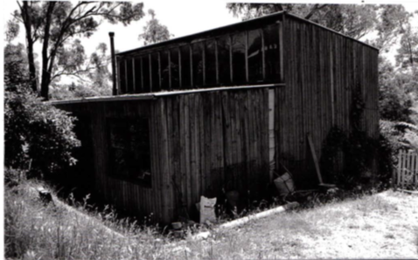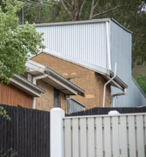
Figure 5. A c1992 image of the studio on the left, showing its original timber cladding. To the right is a current view of the studio, with new corrugated iron cladding. The small mudbrick room is visible in this image. (Source: Bick 1992; Context 2021)
The painting studio at 1/44 Park West Road is a simple square building, with corrugated iron skillion roofs. The northern half of the roof is raised significantly higher than the southern half, which allows for a large row of south-facing clerestory windows. The building has been recently re-clad in corrugated iron.
The pottery building that stood to the south of the house, visible in Figure 2, is not extant.

INTEGRITY
42 Park West Road, Eltham, is moderately intact with a some change visible to original or early significant fabric. The house retains its built form, evidencing the stages in which it was constructed between 1946 and 1977. Cladding on the house, including the vertical timber boards on the principal floor and corrugated metal on the lower portion, appears to have been recently installed.
The rear painting studio also retains its original built form and scale, with large south-facing clerestory windows. Earlier images indicate that this was clad in vertical timber boards, however it has been reclad in corrugated iron. The mudbrick portion, with gable roof, appears to be intact.
It appears that the pottery building was removed, likely following the subdivision of the site in 2006.
Overall, the site has moderate integrity.

COMPARATIVE ANALYSIS
The Nillumbik area has a longstanding association with artistic and intellectual communities, going back to the earliest years of the nineteenth century. The period following Second World War saw a new generation of artists and thinkers, who appreciated the natural surrounds of the area and the communities that had developed. Many newcomers were attracted by the cheap and readily available blocks that had gone unsold in the numerous subdivisions from the prewar and interwar periods. The area was later referred to as ‘the socio-aesthetic centre of Melbourne’ and ‘a rural Bloomsbury’, a reference to the famous group of intelligentsia, artists and philosophers in London (Knox 1980: 76).
The Alan Martin House and Studio at 42 and 1/44 Park Road West, Eltham are directly associated with Alan Martin, a local artist and art teacher who was part of the post-World War II artist community in Nillumbik. While not of the same profile as other more well-known local artists such as Clifton Pugh and Neil Douglas, Martin achieved some success, becoming a finalist in the Art Gallery of New South Wales Archibald Prize in 1959 and winning several prizes in provincial art shows. His career represents many aspects of the cultural lifestyle and artistic community for which Eltham was well known. Martin resided at the site from 1947 until his death in 1989. He is intrinsically linked to the fabric of the place, with the studio to the rear of the property purpose built for the artist in 1964. Martin’s achievements as an artist and teacher were centred on the studio in which he worked and taught. As his personal studio, the property is better than any other to demonstrate associations with Martin and as an example of the low-key artist-owned studios that were common in Eltham at the time.
Within the Shire of Nillumbik, several surviving places are on the Heritage Overlay for their historical (associative) significance in demonstrating their connection to artists, writers, and intellectuals that contributed to this important layer of Nillumbik’s development. The following places are comparable to the Alan Martin House and Studio, 42 and 1/44 Park West Road, Eltham, for their direct association with a person who contributed to the course of the Shire’s history of being associated with artists, writers, and intellectuals and for the tangible evidence the physical fabric of the place provides of this association and the achievements of the person.
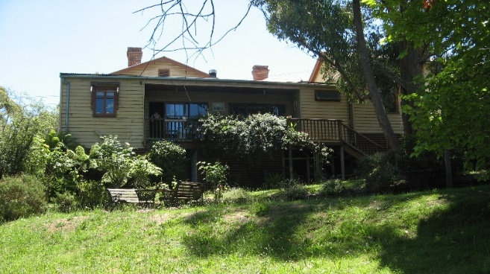  Southernwood, 250 Bolton Street, Eltham (VHR 2235, HO13). (Source: VHD) | Southernwood, Walter Wither’s house, was first built as a four-room cottage in 1891, and in 1903 it was purchased by the artist Walter Withers. The house is of historical significance as the home of the prominent Australian artist Walter Withers from 1903 until his death in 1914. As a member of the 'Heidelberg School' Withers was the first commercially successful painter to come and live in Eltham. Withers played a part in attracting other artists to the area and, thereby, in establishing Eltham's reputation as an artistic community (VHD).
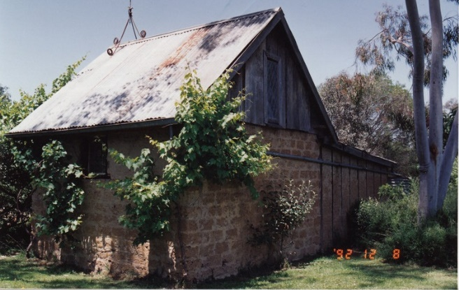  Peter Garner mudbrick studio and adjacent shed 62 Brougham street, Eltham (HO17). (Source: VHD) | The 1969 studio and shed are significant for its use of highly creative structures constructed in the ‘Eltham style’. The studio and shed were associated with Arthur Munday, Peter Garner, Lenore Garner and the Montsalvat artists' community more broadly (VHD).
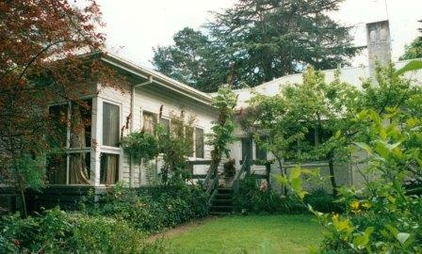  Stanhope Residence and Garden, 10 Peter street, Eltham (HO149). (Source: VHD) | The c1910 residence is historically significant for its connection with Will Longstaff, the official war artist, Bishop Reginald Stephen (warden of Trinity college in the 1930s) and with the prominent journalist turned builder, John Harcourt, who rented the residence while he and his partner were building their adobe home in the 1940s.  During the 1940s the residence was also connected with the important literary figures, Clem, and Nina Christesen (Clem was the founding editor of the influential Meanjin Quarterly). When owned by the Christesens the residence was visited by a number of distinguished writers, artists, and academics, including the Nobel Prize winner, Patrick White, and the world-famous cellist Mstislav Rostropovich (VHD).
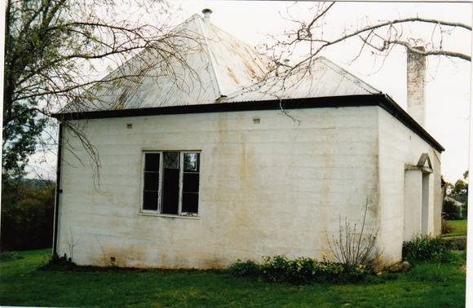  Landscape, 60 Lavender Park Road, Eltham (HO113). (Source: VHD) | The 1926 residence and rear concrete studio are significant because they are connected with the artist, cartoonist and anthropologist, Percy Lesson. During Lesson's occupation (1926-1938) the property became a centre for visiting artists, including Max Meldrum, Justus Jorgensen, Clarice Beckett, ‘Jock’ Frater and Richard McCann (VHD).
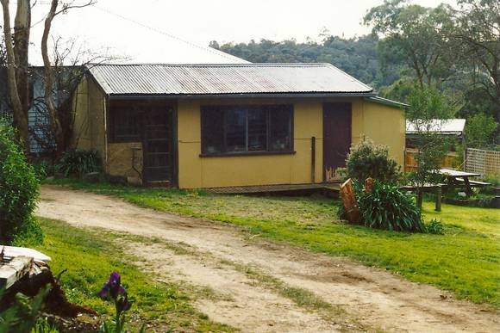  Alan Marshall Bungalow, 13 Park West Road, Eltham (HO147). (Source: VHD) | The 1955 bungalow is significant for its connection with Alan Marshall, a noted author, storyteller and social documenter. While living and working at the bungalow between 1955 to 1972, several of Marshall’s important publications were ‘wholly written’ within its walls. These include his trilogy of fictionalised autobiographies, several collections of highly popular short stories and humorous sketches as well as well as commissioned histories (including the history of Eltham itself). The bungalow was visited by many other famous Australian authors during Marshall’s residence (VHD).

Discussion
The house and studio at 42 and 1/44 Park West Road, Eltham, are directly associated with Alan Martin, a local artist and art instructor in the Nillumbik area. Martin resided and worked at the site from 1946 until his death in 1989. The association of Martin to the fabric of the place is provided through evidence that shows the house and studio were built during the ownership of the Martins for their own use. The site served as Alan Martin’s home and workplace from which he both worked as an artist and instructed art classes.
The Alan Martin House and Studio at 42 and 1/44 Park West Road, Eltham compares favourably against the above Individually Significant places for its demonstrated association with the life or works of a person of importance to the Shire of Nillumbik. The earlier examples such as Southernwood (VHR 2235, HO13) and Landscape (HO113) evidence Nillumbik’s association with artists of earlier generations, who first attracted their peers to the area. The subject site is particularly comparable to the Peter Garner mudbrick studio (HO17) and Alan Marshall Bungalow (HO147) as examples contemporaneous to the subject site, which represent a later generation of artists and intellectuals who were attracted to the area and established their studios in the immediate postwar period. Despite its continued association with a number of important figures, Stanhope Residence and Garden (HO149) provides less direct comparison, as the house retains intact c1910 fabric and thus the associations are less directly legible from the fabric.
Much like many similar artists’ houses in the area, the subject house and studio were constructed in stages as needs arose and finances became available, using simple building forms and materials. In this way the house and studio are significant for their contribution to the ongoing understanding of the history of the Shire of Nillumbik and particularly Eltham as a centre for artists, writers, and intellectuals.
While living and working at the house (and later the studio) between 1946 and his death in 1989, Alan Martin produced much of his artwork as well as holding open days and painting classes for the public. The use of the site for the instruction of art classes contributes directly to the general understanding of the site as being associated with the artist for many. The site is Martin’s only known place of residence in the municipality between 1946 and his death in 1989 and the house and studio have more strong connection with him than most other places with a connection to Alan Martin in the Shire of Nillumbik.

STATEMENT OF SIGNIFICANCE

WHAT IS SIGNIFICANT?
The Alan Martin House and Studio at 42 and 1/44 Park West Road, Eltham, consisting of a house and artist’s studio, built in stages between 1946 and 1977 (with painting studio dating to 1964) for the owners Alan and Lesly Martin, is significant.
Elements that contribute to the significance of the place include:
- the form and scale of the house, which shows the incremental nature in which it was built; and
- the form of the artist’s studio, including the large south-facing clerestory windows.

HOW IS IT SIGNIFICANT?
The Alan Martin House and Studio at 42 and 1/44 Park West Road, Eltham, is of local historic and associative significance to the Shire of Nillumbik.

WHY IS IT SIGNIFICANT?
The Alan Martin House and Studio at 42 and 1/44 Park West Road are historically significant as examples of the artistic lifestyle that the area became known for in the postwar period. Much like similar artists houses in the area, the house and studio were constructed in stages as needs arose and finances became available, using simple building forms and materials including mudbrick, vertical timber boards and corrugated iron. In this way, the house and studio are significant for their contribution to the ongoing understanding of the history of the Shire of Nillumbik and particularly Eltham as a centre for artists, writers, and intellectuals. The Alan Martin house was associated with the life and works of the artist Alan Martin. The house and studios were built by Alan Martin and his wife Lesly, to serve especially as their own home and workspaces. Alan Martin also used the site as a place to instruct art classes, directly informing the association of the place with the artist for many. (Criterion A and H)

RECOMMENDATIONS
Recommended for inclusion in the Schedule to the Heritage Overlay of the Nillumbik Planning Scheme as an Individually Significant place.
Extent of overlay: To title boundaries
Recommendations for the Schedule to the Heritage Overlay (Clause 43.01) in the Nillumbik Planning Scheme:

NIllumbik Planning Scheme
External paint controls | No
Internal alteration controls | No
Tree controls | No
Outbuildings or fences | Yes - Studio
To be included on the Victorian Heritage Register | No
Prohibited uses may be permitted | No
Aboriginal heritage place | No

Other
N/A

REFERENCES
Age, as cited.
Argus, as cited.
Art Gallery New South Wales (AGNSW) 2021, Archibald Prize 1962, https://www.artgallery.nsw.gov.au/, accessed online 3 May 2021.
Bartolomei, Deborah 2008, ‘Eltham’, eMelbourne, School of Historical and Philosophical Studies, The University of Melbourne, https://www.emelbourne.net.au/biogs/EM00516b.htm.
Bick, David, and Kellaway, Carlotta 1992, ‘Shire of Eltham Heritage Study’, Prepared for the Shire of Eltham.
Built Heritage Pty Ltd 2010. ‘Survey of Post-War Built Heritage in Victoria: Stage 2’. Prepared for Heritage Victoria.
Butler, Graeme, and Associates 1996, ‘Nillumbik Shire Heritage Review - Environmental History’, Prepared for the Shire of Nillumbik.
Central Plan Office (CPO), Historic Aerial Photography: 1930s to 1990s, as cited, via Landata, https://www.landata.vic.gov.au/, accessed online March-April 2021.
Eltham District Historical Society 2000, A Chronology of Known Local Events 1835-early 2000 including those in the Shire of Nillumbik and the former shires of Eltham and Diamond Valley, Eltham District Historical Society Incorporated.
Eltham District Historical Society 2019, ‘OTD: Opening of the new Eltham Library, 22 May 1994’, www.elthamhistory.org.au.
Furphy nd, Joseph, Australian and New Zealand Art Sales Digest, https://www.aasd.com.au/artist/12686-alan-albert-martin/, accessed 13 April 2021.
Gowrie Victoria 2019, Our History, www.gowrievictoria.com.au.
James, Don 2020, ‘Blog Archive’, Don James Oil Painter and Teacher, https://donjamesart.com/blog-archive/, accessed 13 April 2021.
Knox, Alistair. 1980. We Are What We Stand On: A Personal History of the Eltham Community. Eltham: Adobe Press.
Land Victoria, Certificates of Title (CT), as cited.
Marshall, Alan 1971. ‘Pioneers & Painters: One Hundred Years of Eltham and its Shire’. Thomas Nelson Australia Pty Ltd, Melbourne.
Mills, Peter and Westbrooke, Samantha 2010, ‘War Memorial Building Complex, 903-907 Main Road, Eltham, Cultural Heritage Significance Assessment’, prepared for Nillumbik Shire Council.
Mills, Peter and Westbrooke, Samantha 2017, ‘Nillumbik Shire Thematic Environmental History - Revision 2016’, prepared for Nillumbik Shire Council.
Montsalvat 2021, Exhibition Trio: Angela Abbott, Don James and Adam Frith, www.montsalvat.com.au/, accessed online 3 May 2021.
Nillumbik Parish Plan 1951, Department of Lands and Survey, Melbourne.
Pierce, Peter (ed.) 1987, The Literary Guide to Australia, Oxford University Press, Melbourne.
Victorian Heritage Database (VHD), https://vhd.heritagecouncil.vic.gov.au/, accessed online April-May 2021.
Victorian Places 2015, ‘Christmas Hills’, Monash University and The University of Queensland, https://www.victorianplaces.com.au/.
Victorian Year Book 1973. Government Printer, Melbourne.
Yeoman, Russell, Pinn, Richards, and Connor, Jim 2020, Sign of the Times: Eltham street names with history, Eltham District Historical Society, www.elthamhistory.org.au.

