61 York Street, Eltham

Macmahon Ball House and Study
Prepared by: Context | Survey date: April 2021
Place type: Residential | Designer: Alistair Knox (1948 mudbrick study and 1959 extension), John Harcourt (c1948 pise house)
Significance level: Significant | Builder: Alistair Knox, Sonia Skipper, Peter Glass
Extent of overlay: To title boundaries | Major construction: 1948 (mudbrick study), c1948 (pise house), 1950 (pottery studio) 1959 (extension)
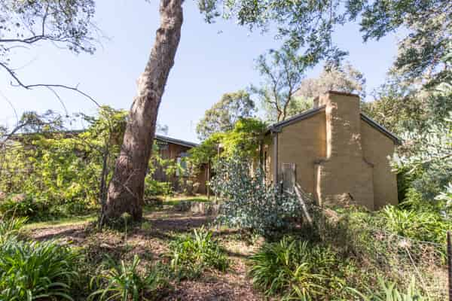
Figure 1. 61 York Street, Eltham. (Source: T Knox nd, Alistair Knox Foundation)
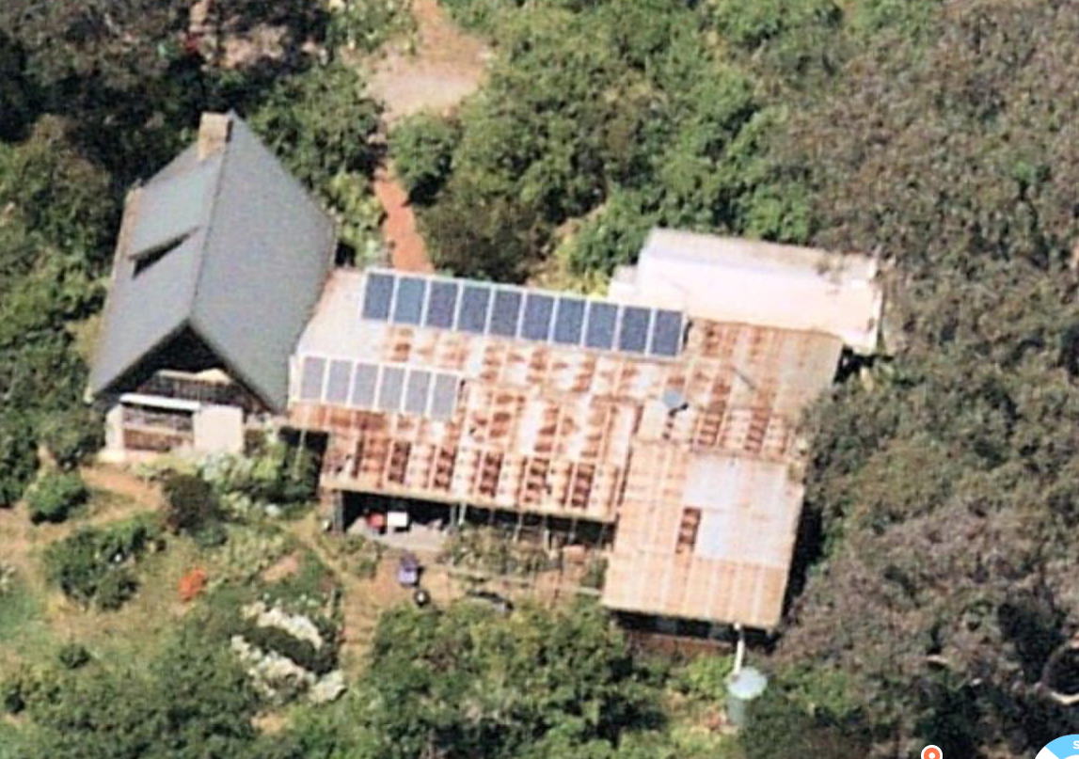
Figure 2. 61 York Street, Eltham (viewed from North). (Source: Nearmap 2020)

HISTORICAL CONTEXT
This place is associated with the following historic themes taken from the Nillumbik Shire Thematic Environmental History (2016):
6 BUILDING TOWNS AND SHAPING SUBURBS
6.4 Postwar growth and experimentation
Paralleling the activity of the Modernist architects, another more prolific experiment in residential building was germinating in the Eltham-Warrandyte area. The trend was characterised by an acceptance of the characteristics of the site, including the local bush, topography and geology and an attempt to blend and adapt to these conditions through building form and siting, choice of materials and landscape approach. The best-known spokesperson for this trend, Alistair Knox, gave it the label ‘Australian environmental building’. (Mills & Westbrooke 2016:78)
Externally the Warrandyte Rustic or Australian Environmental Building style was distinguished by use of a palette of honest natural materials including earth in the form of pisé and mud brick, local stone, expressed structural timber, vertical varnished boards for cladding and corrugated iron, slate or shingle roofs. Recycled materials including timber and brick were also popular. Of all these materials earth and especially mud brick, would become the most ubiquitous in the Nillumbik area. The materials for mud brick were free and usually available on the owner’s property. Mud brick building was better suited to the large semi-rural house sites common in the area, which had ample space for drying bricks and for using farm machinery to help in making and moving them. Owner-builders generally had great difficulty getting home loans in the early postwar period and use of labour-intensive mud brick as a major component could compensate for lack of capital. There was also an ideological and aesthetic element in the choice of this material that appealed to the increasing population of artists and academics who were drawn to the area. ‘Amongst the artistic and literary community in the bush, the participatory hands-on nature of mud brick construction evoked the noble ideals of the Arts and Crafts movement.’ (Mills & Westbrooke 2016:78)
From the early 1940s John Harcourt, who had settled in Eltham in the 1930s, constructed a number of residences in the area in pisé and mud brick. In 1941 his wife was the main driving force in building a mud brick house on the banks of Diamond Creek. Material for the mud bricks came from the excavation of the hillside for footings and the reinforcing straw also came from the property. This may have been the beginnings of the two-storey house Clay Nuneham in Stanhope Street, Eltham (completed around 1950) (HO165). The Harcourts held large New Year’s Eve parties in this house in the 1940s and 50s. (Mills & Westbrooke 2016:79)
Harcourt also sold a number of pisé or mud brick house-and-land packages on land he had purchased and possibly also re-subdivided, in the interwar Handfield’s subdivision in Eltham (also known as The Hill). The pisé Langi Dorn (HO55), the stone, brick and slate roofed Florrie’s Cottage (HO37) and the mud brick Rocknall (HO36) may be part of this group. Miles Lewis suggests there were at least eight pisé or mud brick houses by Harcourt in the locale and describes the style as ‘English cottage character’. Harcourt left the area in the 1950s. (Mills & Westbrooke 2016:79)
Sympathetic treatment by the shire council was another vital element in the rise of earth building. Justus Jorgensen and John Harcourt dealt with a shire secretary who approved building applications without consulting council, provided the plans ‘complied with general building regulations’ (Cuffley 1993, p. 130). When Knox started his first house the council was starting to review such applications. It was opportune that at this time GF Middleton of the Commonwealth Experimental Building Station had just published a pamphlet titled ‘Earth Wall Construction’, which Knox was able to distribute to councillors before they considered his permit. Subsequently, Knox observed, the shire adopted ‘a practical commonsense approach to the innovative building proposals’. In 1947 owner-builder in pisé Vyvyan Williams thought himself ‘fortunate in choosing a site in the Eltham Shire, considering the attitude to earth building of some municipal councils.’ (Mills & Westbrooke 2016:79)
Alistair Knox was the most prolific of the mud brick designers and builders in the district. He was inspired by his visits to Montsalvat in the early 1940s and, after the war, he studied building at the Melbourne Technical College. Knox’s early work in Eltham falls into two main categories: simple rectilinear forms, which were the basis for most of his work up to the 1970s, and a first flush of complex exploratory designs. (Mills & Westbrooke 2016:79)
Knox’s first commission in the area, the English house in Godalmin Street, Eltham (1947) was a simple rectangle in plan with a skillion roof supported on long yellow box pole beams. He was assisted by Sonia Skipper, an experienced mud builder from Montsalvat, who worked on a number of Knox’s buildings. Subsequent projects increasingly explored the potential of the plasticity and flexibility of mud brick. Knox started three houses in 1948. The McMahon Ball [sic] studio was very simple in form and was the first time he used a reinforced concrete slab base, a practice that would become standard for most of his mud brick buildings. Both the Busst house in Eltham (HO162) and the Holmes house (Periwinkle house) (HO11) were more exotic designs, featuring extensive curved walls in mud brick. On the Dowling/La Gallienne house in Yarra Braes Road (HO172), started in 1949, the owners persuaded Knox to return to a simpler gabled rectangular form for their weekender. He later labelled this use of simple forms as ‘the key of all that was to take place during the succeeding years.’ (Mills & Westbrooke 2016:79)
The Lim Joon house (HO119) (started 1950) in Main Road Eltham was a small single-roomed polygonal dwelling with brick walls. The floor-to-ceiling windows were an advanced architectural feature for this time. On the McClennan house in Ryans Road Eltham (1951), Knox returned to the use of curved mud brick walls, with an imposing two-storey half drum on one corner. The next two stages of the Dowling/La Gallienne house were also adventurous with complex geometry and impressive rooflines. Subsequently, as the price of labour rose, mud brick made sense only for the owner-builder and most of Knox’s building commissions would be in more conventional materials, albeit often recycled. (Mills & Westbrooke 2016:80)
Alistair Knox was also a very effective spokesperson for the mud brick pioneers. His promotion of the principles of environmental building in a variety of publications would have a lasting influence on perceptions of the Eltham area. Mud brick and Australian environmental building became an integral part of the regional identity. Knox’s writings would also ensure that the movement would have a far greater impact Australia-wide than the number of completed houses would indicate. (Mills & Westbrooke 2016:80)

LOCALITY HISTORY
Eltham, situated in hilly country northeast of Melbourne, is located on the country of the Wurundjeri-willam clan of the Woi wurrung, one of the five tribes of the Kulin Nation. A small, short-lived reservation south of Eltham on the Yarra River was set aside for Aboriginal people in 1852. The area is situated near the junction of the Yarra River and its tributary, Diamond Creek.
Pastoral settlers moved into the area from around 1840 and took up pastoral leases (Bartolomei 2008). It was located proximate to the track used by the Ryrie brothers to provide access between their ‘Yering’ run, near Yarra Glen, and the Heidelberg village (Victorian Places 2015). In 1841, William Bell and Thomas Armstrong occupied land for a squatting run east of Diamond Creek in what was to become the Eltham district (Eltham District Historical Society 2000: np).
A plan for 50 allotments in the Township of Eltham, Parish of Nillumbik, was announced in 1848, with the name officially gazetted in 1851. The township, near the junction of Diamond Creek and the Yarra River, was laid out in an area bounded by Baxter Street, Diamond Creek, Dalton Street and Bolton Street. The township plan shows that a track to a bridge across Diamond Creek and Main Road was noted as the ‘Track from Melbourne’ (Butler 1996:32). This area is known today as Eltham South.
Present-day Eltham, however, was not established on the township reserve, where land proved difficult to sell. Instead, the town grew from allotments in Section IV of the Parish of Nillumbik located on Main Road, to the north of Dalton Street and the township reserve (Butler 1996:32). In 1851, Melbourne property developer Josiah Holloway purchased one square mile (or 5120 acres) of this land, which he subdivided immediately, calling the subdivision Little Eltham. The central area of current-day Eltham is contained within the Little Eltham subdivision. A number of large farming properties around the township were purchased from the early 1850s (Nillumbik Parish Plan 1951).
Eltham township grew during the 1850s around a cluster of buildings at the corner of Pitt Street and Main Road within the Little Eltham subdivision. Located on the road to the Caledonia goldfields, this small township became a service centre for the surrounding mining areas, and by 1854 supported a population of 282. In this period Eltham had two hotels, a brewery, and a scattering of shops along Main Road (known in the 1850s as Maria Street). The town had a steam flour mill operated by Henry Dendy, and a tannery was located on the Diamond Creek. The Little Eltham School, opened by the Church of England, was built in 1853 near Swan Street and closed in 1872. A second school, a national school (later Eltham Common School No. 209) opened in Dalton Street in 1856. A Wesleyan chapel opened in 1858. Public buildings constructed at this time included a courthouse and a police station in Main Road in 1860. The ‘flat land’, which is now the Eltham Lower Park, near the Yarra, was used as a racecourse (Kellaway cited in Butler 1996:32-33; Eltham District Historical Society 2000:np). A cemetery was established in 1858. The township and wider area was administered by the Shire of Eltham, established in 1856.
Between the 1860s and the 1880s, Eltham supplied food and produce for the goldmining communities of the Caledonia goldfields at Queenstown (St Andrews) and Panton Hill. It also became a stopping place on the route to the Woods Point diggings. Eltham’s population grew in response (Victorian Places 2015).
A Primitive Methodist chapel was built in 1860. The following year St Margaret's Anglican Church, designed by the notable Melbourne architect Nathaniel Billing, was built. In 1881, a Wesleyan church was constructed by George Stebbing to the design of Melbourne architects Crouch and Wilson (Butler 1996:33). A new state school, constructed of local sandstone, opened in 1876.
Several large properties surrounding the township had absentee owners, who subdivided their properties into smaller farms either for lease or for sale. The smaller properties, especially in the Little Eltham township, were run by farmers who often made a modest living as wage labourers. Like many later Eltham residents, they were attracted by cheap land and the country life (Butler 1996:33).
In 1884 Eltham was described as:
… a pretty little township on the Yarra Flats road ... It has a population of nearly 400 inhabitants, but in addition it is the centre of a large district extending over 208 square miles, having a population of 2344. The land in the district is mostly used for grazing purposes, although as a rule the small farms grow a good deal of wheat, oats and other agricultural produce. A large quantity of fruit, especially raspberries and strawberries, is also produced (Illustrated Australian News 20 December 1884, cited by Carlotta Kellaway in Butler 1996:33).
The Australian News noted that gold had been found in the vicinity of the township, ‘but not in remunerative quantities’ (cited by Carlotta Kellaway in Butler 1996:33).
In the 1880s agitation began for the extension of the railway line from Melbourne to Heidelberg to serve Eltham and districts further afield such as Kangaroo Ground. The railway station in Eltham opened in 1902, however the line was never extended to Kangaroo Ground. The railway brought excursionists from Melbourne, many of whom picked wattle during the flowering season, and focused development of the Eltham township around the railway station. Eltham was a picturesque village with the advantage of its proximity to metropolitan Melbourne and to attractive countryside with farms and uncleared stringybark forest (Victorian Places 2015). The bush scenery attracted artists, writers and nature-lovers.
In 1903 the Australian Handbook described Eltham as part of an orcharding and grazing district. In 1901, 4289 acres were under cultivation, of which 2506 acres were planted with orchards and market gardens. The township, with a population of 377, included a state school, a branch of the Commercial Bank, and Catholic, Anglican, Wesleyan Methodist and Primitive Methodist places of worship (cited in Victorian Places 2015). From 1909, rural properties were increasingly subdivided to create residential estates on the outskirts of the Eltham township (Mills & Westbrooke 2017:69).
The electrification of the railway line was extended to Eltham in 1923, eliminating the need to change to steam train at Heidelberg and allowing faster through-trains and shorter commuting times. The establishment of new residential estates in Eltham followed (Mills & Westbrooke 2017:71). Reflecting the town’s growth, a higher elementary school was opened in 1926 (Victorian Places 2015).
Eltham was described in 1940 as ‘residential, horticultural, dairying and grazing ... a beauty spot for artists and picnickers’. By this time, the town had three recreation reserves, swimming baths, tennis courts and a fire brigade (Victorian Places 2015).
Eltham has attracted a number of writers and artists over the years. The landscape painter Walter Withers (1854-1914) moved to Eltham in 1902 when the railway opened; other artists, including members of the Heidelberg School, painted in the area in the open air. Clara Southern and May Vale, landscape painters and students of Frederick McCubbin, settled in the region. Vale resided at Diamond Creek and Southern at Warrandyte (Bartolomei 2008). The war artist Will Longstaff also lived in Eltham for a period. From 1910, painter William ‘Jock’ Frater and cartoonist Percy Leason often camped and painted in the area. Artist Justus Jorgensen established the notable Montsalvat artists’ colony buildings, on land he purchased in 1934. Seeking a closer engagement with the natural environment, the establishment of Montsalvat, with its adobe and rammed earth buildings, influenced future mudbrick construction in the area. Several local designers, including Alistair Knox, specialised in mudbrick housing in the postwar period (Victorian Places 2015). Others who have been inspired by Eltham and have made the Nillumbik region their home include landscape architect Edna Walling; authors Alan Marshall and Carolyn Van Langenberg; artists Clifton Pugh and Danila Vassilieff; composers and musicians Graeme and Roger Bell; jewellers and sculptors Michael Wilson, Simon Icarus Baigent and Matcham Skipper; writer CB Christensen; poet Chris Wallace-Crabbe; and actor Kerry Armstrong (Bartolomei 2008; Pierce 1987:354).
Eltham experienced significant postwar development with a number of residential estates subdivided and put up for sale. The population of the town increased steadily as a result. In 1933, only 927 residents were recorded in the town in 1933; this had increased to 7177 residents in 1971. As a result, Eltham High School opened in 1950 and the Catholic Ladies College was relocated to Eltham in 1971 (Victorian Places 2015). The Eltham War Memorial Trust Baby Health Centre opened in 1951. New shire offices opened in 1965, and Eltham College commenced classes in 1974 (Eltham District Historical Society 2000:np).
A distinctive style in local building emerged in Eltham in the postwar period, with a strong use of natural materials, low form structures, and an integration with the natural environment. Houses were often sited in bush gardens, especially after the 1970s. This style was also adapted to community buildings in the area, with the Eltham Library being constructed in mudbrick and recycled timbers in 1994 (Eltham District Historical Society 2019).
The Shire of Eltham became part of the Shire of Nillumbik in 1994, with a small area becoming part of the City of Banyule.

PLACE HISTORY
The complex of buildings at 61 York Street was built for William Macmahon (Mac) Ball, who, with his wife Katrine (Kay) and daughter Jenny, came to Eltham from Kew in 1942. In 1945 the Ball family moved into an 1890s timber cottage on 18 acres (7.28 hectares) at the eastern end of York Street. The land was part of Crown Allotment 12, Section 4, Parish of Nillumbik, sold to J M Hollow in the early 1850s. Hollow named Crown Allotment 12 'Little Eltham South' and subdivided the land into smaller residential allotments (‘Plan of Little Eltham South’ c1850s). York Street became part of the town grid from this time.
The extant complex of buildings was supervised and partially constructed by Sonia Skipper to a design by Alistair Knox, with assistance from Tony Jackson, Jack McCarthy, and Gordon Ford. A separate mudbrick study for Mac was built on the site in 1948 (Figure 3, Figure 4 and Figure 5) (Alistair Knox, Building With Mud Bricks:np; and Alistair Knox, We Are What We Stand On:np in Alistair Knox Foundation).
The study was the second of Knox’s mudbrick designs and the first in Eltham (the other being a house for Frank English at 47 Phillip Street, Lower Plenty (City of Banyule) in 1947). It was a simple rectangular building with few windows as wall space was needed to store books. Like Knox’s earlier residence for Frank English, it used a brick that was 12" x 9" x 6" (300mm x 225mm x 150mm) laid in a stretcher bond exposing the 12" x 6" on both sides (Alistair Knox, We Are What We Stand On:np in Alistair Knox Foundation).
In his article We Are What We Stand On Knox fondly reminisces on the experience of constructing the study with Tony Jackson and Gordon Ford. He also describes ‘The Pottery’, a studio built for Ball’s wife Katrine, designed by Peter Glass:
The second construction I undertook was a study for Professor Macmahon Ball. William Macmahon Ball has been a political scientist of considerable international repute for many years. We built his studio around the time he was Australia's delegate in the Japanese peace negotiations. Our small community drew a quiet sense of reflected glory from him as if we felt we were involved in the negotiations ourselves. It was a pleasant simple construction and both 'Mac' and Katrine encouraged earth building. Peter Glass at about this time built a beautiful earth building for Katrine called 'The Pottery'. He tells an interesting story about it. One of the main walls was not as straight as it could have been and he kept trying to doctor it up, but nothing he did made it agreeable to his accurate artistic eye. One day in a combined fit of despair, rage and conscience he lost his usual gentlemanly calm and rushed in and pushed it all over and started again.
Tony Jackson, a dynamic eccentric, worked with Gordon Ford on the Macmahon Ball Studio. Many hilarious activities took place during the course of its construction. The bricks were made by digging a pit about a foot deep and partly filling it with water. The dam walls were continually widened as the edges were broken back into the water and pugged as it was walked on by the digger moving forward. It was a hard primitive system because the mixing was all done manually and the mixture had to be lifted up to get it out of the hole. Brickmaking has always been a contract deal, which tends to produce a frenetic tinge into otherwise logical people. They are always beset by the decision as to when a brick is a brick and not just a heap of mud. In addition, they are also pursued by the possibility of rain destroying them when in a half-dry condition. If it wasn't too much rain, it could be too little water.
The shortage of water was another hazard. Eltham had a most inadequate water supply, that always failed on the high sides of the central amphitheatre on the hot summer days. The taps were left on full overnight to try and fill the brick-making dams, but the flow was so slow that there would often be only a few inches in the bottom in the morning. Work would begin early before the heat became-too intense and at any time from about 9 a.m. onwards, voices could be heard from the highest point of the hill calling out, 'The water's off'. Once this happened it nearly always stayed off until after dark, unless a cool change came during the day and the taps that always flowed in the valley were turned off.
The 1950 pottery building (Figure 5) may have been constructed on the southern portion of 61 York Street (also known as 61A), to the south of the driveway. As access to the site was not available for the purposes of this assessment further research regarding the current status of the 1950 pottery studio is likely to be required.
Figure 3. The interior of William Macmahon Ball’s study, built in 1948. (Source: Alistair Knox, Building With Mud Bricks:np in Alistair Knox Foundation)
Figure 4. The Macmahon Ball study, built in 1948. (Source: Alistair Knox, Building With Mud Bricks:np in Alistair Knox Foundation)
In the late 1940s (likely c1948), Ball commissioned designer-builder John Harcourt, to build a pise addition to the existing 1890s house on the site. Harcourt had been active as a builder in the area and had built his own house in Eltham in 1941. The addition comprised two bedrooms (one an attic bedroom), shower, toilet, and fireplace and chimney of local sandstone (Marshall 2008:140; Alistair Knox Foundation; Argus 18 January 1941:9).
In 1959, Ball had the 1890s cottage demolished replacing it with an extension that abutted Harcourt’s pise section of the house (Figure 6 and Figure 7). The extension was built to an Alistair Knox plan titled ‘MCMAHON BALL REBUILDING PROJECT’ (Figure 8 and Figure 9). (Alistair Knox Foundation).
Over the successive years, Ball subdivided the original land parcel in York Street. By the time of his death in 1986 the parcel of land that today is addressed as 61 (59-71) York Street was left to his daughter Jennifer (Jenny) and her children Michael, Bronwyn and David. It is believed that the subject property is still owned by Ball’s family members (CT:V9796 F805; CT:V10126 F922).
The subject complex at 61 York Street today retains private residential use (Figure 10 and Figure 11). It is believed that ‘The Pottery’ was converted to a dwelling with a two-storey addition by 2002 (BP 02/2254) (Figure 12). As a site visit was not possible at the time of assessment, this will require further research to confirm.

Figure 5. The interior of Katrine Ball’s studio, The Pottery, built in 1950. (Source: Alistair Knox, We Are What We Stand On:np in Alistair Knox Foundation)
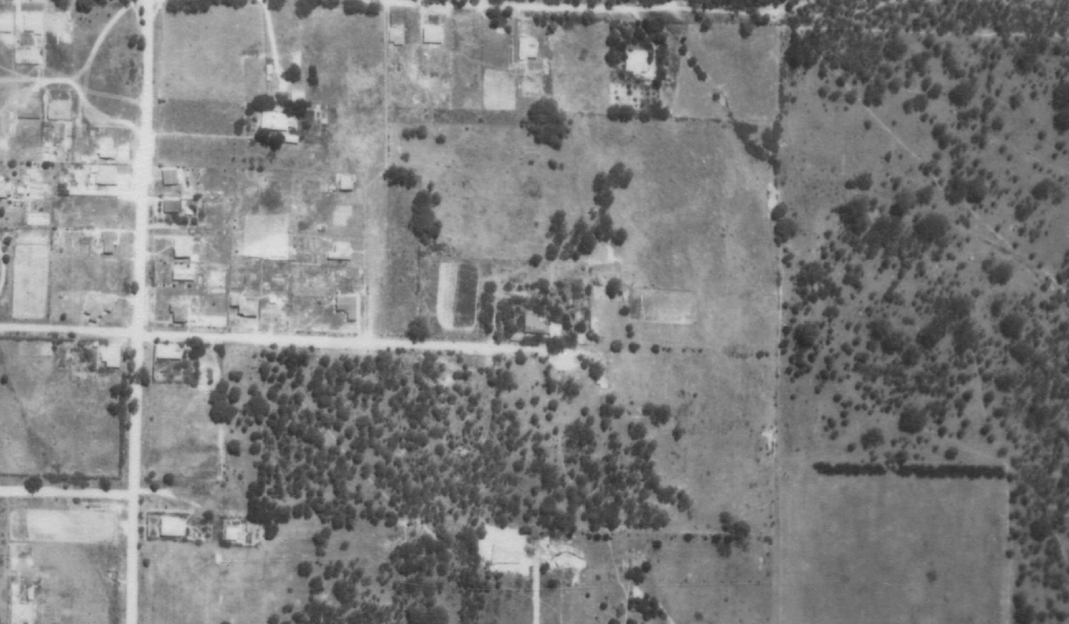
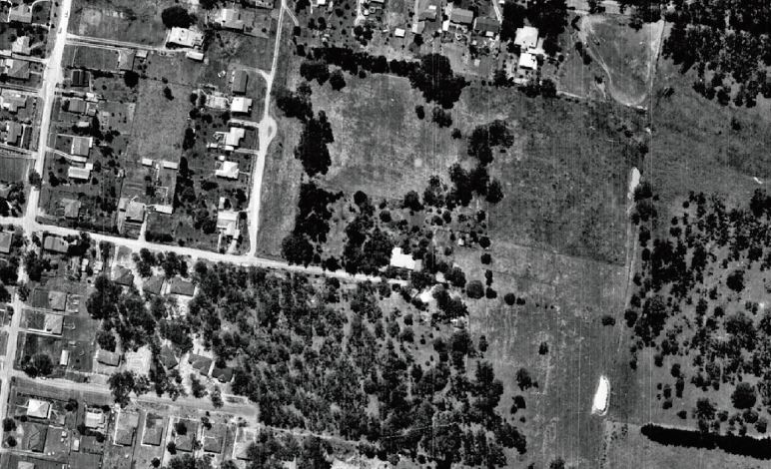
Figure 6. Subject site shown on the 1951 (upper) and 1963 (lower) aerial photograph. Approximate extent of the subject site is outlines in red, with Ball’s earlier landholding outlined in yellow. (Source: CPO, ‘MELBOURNE AND METROPOLITAN PROJECT NO.2’ 1951; ‘Melbourne Project‘ 1963, via Landata)
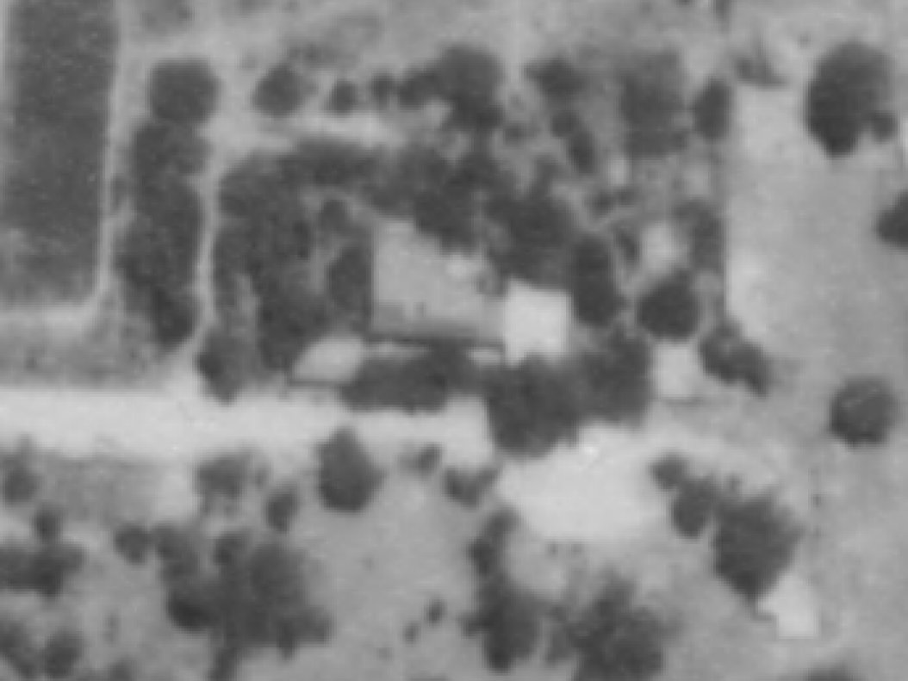
Figure 7. Close up of the subject site from 1951. The structures that existed on site by this time include: the 1948 study (outlined in red), the 1890s cottage (yellow), the c1948 pise addition with two rooms (green) and The Pottery built in 1950 (blue). (Source: ‘MELBOURNE AND METROPOLITAN PROJECT NO.2’ 1951 via LANDATA)

Figure 8. The Knox plan for the Ball rebuilding project, 1959. (Source: A Knox 5 September 1959, Job No 252, Alistair Knox Foundation).

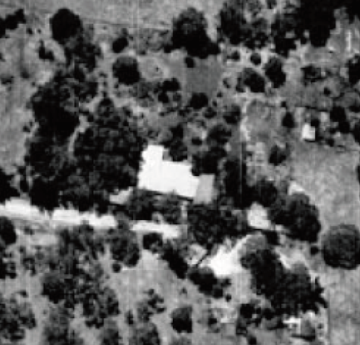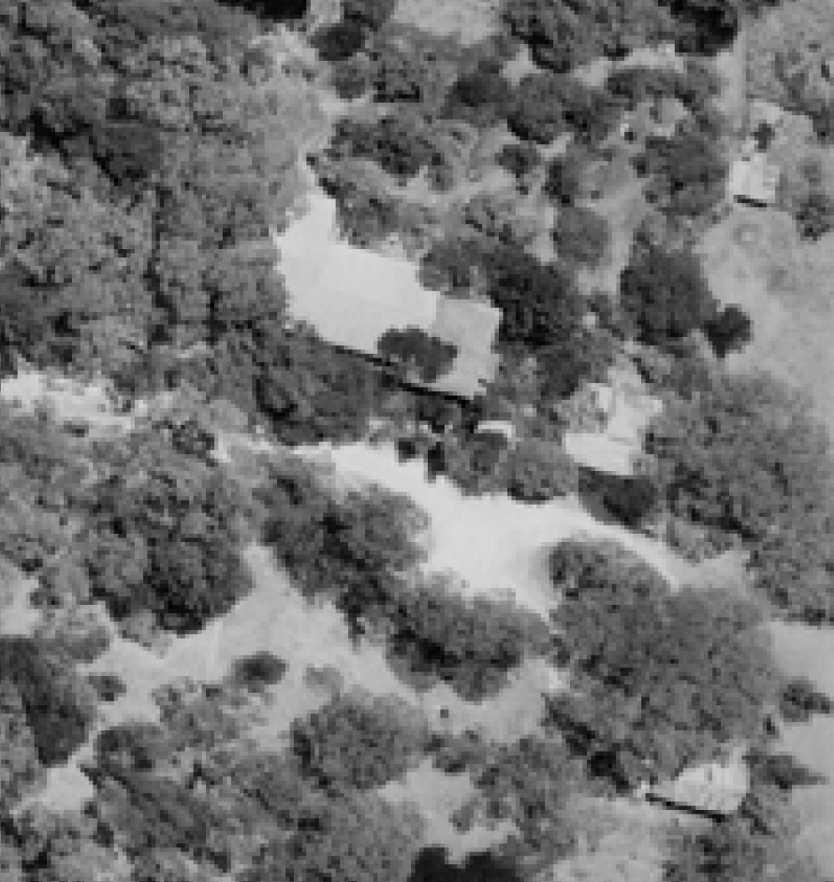
Figure 9. Close up of the subject complex from 1963 (left) and 1978 (right). Note the main house that replaced the 1890s cottage in 1959, outlined in yellow. (Source: ‘Melbourne Project‘ 1963 & ‘Diamond Creek’ 1978, via LANDATA)
Figure 10. A photo of the Ball house, undated. (Source: T Knox nd, Alistair Knox Foundation).
Figure 11. The study, built in 1948. (Source: T Knox nd, Alistair Knox Foundation)

William Macmahon Ball, owner 1945-1986
The following has been abbreviated from The Australian Dictionary of Biography entry for William Macmahon Ball:
William Macmahon Ball (1901-1986), professor of political science, diplomat, author, journalist and radio broadcaster, was born on 29 August 1901 at Casterton, Victoria…An indifferent scholar, he left Caulfield Grammar School…without matriculating. He became a student-teacher at New College, Box Hill, and qualified for entry to the University of Melbourne (BA Hons, 1923)…
On 24 May 1924 at the Congregational manse, Eagle Junction, Brisbane, he married Iris Shield, a journalist; she died childless in 1926. At St Paul’s Church of England, Gisborne, Victoria, on 20 December 1928 he married Muriel Katrine (`Kay’) Sandys Cliffe Anderson, a clerk.
In 1929 Ball won a Rockefeller travelling fellowship in political science, enabling him to study under Harold Laski at the London School of Economics and Political Science…In 1932 he returned to the University of Melbourne as lecturer (later senior lecturer) in political philosophy and modern political institutions…
Ball’s stature increased steadily throughout the troubled and emotional decade that led up to World War II: abroad were the Spanish Civil War, the regimes of Hitler, Mussolini and Stalin, and Japan’s rampage in China; at home, the Depression, the dismissal of Premier Jack Lang, and the New Guard. In such unquiet and strident times, Ball’s voice was one of calm and reason. He was active in the adult education movement as a university extension lecturer…In this period, too, he began giving talks for the Australian Broadcasting Commission, a medium in which he shone. He also wrote articles on international affairs for the Melbourne Herald.
Working for disarmament and the peaceful settlement of international differences, Ball published his views in Possible Peace (1936)...In May 1938 he departed on another visit abroad. After witnessing the German occupation of the Sudetenland, he was given a conducted tour of the notorious Sachsenhausen concentration camp - a horror which never left his memory…
Invited by Prime Minister (Sir) Robert Menzies, in February 1940 Ball was appointed controller of broadcasting in the Department of Information. In June he became responsible solely for short-wave broadcasting…His section was transferred to the ABC in July 1942…Ball remained with the ABC and added to his public laurels by chairing the popular radio debates, `Nation’s Forum of the Air’.
In 1945 `Mac’ Ball returned to his university as senior lecturer-in-charge of the department of political science…That year he was part of Evatt’s entourage at the United Nations Conference on International Organization in San Francisco, USA…
Appointed British Commonwealth member of the Allied Council for Japan, and Australian minister to that country, Ball assumed office on 3 April 1946…
For a short while Ball worked as a special foreign affairs writer on the Melbourne Herald where his elegant articles, largely on relations with South-East Asia, enhanced that newspaper’s best traditions…In 1949 he settled with contentment into the job [the foundation chair of political science at the University of Melbourne] which he was to retain until his retirement in January 1968…
The Balls lived in a several-times-extended timber house in semi-rural Eltham, north of Melbourne. Here Kay’s practical abilities and hard work maintained the `bush and garden’ small estate which provided fresh produce for the table and space for Mac to keep his horse...Aided by Kay’s splendid table, Eltham saw much quiet but significant entertainment of leading figures in Australian and overseas affairs (Ryan 2007).
William Macmahon Ball died in 1986 and Katrine Ball died in 1991. Both are buried in Eltham cemetery.
Part of the Ball’s land backing onto Bridge Street was donated to Eltham Shire Council and is now a reserve called Macmahon Ball Paddock (EDHS).

John Harcourt, builder of the pise extension, date unknown (likely c1948-9)
Journalist John Harcourt was an Eltham resident in the 1930s and 1940s. A pioneer of mudbrick building in Eltham, he was inspired by what he saw at the artists’ colony of Justus Jorgensen's Montsalvat, commenced in 1934, and started building pise-de-terre and mudbrick homes along classic French provincial lines from the late 1930s. He continued to build professionally in pise, mudbrick and stone in Eltham (approximately 20 houses) and various other places until about 1950. Harcourt built several of his residences in the 1940s in an area dubbed ‘Harcourt Hill’ that overlooked Diamond Creek in Eltham (Alistair Knox Foundation; Age 18 November 1972:35; 27 March 1982:39; and 9 September 2000:156).
Harcourt developed an automatic ramming technique which obviated much of the intense labour that ordinary pise required. It also reduced the risk of uneven ramming (Alistair Knox Foundation).
Harcourt, along with Alistair Knox and Peter Glass, played a significant role in the development of the ‘Eltham style’ of architecture and design and were associated with the development of the Australian bush garden aesthetic.

Alistair Knox, designer of study (1948) and residence (1959)
Alistair Knox (1912-1986) was a designer and builder, active in the Nillumbik area between 1946 and his death in 1986. Knox was responsible for over 1266 building designs, including 1000 homes, of which he built approximately 350. Throughout his four-decade long career, Knox was a leading figure in the development of the recognisably regional ‘Eltham style’ of architecture, and its associated landscapes. Through the sheer number of places designed by Knox in Nillumbik, he remains one of the most influential figures in the Shire’s history (Alistair Knox Foundation; Peterson and Kusyk 2014:5-6).
Knox had an interest in design and construction, commencing a Diploma of Architecture and Building Construction at the Melbourne Technical College. Knox left the course after two years (Peterson and Kusyk 2014:9). Following a visit to the Montsalvat artist’s colony in 1947, Knox was evidently impressed with the area and the artistic lifestyle that it was becoming known for. This love of the area was solidified in 1949, when he moved his young gamily to Eltham. The move coincided with Knox leaving his job as a bank clerk and establishing the Knox Building Service in Eltham (Age 19 July 1954:10; Peterson and Kusyk 2014:10). Knox was highly involved with the semi-rural, alternative lifestyle that Eltham and its surrounds had to offer (Alistair Knox Foundation).
The local environment was a constant inspiration to Knox through his career. Many of the homes he designed complemented their Australian bush settings, and his work pioneered forms including flat rooflines, clerestory windows and expanses of glazing that provided a connection between interiors and their settings (NMA 2021). Knox’s work was characterised by its use of second hand bricks, large eaves, natural materials, timber walls and large beams. Perhaps most importantly, Knox was associated with the use of mudbrick and adobe walls (NMA 2021). Knox paid special attention to the placement of buildings in relation to their landscapes and the use of Australian plants.
Knox’s work can be broadly broken into two phases: work completed before 1955, and work completed after 1955. The earlier phase focused on simple building forms, following the style of prominent architects such as Frank Lloyd Wright (Woodhouse 2007). His work was also greatly influenced by the economic austerity brought about by World War II, which encouraged him to use inexpensive and unconventional materials. The later period was defined by Knox’s sophisticated, highly individual designs, often with reclaimed materials. These houses consciously explored uncommon forms and were almost exclusively built in mudbrick (Alistair Knox Foundation).
As Knox was not an architect, his work was often informed by his knowledge that arose from his experience as a builder. Many of his designs were economical and only required limited skills. A preference for reclaimed materials assisted the inexpensive draw of his designs (Alistair Knox Foundation). Although many houses were individually designed, Knox also produced ‘spec’ houses for general sale (Age 19 July 1980:101).
Towards the end of his career, Knox worked extensively with other designers. Some of these included John Pizzey, Peter Jarvis, Barbara Telford, Robert Marshall and Bohdan Kyzuk (Alistair Knox Foundation). Outside of his profession, Knox served as an Eltham Shire councillor in the period 1972-75, and as its president in 1975. Passionate about community activism and the environment, Knox consulted with groups across Melbourne to fight inappropriate development and loss of public space (Peterson and Kusyk 2014:14-15). Additionally, Knox wrote and spoke extensively on matters about building and landscaping. Knox was a founding member of the Australian Institute of Landscape Architects, lectured on environmental design and building, and received an honorary doctorate in architecture from the University of Melbourne shortly before his death (Woodhouse 2007).

DESCRIPTION
61 York Street, Eltham, is located at the eastern end of York Street on a large heavily vegetated parcel of land. The parcel is divided into north and south parts by a curved shared driveway (Figure 12). The southern portion of the land is also known as 61A York Street. The site comprises a complex of key buildings of interest built between 1948-1959 (Figure 12), including:
- a house comprising an originally freestanding mudbrick study built in 1948 to a design by Alistair Knox; a pise extension with attic floor constructed c1948 to a design by John Harcourt (an addition to now demolished 1890s house); and a timber dwelling built in 1959 also designed by Alistair Knox (replacement of the 1890s house); and
- a separate 1950 mudbrick pottery studio (understood to be extended with a two-storey addition).
All buildings of the complex were built for Professor (William) Macmahon Ball. A later carport is located to the south of the main mudbrick dwelling.
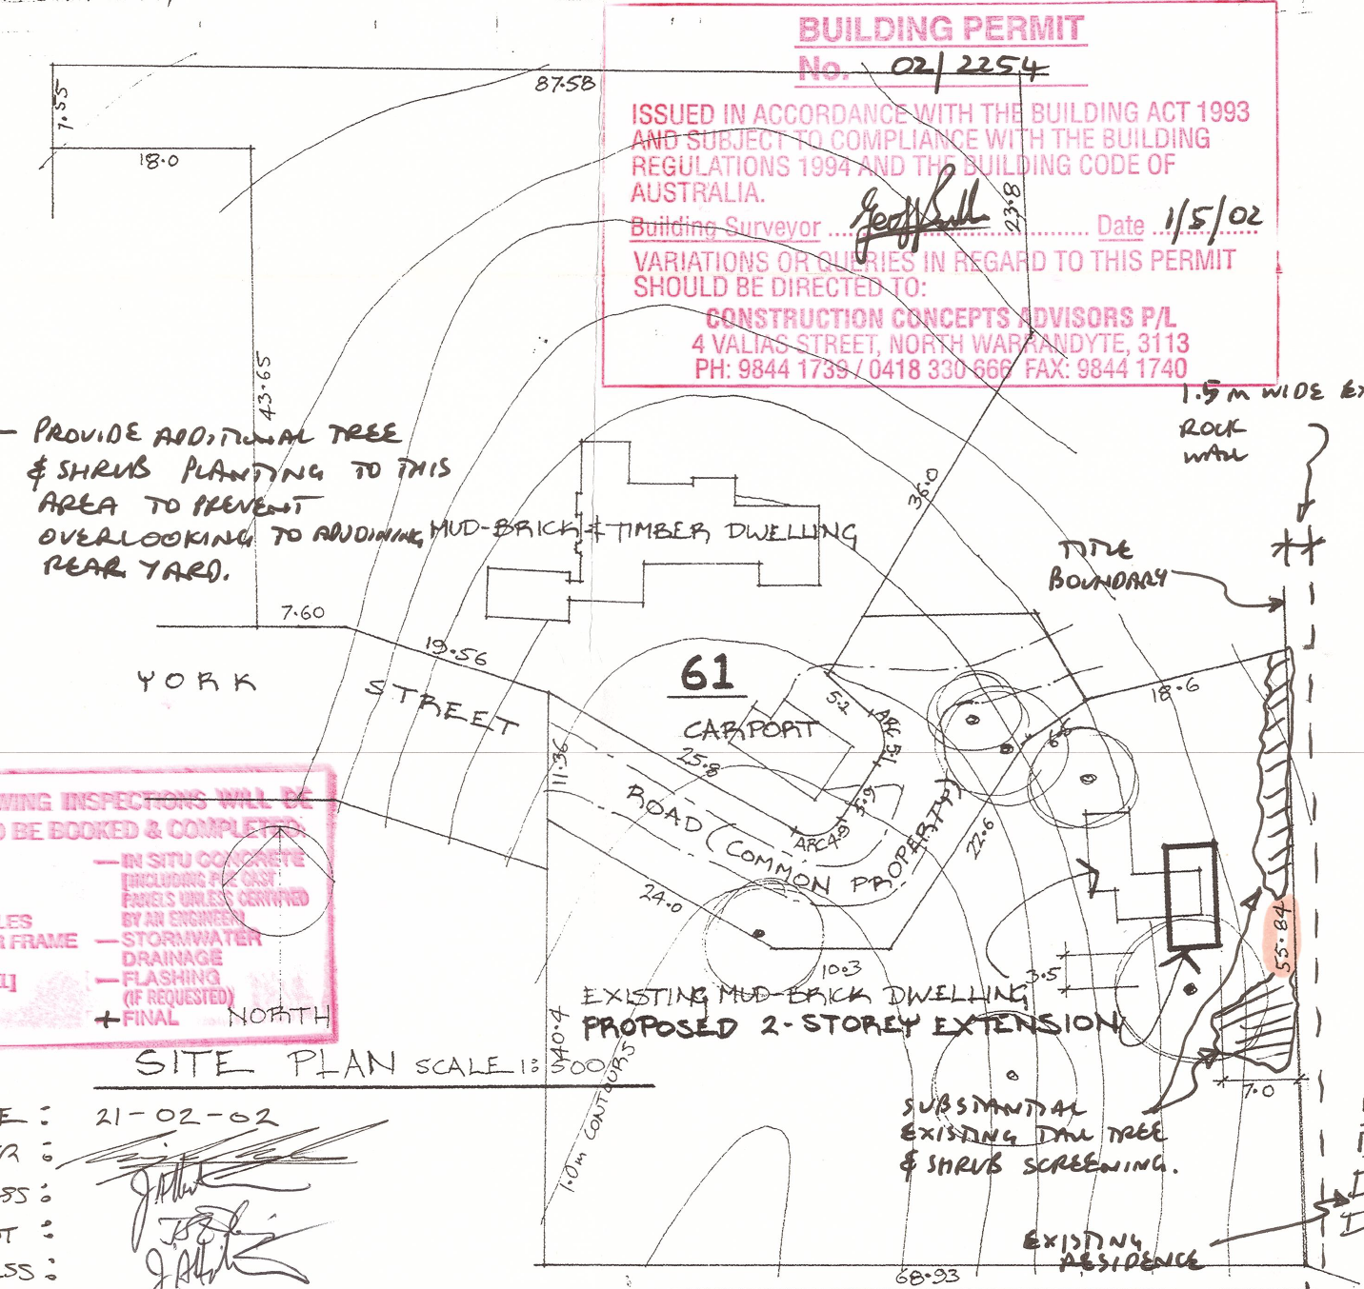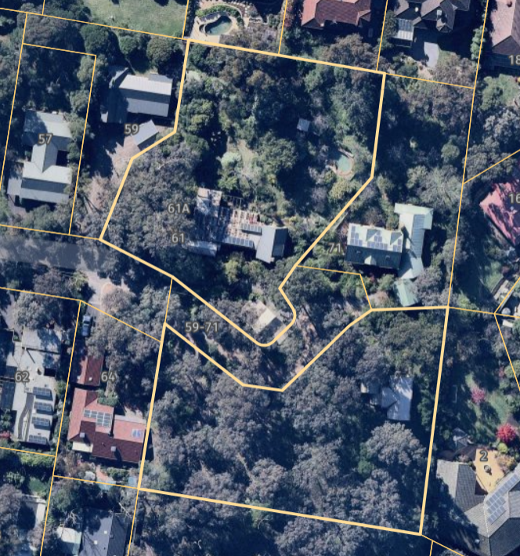
Figure 12. Site plan prepared in 2002, showing the structures of interest (left), and the aerial view of the subject site, with the site boundary outlined in thicker yellow lines (right). Note the house comprising 1948, c1948 and 1959 sections (outlined in red) and a freestanding 1950 pottery now converted to a house (blue). (Source: BP 02/2254; Nearmap 2021)

The 1948 study is a simple rectangular mudbrick room, with gable roof. The building is dominated by a mudbrick chimney with a stepped chimney breast and brick cappings, centrally located on the building’s western elevation (Figure 13). The study was built to accommodate large expanses of bookshelves, historic images show a single vertically proportioned window along the southern elevation and a series of glazed doors to the north. Internally the building is distinguished by its exposed timber-trussed roof structure and timber lined ceiling.
The pise section of the house, built by John Harcourt in c1948, is rectangular in form, with a steep gable roof that allows for an attic area internally. The north end of the gable is recessed accommodating a balcony, while a shed dormer window is evident on the eastern plane of the roof. A chimney is present on the southern elevation of this building (Figure 13).
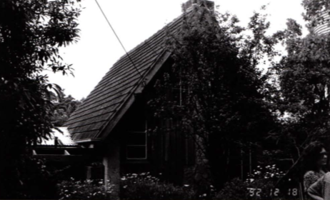
Figure 13 A 1992 image of the pise attic section of the house. (Source: Bick 1992)

The 1950 mudbrick pottery is believed to be the building on the southern portion of the site, which is now converted to a house and added with a two-storey timber addition that replaced the lower wing.
In 1959 Alistair Knox designed an extension to Harcourt’s pise building. L-shaped in plan, this extension is attached to Harcourts building at its eastern end. It is of timber construction with a low -pitched corrugated iron gable roof. When originally built the extension did not abut the mudbrick study building which is located to its southwest. Comprising a recessed entry porch, entry, gallery, living/dining room, kitchen and bedroom, the external walls of the extension are lined with unpainted vertical boards above horizontal baseboards. The vertical boards are laid board-on-board. The outer boards are narrower than the inner boards; this provides a subtle textural depth to the wall plane. Windows and doors are timber framed, many with fixed glazed panels above. A broad brick chimney dominates the western elevation. Internally historic images show timber lined ceilings and exposed rafters and beams that follow the rake of the low-pitched gable roof (Figure 15, Figure 16 and Figure 17).

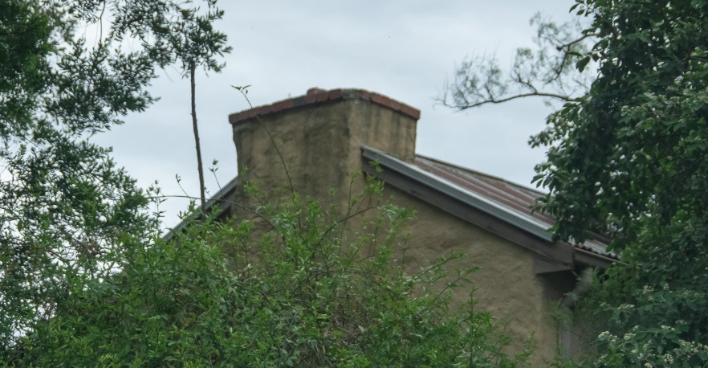
Figure 14. The mudbrick chimney of the study. (Source: Context 2020)

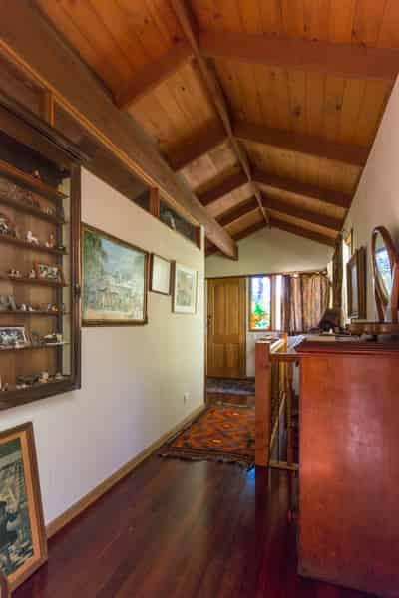
Figure 15. Gallery and entry of the 1959 extension. (Source. T Knox nd, Alistair Knox Foundation)
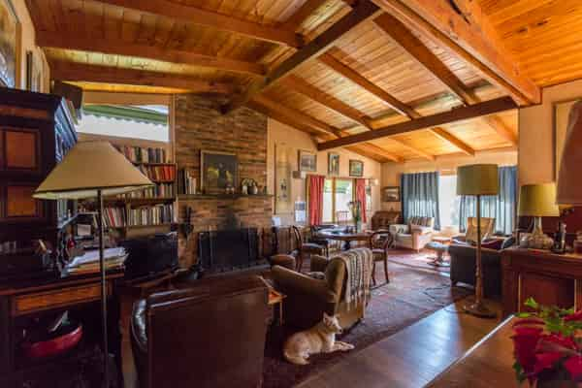
Figure 16. Living room of the 1959 extension showing brick fireplace and exposed timber raked ceiling (Source. T Knox nd, Alistair Knox Foundation)

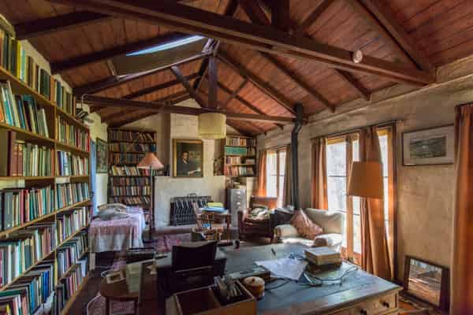
Figure 17. An interior view of the study showing mudbrick fireplace and glazed doors along the northern elevation (Source. T Knox nd, Alistair Knox Foundation)

There are a couple of small buildings and a kidney shape swimming pool located in the northwest corner of the site.

INTEGRITY
Access to the complex of buildings at 61 York Street, Eltham was not possible for the purpose of this assessment. As the site is heavily vegetated only the western elevations of the 1948 study and 1959 extension could be viewed from the public domain. Both these elevations appear highly intact with the study retaining its gable roof form, mudbrick walls and chimney. The 1959 extension retains its low-pitched gable roof form, timber wall linings, brick chimney and original window openings. Overall, these elevations appear highly intact with minimal changes visible to original or early fabric.
Nearmap aerial imagery shows the 1948 study retains its original built form of a rectangular room with corrugated iron gable roof and chimney.
The pise section of the complex designed by Harcourt in 1948 retains its steeply pitched gable roof form. Historical images (Figure 10) show that the roof was originally tiled, however this appears to have been replaced with corrugated iron.
The Knox designed extension built in 1959 retains its L-shaped footprint with low gable roof form and brick chimney.
The pottery studio has been added with a two-storey addition. Further investigation is required to confirm the integrity of this building.

COMPARATIVE ANALYSIS
The Nillumbik area has a longstanding association with artistic and intellectual communities, going back to the earliest years of the nineteenth century. The period following World War II saw the arrival of a new generation of artists and thinkers, who appreciated the natural surrounds of the area and the like-minded communities that had developed. Many newcomers were attracted by the cheap and readily available blocks that had gone unsold in the numerous subdivisions from the prewar and interwar periods. The area was later referred to as ‘the socio-aesthetic centre of Melbourne’ and ‘a rural Bloomsbury’, a reference to the famous group of intelligentsia, artists and philosophers in London (Knox 1980: 76).
The house and study at 61 York Street, Eltham are directly associated with (William) Macmahon Ball, a noted professor of political science, diplomat, author, journalist and radio broadcaster. Ball resided at the site from 1945 until his death in 1986. Ball is intrinsically linked to the fabric of the place, as the 1948 study, c1948 pise house, 1950 pottery and 1959 extension were all commissioned by Ball and his wife Katrine.
In 1946 Ball was appointed British Commonwealth member of the allied Council for Japan. In his book We Are What We Stand On (1980) Alistair Knox comments:
We built his studio around the time he was Australia's delegate in the Japanese peace negotiations. Our small community drew a quiet sense of reflected glory from him as if we felt we were involved in the negotiations ourselves.
This highlights Ball’s prominence in the local community and the sense of pride held by community members in creating a place for Ball to work and live. It is also noted in Ball’s biography prepared for the Australian Dictionary of Biography by Peter Ryan that the Ball’s property in Eltham ‘saw much quiet but significant entertainment’ of leading figures in Australian and overseas affairs (Ryan 2007).). Ball wrote innumerable articles and book reviews while living at 61 York Street presumably working on many of these from his desk in the study. His publications included the volumes Japan: Enemy or Ally (1948); Nationalism and Communism in East Asia (1952); and an edited collection of documents and readings, Australia and Japan (1969). The 41-year long direct association of the subject site with William Macmahon Ball enables it to represent this association better than other places or objects in the Shire of Nillumbik.
Within the Shire of Nillumbik, several surviving places are on the Heritage Overlay for their historical (associative) significance in demonstrating their connection to prominent artists, writers, and intellectuals. The following places are comparable to the Macmahon Ball complex of buildings, 61 York Street, Eltham, for their direct association with a person who contributed to the course of the Shire’s history of being associated with artists, writers, and intellectuals and for the tangible evidence the physical fabric of the place provides of this association and the achievements of the person.
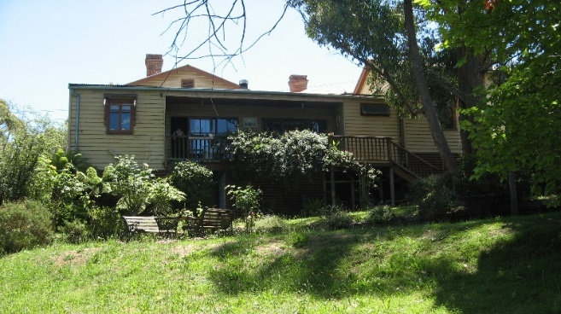  Southernwood, 250 Bolton Street, Eltham (VHR 2235, HO13). (Source: VHD) | Southernwood, Walter Wither’s house, was first built as a four-room cottage in 1891, and in 1903 it was purchased by the artist Walter Withers. The house is of historical significance as the home of the prominent Australian artist Walter Withers from 1903 until his death in 1914. As a member of the 'Heidelberg School' Withers was the first commercially successful painter to come and live in Eltham. Withers played a part in attracting other artists to the area and, thereby, in establishing Eltham's reputation as an artistic community (VHD).
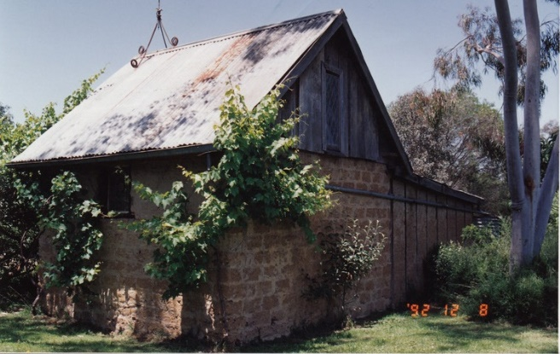  Peter Garner mudbrick studio and adjacent shed 62 Brougham street, Eltham (HO17). (Source: VHD) | The 1969 studio and shed are significant for its use of highly creative structures constructed in the ‘Eltham style’. The studio and shed were associated with Arthur Munday, Peter Garner, Lenore Garner and the Montsalvat artists' community more broadly (VHD).
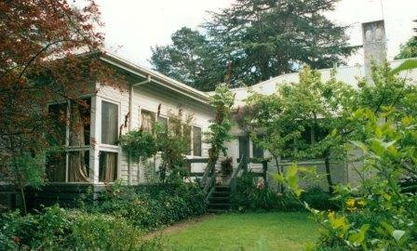  Stanhope Residence and Garden, 10 Peter Street, Eltham (HO149). (Source: VHD) | The c1910 residence is historically significant for its connection with Will Longstaff, the official war artist, Bishop Reginald Stephen (warden of Trinity college in the 1930s) and with the prominent journalist turned builder, John Harcourt, who rented the residence while he and his partner were building their adobe home in the 1940s.  During the 1940s the residence was also connected with the important literary figures, Clem, and Nina Christesen (Clem was the founding editor of the influential Meanjin Quarterly). When owned by the Christesens the residence was visited by a number of distinguished writers, artists, and academics, including the Nobel Prize winner, Patrick White, and the world-famous cellist Mstislav Rostropovich (VHD).
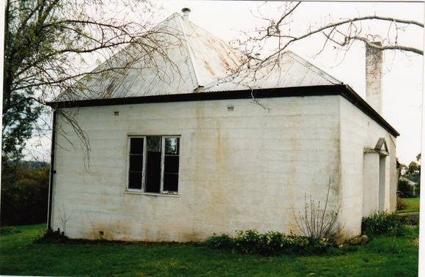  Landscape, 60 Lavender Park Road, Eltham (HO113). (Source: VHD) | The 1926 residence and rear concrete studio are significant because they are connected with the artist, cartoonist and anthropologist, Percy Lesson. During Lesson's occupation (1926-1938) the property became a centre for visiting artists, including Max Meldrum, Justus Jorgensen, Clarice Beckett, ‘Jock’ Frater and Richard McCann (VHD).
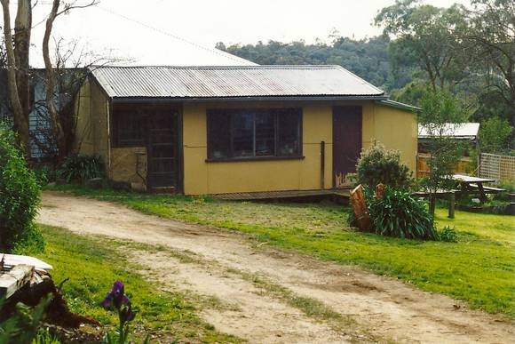  Alan Marshall Bungalow, 13 Park West Road, Eltham (HO147). (Source: VHD) | The 1955 bungalow is significant for its connection with Alan Marshall, a noted author, storyteller and social documenter. While living and working at the bungalow between 1955 to 1972, several of Marshall’s important publications were ‘wholly written’ within its walls. These include his trilogy of fictionalised autobiographies, several collections of highly popular short stories and humorous sketches as well as well as commissioned histories (including the history of Eltham itself). The bungalow was visited by many other famous Australian authors during Marshall’s residence (VHD).

The complex of buildings at 61 York Street are also significant as examples of the work of John Harcourt and Alistair Knox. The following select examples compare well to the subject buildings as work by both designers within the Shire of Nillumbik:
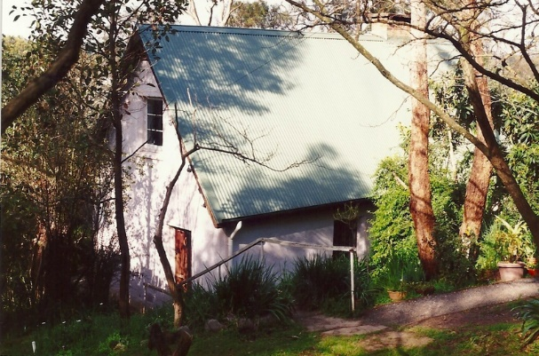  Hazel’s Cottage, 14 Peter Street, Eltham (HO150). (Source: VHD) | The cottage is historically significant because it was constructed by John Harcourt, the local builder and pioneer of adobe and pise building techniques. The cottage is historically and architecturally significant as an example of the work of John Harcourt and because it features an unusual attic design for that time, which was also used by Harcourt at 4 Fay Street and 61 York Street.
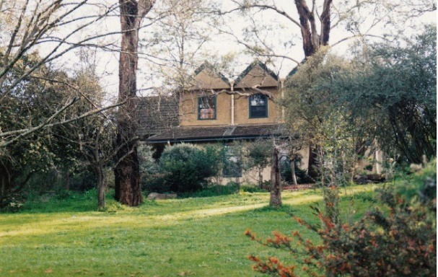  Langi Dorn, 4 Fay Street, Eltham (HO55). (Source: VHD) | The c1940-50 house is historically and architecturally significant as an early example of the use of pise-de-terre and mudbrick building techniques in the Shire and because it is associated with John Harcourt, a pioneer in this type of construction. The house is aesthetically significant because it forms part of a group of mudbrick homes constructed by John Harcourt in "The Hill" area above the Diamond Creek.
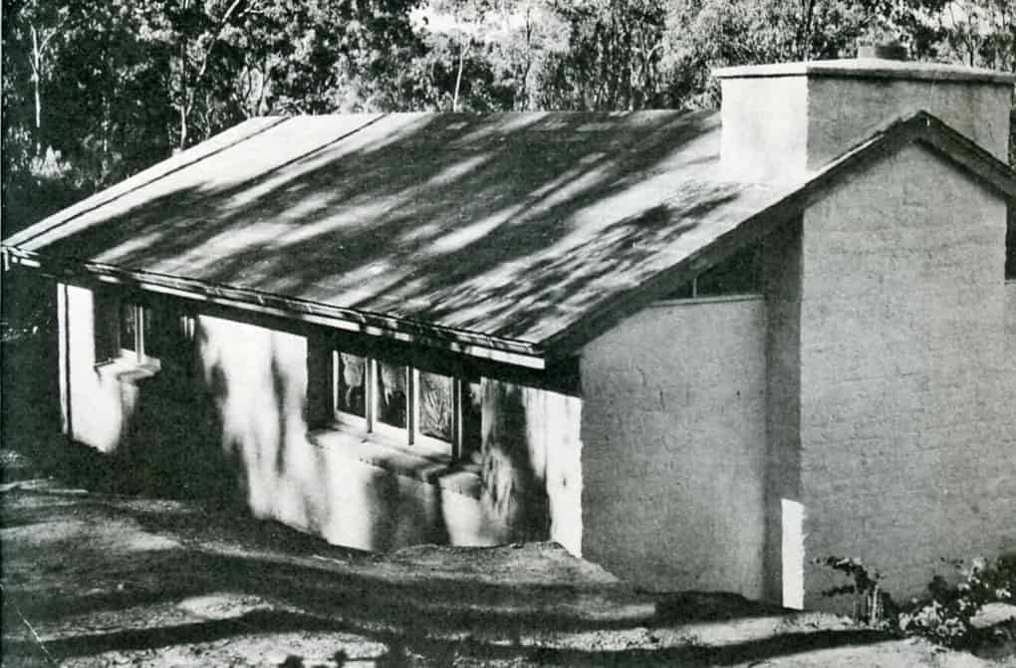  Downing-Le Galienne House and Garden, 12 Yarra Braes Road, Eltham (HO172). (Source: Alistair Knox Foundation) | The house is architecturally significant as an important work by Alistair Knox. Like many other ‘Eltham style’ buildings, the house was constructed in stages over an extended period of time and featured the extensive use of mudbrick. The house is very unusual in both detail and arrangement - it comprises three separate but linked buildings.  The house is historically significant because it is connected with a number of important figures. It was commissioned by the musician and pioneering composer of modern music, Dorian Le Gallienne, and the economist, Richard Downing (who was later Professor of economics and chairman of the ABC). Several prominent local figures helped in the house's construction, including the renowned artists Clifton Pugh and John Howley, and the well-known actor Wynn Roberts. Le Gallienne and Downing's commission of the property illustrates the way in which intellectuals were drawn to Eltham in the period following the end of World War II. The design of the house and its bush setting epitomise the ideal of the 'Eltham lifestyle' that was developed from the 1940s to the 1960s.

Discussion
The Macmahon Ball House and Study at 61 York Street, Eltham, compares favourably with the above Individually Significant places for its demonstrated association with the life or works of a person of importance to the Shire of Nillumbik. It is particularly comparable to the above examples as the site served as Macmahon Ball’s home and long-time private workplace during his lengthy career as a noted professor of political science, diplomat, author, journalist and radio broadcaster.
The Macmahon Ball House and Study complex compares favourably against the above Individually Significant places for its demonstrated association with the life or works of a person of importance to the Shire of Nillumbik. The earlier examples such as Southernwood (VHR 2235, HO13) and Landscape (HO113) evidence Nillumbik’s association with artists of earlier generations, who first attracted their peers to the area. The subject site is particularly comparable to the Peter Garner mudbrick studio (HO17) and Alan Marshall Bungalow (HO147) as examples contemporaneous to the subject site, which represent a later generation of artists and intellectuals who were attracted to the area and established their studios in the immediate postwar period. Despite its continued association with a number of important figures, Stanhope Residence and Garden (HO149) provides less direct comparison, as the house retains intact c1910 fabric and thus the associations are less directly legible from the fabric.
Much like many similar artists houses in the area, the house and study were constructed in stages as needs arose, using simple building forms and materials. In this way the house and study are significant for their contribution to the ongoing understanding of the history of the Shire of Nillumbik and particularly Eltham as a centre for artists, writers, and intellectuals.
The portion of the subject site designed by John Harcourt is particularly comparable to 14 Peter Street, Eltham (HO150), as both places are examples of pise homes with steep gable roof forms that allow for attic floors. Along with the example at 4 Fay Street, Eltham (HO55), the subject site is representative of the work being designed and built by Harcourt at that period that was inspired by traditional building forms.
The Downing-Le Galienne house at 12 Yarra Braes Road, Eltham (HO172), compares well to Knox’s mudbrick portion of the subject site. The Downing-Le Galienne residence was built in stages between 1948 and 1960, a period which very closely coincides with the phases of development by Knox at the subject site. Where the Downing-Le Galienne house differs to the subject site is that its three stages of building were constructed of mudbrick whereas the two Knox sections at 61 York Street utilise different building materials with the 1959 section being of timber construction. The residence was commissioned by the musician and pioneering composer of modern music, Dorian Le Gallienne, and the economist, Richard Downing (who was later Professor of economics and chairman of the ABC), demonstrating the way in which many moving in intellectual circles were drawn to Eltham in the period following the end of World War II. When considered in the context of the Downing-Le Galienne house, the subject site evidences the way in which many artistic or intellectual families established themselves in the area and continued to use the sites with additions and alterations in the postwar period.

STATEMENT OF SIGNIFICANCE

WHAT IS SIGNIFICANT?
The Macmahon Ball House and Study at 61 York Street, Eltham, comprising of a study built in 1948 to a design by Alistair Knox, a pise section with attic floor constructed c1948 to a design by John Harcourt, and an extension built in 1959 to another design by Alistair Knox, all for the owner Professor (William) Macmahon Ball, is significant.
Elements that contribute to the significance of the place include:
- 1948 mudbrick study, inclusive of its mudbrick walls, chimney gable roof and original window and door openings and joinery;
- c1948 pise portion of the house, inclusive of steep gable roof form, dormer window, chimney and original window and door openings and joinery; and
- 1959 main portion of the house, inclusive of its original built form, shallow gable roof, vertical timber wall linings and horizontal base boards, and original window and door openings and joinery.
The mudbrick 1950 pottery (‘The Pottery’) with contemporary extension and the bush setting also contribute to the significance of the place.

HOW IS IT SIGNIFICANT?
The Macmahon Ball House and Study at 61 York Street, Eltham, is of local historic, representative, and associative significance to the Shire of Nillumbik.

WHY IS IT SIGNIFICANT?
The Macmahon Ball House and Study at 61 York Street, Eltham, are of historical significance to the Shire of Nillumbik. Like many properties associated with other local artists and intellectuals houses in the area, the property was developed in stages as needs arose and finances became available, using simple building forms and materials. The buildings show the development of the site as the residence for prominent professor of political science, diplomat, author, journalist and radio broadcaster William Macmahon Ball who lived at the property between 1945 until his death in 1986. The complex of buildings provides important evidence of the collaborative work of key building designers active in Eltham in the postwar period, namely Alistair Knox and John Harcourt. In this way the buildings on the site are significant for their contribution to the ongoing understanding of the history of the Shire of Nillumbik and particularly Eltham as a centre for artists, writers, and intellectuals after World War II (Criterion A).
The mudbrick study at 61 York Street, Eltham, is an important example of the early work of designer and builder Alistair Knox in the suburb. The building is predated only by the English House in Lower Plenty (now Shire of Banyule), and is the first example in Eltham of the earlier building forms and materials that would inform much of Knox’s later career as a well-known and prolific local designer and builder. Between 1946 and 1986 Knox designed over 1000 houses, and a number of churches, schools and other buildings in Nillumbik. Knox built approximately 350 of these himself, and he is best remembered for his use of mudbrick throughout many of these sites. Knox was integral in the development of the recognisably regional ‘Eltham style’ of architecture and landscape practice. Builder John Harcourt also contributed to the complex as a builder of the c1948 pottery studio (likely at today’s 61A York Street). Harcourt, along with Alistair Knox and Peter Glass, played a significant role in the development of the ‘Eltham style’ of architecture and design and were associated with the development of the Australian bush garden aesthetic. (Criterion D)
The site is significant to the Shire of Nillumbik for its associations with William Macmahon Ball (1901-1986), prominent professor of political science, diplomat, author, journalist and radio broadcaster. Ball lived at the site for 41 years from 1945 until his death in 1986. In 1946 Ball was appointed British Commonwealth member of the allied Council for Japan and was Australia’s delegate in the Japanese peace negotiations. Ball wrote innumerable articles and book reviews while living at 61 York Street presumably working on many of these from his desk in his mudbrick study. (Criterion H)

RECOMMENDATIONS
Recommended for inclusion in the Schedule to the Heritage Overlay of the Nillumbik Planning Scheme as an Individually Significant place.
Extent of overlay: To title boundaries
Recommendations for the Schedule to the Heritage Overlay (Clause 43.01) in the Nillumbik Planning Scheme:

Nillumbik Planning Scheme
External paint controls | No
Internal alteration controls | No
Tree controls | No
Outbuildings or fences | Yes - Mudbrick study
To be included on the Victorian Heritage Register | No
Prohibited uses may be permitted | No
Aboriginal heritage place | No

Other
N/A

REFERENCES
Age, as cited.
Alistair Knox Foundation, Alistair Knox: Designer, environmentalist, builder, landscape architect, https://alistairknox.org/, accessed 5 February 2021.
Bick, David 1992, ‘Shire of Eltham Heritage Study’, Prepared for the Shire of Eltham.
Central Plan Office (CPO), Historic Aerial Photography: 1930s to 1990s, as cited, via Landata, https://www.landata.vic.gov.au/, accessed online March-April 2021.
Eltham District Historical Society Inc (EDHS), ‘William MacMahon Ball 1901-1986’, https://elthamhistory.wordpress.com/2019/05/26/william-macmahon-ball-1901-1986/, accessed 11 February 2021.
Knox, Alistair 5 September 1959, Job No 252, Alistair Knox: Designer, environmentalist, builder, landscape architect, Alistair Knox Foundation, https://alistairknox.org/, accessed 12 February 2021.
Knox, Tony undated, ‘Macmahon Ball Studio’ and ‘MacMahon Ball rebuilding 252’, Alistair Knox: Designer, environmentalist, builder, landscape architect, Alistair Knox Foundation, https://alistairknox.org/, accessed 12 February 2021.
Marshall, Alan 1971. ‘Pioneers & Painters: One Hundred Years of Eltham and its Shire’. Thomas Nelson Australia Pty Ltd, Melbourne.
Marshall, Marguerite 2008, Nillumbik Now and Then, Research, MPrint Publications.
Nillumbik Mudbrick Association Inc (NMA), ‘History’, https://www.mudbrick.org.au/history, accessed 12 February 2021.
Peterson Richard, and Kuzyk, Bohdan 2014, ‘Alistair Knox (1912-1986): modernism, environment and the spirit of place’, RMIT Design Archives Journal, Volume 4, Number 3: 5-23.
Hentschel, T c1850s, ‘Plan of Little Eltham South, adjoining the government township of Eltham’, via State Library Victoria: Victoria Suburban & Country Plans, accessed online 4 April 2021.
Ryan, Peter 2007, 'Ball, William Macmahon (1901-1986)', Australian Dictionary of Biography, National Centre of Biography, Australian National University, https://adb.anu.edu.au/biography/ball-william-macmahon-12166/text21801, published first in hardcopy 2007, accessed online 15 February 2021.
Victorian Heritage Database (VHD), https://vhd.heritagecouncil.vic.gov.au/, accessed online 30 April 2021.
Woodhouse, Fay 2007, ‘Knox, Alistair Samuel (1912-1986)', Australian Dictionary of Biography, National Centre of Biography, Australian National University, https://adb.anu.edu.au/biography/knox-alistair-samuel-12750/text22995, published first in hardcopy 2007, accessed online 10 February 2021.
Woollard, Jane 2016, Laughing Waters Road: Art, Landscape and Memory in Eltham, Greensborough, Nillumbik Shire Council.

