144 Progress Road, Eltham North

House
Prepared by: Context | Survey date: December 2020
Place type: Residential | Designer: Glyn Lewis
Significance level: Significant | Builder: Not known
Extent of overlay: To title boundaries | Major construction: c1972-75
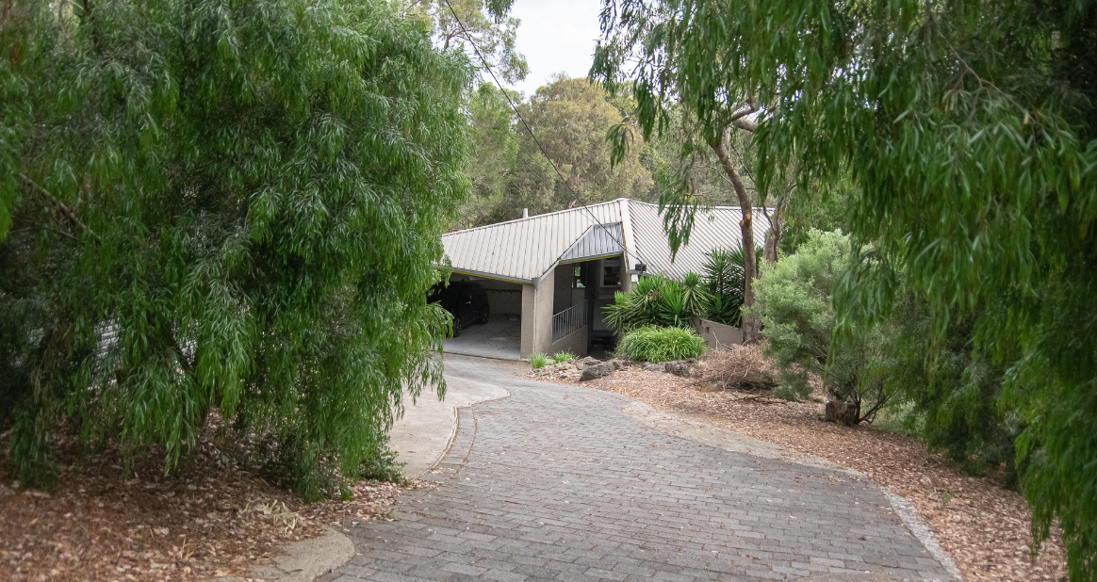
Figure 1. View of 144 Progress Road, Eltham North, from the street. (Source: Context 2020)
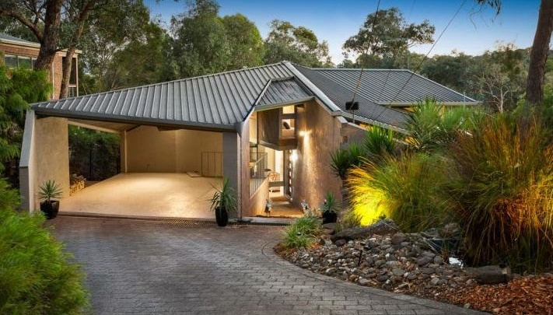
Figure 2. Principal elevation of 144 Progress Road, Eltham North. (Source: realestate.com.au 2017)

HISTORICAL CONTEXT
This place is associated with the following historic themes taken from the Nillumbik Shire Thematic Environmental History (2016):
6 BUILDING TOWNS AND SHAPING SUBURBS
6.6 1960s and 1970s suburbanisation
From the mid-1960s the main suburban expansion in the former Eltham Shire area was east from Eltham, aided by the construction of the new Fitzsimons Lane (Eltham-Templestowe) bridge in 1963. This expansion was limited by topography and by methods of corridor planning including the green wedge and rural zoning. As a result, the eastwards trend would not extend past Research. The occupants of this new residential area were typically high-income families commuting to work in the city. When author and diplomat Graham McInnes returned to Melbourne in 1969 after leaving in the 1930s, he said that one of the most noticeable differences was that ‘Eltham was the country, now it is right in Melbourne’. (Mills & Westbrooke 2016:87)
Residents who had established themselves in the early postwar period questioned the bona fides of this new wave of aspiring bushland home owners. [Alistair] Knox described how ‘the rich and affluent eastern suburbanites started casting sheep’s eyes at this unkempt bushscape.… Eltham was once again under threat from the land profiteer, who would butcher the living qualities of its inhabitants to make their Roman holiday.’. On the other hand, the middle-class professionals of this new influx were environmentally conscious, politically well informed and numerous enough to exert a profound effect on the conservation of the surrounding landscape. (Mills & Westbrooke 2016:87-88)
By the 1970s, the aesthetics of the bush that had been developing throughout Australia were influencing the more sought after city fringe suburban developments. These suburban developments adopted some of the trappings of environmental building that had been developed, in part, by the Eltham mud brick pioneers. The environmental thinking had been translated into a set of standard approaches, including preservation of existing trees, adaptation to contours, underground services and establishment of a network of linked bush parks. Road planning strategies such as cul-de-sacs enabled isolation from busy through streets. Roads were softened with low-profile gutters and the transition from road to driveway was softened with the use of paving materials in the road surface. Even so, these developments substantially remade the landscape. (Mills & Westbrooke 2016:88)
In the 1970s the Nillumbik area and nearby suburbs were graced with a number of residences designed by up-and-coming architects of the day including Kevin Borland, Charles Duncan and Morrice Shaw. Philip Goad describes their works as ‘free and inventive compositions’ and ‘programmatically innovative’. Their designs featured informality, woodsy detailing, mezzanine floors and sliding doors opening onto timber decks. Other features included bagged brick, or brick seconds, window frames stained brown or pale eucalypt green and diagonal timber lining boards (Goad 1999, p. 199). (Mills & Westbrooke 2016:89)

LOCALITY HISTORY
Eltham North is located on the country of the Wurundjeri-willam clan of the Woi wurrung people.
Diamond Creek separates Eltham North from Eltham and was the dividing boundary between municipalities; Eltham North was in Heidelberg City and, from 1964, in Diamond Valley Shire. In 2001 Eltham North’s western boundary moved from Ryans Road into St Helena. As a result, today Eltham North is located within two local government areas: the City of Banyule and Nillumbik Shire (Victorian Places 2015).
Eltham North, originally an outlying rural part of Eltham, became a separate locality with the opening of the Glen Park (later Eltham North) State School No. 4212 in 1924. At the time the locality was known as Glen Park, with that name recorded in street directories until the 1960s. The postal district, however, was Eltham North (Victorian Places 2015).
Extensive subdivision to the northeast and northwest of Eltham occurred from the first decades of the twentieth century, although residential development was slow due to an absence of electricity and water services. A new bridge across Diamond Creek, opened in 1915, improved connections between Eltham and Eltham North.
The Eltham and Glen Park Progress Association was formed in 1921 and called for the construction of a railway station at Glen Park (later Eltham North), midway between Eltham and Diamond Creek stations. In 1924 the Glen Park Progress Association expected such a station would service 387 blocks in the Bellevue and Beard estates and 313 blocks in the Glen Park Estate subdivision. Glen Park at this time had 89 houses with a largely working-class population of 198 people. It also had 97 weekenders (Mills & Westbrooke 2017:72).
Glen Park Primary School No. 4212 was subsequently opened after the Progress Association petitioned the Education Department, stating that the population of the area was growing and complaining that children had to walk two to three miles to Eltham or Diamond Creek schools. The first school opened in May 1924, with 38 pupils, in a private house called ‘Rest-a-While’ in Lower Glen Park Road, where it operated for the next 17 months. In 1925 it was relocated to a single room transported by wagon from Greensborough and moved to land in Banks Road (Eltham North Primary School 2020; Blake 1973:138). The school’s name was changed to Eltham North in that year (Blake 1973:138).
In 1925 a building for the Glen Park Gospel Mission was erected (Advertiser 4 December 1925:3).
Local builder Alistair Knox designed and constructed a number of mudbrick houses in the area from the late 1940s, contributing to a style of architecture that became known as the ‘Eltham style’.
Reflecting the postwar growth in the area, by 1952 there were 62 children attending the Eltham North State School, and in 1953 a new school building was completed in Wattletree Road (Blake 1973:138).
Today the primary school is in the east of the suburb, adjacent to the Glen Park Gospel Church and local shops. There is a kindergarten in Glen Park Road. Eltham North has numerous bushland reserves and playgrounds (Victorian Places 2015).

PLACE HISTORY
The subject site is located on Crown Allotment G, Section 11, Parish of Nillumbik, comprising 89 acres and first purchased by PAC O’Farrell in 1852 (Nillumbik Parish Plan 1961). By 1884 the Crown Allotment had been subdivided, with 75 acres of land acquired by James Darley Mealy, ‘gentleman’, in 1909. Between 1913 and c1919 Mealy served as a member of the Eltham Shire Council (Advertiser, 11 January 1935:2). He died in 1935, and in 1940 the land passed into the ownership of Elise Stewart. In 1947 it was owned by Inter-Urban Builders Pty Ltd (CT:V1537 F305; CT:V3346 V070).
Inter-Urban Builders subdivided the land into residential blocks, with lots sold from 1947 to 1967 (CT:V3346 V070). The subject site is Lot 210 of this subdivision. Lots 209 and 210 were purchased in 1960 by Lower Plenty builders Stanley Brown and Gordon Saw (CT:V8256 F347). Lot 210 changed hands multiple times until 1972, when the property was acquired by Garry and Linda Richardson (CT:V8654 F863). By 1972, residential development had continued along Progress Road (Figure 3).
The subject residence was built for the Richardsons between 1972 and 1975 to a design by architect Glyn Lewis (realestate.com.au 2017). The residence and its complex roof form is depicted in aerial photographs of the area taken in 1975 and 1987 (Figure 4).
A building permit was issued for a carport and garage in 2004 (BP). These are located to the northeast corner of the site, adjacent to the driveway. The site plan attached to the 2004 permit application does not depict the south-facing family room that exists by 2009. Aerial photographs indicate that the family room, the alfresco dining area and the split-level timber decking along the south elevation were added between 2004 and 2009 (Figure 5).

Glyn Lewis, architect
Glyn Lewis graduated with a Bachelor of Architecture from the University of Melbourne’s Faculty of Architecture in 1965 (Age 15 April 1965:13). Lewis’s known works include a Californian Bungalow in Alphington that he remodelled as his own home c1980, which appears to have been influenced by American architect Bruce Alonzo Goff, whose work was distinguished by curvilinear or unconventionally geometric forms. Around 1969, Lewis also designed a more conservative project home in Donvale, which was nominated for the ‘Finest in Family Living’ contest in 1971 (Victorian Modern). Reportedly, Lewis worked in the office of renowned Modernist architect Peter McIntyre in the 1990s (pers. comm with Peter McIntyre 5-6 May 2021).

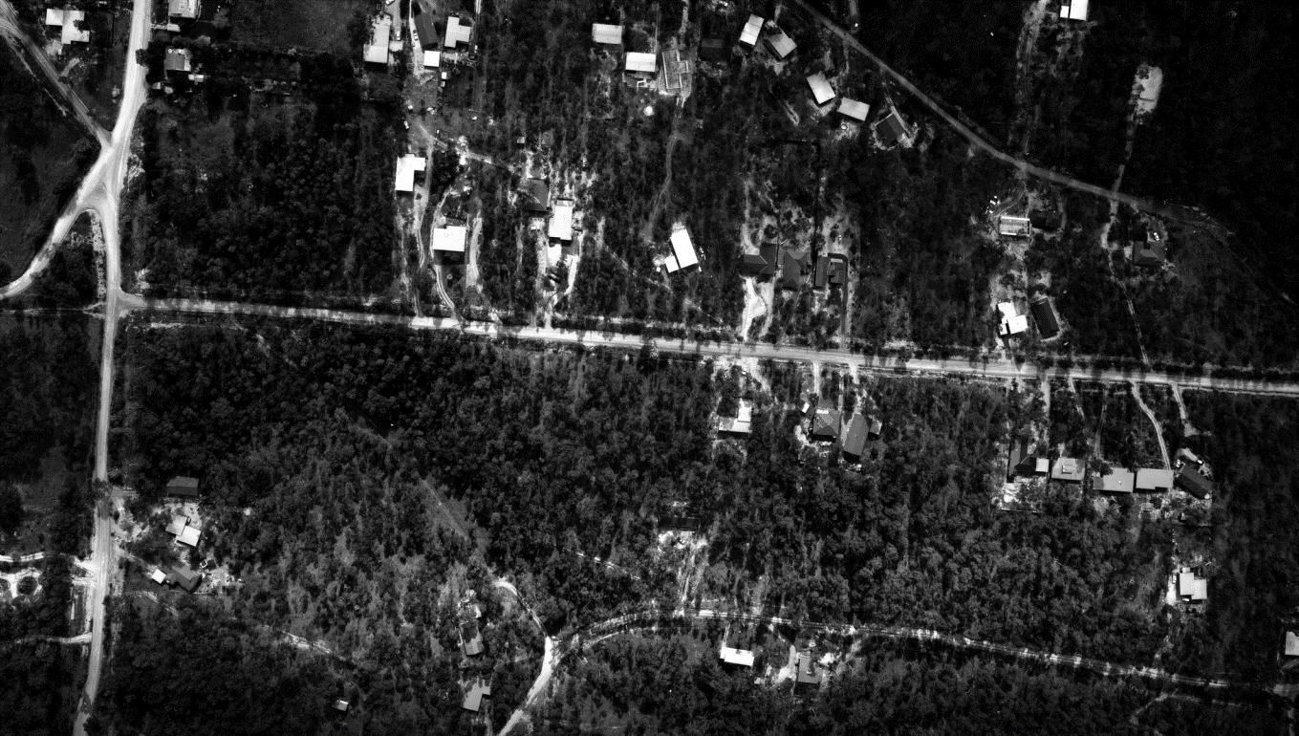
Figure 3. Aerial view of 144 Progress Road, Eltham North, and surrounds in August 1972. The building is not evident. The approximate allotment location is circled in yellow. (Source: CPO, ‘RESEARCH CREEK (8/1972)’ 1972, via LANDATA)
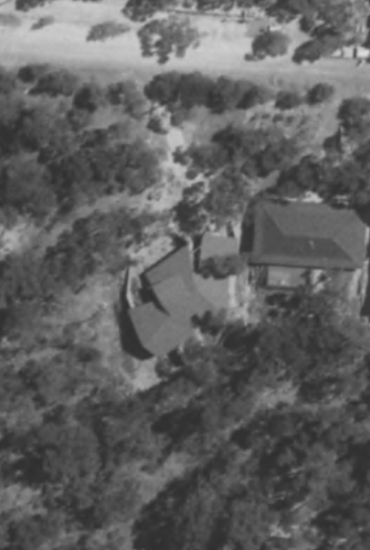
Figure 4. Aerial view of 144 Progress Road, Eltham North, in 1975 (left) and 1987 (right). The approximate allotment boundary is shown in yellow. (Source: CPO, ‘(ALSO A.P. 1227)’ 1975 (left) and ‘WESTERN PORT FORESHORES’ 1987 (right), via LANDATA)
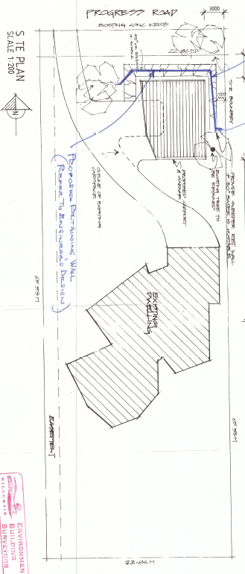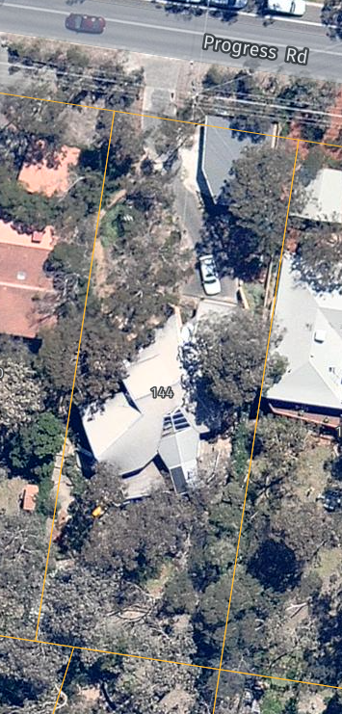
Figure 5. Site plan of 144 Progress Road prepared in 2004 (left) and a 2009 aerial view (right), showing the new carport and garage added in 2004 (outlined in red) and the south-facing family room added between 2004 and 2009. (Source: BP; Nearmap 2009)

DESCRIPTION
The house at 144 Progress Road, Eltham North, built between 1972 and 1975 to a design by architect Glyn Lewis, is constructed predominately of bagged concrete blockwork. Located on the southern side of Progress Road, the house is positioned centrally within a rectangular allotment (Figure 6). The land falls from north to south, providing a secluded setting for the house. Some native and introduced trees exist on the front setback.
A curving paved drive leads from the cross-over at the northwest corner of the block to the original open carport on the eastern side (Figure 7). The recessed entry to the house is accessed via a sloping path located between two converging walls: the western wall of the carport and the eastern walls of the main bedroom and a courtyard to the west.
The subject house sits low in the landscape at its northern end closest to the street but is elevated at its southern end by virtue of the fall of the site, providing views to the south. Its irregular and abstract geometries contrast with the organic forms of the surrounding landscape. In plan, the house comprises a series of fragmented geometric forms with angular wall planes (Figure 8). The internal spaces are distinguished by walls with bagged blockwork and sweeping timber-lined ceilings generated by the house’s complex roof form.
The dynamic roof form is clad in metal roof decking. It comprises several angled roof planes slanting from a central ridgeline that runs generally from northeast to southwest. The main roof ridge has been broken and realigned in association with the northern sections of the building (the bedroom wings) to capture northern light and views to both north and south. Internally, the house is split-level with a small upper floor accessed via a spiral staircase. There is a northwest-facing clerestory window on the upper level (Figure 9). There are two sheltered north-facing courtyards to the north of the residence (Figure 10). A walled courtyard encloses the main bedroom and ensuite area on the north elevation to capture northern light and create sense of intimacy and privacy. A separate enclosed deck is accessed through the dining room.
The original dining room and lounge and the new family room also overlook the backyard to the south, with large expanses of floor-to-ceiling windows and doors that integrate indoor to out. The north-south slope of the site provides unimpeded views from these rooms.
The south-facing kitchen and family room have a large glazed section of roof added between 2004 and 2009. The alfresco area and split-level timber decking with a children’s slide likely date to from the same period.
The backyard, on the south side of the house, is accessed via a sloping footpath on the east. Landscaping elements and garden furniture including a cubbyhouse in the backyard are not original. A carport and garage structure built in 2004 is located at the front of the property but is largely shrouded with vegetation.

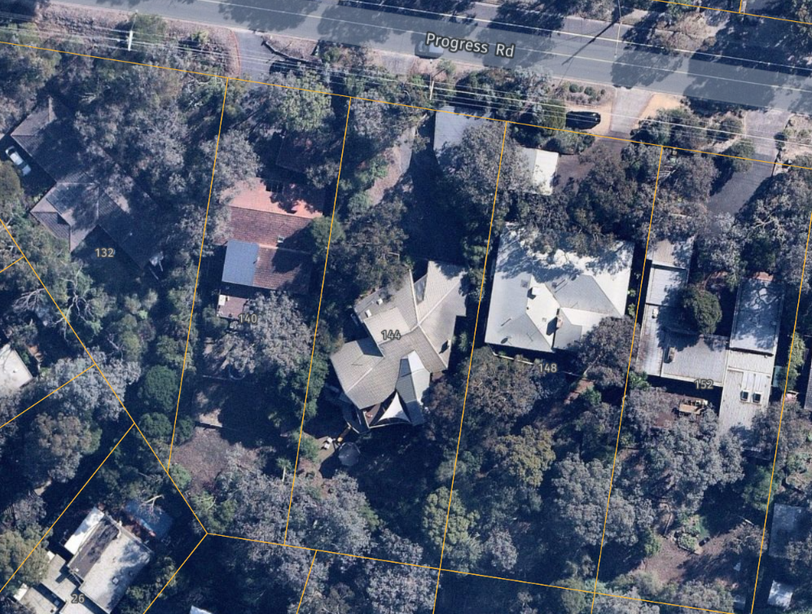
Figure 6. Aerial view of 144 Progress Road, Eltham North (outlined in red), showing its complex corrugated steel roof form. (Source: Nearmap 2021)
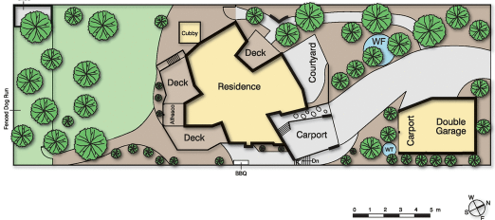 | 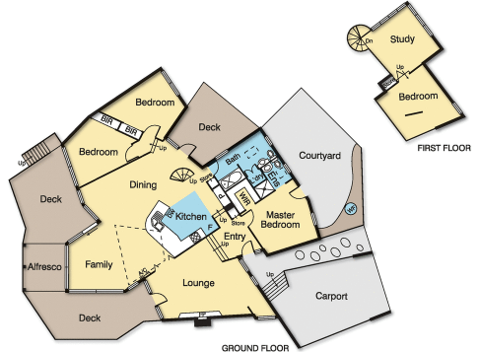
Figure 7. Site plan of the subject site in 2017. (Source: realestate.com.au 2017) | Figure 8. Floorplan of the house in 2017. (Source: realestate.com.au 2017)
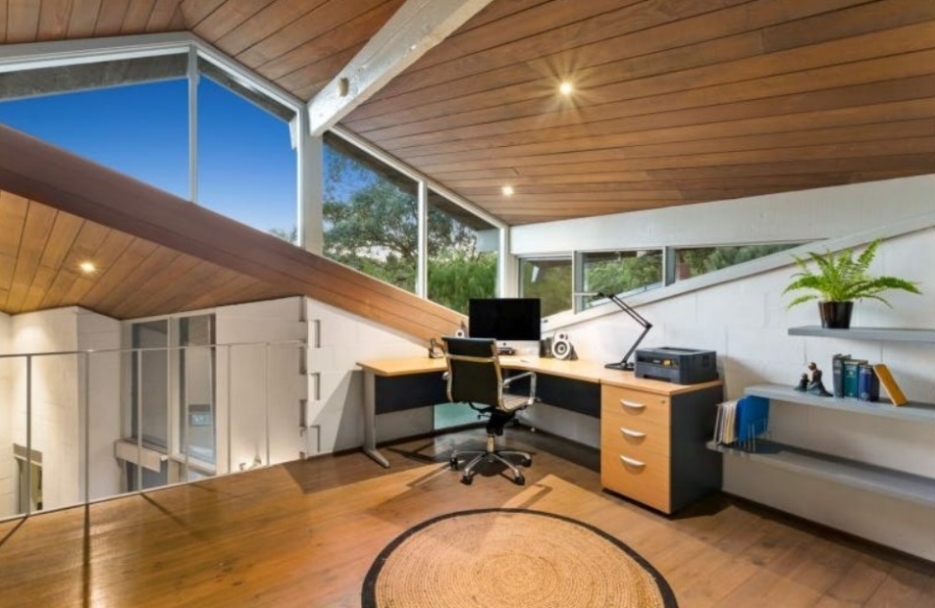
Figure 9. The upper-storey study with the northwest-facing clerestory window. (Source: realestate.com.au 2017)
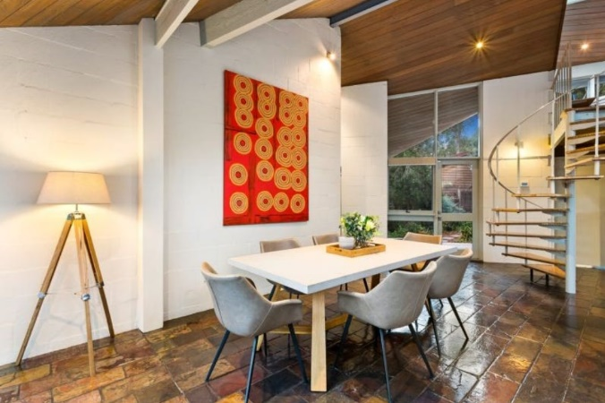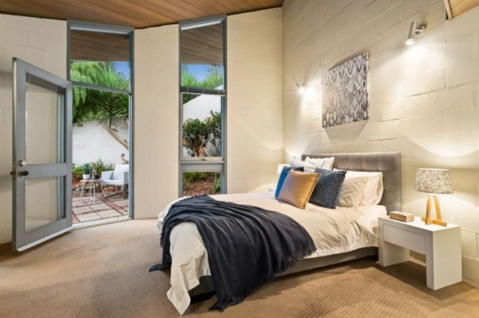
Figure 10. Internal views from the dining room (left) and main bedroom (right). Note the two sheltered north-facing open-air pockets. Also note the spiral staircase. (Source: realestate.com.au 2017)

INTEGRITY
The house at 144 Progress Road, Eltham North, is largely intact, with few changes to the 1970s fabric. The building retains its original built form including a complex, angled roof form; angular wall planes of bagged concrete blockwork; floor-to-ceiling glazing; and the pattern of openings on the original portion of the house. The skylights on the roof and the upper-storey clerestory window facing northwest are also retained.
The south-facing family room added between 2004 and 2009 is not visible from the street. The 2004 carport and garage structure is visible at the front of the property; it is shrouded with vegetation and is not intrusive.
Overall, the house has high integrity to its original design by Glyn Lewis.

COMPARATIVE ANALYSIS
Architect-designed homes became more common in Nillumbik and its surrounds in the postwar period. From the 1970s, up-and-coming Melbourne architects including Kevin Borland, Charles Duncan and Morrice Shaw turned their hand to designing residences in the area. Many of these designs incorporated considerations that had become hallmarks of the ‘Eltham style’ in the immediate postwar period. These included the informality, the use of natural materials and integration with the natural environment. Many of these designs, however, exhibit aesthetic differences that reflected a wider engagement with evolving ideas explored within Australian architecture at the time of their construction. As noted in the Nillumbik Shire Thematic Environmental History, the architect-designed homes of this period featured ‘informality, woodsy detailing, mezzanine floors and sliding doors opening onto timber decks.’ The commonly observed construction materials included bagged brick or concrete, second-hand bricks, window frames stained brown or pale eucalypt green, and diagonal timber lining boards (Mills & Westbrooke 2016:89).
The house at 144 Progress Road, Eltham North both references and departs from the ‘Eltham style’ mudbrick homes that proliferated in the 1950s and 1960s. Its dynamic forms and contrasting materials both consciously respond to and are articulated from the natural world. The architecture presents as a somewhat more discontinuous object within the landscape than earlier ‘Eltham style’ houses. It does not exhibit the same romantic affinity with the landscape, despite being driven by a response to it. It represents a departure from the earthy, organic architectural style that influenced the development of the ‘Eltham style’ with its tendency towards more pure and regular geometric forms and more consciously ‘natural’ materials.
Architect-designed houses from the late 1960s and 1970s are underrepresented on Nillumbik’s Heritage Overlay. The following examples are comparable to 144 Progress Road, Eltham North, for their architectural expression or construction period.
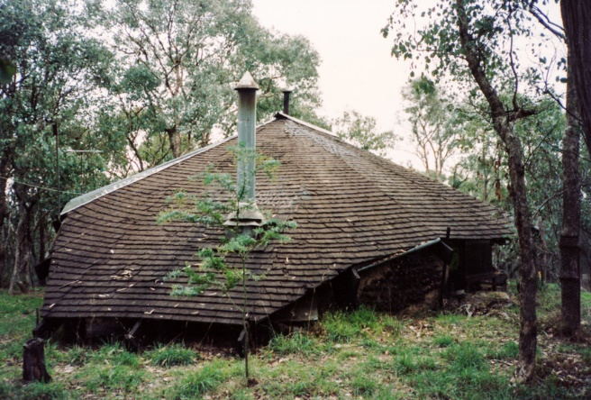  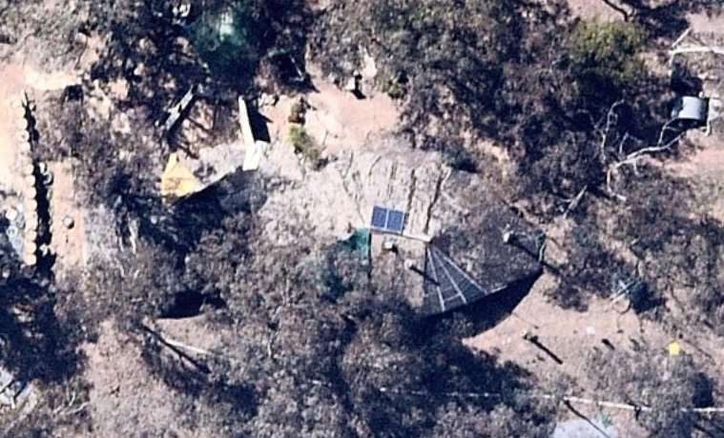  Leon Saper Residence, 60 Dunmoochin Road, Cottles Bridge (HO41). (Source: Victorian Collections; Nearmap 2021) | Built for the well-known potter Leon Saper in c1967, the house is architecturally significant as a work of Morrice Shaw. Shaw was a Modernist architect who worked in the office of Kevin Borland. The house is one of the most creative and unusual dwellings built in Victoria and Australia during the 1960s. It combines the Modernist ideas with the use of mudbrick and recycled materials that are characteristic of the ‘Eltham style’ (VHD).  The house is noted for its highly individualist expression, which Alistair Knox described as ‘one of the most amazing designs that have occurred in mud-brick building’. The building combines a free-form plan with flowing pisé walls and fireplace under a complex organic roof form. It is the earliest known example in Victoria of a strand of the late-twentieth-century organic style (VHD; Mills & Westbrooke 2016:87-89).
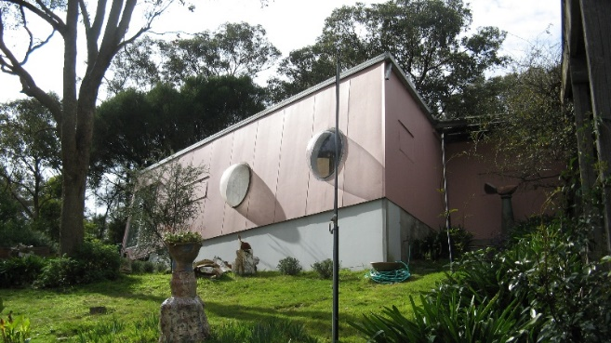  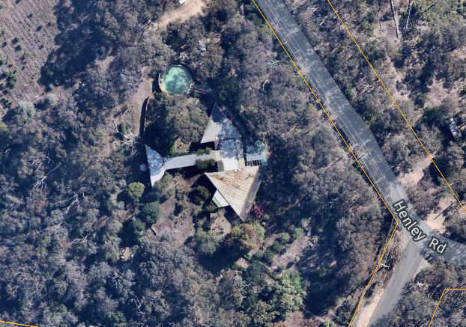  The Burns House (‘Kangaroo’), 644 Henley Road, Bend of Islands (VHR H2314, HO258). (Source: VHD; Nearmap 2021) | The Burns House, known as ‘Kangaroo’, was designed by the architect and artist Peter Burns and built in stages from 1968 on an elevated sloping bush site. The Burns House is made up of three linked triangular-plan pavilions set in informal gardens established largely by Mary Burns. The use of cheap materials, such as fibro cement sheet cladding to the walls and Stramit system ceilings, reflects the relative austerity of the period and the lack of resources of the family (VHD). The inwardly-sloping walls, acrylic dome windows and flaps for ventilation are key design elements. ‘Kangaroo’ was designed not to blend in with the bush setting but ‘as a gesture to come to terms with nature’ (VHD).  The Burns House is architecturally and historically significant at state level.
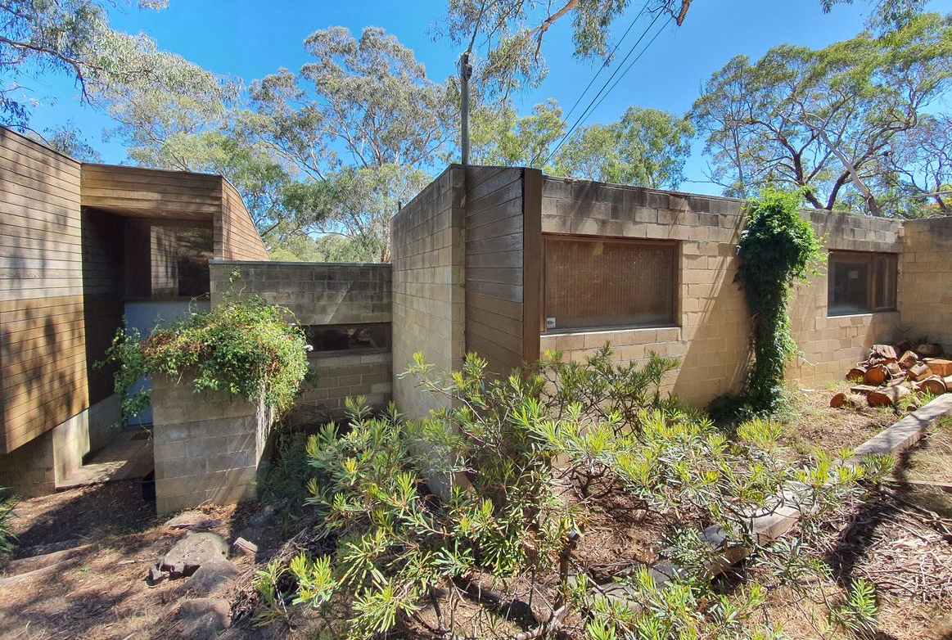  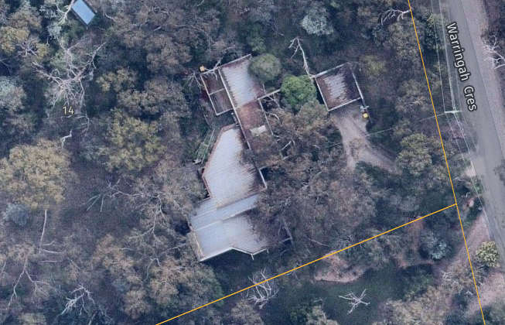  16 Warringah Crescent, Eltham (recommended as an Individually Significant place in this study). (Source: Context 2021; Nearmap 2021) | 16 Warringah Crescent, Eltham, is a substantial concrete block and timber house built c1975 to a design by architect Peter Carmichael of Cocks Carmichael. 16 Warringah Crescent, Eltham, is aesthetically significant as a well-detailed architect-designed house that responds to its sloping bushland block. The house is integrated into the landscape, sited below street level and stepping down the block towards the rear, following the natural fall of the land from east to west. Constructed primarily of clay-coloured concrete blocks, the house is sculptural in form and presents to the street as a series of low interlocking geometric cuboid and angular shapes that both contrast with and complement the natural topography and bush setting of the site.
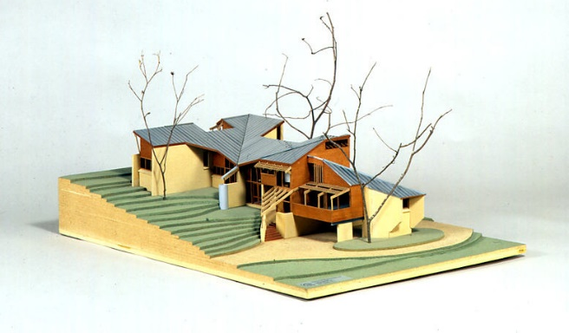  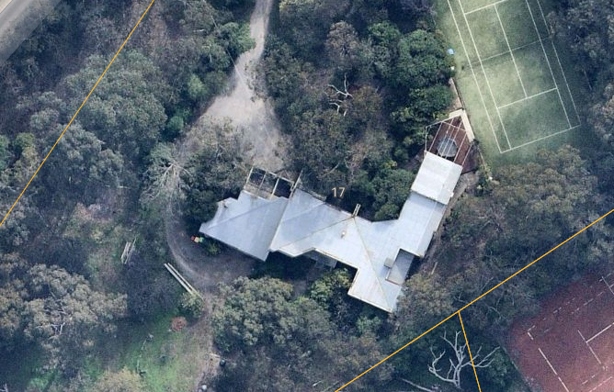  Nichols House, 17 Haldane Road, Eltham (no HO but identified in the Nillumbik Shire Thematic Environmental History). (Source: E. Willis 2009, ‘Nichols House, Eltham, 1972-1973’; Nearmap 2021) | The Nichols House was built in 1973 to a design by architect Kevin Borland. Borland won The Age-RAIA House of the Year Bronze Medal for his design of this large sprawling house of brick and timber, built on a steeply sloping site. The house comprises five different levels with small and large spaces. By 1980 Norman Day wrote that the Eltham area was ‘potted’ with rugged Borland houses (cited in Mills & Westbrooke 2016:89). ‘Their rude frames, rough nailed boards and spiky roofs surprise even the unconservative hill people up there.’ Day further noted that Borland’s signature style of ‘bush-carpentered mixture of simple materials, complex planning and uncompromising form-making’ was perhaps just as suited to the Eltham hillsides as the earlier visions of the mudbrick houses (Mills & Westbrooke 2016:89).

Discussion
144 Progress Road, Eltham North, compares well with the above examples of architect-designed homes of the late 1960s and 1970s that are distinguished from the ‘Eltham style’ mudbrick homes of the earlier decades. These houses represent a period in Nillumbik’s history when a group of architects formulated new and inventive responses to suit the hilly topography of the local area. These examples display individualistic designs that depart from earlier ‘Eltham style’ or Modernist houses that were characterised by far simpler forms, geometries and a more romantic and mimetic identification with the landscape in material terms. The key characteristics that are observed in these later houses include the informality displayed through the irregular geometric plans, the complex broken roof forms, and the sloping walls that reject orthogonal wall planes. The split-level designs with interconnected small and large spaces are also common. Like their earlier ‘Eltham style’ and Modernist counterparts, these buildings responded to the environmental factors of the local landscape including views, topography, sun and wind. They represent, however, a more complex relationship between nature and the built environment with forms that are consciously articulated from it and contrasting with it.
144 Progress Road is distinguished from the Leon Saper Residence (HO41), a pioneering example of the organic architecture in Victoria, which adopts an undulated form. The state-listed Burns House (VHR H2314, HO258) is more similar to 144 Progress Road, Eltham North, for its pursuit of an angular abstract form that sits as a sculptural object within the bush setting. These houses do not attempt to blend in with the natural landscape.
Outside the Heritage Overlay, the architect-designed houses at 16 Warringah Crescent, Eltham (recommended as an Individually Significant place in this study), and 17 Haldane Road, Eltham (no HO but identified in the Nillumbik TEH), are also similar to 144 Progress Road. The houses have a sprawling form that steps down the block, following the natural fall of the land.
Overall, 144 Progress Road, Eltham North, is representative of the innovative architectural explorations of the time. Its notable elements include the irregular geometries, converging and diverging walls, a rejection of orthogonal wall planes, the broken roof ridge and intersecting roof planes, and the pursuit of an angular (rather than undulating) abstract sculptural form.

STATEMENT OF SIGNIFICANCE

WHAT IS SIGNIFICANT?
The house at 144 Progress Road, Eltham North, built c1972-75 to designs by architect Glyn Lewis, is significant.
Elements that contribute to the significance of the place include:
- the original plan comprising a series of fragmented geometric forms;
- the original complex, angled roof form;
- angular wall planes of bagged concrete blockwork; and
- the full-height glazing and pattern of openings including skylights to the roof and a clerestory window;
Later additions including the garage and carport (built in 2004) and the south-facing kitchen and family room area, alfresco and split-level timber decking (built between 2004 and 2009) have been undertaken in a compatible architectural style but are Non-contributory.

HOW IS IT SIGNIFICANT?
The house at 144 Progress Road, Eltham North, is of local representative significance to the Shire of Nillumbik.

WHY IS IT SIGNIFICANT?
The house at 144 Progress Road, Eltham North, is significant as a representative example of an architect-designed house from the late 1960s and 1970s. During this period, Nillumbik saw the development of a new strand of domestic architecture that departed from the ‘Eltham style’ or Modernist houses of earlier decades. The house is responsive to but formally articulated from its bush setting. It does not attempt to blend in with the natural landscape. The notable elements of the subject house include its irregular geometries, weighty converging and diverging walls, a rejection of orthogonal wall planes, the broken roof ridge, intersecting roof planes and the pursuit of an angular (rather than undulating) abstract form. (Criterion D)

RECOMMENDATIONS
Recommended for inclusion in the Schedule to the Heritage Overlay of the Nillumbik Planning Scheme as an Individually Significant place.
Extent of overlay: To title boundaries
Recommendations for the Schedule to the Heritage Overlay (Clause 43.01) in the Nillumbik Planning Scheme:

Nillumbik Planning Scheme
External paint controls | No
Internal alteration controls | No
Tree controls | No
Outbuildings or fences | No
To be included on the Victorian Heritage Register | No
Prohibited uses may be permitted | No
Aboriginal heritage place | No

Other
N/A

REFERENCES
Advertiser, as cited.
Age, as cited.
Blake, Leslie J (ed.) 1973, Vision and Realisation: A centenary history of state education in Victoria, vol. 3, Education Department of Victoria, Melbourne.
Building Permit (BP) for 144 Progress Road, Eltham North.
Central Plan Office, Historic Aerial Photography - 1930s to 1990s, as cited, via LANDATA, https://www.landata.vic.gov.au/, accessed online March-April 2021.
Eltham North Primary School 2020, A Short History, https://www.elthamnorthps.vic.edu.au/history/, accessed online 2 December 2020.
Herald, as cited.
Land Victoria, Certificates of Title (CT) as cited.
McIntyre, Peter, personal communication, 5-6 May 2021.
Mills, Peter & Westbrooke, Samantha 2017, ‘Nillumbik Shire Thematic Environmental History - Revision 2016’, prepared for Nillumbik Shire Council.
Nillumbik Parish Plan 1961, Melbourne, Department of Lands and Survey.
realestate.com.au 2017, ‘144 Progress Road, Eltham North’, https://www.realestate.com.au/, accessed 10 April 2021.
Victorian Collections, ‘Photograph, Leon Saper residence, 60 Dunmoochin Road, Cottlesbridge, 26 May 1991, 26/05/1991’ from the collection of Eltham District Historical Society Inc., https://victoriancollections.net.au/, accessed 10 April 2021.
Victorian Heritage Database (VHD), https://vhd.heritagecouncil.vic.gov.au/, accessed online 30 April 2021.
Victorian Places 2015, Eltham North, Monash University and The University of Queensland, https://www.victorianplaces.com.au/, accessed online 10 December 2020.
Willis, E. 2009, ‘Nichols House, Eltham, 1972-1973’ in Museums Victoria Collections, https://collections.museumsvictoria.com.au/, accessed 15 May 2021.

