200 Ryans Road, Eltham North

Coombe House
Prepared by: Context | Survey date: March 2021
Place type: Residential | Designer: -
Significance level: Significant | Builder: Not known
Extent of overlay: To title boundaries | Major construction: 1933
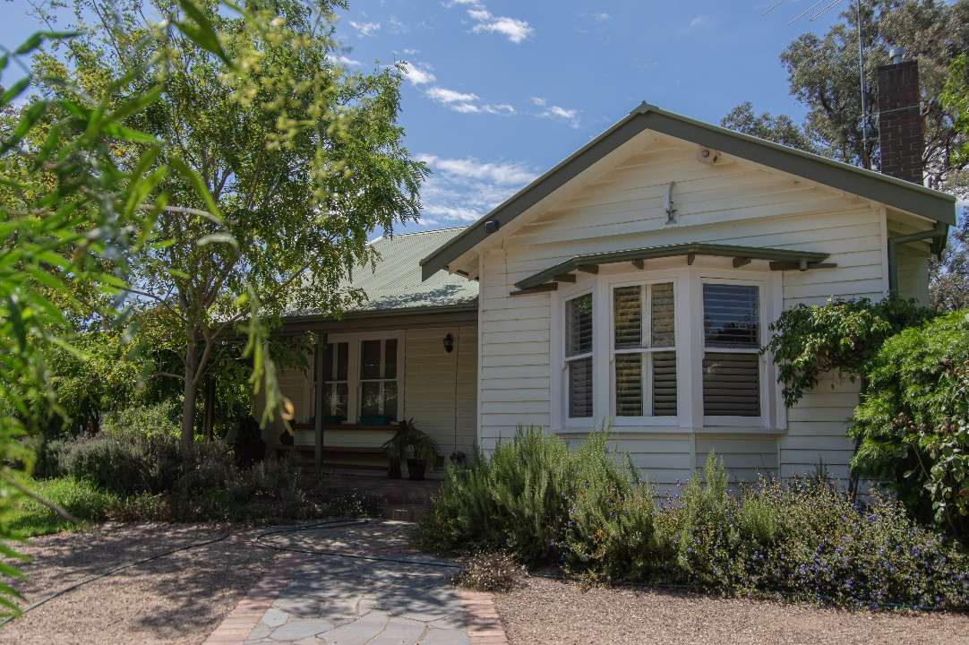
Figure 1. 200 Ryans Road, Eltham North, viewed from the west. (Source: Context, March 2021)
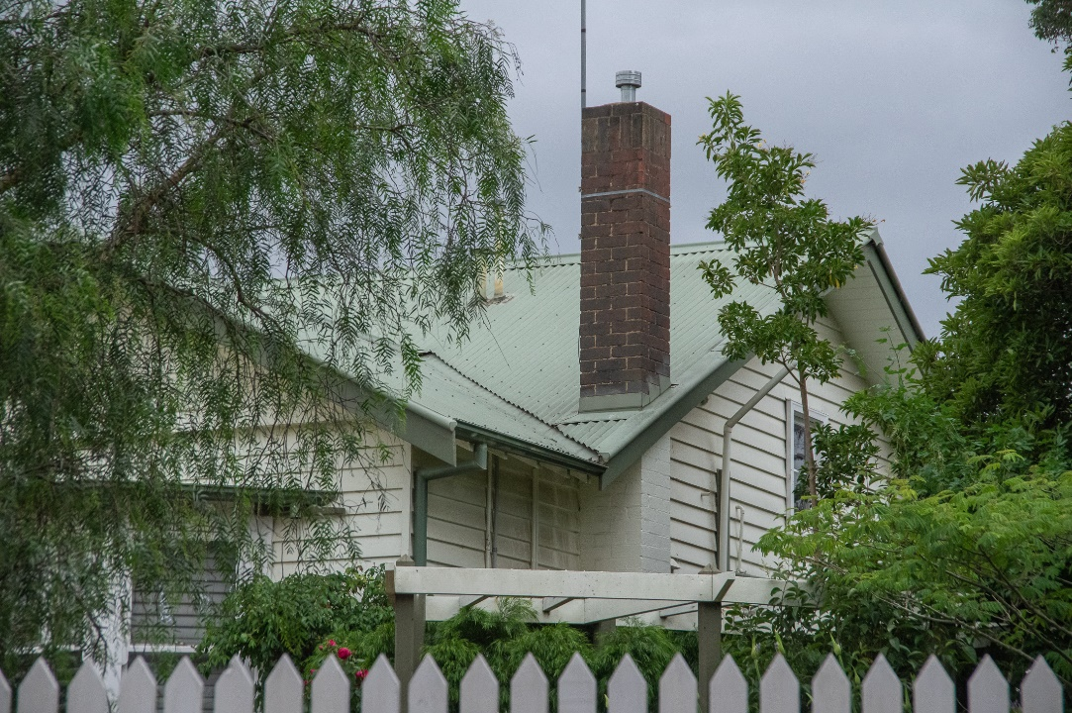
Figure 2. 200 Ryans Road, Eltham North. (Source: Context, March 2021)

HISTORICAL CONTEXT
This place is associated with the following historic themes taken from the Nillumbik Shire Thematic Environmental History (2016):
6 BUILDING TOWNS AND SHAPING SUBURBS
6.3 6.2 Pre-World War I subdivisions and estates
Historians of the Nillumbik area have often focused on the ‘battler’ aspect of settlement in the area but, in the late nineteenth century boom, some speculators had greater aspirations for the locale. In the late 1880s, land estate agents Robert Walker and Company set up a branch in Heidelberg in anticipation of increasing subdivision of estates. In 1888 the Christmas Hills Estate Company purchased land from Mr and Mrs French at £35 per acre, with the anticipation of selling at prices matching those achieved not long before at Mt Macedon, of over £200 per acre. The bottom went out of the land boom before a single block was sold. In all, the land boom of the 1880s had only a fleeting impact on the Nillumbik Shire. (Mills & Westbrooke 2016:69)
From the 1890s Eltham had been included within the boundaries of Greater Melbourne for the purpose of the census, but its setting was still decidedly rural. The first impact of the railway, when it reached Eltham in 1902, was a great expansion in tourism but it was a number of years before new residential subdivisions appeared on the outskirts of the town. These were typically breakups of rural properties from the nineteenth century. In 1909 the Franktonia estate (or Beard’s estate) on the north-east side of Eltham bordering Research was created from land that had been held by the Beard family since 1860. The blocks of six to 29 acres were advertised as ‘well suited for farming and fruit growing and adapted for rural suburban residential purposes, the blocks comprising beautiful crests, some picturesquely wooded’. (Mills & Westbrooke 2016:69)
Two other suburban estates bordering Eltham were subdivided in the same year. These were Bonsack’s estate, which was located between Eltham and Greensborough and Glen Park estate, or Langland’s estate, which was located three-quarters of a mile to the north-west of Eltham Railway Station (Mr John Langlands of Hurst having died in 1907). With all this new development it was expected that at last Eltham would lose its ‘sleepy hollow’ reputation. In 1910 the Evelyn Observer reported that ‘within the last year or two many suburban and city people have invested in building blocks about Glen Park, the Terminus Estate and other parts.’ The Terminus Estate mentioned in the article had 51 allotments, and was first advertised in 1909. In 1910 the council considered the layout of the Terminus Estate. It appears that the proposal included narrow street alignments, but council decided that they must be ‘the full width’. In 1914 a fire threatened a cluster of small ‘weekend’ cottages on the south-east side of the Terminus Estate, near the railway station. At the opening of a new bridge over Diamond Creek at Glen Park in 1915 the chairman of the bridge committee and shire councillors made comments about how far Glen Park, ‘Eltham’s beautiful suburb’, had progressed since it was opened up six years ago. The formation of a Glen Park Progress Association was initiated at this opening. (Mills & Westbrooke 2016:69)
In reality, much of this activity remained speculative and before World War I the area stayed predominantly rural, punctuated by a few small towns. Eltham was still surrounded by cultivated land. To the south, the edge of advancing metropolitan suburbia resulted in infill and consolidation in Montmorency and Greensborough. (Mills & Westbrooke 2016:70)

LOCALITY HISTORY
Eltham North is located on the country of the Wurundjeri-willam clan of the Woi wurrung people.
Diamond Creek separates Eltham North from Eltham and was the dividing boundary between municipalities; Eltham North was in Heidelberg City and, from 1964, in Diamond Valley Shire. In 2001 Eltham North’s western boundary moved from Ryans Road into St Helena. As a result, today Eltham North is located within two local government areas: the City of Banyule and Nillumbik Shire (Victorian Places 2015).
Eltham North, originally an outlying rural part of Eltham, became a separate locality with the opening of the Glen Park (later Eltham North) State School No. 4212 in 1924. At the time the locality was known as Glen Park, with that name recorded in street directories until the 1960s. The postal district, however, was Eltham North (Victorian Places 2015).
Extensive subdivision to the northeast and northwest of Eltham occurred from the first decades of the twentieth century, although residential development was slow due to an absence of electricity and water services. A new bridge across Diamond Creek, opened in 1915, improved connections between Eltham and Eltham North.
The Eltham and Glen Park Progress Association was formed in 1921 and called for the construction of a railway station at Glen Park (later Eltham North), midway between Eltham and Diamond Creek stations. In 1924, the Glen Park Progress Association expected such a station would service 387 blocks in the Bellevue and Beard estates and 313 blocks in the Glen Park Estate subdivision. Glen Park at this time had 89 houses with a largely working-class population of 198 people. It also had 97 weekenders (Mills & Westbrooke 2017:72).
Glen Park Primary School No. 4212 was subsequently opened after the Progress Association petitioned the Education Department, stating that the population of the area was growing and complaining that children had to walk two to three miles to Eltham or Diamond Creek schools. The first school opened in May 1924, with 38 pupils, in a private house called ‘Rest-a-While’ in Lower Glen Park Road, where it operated for the next 17 months. In 1925 it was relocated to a single room transported by wagon from Greensborough and moved to land in Banks Road (Eltham North Primary School 2020; Blake 1973:138). The school’s name was changed to Eltham North in that year (Blake 1973:138).
In 1925 a building for the Glen Park Gospel Mission was erected (Advertiser 4 December 1925:3).
Local builder Alistair Knox designed and constructed a number of mud-brick houses in the area from the late 1940s, contributing to a style of architecture that became known as the ‘Eltham style’.
Reflecting the postwar growth in the area, by 1952 there were 62 children attending the Eltham North State School, and in 1953 a new school building was completed in Wattletree Road (Blake 1973:138).
Today the primary school is in the east of the suburb, adjacent to the Glen Park Gospel Church and local shops. There is a kindergarten in Glen Park Road. Eltham North has numerous bushland reserves and playgrounds (Victorian Places 2015).

PLACE HISTORY
The 1933 house at 200 Ryans Road is located on part of Crown Allotment B Section 11, 90 acres purchased by John Dane in 1852 (Nillumbik Parish Plan 1951).
In 1913, estate agent George Herne purchased the allotment along with neighbouring Crown Allotment D, a total of 198 acres. Herne then subdivided the Crown allotments to form a large residential subdivision, with lots sold from 1913 (Figure 3) (CT:V3682 F252). The area near Glen Park Road was known as the Glen Park, named after the residential subdivision Glen Park Estate established in 1909 (Figure 3). By 1924 the estate comprised 313 blocks (Mills & Westbrooke 2017:72). Because of a lack of services, residential development on the estate was initially slow (Mills & Westbrooke 2016:72).
Figure 3. Part of plan of subdivision at Glen Park, 1913, with approximate boundaries of the subject property outlined in yellow (LHS), and an advertisement for the Glen Park Estate in 1909 (RHS). (Source: CT:V3682 F252; Age 13 November 1909:19)

The land comprising the subject site was sold in 1913, but the subject site remained undeveloped until the 1930s. Ironmonger Arnold Longbottom purchased Lots 2, 3, 70, 71, 72, 73 and 74 of Block B of the subdivision in 1913 (CT:V3739 F601). In 1922, carpenter Thomas Sidwell purchased the aforementioned Lots 2 and 3, along with neighbouring Lot 1 (CT:V4626 F196). Sidwell owned the property until 1931, when his daughter Elsie Coombe (nee Sidwell) became the owner of the three allotments (CT:V4626 F196; Age 14 January 1932:1).
Elsie Sidwell married George William Coombe in 1928 (Ancestry 2021). In 1933, the Hurstbridge Advertiser reported that a villa for Mr Combe [Coombe], facing Ryans Road, was in the course of erection (Advertiser 5 May 1933:1). In 1934, the Commonwealth electoral roll for the subdivision of Diamond Creek listed Elsie Coombe, and traveller, George Coombe, as living at Ryans Road, Mt Hermon, Eltham (ER 1934). The Coombes lived at the property until around 1946 when ownership changed to Violet Hannah; William Wallace became the owner in 1948 (CT:V4626 F196).
The residential development in the 313-lot subdivision of the Glen Park Estate had not fully progressed in the postwar period. The house built for the Elsie and George Coombe was one of the few buildings constructed in the immediate area, shown on the aerial photographs from 1945 and 1951 (Figure 4 Figure 5). Not many houses depicted on the two aerials were replaced with later housing stock.
The property was subdivided in 1968, with Klaus and Ruth Klein becoming the proprietors of Lots 2 and 3 in that year (CT:V8733 F564). In 1992 the property was again subdivided with the subject property located on Lot 1 of that subdivision (CT:V10058 F056).
In 1998, a building permit for a garage with verandah was issued (BP).
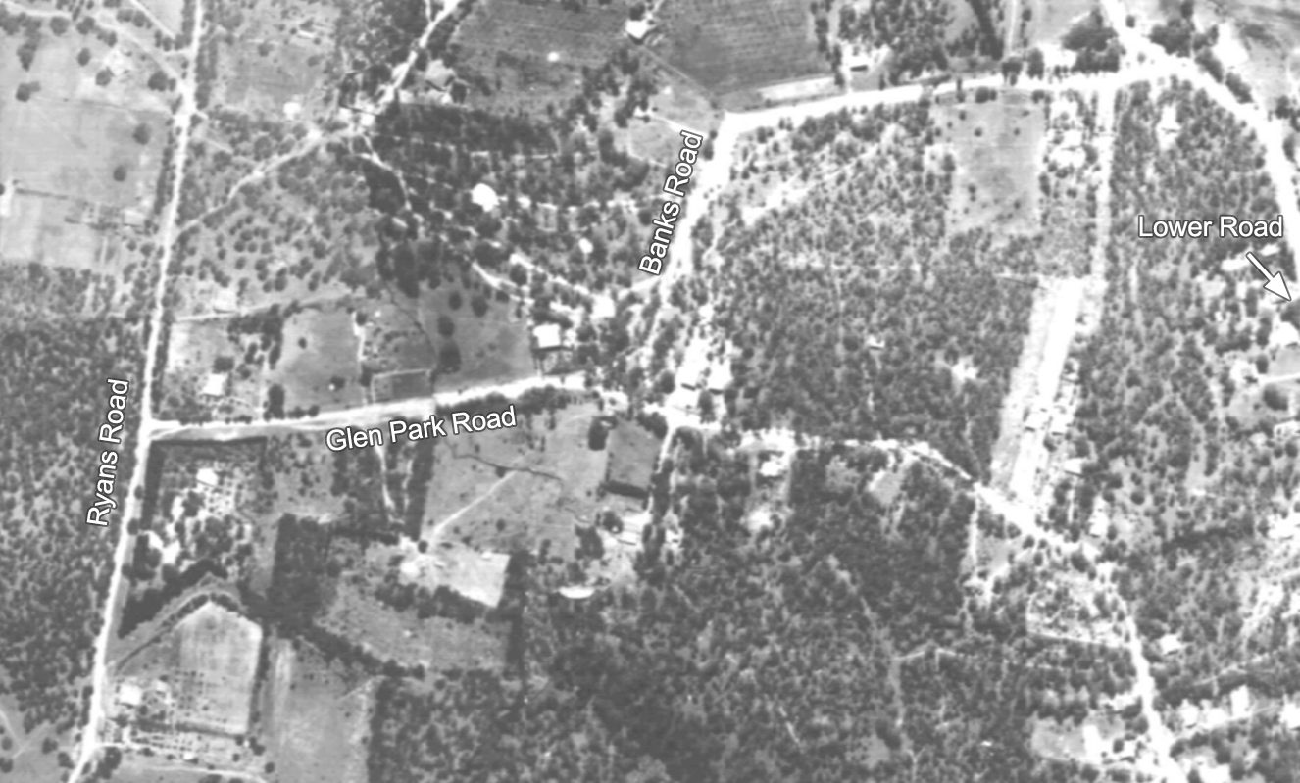
Figure 4. Extract from a 1945 aerial photograph with subject property outlined in yellow. There was more residential development towards the east of Glen Park Road and in Lower Road at this time. (Source: ‘Melbourne 1945’, University of Melbourne)

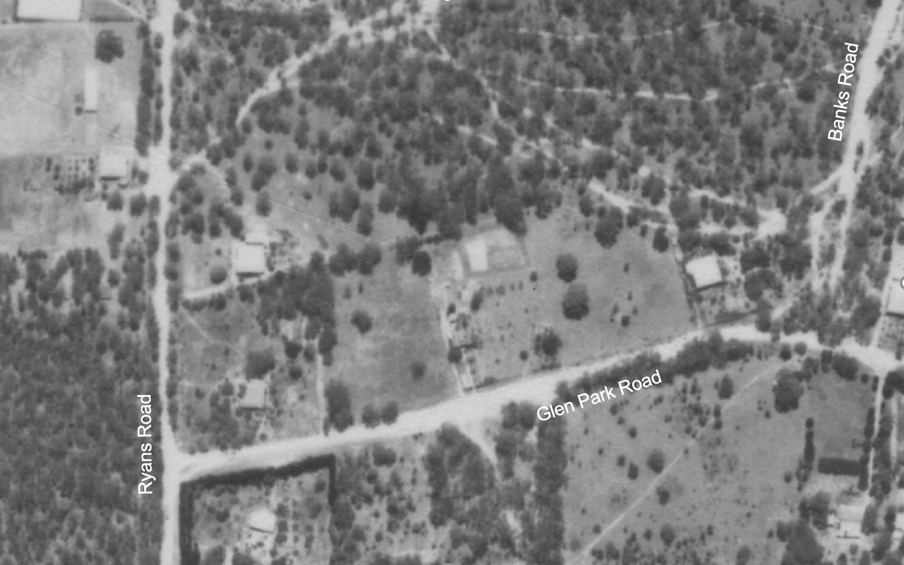
Figure 5. Extract from a 1951 aerial photograph with subject property outlined in yellow. (Source: CPO, ‘MELBOURNE AND METROPOLITAN PROJECT’ 1951, via Landata)

DESCRIPTION
200 Ryans Road, Eltham North, is a single-storey timber-framed house built in 1933 for then owners Elsie and George Coombe. The subject site is located on the elevated eastern side of Ryans Road, between Glen Park Road and Hillcrest Road.
200 Ryans Road a single-storey asymmetrical timber house that has a main gabled roof form with an intersecting transverse gable to the principal façade. The roof is clad in corrugated iron, however this appears to be a later alteration. The house retains a narrow brick chimney topped with soldiered bricks; this chimney has been painted below the eaves and left as face brick above the roofline. The main front verandah is set beneath an extension of the main gable form, and supported by plain timber posts that may be later alterations. The verandah returns down the side of the house, and features a brick floor. To the projecting bay has a canted bay window with a flat roof on exposed rafters. The single-storey double-fronted built form with a projecting bay, canted bay window, use of exposed rafters, deep verandah and face brick chimney are typical of the small to medium size interwar bungalows built in the 1930s.
The house has been extensively altered beyond the primary roof form, particularly to the rear. The property also comprises other recent elements including a garage with verandah erected in 1998, in the northwest corner of the property. To the direct north of the house, an annexe building has been constructed; this is accessed from the main house by an enclosed walkway. Another outbuilding sits close to the northern boundary of the property. There is a swimming pool near the eastern corner of the property.
The property has a wide setback with front garden, comprising substantial trees mostly dating from the late twentieth century. Some early plantings include a rose bush near the northern boundary.

INTEGRITY
The Coombe House at 200 Ryans Road, Eltham North, is generally intact with minimal changes visible to the original 1933 fabric as viewed from the street. The building retains the original asymmetric form and transverse gables, and key stylistic detailing such as a canted bay window with exposed rafters, deep verandah and brick chimney. Significant alterations have been made to the rear and side of the house, including addition of an annexe building accessed by an enclosed walkway. Overall, the house remains clearly legible as an interwar house.

COMPARATIVE ANALYSIS
From the 1890s, the defined area of Greater Melbourne had been expanded to include Eltham and the surrounding district for the purpose of censuses. Despite being included within these boundaries, the area continued to be predominantly rural. The interwar period, however, saw an increase in development and suburbanisation of within the broader Nillumbik area. Following World War I, the ideal of small detached houses set within gardens became increasingly popular, causing a ‘dramatic expansion’ of the greater metropolitan areas of cities (Raworth 1991:9). This preferred housing form, along with the introduction of regular railway services, affordable land and the promise of electrification, encouraged many to come to the Nillumbik area and build homes in the interwar period.
Likely due to a combination of continuing agricultural land use and lack of suburban utilities, development in areas outside the main streets of townships in Nillumbik was still slow. Most houses that appeared in new subdivisional estates in the early twentieth century were modest weatherboard, timber-framed structures. Reflecting the popular architecture of the time, many chose to build ‘bungalows’. The early bungalows from the 1920s were commonly associated with the Californian Bungalow style, which usually featured a high level of detailing. Many houses built in the same period or later, however, conformed to a broader interwar bungalow type, especially those in outer suburban and semi-rural areas. These houses were generally small, single-storey, double-fronted dwellings with dominant verandahs with exposed rafters and beams (Raworth 1991:11). The bungalow form became popular with speculative builders and institutional building schemes, such as that of the State Savings Bank in Victoria. Due to the financial constraints of the 1930s and influence of Modern styles, many bungalows of the 1930s moved away from rustic and crafts-based designs of the earlier decade and are difficult to classify within a specific style.
The following places are comparable to the subject site, being other examples of bungalows in Nillumbik.
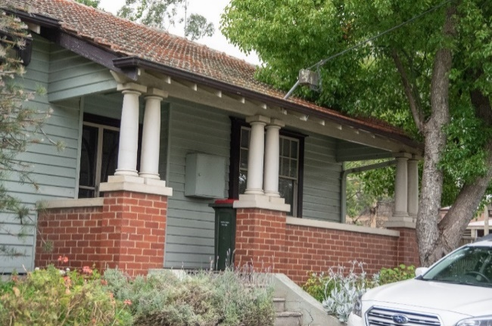  856 Main Road, Eltham (recommended as Individually Significant). (Source; Context 2021) | The property at 856 Main Road, Eltham, is a single-storey timber residence constructed in 1929 to a 1927 design created by the State Savings Bank of Victoria. These State Savings Bank houses were generally modest adaptations of the bungalow style and allowed customers to build affordable houses in the interwar period.
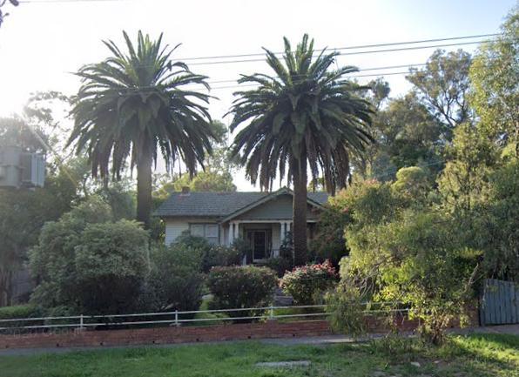  836 Heidelberg-Kinglake Road, Hurstbridge (HO264). (Source: Google 2019) | The property at 836 Heidelberg-Kinglake Road, Hurstbridge, is aesthetically significant as a substantially intact example of an interwar bungalow constructed c1923. Its aesthetic value is enhanced by the intact front garden and fence, including the two Canary Island Palm trees framing the entry to the residence. The residence is demonstrative of the township’s dominant period of development which was stimulated by the orchard industry and introduction of the railway line in 1912 (VHD).
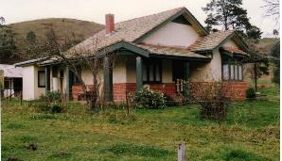  25 Cottles Bridge-Strathewen Road, Cottles Bridge (HO190). (Source: VHD) | The property at 25 Cottles Bridge-Strathewen Road, Cottles Bridge, is significant as one of few brick houses built prior to 1930 in Nillumbik. It is unique in the municipality as an example of the transitional bungalow style, exhibiting elements of both the interwar and Federation eras. It is also significant for its association with Thomas Cottle, the namesake of the Cottles Bridge area, the Cooke orcharding family and the probable builder of the house, Caffin (VHD).
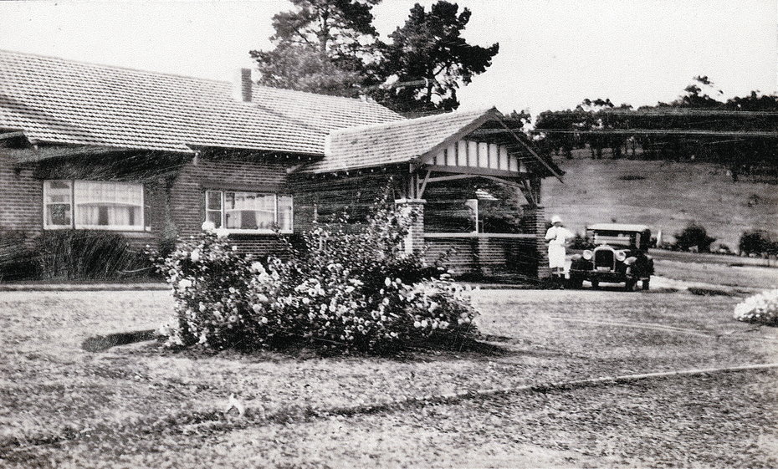  10-26 Banoon Road, Eltham (HO7). (Source: VHD) | The property at 10-26 Banoon Road, Eltham, is historically significant for its associations with the notable anthropologist Donald Thomson, who lived there from the mid-1930s. Built c 1922, it is also important as one of a few substantial homes erected in the Shire during the interwar period, illustrating Eltham's development into a desirable residential locality. It survives as one of few properties to retain its intact farm setting (VHD).
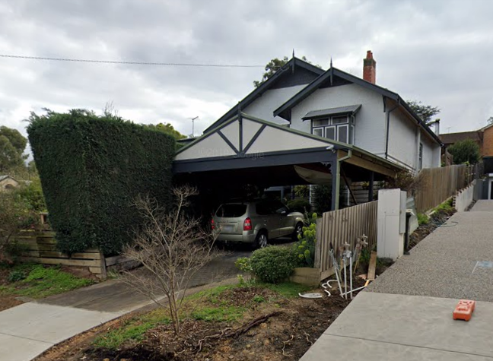  20 Clyde Street, Diamond Creek (HO184). (Source: Google 2019) | The c1920s residence at 34 Clyde Street is of aesthetic significance as a substantially intact California Bungalow demonstrating distinctive design features, which respond to its corner siting with views. These features are the return corner verandah and the corner bay window, both taking advantage of the views from the corner of Cowin and Clyde Streets. The building is of significance for its associations with the Ryan family who were early and prominent residents in Diamond Creek (VHD).

Other areas outside the Shire of Nillumbik exhibit common land development patterns, changing from predominantly rural to semi-suburban areas during the interwar period. The following examples are located in other surrounding municipalities that experienced a similar transition towards suburbanisation at that time.
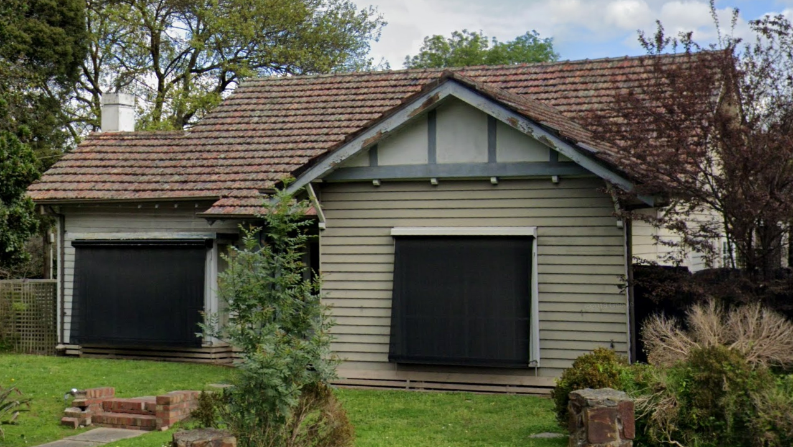  144-146 Mt Dandenong Road, Croydon (HO47, Maroondah City). (Source: Google Streetview) | 144-146 Mt Dandenong Road, Croydon, is an asymmetrical timber house built c1929. The land the house sits on has since been further subdivided, however retains early trees and fences in its garden setting. The house demonstrates the type of housing that was appearing in Croydon during the interwar period, as the area became increasingly transformed (VHD).
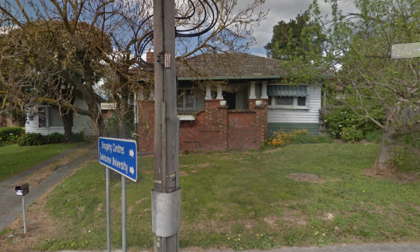  Lilydale Interwar House Types, 30 Anderson Street, Lilydale (Significant within HO412, Yarra Ranges Shire). (Source: Google Streetview) | 30 Anderson Street, Lilydale is a modest suburban interwar house. It is one of a group of similar houses in Lilydale built in the 1920s and 1930s that illustrate the shift from rural living to a more suburban mode of development during the interwar era with housing types that reflected popular typologies and style used in other built-up areas of Melbourne (VHD).
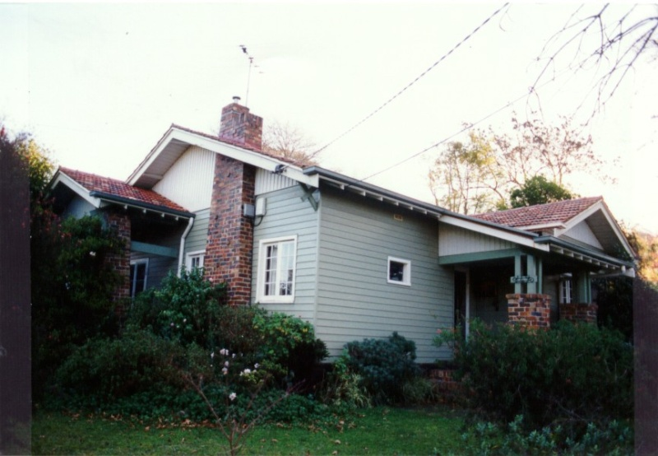  149 Mt Dandenong Road, Croydon (HO105, Maroondah City). (Source: VHD) | 149 Mt Dandenong Road, Croydon is a timber Californian Bungalow built c1929, likely to a State Savings Bank of Victoria design. The house is historically significant as it represents the way in which housing was provided in the predominantly rural area of Croydon during the late 1920s. The property is significant as a highly intact and representative example of a State Savings Bank house in the area, which features two linked groups of similar houses (VHD).

Discussion
The Coombe House at 200 Ryans Road, Eltham North, is of later construction date (1933) than the examples above. As a house built during the time when a general lack of material affluence was evident, the subject house demonstrates key elements typical of 1930s bungalow, which generally incorporated more restrained decorative detailing. The house displays built form elements typical of bungalow types, including a main gabled roof form with an intersecting transverse gable to the principal façade and projecting bay with a flat roofed canted bay window.
The subject house’s timber construction and siting within a suburban subdivision sets it apart from examples of the 1920s bungalows on the overlay such as 25 Cottles Bridge-Strathewen Road, Cottles Bridge, and 10-26 Banoon Road, Eltham, which are of brick construction and set within extensive grounds. The subject house forms a closer comparison with the timber bungalows at 836 Heidelberg-Kinglake Road, Hurstbridge, and 20 Clyde Street, Diamond Creek, located within the more suburban areas of the municipality.
200 Ryans Road, Eltham North, compares well to the above examples of modest interwar housing listed on the Heritage Overlay in surrounding municipalities (30 Anderson Street, Lilydale, 149 and 144-146 Mt Dandenong Road, Croydon), in terms of scale, design elements, materials and setting. Particularly comparable to the house at 144-146 Mt Dandenong Road, the subject building and the above examples have generous setbacks with front garden settings facing primary roads.
The subject house is an example of 1930s bungalow types which reflected the frugal economic context of their construction period in their simple forms and restrained detailing. It remains legible as an early home in the Glen Park Estate subdivision.

STATEMENT OF SIGNIFICANCE

WHAT IS SIGNIFICANT?
The Coombe House at 200 Ryans Road, Eltham North, a single-storey timber-framed and clad interwar bungalow built c1933 for Elsie and George Coombe, is significant.
Elements that contribute to the significance of the place include:
- original asymmetrical bungalow form and scale;
- transverse gable roof form, with front verandah;
- remaining brick chimney;
- canted bay window with flat roof and exposed rafters; and
- deep setback, garden setting and elevated position above the roadway.
The outbuildings, front fence and rear extensions are not significant.

HOW IS IT SIGNIFICANT?
The Coombe House at 200 Ryans Road, Eltham North, is of local historic and representative significance to the Shire of Nillumbik.

WHY IS IT SIGNIFICANT?
The Coombe House at 200 Ryans Road, Eltham North, is historically significant as a house built in the Glen Park Estate area of Eltham North during the 1930s, demonstrating the uptake of properties during the interwar period. Although the Glen Park Estate had been subdivided prior to World War I, the interruptions resulting from the outbreak of war, the Depression, and a lack of services, meant that the land was not rapidly developed. The subject site is important as one of the earliest surviving houses from this initial development period of the Glen Park Estate area of Eltham. (Criterion A)
The house at 200 Ryans Road is also of representative significance, as a 1930s timber house built during the time when a general lack of material affluence was evident. The house demonstrates key elements typical of 1930s bungalow, which were designed with more restrained decorative detailing than bungalow types of earlier decades. The house displays elements of the bungalow style, including a main gabled roof form with an intersecting transverse gable to the principal façade and projecting bay with a flat roofed canted bay window. 200 Ryans Road is also representative of the type of housing being built in formerly rural areas surrounding Melbourne, as they rapidly suburbanised during the interwar period. (Criterion D)

RECOMMENDATIONS
Recommended for inclusion in the Schedule to the Heritage Overlay of the Nillumbik Planning Scheme as an Individually Significant place.
Extent of overlay: To title boundaries
Recommendations for the Schedule to the Heritage Overlay (Clause 43.01) in the Nillumbik Planning Scheme:

Nillumbik Planning Scheme
External paint controls | No
Internal alteration controls | No
Tree controls | No
Outbuildings or fences | No
To be included on the Victorian Heritage Register | No
Prohibited uses may be permitted | No
Aboriginal heritage place | No

Other
N/A

REFERENCES
Advertiser, as cited.
Age, as cited.
Australian Electoral Commission, Electoral Rolls (ER), 1903-1980, via Ancestry.com, https://www.ancestry.com.au, accessed 12 March 2021.
Blake, Leslie J (ed.) 1973, Vision and Realisation: A centenary history of state education in Victoria, vol. 3, Education Department of Victoria, Melbourne.
Building Permit for 200 Ryans Road, Eltham North (BP).
Central Plan Office (CPO), Historic Aerial Photography: 1930s to 1990s, as cited, via Landata, https://www.landata.vic.gov.au/, accessed online March-April 2021.
Eltham North Primary School 2020, A Short History, https://www.elthamnorthps.vic.edu.au/history/, accessed online 2 December 2020.
Herald, as cited.
Land Victoria, Certificates of Title (CT), as cited.
‘Melbourne 1945 Photo-maps’, University of Melbourne, http://maps-collection.library.unimelb.edu.au/ historical/1945melb/, accessed online June 2020.
Mills, Peter & Westbrooke, Samantha 2017, ‘Nillumbik Shire Thematic Environmental History - Revision 2016’, prepared for Nillumbik Shire Council.
Nillumbik Parish Plan 1951, Melbourne, Department of Lands and Survey.
Raworth, Bryce 1991. ‘Our Interwar Housing’. National Trust of Australia (Victoria), Melbourne.
Victorian Places 2015, Eltham North, Monash University and The University of Queensland, https://www.victorianplaces.com.au/, accessed online 10 December 2020.

