14-16 Warringah Crescent, Eltham

House
Prepared by: Context | Survey date: February 2021
Place type: Residential | Designer: Peter Carmichael
Significance level: Significant | Builder: Not known
Extent of overlay: To title boundaries | Major construction: c1975
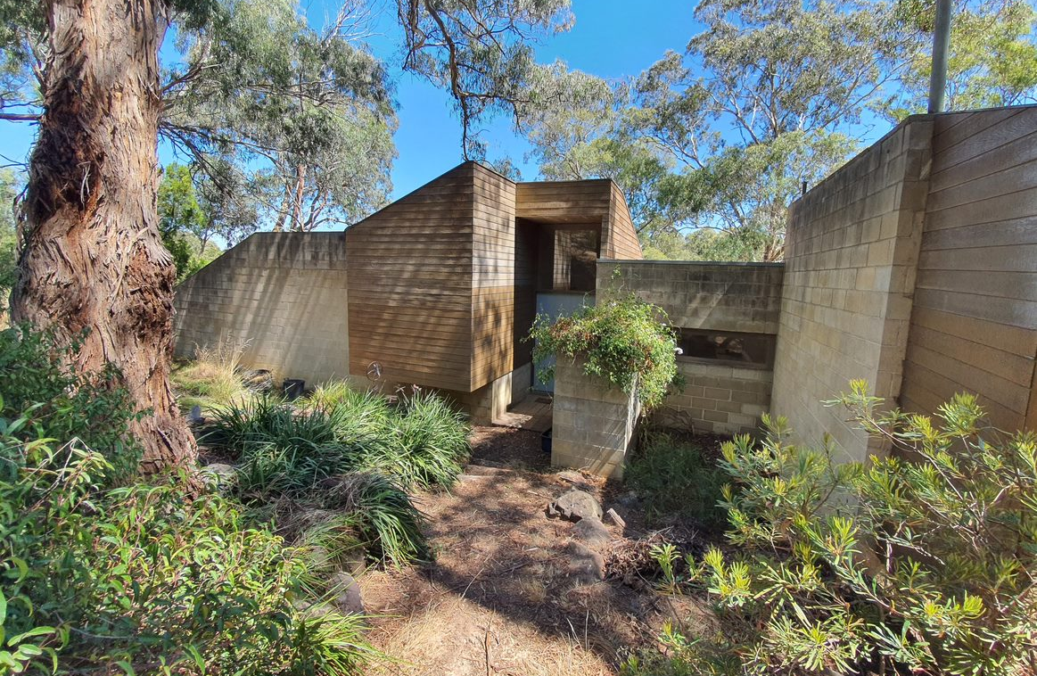
Figure 1. The principal elevation of 14-16 Warringah Crescent, Eltham, looking south-easterly. (Source: Context 2021)
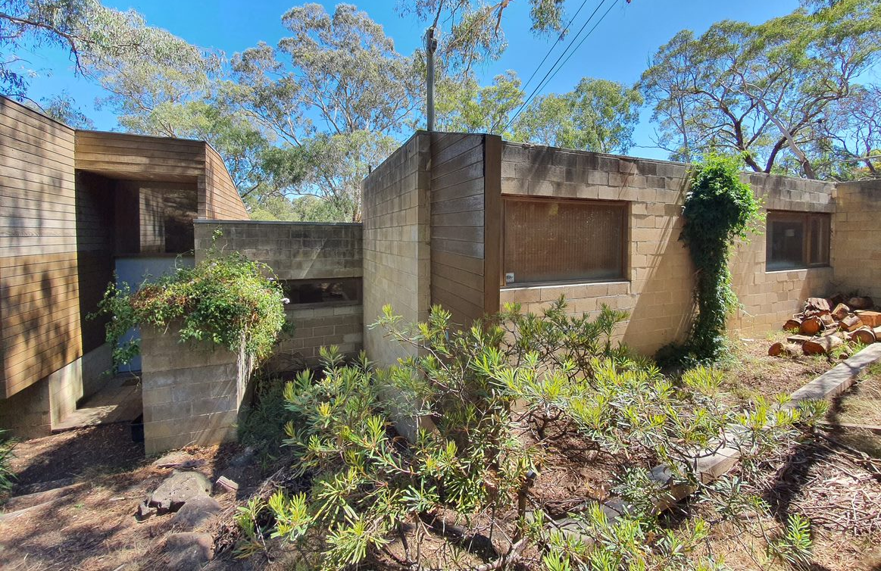
Figure 2. The principal elevation of 14-16 Warringah Crescent, Eltham, looking north-easterly. (Source: Context 2021)

HISTORICAL CONTEXT
This place is associated with the following historic themes taken from the Nillumbik Shire Thematic Environmental History (2016):
6 BUILDING TOWNS AND SHAPING SUBURBS
6.6 1960s and 1970s suburbanisation
From the mid-1960s the main suburban expansion in the former Eltham Shire area was east from Eltham, aided by the construction of the new Fitzsimons Lane (Eltham–Templestowe) bridge in 1963. This expansion was limited by topography and by methods of corridor planning including the green wedge and rural zoning. As a result, the eastwards trend would not extend past Research. The occupants of this new residential area were typically high-income families commuting to work in the city. When author and diplomat Graham McInnes returned to Melbourne in 1969 after leaving in the 1930s, he said that one of the most noticeable differences was that ‘Eltham was the country, now it is right in Melbourne.’ (Mills & Westbrooke 2016:87)
Residents who had established themselves in the early postwar period questioned the bona fides of this new wave of aspiring bushland home owners. [Alistair] Knox described how ‘the rich and affluent eastern suburbanites started casting sheep’s eyes at this unkempt bushscape: ‘Eltham was once again under threat from the land profiteer, who would butcher the living qualities of its inhabitants to make their Roman holiday.’. On the other hand, the middle-class professionals of this new influx were environmentally conscious, politically well informed and numerous enough to exert a profound effect on the conservation of the surrounding landscape. (Mills & Westbrooke 2016:87-88)
By the 1970s, the aesthetics of the bush that had been developing throughout Australia were influencing the more sought-after city fringe suburban developments. These suburban developments adopted some of the trappings of environmental building that had been developed, in part, by the Eltham mud brick pioneers. The environmental thinking had been translated into a set of standard approaches, including preservation of existing trees, adaptation to contours, underground services and establishment of a network of linked bush parks. Road planning strategies such as cul-de-sacs enabled isolation from busy through streets. Roads were softened with low-profile gutters and the transition from road to driveway was softened with the use of paving materials in the road surface. Even so, these developments substantially remade the landscape. (Mills & Westbrooke 2016:88)
In the 1970s the Nillumbik area and nearby suburbs were graced with a number of residences designed by up-and-coming architects of the day including Kevin Borland, Charles Duncan and Morrice Shaw. Philip Goad describes their works as ‘free and inventive compositions’ and ‘programmatically innovative’. Their designs featured informality, woodsy detailing, mezzanine floors and sliding doors opening onto timber decks. Other features included bagged brick, or brick seconds, window frames stained brown or pale eucalypt green and diagonal timber lining boards. (Mills & Westbrooke 2016:89)

LOCALITY HISTORY
Eltham, situated in hilly country northeast of Melbourne, is located on the country of the Wurundjeri-willam clan of the Woi wurrung, one of the five tribes of the Kulin Nation. A small, short-lived reservation south of Eltham on the Yarra River was set aside for Aboriginal people in 1852. The area is situated near the junction of the Yarra River and its tributary, Diamond Creek.
Pastoral settlers moved into the area from around 1840 and took up pastoral leases (Bartolomei 2008). It was located proximate to the track used by the Ryrie brothers to provide access between their ‘Yering’ run, near Yarra Glen, and the Heidelberg village (Victorian Places 2015). In 1841, William Bell and Thomas Armstrong occupied land for a squatting run east of Diamond Creek in what was to become the Eltham district (Eltham District Historical Society 2000: np).
A plan for 50 allotments in the Township of Eltham, Parish of Nillumbik, was announced in 1848, with the name officially gazetted in 1851. The township, near the junction of Diamond Creek and the Yarra River, was laid out in an area bounded by Baxter Street, Diamond Creek, Dalton Street and Bolton Street. The township plan shows that a track to a bridge across Diamond Creek and Main Road was noted as the ‘Track from Melbourne’ (Butler 1996:32). This area is known today as Eltham South.
Present-day Eltham, however, was not established on the township reserve, where land proved difficult to sell. Instead, the town grew from allotments in Section IV of the Parish of Nillumbik located on Main Road, to the north of Dalton Street and the township reserve (Butler 1996:32). In 1851, Melbourne property developer Josiah Holloway purchased one square mile (or 5120 acres) of this land, which he subdivided immediately, calling the subdivision Little Eltham. The central area of current-day Eltham is contained within the Little Eltham subdivision. A number of large farming properties around the township were purchased from the early 1850s (Nillumbik Parish Plan 1951).
Eltham township grew during the 1850s around a cluster of buildings at the corner of Pitt Street and Main Road within the Little Eltham subdivision. Located on the road to the Caledonia goldfields, this small township became a service centre for the surrounding mining areas, and by 1854 supported a population of 282. In this period Eltham had two hotels, a brewery, and a scattering of shops along Main Road (known in the 1850s as Maria Street). The town had a steam flour mill operated by Henry Dendy, and a tannery was located on the Diamond Creek. The Little Eltham School, opened by the Church of England, was built in 1853 near Swan Street and closed in 1872. A second school, a national school (later Eltham Common School No. 209) opened in Dalton Street in 1856. A Wesleyan chapel opened in 1858. Public buildings constructed at this time included a courthouse and a police station in Main Road in 1860. The ‘flat land’, which is now the Eltham Lower Park, near the Yarra, was used as a racecourse (Kellaway cited in Butler 1996:32-33; Eltham District Historical Society 2000:np). A cemetery was established in 1858. The township and wider area was administered by the Shire of Eltham, established in 1856.
Between the 1860s and the 1880s, Eltham supplied food and produce for the goldmining communities of the Caledonia goldfields at Queenstown (St Andrews) and Panton Hill. It also became a stopping place on the route to the Woods Point diggings. Eltham’s population grew in response (Victorian Places 2015).
A Primitive Methodist chapel was built in 1860. The following year St Margaret's Anglican Church, designed by the notable Melbourne architect Nathaniel Billing, was built. In 1881, a Wesleyan church was constructed by George Stebbing to the design of Melbourne architects Crouch and Wilson (Butler 1996:33). A new state school, constructed of local sandstone, opened in 1876.
Several large properties surrounding the township had absentee owners, who subdivided their properties into smaller farms either for lease or for sale. The smaller properties, especially in the Little Eltham township, were run by farmers who often made a modest living as wage labourers. Like many later Eltham residents, they were attracted by cheap land and the country life (Butler 1996:33).
In 1884 Eltham was described as:
… a pretty little township on the Yarra Flats road ... It has a population of nearly 400 inhabitants, but in addition it is the centre of a large district extending over 208 square miles, having a population of 2344. The land in the district is mostly used for grazing purposes, although as a rule the small farms grow a good deal of wheat, oats and other agricultural produce. A large quantity of fruit, especially raspberries and strawberries, is also produced (Illustrated Australian News 20 December 1884, cited by Carlotta Kellaway in Butler 1996:33).
The Australian News noted that gold had been found in the vicinity of the township, ‘but not in remunerative quantities’ (cited by Carlotta Kellaway in Butler 1996:33).
In the 1880s agitation began for the extension of the railway line from Melbourne to Heidelberg to serve Eltham and districts further afield such as Kangaroo Ground. The railway station in Eltham opened in 1902, however the line was never extended to Kangaroo Ground. The railway brought excursionists from Melbourne, many of whom picked wattle during the flowering season, and focused development of the Eltham township around the railway station. Eltham was a picturesque village with the advantage of its proximity to metropolitan Melbourne and to attractive countryside with farms and uncleared stringybark forest (Victorian Places 2015). The bush scenery attracted artists, writers and nature-lovers.
In 1903 the Australian Handbook described Eltham as part of an orcharding and grazing district. In 1901, 4289 acres were under cultivation, of which 2506 acres were planted with orchards and market gardens. The township, with a population of 377, included a state school, a branch of the Commercial Bank, and Catholic, Anglican, Wesleyan Methodist and Primitive Methodist places of worship (cited in Victorian Places 2015). From 1909, rural properties were increasingly subdivided to create residential estates on the outskirts of the Eltham township (Mills & Westbrooke 2017:69).
The electrification of the railway line was extended to Eltham in 1923, eliminating the need to change to steam train at Heidelberg and allowing faster through-trains and shorter commuting times. The establishment of new residential estates in Eltham followed (Mills & Westbrooke 2017:71). Reflecting the town’s growth, a higher elementary school was opened in 1926 (Victorian Places 2015).
Eltham was described in 1940 as ‘residential, horticultural, dairying and grazing ... a beauty spot for artists and picnickers’. By this time, the town had three recreation reserves, swimming baths, tennis courts and a fire brigade (Victorian Places 2015).
Eltham has attracted a number of writers and artists over the years. The landscape painter Walter Withers (1854-1914) moved to Eltham in 1902 when the railway opened; other artists, including members of the Heidelberg School, painted in the area in the open air. Clara Southern and May Vale, landscape painters and students of Frederick McCubbin, settled in the region. Vale resided at Diamond Creek and Southern at Warrandyte (Bartolomei 2008). The war artist Will Longstaff also lived in Eltham for a period. From 1910, painter William ‘Jock’ Frater and cartoonist Percy Leason often camped and painted in the area. Artist Justus Jorgensen established the notable Montsalvat artists’ colony buildings, on land he purchased in 1934. Seeking a closer engagement with the natural environment, the establishment of Montsalvat, with its adobe and rammed earth buildings, influenced future mud-brick construction in the area. Several local designers, including Alistair Knox, specialised in mud-brick housing in the postwar period (Victorian Places 2015). Others who have been inspired by Eltham and have made the Nillumbik region their home include landscape architect Edna Walling; authors Alan Marshall and Carolyn Van Langenberg; artists Clifton Pugh and Danila Vassilieff; composers and musicians Graeme and Roger Bell; jewellers and sculptors Michael Wilson, Simon Icarus Baigent and Matcham Skipper; writer CB Christensen; poet Chris Wallace-Crabbe; and actor Kerry Armstrong (Bartolomei 2008; Pierce 1987:354).
Eltham experienced significant postwar development with a number of residential estates subdivided and put up for sale. The population of the town increased steadily as a result. In 1933, only 927 residents were recorded in the town in 1933; this had increased to 7177 residents in 1971. As a result, Eltham High School opened in 1950 and the Catholic Ladies College was relocated to Eltham in 1971 (Victorian Places 2015). The Eltham War Memorial Trust Baby Health Centre opened in 1951. New shire offices opened in 1965, and Eltham College commenced classes in 1974 (Eltham District Historical Society 2000:np).
A distinctive style in local building emerged in Eltham in the postwar period, with a strong use of natural materials, low form structures, and an integration with the natural environment. Houses were often sited in bush gardens, especially after the 1970s. This style was also adapted to community buildings in the area, with the Eltham Library being constructed in mud brick and recycled timbers in 1994 (Eltham District Historical Society 2019).
The Shire of Eltham became part of the Shire of Nillumbik in 1994, with a small area becoming part of the City of Banyule.

PLACE HISTORY
The residence at 14-16 Warringah Crescent, Eltham, is located on Crown Allotment 12, Section 4, Parish of Nillumbik, 316 acres purchased by JM Holloway in 1853 (Nillumbik Parish Plan 1951).
By 1925 the allotment had been subdivided. The subject site is situated on 25 acres owned by Blanche Thomas in that year (CT:V4646 F051). Under Thomas’s ownership, the 25 acres was subdivided into four lots, which were sold between 1946 and 1954.
The largest lot of 21 acres, on which the subject property is located, was sold to Stirling and Anne Whitington in 1954 (CT:V4646 F051). The Whitingtons had subdivided the land into 16 residential lots by 1965, the majority of which fronted the newly constructed Warringah Crescent (CT:V8049 F875).
The subject site is on lots 9 and 16 of this subdivision (CT:V8540 F914). By 1975, both lots 9 and 16 came under the single ownership. This suggests that the subject house was likely built after 1975.
The current owner has confirmed that the residence was built to a design by architect Peter Carmichael.

Peter Carmichael, architect
Peter Carmichael studied architecture at the University of Melbourne graduating in 1966. Carmichael worked for Bernard Hanmer & Associates (1966), then Richardson Hanmer (1967-68) (Merchant Builders 2015:18).
In 1968, Carmichael, joined with Robin Cocks to form the practice of Cocks Carmichael which would later become Cocks Carmichael Whitford Pty Ltd. Robin Cocks had also studied architecture at the University of Melbourne, graduating in 1965. From the 1980s, the practice broadened its focus from its initial specialisation in residential architecture. The firm operated for more than four decades (Architect Victoria 2010:24).
In the late 1960s and early 1970s, the firm’s initial design approach was characterised by skillion roofing and brick seconds, then newly favoured among younger Melbourne architects. In the same period and into the late 1970s, Cocks and Carmichael designed some of Australia’s most innovative project houses. Clients were provided with a modular grid and a range of components that allowed choice in location, size and character. Their design for the award-winning Civic Growth House (1974) was the most innovative. Some of their one-off designs in Victoria, such as the Falk house (1972), Eastern View, and the Woodley house (1974), Sorrento, were influenced by the designs of American architect, Charles Gwathmey. The later designs for the Johnstone house (1974), Mt Eliza, Carmichael house (1979), Sandringham, and Liberman house (1981), Toorak, depart from this source to create a distinctly local interpretation of Modernism. Larger commissions included the Ministry of Housing Estate (1983), Highett, Moorabbin Town Hall Annexe (1987), Moorabbin, and the Centreway Arcade (1987) in Melbourne (Goad 2003).
In 1977, Peter Carmichael of Cocks Carmichael became a consultant architect for Merchant Builders, a project house-building company founded in 1965 by Melbourne entrepreneurs David Yencken and John Ridge. Merchant Builders was one of the first Victorian development companies to take architect-designed houses to a mass market (Merchant Builders 2015:18).
Cocks and Carmichael won numerous awards for their residential, institutional and urban design commissions, including a RAIA Victorian Chapter Energy-Efficient award for ‘Solar House’ in 1980; RAIA Victorian Chapter Merit Award in residential category for Hopetoun Road House, Toorak, in 1984; RAIA Victorian Chapter Merit Award in institutional category for Moorabbin Council Offices in 1988; RAIA Victorian Chapter Merit Award in Alterations and Extensions Category for Centreway Arcade in 1989; RAIA Victorian Chapter Merit Award in Urban Design Category for Bell-Banksia Street link in 1993 (Architect Victoria 2010:24).

DESCRIPTION
14-16 Warringah Crescent, Eltham, is a substantial concrete block and timber house built c1975 to a design by architect Peter Carmichael of Cocks Carmichael. Located on the western side of Warringah Crescent, the land falls steeply from east to west. The block is heavily treed.
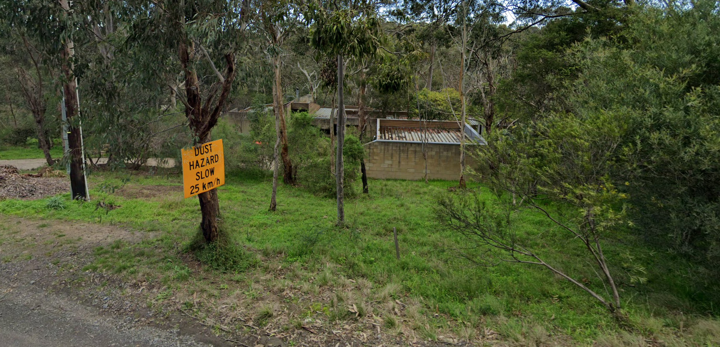
Figure 3. View of the house from Warringah Crescent. The street facing concrete block wall is the carport. Note the deep parapet and flat steel deck roof. (Source: Google 2019)
The house is integrated into the landscape, sited below street level. It steps down the block towards the rear, following the natural fall of the land. Constructed primarily of clay-coloured concrete blocks the house is sculptural in form and presents to the street as a series of low interlocking angular and rectilinear volumes that formally contrast with the natural topography but that materially complement the house’s bush setting. The entry to the house is demarcated by a double height volume clad in horizontal timber weatherboards which is also used for a small wing wall near the front path, and across the front of the double carport.
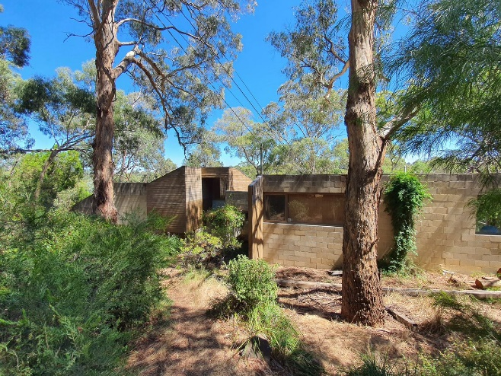  Figure 4.Entry to the house is via a narrow earth path leading past a series of interlocking geometric forms. (Source: Context 2021) | 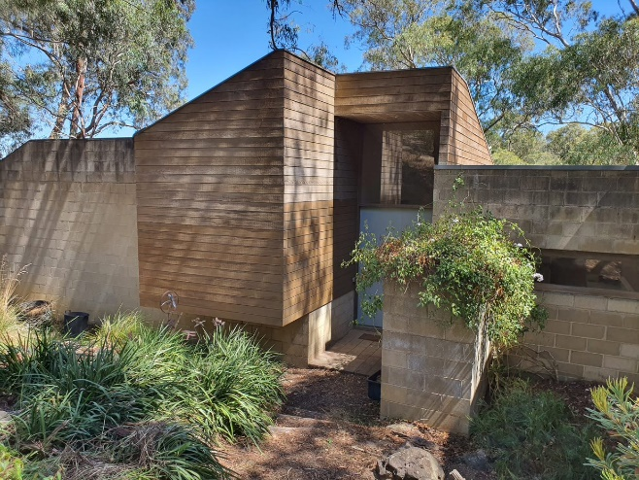  Figure 5. Entry to the house is demarcated by walls clad in horizontaltimber weatherboards. The entry is double height with a skillion roof (Source: Context 2021)
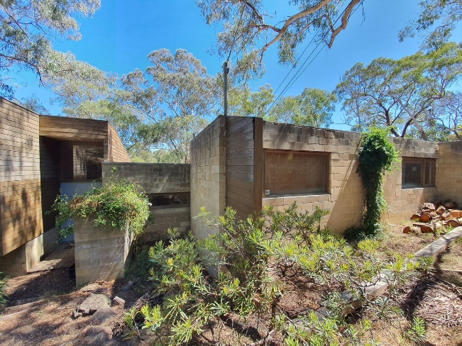  Figure 6. The principal street facing elevation is made up of a series of interlocking rectilinear volumes giving a sculptural quality to the elevation (Source: Context 2021) | 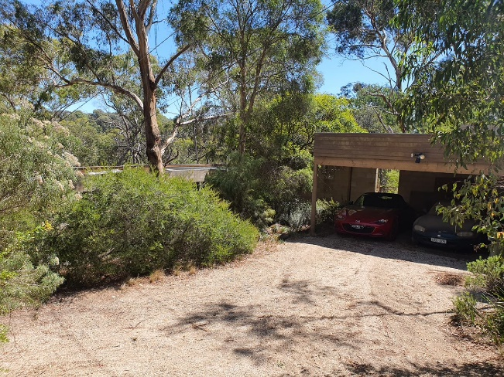  Figure 7. The carport to the front of the house and is enclosed on two sides with concrete block walls. The deep fascia across the front is clad in horizontal timber weatherboards(Source: Context 2021)

The house is built over two levels. The upper level, closest to the street comprises a series of single storey interlocking rectilinear volumes with flat steel deck roofs concealed behind high parapet walls, while the lower level to the rear of the house is more angular in form.

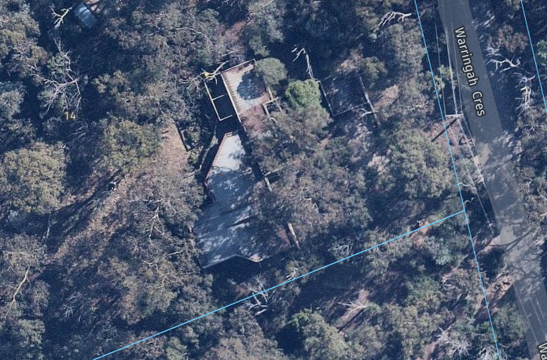
Figure 8. Aerial view showing the two sections of the house with a front single storey block of interconnecting rectilinear volumes and the rear spaces orientated towards the north (Source: Nearmap 2021)
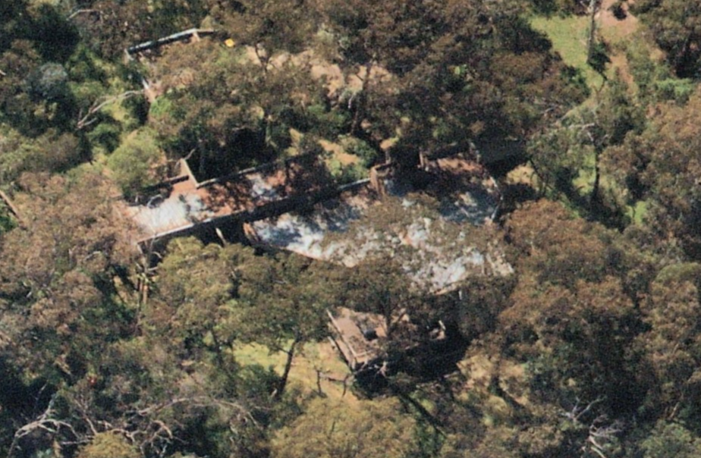
Figure 9. Aerial view looking east showing the carport at the top of the block, single storey wing of interconnecting cubes towards the middle and rear lower portion of the house angled to the north and leading onto an open timber deck. (Source: Nearmap 2020)

INTEGRITY
14-16 Warringah Crescent, Eltham, is highly intact with minimal changes visible to original or early significant fabric. The building retains its original material palette of natural coloured concrete blocks and horizontal timber weatherboards. The building also retains its original built form and scale, which purposefully responds to the steeply sloping block. The site has retained its original open carport, built in matching materials. Overall, the building has very high integrity.

COMPARATIVE ANALYSIS
Architect designed homes became more common in Nillumbik and its surrounds in the postwar period. From the 1970s, up-and-coming Melbourne architects including Kevin Borland, Charles Duncan and Morrice Shaw turned their hand to designing residences in the area. Many architect-designed residences responded to the tradition of informality, natural materials and integration with the natural environment that had become hallmarks of the ‘Eltham Style’ in the immediate postwar period. Many of these designs, however, exhibit aesthetic differences that reflect a wider engagement with evolving ideas being explored within Australian architecture at the time of their construction. As noted in the Nillumbik Shire Thematic Environmental History, the architect-designed homes of this period featured ‘informality, woodsy detailing, mezzanine floors and sliding doors opening onto timber decks.’ The commonly observed construction materials included bagged brick or concrete, second-hand bricks, window frames stained brown or pale eucalypt green, and diagonal timber lining boards (Mills & Westbrooke 2016:89).
The house at 14-16 Warringah Crescent, Eltham, consciously references but departs from the ‘Eltham Style’ mudbrick homes that proliferated in the 1950s and 1960s. The house’s form and natural coloured materials respond to the natural, sloping landscape of the site, while still presenting as a conspicuously man-made structure within its setting. Unlike earlier ‘Eltham Style’ houses, 14-16 Warringah Crescent does not exhibit the same purposeful affinity with the landscape, departing from the earthy, organic architecture that influenced the development of the style. 14-16 Warringah Crescent purposely engages with more abstract three-dimensional geometric forms than houses of the ‘Eltham Style’. Though it materiality it retains a chromatic connection with the surrounding landscape, through the use of clay-coloured concrete blocks and naturally timber panelling.
Architect-designed houses built after the 1970s are underrepresented on Nillumbik’s Heritage Overlay. The following examples are comparable to 14-16 Warringah Crescent, Eltham, for their architectural expression or construction period.
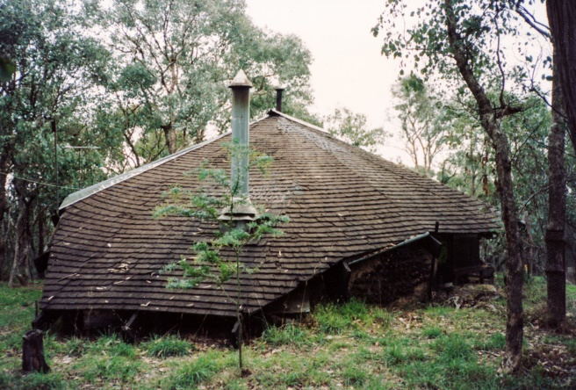  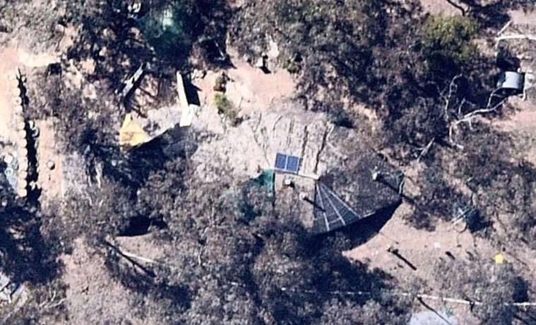  Leon Saper Residence, 60 Dunmoochin Road, Cottles Bridge (HO41). (Source: Victorian Collections; Nearmap 2021) | Built for the well-known potter Leon Saper in c1967, the house is architecturally significant as a work of Morrice Shaw. Shaw was a Modernist architect who worked in the office of Kevin Borland. The house is one of the most creative and unusual dwellings built in Victoria and Australia during the 1960s. It combines the Modernist ideas with the use of mud brick and recycled materials that are characteristic of the ‘Eltham style’ (VHD).  The house is noted for its highly individualist expression, which Alistair Knox described as ‘one of the most amazing designs that have occurred in mud-brick building’. The building combines a free-form plan with flowing pisé walls and fireplace under a complex organic roof form. It is the earliest known example in Victoria of a strand of the late-twentieth-century organic style (VHD; Mills & Westbrooke 2016:87-89).
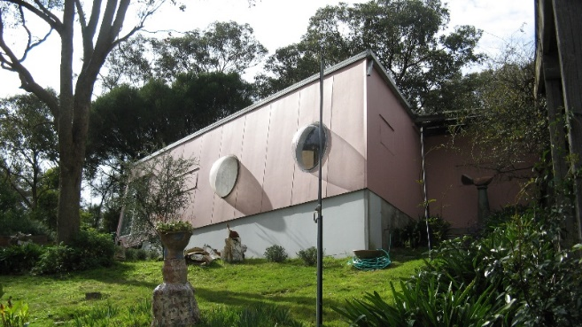  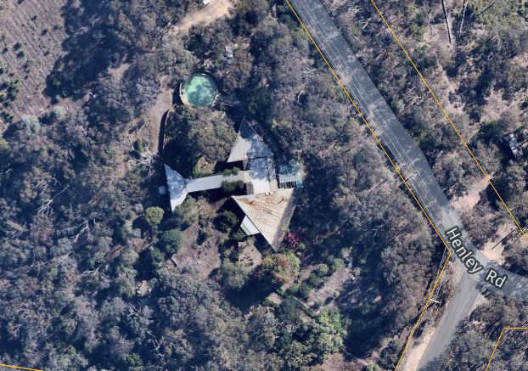  Burns House ‘Kangaroo’, 644 Henley Road, Bend of Islands (VHR H2314, HO258). (Source: VHD; Nearmap 2021) | The Burns House, known as ‘Kangaroo’, was designed by the architect and artist Peter Burns and built in stages from 1968 on an elevated sloping bush site. The Burns House is made up of three linked triangular-plan pavilions set in informal gardens established largely by Mary Burns. The use of cheap materials, such as fibro cement sheet cladding to the walls and Stramit system ceilings, reflects the relative austerity of the period and the lack of resources of the family (VHD). The inwardly-sloping walls, acrylic dome windows and flaps for ventilation are key design elements. ‘Kangaroo’ was designed not to blend in with the bush setting but ‘as a gesture to come to terms with nature’ (VHD).  The Burns House is architecturally and historically significant at state level.
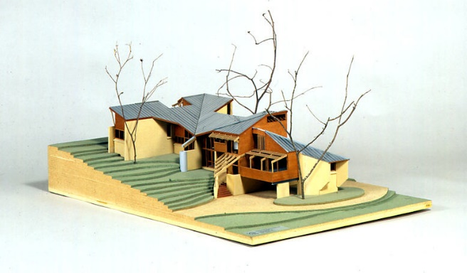  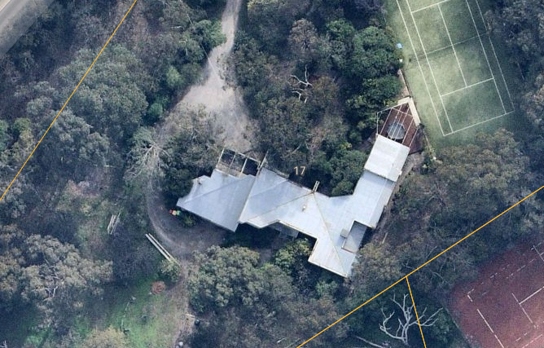  Nichols House, 17 Haldane Road, Eltham (No HO but identified in the Nillumbik Shire Thematic Environmental History). (Source: E. Willis 2009, ‘Nichols House, Eltham, 1972-1973’; Nearmap 2021) | The Nichols House was built in 1973 to a design by architect Kevin Borland. Borland won The Age-RAIA House of the Year Bronze Medal for his design of this large sprawling house of brick and timber, built on a steeply sloping site. The house comprises five different levels with small and large spaces. By 1980 Norman Day wrote that the Eltham area was ‘potted’ with rugged Borland houses (cited in Mills & Westbrooke 2016:89). ‘Their rude frames, rough nailed boards and spiky roofs surprise even the unconservative hill people up there.’ Day further noted that Borland’s signature style of ‘bush-carpentered mixture of simple materials, complex planning and uncompromising form-making’ was perhaps just as suited to the Eltham hillsides as the earlier visions of the mud brick houses (Mills & Westbrooke 2016:89).
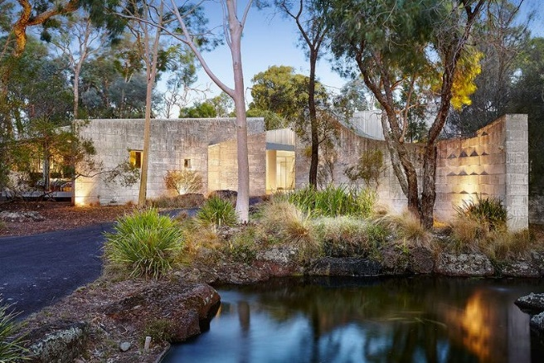  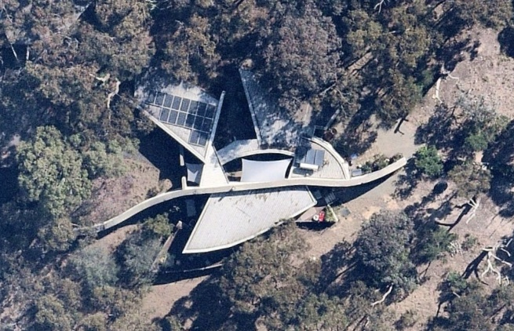  Choong House, 10 Diosma Road, Eltham (recommended as an Individually Significant place in this study). (Source: realestate.com.au, 2016) | The Choong House is significant as a particularly well designed and detailed house built to the design of Biltmoderne between 1985 and 1987. The house is carefully sited within a bush garden landscape designed by Gordon Ford. The building’s sculptural form is expressed in a palette of limestone, aluminium and glass that both references to and clearly breaks from the ‘Eltham Style’. The property is further enhanced by the bush garden elements including Ford’s signature use of ponds, volcanic boulders and native plantings. Also of note is the steel carport, built in 1988 to designs by Wood Marsh (as the firm Biltmoderne would become) in a complementary style to the house.

Beyond the Shire of Nillumbik, the following places are comparable to the subject site as buildings designed by the firm Peter Carmichael and his firm of Cocks Carmichael.

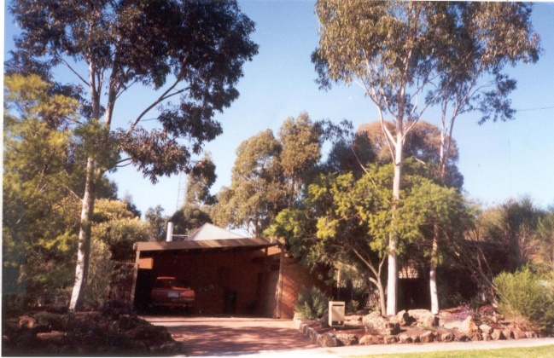  Solar House, 32 Rosco Drive, Templestowe (VHR H1312, HO149, City of Manningham). (Source: VHD) | A split-level open plan Solar House designed by Cocks Carmichael for Landmark Solar Houses Pty Ltd, and constructed by that company for display purposes in 1978-79. The Solar House is technically and architecturally important as the first commercially available solar energy project house in Australia (VHD).
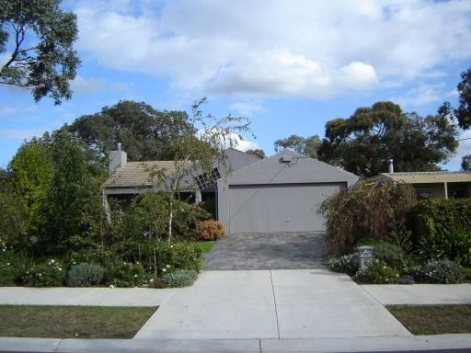  412 Porter Street, Templestowe (within HO17, City of Manningham). (Source: VHD) | A house designed by Cocks Carmichael within a larger precinct of merchant builders display houses in Templestowe. The houses have aesthetic significance as a representative example of a late twentieth century housing precinct, which remains very intact. The house at No. 412 illustrates the influence of post-modern design during the 1980s (VHD).
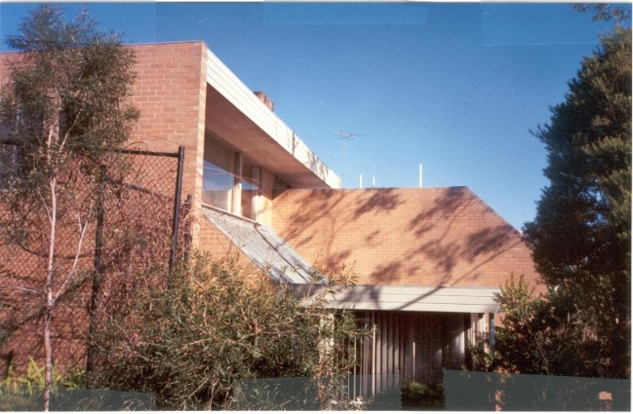  18 Summit Drive, Bulleen (HO158, City of Manningham). (Source: VHD) | A house of local architectural significance as a good example of the domestic work of the architects Cocks Carmichael, built in 1980. The house is carefully related to its site through its design (VHD).

Discussion
14-16 Warringah Crescent, Eltham, compares well to the above examples of homes that were built in the Shire of Nillumbik from the 1970s onwards. The subject site is particularly distinguished as an example of a house that departs from the ‘Eltham Style’ mudbrick homes of the earlier decades. These houses represent a period in Nillumbik’s history when a group of architects formulated new and inventive responses to suit the hilly topography of the local area. These examples display individualistic designs that depart from earlier ‘Eltham style’ or Modernist houses that were characterised by far simpler forms, geometries and a more romantic and mimetic identification with the landscape in material terms. The key characteristics that are observed in these later houses include the informality displayed through the irregular geometric plans, the complex broken roof forms, and the sloping walls that reject orthogonal wall planes. Split-level designs with interconnected internal spaces and here-dimensional volumesare also common. Like their earlier ‘Eltham Style’ and Modernist counterparts these buildings responded to the environmental factors of the local landscape including views, typography, sun and wind. They represent, however, a more complex relationship between nature and the built environment with forms that are consciously articulated from and contrasting with their settling.
The house at 14-16 Warringah Crescent, Eltham, with its hardline abstract geometry is formally distinguished from the undulating organic form of theLeon Saper Residence (HO41) that was a pioneer of organic architecture in Victoria. The State-listed Burns House (VHR H2314, HO258) is more similar to 14-16 Warringah Crescent, Eltham, in use of a more angular geometry which visually articulates it as a sculptural object within its bush setting. Neither houseblends in with the natural landscape in formal terms.
Although later (1988), the Choong House at 10 Diosma Road, Eltham (recommended as an Individually Significant place in this study), is the comparable to the subject site, as an example of a high quality and finely detailed architect-designed home within the locality. Similar to the subject site, the Choong House creates depth and scale through the placement of walls. 17 Haldane Road, Eltham (No HO but identified in the Nillumbik TEH), is also similar to the subject house, having a sprawling form that steps down the block following the natural fall of the land.
When compared to other houses by the firm of Cocks Carmichael beyond the Shire of Nillumbik, the subject site is a good example of the firm’s work. 32 Rosco Drive (VHR H1312, HO149, City of Manningham) and 412 Porter Street (within HO17, City of Manningham), both in Templestowe sit within suburban contexts that are distinguished as precincts of merchant builders’ homes. Both houses appear to have been designed for builders. As such they are smaller in scale,respond to their suburban surrounds and are less architecturally ambitious than the subject site. The house is most comparable to 18 Summit Drive, Bullen (HO158, City of Manningham), as an example of a larger-scale house commissioned by the firm for a private owner.
The house at 18 Summit Drive exhibits some formal similarities to the subject site, and both have been designed to embrace sloping blocks of land. Similarities include the use of angular walls, highlight windows, timber panelling and rooflines that slope with the land. The subject site is set apart, though, by its use of more elaborately interlocking geometric forms and volumes, clay-coloured concrete blocks and its heavily vegetated bushland setting. The house at 14-16 Warringah Crescent is a good example of the work of Cocks Carmichael in the suburbs of Melbourne. Within the Shire of Nillumbik, the house is a good example of the form of architecture that became popular in the later decades of the twentieth century that referenced, but broke with, the established ‘Eltham Style.’

STATEMENT OF SIGNIFICANCE

WHAT IS SIGNIFICANT?
The house at 14-16 Warringah Crescent, Eltham, a concrete block and timber house built c1975 to a design by Peter Carmichael of Cocks Carmichael, is significant.
Elements that contribute to the significance of the place include:
- original form and scale of the house, designed to embrace the steeply sloping site;
- original materiality of the house, including concrete blocks, concealed flat steel deck roofs and horizontal timber boarding;
- original window and door openings and joinery
- open carport, constructed out of matching concrete blocks and timber; and
- siting on a steeply sloping block of land with the retention of it bush setting.

HOW IS IT SIGNIFICANT?
The house at 14-16 Warringah Crescent, Eltham, is of local representative and aesthetic significance to the Shire of Nillumbik.

WHY IS IT SIGNIFICANT?
The house at 14-16 Warringah Crescent, Eltham, is of aesthetic and representative significance as a well-detailed architect-designed house that responds to its sloping bushland block. Designed by architect Peter Carmichael of Cocks Carmichael, the building’s form is a carefully composed arrangement of low interlocking angular and rectilinear volumes set over two levels. Materially, the house has a restrained palette of clay-coloured concrete blocks and naturallyly finished horizontal timber weatherboard cladding. This palette responds chromatically to its landscape setting. The pursuit of complex and abstract geometry marks a distinct break from the ‘Eltham Style’ while the use of a natural palette of materials and low-lying forms maintains links with the earlier style. The property’s aesthetic significance is further enhanced by the purposeful retention of its bush setting. (Criteria D and E)

RECOMMENDATIONS
Recommended for inclusion in the Schedule to the Heritage Overlay of the Nillumbik Planning Scheme as an Individually Significant place.
Extent of overlay: To title boundaries
Recommendations for the Schedule to the Heritage Overlay (Clause 43.01) in the Nillumbik Planning Scheme:

Nillumbik Planning Scheme
External paint controls | No
Internal alteration controls | No
Tree controls | No
Outbuildings or fences | Yes - carport
To be included on the Victorian Heritage Register | No
Prohibited uses may be permitted | No
Aboriginal heritage place | No

Other
N/A

REFERENCES
Argus, as cited.
Architect Victoria: Official Journal of the Australian Institute of Architects Victorian Chapter 2010, ‘Robin Cocks and Peter Carmichael’, Australian Institute of Architects, Summer 2010:24.
Bartolomei, Deborah 2008, ‘Eltham’, eMelbourne, School of Historical and Philosophical Studies, The University of Melbourne, https://www.emelbourne.net.au/biogs/EM00516b.htm.
Built Heritage Pty Ltd 2010. ‘Survey of Post-War Built Heritage in Victoria: Stage 2’. Prepared for Heritage Victoria.
Butler, Graeme, and Associates 1996, ‘Nillumbik Shire Heritage Review – Environmental History’, Prepared for the Shire of Nillumbik.
Eltham District Historical Society 2000, A Chronology of Known Local Events 1835-early 2000 including those in the Shire of Nillumbik and the former shires of Eltham and Diamond Valley, Eltham District Historical Society Incorporated.
Eltham District Historical Society 2019, ‘OTD: Opening of the new Eltham Library, 22 May 1994’, www.elthamhistory.org.au.
Goad, Philip 2003, ‘Cocks and Carmichael’, Grove Art Online, Oxford University Press, https://www.oxfordartonline.com/groveart, accessed 15 April 2021.
Goad, Philip 1999. ‘Melbourne Architecture’. The Watermark Press, Sydney.
Gowrie Victoria 2019, Our History, www.gowrievictoria.com.au.
Land Victoria, Certificates of Title (CT), as cited.
Merchant Builders: Towards a new archive 2015, The University of Melbourne.
Mills, Peter & Westbrooke, Samantha 2010, ‘War Memorial Building Complex, 903-907 Main Road, Eltham, Cultural Heritage Significance Assessment’, prepared for Nillumbik Shire Council.
Mills, Peter & Westbrooke, Samantha 2017, ‘Nillumbik Shire Thematic Environmental History – Revision 2016’, prepared for Nillumbik Shire Council.
Nillumbik Parish Plan 1951, Melbourne, Department of Lands and Survey.
Pierce, Peter (ed.) 1987, The Literary Guide to Australia, Oxford University Press, Melbourne.
realestate.com.au 2016, 10 Diosma Road Eltham, https://www.realestate.com.au/, accessed 30 April 2021.
Victorian Places 2015, ‘Christmas Hills’, Monash University and The University of Queensland, https://www.victorianplaces.com.au/.
Victorian Year Book 1973. Government Printer, Melbourne.
Yeoman, Russell, Pinn, Richards, and Connor, Jim 2020, Sign of the Times: Eltham street names with history, Eltham District Historical Society, www.elthamhistory.org.au.

