23 Glen Park Road, Eltham North

‘Hillside’
Prepared by: Context | Survey date: Month Year
Place type: Residential | Designer: -
Significance level: Significant | Builder: Not known
Extent of overlay: To title boundaries | Major construction: c1914
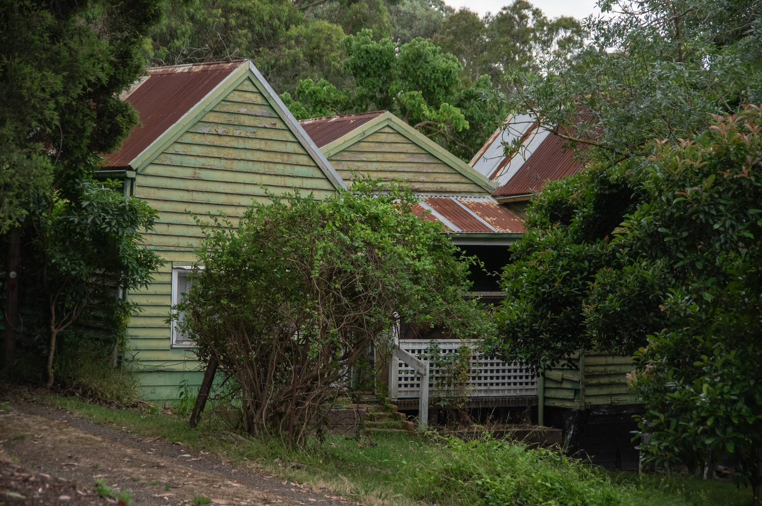
Figure 1. 23 Glen Park Road, Eltham North. (Source: Context 2021)
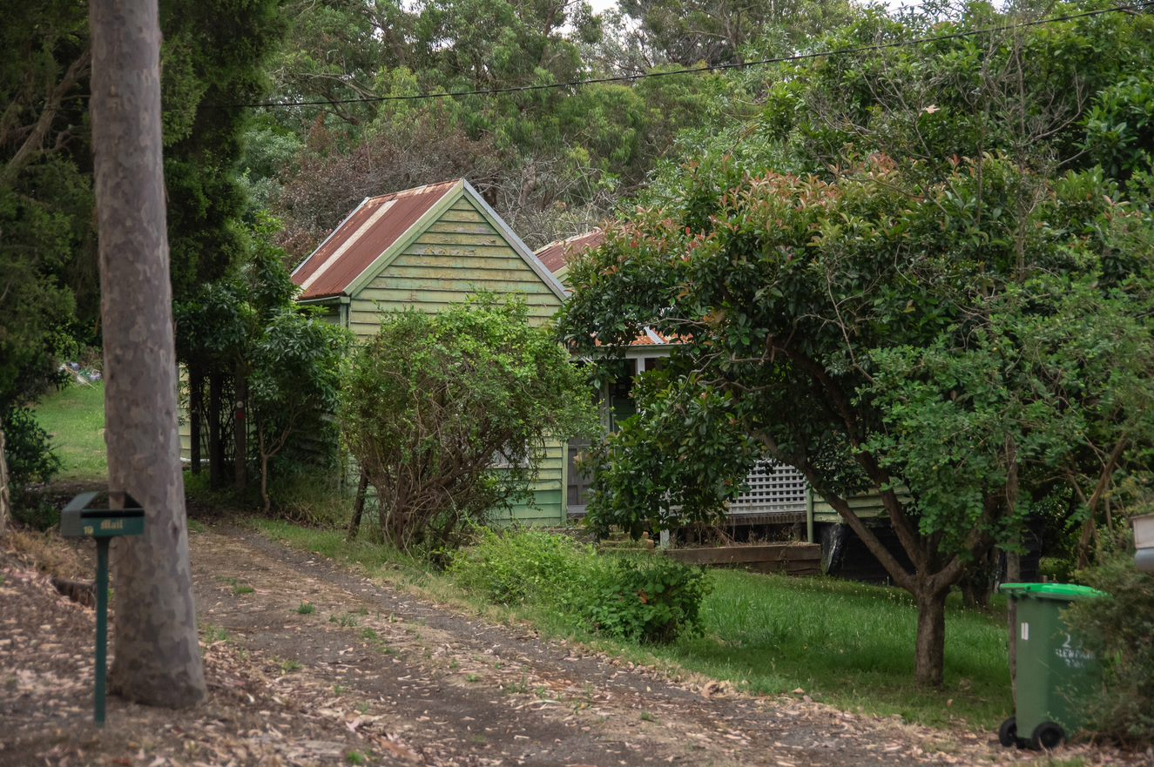
Figure 2. 23 Glen Park Road, Eltham North. (Source: Context 2021)

HISTORICAL CONTEXT
This place is associated with the following historic themes taken from the Nillumbik Shire Thematic Environmental History (2016):
6 BUILDING TOWNS AND SHAPING SUBURBS
6.2 Pre World War I subdivisions and estates
Historians of the Nillumbik area have often focused on the ‘battler’ aspect of settlement in the area but, in the late nineteenth century boom, some speculators had greater aspirations for the locale. In the late 1880s, land estate agents Robert Walker and Company set up a branch in Heidelberg in anticipation of increasing subdivision of estates. In 1888 the Christmas Hills Estate Company purchased land from Mr and Mrs French at £35 per acre, with the anticipation of selling at prices matching those achieved not long before at Mt Macedon, of over £200 per acre. The bottom went out of the land boom before a single block was sold. In all, the land boom of the 1880s had only a fleeting impact on the Nillumbik Shire. (Mills & Westbrooke 2016:69)
From the 1890s Eltham had been included within the boundaries of Greater Melbourne for the purpose of the census, but its setting was still decidedly rural. The first impact of the railway, when it reached Eltham in 1902, was a great expansion in tourism but it was a number of years before new residential subdivisions appeared on the outskirts of the town. These were typically breakups of rural properties from the nineteenth century. In 1909 the Franktonia estate (or Beard’s estate) on the north-east side of Eltham bordering Research was created from land that had been held by the Beard family since 1860. The blocks of six to 29 acres were advertised as ‘well suited for farming and fruit growing and adapted for rural suburban residential purposes, the blocks comprising beautiful crests, some picturesquely wooded’. (Mills & Westbrooke 2016:69)
Two other suburban estates bordering Eltham were subdivided in the same year. These were Bonsack’s estate, which was located between Eltham and Greensborough and Glen Park estate, or Langland’s estate, which was located three-quarters of a mile to the north-west of Eltham Railway Station (Mr John Langlands of Hurst having died in 1907). With all this new development it was expected that at last Eltham would lose its ‘sleepy hollow’ reputation. In 1910 the Evelyn Observer reported that ‘within the last year or two many suburban and city people have invested in building blocks about Glen Park, the Terminus Estate and other parts.’ The Terminus Estate mentioned in the article had 51 allotments, and was first advertised in 1909. In 1910 the council considered the layout of the Terminus Estate. It appears that the proposal included narrow street alignments, but council decided that they must be ‘the full width’. In 1914 a fire threatened a cluster of small ‘weekend’ cottages on the south-east side of the Terminus Estate, near the railway station. At the opening of a new bridge over Diamond Creek at Glen Park in 1915 the chairman of the bridge committee and shire councillors made comments about how far Glen Park, ‘Eltham’s beautiful suburb’, had progressed since it was opened up six years ago. The formation of a Glen Park Progress Association was initiated at this opening. (Mills & Westbrooke 2016:69)
In reality, much of this activity remained speculative and before World War I the area stayed predominantly rural, punctuated by a few small towns. Eltham was still surrounded by cultivated land. To the south, the edge of advancing metropolitan suburbia resulted in infill and consolidation in Montmorency and Greensborough. (Mills & Westbrooke 2016:70)
The extensive subdivision and development to the north-east and north-west of Eltham resulted in the Glen Park Progress Association calling for a railway station at Glen Park (Eltham North), midway between the Eltham and Diamond Creek stations. The Association expected such a station would service 387 blocks in the Bellevue and Beard’s estates and 313 blocks in the Glen Park estate subdivision. Glen Park at this time had 89 houses with a largely working class population of 198 people. It also had 97 weekenders. Services here were primitive with no water or electricity supply. Nonetheless, local reports found that Eltham was on the ‘up grade’. ‘The railway has given the necessary acceleration towards advancement and not only is Eltham becoming popular as an outer suburban residential area, but also as an easily accessible tourist resort.’ (Mills & Westbrooke 2016:72)

LOCALITY HISTORY
Eltham North is located on the country of the Wurundjeri-willam clan of the Woi wurrung people.
Diamond Creek separates Eltham North from Eltham and was the dividing boundary between municipalities; Eltham North was in Heidelberg City and, from 1964, in Diamond Valley Shire. In 2001 Eltham North’s western boundary moved from Ryans Road into St Helena. As a result, today Eltham North is located within two local government areas: the City of Banyule and Nillumbik Shire (Victorian Places 2015).
Eltham North, originally an outlying rural part of Eltham, became a separate locality with the opening of the Glen Park (later Eltham North) State School No. 4212 in 1924. At the time the locality was known as Glen Park, with that name recorded in street directories until the 1960s. The postal district, however, was Eltham North (Victorian Places 2015).
Extensive subdivision to the northeast and northwest of Eltham occurred from the first decades of the twentieth century, although residential development was slow due to an absence of electricity and water services. A new bridge across Diamond Creek, opened in 1915, improved connections between Eltham and Eltham North.
The Eltham and Glen Park Progress Association was formed in 1921 and called for the construction of a railway station at Glen Park (later Eltham North), midway between Eltham and Diamond Creek stations. In 1924, the Glen Park Progress Association expected such a station would service 387 blocks in the Bellevue and Beard estates and 313 blocks in the Glen Park Estate subdivision. Glen Park at this time had 89 houses with a largely working-class population of 198 people. It also had 97 weekenders (Mills & Westbrooke 2017:72).
Glen Park Primary School No. 4212 was subsequently opened after the Progress Association petitioned the Education Department, stating that the population of the area was growing and complaining that children had to walk two to three miles to Eltham or Diamond Creek schools. The first school opened in May 1924, with 38 pupils, in a private house called ‘Rest-a-While’ in Lower Glen Park Road, where it operated for the next 17 months. In 1925 it was relocated to a single room transported by wagon from Greensborough and moved to land in Banks Road (Eltham North Primary School 2020; Blake 1973:138). The school’s name was changed to Eltham North in that year (Blake 1973:138).
In 1925 a building for the Glen Park Gospel Mission was erected (Advertiser 4 December 1925:3).
Local builder Alistair Knox designed and constructed a number of mudbrick houses in the area from the late 1940s, contributing to a style of architecture that became known as the ‘Eltham style’.
Reflecting the postwar growth in the area, by 1952 there were 62 children attending the Eltham North State School, and in 1953 a new school building was completed in Wattletree Road (Blake 1973:138).
Today the primary school is in the east of the suburb, adjacent to the Glen Park Gospel Church and local shops. There is a kindergarten in Glen Park Road. Eltham North has numerous bushland reserves and playgrounds (Victorian Places 2015).

PLACE HISTORY
The subject site is located on Crown Allotment B Section 11, Parish of Nillumbik, 90 acres purchased by John Dane in 1852 (Nillumbik Parish Plan 1951).
In 1913, estate agent George Herne purchased the allotment along with neighbouring Crown Allotment D, a total of 198 acres. Herne then subdivided the Crown allotments to form a large residential subdivision, with lots sold from 1913 (Figure 3) (CT:V3682 F252). The area near Glen Park Road was known as the Glen Park, named after the residential subdivision Glen Park Estate established in 1909 (Figure 3). By 1924 the estate comprised 313 blocks (Mills & Westbrooke 2017:72). Because of a lack of services, residential development on the estate was initially slow (Mills & Westbrooke 2016:72).
In 1913, fruiterer Albert Zillman purchased Lots 66, 67, 68 and 69 of Block B of the subdivision (CT:V3682 F252). The subject residence, ‘Hillside’, was built on Lot 69 at about the same time for Albert Zillman and his wife Anne. In 1914, Anne and Albert Zillman were listed in the Commonwealth electoral roll for the subdivision of Diamond Creek as living in Glen Park, with Albert’s occupation noted as ‘poultryman’ (Ancestry 2020). The subject house was one of the first residences to have been built on the estate.
The Zillmans were active in their local community. Albert was a member of a committee formed in 1925 to lobby for a railway station at Glen Park. Anne was secretary of the Eltham North Red Cross in 1941 (Advertiser 18 September 1925:3; Eltham and Whittlesea Shires Advertiser 8 August 1941:1).
After Albert Zillman died in 1946, the property passed into the ownership of Anne Zillmann in 1947. After Anne’s death in the same year, Annie Smith became the owner in 1947 and subdivided the land into three lots in 1958 (CT:V3682 F252). Thomas and Effie Smith acquired the subject property in 1958 (CT:V8197 F063).
Around the 1945, the property was still one of a number of houses built in Glen Park Road near Ryans Road (Figure 4). The property was shown on two further aerial photographs form 1951 and 1987. A skillion-roofed extension to the rear of the house and a detached shed at the rear of the house are present on the 1987 photograph, indicating that these were built after 1951 (Figure 5 and Figure 6).
A building permit for the construction of a carport adjoining the existing shed at the property was issued in 1996 (BP).
Figure 3. Part of plan of subdivision at Glen Park, 1913, with the lots 66, 67, 68 and 69 outlined in green and the approximate boundaries of 23 Glen Park Road outlined in yellow dotted lines (LHS), and an advertisement for the Glen Park Estate in 1909 (RHS). (Source: CT:V3682 F252; Age 13 November 1909:19)

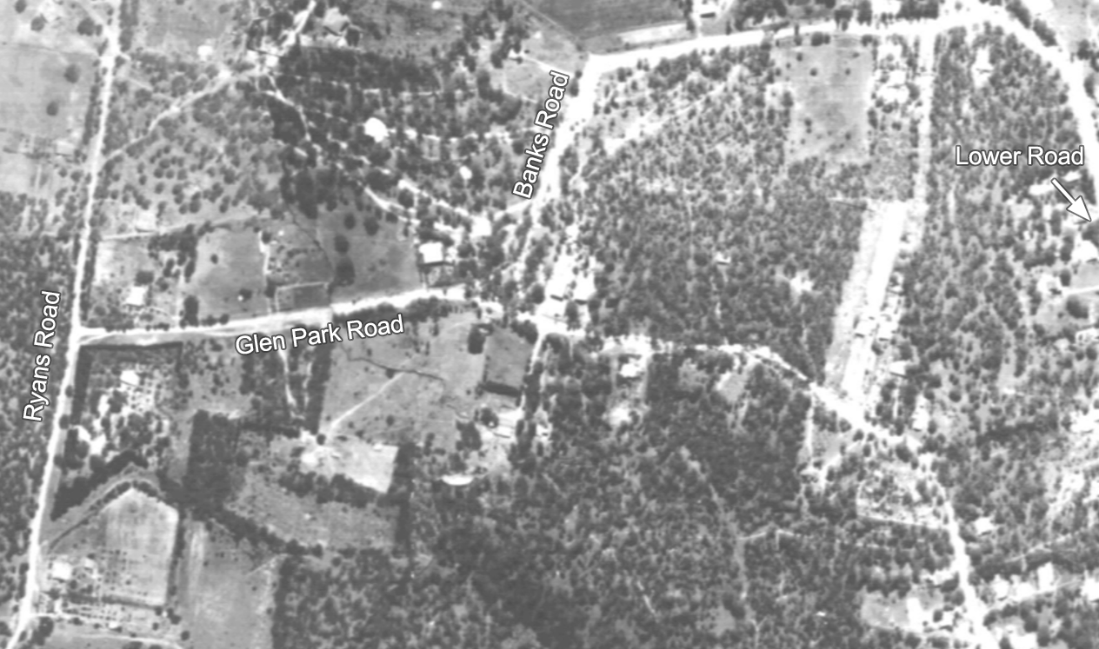
Figure 4. Extract from a 1945 aerial photograph with the approximate property boundaries of 23 Glen Park Road outlined in yellow. There was more residential development towards the east of Glen Park Road and in Lower Road at this time. (Source: ‘Melbourne 1945’, University of Melbourne)
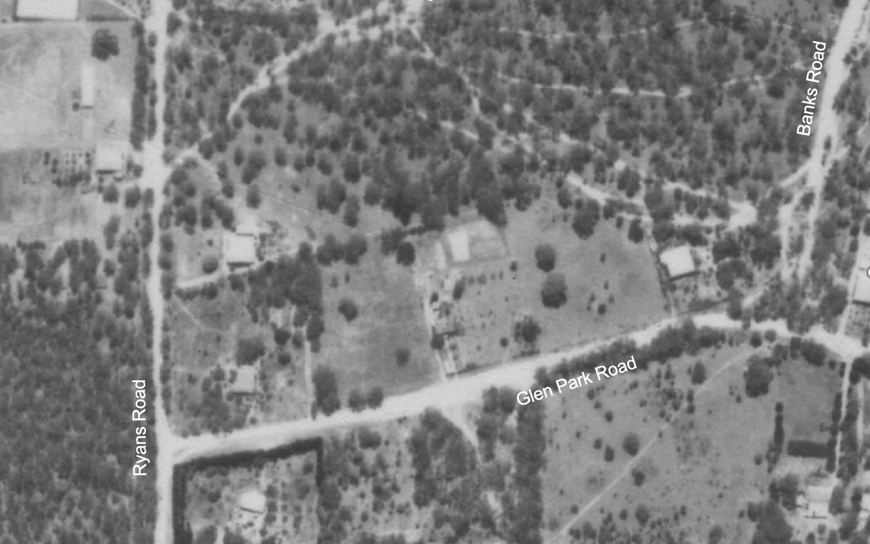
Figure 5. Extract from a 1951 aerial photograph with the approximate property boundaries of 23 Glen Park Road outlined in yellow. (Source: CPO, ‘MELBOURNE AND METROPOLITAN PROJECT’ 1951, via Landata)
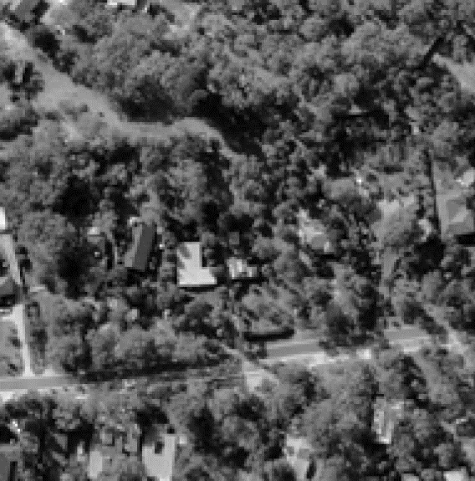
Figure 6. Extract from a 1987 aerial photograph with the approximate property boundaries of 23 Glen Park Road outlined in yellow. Note that the rear extension (outlined in green) and a detached shed (outlined in blue) existed by this time. (Source: CPO, ‘WESTERN PORT FORESHORES’ 1987, via Landata)

DESCRIPTION
Hillside at 23 Glen Park Road, Eltham North, is a single-storey weatherboard cottage with corrugated iron roof, built c1914 following the first land sales of the Glen Park Estate in 1913. The subject site is located on the northern side of Glen Park Road with a setback from the street. The land slopes down eastwards, with a driveway access near the western property boundary. The block is moderately covered in vegetation.
The cottage has a stripped-back design, reflecting its origin as a small workers’ home built in a rural suburb. The weatherboard-clad cottage presents as a series of three rectangular forms, each with a gabled roof portion. The gables run north-south, with the southern gable ends facing the street. The three gables are of different sizes and have different roof pitches (Figure 1), indicating that the earliest sections of the house may have been built in stages. The northern gable form is raised above the ground, which slopes away to the north, the subfloor area is clad in weatherboards. The central gable form is set back between the other two, accommodating an inset verandah with a timber deck and timber-framed and lattice-clad balustrade brick steps lead to the central doorway. Both windows on the either side of doorway appear altered (Figure 7).
There is a large skillion-roofed extension to the rear of the cottage, added between 1951 and 1987. This extension is clad in a wider profile weatherboard than the front sections of the house (Figure 8). The skillion-roofed iron shed was also constructed between 1951 and 1987, with the carport adjoining the shed to the west added in 1996 (Figure 9). These additions are discreet and not readily visible when viewed from the street.
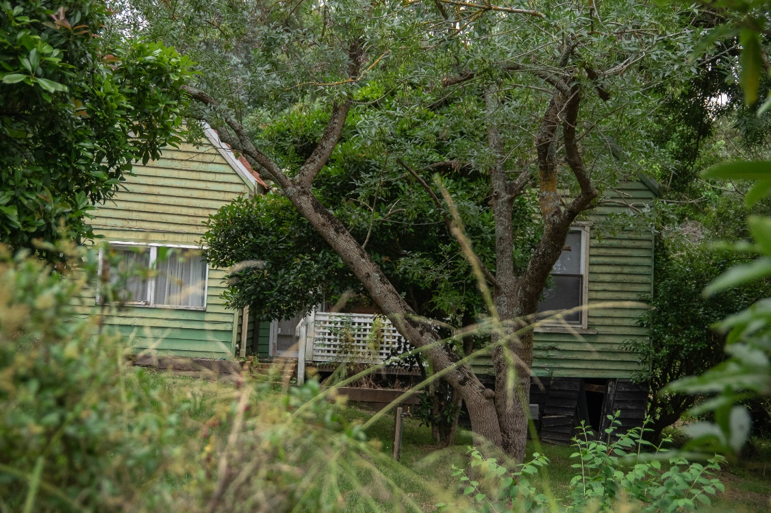
Figure 7. 23 Glen Park Road, with altered windows on the either side of the entrance. The northern portion of the building is raised on above ground that slopes away to the north. The inset verandah has a lattice balustrade. (Source: Context 2020)
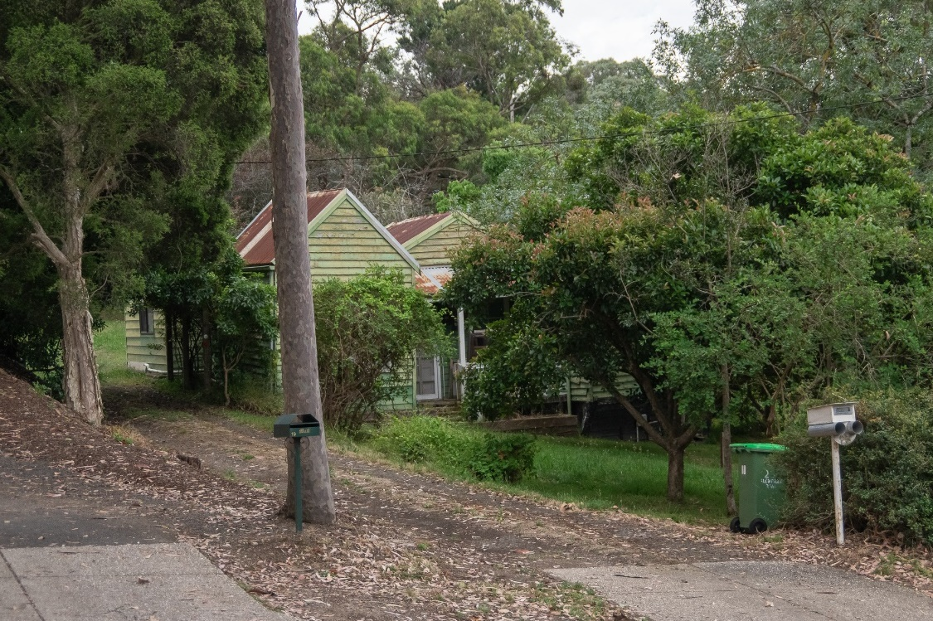
Figure 8. 23 Glen Park Road, Eltham North, viewed from the southwest. Note the rear extension clad in wider weatherboards (outlined in green). (Source: Context 2020)
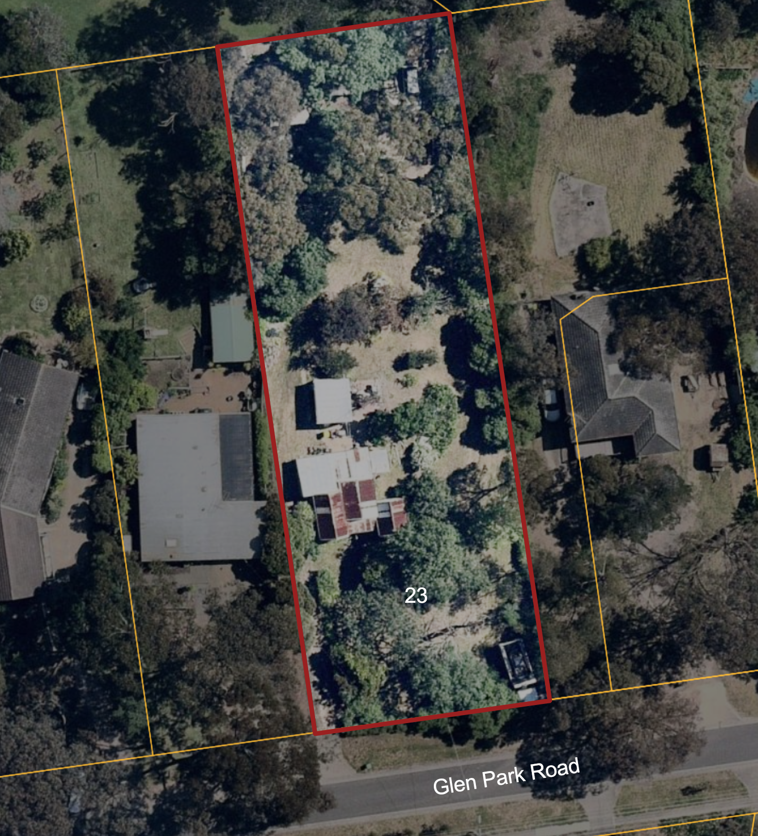
Figure 9. An aerial view of 23 Glen Park Road, Eltham North. Note the existing rear extension (outlined in green) and a detached shed (outlined in blue). (Source: Nearmap 2021)

INTEGRITY
Hillside at 23 Glen Park Road, Eltham North, is generally intact with some changes visible to the foremost gable forms and associated early fabric when viewed from the street. The vernacular architecture of the single-storey building reflects its origins as a small workers’ home. The early built form consisting of three differentiated gable roofed forms with an inset verandah remains intact and legible. The house retains its original construction materials including weatherboard wall cladding and corrugated iron roof cladding. The house also retains intact early elements including the timber deck, timber-framed and lattice-clad balustrade, and brick front steps. The altered windows, later rear extensions, a detached shed and carport does not obstruct overall legibility of the building as an early timber cottage. The deep set back and vegetated site reflects its original rural setting. Overall, the building has medium integrity.

COMPARATIVE ANALYSIS
From the 1890s, the defined area of Greater Melbourne had been expanded to include Eltham and the surrounding district for the purpose of censuses. Despite being included within these boundaries, the area continued to be predominantly rural. The extension of the railway into Eltham in 1902 did little to impact this, however by 1909 subdivisions on the outskirts of the town began to appear. These subdivisions were often the result of the breakup of larger landholdings that had been purchased in the nineteenth century. These subdivisions did not drastically change the rural nature of the area.
Suburban development had been slowly increasing around the main townships since their early settlement. In the immediate vicinity of these townships, the housing stock became increasingly similar in typology and style to Victorian or Edwardian residences evident in other suburban areas of Melbourne.
Likely due to a combination of continuing agricultural land use and lack of suburban utilities, development in areas outside the main streets of townships in Nillumbik was often slow. Most houses that appeared in these subdivided areas in the early twentieth century were weatherboard-clad, timber-framed structures often small in scale. These houses usually reflected a more vernacular typology that prioritised function over the application of popular stylistic forms and decorative elements. They similarly reflected the relative frugality of their inhabitants.
Hillside is an example of the type of small workers’ homes that were built within the Shire of Nillumbik in the early decades of the twentieth century, after the early subdivision of land for residential use.
The following sites are directly comparable to the subject site, being of similar construction date or modest vernacular style.
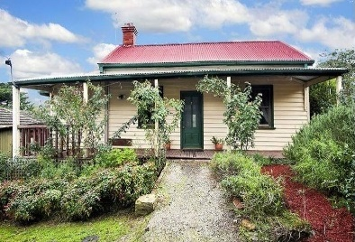  Pizzey House, 29 Main Street, Diamond Creek (HO225). (Source: realestate.com.au 2013) | Pizzey house (c1904) house is considered to be one of the earliest in the Diamond Creek township. The house was associated with Alfred Pizzey, a locally important industrialist, and his family.
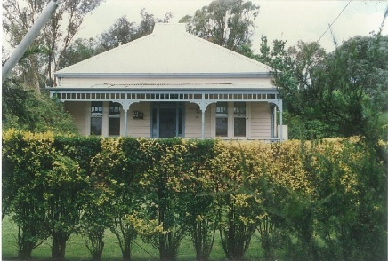  840 Heidelberg-Kinglake Road, Hurstbridge (HO73). (Source: VHD) | 840 Heidelberg-Kinglake Road (c1917) is historically important as a reminder of the changes in the township that occurred after the railway line was opened to Hurstbridge in 1912. The house is of representative significance for its modest scale and simple design and as one of a cluster of similar houses built around the 1910s in Hurstbridge.
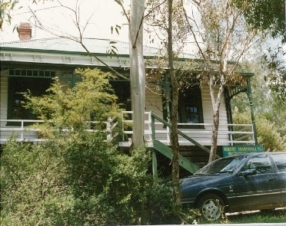  ‘Daraville’, 828 Heidelberg-Kinglake Road, Hurstbridge (HO70). (Source: VHD) | Like 840 Heidelberg-Kinglake Road, ‘Daraville’ at 828 Heidelberg-Kinglake Road (c1910-12) is historically important also as an example of development of the township during and just prior to the construction of the railway line that was extended to Hurstbridge in 1912.  The house is of representative significance for its modest scale and simple design and as one of a cluster of similar houses built around the 1910s in Hurstbridge.
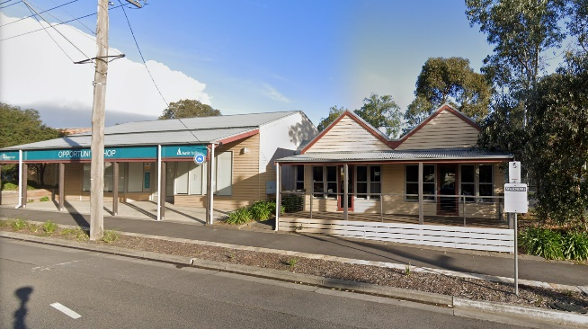  Former Milthorpe Store, 42-44 Main-Hurstbridge Road, Diamond Creek (HO259). (Source: Google 2019) | The former Milthorpe Store (c1915) is of historical significance for its associations with the Milthorpe family, who ran a store and carrier business from this location from c1915 until c1960. The site is of historical importance as an early surviving commercial building in Damond Creek. The timber building with double gables is an evidence that the simple, vernacular construction was still prevalent in this area around the mid-1910s.

Discussion
Hillside at 23 Glen Park Road, Eltham North, is most comparable to the Pizzey house at 29 Main Street, Diamond Creek, with its simple, unadorned corrugated iron clad gable roof form, weatherboard wall cladding. Like the house at 23 Glen Park Road, this house illustrates a simpler and more vernacular typology with less complex construction and detailing. This simplicity of form and expression was likely driven by economic constraints. Although many houses in the area were built to reflect building typologies and styles that had become popular in in the towns and suburbs of Greater Melbourne, the subject site indicates how families often relied on easily constructed, simple building forms to provide affordable accommodation in the semi-rural and slowly developing parts of the municipality.
Although built at a similar time to the subject house, the houses at 828 and 840 Heidelberg-Kinglake Road, Hurstbridge, demonstrate a more suburban attitude towards house design than the subject site. Both of these houses are representative of the Edwardian domestic typology that was popular across Victoria at that time of their construction. They illustrate typical characteristics of Edwardian housing design with their simple symmetrical frontages with weatherboard cladding and decorative timber detailing.
The former Milthorpe Store at 42-44 Main-Hurstbridge Road, Diamond Creek, bears a similar form to the subject site, with its simple grouping of gabled roofs and timber construction. Although fundamentally of a different use, the store indicates that the simple building style was used in the municipality for various functions for its affordability and ease of construction.
Overall, Hillside represents the basic housing that was being erected in the early decades of the twentieth century in Nillumbik, preceding the majority of the residential development in the locality.

STATEMENT OF SIGNIFICANCE

WHAT IS SIGNIFICANT?
‘Hillside’ at 23 Glen Park Road, Eltham North, a single-storey weatherboard cottage with corrugated iron roof, built c1914 for Anne and Albert Zillman, is significant.
Elements that contribute to the significance of the place include:
- the building’s built form and scale, including the three rectangular gabled forms;
- the building’s original/early materiality, including weatherboard wall cladding and corrugated iron roof; and
- the inset verandah with timber deck and timber-framed balustrade.
Later additions the rear of the main roof form and the detached garage and carport are not significant.

HOW IS IT SIGNIFICANT?
Hillside at 23 Glen Park Road, Eltham North, is of local historic significance to the Shire of Nillumbik.

WHY IS IT SIGNIFICANT?
Hillside at 23 Glen Park Road, Eltham North, is historically significant as one of the first residences to have been built on the Glen Park Estate (subdivided in 1909 and first sold in 1913), preceding the majority of the residential development in the locality, which later became Eltham North. The simple vernacular form and materiality of the cottage demonstrates the manner in which low-cost residential development was undertaken in the formerly rural areas of the Shire of Nillumbik in the early twentieth century. Built as a small workers’ home, the subject building indicates how families often relied on easily constructed, simple building forms to provide affordable accommodation in often rural, slowly developing parts of the municipality. (Criterion A)

RECOMMENDATIONS
Recommended for inclusion in the Schedule to the Heritage Overlay of the Nillumbik Planning Scheme as an Individually Significant place.
Extent of overlay: To title boundaries
Recommendations for the Schedule to the Heritage Overlay (Clause 43.01) in the Nillumbik Planning Scheme:

Nillumbik Planning Scheme
External paint controls | No
Internal alteration controls | No
Tree controls | No
Outbuildings or fences | No
To be included on the Victorian Heritage Register | No
Prohibited uses may be permitted | No
Aboriginal heritage place | No

Other
N/A

REFERENCES
Advertiser, as cited.
Ancestry 2020, https://www.ancestry.com.au, accessed 11 March 2021.
Blake, Leslie J (ed.) 1973, Vision and Realisation: A centenary history of state education in Victoria, vol. 3, Education Department of Victoria, Melbourne.
Building Permit for 23 Glen Park Road, Eltham North (BP).
Central Plan Office (CPO), Historic Aerial Photography: – 1930s to 1990s, as cited, via Landata, https://www.landata.vic.gov.au/, accessed online March-April 2021.
Eltham and Whittlesea Shires Advertiser, as cited.
Eltham North Primary School 2020, A Short History, https://www.elthamnorthps.vic.edu.au/history/, accessed online 2 December 2020.
Herald, as cited.
Land Victoria, Certificates of Title (CT), as cited.
‘Melbourne 1945 Photo-maps’, University of Melbourne, http://maps-collection.library.unimelb.edu.au/ historical/1945melb/, accessed online June 2020.
Mills, Peter & Westbrooke, Samantha 2017, ‘Nillumbik Shire Thematic Environmental History - Revision 2016’, prepared for Nillumbik Shire Council.
Nillumbik Parish Plan 1950, Melbourne, Department of Lands and Survey.
realestate.com.au 2013, 29 Main Street, Diamond Creek, https://www.realestate.com.au/, accessed online 30 April 2021.
Victorian Places 2015, Eltham North, Monash University and The University of Queensland, https://www.victorianplaces.com.au/, accessed online 10 December 2020.

