180 Cherry Tree Road, Hurstbridge

Timber cool store
Prepared by: Context | Survey date: December 2020
Place type: Orcharding | Architect: -
Significance level: Significant | Builder: Not known
Extent of overlay: To title boundaries | Major construction: c1936
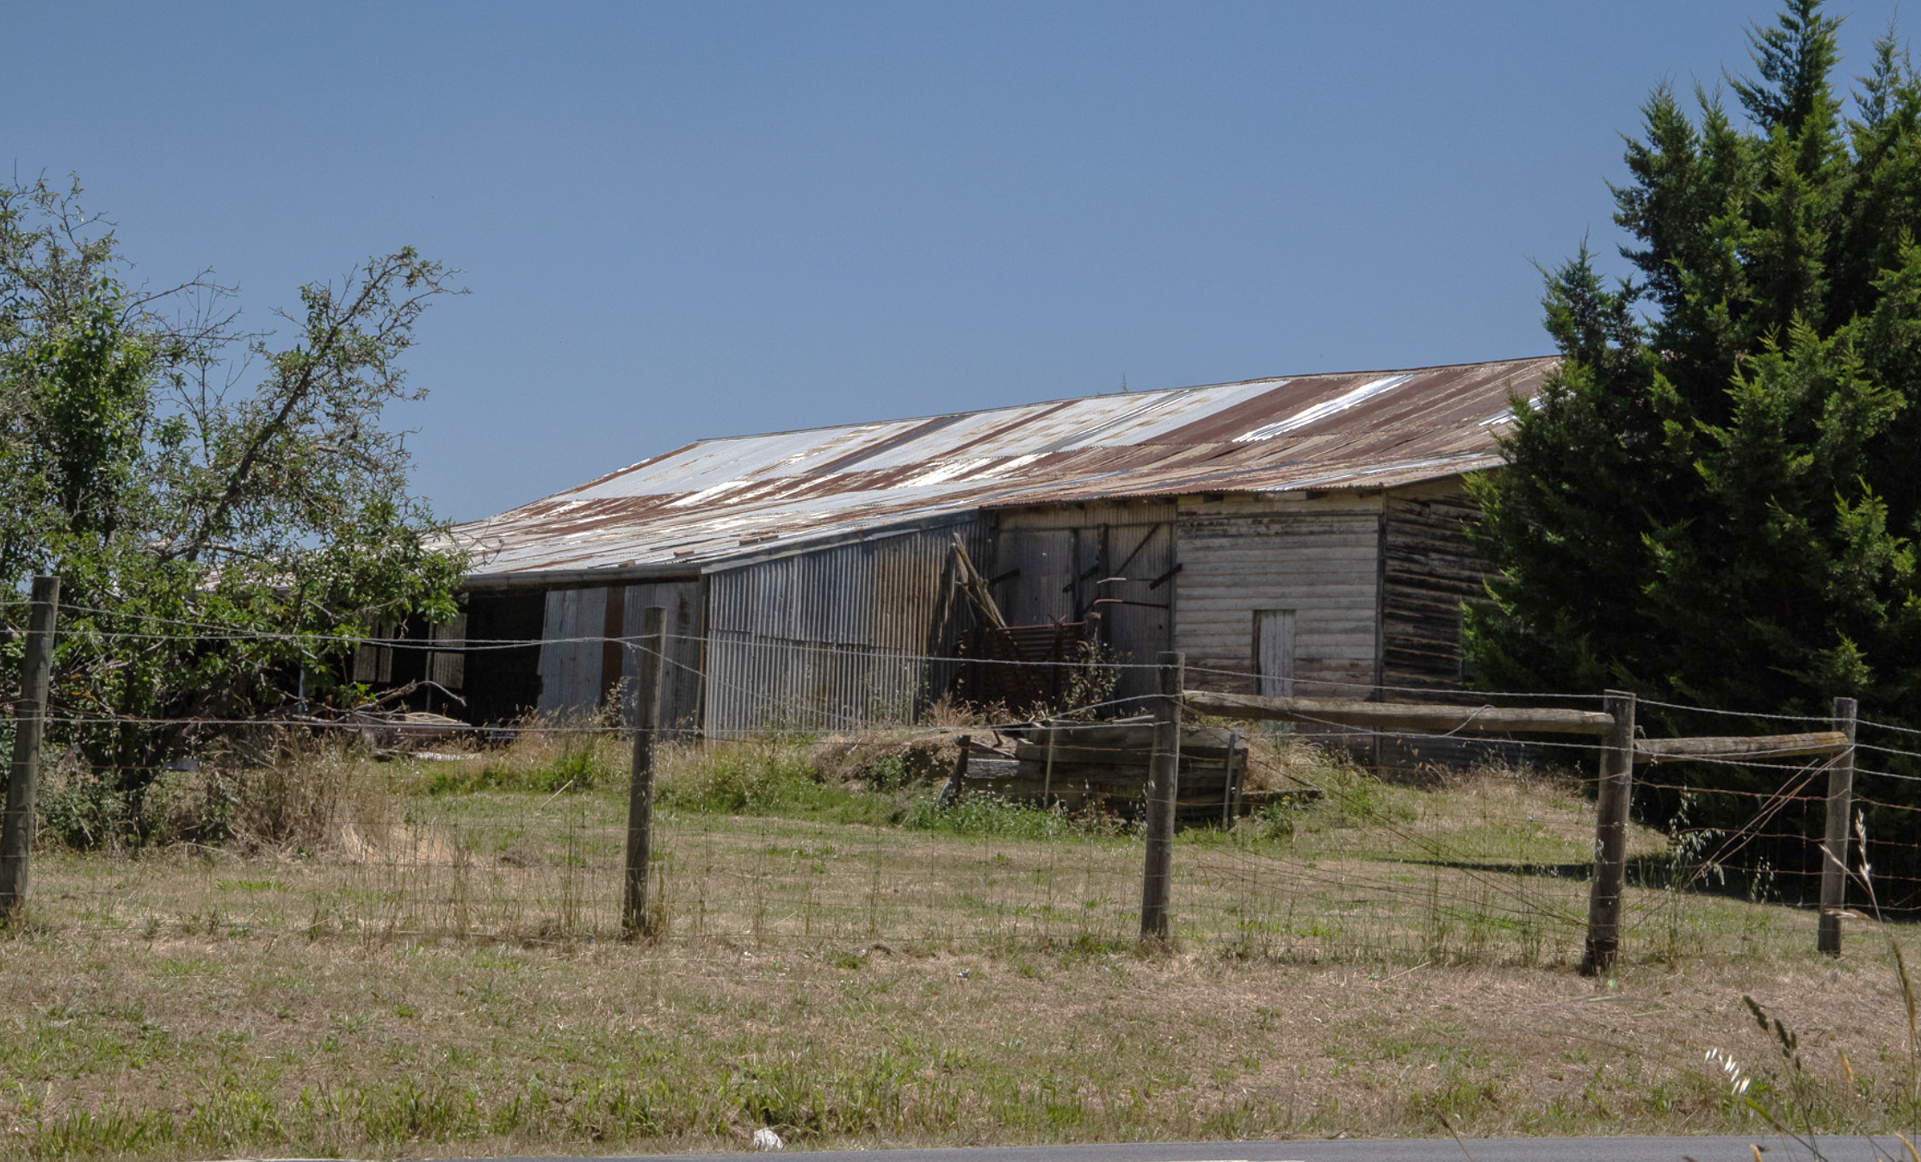
Figure 1. The cool store at 180 Cherry Tree Road, Hurstbridge, viewed from the northeast. (Source: Context 2020)
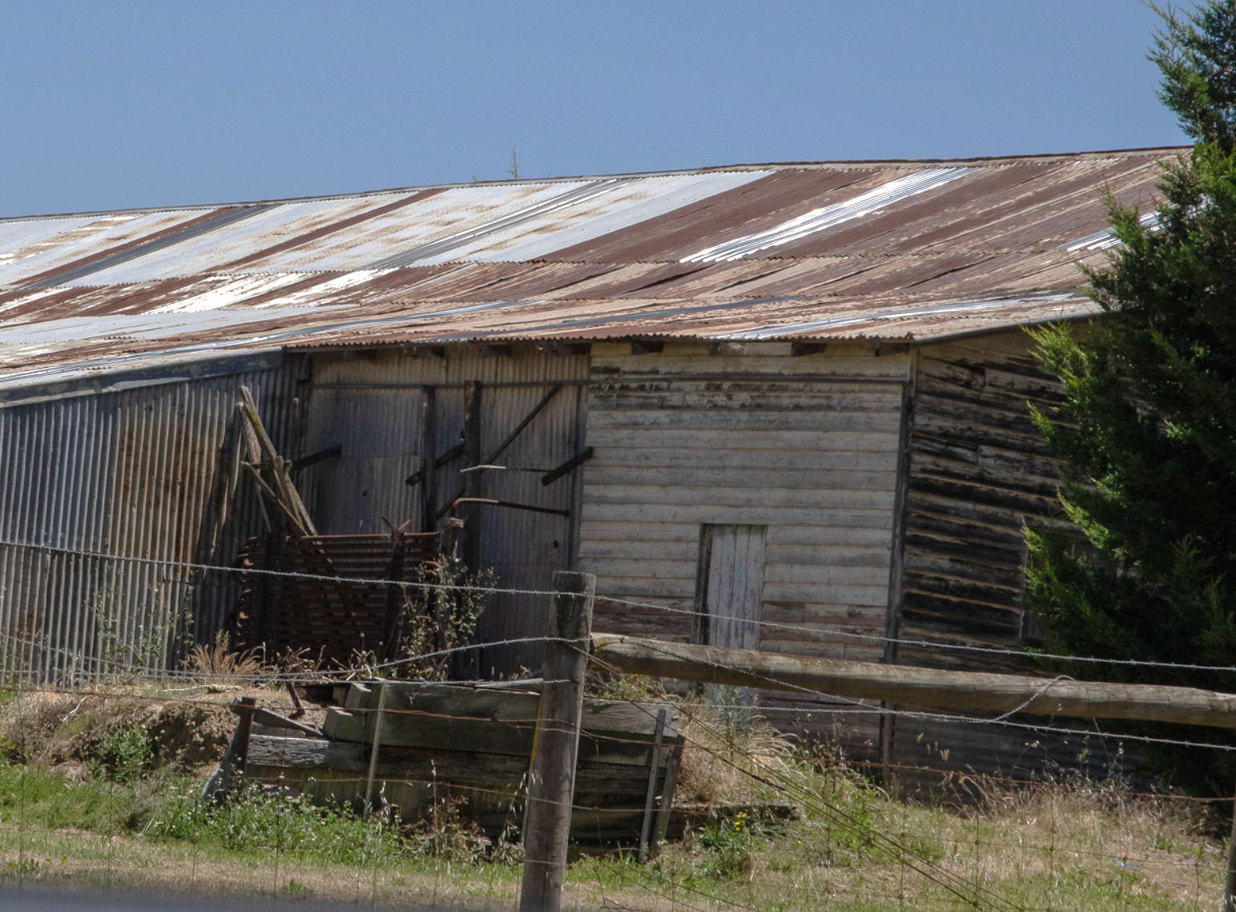
Figure 2. 180 Cherry Tree Road, Hurstbridge. Detail of the cool store showing the early timber section. (Source: Context 2020)

HISTORICAL CONTEXT
This place is associated with the following historic themes presented in the Nillumbik Shire Thematic Environmental History (2016):
2 PEOPLING NILLUMBIK’S PLACES AND LANDSCAPES
2.8 Twenty-acre occupation licences
One of the most conspicuous features of the cadastral map of the Nillumbik area is the concentrated clusters of hundreds of small lots of around eight hectares (20 acres), which are located almost exactly over the old auriferous (gold-bearing) lands of the area. There are around 800 of these small lots, amounting to around 6,500 hectares, or 15 per cent, of the land area of the current Nillumbik Shire. This settlement pattern originated in a system of temporary tenure on auriferous Crown land that was introduced in the land Acts from the 1860s and would prove a useful safety valve to the problems that arose from selection (Mills & Westbrooke 2016:34).
Victoria’s land acts are best known for the introduction of selection but this was accompanied by an evolving system for licensed occupation of Crown land for residential and cultivation purposes. The Nicholson Act 1860 provided for licences to occupy Crown lands for purposes such as stores, inns, ferries and bridges. This provision stretched to include ‘occupation licences’ and hundreds were taken up by miners and tradesmen on goldfields and on other Crown land (Mills & Westbrooke 2016:34).
By June 1866 more than 5,000 settlers had occupied over 120,000 acres in the colony under this section [Section 42 of the Land Act 1865] (Nelson & Alves 2009, p. 253; Powell 1970, p. 126). Section 42 licensees were typically tenant farmers, married farm labourers, working miners, storekeepers, small traders and carriers (Mills & Westbrooke 2016:34).
The success of Section 42 was also the cause of some dissent, as many considered the application of this section of the Act to be a distortion of the original purpose, which was to assist needy miners. As a result, under the Amending Land Act 1869, Section 42 was replaced with the more stringent Section 49 under which licensees could apply to occupy and cultivate a maximum of 20 acres exclusively on auriferous land. They could only hold one licence and there was no provision for later sale. This was soon found to be too severe and, by 1873 under new land Regulations, licensees could apply to have the land sold at public auction. Under Section 4 of the Amending Land Act 1880 licensees were able to purchase the land directly and could then take out further licences (Mills & Westbrooke 2016:36-37).
As mining slowed around Queenstown and Panton Hill in the late 1860s, miners turned to the land as another source of sustenance. Alan Marshall illustrated this process when he wrote about selectors including Burrows, Purcell, Smith, Owens, Clarke, Ellis and Harvey occupying Cherry Tree Road, (on the way to Panton Hill from Hurstbridge). The majority took up licences under Section 49 then purchased the land after 1880 and, in many cases, acquired further licences. One of these was Lot 3, Section C, Greensborough, later the site of the Smith Orchard House (HO182), first licensed to E Smith in 1877 and purchased by him in 1880 (Mills & Westbrooke 2016:36-37).
4 TRANSFORMING AND MANAGING THE LAND AND NATURAL RESOURCES
4.4 Agriculture, orchards and viticulture
The spread of orchards began with the selectors in the 1860s and by 1900 orchards covered much of the west of the shire, from Diamond Creek up to Strathewen in the north. Auriferous or quartz-laden soil was said to be suitable for fruit growing and the slopes of the Diamond Valley offered well-drained soil for the trees. Fruit growing is a labour-intensive activity, well suited to the small blocks of land selected in the Diamond Valley. The growing population of Melbourne in the second half of the nineteenth century provided a handy market for the fruit of the Diamond Valley (Mills & Westbrooke 2016:61).
Arthurs Creek, Doreen, Hurstbridge, Strathewen, Plenty, Diamond Creek, Yarrambat and Research became important centres for a fruit-growing industry that was based at Diamond Creek. While many smaller orchardists probably struggled to make profits in a labour-intensive industry, those who planted on a larger scale did very well (Mills & Westbrooke 2016:61).
The Arthurs Creek Fruitgrowers Association was formed in 1890. Members held regular shows at Diamond Creek and were active in the fight for railway connections between the fruit-growing districts and Melbourne. By the turn of the century, Arthurs Creek dominated the Melbourne fruit market. In 1912, following the passing of the Cool Store Trust Bill, for which the Arthurs Creek Association had actively lobbied, a cool store was constructed at Diamond Creek (on the site now occupied by squash courts). As well as the co-operative coolstore there were, by 1931, two privately owned cool stores at Diamond Creek operated by TJ Clark and Burke Brothers respectively. Even in the 1950s and 1960s Yarrambat orchardist Otto Rupp was placing his apples and pears in Mr Collins' cool store. In 1931 The Leader's correspondent wrote that ‘scores of small orchards few more than 20 acres in extent, are to be found within the neighbourhood of Diamond Creek and Eltham, and it is on fruit growing that most of the inhabitants of this district depend for their livelihood.’ Writing of the 1920s, Graham McInnes recalled that from Hurstbridge to Panton Hill the ‘immediate countryside was undulating park-like bush with the trees widely spaced, or else rolled aside by the fastidious patterns of orchards. As we bowled merrily on the downhill stretches the neatly planted rows of peaches, apples, nectarines and pears went by like wheel spokes and made a neat line from every angle’ (Mills & Westbrooke 2016:61).
The Shire of Nillumbik orchards probably peaked around the turn of the century, when local fruit was being exported to other states and overseas. By the First World War however, many local orchardists were experiencing difficulties. The Australasian reported in 1910 that ‘growers have been loath to part with their old trees and their hesitation has resulted in one of the most important fruit-growing districts being left in the background.’ Smaller orchardists struggled at the best of times to make a living from their trees, turning to raising chickens, selling firewood like Otto Rupp, even working for other landowners or in goldmines as well as tending their fruit trees. Even large growers like Draper disadvantaged themselves by offering too wide a variety of fruits at a time when dealers began to demand fewer varieties, but steady supplies, especially for overseas markets (Mills & Westbrooke 2016:62).
The Federation of Australia had removed tariffs between colonies so Tasmanian apples now competed with local produce, while the spread of railways throughout Victoria made fruit from the Goulburn Valley an equal competitor for the Melbourne market. There are still fruit growers in the shire today, but as a major local industry, orchards were finally defeated by the drop in exports to the United Kingdom during the Second World War. Disease wiped out some fruit trees and, as the city crept nearer, land became more valuable as building blocks rather than for farming or orcharding (Mills & Westbrooke 2016:62).

LOCALITY HISTORY
Hurstbridge, established near the junction of Arthurs Creek and Diamond Creek, is located on the country of the Wurundjeri-willam clan of the Woi wurrung people.
The Hurstbridge area, named after Henry Hurst and a ford he built over Diamond Creek in 1860, was originally known as Upper Diamond Creek, or Allwood, after Cornelius Haley’s cattle run of the same name. ‘Allwood’ was taken up in 1841 and occupied by Robert Hurst, father of Henry, and his family from 1868 (Hurstbridge and District Local History Group). In 1894, Henry Hurst’s daughter, Frances, and her husband, William (Bill) Gray, rebuilt the Allwood residence, incorporating a transported building, and named it ‘Allwood House’. They developed the extensive Allwood Nurseries on the property, from which they exported fruit trees (‘Hurstbridge Heritage Trail’ n.d.).
A number of land Acts were introduced after the 1850s gold rushes in Victoria, to establish an agricultural industry. Land was made available in the Hurstbridge area under the 1869 land Act. Some of the land taken up under this Act was held freehold by the 1870s; other allotments were leased until the introduction of the 1901 land Act, and not held freehold until the first decades of the twentieth century (Greensborough Parish Plan 1961). Orchards and nurseries were subsequently established, with apples, in particular, grown in large quantities.
Hurstbridge was a part of a substantial area given over to the growing of apples, pears and stone fruit, the main agricultural industry in the Diamond Valley region (the area covered by much of the present Nillumbik Shire), from the 1880s to the 1930s. With its soil and climate suited to the growing of fruit, Diamond Valley formed a significant part of the wider fruit-growing region situated to the north and east of Melbourne in the counties of Evelyn, Bourke and Mornington. Orchards and nurseries were established on the hills and in the gullies of the catchments of Diamond Creek and Arthurs Creek, stretching from the township of Diamond Creek, through Hurstbridge, Cottles Bridge, Arthurs Creek and Panton Hill, to the foot of the Kinglake Ranges at Strathewen and Queenstown (now St Andrews) (National Trust Report, ‘Shaws Cool Store, Cottlesbridge’, B6979, cited in Butler 2006:140).
Up until 1900, when private subdivision commenced, Hurstbridge’s businesses comprised only tearooms, a wine and billiard saloon, a butcher shop, a bakery and a blacksmith (Butler 1996:43). A public hall opened in 1892 (Eltham District Historical Society 2000).
When the Melbourne-Eltham railway line was extended to Hurstbridge in 1912, the railway station at today’s Hurstbridge was named Allwood and a settlement subsequently developed (Hurstbridge Historical Trail; Victorian Places 2015). The Allwood Post Office and store opened in 1911 opposite the railway station (Eltham District Historical Society 2000). Fruit-drying works and a cool store for fruit were constructed behind the station in 1912. The railway station became a central point for the transport of fruit and timber from surrounding areas (Eltham District Historical Society 2000).
Subdivision of residential estates followed. In 1913, a sale advertisement noted that 219 acres in the ‘Home of the Wattle’ at Hurstbridge had been subdivided into allotments ‘admirably adapted for week-end homes, small farms, orchard blocks’ (Argus 10 December 1913:5).
Most of the town’s growth between 1912 and the mid-1920s took place along Main Road. Offices to house the Evelyn Observer newspaper opened in 1918 (the building now houses the Hurstbridge Post Office) (Victorian Places 2015; ‘Hurstbridge Heritage Trail’ n.d.). Hurstbridge State School No. 3939 opened in the Church of England Sunday school hall in 1916, with a dedicated school building opened in 1922 (the building was destroyed by fire in 2005) (Blake 1973:445). A memorial sports oval was opened at Hurstbridge in 1921 (Eltham District Historical Society 2000). A single lane bridge, designed by John Monash, opened in 1918 to replace the ford built by Henry Hurst.
Special trains ran to Hurstbridge so that Melbourne visitors could gather wattle. So great were their numbers and the destruction they wrought that a charity, the Wattle Day Red Cross afternoon tea, was established in the Hurstbridge to bring some control to the crowds (Butler 1996:48).
Further subdivision occurred in Hurstbridge in the interwar period. In 1920, for example, landowners Frances and Bill Gray subdivided 34 lots on the west side of Main Road in the northern part of what is now Hurstbridge; by 1925 a few lots had also been subdivided on the west side of Main Road. The Hurstbridge Railway Estate also opened in 1924 (Mills and Westbrooke 2017:72). Some soldier settlement also occurred on rural blocks in the area in the 1920s.
The township was renamed Hurstbridge in 1924 after Henry Hurst, although the derivations ‘Hurst’s Bridge’ and ‘Hurst Bridge’ were in use until the 1950s. The section of railway line between Eltham and Hurstbridge was electrified in 1926, three years after the electrification of the line between Melbourne and Eltham.
Due to the increased competition in fruit-growing from irrigated districts after World War I and the impact of the economic depression of the 1930s, many of the area’s orchardists turned to other pursuits such as raising poultry, selling firewood, or supplementing their incomes by working for other landowners or in the few goldmines still in operation in the Diamond Creek, Greensborough and Smiths Gully areas (Nillumbik Shire 2020; ‘Victorian Gold Project’ 1999:14).
By 1940, a recreation reserve, a croquet green and tennis courts had been established (Victorian Places 2015). The majority of the Hurstbridge township area was not subdivided into residential blocks until after World War II. With this subdivision and the availability of rail services to Melbourne, Hurstbridge’s population nearly doubled between 1933 and 1954, increasing from 433 to 824. Electricity was supplied to the town in 1957, and in 1967 a high school was opened (Victorian Places 2015; ‘Hurstbridge Heritage Trail’).
Hurstbridge has been a tourist destination since the opening of the railway line in 1912, with visitor numbers rising with increased car ownership from the 1920s and particularly after World War II.
Like Eltham, Hurstbridge attracted artists, with Albert Tucker moving to a five-acre property with his wife, Barbara Bilcock, at Hurstbridge in the 1960s (Hurstbridge and District Local History Group).
The population had grown to 2350 residents in 1981. By the 1980s, Hurstbridge featured clubs, four churches and an active shopping centre (Victorian Places 2015).

PLACE HISTORY
The timber cool store at 180 Cherry Tree Road, Hurstbridge, is located on parts of three Crown Allotments, all taken up under the 1869 Land Act: Crown Allotment 2, Section E; Crown Allotment 3, Section E; and Crown Allotment 10, Section E, Parish of Greensborough (Greensborough Parish Plan 1961). All allotments, as well as neighbouring Crown Allotment 11 of 20 acres, were owned by the Moore family from the early 1890s to 1940. The Moore family established an orchard on the approximately 60 acres of land, where they built the subject timber cool store. A residence is also located on Crown Allotment 3.
In 1891, Sarah Moore, farmer, took over the original Crown grantees the Crown Allotment 2 (20 acres), Crown Allotment 3 (20 acres) and Crown Allotment 10 (5 acres). After Sarah Moore died in 1893, her son John (Jack) Andrew Moore, fruit grower of Panton Hill, took over ownership of Crown Allotment 2 in 1898. In the same year, another son Joseph Everard Moore, fruit grower of Panton Hill, became the owner of Crown Allotments 3 and 10. Following the death of the Moore brothers in 1915, John’s widow Elizabeth Moore of Cherry Tree Road became the owner (CT:V1936 F122; CT:V3932 F242). Three acres of Crown Allotment 2 were transferred to Leigh, Catherine and John Ellis-Henderson in 1936. In 1940, all remaining land on Crown Allotments 2, 3 and 10 was acquired by orchardist Thomas Clarke (CT:V1936 F122; CT:V3932 F242).
Orcharding continued on the subject property and surrounding land under the ownership of local orchardists. In 1940, Thomas Clarke, orchardist of Wattle Glen, owned all three aforementioned allotments as well as neighbouring Crown Allotment 11, a total of approximately 55 acres (CT:V8600 F157). In 1951, the land was sold to Frederick William Buck, orchardist of Hurstbridge, who subdivided it into three lots in 1966. The subject site is located on Lot 3, approximately 36 acres, of Buck’s subdivision (CT:V6360 F948). Orchardists Raymond and Kenneth Bloom became the owners of the property in 1972 (CT:V8694 F662). Bloom ran the orchard until the late 1990s, and in 2001 it was leased to George Apted, whose family owned a large fruit growing property, 'Glen Ard', at Strathewen (Ken Bloom cited in Butler 2006:144; Lawson 2021). The Apteds continue to operate orchards in the area and a fruit retail business at Arthurs Creek.
From aerial photographic evidence, the northern section of the cool store was in existence prior to 1951. An extension was constructed to the existing cool store building by 1987 (Figure 3 and Figure 4).
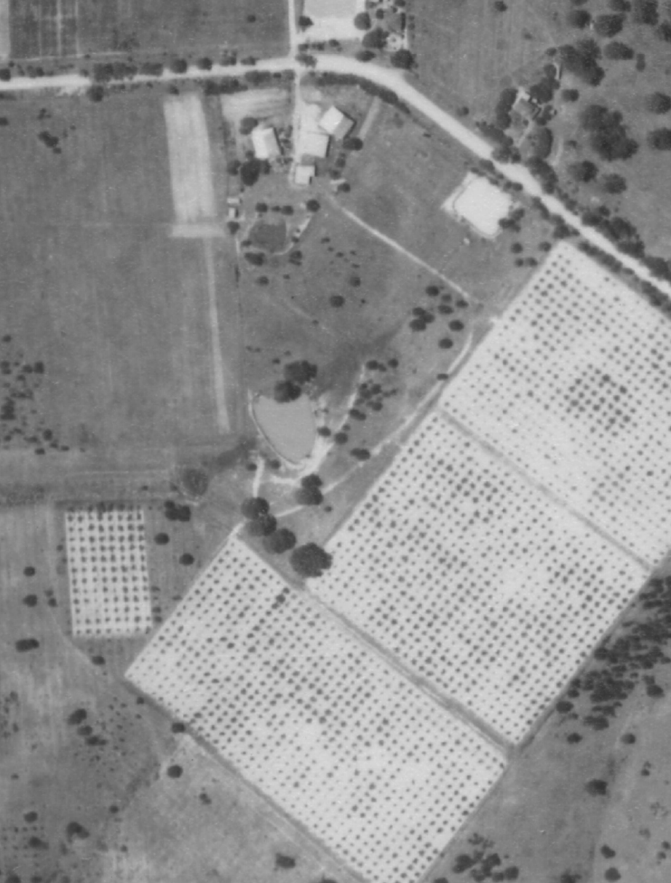
Figure 3. Extract of a 1951 aerial photograph showing the early part of the subject cool store (outlined in yellow) at 180 Cherry Tree Road. A cool chamber is also shown at the rear of the cool store. The rows of planting to the south of the subject building evidence the agricultural activities on the property. (Source: CPO, ‘MELBOURNE AND METROPOLITAN PROJECT’ 1951, via Landata)
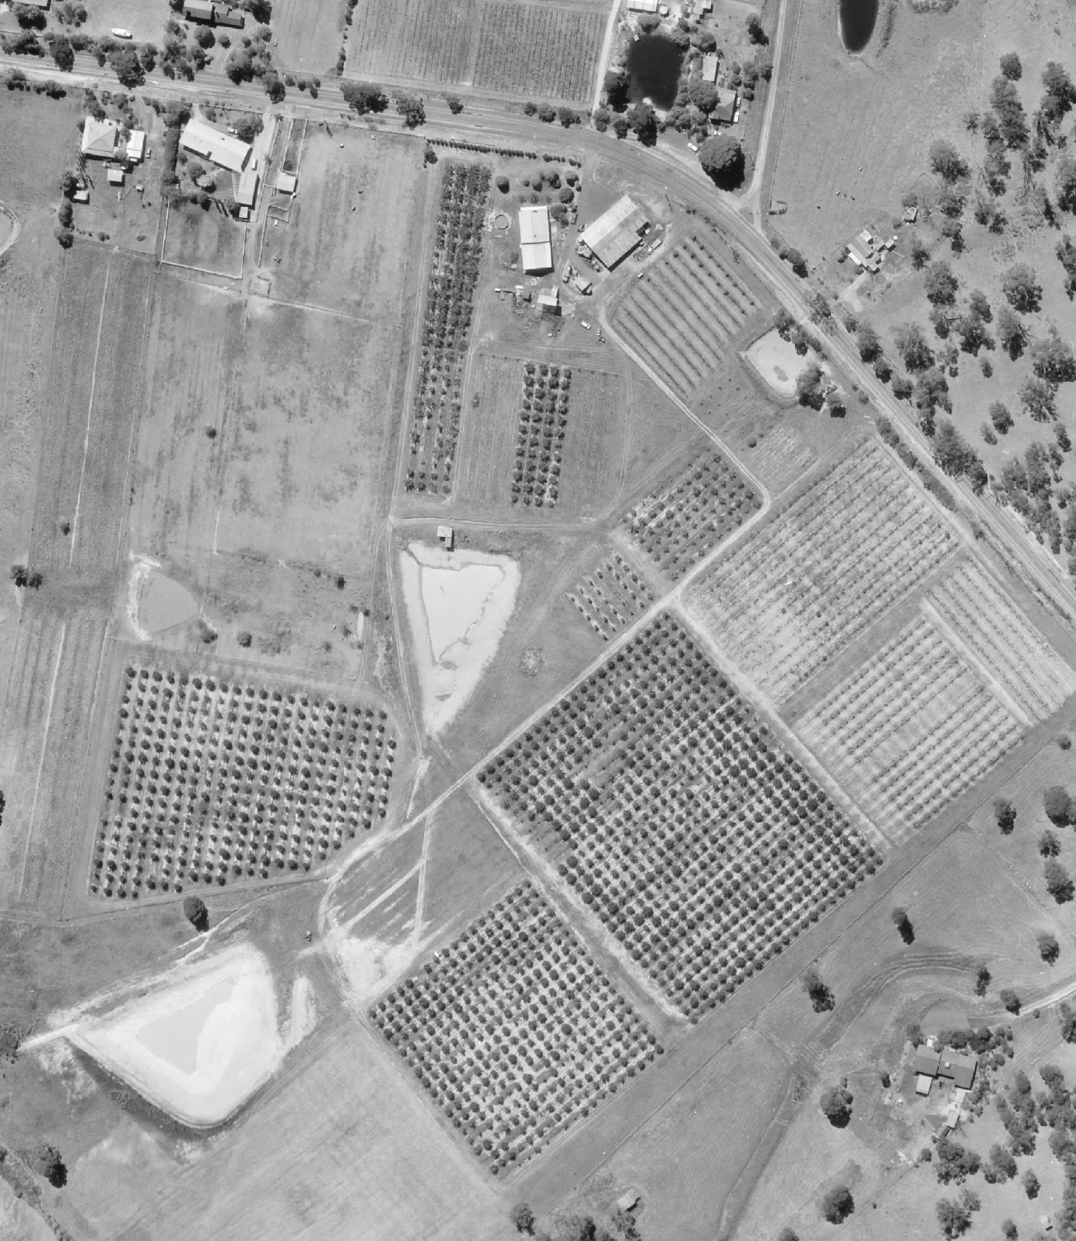
Figure 4. Extract of a 1987 aerial photograph showing the early part of the subject cool store (outlined in yellow) at 180 Cherry Tree Road with an extension. The rows of planting to the south of the subject building evidence the continued agricultural activities on the property. (Source: CPO, ‘WESTERN PORT FORESHORES’ 1987, via Landata)

A typical interwar period timber cool store, the extant cool store at 180 Cherry Tree Road is believed to have been erected in c1936 to replace the original 1914 store erected for Jack Moore. The cool store was surveyed as part of a heritage study in 2006 (Butler 2006:144). Although much enlarged and altered, in 2006 the building still displayed some of the traditional characteristics of the cool stores of the district. The northern end of the building comprised an original timber section, with the packing shed facing north west and the remains of the refrigeration plant located on the eastern side. The old cool chamber had been removed. The building has a large, corrugated iron-clad addition (pre-1987), with a modern cooling chamber, which was installed by Ken Bloom during his occupation of the property between 1972 and the 1990s. This addition was built in response to changing needs associated with the continued use of the building for its original purpose.
According to the National Trust (Vic), the building is one of about seven cool stores in the Shire of Nillumbik surviving from the 1920s-30s. The two public cool stores built in the Diamond Valley region no longer exist (Ken Bloom and National Trust of Australia (Victoria) File Number B6979, cited in Butler 2006: 139, 142, 144).

DESCRIPTION
180 Cherry Tree Road, Hurstbridge, comprises about 36 acres on the south side of Cherry Tree Road, across the Manuka Road intersection. The property retains its agricultural use, with orchards covering most of the land. The property includes two dams; one centrally located and the other in the southern part of property. The c1936 timber cool store at 180 Cherry Tree Road, Hurstbridge, is located near the northern property boundary, east of the driveway off Cherry Tree Road. There is a house with a postwar rear extension (pre-1987) to the west of the cool store.
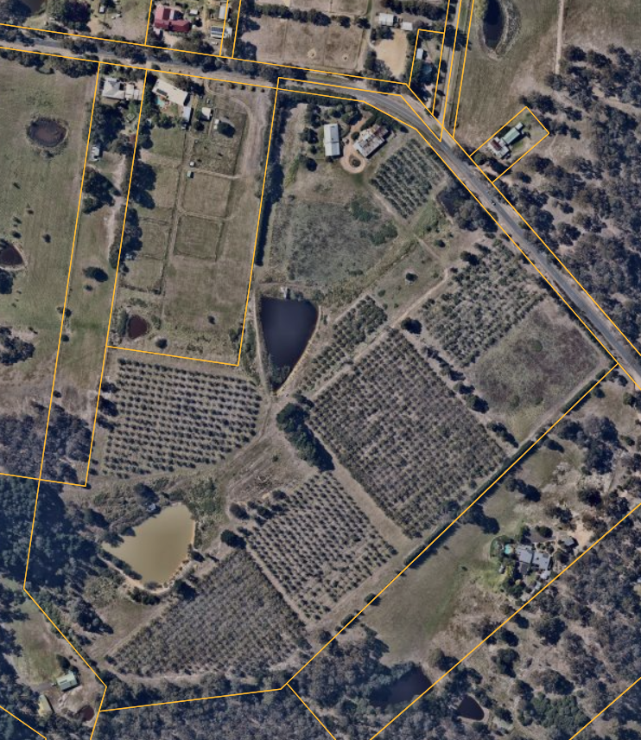
Figure 5. Aerial view of 180 Cherry Tree Road, showing the c1936 cool shed outlined in red.
The c1936 weatherboard-clad cool store displays some of the traditional characteristics of the cool stores of the district, including a symmetrical single-storey form with a corrugated metal-clad broken gable roof. There is a postwar shed (pre-1987) addition to the south elevation of the cool store. This addition houses a modern cooling chamber and has a corrugated metal roofing and cladding. In 2006, the c1936 cool store housed the packing shed facing northwest with the refrigeration plant located on the eastern side (Butler 2006:144)
The original portion of the timber cool store retains several early openings, including a timber door on the east elevation (Figure 2). Views of the north and west elevations from the public domain are obscured by new trees (planted after 1992) which are located to the north and west. In 1992, there were two window openings created in the north elevation along with a door and a window opening in the original portion of the west elevation (Figure 6).
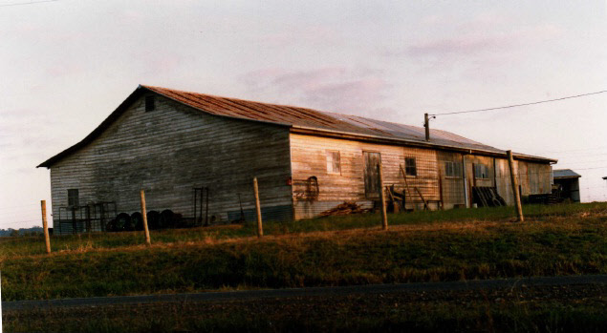
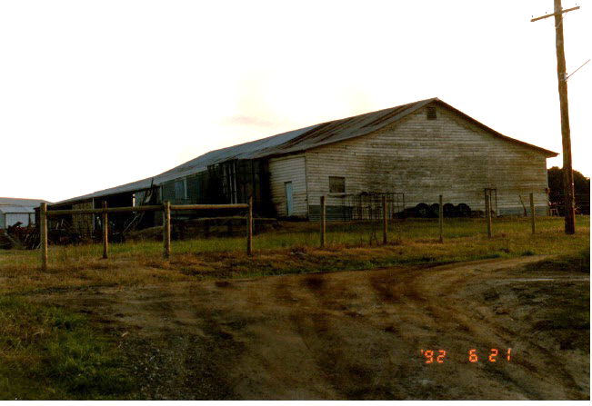
Figure 6. Cool shed at 180 Cherry Tree Road in 1992, viewed from the northwest (upper) and the northeast (lower). (Source: VHD)

The extant house on the site has a roof form that indicates construction in the early decades of the twentieth century. The design or integrity of this house was not able be confirmed at this stage, as the building is not visible from public domain. Information from other sources that would provide evidence of its design or condition of this house was not able to be obtained.

INTEGRITY
The c1936 timber cool store at 180 Cherry Tree Road, Hurstbridge, retains most of its external built fabric characteristic of typical 1920s-30s cool stores built in the district. The building retains its original single storey form with broken gable roof; corrugated iron roof cladding and weatherboard wall cladding; and an early timber door on the east elevation. Despite the postwar (pre-1987) extension to the south elevation, the basic built form and simple construction method of the earlier northern section have been retained. External elements that are characteristic of interwar cool stores built on agricultural properties in the district have also been retained. Overall, the c1936 cool store remains clearly legible and has high integrity.

COMPARATIVE ANALYSIS
The planting of orchards in the municipality began in the 1860s with the selectors who applied for 20-acre occupation licences under the Amending Land Act 1869. By 1900 orchards covered much of the Shire of Nillumbik. Diamond Creek was the base for the Nillumbik Shire fruit-growing industry and Arthurs Creek, Doreen, Hurstbridge, Strathewen, Plenty, Yarrambat and Research became key fruit-growing areas. Orcharding in Nillumbik peaked from the 1880s to the 1910s until World War I, when local orchards were exporting their produce to other states and overseas.
Although the industry declined from the 1930s, a few commercial orchards in more rural parts of the Shire remained productive into the 1990s and the present. Parts of Nillumbik played a major role in the wider orcharding regions situated to the north and east of Melbourne in the counties of Evelyn, Bourke and Mornington.
Built c1936, the timber cool store at 180 Cherry Tree Road is tangible evidence of the interwar fruit-growing industry that was led by a smaller number of commercial orchards in the municipality that survived the downturn from the World War I. In the absence of refrigeration, cool stores were a means by which fruit could be kept from deteriorating. The first government cool store was established nearby to coincide with the opening of the railway line in 1912. The two government cool stores built in the Diamond Valley region no longer exist.
Typically, cool stores of this time featured insulation and a refrigeration plant for air circulation. The produce was stored and packed for the local and export market at the cool store (sometimes packed at a nearby packing shed).
In Nillumbik, three cool stores are listed on the Heritage Overlay currently.

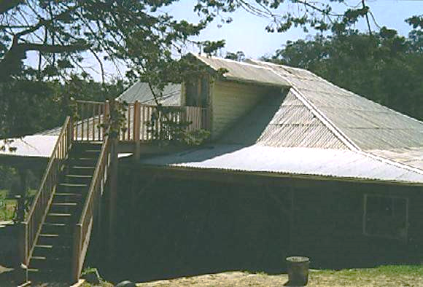  Shaw's Cool Store, 345 Hilderbrand Road, Cottles Bridge (HO212). (Source: HERMES no 66286) | The cool store at 345 Hilderbrand Road, Cottles Bridge was built in the c1930s for the orcharding property of William and Edward Shaw (HERMES no 66286).  Shaw's cool store is significant architecturally and historically, as a small private cool store typical of those built in the orchard districts near Melbourne in the interwar period. The cool store is a remnant of the important fruit-growing industry which flourished in the districts near Melbourne, including the Diamond Valley. Cottles Bridge has retained its rural character to date. The site is also historically significant as part of a Closer Settlement holding.  The cool store displays the typical design of the combined cool stores and packing sheds of the region. The building shows the techniques for insulation and air circulation used in a typical cool store of the era, however the cool store now lacks the essential refrigeration plant, except for remnants of the refrigeration pipes.  The cool store's significance is enhanced by the associated house, remnant fruit trees from the orchard and the property's rural setting (HERMES no 66286).
Cowin's Orchard Cool Store, 93-113 Murray Road, Diamond Creek (HO140).  [No image available] | Cowin’s orchard cool store built in c1920s is historically, technically and aesthetically significant. The orchard cool store is historically significant as an example of cool store associated with the key phase of fruit-growing in the region. The cool store is a reminder of this important industry and an example of a technical innovation that enabled local farmers to adapt to conditions in the region. The cool store has been dug into the hillside and clad with log walls and a thatched roof. The cool store is also important for its unusual construction technique (HERMES no 73564).
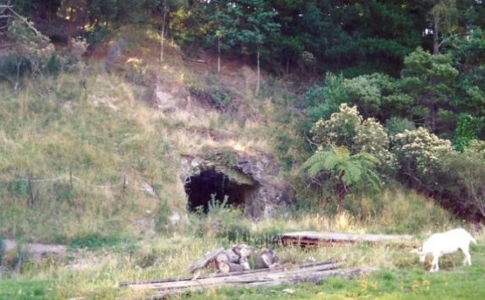  Cave Cool Store, Glen Halcyon, 145 Ninks Road, St Andrews North (HO143). (Source: HERMES no 104391) | The early 1920s cave cool store is historically and technically significant. The cool store was a 'man-made' cave store and illustrates the ingenuity of the farmers/orchardists in the area who used it to preserve their produce. The cool store is unique in the former Shire of Eltham and serves as a reminder of the important role that agriculture played in the economic development of the area (HERMES no 104391).

Discussion
The subject cool store at 180 Cherry Tree Road, Hurstbridge, is one of a few (about seven cool stores remaining in 2006) in the Shire of Nillumbik surviving from the 1920s and 30s. The subject store and the HO-listed examples were developed as private cool stores that served local orchardists. The surviving examples feature different designs. As a detached building that formerly incorporated packing facilities and refrigerating plant, the cool store at 345 Hilderbrand Road, Cottles Bridge is most closely comparable to the subject building. Utilising the natural landscape, 93-113 Murray Road, Diamond Creek and 145 Ninks Road, St Andrews North represent slightly different ways of preserving the produce.
As part of the remnant group of now rare cool stores in the Shire, the c1936 cool store at 180 Cherry Tree Road provides important evidence of the local fruit-growing industry which flourished in the Shire from the 1880s to the 1910s.

STATEMENT OF SIGNIFICANCE

WHAT IS SIGNIFICANT?
The timber cool store at 180 Cherry Tree Road, Hurstbridge, built c1936, is significant.
Elements that contribute to the significance of the place include:
- original single-storey form and scale;
- original broken gable roof with corrugated metal cladding; and
- original weatherboard-clad walls and early windows and doors, including the timber door on the east elevation visible from the street.

HOW IS IT SIGNIFICANT?
The timber cool store at 180 Cherry Tree Road, Hurstbridge, is of local historical, rarity and representative significance to the Shire of Nillumbik.

WHY IS IT SIGNIFICANT?
The timber cool store at 180 Cherry Tree Road, Hurstbridge, is historically significant as one of only a few such buildings that survive in the Shire of Nillumbik from the 1920s and 30s. Built c1936 as a private cool store for orchardist Thomas Clarke, the cool store continues to be used for its original purpose in association with the continuing agricultural activities on the property. It provides important evidence of the long-standing day-to-day operations of the local orchards from the interwar period. As one of only a few surviving interwar cool stores in the Shire, the timber cool store is important as an increasingly rare structure that was once common in the Shire of Nillumbik, where the orcharding was one of its major industries. The subject cool store is important as an example of a private cool store built for the property owner. (Criteria A and B)
The cool store is also significant as an example of a once common building type in the Shire during the interwar period. The weatherboard-clad cool score incorporated packing facilities and refrigeration plant for long-term preservation of the fruits, which was essential for local orchards. Its basic timber construction and simple form including the broken gable roof is also representative of the industrial timber buildings erected for agricultural use in rural properties. (Criterion D)

RECOMMENDATIONS
Recommended for inclusion in the Schedule to the Heritage Overlay of the Nillumbik Planning Scheme as an Individually Significant place.
Extent of overlay: To title boundaries
Recommendations for the Schedule to the Heritage Overlay (Clause 43.01) in the Nillumbik Planning Scheme:

Nillumbik Planning Scheme
External paint controls | No
Internal alteration controls | No
Tree controls | No
Outbuildings or fences | No
To be included on the Victorian Heritage Register | No
Prohibited uses may be permitted | No
Aboriginal heritage place | No

Other
N/A

REFERENCES
Blake, Leslie J (ed) 1973, Vision and Realisation: A centenary history of state education in Victoria vol. 3, Melbourne, Education Department of Victoria.
Butler, Graeme, and Associates 1996, ‘Nillumbik Shire Heritage Review - Environmental History’, Prepared for the Shire of Nillumbik.
Butler, Graeme, and Associates 2006, ‘Heritage Assessments, Shire of Nillumbik Amendment C13’, Prepared for the Shire of Nillumbik.
Central Plan Office (CPO), Historic Aerial Photography: 1930s to 1990s, as cited, via Landata, https://www.landata.vic.gov.au/, accessed online March-May 2021.
Eltham District Historical Society 2000, A Chronology of Known Local Events 1835-Early 2000 Including Those in the Shire of Nillumbik and the Former Shires of Eltham and Diamond Valley, Eltham District Historical Society Incorporated.
Greensborough Parish Plan 1961, Melbourne, Department of Lands and Survey.
Heritage Victoria, HERMES Database (HERMES), as cited.
Hurstbridge and District Local History Group, ‘Hurstbridge and Local Districts’ History’, https://allwoodhouse.org.au/, accessed online 21 November 2020.
‘Hurstbridge Heritage Trail’ n.d., http://www.hurstbridgeheritagetrail.websyte.com.au, accessed online 21 November 2020.
Land Victoria, Certificates of Title (CT), as cited.
Lawson, Pam 2021, Hurstbridge and District Local History Group, Personal Communication 9 April 2021.
Mills, Peter & Westbrooke, Samantha 2017, ‘Nillumbik Shire Thematic Environmental History - Revision 2016’, prepared for Nillumbik Shire Council.
Nillumbik Shire 2020, ‘History of the Shire’, https://www.nillumbik.vic.gov.au/Council/About-the-Shire/History-of-the-Shire, accessed online 23 November 2020.
‘Victorian Gold Project: Historic Gold Mining Sites in the St Andrews Mining Division’ 1999, Melbourne, Department of Natural Resources and Environment.
Victorian Heritage Database (VHD), https://vhd.heritagecouncil.vic.gov.au/, accessed online April-May 2021.
Victorian Places 2015, Christmas Hills, Monash University and The University of Queensland, https://www.victorianplaces.com.au/, accessed online 10 December 2020.

