Title: HO49 War Memorial Tower, Sandstone Building and Park
Identified by: Peter Mills and Samantha Westbrooke
Updated and Prepared by: Trethowan Architecture

Address: 385 Eltham-Yarra Glen Road, Kangaroo Ground
Name: Kangaroo Ground War Memorial Park | Survey Date: 22 January 2022
Place Type: Memorial Park | Architect:  Harold Herbert (designer), Percy Meldrum (Architect)
Grading: Significant | Builder: Mr Rousell
Extent of Overlay: Property Boundaries | Construction Date: 1919-1926, with later additions

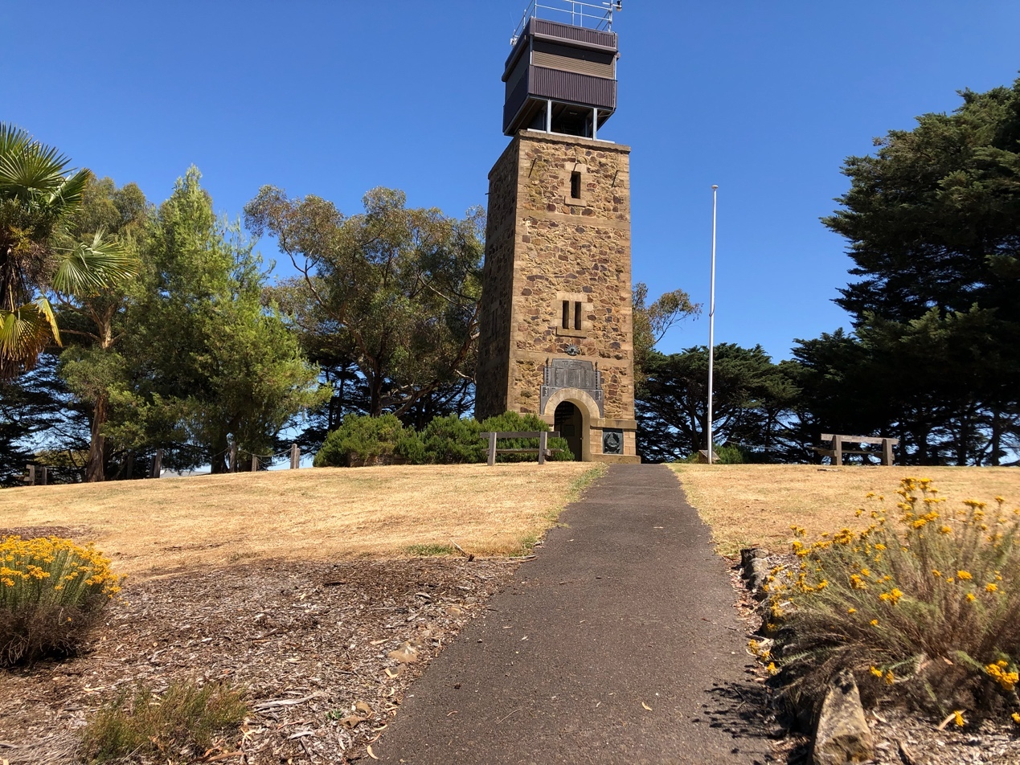

Historical Context

The following history is based on Peter Mills Revised Citation HO 49 Memorial Park, Kangaroo Ground’ (Final draft 12 October 2020) and Victorian Place (Monash University and University of Queensland, 2015).

The area now known as Kangaroo Ground is part of the lands of the Wurundjeri. There is evidence that the landscape of Kangaroo Ground may have been managed by the Wurundjeri with fire to create productive open ground for animals and plants, which also favoured hunting. There is unfortunately little written evidence of other aspects of Wurundjeri occupation of Kangaroo Ground.

Dispossession of the Wurundjeri from their lands by pastoralists began in the mid-1830s. Interpolating from the wider history of dispossession in Victoria, it is likely the Wurundjeri were driven from their lands by a number of strategies and impacts. Squatters actively destroyed Aboriginal people’s means of livelihood including their houses, encampments and fish traps. Stock trampled and destroyed Aboriginal food plants and waterholes, and game was driven away. Aboriginal people starved and resorted to killing the squatters’ stock, which resulted in violent reprisals. The influx of European population in the gold- rushes only accelerated this process, and the 1850s saw a steady decline in the Aboriginal population in the area.

The area, in which the summit later known as Garden Hill was located, was marked by relatively open woodland with good soil. The area was named ‘Kangaroo Ground’ as it attracted grazing kangaroos. A village was settled in 1842, and a farming community, predominantly of Scottish descent, began to grow following the land selection in the 1850s. Kangaroo Ground had been good for cereal and wheat production, and was dominated by market gardens and orchards. From 1854 to the 1880s, gold mining in the Diamond Creek and Warrandyte areas provided a market for Kangaroo Ground farmers. Notably early landholders and pastoralists in the area included James Donald Bruce, George Kirk and the Alexander Thomson family. In 1851, a school and Presbyterian church were established in the area and in 1864 a hotel opened. By the 1880s, the Garden Hill summit had become a well-known feature on tours of the district. In 1892, the Kangaroo Ground Fire Brigade was formed and remains a significant community focus until this day (Herald Sun, 22 March 2017). In 1921, a War Memorial Park was created at 385 Eltham Yarra Glen road.

The area remained a predominantly rural and agricultural area up to the 1970s.

History

Summary History of the Memorial Park
Prepared by Dr Peter Mills June 2020

The land prior to establishment of the Memorial Park
The area now known as Kangaroo Ground is part of the lands of the Wurundjeri. There is evidence that the landscape of Kangaroo Ground may have been managed by the Wurundjeri with fire to create productive open ground for animals and plants, which also favoured hunting. There is unfortunately little written evidence of other aspects of Wurundjeri occupation of Kangaroo Ground.

Dispossession of the Wurundjeri from their lands by pastoralists began in the mid-1830s. Interpolating from the wider history of dispossession in Victoria, it is likely the Wurundjeri were driven from their lands by a number of strategies and impacts. Squatters actively destroyed Aboriginal people’s means of livelihood including their houses, encampments and fish traps. Stock trampled and destroyed Aboriginal food plants and waterholes, and game was driven away. Aboriginal people starved and resorted to killing the squatters’ stock, which resulted in violent reprisals. The influx of European population in the gold- rushes only accelerated this process, and the 1850s saw a steady decline in the Aboriginal population in the area.

The Kangaroo Ground run, in which the summit later known as Garden Hill was located, was held by James Donald Bruce from 1840, and by Brown and Draper from 1844-49. Brown and Draper had a fenced-off cultivation area on the ridge 600m to the north of the summit. This part of the Parish of Nillumbik was surveyed in the late 1840s, and at the Crown land sales that followed soon after Allotment 4 Section 2, on which the summit of Garden Hill was located, was purchased by investor George Kirk. Kirk’s land was leased by Scottish immigrants Jane and Alexander Thomson and family. Allotment 3 Section 2, just to the east of the summit of Garden Hill, was purchased by Andrew Harkness in 1848.

The open woodland of Kangaroo Ground around Garden Hill was progressively cleared and cultivated. The southern half of Allotment 4, which had been acquired by the Thomson’s, was purchased by James and Jane (Stevenson) Mess in 1891. The summit of Garden Hill soon gained a wide reputation as a lookout and picnic area with expansive views in all directions. The Eltham-Yarra Glen Road followed the surveyed government road reserve on the south side Allotments 4 and 3, passing conveniently close to the summit. By the 1880s the Garden Hill summit had become a well-known feature on tours of the district.

Establishing the Memorial Park

After James Mess died in 1901 the property known as ‘Garden Hill’ was farmed by his sons. Towards the end of World War 1 Eltham Shire councillors began to consider creation of a memorial park with a monument at Garden Hill. Two acres at the southeast corner of Allotment 4 was purchased from the Mess brothers in 1919 and the land was ploughed and cleared of rocks. Planting of ornamental trees including rows of Cypresses on the four boundaries began in 1920. A small block of land to the east was donated by Frances (Harkness) White to create an entrance road, which was soon marked by a timber archway and gate. The Shire of Eltham Memorial Park was opened in September 1921.

In 1922 a delegation of members of the Panton Hill Returned Sailors and Soldiers Imperial League of Australia attended an Eltham Shire Council meeting and suggested that a memorial to fallen soldiers from the district should be built in the park, taking the form of a cairn of local stone crowned with a monument. The Council allocated £250 to the project, a War Memorial Committee was appointed, and fundraising events followed. The Anzac Day memorial service held in the Memorial Park in 1923 was attended by 1000, starting with a procession of school children and a band from the Shire Hall (then in Kangaroo Ground) to Garden Hill.

A rounded cairn of field stone with a flagstaff above was in place by 1924. That year the Eltham Shire Memorial League was formed to plan and raise funds for a more substantial memorial. A design competition was held with entries invited from Melbourne monumental masons and technical schools, but the resulting proposals were considered too polished, when a more rustic effect was desired. A competition entry design for a 70ft lookout tower in local stone by the shire engineer was chosen.

Local resident Basil Hall recalled in 1963 that at a gathering at his house, presumably soon after the competition, artist Harold Herbert had sketched up a design inspired by watch towers built on the Scottish-English border from the 1450s and ca1600. Architect Percy Meldrum then volunteered to produce architectural drawings. By early 1925 the League had approved Meldrum’s drawings for a 50ft tower, and this was reduced to 40ft because of cost constraints. The Shire arranged for sandstone to be brought to the tower site from a quarry on the nearby farm of Dr Ethel and Professor William Osborne. Builder Mr Rousell used cast-concrete quoins and dressings with the local stone as rubble veneer in between. The main structure of the tower was in reinforced concrete.

1500 people attended the opening of the tower on Armistice Day 1926. School children from Eltham, Panton Hill, Hurstbridge, Kangaroo Ground, Research, and Queenstown formed a guard of honour for the Governor General and Lady Stonehaven as they approached the tower and unveiled the temporary honour board painted on the panels on either side of the doorway. A pair of captured German field guns were arranged on either side of the tower in ca1929 but were mysteriously taken away during World War II.

Interwar and World War 2 history of the Memorial Park

With the rise of motor travel, the lookout tower became a very popular stopping point on day tours from Melbourne. A series of returned-soldier caretakers were employed to look after the site, with a one-room caretaker’s cottage built in ca1927 from the same local rubble stone as the tower. In September 1930 a “handsome” bronze tablet costing over £100 and bearing the names of the fallen was erected on the tower above arch of the doorway. Returned soldier and ex prize-fighter William ‘Tiny’ Carroll was the most conspicuous of the early caretakers, living at the tower from c1934 to ca1938 and providing vivid interpretation for visitors.

Four cast iron direction plates were fitted to the lookout balustrades in 1931. The timber doors in the entrance were replaced with wrought iron gates in ca1936. The inside of the tower was painted white in ca1938 in an effort to improve the lighting of the stairs. The park and tower were considered somewhat neglected by 1939, and extensions to the caretaker’s cottage to allow a married couple were considered. When the tower was rededicated by the Governor Sir Dallas Brooks in 1951, with new plaques for the names of the fallen in World War II, a new fibro house had been built for the caretakers.

Post World War 2 history of the Memorial Park

The potential of the tower for fire spotting was first canvassed in 1939, but the first spotter started in 1948. In 1966 the need for the addition of a spotter’s cabin to the top of the tower was pushed by the Forestry Commission and opposed by the local Returned Services League branches. University of Melbourne architecture professor Brian Lewis and the aging Percy Meldrum advised that a suitable design would not compromise the tower, and a prefabricated cabin was finally erected by crane in 1974. The Shire of Eltham purchased another block of land to the west in 1973, with the intention of providing better road access to the park.

Another rededication ceremony was held in 2001, with plaques installed to honour the fallen from the Korea, Borneo, Malaya and Vietnam conflicts. In 2008 the Moor-rul viewing platform, which functioned as a lookout for those unable to climb the stairs in the tower, was built on the upper part of the land acquired in 1973. The platform also accommodated interpretation panels. A new fire spotting cabin, this time raised above the original lookout level, was installed in 2010, as well as a new steel spiral staircase inside the tower.

Description & Integrity

The site
The Memorial Park site consists of the original two-acre rectangular park at the top of a hill and a piece of land containing the driveway entry at the south east corner, as well as the triangular piece of land to the west of the park and sloping down toward the Kangaroo Ground township, acquired in 1973.

The original area of the Memorial Park is defined by perimeter plantings of Cypress trees on the north, east and south boundaries, dating back to the 1920s. It is thought these trees were planted as a boundary demarcation but also had a memorial association in that they were evergreens. It is acknowledged that these trees are in poor health and will require replacement within 10 years. Planting of replacement trees that retain the landmark contribution, boundary demarcation and evergreen memorial association would be considered acceptable in retaining the significance of this historical boundary planting.

The War Memorial Tower (opened in 1926) is located at the highest point of the hill with a diagonal pedestrian path leading from the driveway entry to the tower entrance. A small stone clad former caretaker’s cottage, built c1927, sits on the northern boundary and the 1951 caretaker’s house is located in the north eastern corner and is fenced off from the park with a residential yard around the house.

The driveway is accessed from Eltham-Yarra Glen Road at the south east corner and follows the southern boundary, curving around the south west corner and along the eastern boundary of the original rectangular park to the asphalt car park.

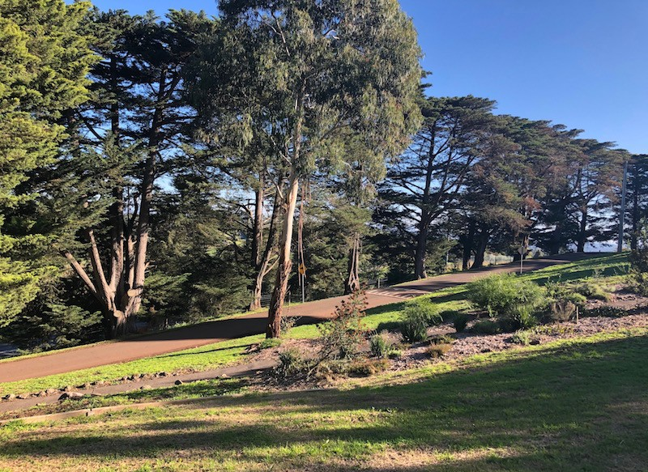 | 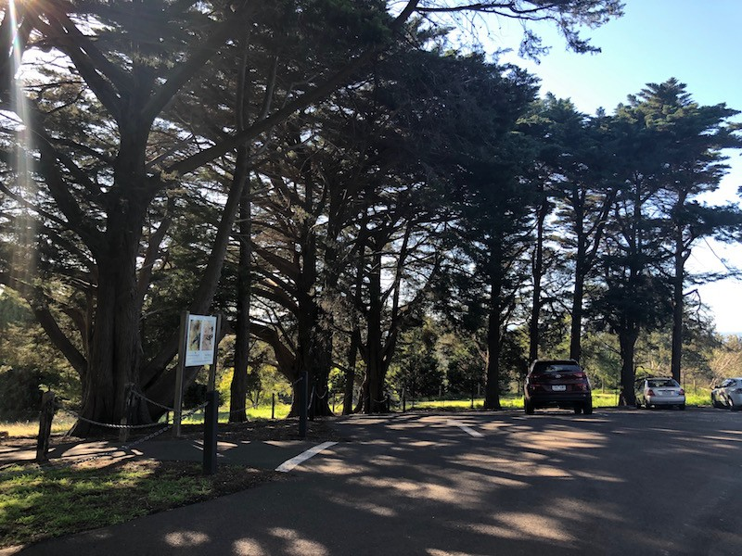
Entrance driveway along southern boundary of the rectangular original rectangular park | North west corner car park of the original park

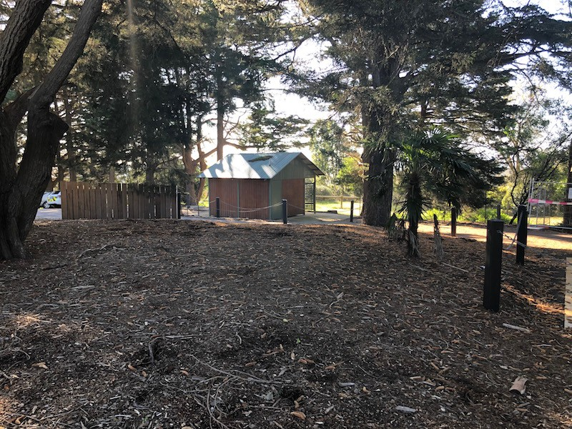 | 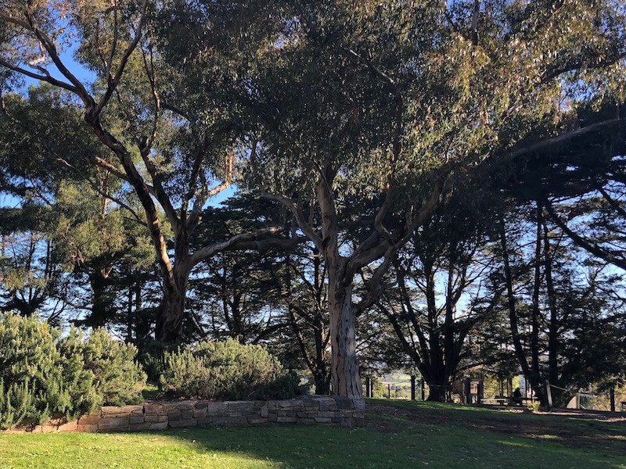
View towards 2010 toilet building on north boundary platform of the original rectangular park | View west towards Moor-rul viewing platform

At the top of the later acquired triangular parcel of grassland is the Moor-rul viewing platform, a roofed, steel and timber structure constructed in 2008.

There is a scatter of other memorials on the site including cairns, seats, interpretation panels and a 'Lone Pine' planted in 2005.

Seats and tables were added to the site in 2004 and a toilet building located adjacent to the car park on the central north side of the site was constructed in 2005 and replaced the earlier 1969 toilet block.

Other tree species on the site include five Chusan Palms (Trachycarpus fortunei), which were planted in 2001 most likely as replacements of the original (7) Cabbage Palms, a Cedar (Cedrus deodara) between the tower and the cottage and two early Sugar Gums (Eucalyptus cladocalyx) and a Manna Gum (Eucalyptus viminalis) to the west of the tower likely to have been planted in the 1920s.

War Memorial Tower

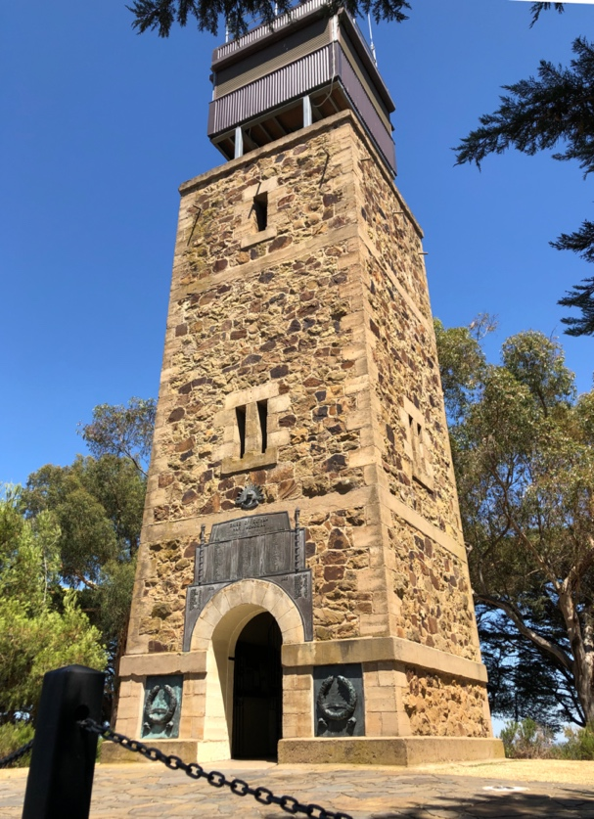 | 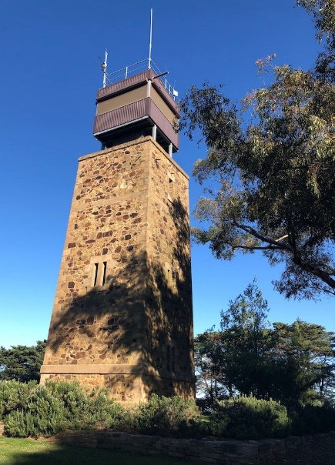

The tower has a square plan and tapers slightly towards the top. The tower has a concrete plinth and has cast-concrete quoins and dressings with local sandstone, quarried from a nearby site, as rubble veneer in between. The main structure of the tower is reinforced concrete. A rendered string-course runs around the tower below the springing line of the arch. Reinforced concrete ring beams are located at the levels of the landings inside the tower. The internal walls still show the lines of formwork for the reinforced concrete structure.

The tower is 16 metres high with an arched entry facing east and a large bronze tablet above the doorway listing 79 names of men from the Shire who died in World War One and 28 from World War Two. Two bronze plaques with wreaths for the Korea, Borneo Malaya and Vietnam conflicts were installed in the panels on either side of the doorway of the tower in 2001. Because of the 2009 bushfires, the current fire spotting cabin at the top of the tower was installed in 2010 and replaced the previous 1974 fire spotter’s cabin, which was a prefabricated structure hoisted onto the top of the tower and that involved the removal of the original stone structure around the rooftop exit door. The old ladders inside the tower were replaced in 2010 with a steel spiral staircase.

A square-shaped area of earth/ grass immediately around the tower base was originally implied and differentiated from the rest of the park by rubble edging (visible in photographs of the tower in the 1930s). The square-shaped area around the tower base was formalised in 1994 by levelling the area and defining it with a low stone retaining wall (replacing the original rubble edging), and the entry to the tower paved. Rosemary planting has been added along the top of the stone retaining wall.

c.1927 Caretakers Cottage

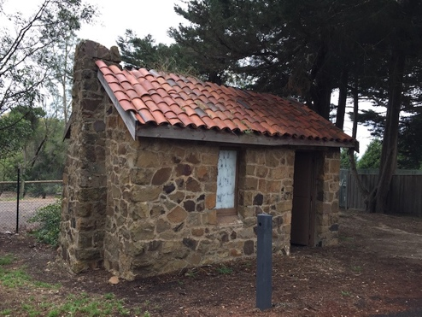

The single room caretaker’s cottage is also random course rubble sandstone facing, over cast concrete walls. The rubble sandstone was most likely left over from construction of the tower. It has a simple gable roof clad in terracotta Marseille tiles, with a single door and window on the front (south) elevation and a chimney on the west end.

1951 Caretaker’s Residence
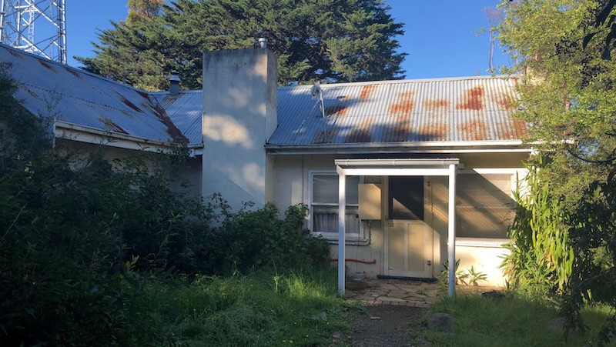

The 1951 caretaker’s residence has a t-shaped plan and is constructed of rendered brick walls with intersecting gable roofs clad in corrugated iron and timber framed openings. The residence has four rooms and separate yard bounded by a timber-paling fence.

Comparative Analysis

Other surviving World War 1 Memorials in Nillumbik Shire are as follows:

• Former Memorial Park (HO260), 36 Greysharps Road Hurstbridge. Created in 1923 on ten acres of land adjacent to the railway, which was purchased from Sharp’s orchards. Volunteers built sports ovals and a picnic area.

• Eltham War Memorial Cenotaph (HO126), 903–907 Main Road, Eltham. A granite obelisk erected in a prominent position at the corner of Main Road and Bridge Street in 1919, which was moved to the front of the Eltham RSL building in the 1950s, and to a new Main Road site in 2012.
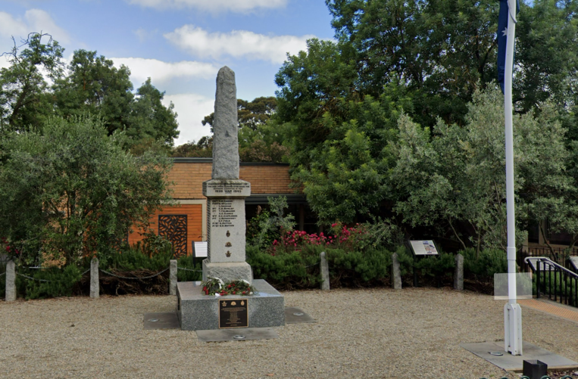
Image Source: Google Street View 2022

• Memorial Cross (HO96), 575 Kangaroo Ground-St Andrews Road, Panton Hill. Residents of Panton Hill chose to erect a Memorial Cross in the yard of St Matthews Church of England opposite the Soldiers’ Memorial Hall, which was dedicated in 1926.
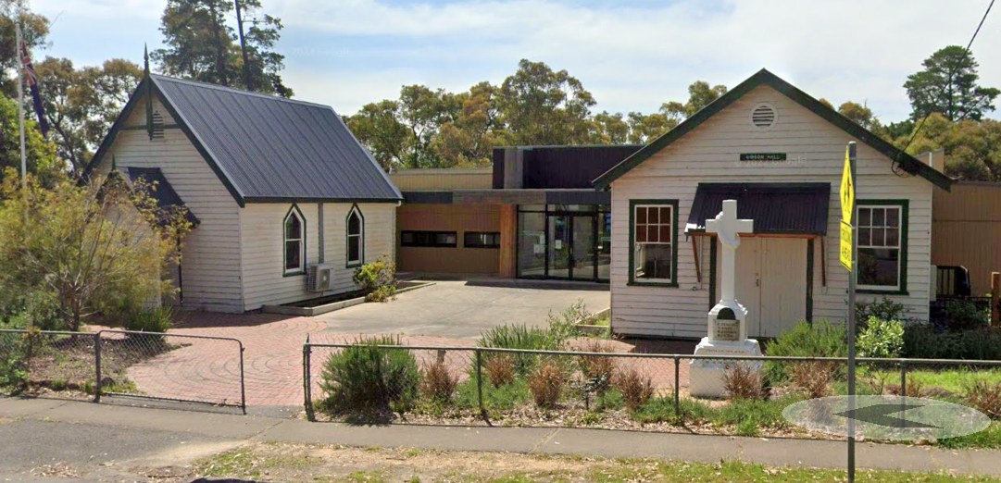
Image Source: Google Street View 2022

• Diamond Creek War Memorial, Reserve Circuit-Main Hurstbridge Road Diamond Creek. In 1921 the citizens of Diamond Creek erected a red-granite column in Collins Street, Diamond Creek. In 1996 this memorial was relocated to Reserve Circuit and re-dedicated to cover the loss of all lives in conflicts since the Great War.
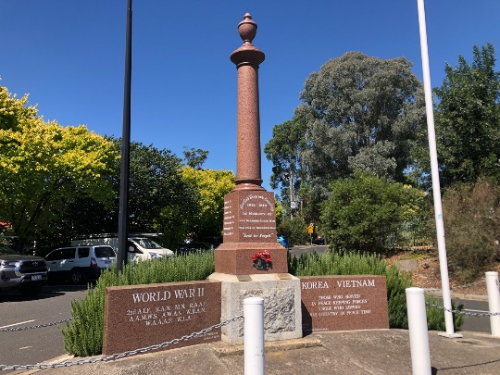
• Christmas Hills Memorial Park, Eltham-Yarra Glen Road, Christmas Hills. Planted with Oaks and Kurrajongs and equipped with garden seats. A granite tablet memorial was unveiled in the Christmas Hills Memorial Park in 1921.

• Yarrambat War Memorial Park, 448 Ironbark Road, Yarrambat.

Although there were other impressive parks and memorials constructed in the Shire following World War 1, the Memorial Park and War Memorial Tower has more significance to the whole Shire due to its establishment and construction as a whole-of-Shire memorial honouring all of those in the Shire who served and died in the wars rather than just from an individual town or locality within the Shire. In addition, the construction of the War Memorial Tower at the summit of the park as a memorial to those who died was seen as the highlight of the Shire’s inter-war memorial building activity. A Shire holiday was declared for the opening of the tower on Armistice Day 1926. It is also distinctive as an all-encompassing memorial site with a park and monument rather than just one of these.

The War Memorial Tower, constructed in 1926, is one of only six War Memorial Towers constructed in Victoria to memorialise World War 1. The Kangaroo Ground Memorial is unusual in its location in a rural rather than town setting and its rustic styling compared to the more formal other examples. Apart from the water tower at Portland, which had the lookout function added at a much later date (1996), the Kangaroo Tower is the only other lookout tower of these examples. The other five memorial towers are shown below:

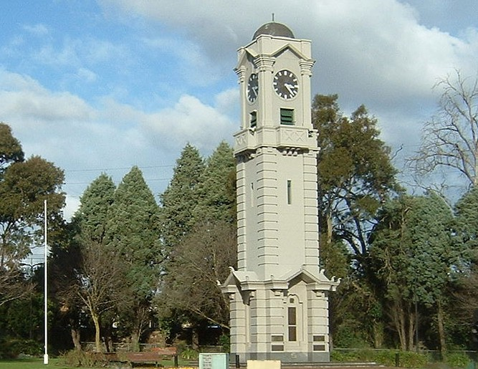 | 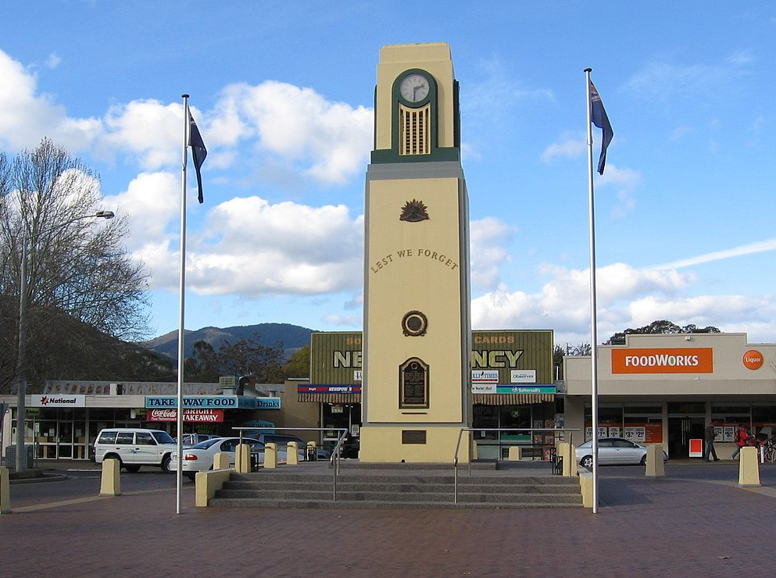
Ringwood War Memorial Clock tower 1928 | Bright War Memorial Clock Tower 1929

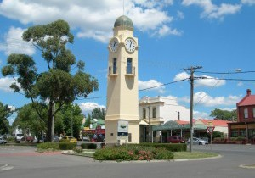 | 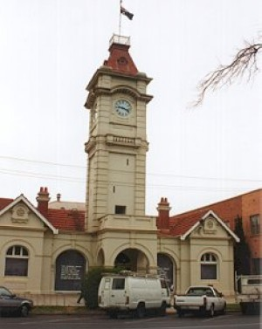
Woodend War Memorial Clock Tower 1927 | Mildura war memorial clock tower 1921

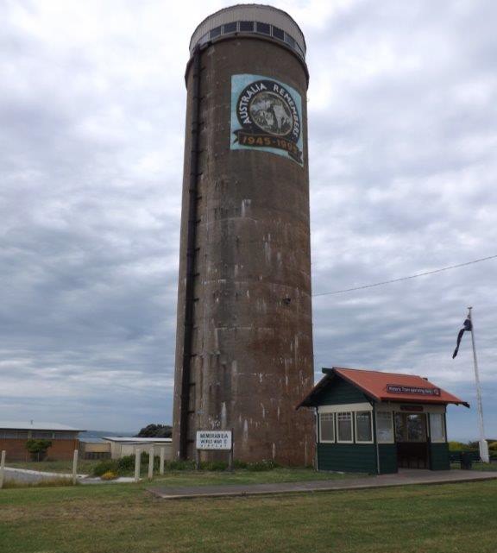
Portland War Memorial Lookout Tower – the 1930s water tower
was converted to a memorial lookout at 50th anniversary of end of WW 2 - 1996

Assessment Against Criteria

Criteria referred to in Practice Note 1: Applying the Heritage Overlay, Department of Planning and Community Development, revised July 2015, modified for the local context.

CRITERION A: Importance to the course or pattern of the Shire of Nillumbik’s cultural or natural history (historical significance).

The Memorial Park is historically significant for its role in civic commemoration of all those who enlisted in the wars, from the former Shire of Eltham. The park, established in 1921 following World War One, as the ‘Shire of Eltham Memorial Park’, intended to serve the whole Shire rather than an individual town or locality. In addition, the construction of the War Memorial Tower at the summit of the park as a memorial to those who died was the highlight of the Shire’s inter-war memorial building activity. A Shire holiday was declared for the opening of the tower on Armistice Day 1926.

The Memorial Park and War Memorial Tower are of historical significance for demonstrating the promotion of the idea that the war effort of the young nation proved its right to be on the world stage. The visiting governors and bishops were the symbolic carriers of this knowledge. This nationalistic role was linked in speeches to the view from the lookout of the successfully settled land.

The Memorial Park is of historical significance as a site that has been used as a tourist and picnic destination since at least the 1860s, long before the establishment of the Memorial Park and when the popular summit lookout was known as Garden Hill. This role of the site as a tourist and picnic destination that is further enhanced by the presence of a lookout tower, continues to the present day.

The Memorial Park is of historical significance for its association with the repatriation scheme for returned soldiers who were employed to establish and maintain the grounds as well as employed as caretakers, first living in the Caretaker’s Cottage constructed c1927 and later in the larger residence constructed in 1951. The Caretaker’s residences also indicate the importance of the park to the Shire indicating that it had to be cared for and demonstrating those early methods of care with an on-site caretaker.

The Memorial Park is of historical significance for its role in the fire history of the area with the use of the tower for fire spotting since 1939 to the present day.

CRITERION B: Possession of uncommon, rare or endangered aspects of the Shire of Nillumbik’s cultural or natural history (rarity).

The War Memorial Tower is of significance as a rare form of a World War One memorial, which more commonly took the form of a stone obelisk located in the centre of a town. There are only five other known War Memorial Lookout Towers in the State. The War Memorial Tower is also unusual for its rustic architectural expression using local rubble stone and minimal ornamentation, which was purposefully chosen for the tower, to reflect the largely rural character of the Shire and to set it apart from the more polished urban manifestations of memorialisation.

CRITERION C: Potential to yield information that will contribute to an understanding of the Shire of Nillumbik’s cultural or natural history (research potential).

CRITERION D: Importance in demonstrating the principal characteristics of a class of cultural or natural places or environments (representativeness).

CRITERION E: Importance in exhibiting particular aesthetic characteristics (aesthetic significance).

The Memorial Park is of aesthetic significance for its setting on a prominent hill with landmark evergreen plantings (Cypress trees) to the north, south and west boundaries of the original park, other specimen plantings and stone tower at the highest point offering magnificent views of the district. The views to the west of the site through the 1973 purchase of the triangular piece of land, contributes to this setting.

The War Memorial Tower and c.1927 Caretaker’s Cottage are of aesthetic significance for their rustic styling and use of random rubble stone quarried locally, reflecting the largely rural character of the former Shire of Eltham.

The fire spotter’s cabin on the top of this tower installed originally in 1974 and replaced with the current cabin in 2010 detrimentally impacts on this aesthetic significance.

CRITERION F: Importance in demonstrating a high degree of creative or technical achievement at a particular period (technical significance).

CRITERION G: Strong or special association with a particular community or cultural group for social, cultural or spiritual reasons. This includes the significance of a place to Indigenous peoples as part of their continuing and developing cultural traditions (social significance).

The Memorial Park is of social significance as a commemorative focus for the Nillumbik community to remember those who fought in the Wars. The primary role of a memorial was to enable commemoration of the enlisted and fallen. In the early years there was great immediacy with the presence of the parents of the fallen at the services.

The Memorial Park is of social significance for its representation of community strength demonstrated by the involvement of locals in its establishment through community committees and leagues, fund raising efforts and continuing community involvement in its care and how it has evolved. This is also demonstrated in the ongoing need to honour, memorialise and tell stories at the site, including the need to acknowledge the previously unacknowledged traditional owners of the land, which saw the construction of the Moor-rul viewing platform in 2008.

The Moor-rul viewing platform also extends the educative role the site has played in teaching children and other visitors, initially about the young nation and ideas of loyalty and duty but also providing stories of the developing nation and its changing values over time.

CRITERION H: Special association with the life or works of a person, or group of persons, of importance in the Shire of Nillumbik’s history (associative significance).

Grading and Recommendations

Recommended for inclusion in the schedule to the Heritage Overlay of the Nillumbik Planning Scheme.

The recommended revised (increased) extent for the HO49 Heritage Overlay listing is provided below:

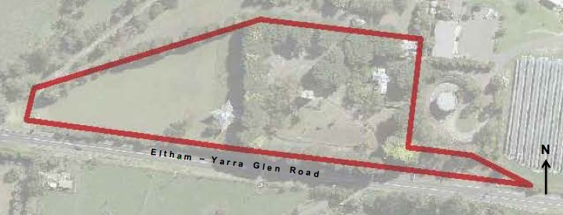

Recommendations for the Schedule to the Heritage Overlay (Clause 43.01) in the Nillumbik Planning Scheme:

External Paint Controls  Is a permit required to paint an already painted surface? | No
Internal Alteration Controls  Is a permit required for internal alterations? | No
Tree Controls  Is a permit required to remove a tree? | Yes – mature planting including Monterey Cypress, English oak,  Eucalyptus  botryoides, &  Livistona australis, ‘Lone Pine’, chusan Palms (Trachycarpus fortunei), Cedar (Cedrus Deodara), Sugar Gum (Eucalyptus cladocalyx), Manna Gum (Eucalyptus viminalis)
Victorian Heritage Register  Is the place included on the Victorian Heritage Register? | No
Incorporated Plan  Does an Incorporated Plan apply to the site? | No
Outbuildings and fences exemptions  Are there outbuildings and fences which are not exempt from notice and review? | Yes – caretaker’s cottage
Prohibited uses may be permitted  Can a permit be granted to use the place for a use which would otherwise be prohibited? | Yes
Aboriginal Heritage Place  Is the place an Aboriginal heritage place which is subject to the requirements of the Aboriginal Heritage Act 2006? | No

References

Mills, P, 2020, Revised Citation HO 49 Memorial Park, Kangaroo Ground (final draft, 121 October 2020). Samantha Westbrooke Pty Ltd.

Monash University and University of Queensland, 2015, Victorian Places- Kangaroo Ground, https://www.victorianplaces.com.au/kangaroo-ground, accessed online 07 February 2022.

Shanahan, B. ‘Kangaroo Ground CFA brigade celebrates 125 years of keeping the community safe’, in Harald Sun, https://www.heraldsun.com.au/leader/north/kangaroo-ground-cfa-brigade-celebrates-125-years-of-keeping-the-community-safe/news-story/91b322614bed015494560af249f71dfe published 22 March 2017, accessed online at 07 February 2022.

