160 Henley Road, Kangaroo Ground

Stevens House
Prepared by: Context | Survey date: February 2021
Place type: Residential | Designer: Alistair Knox
Significance level: Significant | Builder: Alistair Knox
Extent of overlay: To title boundaries | Major construction: c1973
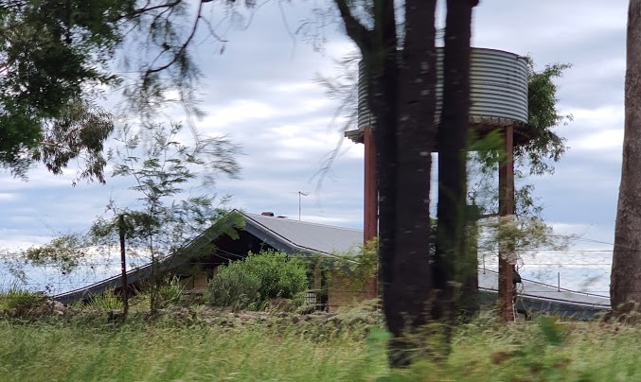
Figure 1. Stevens House at 160 Henley Road, Kangaroo Ground. (Source: Context 2020)
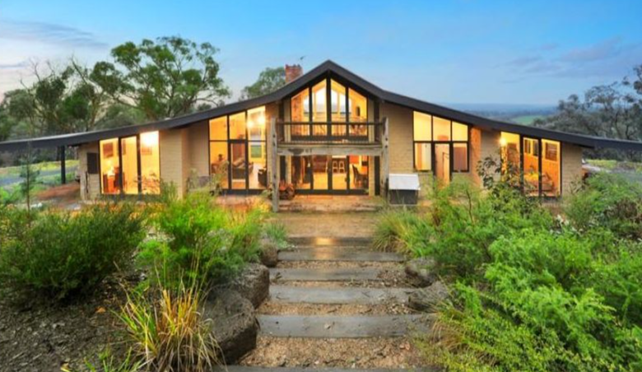
Figure 2. Stevens House at 160 Henley Road, Kangaroo Ground, view from the site. (Source: realestate.com.au 2013)

HISTORICAL CONTEXT
This place is associated with the following historic themes taken from the Nillumbik Shire Thematic Environmental History (2016):
6 BUILDING TOWNS AND SHAPING SUBURBS
6.6 1960s and 1970s suburbanisation
From the mid-1960s the main suburban expansion in the former Eltham Shire area was east from Eltham, aided by the construction of the new Fitzsimons Lane (Eltham-Templestowe) bridge in 1963. This expansion was limited by topography and by methods of corridor planning including the green wedge and rural zoning. As a result, the eastwards trend would not extend past Research. The occupants of this new residential area were typically high-income families commuting to work in the city. When author and diplomat Graham McInnes returned to Melbourne in 1969 after leaving in the 1930s, he said that one of the most noticeable differences was that ‘Eltham was the country, now it is right in Melbourne’ (Mills & Westbrooke 2016:87).
Residents who had established themselves in the early postwar period questioned the bona fides of this new wave of aspiring bushland home owners. [Alistair] Knox described how ‘the rich and affluent eastern suburbanites started casting sheep’s eyes at this unkempt bushscape: ‘Eltham was once again under threat from the land profiteer, who would butcher the living qualities of its inhabitants to make their Roman holiday.’. On the other hand, the middle-class professionals of this new influx were environmentally conscious, politically well informed and numerous enough to exert a profound effect on the conservation of the surrounding landscape (Mills & Westbrooke 2016:87-88).
By the 1970s, the aesthetics of the bush that had been developing throughout Australia were influencing the more sought after city fringe suburban developments. These suburban developments adopted some of the trappings of environmental building that had been developed, in part, by the Eltham mudbrick pioneers. The environmental thinking had been translated into a set of standard approaches, including preservation of existing trees, adaptation to contours, underground services and establishment of a network of linked bush parks. Road planning strategies such as cul-de-sacs enabled isolation from busy through streets. Roads were softened with low-profile gutters and the transition from road to driveway was softened with the use of paving materials in the road surface. Even so, these developments substantially remade the landscape (Mills & Westbrooke 2016:88).

LOCALITY HISTORY
The area of Kangaroo Ground, located on the country of the Wurundjeri-willam clan of the Woi wurrung people, was part of the squatting run, ‘Yering’, taken up in 1838 by the Ryrie brothers (Eltham District Historical Society 2000:np). The area featured hilly but relatively open country with good soil.
An area of 805 acres, spanning an area from Kangaroo Ground to the Yarra River, was put aside in 1841 for an Aboriginal reserve (Eltham District Historical Society 2000:np).
In 1848 families from Scotland purchased allotments, measuring 150-160 acres, in the district (Howe 1848). Eight or so wheat farms were subsequently established around the main road from Greensborough to the Yarra Flats, beside Salvation Hill and Garden Hill. Some of the early farms still survive today (Butler 1996:31; Victorian Places 2015; Nillumbik Parish Plan 1947). Between 1854 and the mid-1860s Kangaroo Ground farmers provided produce, including cereals and pasture, to goldmining residents in the Diamond Creek and Warrandyte areas (Victorian Places 2015).
Minor gold discoveries occurred in the area of Kangaroo Ground in the early 1850s. A small settlement was subsequently established near the intersection of today’s Graham Road and Eltham-Yarra Glen Road and provided for gold seekers on the Woods Point diggings passing through on their way to and from Melbourne (Butler 1996:32).
The local community established its first school, the Kangaroo Ground Presbyterian School, in 1851, and a post office opened in 1854. An unofficial cemetery was established in 1851 and gazetted in 1858 (Eltham District Historical Society 2000:np).
Lay preacher Andrew Ross, also the first teacher at the school, built the Kangaroo Ground Hotel in 1863. After the Eltham Roads Board was created in 1856, it met for a short time at Watsons Creek, before the establishment of the Kangaroo Ground Hotel. The Shire of Eltham council held its meetings at the hotel until 1916, when it took over the premises vacated by the Evelyn Observer newspaper, which had moved to Hurstbridge (Butler 1996:31).
Andrew Ross transported two buildings to Kangaroo Ground; these were intended as boarding houses for students at the industrial school he established in 1854, a short-lived venture. The buildings served instead as a store and post office (Butler 1996:31).
Additional farms were established under the 1869 land Act, one of several land Acts introduced in Victoria from 1860 to encourage the establishment of agriculture. Subsequent land Acts introduced in 1894, 1890 and 1901 saw further growth in the take-up of small farms in the district (Nillumbik Parish Plan 1947).
By the 1870s, the cropping of oats and wheat on surveyed allotments of 80160 acres was not viable because of the inadequate size of the land. Instead, the district’s farmers used the land to grow hay and graze stock (Leader 20 June 1874:7). Some vineyards were also established.
Kangaroo Ground experienced a period of growth in the 1870s and 1880s. Another hotel was established by Edward and Mary Weller in 1872 (Butler 1996:31). The Kangaroo Ground State School No. 2105 opened in 1874 and Andrew Burns opened a store in 1875 (Eltham District Historical Society 2000:np). The Evelyn Observer newspaper, the first local newspaper in the Diamond Valley, was first published in 1873 in the Kangaroo Ground school. It was moved to new offices, beside the hotel, in 1878 (it now serves as the Andrew Ross School House Museum) (Butler 1996:32). A new brick school for Kangaroo Ground State School No. 2105 was built in 1878 and the Kangaroo Ground Presbyterian Church (HO96), designed by architect CW Maplestone, was consecrated in the same year (Eltham District Historical Society 2000:np). A public hall was constructed in 1885 (demolished 1969) and Eltham Shire Council meetings were conducted from the building from the same year. A general store opened in 1888 (Eltham District Historical Society 2000:np).
After severe bushfires in 1890, the Kangaroo Ground Fire Brigade was formed in 1892 and was reformed in 1913 and 1938 (Eltham District Historical Society 2000:np).
After the railway reached Eltham in 1902, Kangaroo Ground experienced a decline. In 1903, the Australian Handbook described Kangaroo Ground as a township with a post office, two hotels (Kangaroo Ground and Weller’s), State School No. 2105, and a Presbyterian church. Industries in the area included mining and grazing, but chiefly comprised agriculture and horticulture (mainly fruit-growing and market gardens). Four hundred people, mostly farmers and their families, lived in the district (cited in Victorian Places 2015). By this time, hay and other fodder production were the mainstays of agricultural production in the area (Victorian Places 2015).
In 1919 a war memorial park was established, and in 1926 a memorial, modelled on a Scottish watchtower, was erected on Garden Hill to commemorate those in Eltham Shire who had served in World War I (Victorian Places 2015; Eltham District Historical Society 2000:np). Some limited soldier settlement occurred in the area in the 1920s.
Fruit-growing in the district declined with the economic depression of the 1930s and dairying became viable because of the availability of milk transport on the Hurstbridge railway line. However, milk contracts favoured bigger holdings in the postwar period, and farms were subsequently amalgamated (Victorian Places 2015).
The Eltham Shire offices, housed in the former Evelyn Observer newspaper offices in Kangaroo Ground from 1916 to 1934, moved to Eltham in 1937 (Butler 1996:32). In 1958, Kangaroo Ground was connected to electricity (Victorian Places 2015). Subdivision in the area in the late 1960s resulted in a population increase.
Ten homes in Kangaroo Ground were destroyed by bushfires in 1969 (Eltham District Historical Society 2000:np). After 1971, further subdivision of existing farmland at Kangaroo Ground was halted because the Melbourne Master Plan put a minimum threshold on farm sizes (Victorian Places 2015).

PLACE HISTORY
The Stevens House at 160 Henley Road, Kangaroo Ground, is located on Crown Allotment 4, Section 4, Parish of Nillumbik, 148 acres taken up by Henry Scarce junior under the 1869 Land Act and owned by him in 1887. By 1895, members of the Scarce family owned a number of adjoining allotments (Nillumbik Parish Plan 1951).
By 1920, Crown Allotment 4 was owned by RC Bourchier, and formed part of his farm, ‘Bikkora’ (Eltham and Whittlesea Shires Advertiser and Diamond Creek Valley Advocate 10 September 1920:3).
The allotment was subdivided c1952, with Alan Douglas becoming the owner of Lot 18 (today’s 160 Henley Road), approximately 24 acres, in 1952 (CT:V8042 F569).
The subject property was sold several times before Roger and Joan Stevens purchased the property in 1973 (CT:V8042 F569).
The subject house was designed and built for the Stevens c1973 by designer and builder Alistair Knox, with Gordon Doering as the engineer (Knox c1973, YLTAD28-371, SLV). The design of the house was consistent with the principles of Knox’s signature ‘Eltham style’ of architecture and landscape design that he had developed since 1946.
The house featured large windows to living spaces to give access to natural light and create a strong visual connection with the surrounding landscape. It used natural materials and finishes, including mudbrick walls, verandahs constructed of large timber beams and slate flooring to the interior. An elongated gable roof with deep eaves grounded the building within its natural bush block. Bush garden landscaping featured boulders and native plantings.
Figure 3. Plans by Alistair Knox for the subject house for the Stevens family, c1973. (Source: Alistair Knox c1973, YLTAD28-371, SLV)

A portion of the land was compulsorily acquired by the Melbourne Metropolitan Board of Works in 1979 to form part of the Yarra Valley Parklands (CT:V8042 F569).
The Stevens family owned the property until 2000 (CT:V8042 F569).
Historical aerial imagery from 1987 shows a small outbuilding with a similar elongated gabled roof to the rear of the house. Building permit plans from 2018 indicate that this is a studio. It is likely that this is an early addition, if not contemporary with the construction of the house. In late 2018 a flat-roofed carport was added to the studio at the rear (south) and the east (BP). In 2013 it was reported that renovations to the house had been carried out by architect Hamish Knox, Alistair’s son (Fletchers 2013). The extent of these renovations is not known.
A large, raised deck was erected to the rear of the house sometime after 1987.

Figure 4. View of the rear (south) elevation of the property at 160 Henley Road, undated. (Source: Tony Knox nd)

Alistair Knox, designer and builder
Alistair Knox (1912-1986) was a designer and builder, active in the Nillumbik area between 1946 and his death in 1986. Knox was responsible for over 1266 building designs, including 1000 homes, of which he built approximately 350. Throughout his four-decade long career, Knox was a leading figure in the development of the recognisably regional ‘Eltham style of architecture, and its associated landscapes. Through the sheer number of places designed by Knox in Nillumbik, he remains one of the most influential figures in the Shire’s history (Alistair Knox Foundation; Peterson and Kusyk 2014:5-6).
Knox had an interest in design and construction, commencing a Diploma of Architecture and Building Construction at the Melbourne Technical College. Knox left the course after two years (Peterson and Kusyk 2014:9). Following a visit to the Montsalvat artist’s colony in 1947, Knox was evidently impressed with the area and the artistic lifestyle that it was becoming known for. This love of the area was solidified in 1949, when he moved his young gamily to Eltham. The move coincided with Knox leaving his job as a bank clerk and establishing the Knox Building Service in Eltham (Age 19 July 1954:10; Peterson and Kusyk 2014:10). Knox was highly involved with the semi-rural, alternative lifestyle that Eltham and its surrounds had to offer (Alistair Knox Foundation).
The local environment was a constant inspiration to Knox through his career. Many of the homes he designed complemented their Australian bush settings, and his work pioneered forms including flat rooflines, clerestory windows and expanses of glazing that provided a connection between interiors and their settings (NMA 2021). Knox’s work was characterised by its use of second hand bricks, large eaves, natural materials, timber walls and large beams. Perhaps most importantly, Knox was associated with the use of mudbrick walls (NMA 2021). Knox paid special attention to the placement of buildings in relation to their landscapes and the use of Australian plants.
Knox’s work can be broadly broken into two phases: work completed before 1955, and work completed after 1955. The earlier phase focused on simple building forms, following the style of prominent architects such as Frank Lloyd Wright (Woodhouse 2007). His work was also greatly influenced by the economic austerity brought about by World War II, which encouraged him to use inexpensive and unconventional materials. The later period was defined by Knox’s sophisticated, highly individual designs, often with reclaimed materials. These houses consciously explored uncommon forms and were almost exclusively built in mudbrick (Alistair Knox Foundation).
As Knox was not an architect, his work was often informed by his knowledge that arose from his experience as a builder. Many of his designs were economical and only required limited skills. A preference for reclaimed materials assisted the inexpensive draw of his designs (Alistair Knox Foundation). Although many houses were individually designed, Knox also produced ‘spec’ houses for general sale (Age 19 July 1980:101).
Towards the end of his career, Knox worked extensively with other designers. Some of these included John Pizzey, Peter Jarvis, Barbara Telford, Robert Marshall and Bohdan Kyzuk (Alistair Knox Foundation). Outside of his profession, Knox served as an Eltham Shire councillor in the period 1972-75, and as its president in 1975. Passionate about community activism and the environment, Knox consulted with groups across Melbourne to fight inappropriate development and loss of public space (Peterson and Kusyk 2014:14-15). Additionally, Knox wrote and spoke extensively on matters about building and landscaping. Knox was a founding member of the Australian Institute of Landscape Architects, lectured on environmental design and building, and received an honorary doctorate in architecture from the University of Melbourne shortly before his death (Woodhouse 2007).

DESCRIPTION
The Stevens House at 160 Henley Road, Kangaroo Ground, is a mudbrick house built in c1973 to designs by Alistair Knox. The house is positioned at the northern end of a substantial allotment, where the land is fairly flat. The land falls to the south across the remainder of the block and is heavily treed.
Designed in Knox’s signature ‘Eltham style’, the house is symmetrical in plan with a dominant elongated gable roof form with deep eaves and wide barge boards. At the centre of the house the roof is steeply pitched, this allows for double-height living spaces with a mezzanine gallery area, and first-floor level balconies to the front and rear of the dwelling. The roof tapers off to envelop bedroom and bathroom spaces to either side of the central living areas. These project slightly to both the north and south. Carports at each end of the house are incorporated under the sweep of the roof. A simple red brick chimney rises from the eastern slope of the roof, near the central ridgeline.
Both the principal (north) and rear (south) elevations are dominated by panels of full-height glazing, broken up with sections of bagged mudbrick wall.
At the rear of the house is a large, raised timber deck. To the southeast of the deck is a studio which appears to be mudbrick construction. Its shares a similar form to the house, indicating that it may have been constructed at the same time.
Bush garden landscaping is located at the front of the house, around the studio and immediately surrounding of house. This landscaping reflects the natural Australian landscape and includes use of volcanic boulders, stone garden edging and low-profile native plantings and groundcover. Large timber boards set centrally into the front garden act as steps leading to the entry of the house.

INTEGRITY
The Stevens House is largely intact with very few changes visible to original fabric. The building retains its symmetrical built form and distinct elongated gable roof form with deep eaves and wide barge boards. Intact detailing characteristic of the ‘Eltham style’ includes the mudbrick walls, panels of full-height glazing, and window and door joinery. The retention of the early (if not original) mudbrick studio at the rear of the property, and natural bush garden landscaping including the use of volcanic boulders, stone garden edging and low-profile native plantings and groundcover, further enhances the integrity of the place.
Overall, the place has high integrity to its original design by Alistair Knox.

COMPARATIVE ANALYSIS
Mudbrick homes have been a significant feature in the architectural history of Nillumbik, forming a central theme of the building typology often referred to as the ‘Eltham style’. The use of low-cost materials such as mudbricks, adobe and pise-de-terre had gained currency in the area by the 1930s, influenced by builders such as John Harcourt and the community at Montsalvat. These earthy materials were often combined with recycled and exposed timber, face brickwork and corrugated iron to create a material palette characterised by natural materials and finishes. Alistair Knox became the most prolific of designers and builders working in this style throughout the second half of the twentieth century, influencing many people to adopt the style upon moving to the area.
This low-cost building type was built largely with amateur labour, often by the owners themselves. Knox regarded the style as the most suitable style for the Eltham environment, and the do-it-yourself nature of construction exemplified the beginnings of the ‘Eltham lifestyle’ that became an integral component of Nillumbik’s cultural heritage. Responding to their environment materially, these buildings demonstrated an intentional integration with their bushland surrounds.
While the interwar and postwar austerity encouraged the use of low-cost materials, examples from later decades show how the style continued to grow and develop as more affluent families were drawn to the area. Many of the houses built between the late-1960s and the mid-1980s are significantly larger than forerunning examples, with highly individualised architectural features and arrangements of space. As opposed to the earlier cottage style buildings, later houses often demonstrate typical Modernist elements, employing curved floor plans, flat or skillion roofs, clerestory windows, and large voluminous spaces.
The subject site illustrates both a formal preoccupation with simple geometry and an adherence to the material aesthetics made popular as part of the ‘Eltham style’ championed by Alistair Knox and his contemporaries. It demonstrates the enduring influenced of the ‘Eltham style’ and its nature-centred aesthetic.
Though Knox designed and built several mudbrick residences in Kangaroo Ground, none are included on the Nillumbik Heritage Overlay. Notable comparisons in Kangaroo Ground include the Telford House built c1972, the Steele House built c1974-75, the McCullagh House built c1975-77 and the Shore House built c1982.
The following buildings are Individually Significant places on the Nillumbik Heritage Overlay and compare well to the subject site, similar in their use of materials, form and construction period.
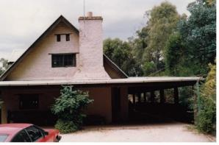  Kurema-Eddie Batement House, 57 Dodd Street, St Andrews (HO38). (Source: VHD) | Kurema-Eddie Bateman House and studio, built c1972, are historically significant for their associations with owner Eddie Bateman, a local builder and proponent of the 'Eltham style' of architecture and landscape design. As such it is a good representative example of the 'Eltham style' in the Shire, featuring the use of mudbrick and recycled materials (VHD).
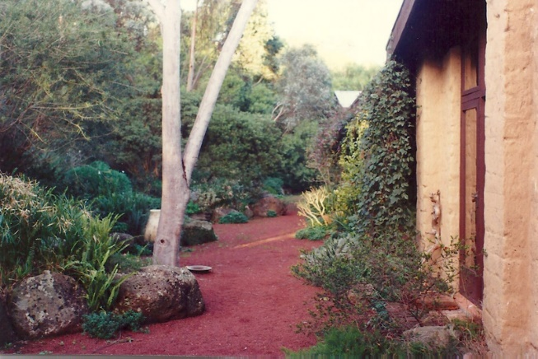  Coller House, 185 Mount Pleasant Road, Eltham (HO136). (Source: VHD) | Coller House, built c1975, is historically significant as an important work by noted designer and builder and Eltham local, Alistair Knox. The house is architecturally significant as a good example of the 'Eltham style' of architecture and landscape design that Knox had developed over the years (VHD).
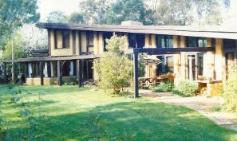  Pittard Residence, 430 Mount Pleasant Road, Research (HO139). (Source: VHD) | Pittard Residence, built 1978-79, is architecturally and historically significant as a particularly innovative example of Alistair Knox's later work. The curved plan and single plane roof rising up over the living area to the double storey end section are of particular note (VHD).
Discussion
The Stevens House at 160 Henley Road, Kangaroo Ground, compares well to the above examples in terms of its intactness. The house compares closely to the houses at 185 Mount Pleasant Road, Eltham (HO136) and 430 Mount Pleasant Road, Research (HO139), as a good representative example of Knox’s signature ‘Eltham style’ mudbrick residences and their natural earthy materials. These houses were characterised by a low-pitched or flat roof line. They were positioned low in the surrounding landscape which often included bush gardens featuring volcanic boulders and low-profile native plantings. Extensive glazing introduced light to the centre of the house and large windows to the living areas brought the 'outside in'.
The Stevens House is distinguished from the above examples as a particularly well-executed and intact example of Knox’s work. The symmetry of the plan form and principal elevations combined with the dominant and sweeping elongated gable roof makes for a coherent and legible composition that is more orderly and refined than the examples above. The property’s aesthetic qualities are further enhanced by the retention of the bush garden landscape setting.

STATEMENT OF SIGNIFICANCE

WHAT IS SIGNIFICANT?
The Stevens House at 160 Henley Road, Kangaroo Ground, a mudbrick residence designed and built in c1973 by Alistair Knox for owners Roger and Joan Stevens, is significant.
Elements that contribute to the significance of the place include:
- original symmetrical plan form of the house;
- dominant broken back gabled roof form;
- mudbrick walls, panels of full-height glazing and window and door joinery;
- timber balconies and posts to the front and rear elevations;
- natural bush garden landscaping including the use of volcanic boulders, stone garden edging and low-profile native plantings and groundcover; and
- early (if not original) mudbrick studio at the rear of the property.
The raised timber deck and later additions to the studio are not significant.

HOW IS IT SIGNIFICANT?
The Stevens House at 160 Henley Road, Kangaroo Ground, is of local representative and aesthetic significance to the Shire of Nillumbik.

WHY IS IT SIGNIFICANT?

The Stevens House is significant as a good representative example of Alistair Knox’s signature ‘Eltham style’ mudbrick residences. These houses typically incorporated a combination of earthy materials such as mudbrick walls, with recycled and exposed timber, and corrugated iron to create a material palette characterised by natural materials and finishes. Knox’s houses were characterised by a low low-pitched roof or and often flat roof line. They were positioned low in the surrounding landscape which often included bush gardens featuring volcanic boulders and low-profile native plantings. Extensive glazing introduced light to the centre of the house and large windows to the living areas brought the 'outside in'. (Criterion D)
The Stevens House is distinguished from the above examples as a particularly well-executed and intact example of Knox’s work. The symmetry of the plan form and principal elevations combined with the dominant and sweeping elongated gable roof makes for a coherent and legible composition that is more orderly and refined than the examples above. The property’s aesthetic qualities are further enhanced by the retention of the bush garden landscape setting. (Criterion E)

RECOMMENDATIONS
Recommended for inclusion in the Schedule to the Heritage Overlay of the Nillumbik Planning Scheme as an Individually Significant place.
Extent of overlay: To title boundaries
Recommendations for the Schedule to the Heritage Overlay (Clause 43.01) in the Municipality Planning Scheme:

Nillumbik Planning Scheme
External paint controls | No
Internal alteration controls | No
Tree controls | No
Outbuildings or fences | Yes - mudbrick studio
To be included on the Victorian Heritage Register | No
Prohibited uses may be permitted | No
Aboriginal heritage place | No

Other
N/A

REFERENCES
Age, as cited.
Alistair Knox Foundation, Alistair Knox: Designer, environmentalist, builder, landscape architect, https://alistairknox.org, accessed online 4 February 2021.
Butler, Graeme, and Associates 1996, ‘Nillumbik Shire Heritage Review - Environmental History’, Prepared for the Shire of Nillumbik.
Eltham and Whittlesea Shires Advertiser and Diamond Creek Valley Advocate, as cited.
Eltham District Historical Society 2000, A Chronology of Known Local Events 1835-early 2000 including those in the Shire of Nillumbik and the former shires of Eltham and Diamond Valley, Eltham District Historical Society Incorporated.
Howe 1848, Plan of subdivided sections in and adjoining the Parish of Nillumbik, Sydney, PROV VPRS 08168 P2/6221.
Knox, Alistair c1973, ‘Collection of architectural drawings mostly for earth houses in Melbourne and Victoria c1969-c1980’, State Library of Victoria (SLV) Alistair Knox Collection.
Knox, Tony nd, ‘160 Henley Road, Kangaroo Ground’, Alistair Knox: Designer, environmentalist, builder, landscape architect, Alistair Knox Foundation, https://alistairknox.org/akimages/1013, accessed 4 February 2021.Nillumbik Mudbrick Association Inc (NMA) 2021, ‘Local Historical Overview’, https://www.mudbrick.org.au/, accessed online 4 February 2021.
Leader, as cited.
Mills, Peter & Westbrooke, Samantha 2017, ‘Nillumbik Shire Thematic Environmental History - Revision 2016’, prepared for Nillumbik Shire Council.
Nillumbik Parish Plan 1951, Melbourne, Department of Lands and Survey.
Peterson Richard, and Kuzyk, Bohdan 2014, ‘Alistair Knox (1912-1986): modernism, environment and the spirit of place’, RMIT Design Archives Journal, Volume 4, Number 3: 5-23.
Victorian Heritage Database (VHD), https://vhd.heritagecouncil.vic.gov.au/, accessed online 30 April 2021.
Victorian Places 2015, ‘Kangaroo Ground’, Monash University and The University of Queensland, https://www.victorianplaces.com.au/, accessed online 10 December 2020.
Woodhouse, Fay 2007, ‘Knox, Alistair Samuel (1912-1986)', Australian Dictionary of Biography, National Centre of Biography, Australian National University, https://adb.anu.edu.au/, published first in hardcopy 2007, accessed online 10 February 2021.
Woollard, Jane 2016, Laughing Waters Road: Art, Landscape and Memory in Eltham, Greensborough, Nillumbik Shire Council.

