633 Kangaroo Ground-St Andrews Road, PANTON HILL

Panton Hill Hotel
Prepared by: Context | Survey date: December 2020
Place type: Commercial | Designer: -
Significance level: Significant | Builder: Not Known
Extent of overlay: To title boundaries | Major construction: 1935, with later alterations
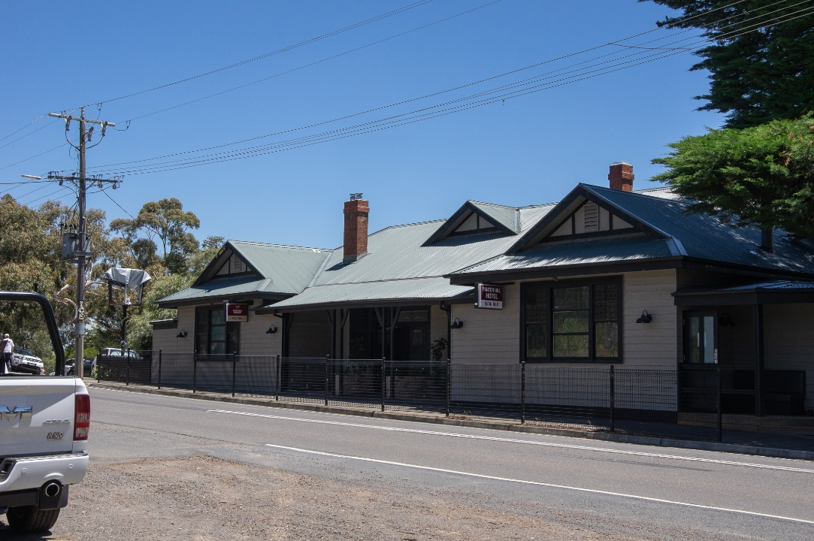
Figure 1. Panton Hill Hotel from St Andrew-Kangaroo Ground Road. (Source: Context 2020)
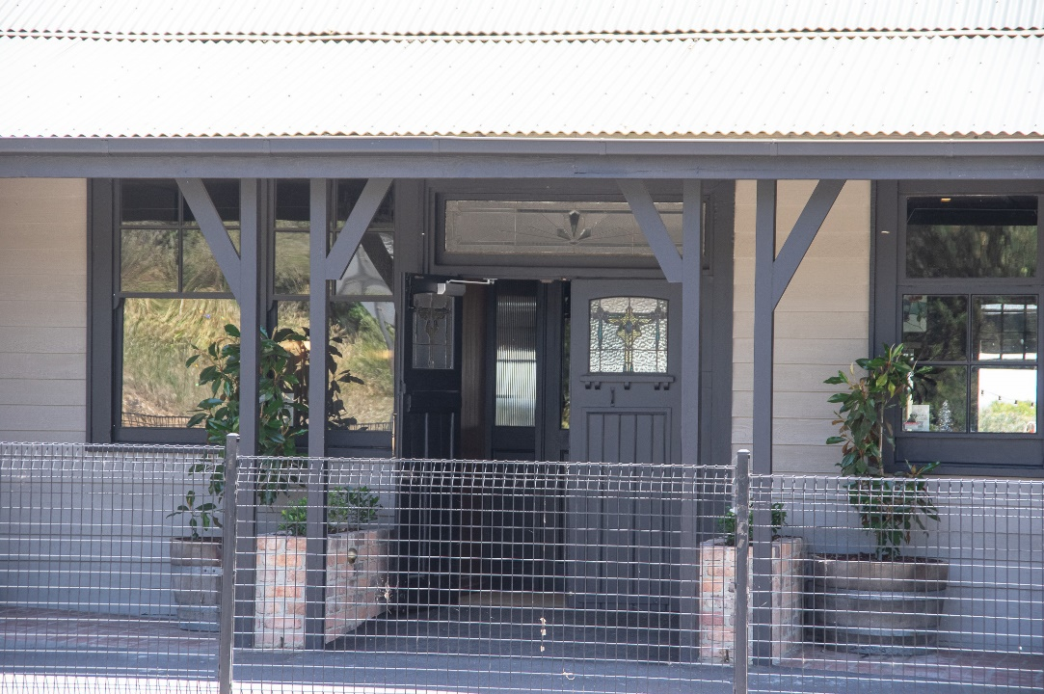
Figure 2. The main entrance to Panton Hill Hotel from St Andrews-Kangaroo Ground Road. (Source: Context 2020)

HISTORICAL CONTEXT
This place is associated with the following historic themes taken from the Nillumbik Shire Thematic Environmental History (2016):
5 BUILDING NILLUMBIK’S WORKFORCE
5.1 Catering for tourists
Throughout Victoria, city dwellers became inveterate train travellers, setting off on excursions, usually daytrips to rural areas that were now within easy reach of the metropolis. They came to picnic, ride their bicycles and see the sights; sometimes they came to camp, fish or hunt. The Railways Department encouraged these suburban excursionists, publishing railway guides with detailed advice on the best trains to catch, the cost of tickets, desirable places to visit and even what to wear. Eltham and other rural districts where suburbanites could view the bush, became popular. Newspapers like The Australasian, fed the passion for tourism by including illustrated articles about train journeys and the country towns that could be visited. Soon after the opening of the Eltham line, for example, an article appeared in The Australasian featuring ‘the views along the line’ in a journey from Heidelberg to Eltham. A later, 1903 article in the same journal, described Eltham as a ‘popular holiday spot’ and emphasised its rural village aspect. (Mills & Westbrooke 2016:63)
After Wattle Day was proclaimed in the early 1900s, special trains ran to Hurstbridge, bringing hordes of city folk determined to gather wattle. The destruction the visitors wrought prompted the establishment of a Wattle Day Red Cross afternoon tea in the Hurstbridge Hall, where money was raised for charity and where visitors were kept under some sort of control. Even so, in 1928 Robert Croll, the naturalist and author, wrote that ‘Hurstbridge has ever to me a watchful look, half of welcome and half of suspicion. The visitor is esteemed, but there is still the memory of those days, not so far back, when the sleepy village woke to find itself made famous by proclamation as the desirable spot to visit on Wattle Day, and all suburbia, with his wife and children, raided the paddocks’. (Mills & Westbrooke 2016:63)
Croll extolled the virtues of the region as a place for walking in his Open Road to Victoria, published in 1928, while the periodical, the Melbourne Walker, published articles on Diamond Creek, Christmas Hills, Panton Hill, Wattle Glen, St Andrews and Eltham throughout the 1930s, 1940s and 1950s. (Mills & Westbrooke 2016:64)
8 BUILDING COMMUNITY LIFE
8.3 Establishing meeting places
Some of the first meeting places were hotels built on key roads through the shire and leading to the goldfields. Hotels were essential facilities in the goldmining towns and often served a number of purposes being the centre of community activities. They were often the location of a staging post for Cobb and Co. coaches bound for the goldfields and may have been used as general stores and in some cases served as the local hall. (Mills & Westbrooke 2016:102)
The shire’s oldest surviving hotel building, St Andrews Hotel (HO19), was built on the Caledonia goldfields in Queenstown in circa 1860. The present name of the township reputedly derives from the name of the hotel but it may also have derived from St Andrews Church (also erected in the 1860s) or the name of the mining district. A weatherboard hotel was built at Kangaroo Ground, also in the 1860s and of a very similar appearance. It has since been demolished. Later in 1872 Edward Weller, publican and storekeeper, built a hotel and store on the main road at Kangaroo Ground (HO45). Known earlier as Weller’s Pub, this building was an overnight stopping place and changing post for Cobb and Co. coaches bound for the Caledonian Goldfields and Woods Point goldmines, some 80 kilometres to the east of Warburton. (Mills & Westbrooke 2016:102)
A Frenchman, Emile Hude, established the first known building, the Hôtel Français at Kingstown (Panton Hill) in 1861, by applying for a licence to erect a residence and cultivate two acres of land. When the next Land Act was proclaimed in 1862, Hude was able to buy the property on which his hotel stood. After Hude's death, his wife carried on the hotel until the 1890s. The hotel burned down in the early twentieth century, but was replaced by the Panton Hill Hotel and there is still a hotel on the site. The site of another hotel situated near the Hôtel Français in the nineteenth century, is marked by an old well. (Mills & Westbrooke 2016:102)
A hotel licence was issued to Isaac Hawkins in 1866 for the Evelyn Arms Hotel on the Diamond Creek Road. In 1867 Thomas Hill opened the Loyal Diamond Lodge Hotel, so-named because the Loyal Diamond Manchester Unity Lodge used it for meetings until they moved to their own hall. It was located on the corner of Collins and Main Streets. Three years later the first Royal Mail Hotel was built on the site in Chute Street. This stringy-bark structure was soon replaced by a weatherboard building, which in turn was superseded by a brick hotel, constructed with bricks made on the property. This building burned down in 1925 and its replacement was built on the site currently occupied by the Royal Mail Hotel (HO115). (Mills & Westbrooke 2016:102)
In Eltham, the first building on the south-east corner of Main Road and Pitt Street, was first listed in rate books in 1887 as a hotel owned and occupied by Christopher Watson, publican. From the beginning, it was an important local landmark. John Fitzsimmons, hotelkeeper, was the licensee in the early 1920s. There were additions in the 1920s and later. Today's hotel dates mainly from this period and recent decades. The hotel served as an early hotel, store and a staging post for Cobb and Co. coaches bound for the Caledonian goldfields and the Woods Point goldmine (HO116). (Mills & Westbrooke 2016:103)

LOCALITY HISTORY
Panton Hill is located on the country of the Wurundjeri-willam clan of the Woi wurrung people.
Panton Hill, named by Joseph Panton, Commissioner for Andersons Creek and other goldfields, and later magistrate for Heidelberg, is situated on Oram’s Reef, part of the Caledonian goldfields. Panton Hill was established a goldfield in 1859, the resulting gold rush established the nucleus of a settlement known as Kingstown (renamed Panton Hill in 1874). Emile and Jeanne Hude opened a hotel in Kingstown in 1861, which became known as ‘The Frenchman’s’. A post office was opened in 1875, possibly at Hude’s hotel, known by that time as the ‘Hotel de France’ (Westbrooke and Mills 2017:5; Victorian Places 2015).
A school opened at Kingstown in 1865, and in 1871 a Common school opened, which also served as a hall, church and Sunday school. Panton Hill State School No. 1134 opened in 1876 in a building purchased by the Education Department and remodelled (Blake 1973:327).
By 1880 the settlement of Kingstown comprised two hotels, one store and approximately 20 miners’ huts (Shire of Eltham rate book 1880, cited in Westbrooke & Mills 2017:6).
As gold returns diminished, a series of land Acts introduced in Victoria from 1860 aimed to encourage former gold seekers to take up farming. Although land leased under the 1869 land Act saw the establishment of orchards and vineyards on small blocks of about 20-30 acres in the Panton Hill district, freehold ownership of allotments in the area was not achieved until the land Acts of 1884, 1901 and 1915 (Greensborough Parish Plan 1961). A number of cool stores for fruit storage were built by orchardists in the area.
Panton Hill was a part of a substantial area given over to the growing of apples, pears and stone fruit, the main agricultural industry in the Diamond Valley region (the area covered by much of the present Nillumbik Shire) from the 1880s to the 1930s. With its soil and climate suited to the growing of fruit, Diamond Valley formed a significant part of the wider fruit-growing region situated to the north and east of Melbourne in the counties of Evelyn, Bourke and Mornington. Orchards and nurseries were established on the hills and in the gullies of the catchments of Diamond Creek and Arthurs Creek, stretching from the township of Diamond Creek, through Hurstbridge, Cottles Bridge, Arthurs Creek and Panton Hill, to the foot of the Kinglake Ranges at Strathewen and Queenstown (now St Andrews) (National Trust Report, ‘Shaws Cool Store, Cottlesbridge’, B6979, cited in Butler 2006:140).
By 1891 Panton Hill had a population of 100, as well as two hotels and one church. A local committee raised funds to build a hall. When the township of Kingstown was proclaimed in 1891, land was set aside for a Church of England (built in 1896) and a cricket and recreation reserve. The Panton Hill Mechanics Institute and Free Library was built on part of this reserve in 1901 (Butler 1996:41). The area was mined again during the economic depression of the 1890s when unemployed men were paid by the government to fossick for gold.
In 1903, the Australian Handbook described Panton Hill, with a population of 130, as part of a mining district. It noted that the township featured a hotel, a state school and an Anglican church (cited in Victorian Places 2015).
In 1904, a fire destroyed the Hotel de France, the general store and the post office (Eltham District Historical Society 2000:np). By 1911, Panton Hill’s population was 267 (Victorian Places 2015).
Reflecting population growth in the area, the Smiths Gully State School No. 1737 building was moved to the Panton Hill State School site in 1909 for use as an additional classroom (HO97) (Blake 1973:327).
The railway extension from Heidelberg to Hurstbridge in 1912 provided fruit-growers with easier access to the Melbourne markets (Victorian Places 2015).
Increased competition from new irrigated fruit-growing areas established in Victoria after World War I and the impact of the economic depression of the 1930s saw many of the district’s orchardists turning to other pursuits such as raising poultry, selling firewood, or supplementing their incomes by working for other landowners or through goldmining (Nillumbik Shire 2020; ‘Victorian Gold Project’ 1999:14).
In 1939, the Black Friday bushfires destroyed parts of Eltham, Warrandyte, Panton Hill, St Andrews, Kinglake and Christmas Hills (Eltham District Historical Society 2000:np).
Electricity was connected to the town in 1958 (Victorian Places 2015).
By 1947, Panton Hill’s population was 337. Further classrooms were added to the school in 1955. Subdivision in the area from the 1960s allowed Melbourne city commuters to take up residence in the area and further classrooms were added again in 1963 and 1970 (Blake 1973:327; Lemon 2008).
The present township includes a general store, a primary school and infant welfare centre, a hotel, the Anglican church and a fire station. The voluntary fire brigade is an important community organisation. During the 1983 Ash Wednesday fires crews from Panton Hill and Narre Warren were trapped in their vehicles when the fire raced up a steep ravine towards the town. Tragically, five were killed. Panton Hill has a memorial park to honour their deaths (Victorian Places 2015).

PLACE HISTORY
The Panton Hill Hotel at 633 Kangaroo Ground-St Andrews Road, Panton Hill, is located on Crown Allotment 1A, one acre, and Crown Allotment 2, two acres, of the Panton Hill Township, purchased respectively by Emile Hude in 1863 and Jeanne Hude in 1876 (Panton Hill Township Plan 1942). The existing hotel on the subject site is result of multiple rebuilds due to fire. The extant hotel building was erected in 1934 replacing an earlier structure destroyed by fire earlier that year.
in 1961, a Frenchman, Emile Hude, established one of the first recorded buildings in the Shire, the Hôtel Français (also known as Hotel de France), on the subject site comprising Crown allotments 1A and 2 (Mills & Westbrooke 2016:102; CT:V997 F294; V931 F120). Hude died in 1869, and the hotel was managed after this time by his widow Jeanne, who applied for a Publican’s Licence in 1870 (CT:V997 F294; Argus 8 January 1870:8).
By 1876, it was one of two hotels in Panton Hill: Jeanne Hude’s Hotel de France and Scott’s Hotel, which was later known as the Panton Hill Hotel in the 1880s and 1890s. (Leader 28 October 1876:1; Age 31 July 1888:2). The Hotel de France is thought to have occupied the site of today’s Panton Hill Hotel at 633 Kangaroo Ground-St Andrews Road. The Scott’s Hotel (later Panton Hill Hotel) was located on Crown allotments 4 and 4A, in close proximity to the subject site (CT:V2464 F689; Herald 11 August 1888:4). This hotel does not survive today.
In 1876, the following accounts of the Hotel de France was published in The Leader.
It has, too, a possible sense that it is an anomaly in Victoria – that it is really a transplanted bit of France, just as New Caledonia is the neoteric Gaul of tChe Pacific. The tricolor lazily pendent from the Hagstaff by the roadside; the name Jeanne Hade [sic] over the door of the principal hotel; the frequent vocal patter of the French language, instantly flash to the visitor’s mind the impression “Here are the hills of sunny France.” The very rooster in the yard has the “swank” and swagger of the Gallic cock; the odor of strangely recondite mysterious modes of cookery salutes the olfactories; the boy who holds your horse gazes open-mouthed at your English in evident pity that you speak a foreign tongue; while the ballads of Beranger, lilted by the musical voices of the hotelkeeper’s fair daughters, mingle with the less-trillingly [sic] sweet English expression of the loves and hopes in which the female heart delights.
This Franco-Australian territory of Victoria, the very existence of which is unsuspected save by those whose business relations compel them to travel the pleasant ways which lead to it, lies within twenty-six miles of Melbourne (Leader 28 October 1876:1).
Various public events including hospital ball and public meetings were held at the Hotel de France over the decades of Jeanne Hude’s ownership (Age 13 March 1879:2; Evelyn Observer, and South and East Bourke Record 5 September 1884:2). The main clientele was visitors and travellers. As an 1890 advertisement for the hotel observed, it offered ‘first-class accommodation for visitors and travellers … detached cottage for families’ (Evelyn Observer, and South and East Bourke Record 28 November 1890:3)
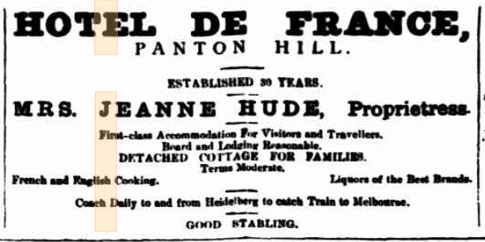
Figure 3. Advertisement for the Hotel de France. (Source: Evelyn Observer, and South and East Bourke Record 28 November 1890:3).

In 1893, following Jeanne Hude’s death, the property was granted to James Hatton Miller, a son-in-law of the Hudes (Argus 22 March 1893:8).
In 1894, Walter Halliley Tiffin purchased Crown Allotments 1A, 2 and 4B, five acres, on which the Hotel de France was located. In 1895, Ellen Howell Tiffin, Walter’s wife, became the owner of these allotments and neighbouring Crown Allotments 4 and 4A, on which the adjacent Panton Hill Hotel was located, making a total of approximately eight acres (CT:V2549 F798; CT:V2740 F880). The original Panton Hill Hotel was totally destroyed by fire again in 1899 (Evelyn Observer, and South and East Bourke Record 9 June 1899:2). It is likely that this hotel was never rebuilt after this fire.
In September 1904, the Hotel de France, comprising general store, post office and a detached cottage, was also destroyed by fire (Evelyn Observer and South and East Bourke Record 16 September 1904:2). By December that year, the Hotel de France had been rebuilt (Evelyn Observer, and South and East Bourke Record 2 December 1904:2).
In 1905, James Henry Bradley became the owner of the property (CT:V2740 F880). In 1905, Emma Maurice, licensee of the Hotel de France, was granted permission to have the hotel’s name altered to the Panton Hill Hotel (Figure 3) (Evelyn Observer and South and East Bourke Record 22 December 1905:2).
In 1912, Theresa Mary Wigham, wife of William Wigham, hotel keeper at the Panton Hill Hotel, took over ownership of the property. Other owners included James Lewis in 1928, and John Moore in 1933 (CT:V3575 F996). Mining meetings and social events continued to be held in the hotel over these years.

Figure 4.View of Panton Hill Hotel, c1910-c1930, before it was destroyed by fire in 1934. (Source: Jones c1910-c1930, SLV)

In April 1934, the timber Panton Hill Hotel, comprising ten rooms and five detached sleep outs and licensed to Mr and Mrs Kuhwald, was destroyed again by fire (Advertiser 27 April 1934:4). The site of approximately nine acres was advertised for auction on 27 September of that year. The advertisement stated:
The old Panton Hill Hotel was recently destroyed by fire. This sale represents an opportunity to secure a valuable Victualler’s License and attractive site on which to erect a modern hotel, which will serve this popular district, only 25 miles from Melbourne (Age 26 September 1934:5).
In November 1934, a newspaper report noted that the Panton Hill Hotel was to be rebuilt, with the construction of a new modern and up-to-date building to begin almost immediately. Former licensee, Mr Kuhwald, was to take over the new building (Advertiser 16 November 1934:2). In December 1934, John and Beatrice Foley and John Barrett became the owners of the property (CT:V5946 F124).
The re-opening of the Panton Hill Hotel was advertised for April 1935, with F Kuhwald stating that the new sewered hotel offered all modern comforts and conveniences with excellent cuisine and electric light. Trains were met free of charge and passengers taken to the hotel (Herald 16 March 1935:38). John Brennan took over the licence in 1936 (Argus 1 April 1936:9).
Throughout the 1930s various sporting groups, including residents interested in forming a golf club at Panton Hill and the local football club, held meetings at the hotel (Advertiser 7 August 1936:2 and 14 August 1936:3). The Bachelors’ Club was formed at the hotel and the Panton Hill Fruitgrowers’ Association also held events there (Advertiser 30 July 1937:1; 1 April 1938:1).
In 1942, Catherine and Beatrice Foley and John Barrett were proprietors of the hotel, with members of their families retaining ownership of the hotel until 1980 (CT:6617 F330; CT:6617 F330).
In 1961, architects Robert H McIntyre and Associates called for tenders for alterations to the Panton Hill Hotel (Age 1 July 1961:44).
The two Monterey Cypress trees to the north of the building appear to be present in aerial imagery from 1962 (Figure 3).
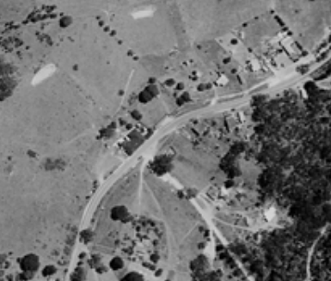
Figure 5. Aerial imagery of the building and site in 1962. Cypress trees to the north of the building appear to be present. The building and environs is circled in orange and the cypress trees in blue. (Source: CPO, BUSHFIRE AREAS PROJECT (WARRANDYTE AREA)’, via Landata)

In April 1980, the Panton Hill Hotel building, land and licence were auctioned. The auction notice described the subject site as approximately eight acres on which was located the single-storey fibro cement hotel building with bar, two lounges and three bedrooms; and a nine-hole golf course (Age 12 April 1980:147).
In June 1980, Panton Hill Hotel Pty Ltd took over ownership of the subject building and land then subdivided the land into four parts. Crown Allotments 1A and 2, on which the hotel stands, sold in 1983 to Di Martino and Sons (CT: V9389 F094). These allotments were consolidated in 1988 into one block (CT:V9482 F845).

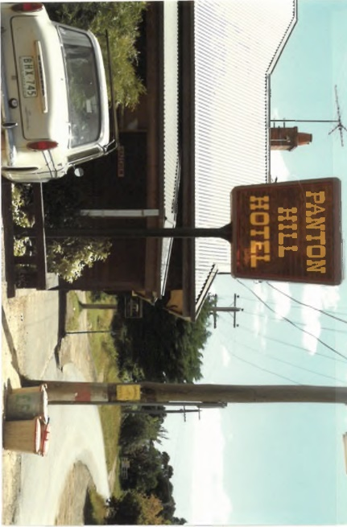  Figure 6. Photograph of Panton Hill Hotel in 1988 showing the sign. (Source: BP, provided by Nillumbik Shire Council) | 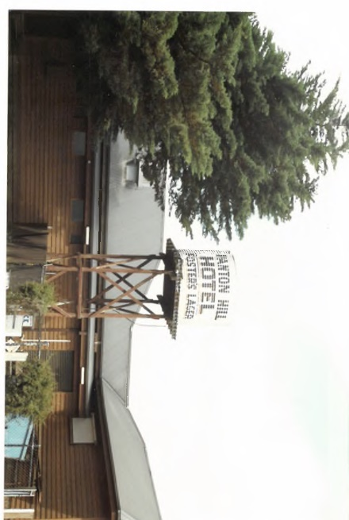  Figure 7. Photograph of the northern corner of Panton Hill Hotel in 1988 showing Cypress trees and a sign (now removed). (Source: BP, provided by Nillumbik Shire Council)

After a fire in 2003, a refurbishment of the building, designed by architects and town planners, Robert Marshall Pty Ltd, took place in 2004 (Figure 5). Some demolition of interior features occurred, and it appears that the existing western red cedar weatherboards used for external cladding were added as part of this work. Additional alterations, comprising a new deck area at the rear of the building, were carried out in 2014 (BP).
The Panton Hill Hotel continues to operate today as a popular venue for meals and live music, which it has hosted since the 1980s.
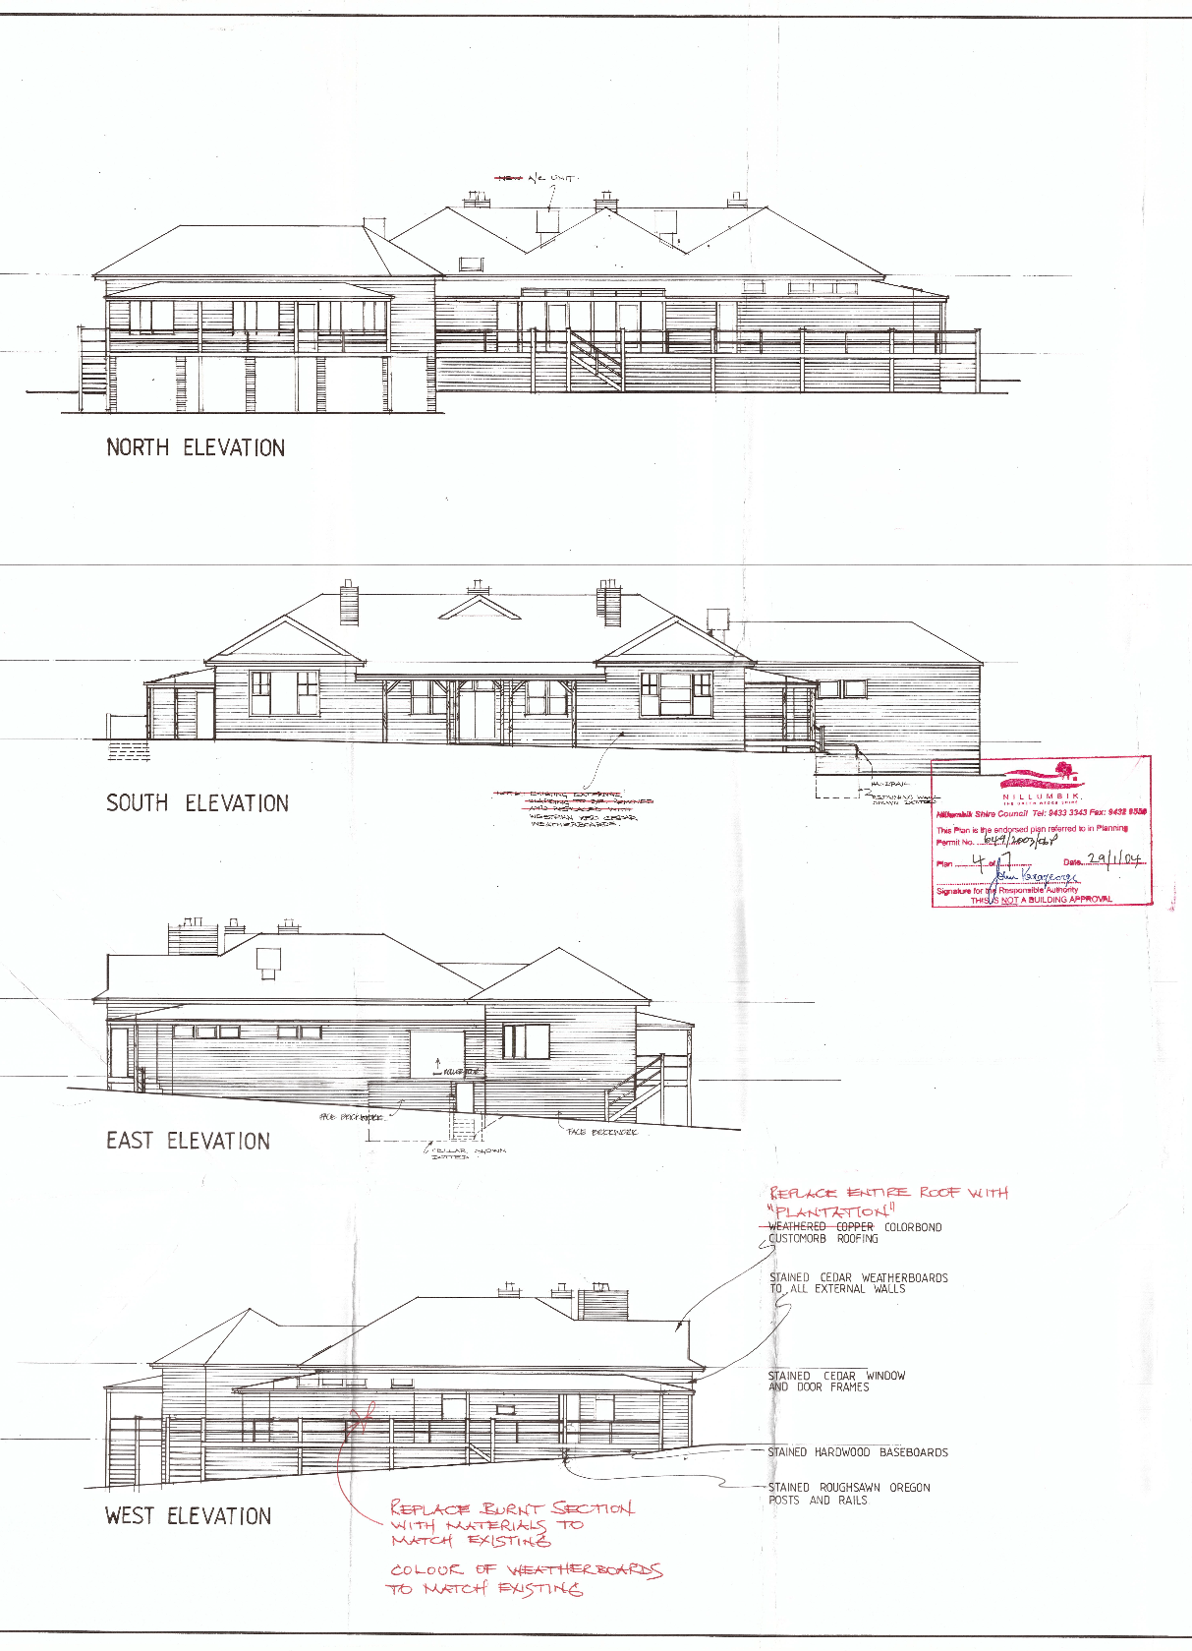
Figure 8. Plans for refurbishment work to the Panton Hill Hotel after fire damage, 2003. (Source: BP).

DESCRIPTION
633 Kangaroo Ground-St Andrews Road, Panton Hill, is an interwar Hotel built in 1934-1935, with alterations from 2003 and 2014.
The subject site sits on the northern side of the Kangaroo Ground-St Andrews Road and is centrally located within the Panton Hill township. The single-storey hotel building sits in the central third of the Kangaroo Ground-St Andrews Road frontage abutting the pavement. On either side of the building is a carpark accessed from Kangaroo Ground-St Andrews Road. Behind the building is a beer garden area, deck and landscaped garden setting. A fence extends behind the carparking and garden area demarcating the hotel grounds. Beyond the fence, the northern portion of the site includes a grassed area with three dams. Two substantial Monterey Cyprus trees sit between the northeast corner of the building and Kangaroo Ground-St Andrews Road.
The building footprint is rectangular with an additional rectangular addition attached to the northeast rear corner. The corrugated iron clad roof sits above weatherboard clad walls with deep fascias.
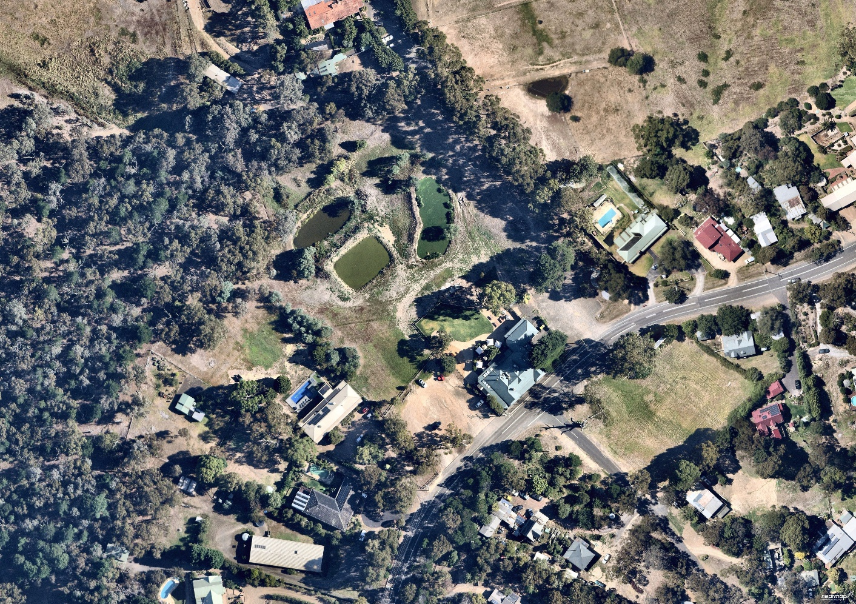
Figure 9. The subject site is outlined in red. (Source: Nearmap 2021)

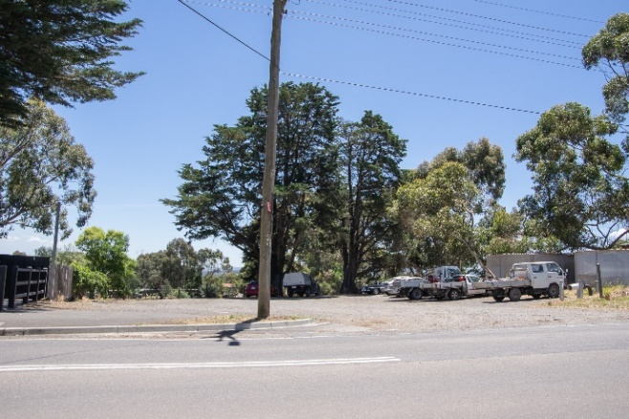  Figure 10. Gravel carpark and tanks to the northeast of the building. (Source: Context 2020) | 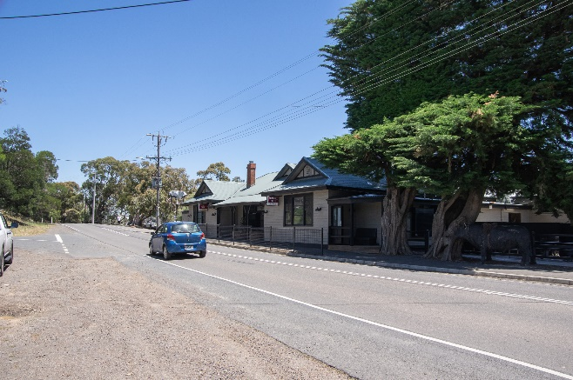  Figure 11. View of the hotel from the north. (Source: Context 2020)
The primary façade is symmetrically arranged around the central entrance doorway. A gable dormer extends from the roof ridgeline above the central doorway. Two brick chimneys penetrate the southern roof plane (Figure 15). The main entrance comprises double timber doors with stained glass panels and a transom light above with double timber framed windows on either side (Figure 13). A verandah extends from the roof above the main entrance. It is supported by simple timber posts with timber brackets and spans between the projecting gable-ended bays at each end of the façade (Figure 16). Each bay has a timber-framed tripartite window with leadlight and textured glass glazing (Figure 14).
At the northeast corner of the primary elevation is a recessed and covered portico with a secondary entrance. A small, paved area offering outdoor dining is also provided to the north. This area is lined with a simple timber log fence.
A rigid wire fence lines the edge of the road.
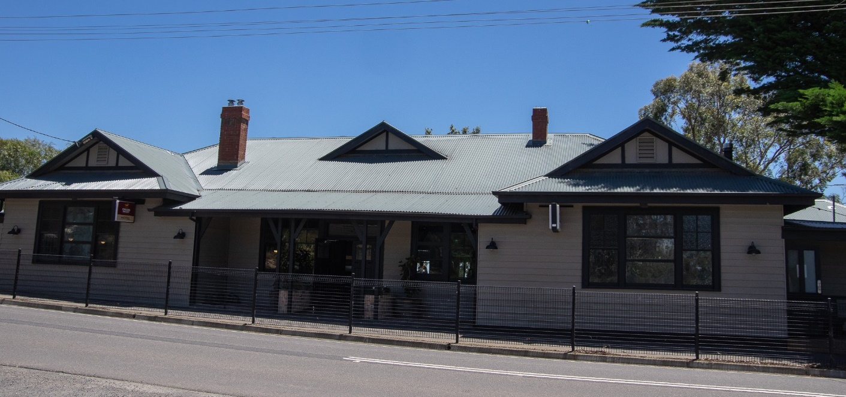
Figure 12. The primary elevation to St Andrews-Kangaroo Ground Road. (Source: Context 2020)
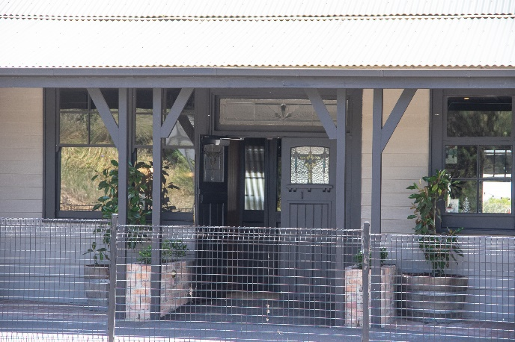  Figure 13. Main entrance door on Kangaroo Ground-St Andrews Road. (Source: Context 2020) | 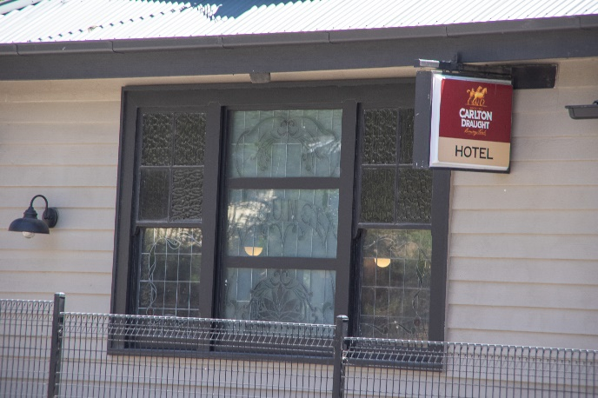  Figure 14. Tripartite bay window with ledlight and textured glass glazing. (Source: Context 2020)

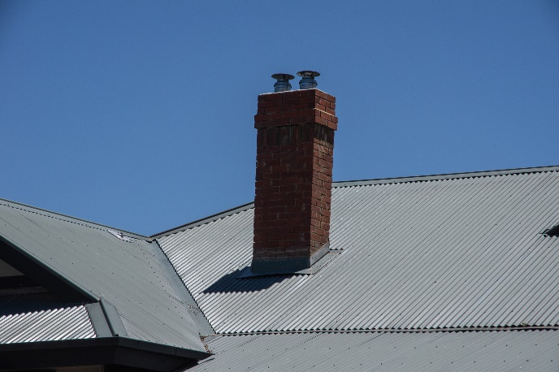  Figure 15. Brick chimney extending through the roof plane. (Source: Context 2020) | 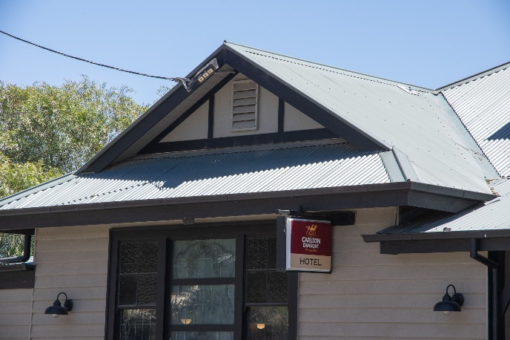  Figure 16. Projecting gable-ended bay. (Source: Context 2020)

Two mature Monterey Cyprus (Hesperocyparis macrocarpa) trees sit in front. Their form has been altered to allow for the power lines (Figure 18). The rear extension to the building is visible behind a fence.
An unused sign extending approximately to the height of the roofline on a black pole sits to the south of the building on Kangaroo Ground-St Andrews Road (Figure 17).

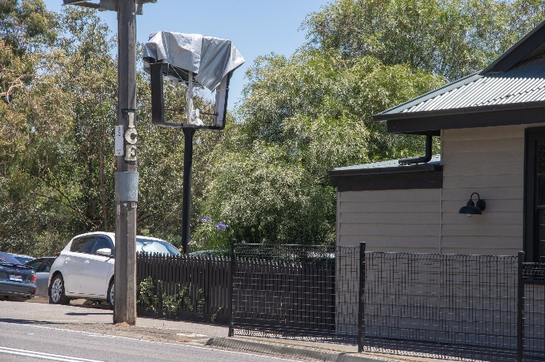  Figure 17. Southwest corner of the building and unused sign. (Source: Context 2020) | 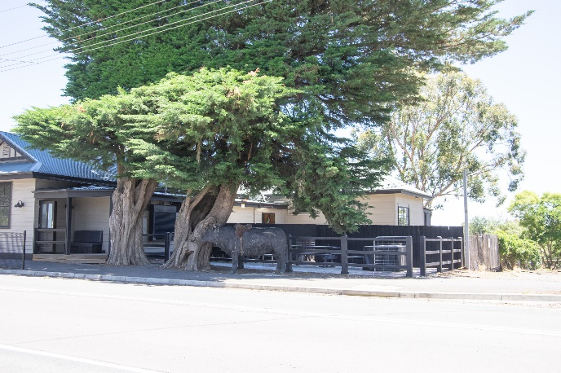  Figure 18. Two Monterey Cyprus trees and additions to the rear of the building on the northeast corner. (Source: Context 2020)

INTEGRITY
633 Kangaroo Ground-St Andrews Road, Panton Hill, is mostly intact in its presentation to the streetscape as an interwar timber hotel. Substantial changes to original 1935 fabric (including the 2003 alterations and restoration) are recessed and not visually intrusive. The subsequent changes reflect the building’s its long use as a hotel. The building retains its original scale as a single-storey hotel and key interwar detailing such as the gable-roofed form, weatherboard cladding, windows and brick chimneys are extant. The building also retains its use as a hotel, continuing the use of the site for this purpose since 1861, and as a local landmark.
Overall, the building has high integrity as it remains legible as an interwar timber hotel in its presentation to the streetscape, and through its form and materiality.
The two Monterey Cyprus trees to the rear of the building are likely to date from the 1935 reconstruction of the building and enhance the interwar character of the place.

COMPARATIVE ANALYSIS
In the Nillumbik Shire, hotels were established from the early 1860s along main roads through the shire and leading to the goldfields. Hotels played a key role in the development of early townships, serving as staging post for goldfields-bound Cobb and Co coaches, used as general stores and, in some cases, as the local hall (Mills & Westbrooke 2016:102). They were community focal points for the consumption and sale of alcohol and providers of accommodation and meals since early settlement and quickly assumed an enduring role in the provision of food, leisure and entertainment. From the turn of the twentieth century, the former Shire of Eltham and adjacent rural areas was within easy reach of Melbourne after the opening of the trains line to Eltham in 1902. Hotels have ever since served the day trippers and long term travellers as well as locals.
In Panton Hill, the subject hotel is the only remaining early hotel. While variable architecturally, hotels typically command a central and prominent location in townships or along key roads reflecting the early town centres of the area now known as Shire of Nillumbik.
The following four hotels are currently listed on the Nillumbik Heritage Overlay.
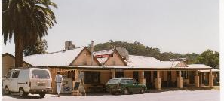  St Andrews Hotel and Canary Island Palm Tree, 79 Burns Street, St Andrews (HO19). (Source: VHD) | The c1860 St Andrews Hotel, with c1930 additions, and a Canary Island Palm is historically significant. It is the oldest hotel building in the former Shire of Eltham, and one of the few surviving buildings connected with the Caledonia goldfields era. The additions and alterations to the hotel reflect its long life. The hotel is socially significant because it has served as an important meeting place for almost 150 years (VHD).
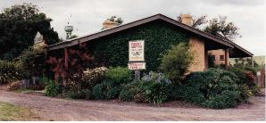  Weller’s Hotel, Pitman Corner, Eltham-Yarra Glen Road, Kangaroo Ground (HO45). (Source: VHD) | The c1872 hotel is historically significant as an early hotel, store and a staging post for Cobb and Co coaches bound for the Caledonian goldfields (near St Andrews) and the Woods Point gold mine, some 80 kilometres to the east of Warburton. The hotel was associated with Edward Weller, who was also connected with the Kangaroo Ground general store and post office. It has served as a local landmark for almost 140 years (VHD).
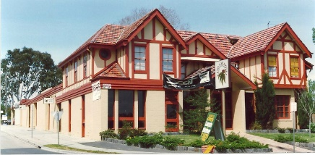  Eltham Hotel (pre 1940 section), 746 Main Road, Eltham (HO116). (Source: VHD) | The Eltham hotel is historically significant as a hotel first established on the site in 1887. In the 20th century the hotel became a meeting place for Eltham's artists, intellectuals and mud brick builders, who were developing a distinctive local lifestyle. The hotel is historically significant for its gradual expansion that reflects the increase in Eltham's popularity as a holiday destination, and later a suburb, following the arrival of the railway. The hotel is aesthetically and socially significant because it features a half-timbered exterior and is a local landmark (VHD).
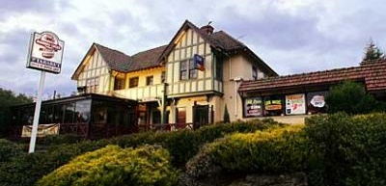  Royal Mail Hotel & pine, 29 Main Hurstbridge Road, Diamond Creek (HO115). (Source: VHD) | The c1927 Royal Mail hotel is architecturally and historically significant as the only example of an Old English/Tudor Revival style hotel in the Shire of Nillumbik and as a good example of this style. The hotel was first established on this site c1870. The extant hotel is socially significant as it has been an important gathering point for the community since 1927 (VHD).
Discussion
The Panton Hill Hotel at 633 Kangaroo Ground-St Andrews Road, Panton Hill, compares well to the above hotels historically and architecturally.
Established as early as 1861, the subject property was the site of one of the first known building in the Shire, the Hôtel Français (also known as Hotel de France). The long historical use of the site for the purpose of a commercial hotel is highly important.. As with the examples above, Panton Hill Hotel has strong landmark qualities as an old hotel.
The subject site and HO-listed hotels had been established in the nineteenth century and rebuilt or altered over the twentieth century. Enforced by the renewed liquor licencing law in the 1920s, substantial alterations or rebuilding of hotels in the interwar period is also very common across Victoria. Like the Panton Hill Hotel, the HO-listed display some alterations to their original fabric, but these changes are part of the story of the place and reflective of the development of the hotel type.
As an example of a hotel rebuilt during the interwar period, 633 Kangaroo Ground-St Andrews Road is more directly comparable with other interwar hotel buildings at 746 Main Road, Eltham (HO116) and 29 Main Hurstbridge Road, Diamond Creek (HO115).
Overall, the Panton Hill Hotel is an important example of an interwar hotel, within the Shire that continues to operate today.

STATEMENT OF SIGNIFICANCE

WHAT IS SIGNIFICANT?
633 Kangaroo Ground-St Andrews Road, Panton Hill, a single-storey hotel built c1935, with later alterations and refurbishment, is significant.
Elements that contribute to the significance of the place include:
- the original single-storey hotel building with gable roof and weatherboard-clad walls; and
- early elements including the brick chimneys and windows.
Two Monterey Cypress trees that appear to date from the interwar period contribute to the significance of the place.

HOW IS IT SIGNIFICANT?
633 Kangaroo Ground-St Andrews Road, Panton Hill, is of local historic and social significance to the Shire of Nillumbik.

WHY IS IT SIGNIFICANT?
Panton Hill Hotel at 633 Kangaroo Ground-St Andrews Road, Panton Hill, is historically significant as the only remaining hotel in the township of Panton Hill, standing on the site of the township’s first building, a hotel built in 1861. It is the latest in a series of hotel buildings that were destroyed by fire then rebuilt on the same site. The single storey gable roofed form, weatherboard cladding, windows and brick chimneys demonstrate the interwar period of its construction (Criterion A)
Panton Hill Hotel at 633 Kangaroo Ground-St Andrews Road, Panton Hill, is socially significant as a gathering place and local landmark, having served the community and travellers since the 1860s. (Criterion G)

RECOMMENDATIONS
Recommended for inclusion in the Schedule to the Heritage Overlay of the Nillumbik Planning Scheme as an Individually Significant place.
Extent of overlay: To the title boundary
Recommendations for the Schedule to the Heritage Overlay (Clause 43.01) in the Nillumbik Planning Scheme:

Nillumbik Planning Scheme
External paint controls | No
Internal alteration controls | No
Tree controls | No
Outbuildings or fences | No
To be included on the Victorian Heritage Register | No
Prohibited uses may be permitted | No
Aboriginal heritage place | No

Other
N/A

REFERENCES
Advertiser, as cited.
Age, as cited.
Argus, as cited.
Blake, Leslie J (ed) 1973, Vision and Realisation: A centenary History of State Education in Victoria, vol 3, Education Department of Victoria, Melbourne.
Building permit records for Panton Hill Hotel, Kangaroo Ground-St Andrews Road, Panton Hill (BP).
Butler, Graeme, and Associates 1996, ‘Nillumbik Shire Heritage Review – Environmental History’, Prepared for the Shire of Nillumbik Council.
Butler, Graeme, and Associates 2006, ‘Heritage Assessments, Shire of Nillumbik Amendment C13’, Prepared for the Shire of Nillumbik Council.
Central Plan Office (CPO), Historic Aerial Photography: 1930s to 1990s, as cited, via Landata, https://www.landata.vic.gov.au/, accessed online March-April 2021.
Eltham District Historical Society 2000, A Chronology of Known Local Events 1835-early 2000 including those in the Shire of Nillumbik and the former shires of Eltham and Diamond Valley, Eltham District Historical Society Incorporated.
Evelyn Observer, and South and East Bourke Record, as cited.
Greensborough Parish Plan 1961, Melbourne, Department of Lands and Survey.
Herald, as cited.
Howe 1848, Plan of subdivided sections in and adjoining the Parish of Nillumbik, Sydney, PROV VPRS 08168 P2/6221.
Jones, Albert c1910-1930, ‘View along street of country town ca 1910-ca1930’, State Library of Victoria (SLV) Spark Collection of glass negatives and prints, accessed online 17 April 2021.
Land Victoria, Certificates of Title (CT), as cited.
Leader, as cited.
Lemon, Andrew 2008, ‘Panton Hills’, eMelbourne, School of Historical & Philosophical Studies, The University of Melbourne, https://www.emelbourne.net.au, accessed online 29 November 2020.
Mills, Peter & Westbrooke, Samantha 2017, ‘Nillumbik Shire Thematic Environmental History -– Revision 2016’, prepared for Nillumbik Shire Council.
Nearmap, as cited.
Nillumbik Parish Plan 1947, Melbourne, Department of Lands and Survey.
Nillumbik Shire 2020, ‘History of the Shire’, https://www.nillumbik.vic.gov.au/Council/About-the-Shire/History-of-the-Shire, accessed online 23 November 2020.
Nillumbik Shire Council 2015, ‘Nillumbik Heritage Guide’.
Panton Hill Township Plan 1942, Melbourne, Department of Lands and Survey.
‘Victorian Gold Project: Historic Gold Mining Sites in the St Andrews Mining Division’ 1999, Melbourne, Department of Natural Resources and Environment.
Victorian Heritage Database (VHD), https://vhd.heritagecouncil.vic.gov.au/, accessed online 30 April 2021.
Victorian Places 2015, ‘Kangaroo Ground’, Monash University and The University of Queensland, https://www.victorianplaces.com.au/, accessed online 10 December 2020.
Westbrooke, Samantha, & Mills, Peter 2017, ‘Panton Hill Store & Residence and former Post Office, 586 and 588 Kangaroo Ground-St Andrews Road, Panton Hill Heritage Assessment Report’, Prepared for Nillumbik Shire Council.

