Title: Panton Hill Store and Post Office Precinct
Identified by: Peter Mills and Samantha Westbrooke
Updated and Prepared by: Trethowan Architecture

Address: 586 and 588 Kangaroo Ground-St Andrews Road, Panton Hill
Name: The Panton Hill Store and Post Office Precinct | Survey Date: 20/1/2022
Place Type: Store and Former Post Office and associated residences | Architect:
Grading: Locally Significant | Builder:
Extent of Overlay: Title boundaries of 586 and 588 Kangaroo Ground-St Andrews Road, Panton Hill | Construction Date: 1926 (Post Office), c.1880--1939 (General Store)

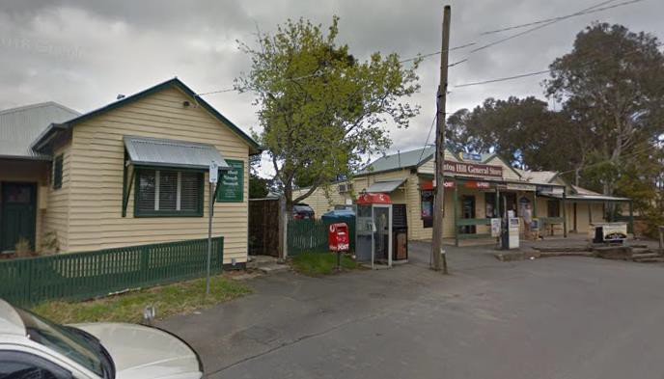
586 and 588 Kangaroo Ground-St Andrews Road, Panton Hill. Image: Westbrooke and Mills, 2017

586 and 588 Kangaroo Ground-St Andrews Road, Panton Hill. Image: Google Maps 2022
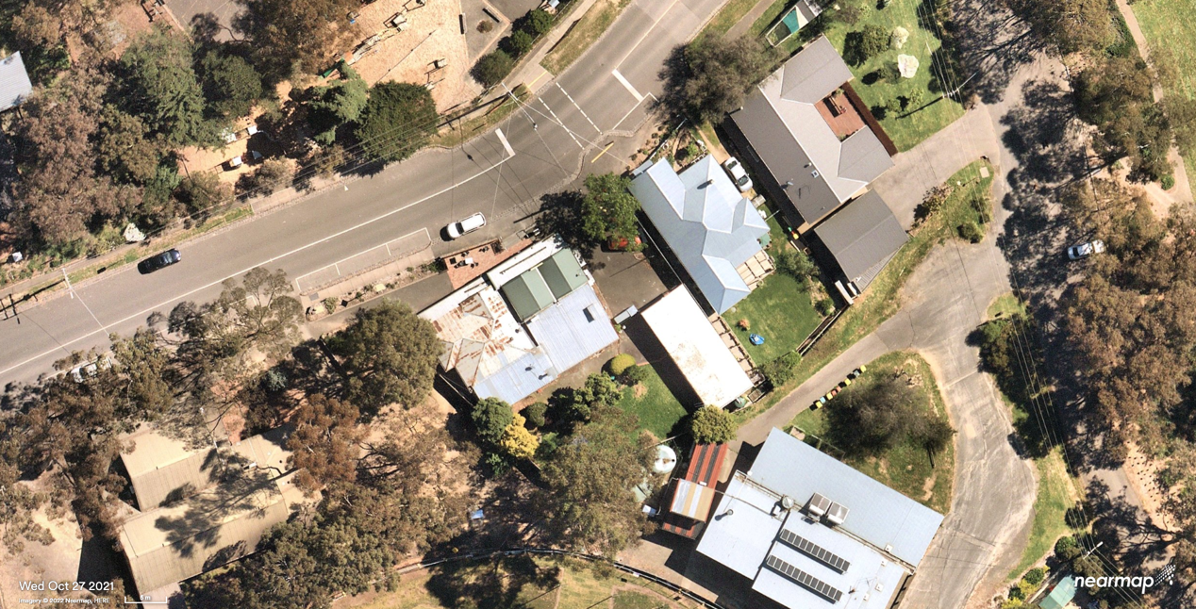
586
588

Aerial view of subject sites, with street numbers indicated. Source: NearMap October 2021

Historical Context

Panton Hill was established as a goldfield in 1859 in the area generally called the Caledonia Diggings (1855). Its northern neighbour, Queenstown, is now St Andrews. By the end of the 1860s the goldfield became less profitable and miners turned to farming. Several introduced viticulture and orchards to Panton Hill. A primary school was opened in 1865, and by 1880 there were two hotels and a Church of England. A mechanics' institute was opened in 1901. In 1903 Panton Hill was described in the Australian handbook:

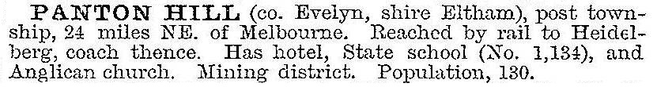

The railway extension from Heidelberg to Hurstbridge in 1912 provided quicker access for fruit-growers to the Melbourne markets. Electricity was turned on in 1958. For most of the twentieth century Panton Hill's population was around 300, indicating a steady rural economy. (‘Panton Hill’, Victorian Places, 2014)

History
Early Buildings in Kingstown (later Panton Hill)
Gold was discovered at Oram’s Reef in 1859 and the resulting gold rush ushered in the beginnings of Kingstown (later Panton Hill). Emile and Jeanne Hude opened a hotel in Kingstown in c1860, which became known as ‘The Frenchman’s’ (Marshall 1971:37; EO&S&EBR, 17 October 1890:3). In 1870, Jeanne Hude, described as “storekeeper of Panton Hill”, acquired a certificate authorising the issuing of a publican’s license (Argus 8 January 1870:8). This is the first indication of a store in the town (Argus 8 February 1871:8). A post office was opened at Panton Hill in 1875 (Australasian (Melbourne), 2 October 1875:20). This may have been run by Mrs Hude from her hotel, by this time known as the ‘Hotel de France’ (EO&S&EBR, 11 December 1885:3).

By 1880 Kingstown (Panton Hill) was a basic mining settlement – it had 2 hotels, 1 store and around 20 miners’ huts. There were no residences substantial enough to be described as houses (RB year to December 1880).

586 and 588 Kangaroo Ground-St Andrews Road
On 9 January 1883 the ‘rural store site’ of William Hopkinson was offered at a Crown land auction. The area advertised corresponds to the land that now contains the Panton Hill Store and residence at 586 Main Road as well as the adjacent former Post office at 588 Main Road. The three-year minimum period before the licensee could request sale of the site by the Crown indicates that Hopkinson had taken up the land in c1880. William purchased the land, which became Lot 6 in the Panton Hill Township (Panton Hill Township Plan. CT: V1439 F698).

The Hopkinson Family
Grace Harriet and William Hopkinson had arrived in Port Phillip on the Prince Arthur in May 1853. Grace was born in England, William in Derbyshire, and both were 22 (Inward overseas passenger lists [1852-1923] VPRS 947, Argus 11 January 1912:1, EO&BER 12 January 1912:2). Presumably they were headed for the goldfields. William Hopkinson appears as an elector in Queenstown (St Andrews) in 1859 (Argus 30 June 1859:8). From this time the Hopkinson’s based themselves in Smith’s Gully, where they had a store.

The Hopkinson’s’ Smith’s Gully store first appears in the Eltham Road District rate rolls in 1870, under William’s name. This continues until 1880, but in that year and in 1881 his eldest daughter Annie Ellen Hopkinson, also appears in the rate roll, as storekeeper for a store in Kingstown (Panton Hill) (RB year to December 1880). Annie would marry William Hopkinson's long-term mining partner Walter Joseph Joyce in 1881 (BDM Victoria Event No.436/1881).

By 1887 Kingstown becomes known as Panton Hill. Until William's wife Grace’s death in 1893 it appears the Hopkinson family ran stores in both towns (RB, years to December 1882 to 1890). William Hopkinson was quick to marry again after Grace's death, this time to Mary Susan Watkins in 1894 (BDM Victoria Event No.5056/1894). As well as running stores in Smith's Gully and Kingstown/Panton Hill, in the late 1890s and early 1900s William Hopkinson was a successful miner and prospector, having famously struck it rich at One Tree Hill (EO&BER 12 January 1912:2).

Mary Susan Hopkinson took over ownership of the property in Panton Hill in 1904 (CT: V1439 F698). In 1906 W. Hopkinson obtained permission from the Eltham Shire Council to build a verandah in front of the store (H&YGG 10 February 1906:2). Mary became the post mistress in c1907 and remained in that position until 1937 (Advertiser (Hurstbridge) 27 August 1937:5, 3 September 1937:5). A c1900-1910 photograph shows the store on the left with the residence on the right. The sign over the store reads ‘Hopkinson Licensed to sell Tobacco, Cigars & Snuff’ (‘Panton Hill’, photographer Albert Jones, c1900-1910, SLV photograph collection Accession no(s) H2007.130/61). The presence of the verandah indicates that the photograph was post-1906. In 1908 Mrs. M. Hopkinson applied for a “special gold buyers license in sparsely populated part”, for “her premises” at Panton Hill. Her application was supported by 6 locals - 4 miners, a butcher and a farmer (EO&BER 1 May 1908:2).

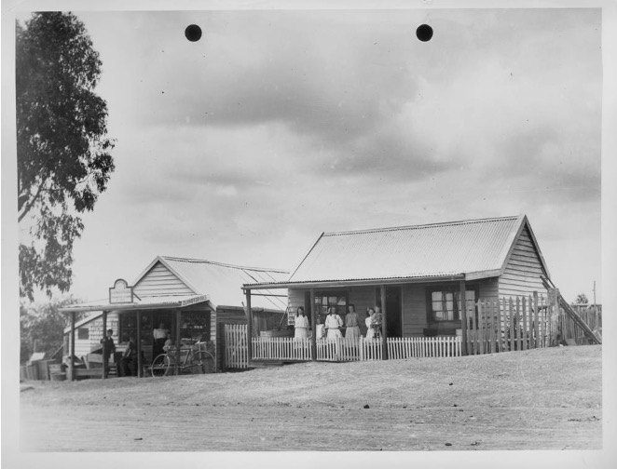

The Hopkinson’s’ Panton Hill store and residence c1906-1910. Source: ‘Panton Hill’, photographer Albert Jones, c1900-1910, SLV photograph collection. Accession no(s) H2007.130/61.

William Hopkinson died at his residence in Main Street Panton Hill in 1912 after a ‘long and painful illness”, at the age of 82 (BDM Victoria Event No.2110/1912, Argus 11 January 1912:1, EO&BER 12 January 1912:2).

Mary Susan Hopkinson married George Adams in 1914 or 1915 (BDM Victoria Event No.1667/1915). George was for many years the roads foreman for the North Riding of the Eltham Shire, staying in that position until forced to retire because of ill health in 1937 (Advertiser (Hurstbridge) 6 August 1937:1). It appears that Mary Susan Hopkinson/Adams went through financial difficulties after William’s death, with a series of 5 mortgages of the Panton Hill land up to her son Stephen Arthur’s purchase of the eastern corner of the block in 1926, and a further two mortgages before the remainder was sold to William Horatio Lowe in 1937 (CT: V1439 F698).

Despite the financial difficulties, records indicate that Mary and her children continued to operate the store and post office. Works were done on the road near Mrs Adams’ store in 1918 (EWSADCVA 11 October 1918:3). A visitor in the 1920s remembered “Mrs Adams’ general store and Post Office” (Graeme Butler & Associates 1996:41). In 1926 she sold the western corner of the property, where the store and residence now stand, to her son Stephen Arthur Hopkinson (born in 1906) (BDM Victoria Event No.21496/1906, CT: V1439 F698).

Mary (Hopkinson) Adams continued to reside on the larger part of the block. It appears that she built a new house and post office on this land after selling the corner lot to her son, which is the building that still remains on the street front to the left of the store (588 Kangaroo Ground-St Andrews Road). She is described only as a post mistress in this period, not a storekeeper as well (Advertiser (Hurstbridge) 11 November 1932:1). The 1935-6 rate book indicates she owned part of Lot 6 with post office and dwelling (RB 1935-6). She remained the post mistress until she and her husband George moved to Whittlesea in 1937, and ex-orchardist Albert Barber took over as post master (Advertiser (Hurstbridge) 14 March 1924:3, 27 August 1937:5, 18 March 1938:3, EWSA 3 July 1942:3).

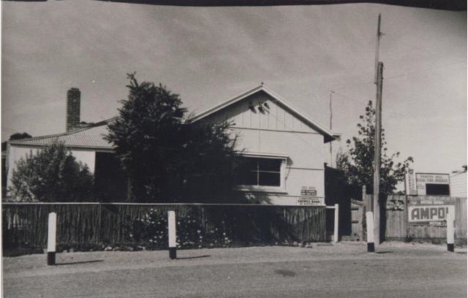

Residence, Post Office and Commonwealth Savings Bank c1955. This was Mary (Hopkinson) Adams' residence and post office, built c1926 and occupied by her until 1937, then by Albert Barber. Note Rural Fire Brigade sign on small block between Post Office/Bank and the store wall just visible on the right. Source: Eltham District Historical Society Inc. Object 00041 Post Office Panton Hill.

After the Hopkinson’s
Mr William H. Lowe acquired the old store and house on the smaller part of Lot 6 from Stephen Arthur Hopkinson in March 1936 (CT: V5146 F021, RB 1935-6). Lowe also purchased the remainder of the original lot, Mary (Hopkinson) Adams' land, a year later in 1937 (CT: Vol.1439 Fol.698). From this time Post Master Albert Barber may have rented the post office and dwelling until he himself purchased it in 1946 (CT: V5146 F021).

The increasing importance of the car in the district is reflected in innovations by Mr. Lowe. A petrol bowser was installed in June 1936 (Advertiser (Hurstbridge) 19 June 1936:3). By November Mr. Lowe had organised for a mechanic from his supplier, the ‘Alba’ petroleum Company, to attend on Tuesdays and give free car “overhauls” (Advertiser (Hurstbridge) 20 November 1936:2). Cut lunches, especially for school children, were provided at the store for sixpence (Advertiser (Hurstbridge) 20 March 1936:5).

In 1939 Mr. G.T. Innes of Murrumbeena took over management of the store from Lowe, apparently under lease, as there is no transfer of title at this time. The Innes family stayed with Mr. & Mrs. A.R. McLaughlin until their new residence was built alongside the store (Advertiser (Hurstbridge) 4 August 1939:3, CT: V5146 F021). The c1880 house was probably dilapidated and small by this time, Mr. Innes advertised asking for the patronage of residents from Panton Hill and the surrounding district (Advertiser (Hurstbridge) 4 August 1939:5).

Lowe subdivided the larger part of the original lot, which he had acquired in 1937, selling off the first lot facing the Main Road, containing Mrs Adams ‘post office/dwelling, to post master Albert Barber in 1946. A photo c1955 shows that the building housed a Commonwealth Savings Bank branch and Post Office (EDHS Object 00041 Post Office Panton Hill). The narrow block between the store and residence and the Savings Bank/Post Office was sold in 1955 (CT: V6133 F411.). From the above photo it appears that it may have been occupied for a time by the Panton Hill Rural Fire Brigade.

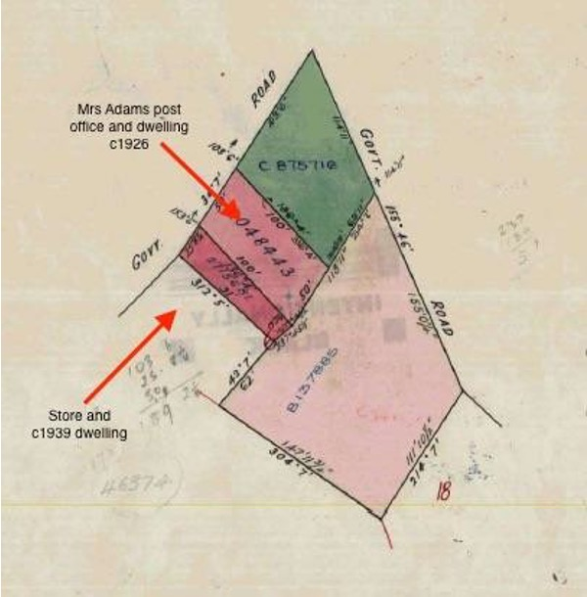

Lowe’s subdivision c1946. Dashed blue line indicates current lot boundaries.
Source: Certificate of Title Vol.6133 Fol.411.

Bertha Lindsay and Russell Edwin Clinton, storekeepers of Main Road Panton Hill, obtained title to the lot with the store and residence in 1955 (CT: V5146 F021). They also purchased the narrow lot which had been subdivided by Lowe.

Dorothy Joan and Raymond Francis Adams, storekeepers of Main Road Panton Hill, acquired ownership of the Clintons’ two lots in 1968, and the Melbourne and Metropolitan Board of Works (MMBW) acquired those lots in 1969 (CT: V5146 F021). Joel Resources acquired the combined land in 1992, and Alastair Donald and Barbara Maureen McInnes became the owners in 2004 (CT: V10033 F509).

Description & Integrity

Store and Former Residence at 586 Kangaroo Ground-St Andrews Road
The former store and residence consists of linked weatherboard buildings with pitched, corrugated metal clad roofs. The former store building is made up of two gable wings of different widths with the gable ends fronting the street. The gable section of these wings does not extend far before there is a skillion roof extending across the width of both of the gables to the rear. It is possible that one of the gable wings is a remaining section of the early gable roofed store. The gable wings have a skillion verandah spanning across the front of the store. This is not an early verandah but is similar to the original verandah. The end gable wing contains an almost square timber framed window with four panes. A single entry door sits almost centrally between the two gable wings and the central gable wing contains a rectangular shopfront window lower to the ground that the earlier described window.

The adjacent former residence on the west side sits slightly forward of the store and is set down lower than the store. The residence has a main tall hipped roof with what would have been a projecting gable wing on the north side. The roof form indicates that the original verandah, which would have extended across the front but ended at the front gable wing has been filled in and a second verandah spanning the front of the entire residence has been installed. The gable end of the front wing has half timbering and a twin timber framed double hung window with wide framing and four panes in the upper sashes. The only other feature of the front elevation is a single entry door, which is a later alteration after the verandah was filled in. The roof form of the residence is unusual, with a hipped roof running parallel to the front intersecting with the gable wing. There is then a hipped wing behind this that is narrower than the front hipped roof wing. This may indicate that the earlier residence was incorporated into the c.1939 residence.

Former Post Office and Residence at 588 Kangaroo Ground-St Andrews Road
The former Post Office and Residence is also a weatherboard building with pitched roof forms clad in corrugated metal. While the form of the building with a projecting gable wing to the front and a wider hipped roof wing to the rear has been retained, the original cement sheet cladding with timber strapping has been replaced with weatherboards. The porch and entry to what would have been the residence is set back from the street and is at the front of the hipped roof wing. The window to the front of the gable wing has been altered but many other features remain such as the front door set back on the rear hip roofed wing.

There is a capped picket fence to the front of the property but this is not original fabric.

Current Images of the Site
The following photographs were taken by Samantha Westbrooke Thursday 2nd March 2017.

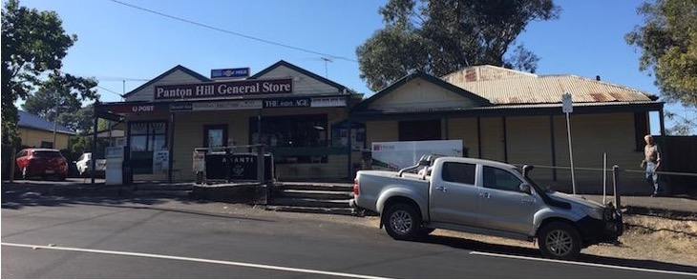
Store and Residence at 586 Kangaroo Ground-St Andrews Road

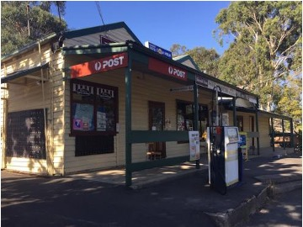
Front of store from Kangaroo Ground-St Andrews Road

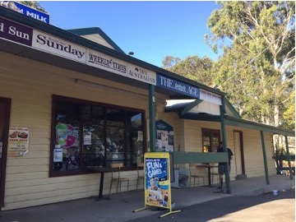
Front of store from Kangaroo Ground-St Andrews Road

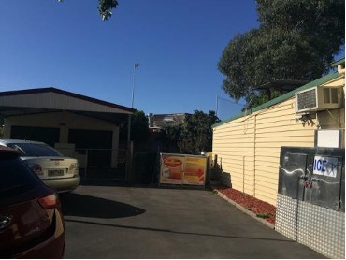
Driveway between the Store and former Post Office

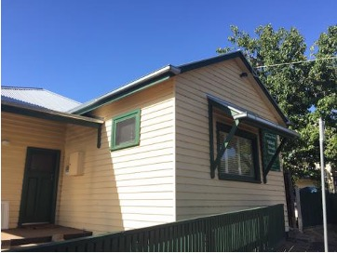
Front of the former Post Office

Comparative Analysis

The general store and former Post Office are two of six key early buildings that form the social, community and civic core of Panton Hill and demonstrate its scale and appearance in its heyday. The other four buildings are:

- HO96 St Matthews Church and Church Hall at 575 Kangaroo Ground-St Andrews Road.
- HO97 Panton Hill Primary School No.1134, 595 Kangaroo Ground – St Andrews Road The 1889 schoolhouse and the 1882 portable classroom.
- HO98 Former Panton Hill State School, 1889 Teacher’s Residence.

The buildings are also important and rare surviving examples of a rural General Store and Post Office in the Shire. These General Stores and Post Offices illustrate the key early and formerly rural towns in the Shire and their social centres. Other towns within Nillumbik that retain their early General Store and/or Post Office buildings and are in the Heritage Overlay are as follows:

- HO48 Kangaroo Ground General Store & Post Office, 280 Eltham-Yarra Glen Road, Kangaroo Ground c1900s General Store and Post Office.

- HO68 Hurstbridge Post Office - Evelyn Observer Office, 794 Heidelberg-Kinglake Road, Hurstbridge, The 1918 Evelyn Observer office and the 1930s additions (when it was converted to a post office).

- HO179 Old Store and Post Office, 910 Arthurs Creek Road, Arthurs Creek, 1880s.

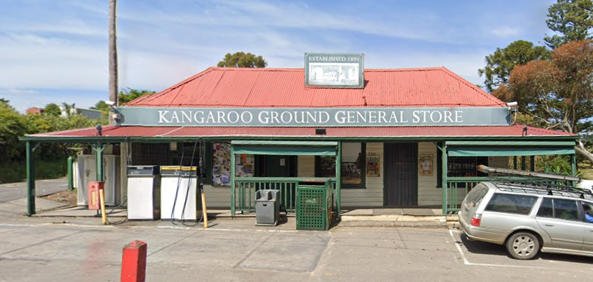  HO48 Kangaroo Ground General Store & Post Office, 280 Eltham-Yarra Glen Road, Kangaroo Ground c1900s General Store and Post Office. | 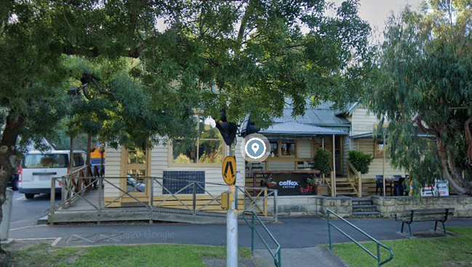  HO68 Hurstbridge Post Office - Evelyn Observer Office, 794 Heidelberg-Kinglake Road, Hurstbridge
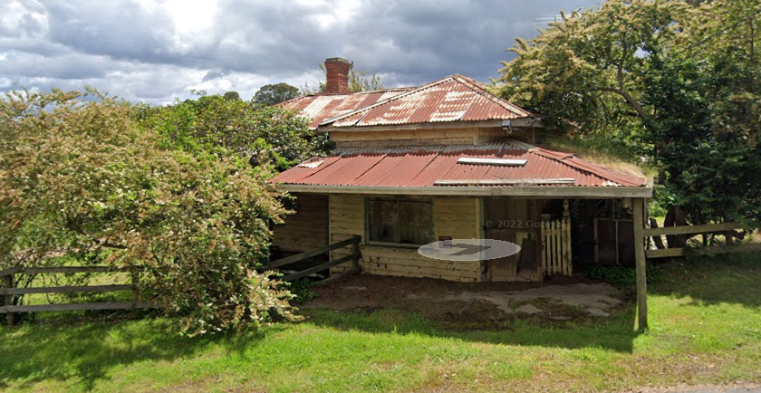
HO179 Old Store and Post Office, 910 Arthurs Creek Road, Arthurs Creek.

The two properties at Panton Hill compare favourably in terms of their historical use and significance to their respective locality. Like the comparative examples, the subject properties within the proposed precinct have been added to over time and demonstrate the historical evolution of the town over an extended period, particularly from the early twentieth century. While both properties are Significant historically, their unique development and location together side by side on Panton Hill means they are intelligible grouped together as a small Precinct.

Assessment Against Criteria

Criteria referred to in Practice Note 1: Applying the Heritage Overlay, Department of Planning and Community Development, revised July 2015, modified for the local context.

CRITERION A: Importance to the course or pattern of the Shire of Nillumbik’s cultural or natural history (historical significance).

The General Store is historically significant because it has a long association with Panton Hill and has been an important centre of community life for more than 120 years and the Post Office has been an important community building for more than 80 years. The General Store and former Post Office and their associated residences are historically significant as two of six key early buildings that form the core of Panton Hill (the former school, teacher’s residence, the Anglican Church and church hall being the others). The site is important for its associations with the Hopkinson family who were involved in goldmining in the area and were important pioneer settlers in the district. The first record of the Hopkinson’s General Store at Panton Hill was in 1881 and the family occupied the site up until 1936. The Post Office and residence was constructed for Mary Adams (formerly Hopkinson) in 1926.

CRITERION B: Possession of uncommon, rare or endangered aspects of the Shire of Nillumbik’s cultural or natural history (rarity).

The General Store and former Post Office are rare surviving examples of such buildings in the Shire.

CRITERION C: Potential to yield information that will contribute to an understanding of the Shire of Nillumbik’s cultural or natural history (research potential).

CRITERION D: Importance in demonstrating the principal characteristics of a class of cultural or natural places or environments (representativeness).

The grouping of church, hall, school, store and post office that occurs within the centre of Panton Hill is typical of the pattern of development in country towns throughout Victoria. The Precinct, comprising general store and former Post Office and their associated residences is representatively significant as a grouping of essential services at the heart of a rural community in the early twentieth century. The overall layout and forms, roof forms, materials and openings to the complex of buildings are evocative of the appearance of Panton Hill around this time.

CRITERION E: Importance in exhibiting particular aesthetic characteristics (aesthetic significance).

CRITERION F: Importance in demonstrating a high degree of creative or technical achievement at a particular period (technical significance).

CRITERION G: Strong or special association with a particular community or cultural group for social, cultural or spiritual reasons. This includes the significance of a place to Indigenous peoples as part of their continuing and developing cultural traditions (social significance).

The General Store is of social significance as an important centre of community life in the district for more than 120 years and the Post Office has been an important community building for more than 80 years.

CRITERION H: Special association with the life or works of a person, or group of persons, of importance in the Shire of Nillumbik’s history (associative significance).

Grading and Recommendations

Recommended for inclusion in the schedule to the Heritage Overlay of the Nillumbik Planning Scheme.

Proposed Extent of HO.

Recommendations for the Schedule to the Heritage Overlay (Clause 43.01) in the Nillumbik Planning Scheme:

External Paint Controls  Is a permit required to paint an already painted surface? | No
Internal Alteration Controls  Is a permit required for internal alterations? | No
Tree Controls  Is a permit required to remove a tree? | No
Victorian Heritage Register  Is the place included on the Victorian Heritage Register? | No
Incorporated Plan  Does an Incorporated Plan apply to the site? | No
Outbuildings and fences exemptions  Are there outbuildings and fences which are not exempt from notice and review? | No
Prohibited uses may be permitted  Can a permit be granted to use the place for a use which would otherwise be prohibited? | Yes
Aboriginal Heritage Place  Is the place an Aboriginal heritage place which is subject to the requirements of the Aboriginal Heritage Act 2006? | No

References

Advertiser (Hurstbridge), as cited.
Age, as cited.
Argus, as cited.
Australasian (Melbourne), as cited.
Colac Herald, as cited.
Eltham District Historical Society Inc. as cited.
Eltham & Whittlesea Shires Advertiser (EWSA), as cited.
Eltham and Whittlesea Shires Advertiser and Diamond Creek Valley Advocate (EWSADCVA), as cited.
Evelyn Observer & Bourke East Record (EO&BER), as cited.
Evelyn Observer & South & East Bourke Record (EO&S&EBR), as cited.
Graeme Butler & Associates, 1996, 'Nillumbik Shire Heritage Study Stage 1, Review, Heritage Survey and Environmental History', prepared for the Shire of Nillumbik.
Healesville & Yarra Glen Guardian (H&YGG), as cited.
Inward overseas passenger lists (1852-1923) VPRS 947
Land Victoria, Certificates of Title (CT), as cited.
Marshall, A 1971, Pioneers and Painters: One Hundred Years of Eltham and its Shire, Nelson Australia, Melbourne.
Mercury & Weekly Courier, as cited.
Nelson, P and Alves, L 2009, Lands Guide: A guide to finding records of Crown land at Public Record Office Victoria, Public Record Office Victoria, Melbourne.
Portland Guardian, as cited.
Public Records Office of Victoria, as cited.
Registry of Births Deaths and Marriages Victoria, as cited.
Shire of Eltham Municipal Rate Books (RB), as cited.
State Library of Victoria collection, as cited.
Victorian Places 2014, ‘Panton Hill’, www.victorianplaces.com.au/abbotsford, accessed on 12/04/2022

