Title: House, Farm, 145 River Avenue, Plenty
Prepared by: Trethowan Architecture

Address: 145 River Avenue, Plenty
Name: Former farmhouse | Survey Date:
Place Type: Residence, outbuildings | Architect:
Grading: Significant | Builder:
Extent of Overlay: To property boundary | Construction Date: 1920s

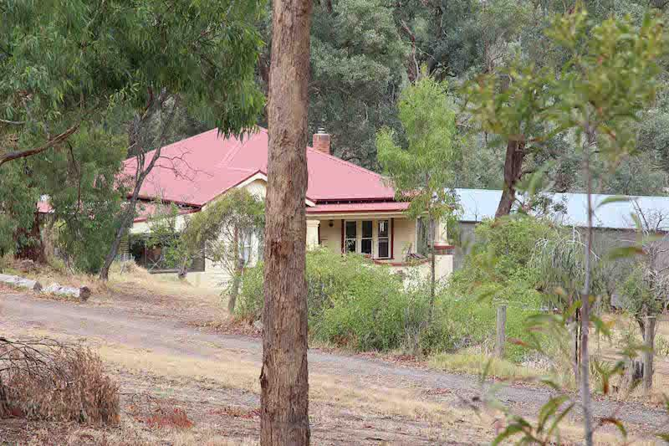
View of 145 River Avenue, Plenty. Source: Peter Mills, 2016.

Historical Context
Plenty is a semi-rural district north of Greensborough, located 20 km northeast of Melbourne. The name Plenty is drawn from the nearby Plenty River, which had been proclaimed by Joseph Tice Gellibrand in 1835. Gellibrand chose the name to reflect the promising countryside of the area (Victorian Places).

In 1840, Crown land sales of the area began with blocks ranging from around 300 to 800 acres. Alexander McKillop was the first to purchase a block; Crown Portion 5 Parish of Morang constituting 820 acres. The Crown continued to auction the other blocks in 1853; Patrick Mornane obtaining Portion 3 Section 4, and L.C Luscombe purchasing 308 acres Portion 2 Section 4 (Westbrook 2016).

The settlement of the land between Plenty River and the early Yan Yean Road, (now partly Heard Avenue and partly Yan Yean Road), was gradually subdivided up until the early twentieth century. From this time the need for smallholdings increased substantially and land was divided more frequently as a result (Westbrook 2016).

This initial, ad hoc settlement pattern varies to other settlements in the Nillumbik Shire and relates to selection and the take-up of occupation licences in and around the auriferous areas. ‘Glenaulin’ on Portion 2 Section 12 of the Parish of Yan Yean further north, was subdivided into 108 2-acre lots and 72 1-acre lots advertised in early 1854. The selling of the lots, however, was unsuccessful (Westbrook 2016).

The alignment of the Greensborough Road (now Yan Yean Road) was altered from the original survey line with a series of curves to the west in 1869 (Argus, 23 June 1869:2). This new road formed a boundary for a number of subsequent subdivisions (Westbrook 2016).

Those who owned large blocks of land towards the north in Yan Yean Parish attempted ambitious early subdivisions into several smallholder blocks. Portion 2 Section 4 of Yan Yean, to the north of Plenty, was subdivided by Henry and John Cooke who advertised the blocks as, ‘Egglestone Estate’ c1885 (Westbrooke 2016).

The 1870s marked a more traditional pattern of subdivision in the area where larger blocks were divided into two or three lots. This pattern lasted up until 1900 with only few significant homesteads erected during this time.

The early twentieth century marked the height of a subdivision trend in the area. This was likely influenced by the success of smallholders, particularly orchardists, in surrounding areas such as Arthurs Creek. Leslie Woodbourne Clarke, a grazier from the Doreen property Linton Grange, is seen to have inspired this trend in 1905 having bought the northern lot of the northern half of the Crown Portion 5 and subdividing it into 9 lots from 10 to 28 acres. The first plot was purchased in 1906 and 8 had been sold by 1914, and the last selling in 1927 (CT: V3098 F446). The southern edge of the subdivision included a private road, Clarkes Road, now Worn’s Lane. This success led to an increase in subdivision in the Plenty area where most smallholdings ranged from 10 to 30 acres.

Portion 5 west of Yan Yean Road, owned by Bank of Australia Ltd (presumably the rebadged Real Estate Bank Ltd which had purchased the land in 1888) was subdivided into 17 lots of approximately 20 acres each in 1911. Browns Road provided a central dividing line for the subdivision. 14 had sold by 1916 (CT: V2020 F836).

Arthur Grenbry Outhwaite of ‘Tallarook’, Walsh St South Yarra purchased 496 acres, the section of Portion 3 Section 4 west of the Yan Yean Road, from John Butler’s executors in April 1912 (CT: V2326 F062). He subdivided his property into 40 lots immediately (CT: 3589 F730). The Lierse brothers (previously of Oatlands Road) bought the 38 acres at the western end of the subdivision in 1925, which included a number of the weekender lots (CT: V3589 F 730). When Outhwaite died in 1938, only two lots remained unsold (CT: V3589 F730).

Plenty’s new landscape was celebrated in an article in the Advertiser 1925, declaring it ‘the Toorak of the northern suburbs, where you get a panoramic view of the surrounding landscape for miles; a grand health resort, and only fifteen miles from the GPO. ’It is also notable that the area is described to be ‘thrown open for selection’ in 1913, which is likely referring to the recent surge in subdivisions, that a school had been built, that ‘fine dwellings (were) built here and there’ and the Plenty Social Club and Progress Association had formed (Hurstbridge Advertiser, 31 July 1925:4).

Plenty’s town centre was established in the 1920s when the first group of facilities was established such as the school, Methodist church and store (Westbrook 2016). In 1928-29 the Heidelberg Shire resumed 10 acres of land in Portion 2 Section 4 to create a ‘pleasure ground and place of public resort’. In May 1930, the Plenty Progress Association began to raise funds to build a hall on this new recreation reserve (Hurstbridge Advertiser, 9 May 1930:4). Tenders were called in May 1931 and the hall was opened in July 1931 (Hurstbridge Advertiser, 9 May 1930:4; 23 May 1930:1).

After World War II, additional community facilities were built. The Plenty reserve became a War Memorial Park with memorial gates, toilets, a playground and trees planted by schoolchildren on Arbour Day. (Pearce and Plenty Historical Society 2009). A fire station shed was erected on the corner of Howell Road (Westbrook 2016).

History

The first title record for this land shows it was purchased in 1891 by John Butler, who then subdivided the land (CT: V2326 F062). The subject land was purchased in 1912 by Arthur Outhwaite, who immediately subdivided it into 52 lots (CT: V3589 F730).

The resulting ‘Plenty River Estate’ was advertised as “splendid fruit growing land, also very suitable for poultry, flowers, bees or pig rearing” (‘Plenty River Estate’ c1912). Less than a third of the lots had been sold by 1920, and little if any house or road building had occurred at this stage (Cth Dept. of Defence 1920).

Edward William Gladman, labourer of Tanck’s Corner (now Yarrambat), purchased 11 acres in 1921. A 1928 newspaper article explains that the Gladman’s had built their own residence by that time and they were lauded as “indefatigable workers for the welfare of the district” (Advertiser (Hurstbridge) 27 July 1928:2). The house is visible on a 1930 topographic map, which also shows orchards in the vicinity, but not on this property (Australian Section, Imperial General Staff c1930). This dates the house between 1921 and 1928.

While the land settled and house constructed during the period of the Closer Settlement program, no evidence has been found that indicates this property was part of the scheme.

Edward Ernest Cunningham, toolmaker of Northcote, purchased the land in October 1928 (CT: V4501 F118). Cunningham married in 1930 (BDM, Victoria). It appears he initially engaged in poultry farming (Advertiser (Hurstbridge) 17 May 1929). Mr and Mrs Cunningham appeared regularly at the Plenty ball during the 1930s (Advertiser, (Hurstbridge), 21 July 1933 p4; 10 November 1939, p2).

The Cunningham’s subdivided the land into two lots in 1969. The subject site was the northern portion, Lot 1 (CT: V4501 F118). Edward Cunningham died in 1983 (BDM, Victoria) and in 1984 the land passed to Edward Arthur and Carmel Louise Cunningham who were living on Lot 2 (CT: V8779 F118). The property was most recently sold in 2010 (realestate.com).

Description & Integrity

The site contains a substantially intact 1920s brick bungalow with an all-encompassing hipped roof and a projecting gable wing to the front with a skillion verandah. The verandah has detailing typical of a 1920s bungalow with a brick balustrade and pillars. There has been a skillion porch addition to the east side. The original timber-framed windows to the front and sides appear to be intact. There are two sheds to the rear of the house which have gable roofs clad in corrugated galvanised iron. The house is set well back from the road.

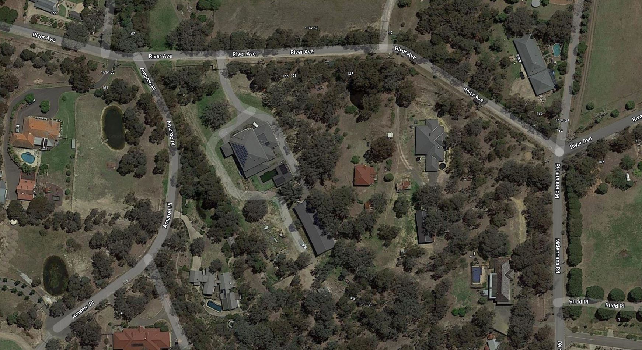
Figure 1: Aerial view of 145 River Avenue, the site boundaries are indicated in red and the relevant house indicated in blue. Source: Google Maps.

Figure 2: View of 145 River Avenue, Plenty. Source: Peter Mills, 2016.
Comparative Analysis

145 River Avenue, Plenty compares with other inter-war farming properties in Nillumbik already included on the Heritage Overlay. The inter-war period of development was identified in the Shire of Nillumbik Heritage Gap Study Framework, June 2009 as being an under-represented development period in the Heritage Overlay. Interwar development was slow, likely related to the distance from central Melbourne and the continuing agricultural setting – hampered by failures of the Closer Settlement scheme. Nevertheless, prosperous farming families were able to construct residences conforming to contemporary stylistic trends seen in suburban Melbourne.

Many farming properties of this period were involved in mixed farming, often combining orcharding with raising poultry for meat and eggs. It is not clear if this practice occurred at 145 River Avenue, although the Cunningham’s were, at least, involved in poultry raising. The 1930 topographic map does not show orchards at this property, although they were in the vicinity.

14-26 Browns Lane, Plenty (c1924) is covered by interim Overlay HO270. It is a representative example of an interwar bungalow, originally part of a mixed farming property including orcharding and poultry. Both properties are representative of agricultural development in the interwar period. The house at 145 River Avenue stands out as an example of a brick bungalow dwelling, rather than the more dominant weatherboard found during this period. Stylistically, 14-26 Browns Lane include earlier features and details, reminiscent of Edwardian-era design. Whereas 145 River Avenue demonstrates the newer ideas and development of the brick bungalow.

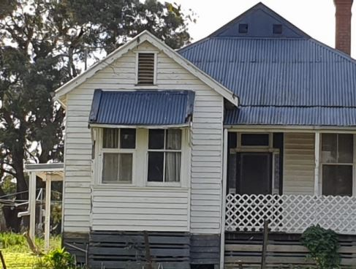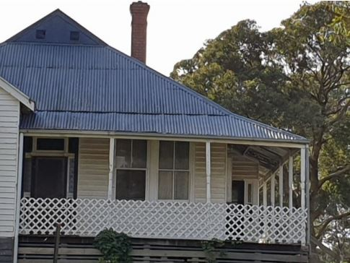
Figure 3: Façade of house at 14-26 Browns Lane, Plenty. Note the weatherboard construction. Source: Citation for 14-26 Browns Lane, plenty prepared by Context 2021.

860 Cottles Bridge-Strathewan Road, Arthurs Creek (HO28) is an orcharding property that incorporates a c1913 weatherboard house as well as a 1920s/1930s house. The later house demonstrates the transition to the bungalow style incorporating nested front gables, shingles to the gable ends, low roof pitch and timber detailing. The house at 145 River Avenue is similarly demonstrative of the transition to newer bungalow style, but stands out due to its unusual brick construction.

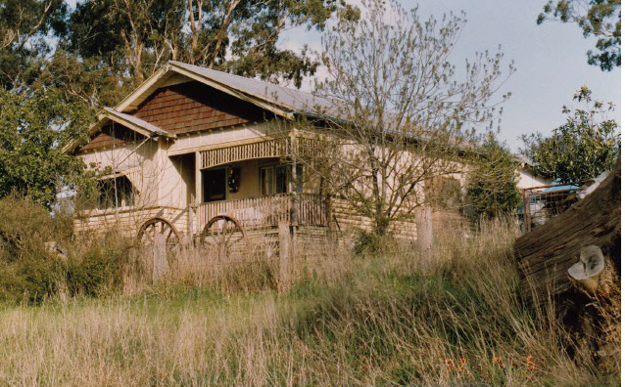
Figure 4: View of the 1920s/1930s weatherboard bungalow at 80 Cottles Bridge-Strathewan Road. Source: Shire of Eltham Heritage Study, 1992.

Orchard House at 25 Cottles Bridge-Strathewan Road, Cottles Bridge (HO190) dates from the 1920s is and significant as one of the few pre-WW2 brick houses in the Shire. It is a good examples of an inter-war orchard house. Orchard House is a good example of its type, possibly a reflection of its being located on fertile farming land. 145 River Avenue compares favourably against Orchard House as both are rare examples of pre-WWII brick dwellings, and both demonstrate the transition from Edwardian to bungalow design.

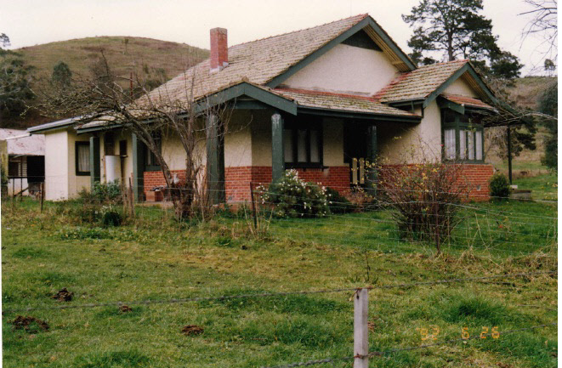
Figure 5: Orchard House at 25 Cottles Bridge-Strathewan Road. Source: Shire of Eltham Heritage Study, 1992.

Worlingworth, at 10-26 Banoon Road, Eltham (HO7) dates from c1922 and is historically and aesthetically significant. Worlingworth is an example of a substantial brick dwelling and farm. The property is associated with notable anthropologist Donald Thompson, and illustrates Eltham’s development to a desirable residential suburb. 145 River Avenue compares favourably as an interwar brick residence, with both properties retaining their setting and evidence of farming practices.
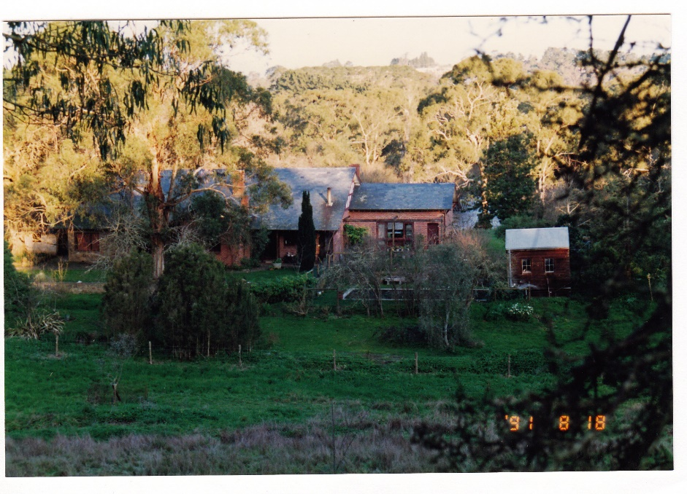
Figure 6: Worlingworth, at 10-26 Banoon Road, Eltham. Source: Shire of Eltham Heritage Study, 1992.

The property at 145 River Avenue compares favourably as a remarkably intact example of a brick inter-war bungalow. The site retains two large outbuildings. The property is associated with the Gladmans, who made a large contribution to the welfare of the district as noted when they left the area in 1928. The setting of the house, including the setback from the road and the remnant outbuildings, further demonstrates the property’s farming history.

Assessment Against Criteria

Criteria referred to in Practice Note 1: Applying the Heritage Overlay, Department of Planning and Community Development, revised July 2015, modified for the local context.

CRITERION A: Importance to the course or pattern of the Shire of Nillumbik’s cultural or natural history (historical significance).

145 River Avenue, Plenty is historically significant to the Shire of Nillumbik as an example of a 1920s residence retaining evidence of its original farm setting and use. It is an example of early development within small-holder subdivision, the Plenty Rover Estate. It is one of a few brick dwellings in the area from this period, demonstrating the stylistic transitions common in the interwar period, and is distinguished for its intactness.

CRITERION B: Possession of uncommon, rare or endangered aspects of the Shire of Nillumbik’s cultural or natural history (rarity).
N/A

CRITERION C: Potential to yield information that will contribute to an understanding of the Shire of Nillumbik’s cultural or natural history (research potential).
N/A

CRITERION D: Importance in demonstrating the principal characteristics of a class of cultural or natural places or environments (representativeness).
145 River Avenue, Plenty is a representative example of an interwar farm and dwelling. The house is remarkably intact and demonstrates the transition to interwar bungalow design and the use of these popular suburban styles in the rural setting.

CRITERION E: Importance in exhibiting particular aesthetic characteristics (aesthetic significance).
N/A

CRITERION F: Importance in demonstrating a high degree of creative or technical achievement at a particular period (technical significance).
N/A

CRITERION G: Strong or special association with a particular community or cultural group for social, cultural or spiritual reasons. This includes the significance of a place to Indigenous peoples as part of their continuing and developing cultural traditions (social significance).
N/A

CRITERION H: Special association with the life or works of a person, or group of persons, of importance in the Shire of Nillumbik’s history (associative significance).
N/A

Grading and Recommendations

Recommended for inclusion in the schedule to the Heritage Overlay of the Nillumbik Planning Scheme.

Recommendations for the Schedule to the Heritage Overlay (Clause 43.01) in the Nillumbik Planning Scheme:

External Paint Controls  Is a permit required to paint an already painted surface? | No
Internal Alteration Controls  Is a permit required for internal alterations? | No
Tree Controls  Is a permit required to remove a tree? | No
Victorian Heritage Register  Is the place included on the Victorian Heritage Register? | No
Incorporated Plan  Does an Incorporated Plan apply to the site? | No
Outbuildings and fences exemptions  Are there outbuildings and fences which are not exempt from notice and review? | No
Prohibited uses may be permitted  Can a permit be granted to use the place for a use which would otherwise be prohibited? | No
Aboriginal Heritage Place  Is the place an Aboriginal heritage place which is subject to the requirements of the Aboriginal Heritage Act 2006? | No

Recommended Extent

Identified By

Mills & Westbrooke

References

Advertiser (Hurstbridge), as cited.

Argus, as cited.

Australian Section, Imperial General Staff Great Britain c1930, ‘Victoria, Yan Yean [cartographic material] 1:63,360 topo series’ War Office, General Staff, Australian Section, State Library of Victoria (SLV) Map Collection

Births Deaths & Marriages, Victoria (BDM), as cited.

Commonwealth Department of Defence, 1920, ‘Victoria, Yan Yean [cartographic material], Australia 1:63,360 topo series’ Government Printer, State Library of Victoria (SLV) Map Collection.

Land Victoria, Certificates of Title (CT), as cited.

Morang Parish Plan

Payne, J.W. 1975, The Plenty: A centenary history of the Whittlesea Shire, Lowden Publishing, Kilmore (Vic).

Pearce, A, and Plenty Historical Society, 2009, Plenty War Memorial Gates - A Short History, Plenty Historical Society, Plenty (Vic).

‘Plenty River Estate’ advertisement poster c1912, State Library of Victoria (SLV) Map Collection

