Title: Nilgiris, 183 Yan Yean Road, Plenty
Prepared by: Trethowan Architecture.

Address: 183 Yan Yean Road, Plenty
Name: Nilgiris | Survey Date:
Place Type: Residence, outbuildings – poultry farming | Architect: Unknown
Grading: Significant | Builder: Unknown
Extent of Overlay: To property boundaries | Construction Date: c1926
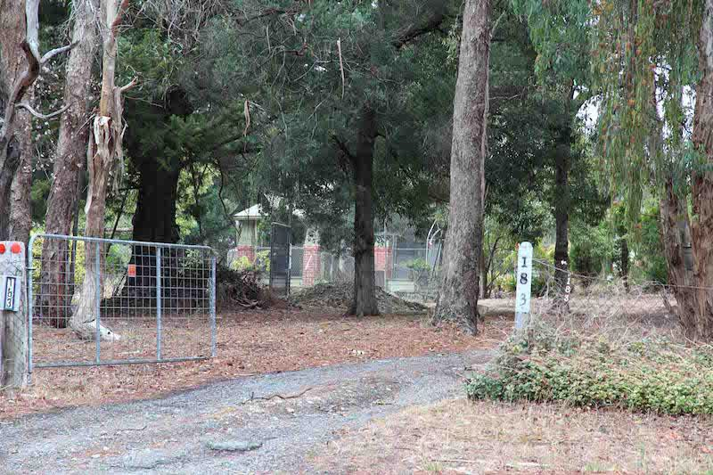
View of Nilgiris, 183 Yan Yean Road, Plenty. Source: Peter Mills, 2016.

Historical Context

Plenty is a semi-rural district north of Greensborough, located 20 km northeast of Melbourne. The name Plenty is drawn from the nearby Plenty River, which had been proclaimed by Joseph Tice Gellibrand in 1835. Gellibrand chose the name to reflect the promising countryside of the area (Victorian Places).

In 1840, Crown land sales of the area began with blocks ranging from around 300 to 800 acres. Alexander McKillop was the first to purchase a block; Crown Portion 5 Parish of Morang constituting 820 acres. The Crown continued to auction the other blocks in 1853; Patrick Mornane obtaining Portion 3 Section 4, and L.C Luscombe purchasing 308 acres Portion 2 Section 4 (Westbrook 2016).

The settlement of the land between Plenty River and the early Yan Yean Road, (now partly Heard Avenue and partly Yan Yean Road), was gradually subdivided up until the early twentieth century. From this time the need for smallholdings increased substantially and land was divided more frequently as a result (Westbrook 2016).

This initial, ad hoc settlement pattern varies to other settlements in the Nillumbik Shire and relates to selection and the take-up of occupation licences in and around the auriferous areas. ‘Glenaulin’ on Portion 2 Section 12 of the Parish of Yan Yean further north, was subdivided into 108 2-acre lots and 72 1-acre lots advertised in early 1854. The selling of the lots, however, was unsuccessful (Westbrook 2016).

The alignment of the Greensborough Road (now Yan Yean Road) was altered from the original survey line with a series of curves to the west in 1869 (Argus, 23 June 1869:2). This new road formed a boundary for a number of subsequent subdivisions (Westbrook 2016).

Those who owned large blocks of land towards the north in Yan Yean Parish attempted ambitious early subdivisions into several smallholder blocks. Portion 2 Section 4 of Yan Yean, to the north of Plenty, was subdivided by Henry and John Cooke who advertised the blocks as, ‘Egglestone Estate’ c1885 (Westbrooke 2016).

The 1870s marked a more traditional pattern of subdivision in the area where larger blocks were divided into two or three lots. This pattern lasted up until 1900 with only few significant homesteads erected during this time.

The early twentieth century marked the height of a subdivision trend in the area. This was likely influenced by the success of smallholders, particularly orchardists, in surrounding areas such as Arthurs Creek. Leslie Woodbourne Clarke, a grazier from the Doreen property Linton Grange, is seen to have inspired this trend in 1905 having bought the northern lot of the northern half of the Crown Portion 5 and subdividing it into 9 lots from 10 to 28 acres. The first plot was purchased in 1906 and 8 had been sold by 1914, and the last selling in 1927 (CT: V3098 F446). The southern edge of the subdivision included a private road, Clarkes Road, now Worn’s Lane. This success led to an increase in subdivision in the Plenty area where most smallholdings ranged from 10 to 30 acres.

Portion 5 west of Yan Yean Road, owned by Bank of Australia Ltd (presumably the rebadged Real Estate Bank Ltd which had purchased the land in 1888) was subdivided into 17 lots of approximately 20 acres each in 1911. Browns Road provided a central dividing line for the subdivision. 14 had sold by 1916 (CT: V2020 F836).

Arthur Grenbry Outhwaite of ‘Tallarook’, Walsh St South Yarra purchased 496 acres, the section of Portion 3 Section 4 west of the Yan Yean Road, from John Butler’s executors in April 1912 (CT: V2326 F062). He subdivided his property into 40 lots immediately (CT: 3589 F730). The Lierse brothers (previously of Oatlands Road) bought the 38 acres at the western end of the subdivision in 1925, which included a number of the weekender lots (CT: V3589 F 730). When Outhwaite died in 1938, only two lots remained unsold (CT: V3589 F730).

Plenty’s new landscape was celebrated in an article in the Advertiser 1925, declaring it ‘the Toorak of the northern suburbs, where you get a panoramic view of the surrounding landscape for miles; a grand health resort, and only fifteen miles from the GPO. ’It is also notable that the area is described to be ‘thrown open for selection’ in 1913, which is likely referring to the recent surge in subdivisions, that a school had been built, that ‘fine dwellings (were) built here and there’ and the Plenty Social Club and Progress Association had formed (Hurstbridge Advertiser, 31 July 1925:4).

Plenty’s town centre was established in the 1920s when the first group of facilities was established such as the school, Methodist church and store (Westbrook 2016). In 1928-29 the Heidelberg Shire resumed 10 acres of land in Portion 2 Section 4 to create a ‘pleasure ground and place of public resort’. In May 1930, the Plenty Progress Association began to raise funds to build a hall on this new recreation reserve (Hurstbridge Advertiser, 9 May 1930:4). Tenders were called in May 1931 and the hall was opened in July 1931 (Hurstbridge Advertiser, 9 May 1930:4; 23 May 1930:1).

After World War II, additional community facilities were built. The Plenty reserve became a War Memorial Park with memorial gates, toilets, a playground and trees planted by schoolchildren on Arbour Day. (Pearce and Plenty Historical Society 2009). A fire station shed was erected on the corner of Howell Road (Westbrook 2016).

History

The history of this site prior to the interwar period is typical of the development of the Plenty locality. The first land sales were in 1853 (Morang Parish Plan), with the subject land later forming part of a 1912 subdivision ‘Plenty River Estate’ (‘Plenty River Estate’ advertisement poster c1912). Alfred Charles Webber purchased Lot 5 of the subdivision in 1917. He sold it to his son Charles (Robert) Fitzroy Webber in 1919 (CT: V4088 F501), who then bought the adjoining land to the north in 1920 (CT: V4311 Fol.153). The 1920 topographic map does not show a house on the land at that time (Cth Dept. of Defence, 1920).

The land was mortgaged to the War Service Homes Commission (WSHC) in 1921 (CT: V4088 F501). By 1921 the WSHC had ceased building houses and was rather issuing tenders for others to build the homes. As such, it is unlikely that the WSHC directly built the house at 183 Yan Yean Road, providing finance and pre-prepared design.

In 1926 Charles Webber subdivided the property. The sale offering described a “splendidly built H.W. [hardwood] bungalow, 4 rooms and all conveniences, 6 acres’ land, with garage, sheds, poultry pens &c; adjoining the Plenty P.O. Store State School etc.” (Advertiser (Hurstbridge) 24 September 1926:2) The house also appears on a 1930 topographic map (Australian Section, Imperial General Staff, c1930). This indicates the house was built between 1921 and 1926.

Lot 1 of the new subdivision was purchased by John Larwill Edgcumbe in 1929 (CT: V4088 F501). The land was a 6-acre property of “virgin bush” on the Yan Yean Road, named ‘Nilgiris’ (Australasian 1 June 1935:48). Nilgiris is a Tamil word meaning ‘blue hills / mountains’ and refers to a district in Tamil Nadu. India. A 1935 newspaper article was dedicated to Edgcumbe’s farm. “This property has a gentle slope to the west, and on this today are rows of laying and single test pens, a modern incubator-house and an underground egg-room” (Australasian 1 June 1935:48). The poultry industry was developing rapidly in the district in the mid-1930s. With the poor prices for fruit in this period, many in the district now combined poultry farming with fruit growing (Advertiser (Hurstbridge) 5 February 1932:1 and 9 March 1934:2).

John was president of the Plenty Tennis Club, which may relate to the tennis court in front of the house (Advertiser (Hurstbridge) 28 September 1934:7). He died at ‘Nilgiris’ in 1936 at the age of 38 from after-effects of his war injuries (Argus 11 February 1936:1; Advertiser (Hurstbridge) 14 February 1936:5 and 28 February 1936:2). John’s sister, Erica Valletort Edgcumbe, administered his estate (CT: V5267 F360).

Lawrence Leslie and Eilene Dunn, poultry farmers, purchased the land in 1944. It was subdivided into two lots in 1974 (CT: V5267 F360). The property was last sold in 2010 (realestate.com.au).

Description & Integrity

The property comprises a large block with the house set within the front third, along with outbuildings and tennis court in front of the house. The series of sheds to the rear may relate to the 1930s poultry farm. The house is accessed via a driveway at the north-east corner of the site. The landscape includes mature trees to the site boundaries and surrounding the house, but there are otherwise no distinguishing features or elements.

The house is a weatherboard inter-war bungalow with a dominating transverse gable roof and deep front verandah with wide brick piers.

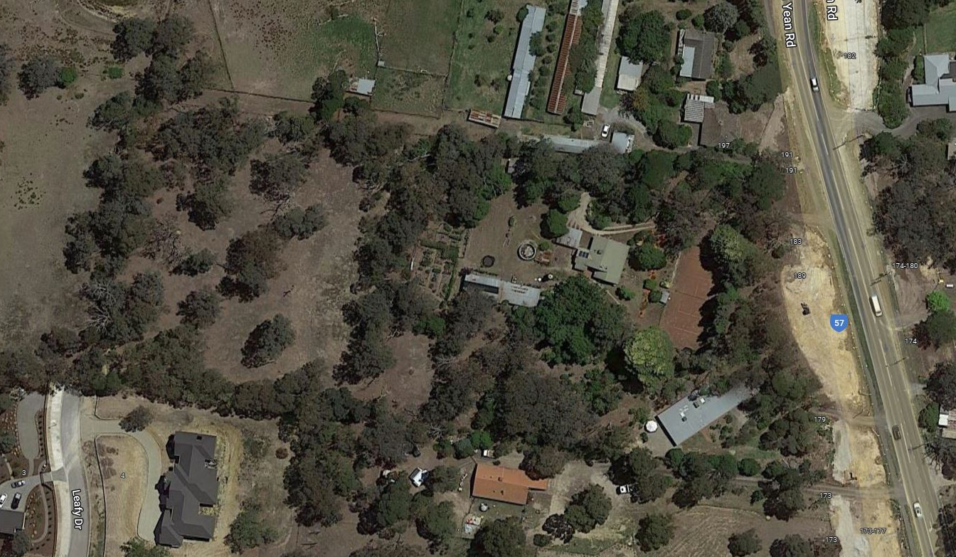
Figure 1: Aerial view of the property (indicated in red). Source: Google Maps.

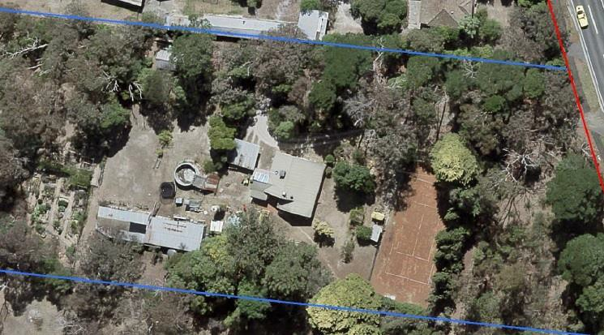
Figure 2: Closer aerial view of the house, outbuildings and tennis court. Source: Courtesy of Shire of Nillumbik.

Comparative Analysis

Nilgiris at 183 Yan Yean Road, Plenty is an example of an inter war bungalow and poultry farming property. Nilgiris compares with other farming properties in Nillumbik, particularly those demonstrating the shift away from the dominant fruit growing industry to incorporate other farming practices. And, to other interwar bungalow dwellings in the Shire.

Orcharding was a dominant agricultural practice in Nillumbik from the 1860s, and by the early twentieth-century the western parts of the shire were important centres supplying fruit to Melbourne (Mills & Westbrook 2016: 61). The turn of the century peak in fruit growing began to decline by the First World War. As orchardists began to struggle they supplemented their income by introducing mixed farming practices, or seeking other types of work. By the Second World War fruit growing was no longer a dominant industry in the area (Mills & Westbrook 2016: 61-62). Mixed farming was further encouraged by the soldier settlement program after the First World War (Mills & Westbrook 2016: 44-45). Thus, the pattern of farming in the area shifted in the first part of the twentieth century from fruit growing to mixed uses including raising poultry for meat and eggs. There are few farming properties of this period currently listed on the Heritage Overlay.

Interwar development in Nillumbik was slow compared with the rapid suburban expansion seen elsewhere in Australia (Cuffley 1989:14). The area remained somewhat isolated from Melbourne and retained its agricultural character. New architectural ideas took longer to reach, and be adopted in, these areas. Houses of this period tend to be modest, low cost, weatherboard structures with limited detailing. Interwar dwellings are under-represented on the Heritage Overlay (HLCD 2009) and those which are included tend to be more substantial homes for wealthy families, rather than farmhouses.

14-26 Browns Lane, Plenty is covered by interim Heritage Overlay HO270. It is a representative example of an interwar (c1924) dwelling, originally part of a mixed farming property including orcharding and poultry. Nilgiris compares with 14-26 Browns Lane as both date from the mid-1920s and are examples of farmhouses associated with poultry raising. The house at 14-26 Browns Lane reflects a conservative architectural approach, retaining Edwardian-era characteristics. Nilgiris is distinguished as an early example of the newer Californian Bungalow mode, demonstrating stylistic influences from suburban Melbourne.

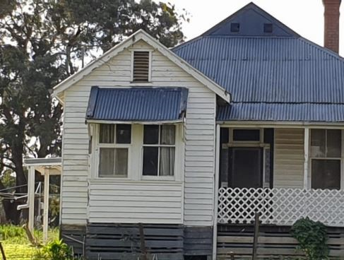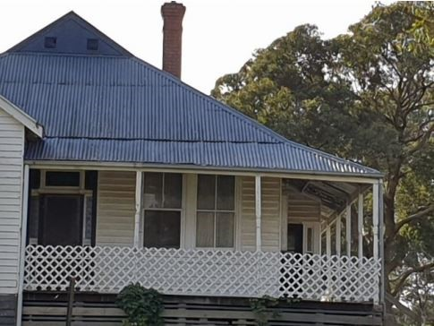
Figure 3: Front elevation of 14-26 Browns Lane, Plenty. Source: Citation for 14-26 Browns Lane, Plenty. Prepared by Context, 2021.

Apted Weatherboard House and adjacent forge, 1920s/1930s house and mature exotic planting, 860 Cottles Bridge-Strathewan Road, Arthurs Creek (HO28). This site is associated with the Apted family of prominent orchardists, and the site includes a 1920s / 1930s house, a rare example in the municipality. Nilgiris compares favourably against this house as both are inter war weatherboard bungalows associated with a farming property. The Apted property demonstrates the importance of orcharding to the early development of Nillumbik, whereas Nilgiris relates to the later shifts away from fruit growing to other forms of farming, and the smaller lot sizes associated with soldier resettlement.

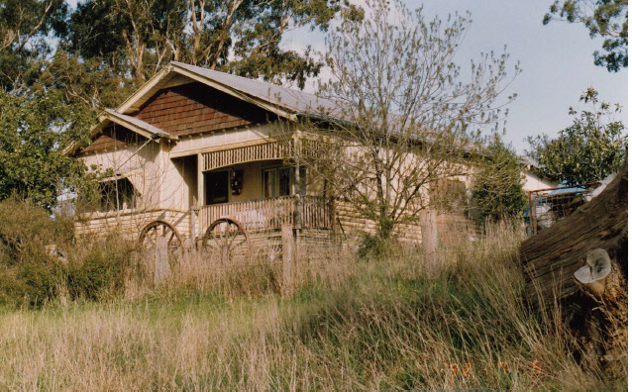
Figure 4: The 1920s/1930s weatherboard house at the Apted property. Source: Shire of Eltham Heritage Study, 1992.

40 Greysharps Road, Hurstbridge (HO261) was constructed c1923 and is significant for its associations with the orchard industry, and as a substantially intact weatherboard interwar bungalow. The house at Nilgiris is of a comparable construction date and is also associated with farming. Both properties are evidence of the introduction of new architectural ideas from Melbourne into the more conservative agricultural area.

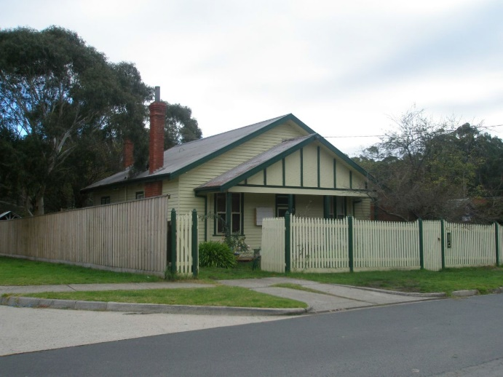
Figure 5: House at 40 Greysharps Road, Hurstbridge, image dated 2012. Source: Place citation 40 Greysharps Road, Hurstbridge.

Weatherboard House, 936 Heidelberg-Kinglake Road, Hurstbridge (HO76) was constructed c1920-21 is historically and aesthetically significant as an example of an Edwardian style house constructed in the interwar period. The house demonstrates the conservatism of the area at a time when the Californian Bungalow came into prominence. The house at Nilgiris is distinguished as an example of the changing fashions of the time and the move away from Edwardian era tastes. Both houses are comparable in their use of weatherboard, a relatively economic and available construction material at the time.

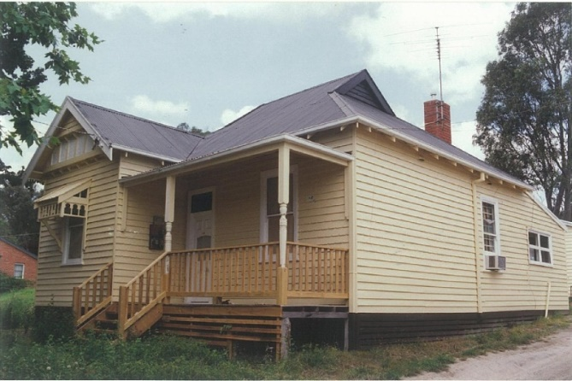
Figure 6: Weatherboard house at 936 Heidelberg-Kinglake Road, Hurstbridge. Source: Shire of Eltham Heritage Study, 1992.

The farm and residence at Nilgiris, 183 Yan Yean Road, Plenty, fits within the established pattern of interwar development in Nillumbik. It is an example of changing architectural tastes and the introduction of Californian Bungalows as a dominant residential form. The property also demonstrates the development of diverse farming practices after the First World War as the dominance of orcharding declined and soldier settlers were encouraged to diversify their activities to ensure profitability. The property at Nilgiris is distinguished as an example of development supported by the War Service Homes Commission.

Assessment Against Criteria

Criteria referred to in Practice Note 1: Applying the Heritage Overlay, Department of Planning and Community Development, revised July 2015, modified for the local context.

CRITERION A: Importance to the course or pattern of the Shire of Nillumbik’s cultural or natural history (historical significance).
Nilgiris is significant as a representative example of the farm properties established during the development of Plenty in the 1920s after the major subdivisions in the early twentieth century. It is significant as an example of a War Service Home erected in the 1920s. It is an example of a successful poultry farm established and operated from the 1930s by John Edgcumbe, a returned serviceman. It is an important example of the once-common farming practice of poultry farming in the area

CRITERION B: Possession of uncommon, rare or endangered aspects of the Shire of Nillumbik’s cultural or natural history (rarity).
N/A

CRITERION C: Potential to yield information that will contribute to an understanding of the Shire of Nillumbik’s cultural or natural history (research potential).
N/A

CRITERION D: Importance in demonstrating the principal characteristics of a class of cultural or natural places or environments (representativeness).
Nilgiris at 183 Yan Yean Road, Plenty is a representative example of a weatherboard, interwar farmhouse in the bungalow style. The setting of the house including outbuildings and mature landscaping to the site boundaries demonstrates the use of the property for farming.

The property is a representative example of interwar development supported by the War Service Homes Commission.

CRITERION E: Importance in exhibiting particular aesthetic characteristics (aesthetic significance).
N/A

CRITERION F: Importance in demonstrating a high degree of creative or technical achievement at a particular period (technical significance).
N/A

CRITERION G: Strong or special association with a particular community or cultural group for social, cultural or spiritual reasons. This includes the significance of a place to Indigenous peoples as part of their continuing and developing cultural traditions (social significance).
N/A

CRITERION H: Special association with the life or works of a person, or group of persons, of importance in the Shire of Nillumbik’s history (associative significance).
N/A

Grading and Recommendations

Recommended for inclusion in the schedule to the Heritage Overlay of the Nillumbik Planning Scheme.

Recommendations for the Schedule to the Heritage Overlay (Clause 43.01) in the Nillumbik Planning Scheme:

External Paint Controls  Is a permit required to paint an already painted surface? | No
Internal Alteration Controls  Is a permit required for internal alterations? | No
Tree Controls  Is a permit required to remove a tree? | No
Victorian Heritage Register  Is the place included on the Victorian Heritage Register? | No
Incorporated Plan  Does an Incorporated Plan apply to the site? | No
Outbuildings and fences exemptions  Are there outbuildings and fences which are not exempt from notice and review? | No
Prohibited uses may be permitted  Can a permit be granted to use the place for a use which would otherwise be prohibited? | Yes
Aboriginal Heritage Place  Is the place an Aboriginal heritage place which is subject to the requirements of the Aboriginal Heritage Act 2006? | No

Recommended Extent

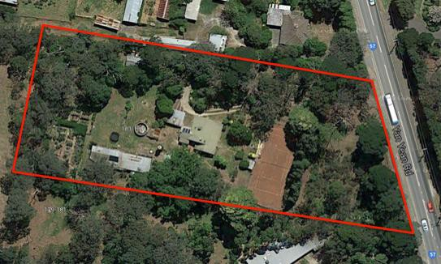

References

Advertiser (Hurstbridge), as cited.

Anon, 1912. Plenty River Estate. [cartographic material]., [Melbourne?]: [s.n.].

Argus, as cited.

Australasian, as cited.

Australian Section, Imperial General Staff, c1930, ‘Victoria, Yan Yean [cartographic material] 1:63,360 topo series’ Great Britain War Office, General Staff, State Library of Victoria (SLV) Map Collection.

Commonwealth Department of Defence Melbourne, 1920 ‘Victoria, Yan Yean [cartographic material], Australia 1:63,360 topo series’ Government Printer, State Library of Victoria (SLV) Map Collection.

Cuffley, P 1989, Australian Houses of the Twenties & Thirties, The Five Mile Press, Rowville.

HLCD Pty Ltd, 2009, ‘Shire of Nillumbik Heritage Gap Study Framework – a framework for the assessment of places of potential significance in the Shire of Nillumbik’ prepared for Nillumbik Shire Council.

Land Victoria, Certificates of Title (CT), as cited.

Mills, Peter & Westbrook, Samantha 2016, ‘Nillumbik Shire Thematic Environmental History, revision 2016’, prepared for Nillumbik Shire Council.

Morang Parish Plan

Payne, J.W. 1975. The Plenty: A centenary history of the Whittlesea Shire. Lowden Publishing, Kilmore (Vic).

Pearce, A and Plenty Historical Society. 2009. Plenty War Memorial Gates - A Short History, Plenty Historical Society, Plenty (Vic).

