Title: Plenty Heritage Park
Prepared by: Trethowan Architecture

Address: 2-6 Memorial Drive, Plenty (Lot 2 PS817427)
Name: Plenty Heritage Park, 2-6 Memorial Drive, Plenty | Survey Date: 20/1/2022
Place Type: Individual Place | Architect:
Grading: Significant | Builder:
Extent of Overlay: To Title Boundaries, | Construction Date:  Hall (1930-31, additions 2010), CFA Fire Station (1970, additions 1979,  1994), Church (1924, relocated to site 2018,  additions 2020)

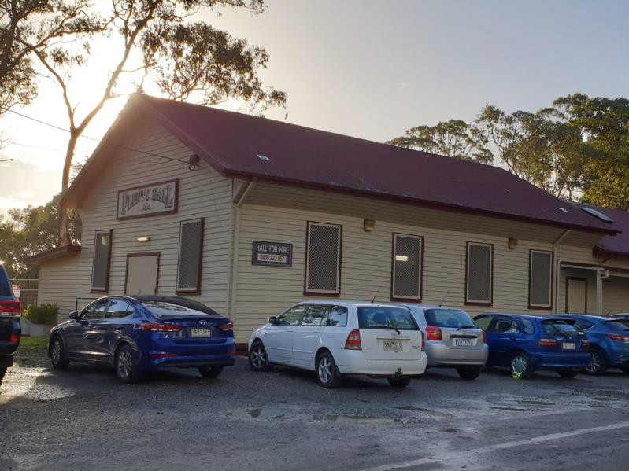
Figure 1. Plenty Hall, built 1930-31 (Source: Context June 2021).

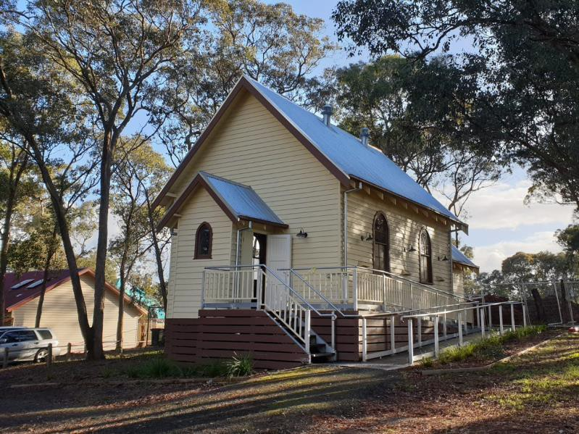
Figure 2. Plenty Methodist, later Uniting Church, built 1924, relocated to this site 2018 (Source: Context June 2021)

Historical Context

Plenty is a semi-rural district north of Greensborough, located 20 km northeast of Melbourne. The name Plenty is drawn from the nearby Plenty River, which had been proclaimed by Joseph Tice Gellibrand in 1835. Gellibrand chose the name to reflect the promising countryside of the area (Victorian Places).

In 1840, Crown land sales of the area began with blocks ranging from around 300 to 800 acres. Alexander McKillop was the first to purchase a block; Crown Portion 5 Parish of Morang constituting 820 acres. The Crown continued to auction the other blocks in 1853; Patrick Mornane obtaining Portion 3 Section 4, and L.C Luscombe purchasing 308 acres Portion 2 Section 4 (Westbrook 2016).

The settlement of the land between Plenty River and the early Yan Yean Road, (now partly Heard Avenue and partly Yan Yean Road), was gradually subdivided up until the early twentieth century. From this time the need for smallholdings increased substantially and land was divided more frequently as a result (Westbrook 2016).

This initial, ad hoc settlement pattern varies to other settlements in the Nillumbik Shire and relates to selection and the take-up of occupation licences in and around the auriferous areas. ‘Glenaulin’ on Portion 2 Section 12 of the Parish of Yan Yean further north, was subdivided into 108 2-acre lots and 72 1-acre lots advertised in early 1854. The selling of the lots, however, was unsuccessful (Westbrook 2016).

The alignment of the Greensborough Road (now Yan Yean Road) was altered from the original survey line with a series of curves to the west in 1869 (Argus, 23 June 1869:2). This new road formed a boundary for a number of subsequent subdivisions (Westbrook 2016).

Those who owned large blocks of land towards the north in Yan Yean Parish attempted ambitious early subdivisions into several smallholder blocks. Portion 2 Section 4 of Yan Yean, to the north of Plenty, was subdivided by Henry and John Cooke who advertised the blocks as, ‘Egglestone Estate’ c1885 (Westbrooke 2016).

The 1870s marked a more traditional pattern of subdivision in the area where larger blocks were divided into two or three lots. This pattern lasted up until 1900 with only few significant homesteads erected during this time.

The early twentieth century marked the height of a subdivision trend in the area. This was likely influenced by the success of smallholders, particularly orchardists, in surrounding areas such as Arthurs Creek. Leslie Woodbourne Clarke, a grazier from the Doreen property Linton Grange, is seen to have inspired this trend in 1905 having bought the northern lot of the northern half of the Crown Portion 5 and subdividing it into 9 lots from 10 to 28 acres. The first plot was purchased in 1906 and 8 had been sold by 1914, and the last selling in 1927 (CT: V3098 F446). The southern edge of the subdivision included a private road, Clarkes Road, now Worn’s Lane. This success led to an increase in subdivision in the Plenty area where most smallholdings ranged from 10 to 30 acres.

Portion 5 west of Yan Yean Road, owned by Bank of Australia Ltd (presumably the rebadged Real Estate Bank Ltd which had purchased the land in 1888) was subdivided into 17 lots of approximately 20 acres each in 1911. Browns Road provided a central dividing line for the subdivision. 14 had sold by 1916 (CT: V2020 F836).

Arthur Grenbry Outhwaite of ‘Tallarook’, Walsh St South Yarra purchased 496 acres, the section of Portion 3 Section 4 west of the Yan Yean Road, from John Butler’s executors in April 1912 (CT: V2326 F062). He subdivided his property into 40 lots immediately (CT: 3589 F730). The Lierse brothers (previously of Oatlands Road) bought the 38 acres at the western end of the subdivision in 1925, which included a number of the weekender lots (CT: V3589 F 730). When Outhwaite died in 1938, only two lots remained unsold (CT: V3589 F730).

Plenty’s new landscape was celebrated in an article in the Advertiser 1925, declaring it ‘the Toorak of the northern suburbs, where you get a panoramic view of the surrounding landscape for miles; a grand health resort, and only fifteen miles from the GPO. ’It is also notable that the area is described to be ‘thrown open for selection’ in 1913, which is likely referring to the recent surge in subdivisions, that a school had been built, that ‘fine dwellings (were) built here and there’ and the Plenty Social Club and Progress Association had formed (Hurstbridge Advertiser, 31 July 1925:4).

Plenty’s town centre was established in the 1920s when the first group of facilities was established such as the school, Methodist church and store (Westbrook 2016). In 1928-29 the Heidelberg Shire resumed 10 acres of land in Portion 2 Section 4 to create a ‘pleasure ground and place of public resort’. In May 1930, the Plenty Progress Association began to raise funds to build a hall on this new recreation reserve (Hurstbridge Advertiser, 9 May 1930:4). Tenders were called in May 1931 and the hall was opened in July 1931 (Hurstbridge Advertiser, 9 May 1930:4; 23 May 1930:1).

After World War II, additional community facilities were built. The Plenty reserve became a War Memorial Park with memorial gates, toilets, a playground and trees planted by schoolchildren on Arbour Day. (Pearce and Plenty Historical Society 2009). A fire station shed was erected on the corner of Howell Road (Westbrook 2016).

History

The subject site is on part of Crown Portion 2, Section 4, in the Parish of Morang, a 308-acre lot which was purchased by LC Luscombe in 1853 from the Crown. In 1875 a fifty-acre parcel of this land was purchased by Thomas Bennet with the land being sold again in 1888 to John Pritchard, Butcher and Thomas Bodycoat, farmer (CT: V1144 F732; CT: V2043 F454). Thomas Bodycoat became the sole proprietor of the 35 acres of the original 50-acre parcel in 1889. Thomas Bodycoat died in 1905 with the land passing to his widow Alice and Joseph, Farmer and Frederick Bodycoat, Farmer (CT: V2166 F010). It appears that up to this time the land was largely undeveloped, and may have been used for farming. In 1922 the land was purchased by orchardists Frederick and Annie Deumer (CT: V4586 F140). In 1929, the Deumer’s sold the land to Edward Jacob Cane. Cane subdivided the land, and sold the subject site to the President, Councillors and Ratepayers of the Shire of Heidelberg shortly after (CT: V2166 F536). Ownership of the site was transferred to the President and Ratepayers of the Shire of Diamond Valley in 1982 and then to the Nillumbik Shire Council in 1997 (CT: V2166 F536).
The site was recently subdivided to allow for the building of a new CFA building on its western half. Now known as the Plenty Heritage Park, 2-6 Memorial Drive, Plenty, the site incorporates the following individual elements:

• The Plenty Hall (HO248)
• Plenty Fire Station
• Bell and Time Capsule
• Former Plenty Uniting (Methodist) Church (HO250)

The Plenty Hall

The Plenty Hall (HO248), facing Memorial Drive, was constructed on the site opening in 1931. The Plenty Progress Association had held a series of fund raisers through the 1920s, collecting £700 to build the hall. The Association asked Council that they had the building inspector prepare plans for the hall in November 1930 (Plenty Historical Society Inc. 2020, Hurstbridge Advertiser 21 November 1930:6). The opening of the hall in July 1931 was marked by a large dance inside the new building Hurst Bridge Advertiser 10 July 1931:2). The Plenty Hall Trustees were first rated for the hall in 1932- 33, with an annual value of £15 (Hermes record for ‘Plenty Hall, 103-107 Yan Yean Road, Plenty’).

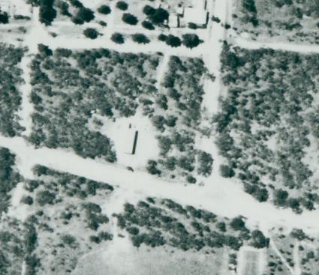

Figure 3 The Plenty Hall in 1945, circled in red. (Source: Landata)

Within a few years the hall was already proving too small, and extensions have been undertaken intermittently since, reflecting its integral position in the local community. Electricity was introduced to the area throughout the late 1940s and early 1950s, and the hall was likely to have been electrified at this time. Additions include a kitchenette and hall ceiling, a concrete toilet block added to the northwest of the hall in the 1960s (demolished 2009), weatherboard clad wings to the north (two bays since demolished) and west sides (three bays), as well as an open porch at the side entry (now demolished).

In 2010 the rear of the hall was extended, almost doubling its size. The extension included a new hall kitchen, storage areas and bathrooms. (Hermes record for ‘Plenty Hall, 103-107 Yan Yean Road, Plenty’; K Fitzmaurice, Plenty Historical Society Inc. 2020, pers. comm, 6 July 2021, Dennis Ward architects 2008).

There is a record of continued use of the hall by a variety of community organisations, including the Girl Guides who have used the site almost continuously from the mid-1960s. The local social and cricket club (one of the earliest clubs in the area established in 1946) and the Plenty Progress Association are also associated with the site. The hall has hosted regular dances and concerts, and its grounds were regularly used for large community picnics in the 1950s and 1960s. Some of the groups currently using the hall include a dancing group for disabled children, the Girl Guides and a local art group (K Fitzmaurice, Plenty Historical Society Inc., pers. comm, 6 July 2021).

Plenty Fire Station

The Plenty branch of the Country Fire Authority was formed c1961, at a time when many CFA branches were established in the area. (Mills & Westbrooke 2016:7). This date is indicated by the plaque commemorating the rededication of the cast iron bell on the corner of Yan Yean Road and Memorial Drive, which states that 2011 marked the fiftieth anniversary of the Plenty branch. Like other early CFA stations, the Plenty station was originally an iron shed (Figure 4). This building was located in what is now the car park at the corner of Howell and Yan Yean Roads (Plenty Historical Society Inc. 2012).

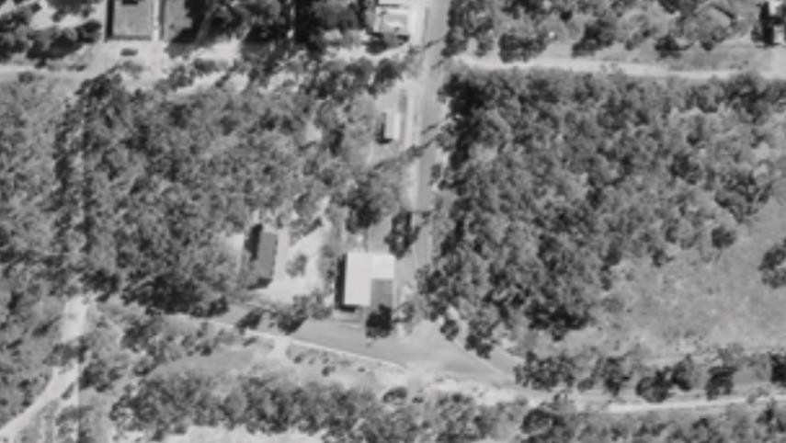

Figure 4. 1972 aerial showing the Plenty Hall outlined in red, the 1970 Plenty CFA building outlined in green, and the original tin shed used by the CFA outlined in blue (Source: Landata).

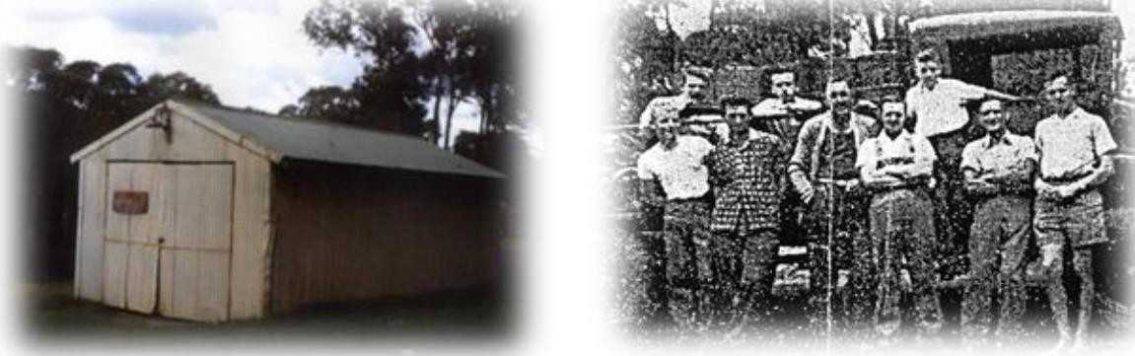

Figure 5. An image of the original Plenty Fire Station on the left (likely c1960s) and early volunteers on the right. (Source: Plenty Historical Society Inc. 2012, Plenty Heritage Walk, www.plentyhistoricalsociety.com.au)

The fire station building appears to have been completed in three stages, with the southern portion of the building being constructed first. This section of the building was opened in 1970, as commemorated on the granite plaque located on the front of this portion of the building (Figure 6). The central section of the building appears to have been added in 1979 for a cost of $9,500. The northern section, sited forward of the rest of the building, was built in 1994 for a cost of $30,000 (Shire of Diamond Valley Building Card). The latter two stages of the building are built in slightly different coloured bricks.

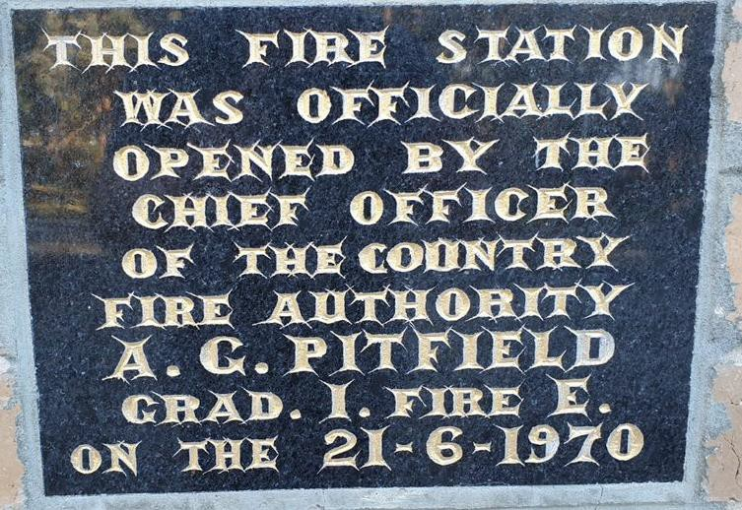

Figure 6. An image of the plaque on the front of the Plenty Fire Station, noting its opening date in 1970. (Source: Context May 2021)

In February 2009, the Plenty Brigade was involved in fighting the Black Saturday fires. These fires were one of the worst bushfires in Australian history and were responsible for the worst loss of life in the Nillumbik area.

The building has been used for various other civic and community functions. These include functions connected to local sporting clubs, serving as a polling booth, as well as providing a meeting place for the Plenty Historical Society.

In 2021, construction begun on the new Plenty Fire Station, to the north of the Plenty Hall.

Bell and Time Capsule

A time capsule was buried at the site near the corner of Yan Yean Road and Memorial Drive in c1984-85 to mark the 150th anniversary of Victoria. The capsule is set to be opened in 2034-35 (Figure 8).

In 2011, a cast iron bell (Figure 7) was rededicated at the site, and placed above the time capsule. The rededication commemorated the fiftieth anniversary of the Plenty Branch of the Country Fire Authority. Discussions with the Plenty Historical Society indicate that the bell was originally located at Larundel Mental Asylum in Plenty Road, Bundoora. The Bell was relocated to the Upton’s property in Browns Lane, Plenty in the 1940s and was rung in conjunction with a siren on the shop in Yan Yean Road to warn of fires. It is thought that the bell was moved to its current location in 1984-5 when the time capsule was buried. This coincided with the closure of the Plenty State School (HO213) in Howell Road.

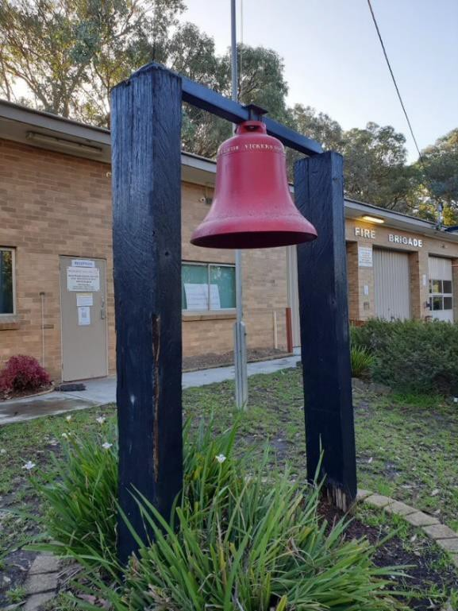 | 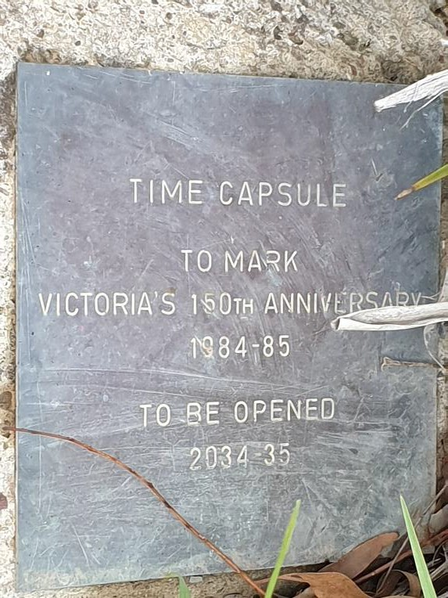
Figure 7. Cast Iron Fire Bell outside the Plenty  CFA Fire Station. (Source: Context May 2021) | Figure 8. Time Capsule underneath the Fire Bell outside the Plenty CFA Fire Station (Source: Context May 2021)

Former Plenty Uniting (Methodist) Church

Originally built for Methodist worship, the Plenty Uniting Church was erected at 171 Yan Yean Road, Plenty (near the corner of River Avenue) in 1924 (Figure 9). The parcel of land, part of Crown Portion 3 Section 4 in the Parish of Morang, County of Evelyn, was part of a larger property of sixteen acres owned by farmer Alfred Hill, who purchased it in 1919 (CT: V4189 F837625). He later subdivided the land, becoming one of nine joint proprietors of the existing land parcel, Lot 3, Subdivision No. 6039, in November 1925 (CT: V5065 F1012881).
The church was built with funds raised by local Methodists, encouraged by the Victorian Methodist Church offer of £50 to communities who could raise £100 to put towards construction costs (History Victoria 2018). Aside from worship, the church hosted local events including weddings, harvest festivals, Sunday School and gatherings (Hurstbridge Advertiser, 28 March 1930:2, 17 May 1935:5 and 31 May 1935:5). The building was extended on the west side in 1967.

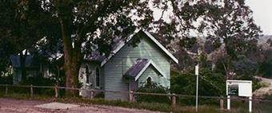
Figure 9. Former Plenty Uniting (Methodist) Church at its original location in Yan Yean Road. (Source: Yarra Plenty Regional Library)

In 1977 the church became part of the Uniting Church in Australia. The church was closed in 1985 and was later used as an artist’s residence and then a gift shop (Hermes record for ‘Plenty Methodist, later Uniting Church’). The church building was included in the Heritage Overlay as HO250 in 2009, with the following statement of significance:

Plenty Methodist, later Uniting Church is significant for its long association with religious community gatherings and activities in the Plenty farming area, since its construction in the 1920s, and one of a group of much valued civic structures in the immediate area.

The building was subsequently acquired from the Uniting Church by the Major Roads Projects Authority. It was relocated to its present site, north of the Fire Station in the Plenty Heritage Park in Memorial Drive, Plenty, in September 2018 (Figure 10). The relocation was necessitated by the reconstruction of the Yan Yean Road, and was undertaken following a review and heritage assessment by an independent panel (McCullough, T & Walters 2012).

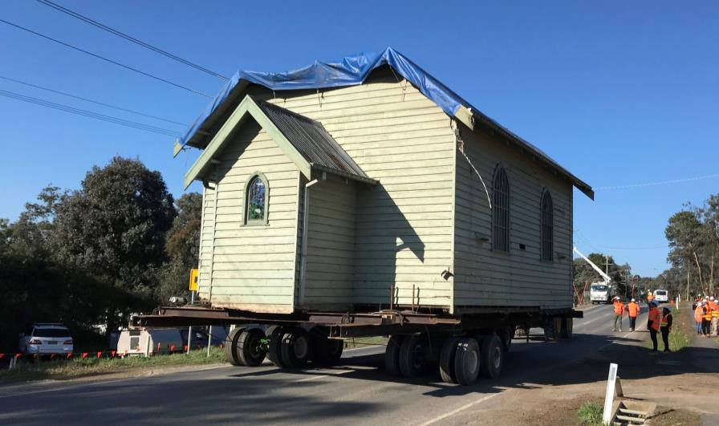
Figure 10. The former Plenty Methodist Church being relocated from its original site at 171 Yan Yean Road, Plenty to its current location on 12 September 2018 (Source: www.rbaarchitects.com.au accessed July 2021)

As part of its relocation the church building has been restored. Skillion additions made to the west side of the church in 1967 have been removed and the roof was reclad in corrugated galvanised iron, four new cylindrical roof vents were also installed. Changes to the building in 2020 have included the relocation of the entry doors from the south side to the north side of the porch, the addition of a disabled ramp along the northern side of the building and the addition of a lower gabled roofed section at the rear of the original 1924 church.

The building is available for community use and is the home of the Plenty Historical Society who campaigned for its protection (Plenty Historical Society Inc. 2020).

Description & Integrity

The Plenty Hall, Plenty CFA Building and Plenty Methodist (later Uniting) Church are located within the Plenty Heritage Park at 2-6 Memorial Drive, Plenty. The site is bound by Howell Road to the north, Yan Yean Road to the east, Memorial Drive to the south and extends through to Butlers Road at the corner of Howell Road. The site falls north to south and is largely gravelled, providing car and pedestrian access to the site from both Memorial Drive and Yan Yean Road. The site is characterised by unstructured plantings of Australian native trees which provides an informal bush setting for the buildings. The site is largely unfenced with the exception of a low timber post and rail fence enclosing a small lawned garden area at the corner of Yan Yean Road and Memorial Drive, and a high cyclone wire fence that encloses a utility area at the back of the CFA building.

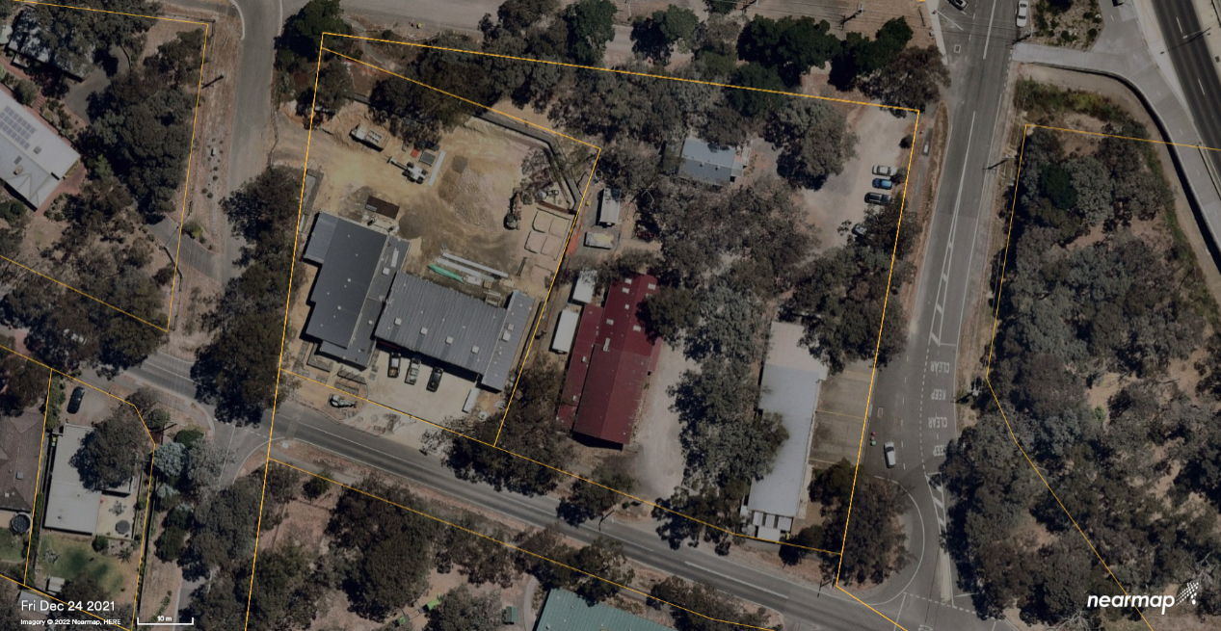
Figure 11. Map of the now subdivided site at 2-10 Memorial Drive, Plenty. The Plenty Fire Station is highlighted in red, the location of the bell and time capsule is highlighted in yellow. The Plenty Hall is highlighted in blue; the former Methodist (later Uniting) Church in green. Note, the area to the west of the Plenty Hall is the location for the new CFA building. At the time of a site inspection on 22 January 2022 the site works for the new building had commenced. (Source: Nearmap 24 December 2021, with property boundaries shown in yellow)

The Plenty Hall (c1931)

The Plenty Hall is single storey bullnose weatherboard building located along Memorial Drive midway between Yan Yean Road and Butlers Road. The building is rectangular in plan with a gable Colourbond corrugated iron roof with several skylights penetrating the rear section of the roof.

The building was constructed in two main stages. The taller front section of the building facing Memorial Drive is the original Hall building constructed in 1930. The lower rear section is an addition built in 2010. The front section of the building is distinguished by its unusual, chamfered eaves lined with open timber slats. The later addition has standard boxed eaves.

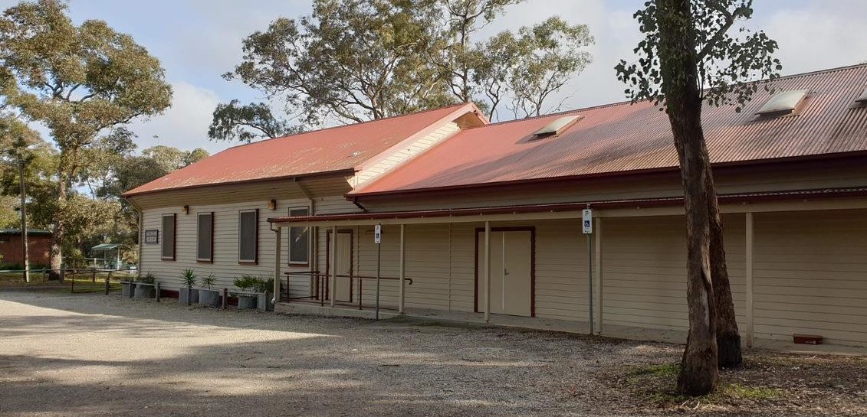
Figure 12. Eastern elevation of the Plenty Hall showing the taller original building built in 1930-31 and the lower extension added in 2010. (Source: Context June 2021).

Skillion roofed additions that sit below the gutter line run along three quarters of the western face of the hall and a verandah runs along the eastern façade to the northern half of the building.

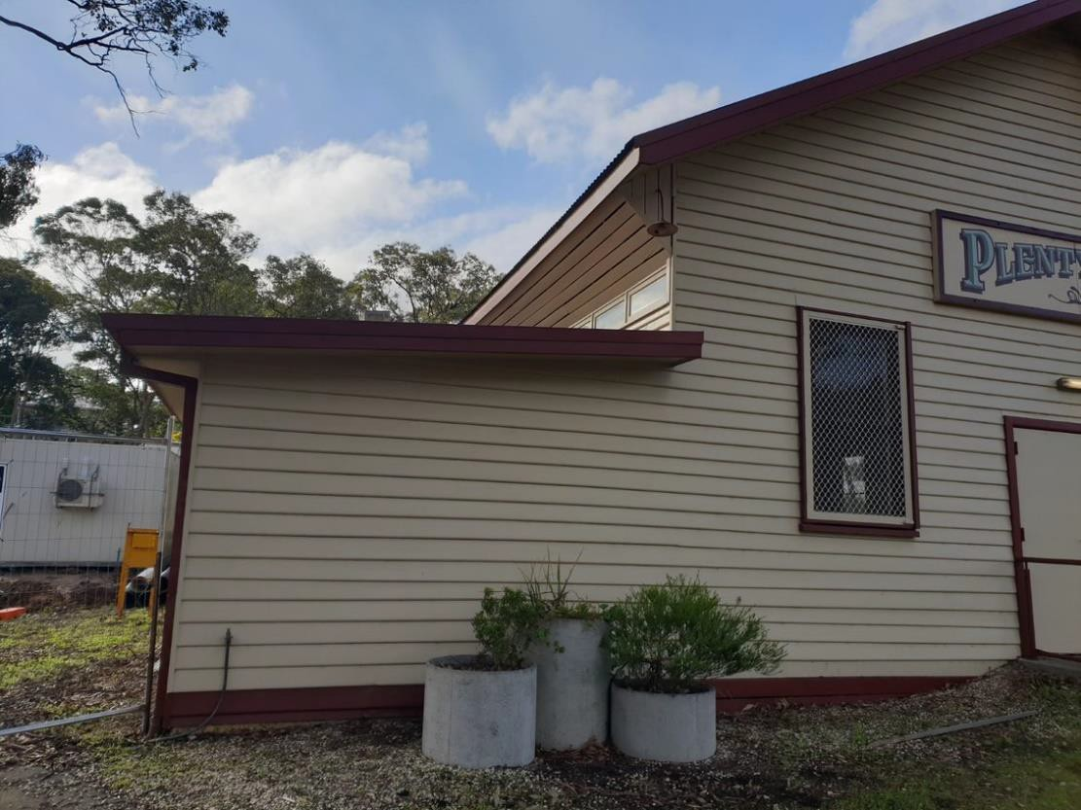
Figure 13. South west corner of the Plenty Hall showing the skillin roofed additions along the building western side. Note the chamfered open slatted eave detail of the original Hall building. (Source: Context June 2021)

The principal elevation facing Memorial Drive is symmetrically arranged with vertical timber double hung sash windows either side of a pair of flush panel doors. Access to the building is via a concrete ramp with a painted tubular steel balustrade. A large sign attached to the wall above the doors reads ‘PLENTY HALL’.

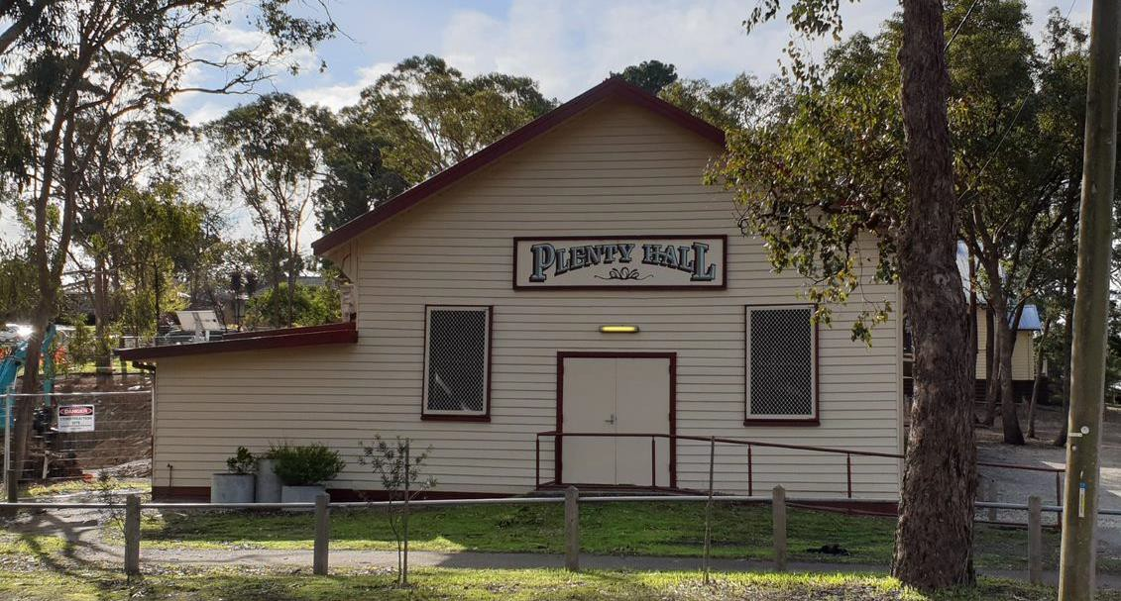
Figure 14. Principal elevation of the Plenty Hall facing Memorial Drive, Plenty. (Source: Context May 2021).

Along the eastern elevation there are four equally spaced vertical timber framed sash window and a single timber panelled door on the front section of the building. There are a pair of flush panel doors under the verandah of the rear section. The western elevation is utilitarian in nature with high horizontal windows that provide light and ventilation to the service area of the building.

The Plenty CFA Fire Station (1970)

The Plenty CFA Fire Station is located in the southeast of the site, near the corner of Yan Yean Road and Memorial Drive.

The building is a utilitarian single storey rectilinear building constructed in beige-coloured brick. Its function as a fire station has dictated its overall form. It has a simple corrugated iron clad skillion roof which falls east to west.

The eastern elevation, facing Yan Yean Road, is the building’s principal façade. This elevation contains the main pedestrian entry, as well as four large entries for fire trucks. The building projects forward at its northern end, housing a tall double-width garage door with inset glazed upper panes. Three further single-width garage doors are centrally located on this elevation: are solid and one is inset with glazed upper panes. Between the two solid doors a small granite plaque is set into the wall noting its official opening in 1970. To the south of this elevation, a glazed door is placed between two natural aluminium framed windows. ‘Plenty Fire Brigade’ is visible in white lettering above the two solid garage doors.

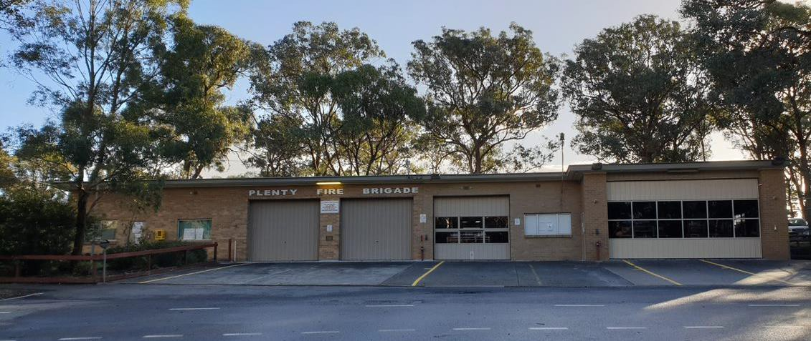
Figure 15. Principal elevation of the Plenty CFA Fire Station facing Yan Yean Road. (Source: Context May 2021)

The northern elevation has a centrally set window. The southern elevation has had a verandah added. The western elevation is predominantly face brick, with various small windows. All windows are framed in natural aluminium and are functional in purpose providing light and ventilation to the
service areas of the building.

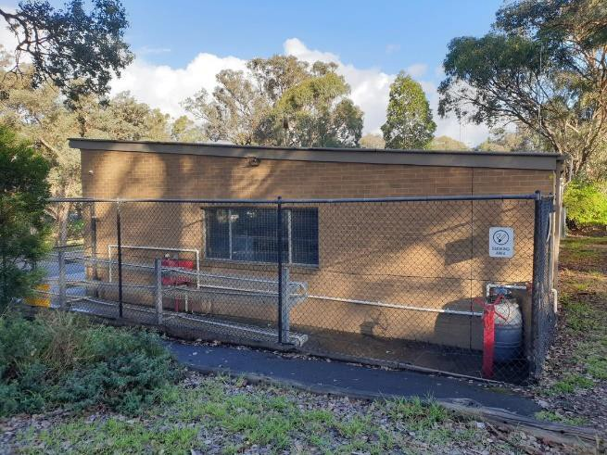 | 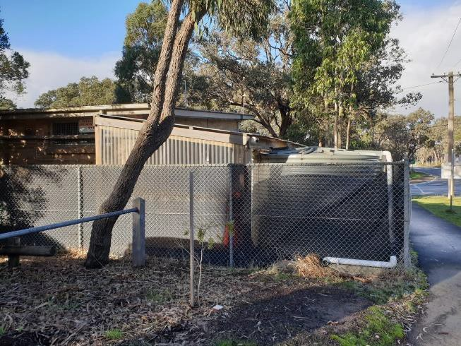
Figure 16. North elevation of the Plenty CFA Fire Station. (Source: Context May 2021) | Figure 17. Southeast corner of the Plenty CFA Fire Station showing the addition of a pergola structure. (Source: Context May 2021).

Bell and Time Capsule

A small area of garden located on the corner of Memorial Drive and Yan Yean Road is set behind a low post and rail timber fence. A cast iron fire bell is located within this garden. The bell is painted red and set on a simple frame of dark stained timber. A small metal plaque on this frame commemorates the rededication of the bell in 2011 to mark the Plenty CFA’s fiftieth anniversary. Around the top of the bell are cast the letters reading Vickers Sons & co Limited Sheffield 1875 Patent Cast Steel 6316. A time capsule was buried under the bell in c1984-85 to mark the 150th anniversary of Victoria.

Former Plenty Methodist (later Uniting) Church (1924, relocated to this site 2018)

The former Plenty Methodist Church is located towards the northern end of the site behind the Plenty Hall. The building faces Yan Yean Road and is set back a distance from the road allowing for a gravel carpark in front. The relocated church is positioned on the highest point of the land and elevated on concrete stumps (concealed by open timber base boards). It is a simple rectangular weatherboard building with a steeply pitched galvanised corrugated iron gable roof with exposed rafter ends and four cylindrical roof vents, pointed window openings and projecting front vestibule. These features are characteristic of the interwar Carpenter Gothic style.

The building has been constructed in two sections, with the front taller section being the original church built in 1924 and the rear section being added in 2020. The original section of the building features two pointed arched opening on its northern and southern elevations. These openings are fitted with timber double hung sash windows. The bottom sashes are divided into four and are glazed with opaque ripple glass. The top sections are divided into six clear glazed panes centred on a stylised Y-shaped tracery element. Along the southern elevation towards the rear of the original church building is a single vertical boarded door that is elevated above the ground. A disabled ramp and timber steps have been added to the northern side of the building, these provide access to a pair of vertically boarded doors on the northern side of the front projecting vestibule. The rear, lower addition to the church has been built to mimic the detailing of the original building with a steeply pitched gable roof, exposed rafter ends and a timber slated air vent on the gable end.

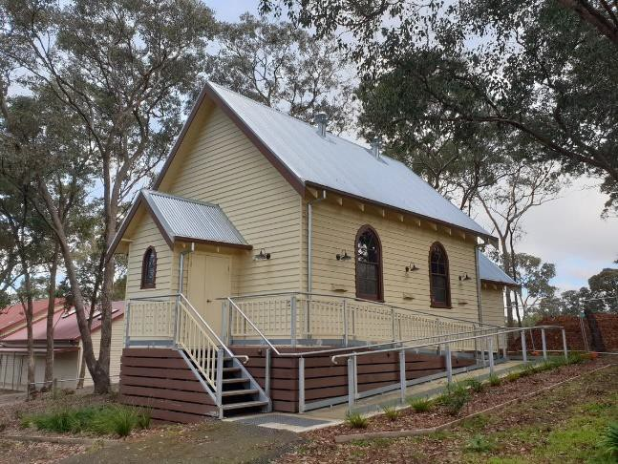 | 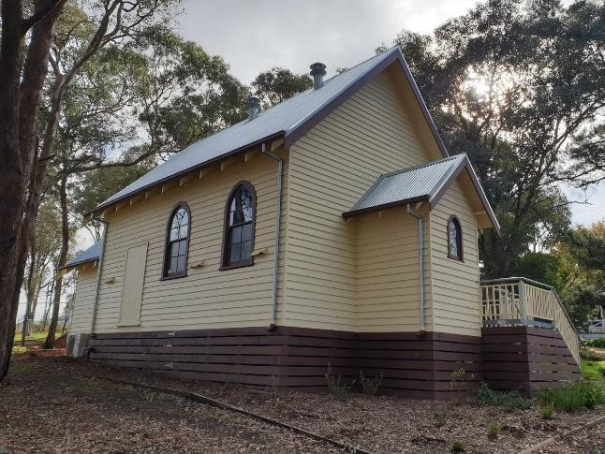
Figure 18. Relocated former Plenty Methodist (later Uniting) Church showing northern elevation and the entry vestibule. Note the lower rear section of the building was added in 2020. Source: Context June 2021). | Figure 19. Relocated former Plenty Methodist (later Uniting) Church showing southern elevation. (Source: Context June 2021).

The Plenty Hall at 2-6 Memorial Drive, Plenty is largely intact with some changes visible to original or early fabric. The building’s original gable roofed form as built in 1930 remains clearly legible. The building retains its original pattern of openings and window joinery. Changes to the building include the addition of skillion roofed sections to the western elevation and a large gabled roof addition at its northern end in 2010. These additions are clear identifiable leaving the original hall building clearly legible.
The Plenty Fire Station at 2-6 Memorial Drive, Plenty is largely intact with some changes visible to original or early fabric. The buildings original built form as built in 1970 is still legible and retains it skillion roofed form and pattern of window and door openings that retain their original fittings.

Changes to the building include two additions to its northern end (1979 and 1994) that doubled the size of the building. These additions have been designed to seamlessly merge with the earlier section of the building although they have used a different colour brick making the early section of the building clearly distinguishable.

The former Plenty Methodist (later Uniting) Church at 2-6 Memorial Drive is largely intact with some changes visible to original or early fabric. The buildings original 1924 gable roofed form with projecting gable roofed entry vestibule remains clearly legible. The building retains its original pattern of pointed arch window openings and joinery. Changes include the moving of the entry doors from the southern side to the northern side of the entry vestibule, construction of a ramp and steps along the northern side of the building, recladding of the roof with galvanised corrugated iron and a gable roofed addition to its western end in 2020. These additions are clear identifiable leaving the original church building clearly legible. While the building has been relocated to this site in 2018 this site is only 430 meters from its original location and retains the original bush setting of the building.

Comparative Analysis

Church buildings

Churches played an important role in the lives of early settlers to the Shire, becoming the centre of the spiritual and social lives of communities. Many miners who came to Victoria were of Protestant, nonconformist background and, as a result, many of the earliest churches in the former goldmining towns in the shire were Methodist. Eltham and Diamond Creek are noted as being one of the earliest areas in Victoria to establish primitive Methodist churches with services conducted out of a home in Eltham in 1850 (Mills & Westbrooke 2017). The first Wesleyan Church was built on the corner of Susan and Bridge streets, Eltham in 1860. The Diamond Creek community built a small chapel in 1861 and a Nillumbik church was built in 1871. Other congregations followed soon after. In some situations, due to the small and fluctuating population of a district, the church was constructed many years after a congregation was present. In the interim, other community buildings were used for services until a township was stably established (Mills & Westbrooke 2017).

There are only eight other churches represented on the Shire of Nillumbik’s Heritage Overlay. Of these, four date from the nineteenth century (St Margaret’s Anglican Church, Eltham c1860-1 (HO154); St Andrew’s Anglican Church, St Andrews c1868 (HO21); Presbyterian Church, Kangaroo Ground (HO46); Uniting Church, originally Methodist Church, Eltham 1880 (HO118). Two date from the early twentieth century (St Matthews Church, Hall, War Memorial and Plantings, Panton Hill c1900-1920s (HO96); Hurstbridge Uniting Church and Hall originally Methodist Church, Hurstbridge (1925 HO60). One dates from the 1950s (St Michaels Anglican Church, Yarrambat 1954 (HO219) and one dates from the 1970s (St Peters Anglican Church’, Hurstbridge c1970s (HO62).

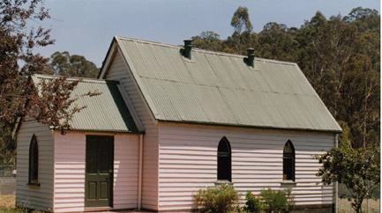  Figure 20. St Andrews Anglican Church 15 Caledonia Street, St Andrews c1868 (HO21 Shire of Nillumbik). | 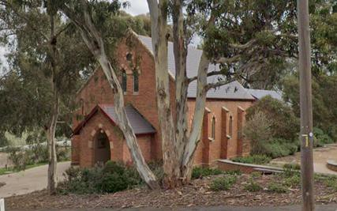  Figure 21. Presbyterian Church 265 Eltham-Yarra Glen Road, Kangaroo Ground c1878 (HO46 Shire of Nillumbik)
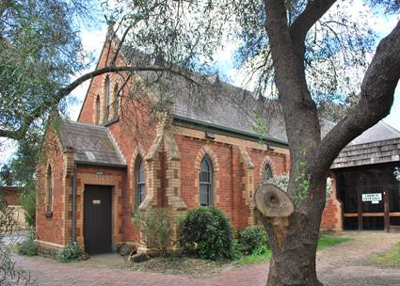  Figure 22. Uniting Church (originally Methodist) 810 Main Road, Eltham 1880 (HO118 Shire of Nillumbik) | 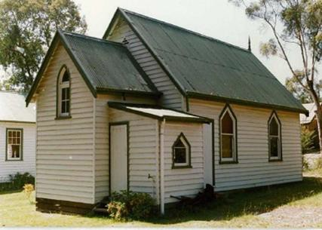  Figure 23. St Matthews Church 575 Kangaroo Ground-St Andrews Road, Panton Hill c1900-1920s (HO96 Shire of Nillumbik)
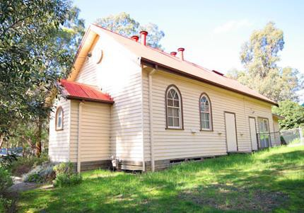  Figure 24. Hurstbridge Uniting Church and hall (originally Methodist) 998 Heidelberg-Kinglake Road, Hurstbridge c1925 (HO60 Shire of Nillumbik). | 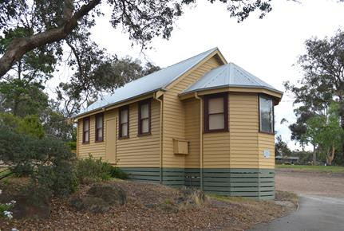  Figure 25. St Michaels Anglican Church 469-475 Ironbark Road, Yarrambat 1954 (HO219 Shire of Nillumbik)

While built much earlier than the Plenty Methodist Church, the St Andrew’s Anglican Church (HO21), the Kangaroo Ground Presbyterian Church, (HO46) and the Eltham Uniting Church (HO118) all have a similar built form and scale to the subject site and are also designed in the Carpenter Gothic style.

The Carpenter Gothic style was used for churches of modest size, commonly in country areas when the economy and simplicity of construction was important. This style followed through from the Victorian to Federation eras and into the interwar years. The most directly comparable to the subject site is St Andrews Anglican Church (HO28) built in 1868. It is of timber construction and has an almost identical form with simple pointed arch openings.

Although larger in scale the most comparable church on the Heritage Overlay to the subject building is the Hurstbridge Uniting Church (HO60). Built in the same year (1925) for the Methodist Church, both buildings having a similar Carpenter Gothic form with pointed arch windows divided into panes that form a stylised Y-shaped tracery in the upper sashes. St Mathews Church, Panton Hill (HO96) is also of a similar scale, materiality and style to the subject church building although it was built earlier. It is interesting to note that St Michael’s Anglican Church, Yarrambat (HO219) is still employing a Carpenter Gothic form in 1954.

What all these churches share is there historical, social and spiritual importance to fledgling communities as they established themselves within the district.

Community Halls

The earliest halls in the Nillumbik area usually took the form of mechanics’ institutes and free libraries. The mechanics’ institute movement started in Scotland in 1800 with the intention of improving the education of working men (Mills & Westbrooke 2017). Several of these early halls were either destroyed by fire or demolished over time. For example, the Diamond Creek Public Hall and Literary Institute was possibly the earliest hall in the area, opening in 1868. The hall was used to house the infant grades of the state school when there was a rapid increase of pupils in the early 1870s (Mills & Westbrooke 2016:103). A new hall incorporating sections of the old was built in 1905 however this building was destroyed by fire in 1969 (Mills & Westbrooke 2017). At Kangaroo Ground a hall, which became known as Stevenson Hall after its builder, was built in 1885. It did not have a library, but did host the typical list of entertainments and meetings and was noted for its good dance floor. The Shire ordered the demolition of the dilapidated hall in 1969. (Mills & Westbrooke 2017)

Surviving community halls in the Shire include:

- Christmas Hills Mechanics Institute, 775 – 787 Ridge Road, Christmas Hills, rebuilt in 2013 (HO243)
- St Andrews Hall, 1 Proctor Street, St Andrews 1925
- Arthurs Creek Mechanics Institute, 906 Arthurs Creek road, Arthurs Creek
- Gibson Hall, 575 Kangaroo Ground-St Andrews Road, Panton Hill c1924 (HO96).

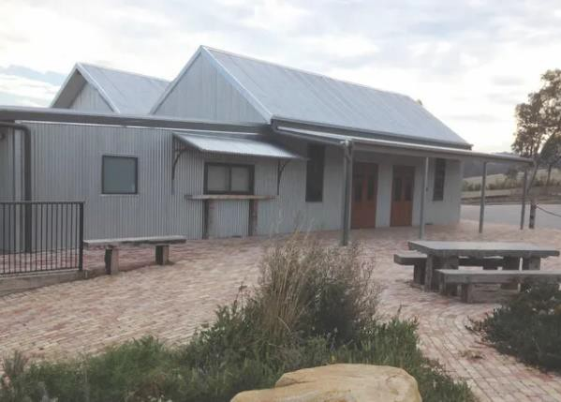  Figure 20. Christmas Hills Mechanics Institute, 775 – 787 Ridge Road, Christmas Hills rebuilt in 2013 (HO243 Shire of Nillumbik). Source: https://christmashillshall.org.au/ | 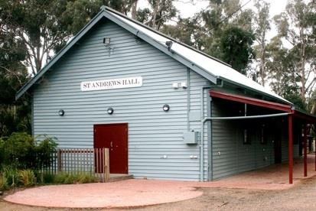  Figure 21. St Andrews Hall, 1 Proctor Street, St Andrews built 1925. Source: https://www.standrewscommunitycentre.org/history-of-st- andrews-hall.html
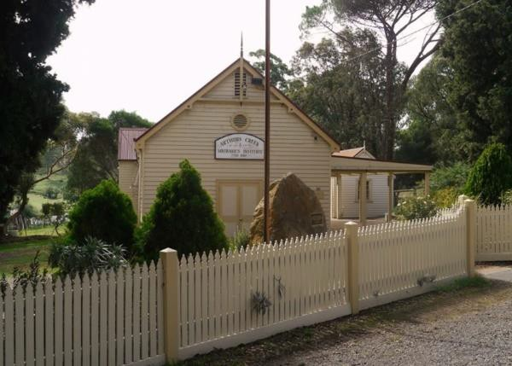  Figure 22. Arthurs Creek Mechanics Institute, 906 Arthurs Creek road, Arthurs Creek Source: https://www.creativespaces.net.au/space/arthur s-creek-mechanics-institute-inc | 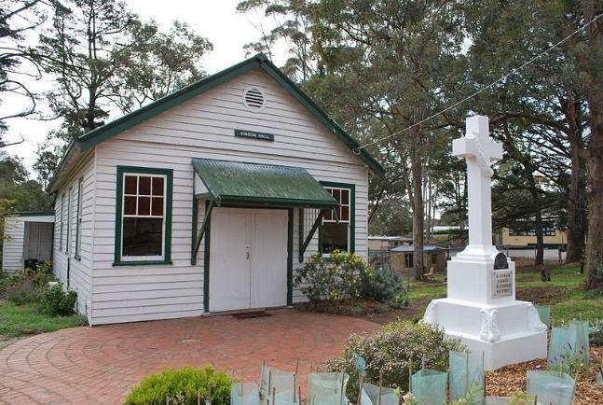  Figure 23. Gibson Hall, 575 Kangaroo Ground-St Andrews Road, Panton Hill built in c1924 (HO96). Source: https://commons.wikimedia.org/wiki/File:PantonHillGibsonH all.JPG

The Christmas Hills Mechanics’ Institute and Free Library (HO243) opened in 1877. It was funded partly by public donations and partly by a government grant and was located on a temporary Crown land reserve (Mills & Westbrooke 2017). Destroyed by fire in 1894, the hall was rebuilt on its current site in 1895 and again in 2013. Other than the subject building this is the only hall on the Shire of Nillumbik’s Heritage Overlay. Although still in use as a hall this building is not directly comparable to the Plenty Hall as it was rebuilt in 2013.

Fundraising for the Queenstown Mechanics’ Institute and Free Library started in 1882 with the building opening in 1883. In 1889 the building was moved to a more central position in the town, as it had been too inaccessible. The institute was reopened in 1899 and was an important part of the community until 1924 when it was destroyed by fire. It was rebuilt in 1925 at its current location and is now known as the St Andrews Hall (Mills & Westbrooke 2017). It is most comparable to the Plenty Hall for its interwar build date and for being of a similar materiality and form.

Tenders for the erection of a mechanics’ institute and library at Arthurs Creek were let in 1887 by architect Edgar J Henderson. The Institute was opened in September of that year (Mills & Westbrooke 2017). The hall is still in use. Although of a much earlier build date this hall is somewhat comparable to the subject building for its materiality and form and for being in continual use as a community hall.

There is also a small timber hall building adjacent to the St Matthews Church at 575 Kangaroo Ground-St Andrews Road, Panton Hill. Known as Gibson Hall and built in c1924 the building is within the curtilage of HO96 and is comparable to the Plenty Hall having a similar materiality, form and interwar build date. Like the subject building it has also been in continual use as a hall since built.

Compared to the above examples The Plenty Hall is a rare surviving purpose-built community timber hall that has been in continual for 90 years without being destroyed by fire and re-built or significantly altered.

CFA Fire Stations

In the early twentieth century there was little organised firefighting in the Nillumbik area. Bush fire brigades were established throughout Victoria in the aftermath of the Black Sunday 1926 fires. The Panton Hill and Diamond Creek bush fire brigades were both formed in 1927 (Advertiser (Hurstbridge), 16 September 1927:33; 21 December 1928:2). The Eltham town brigade, formed in 1926, often helped in bush firefighting in surrounding areas outside of the town itself. Few buildings relating to firefighting survive from the pre-World War II period. Small towns and settlements have always made varied use of their few public buildings, and this extended to a range of activities concerning fire management. Public meetings to call for the formation of fire brigades were often held in halls after fires. These halls where also used for public meetings held to organise the raising of money for victims of the fires and fundraising concerts and balls were held in the same venues.

In the aftermath of the Black Friday bushfires of 1939 additional fire brigades were established within Nillumbik. The Hurstbridge, Panton Hill and St Andrews bushfire brigades were all formed around 1939 and the Diamond Creek bush fire brigade was formed in November 1940. When the Country Fire Authority (CFA) was established in 1945, volunteer bush fire brigades became the basis of bushfire fighting in Victoria. The CFA soon began to provide new equipment for brigades, including trucks, and corrugated iron sheds to house them.

There are several CFA fire stations in the Shire of Nillumbik. The majority of these Fire Stations appear to have been built after the 1950s, with some more recent station buildings, such as that at Diamond Creek. Fire stations are a utilitarian typology, designed to respond to their function. They are often altered to meet changing demands faced by emergency services.

To date, no fire station building has been included on the Shire of Nillumbik Heritage Overlay. The fire bell, located at the Eltham CFA Fire Station at 909 Main Road, Eltham, has been included as HO129.

The following CFA Fire Stations are comparable to the subject site for their post-war build dates and their utilitarian single storey rectilinear built form where the function of the building as a fire station has dictated their design:

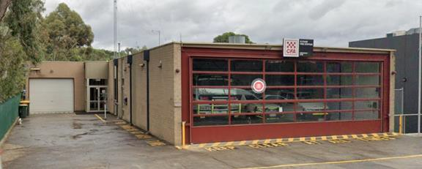  Figure 26. Eltham CFA Fire Station, 909 Main Road, Eltham. (Source: Google maps) | 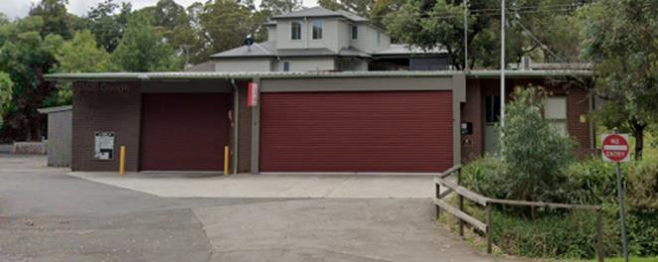  Figure 27. Kangaroo Ground CFA Fire Station, 50 Kangaroo Ground- St Andrews Road, Kangaroo Ground. (Source: Google Maps)
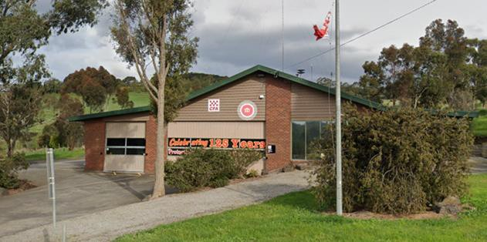  Figure 28. Research CFA Fire Station, 3 Research-Warrandyte Road, Research. (Source: Google Maps) | 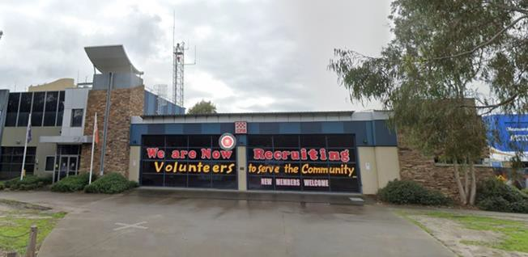  Figure 29 Diamond Creek CFA Fire Station, 83 Main Hurstbridge Road, Diamond Creek. (Source: Google Maps)
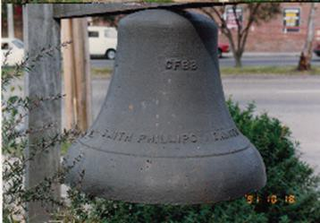

Figure 30. Eltham CFA Fire Station (left) and bell (right). (Source: Hermes)

Country Fire Authority fire stations have been included on Heritage Overlays outside the Shire of Nillumbik. However, these building tend to be of an earlier construction date, pre World-War II, and are not directly comparable.

The Plenty Fire Station is distinguished from the Nillumbik example above by its inclusion within a civic precinct that forms the centre of the town of Plenty. The building’s location on a prominent corner within this precinct setting highlights the importance of fire service in towns in the Shire of Nillumbik.

Catastrophic events like the 2009 Black Saturday bushfires form the basis of a strong and enduring collective memory for those in the area. The Plenty Fire Station would have played a pivotal role in protecting the township during that time. Further, the nearby proximity of the Plenty Hall is important, due to the known community connections between public halls and fire stations in times of crisis in the Shire. The volunteer nature of the organisation also provides a close tie to the local community.

Conclusion

As a collection of buildings on a site that has been in Council ownership since 1929, the Plenty Hall, Plenty CFA Fire Station and relocated former Plenty Methodist (later Uniting) Church are significant for the tangible evidence they provide of the early settlement and growth of the township of Plenty. This is reinforced by the site close proximity to Plenty High School site (HO213) at 17 Howell Road and the Plenty War Memorial Gates (HO249) at 109-115B Yan Yean Road, in this way the group of buildings is comparable to a number of other early groups of buildings in the Shire that form civic precincts. These include those at Kangaroo Ground which includes the Presbyterian Church (HO46), State School (HO47) and General Store and Post Office (HO48), those at Panton Hill which include the St Matthews Church and Memorial Cross (HO96), Panton Hill Primary School and Maud Rattray Memorial Bell (HO97) and the Panton Hill Primary School residence (HO98) and those at St Andrews which include a shop and residence (HO18), St Andrews Hotel (HO19), St Andrews State School (HO20) and St Andrews Anglican Church (HO21).

Assessment Against Criteria

Criteria referred to in Practice Note 1: Applying the Heritage Overlay, Department of Planning and Community Development, revised July 2015, modified for the local context.

CRITERION A: Importance to the course or pattern of the Shire of Nillumbik’s cultural or natural history (historical significance).
Taken together, the buildings on the site demonstrate a strong and clear connection to important themes in the history of the Shire. These include the story of living with natural processes, particularly fire, in the municipality (the former fire station and bell). The church and hall relate strongly to the theme of building community life, particularly maintaining spiritual life (the former church) and establishing meeting places (the hall).

The informal bush character that is distinguished by its natural topography, unstructured plantings of indigenous trees and unpaved, gravelled surfaces with no kerbing, also contributes to the setting of the place, evoking the original settings of the buildings that have been moved.

CRITERION B: Possession of uncommon, rare or endangered aspects of the Shire of Nillumbik’s cultural or natural history (rarity).

CRITERION C: Potential to yield information that will contribute to an understanding of the Shire of Nillumbik’s cultural or natural history (research potential).

CRITERION D: Importance in demonstrating the principal characteristics of a class of cultural or natural places or environments (representativeness).

The Plenty Hall is of representative (architectural) significance. It is a largely intact, highly representative example of a utilitarian timber community hall built in the interwar period. It is characterised by its simple rectangular plan with corrugated iron gable roof and double hung timber sash windows and double door openings. Of note are the unusually detailed chamfered timber slated eaves. Similarly, the former Methodist (later Uniting) Church building is a largely intact, highly representative example of a country interwar timber church. It is characterised by its simple rectangular plan with a steeply pitched galvanised corrugated iron gable roof with exposed rafter ends and four cylindrical roof vents, pointed window openings and projecting front vestibule. These features are characteristic of the interwar Carpenter Gothic style.

CRITERION E: Importance in exhibiting particular aesthetic characteristics (aesthetic significance).

CRITERION F: Importance in demonstrating a high degree of creative or technical achievement at a particular period (technical significance).

CRITERION G: Strong or special association with a particular community or cultural group for social, cultural or spiritual reasons. This includes the significance of a place to Indigenous peoples as part of their continuing and developing cultural traditions (social significance).

The Plenty Heritage Park has a long and continuing associations with the local Plenty community, and specific local groups within the broader community, including the CFA, Plenty Cricket Club, Plenty Girl Guides and Plenty Historical Society. The site as a whole has played an ongoing role in the social life of the local Plenty community since 1931, when the hall opened.

CRITERION H: Special association with the life or works of a person, or group of persons, of importance in the Shire of Nillumbik’s history (associative significance).

Grading and Recommendations

Recommended for inclusion in the schedule to the Heritage Overlay of the Nillumbik Planning Scheme.

Recommendations for the Schedule to the Heritage Overlay (Clause 43.01) in the Nillumbik Planning Scheme:

External Paint Controls  Is a permit required to paint an already painted surface? | No
Internal Alteration Controls  Is a permit required for internal alterations? | No
Tree Controls  Is a permit required to remove a tree? | No
Victorian Heritage Register  Is the place included on the Victorian Heritage Register? | No
Incorporated Plan  Does an Incorporated Plan apply to the site? | No
Outbuildings and fences exemptions  Are there outbuildings and fences which are not exempt from notice and review? | No
Prohibited uses may be permitted  Can a permit be granted to use the place for a use which would otherwise be prohibited? | Yes
Aboriginal Heritage Place  Is the place an Aboriginal heritage place which is subject to the requirements of the Aboriginal Heritage Act 2006? | No

Identified By

Samantha Westbrooke Pty Ltd, Context Pty Ltd

References

Argus, as cited

Benson, C Irving. 1935, A century of Victorian Methodism Spectator Pub. Co, Melbourne viewed 8 July 2021 http://nla.gov.au/nla.obj-30074952

Country Fire Authority (CFA) 2021, History Timeline, www.cfa.vic.gov.au. Fitzmaurice, Kerry, (Plenty Historical Society), personal communication, 6 July 2021.

Hermes record for ‘Plenty Hall, 103-107 Yan Yean Road, Plenty’, Nillumbik Shire, accessed 6 July 2021.

Hermes record for ‘Plenty Methodist, later Uniting Church’, Nillumbik Shire, accessed 6 July 2021.

History Victoria 2018, Plenty Historical Society Inc., https://www.historyvictoria.org.au/directory/listing/ plenty-historical-society-inc.
Hurstbridge Advertiser, as cited.

Mills, Peter & Westbrooke, Samantha 2017, ‘Nillumbik Shire Thematic Environmental History - Revision 2016’, prepared for Nillumbik Shire Council.

Plenty Historical Society Incorporated 2012, Plenty Heritage Walk, www.plentyhistoricalsociety.com.

Plenty Historical Society Incorporated 2020, Plenty Historical Society, https://plentyhistoricalsociety.com/.

McCullough, T & Walters 2012, I, Nillumbik Planning Scheme Amendment C67 – Yan Yean Road Duplication, Panel Report, prepared for the Shire of Nillumbik.

Land Victoria, Certificates of Title (CT), as cited.

Westbrook, S. 2016, Draft Heritage Citation, House, Farm, 14 Browns Lane, Plenty, prepared for Shire of Nillumbik

