57 Thompson Crescent, Research

House
Prepared by: Context | Survey date: February 2021
Place type: Residential | Designer: -
Significance level: Significant | Builder: Not known
Extent of overlay: To title boundaries | Major construction: c1984
Figure 1. 57 Thompson Crescent, Research. (Source: Context 2021)
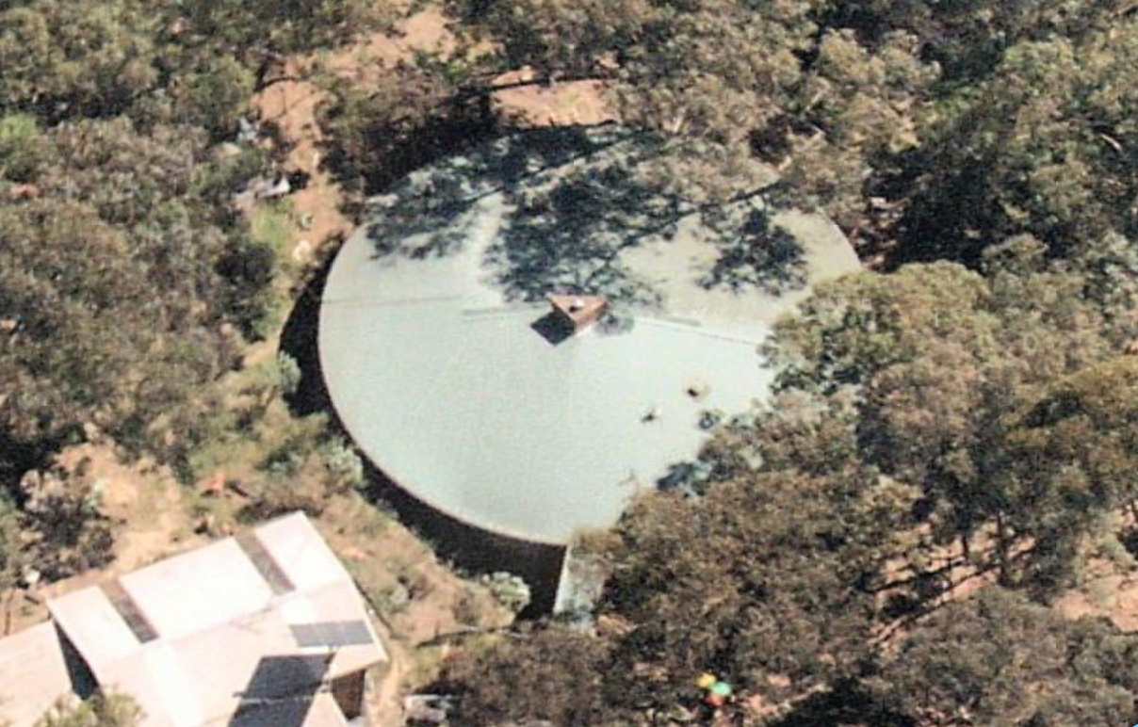
Figure 2. 57 Thompson Crescent, Research. (Source: Nearmap, November 2020)

HISTORICAL CONTEXT
This place is associated with the following historic themes taken from the Nillumbik Shire Thematic Environmental History (2016):
6 BUILDING TOWNS AND SHAPING SUBURBS
6.6 1960s and 1970s suburbanisation
From the mid-1960s the main suburban expansion in the former Eltham Shire area was east from Eltham, aided by the construction of the new Fitzsimons Lane (Eltham-Templestowe) bridge in 1963. This expansion was limited by topography and by methods of corridor planning including the green wedge and rural zoning. As a result, the eastwards trend would not extend past Research. The occupants of this new residential area were typically high-income families commuting to work in the city. When author and diplomat Graham McInnes returned to Melbourne in 1969 after leaving in the 1930s, he said that one of the most noticeable differences was that ‘Eltham was the country, now it is right in Melbourne’. (Mills & Westbrooke 2016:87)
Residents who had established themselves in the early postwar period questioned the bona fides of this new wave of aspiring bushland home owners. Knox described how ‘the rich and affluent eastern suburbanites started casting sheep’s eyes at this unkempt bushscape… Eltham was once again under threat from the land profiteer, who would butcher the living qualities of its inhabitants to make their Roman holiday.’ On the other hand, the middle-class professionals of this new influx were environmentally conscious, politically well informed and numerous enough to exert a profound effect on the conservation of the surrounding landscape. (Mills & Westbrooke 2016:87-88)
By the 1970s, the aesthetics of the bush that had been developing throughout Australia were influencing the more sought-after city fringe suburban developments. These suburban developments adopted some of the trappings of environmental building that had been developed, in part, by the Eltham mudbrick pioneers. The environmental thinking had been translated into a set of standard approaches, including preservation of existing trees, adaptation to contours, underground services and establishment of a network of linked bush parks. Road planning strategies such as cul-de-sacs enabled isolation from busy through streets. Roads were softened with low-profile gutters and the transition from road to driveway was softened with the use of paving materials in the road surface. Even so, these developments substantially remade the landscape. (Mills & Westbrooke 2016:88)
In the 1970s owner-builders were responsible for from 10 to 25 per cent of houses in Melbourne. The character of these buildings in the Nillumbik area was, by this time, driven more by ideology than by the necessities of the austerity period. Environmentalism had come of age, with both a global and a personal component, the latter often being expressed in personal attempts to get back to the earth and to achieve self-sufficiency. These sentiments were encapsulated in publications such as Grass Roots and Earth Garden. Tony Dingle describes how ‘individuals interested in self-sufficiency and a simpler life went into the bush to build cheaply and often in sympathy with their surroundings’. (Mills & Westbrooke 2016:90)
Mud brick building became an integral part of this trend. Academic Jim Pittard and family engaged Alastair Knox to design a mudbrick house at 430 Mount Pleasant Road Research (HO139). The design is considered one of the best of Knox’s later works. The Pittards started as owner-builders in 1978, making their own mudbricks and salvaging much of the timber from demolitions in Melbourne. (Mills & Westbrooke 2016:90)

LOCALITY HISTORY
Research, situated in the hills and tributary gullies of Diamond Creek, is located on the country of the Wurundjeri-willam clan of the Woi wurrung people.
The area, also known earlier as Swipers Gully and Wallaby Town, was subject to a minor gold rush in 1855. Part of the St Andrews Mining Division, it was ‘re-searched’, hence its name, in 1861. The district became known as Research Gully, and later as Research (Victorian Places 2015; Lemon 2008). Its location on the main road between Eltham and Queenstown (St Andrews) accounted for much of the activity in the area. By the end of the 1850s, the settlement of Research comprised a store and few cottages at today’s Main and Ingrams roads corner (Butler 1996:41-42). Gold continued to be mined at Research Gully until the 1880s (Weekly Times 15 July 1882:7).
Some land in the district was purchased for farming in the 1850s, but it wasn’t until the 1870s that consolidated development occurred. After the decline of alluvial mining in Victoria, a series of land Acts were introduced from 1860 to encourage an agricultural industry. Crown allotments were made available in the Research area under the 1869 land Act, with orchards and small farms subsequently established. The heavily treed country, however, was difficult to work (Lemon 2008; Nillumbik Parish Plan 1947).
After land was taken up for farming, by 1871 the Research Hotel had opened (the hotel was destroyed by fire in 1931) (Age 7 December 1871:2; Advertiser 20 March 1931:1).
Research was a part of a substantial area given over to the growing of apples, pears and stone fruit, the main agricultural industry in the Diamond Valley region (the area covered by much of the present Nillumbik Shire) from the 1880s to the 1930s. With its soil and climate suited to the growing of fruit, Diamond Valley formed a significant part of the wider fruit-growing region situated to the north and east of Melbourne in the counties of Evelyn, Bourke and Mornington. Orchards and nurseries were established on the hills and in the gullies of the catchments of Diamond Creek and Arthurs Creek, stretching from the township of Diamond Creek, through Hurstbridge, Cottles Bridge, Arthurs Creek and Panton Hill, to the foot of the Kinglake ranges at Strathewen and Queenstown (now St Andrews) (National Trust Report, ‘Shaws Cool Store, Cottlesbridge’, B6979, cited in Butler 2006:140).
In 1889 the local community of orchardists, tradespeople and labourers succeeded in getting a state school opened. Research State School No. 2959 opened in a four-room cottage and moved to a new building in 1891. It was the only public building in the area and was therefore also used for church services and community meetings. Some small mining operations and tree-felling for firewood continued at this time (Victorian Places 2015; Blake 1973:103). A post office opened at Research in 1902 and a public hall in 1931 (Eltham District Historical Society 2000:np).
The availability of cheap land encouraged further residential settlement in the 1920s (Lemon 2008). Due to the increased competition in fruit-growing from irrigated districts after World War I and the impact of the economic depression of the 1930s, many of the area’s orchardists turned to other pursuits such as raising poultry, selling firewood, or supplementing their incomes by working for other landowners or in the few goldmines still in operation in the Diamond Creek, Greensborough and Smiths Gully areas (Nillumbik Shire 2020; ‘Victorian Gold Project’ 1999:14).
Substantial bushfires affected the Research area in 1908, 1938 and 1965 (Eltham District Historical Society 2000:np).
The postwar growth of Eltham affected Research, with further residential subdivision occurring and additions made to the school in the 1950s and 1960s. Road access to the area was improved in the 1970s and residential development followed. The Eltham Performing Arts Centre and Eltham College (1972) are located in Research. Other amenities include Research Park, which has an oval and tennis courts (Victorian Places 2015; Lemon 2008).
By the end of the twentieth century Research had a high proportion of high-income households (Lemon 2008).

PLACE HISTORY
The subject site is located on Crown Allotment 3, Section 9, Parish of Nillumbik, 96 acres taken up under the Land Act 1869 by and owned by T Baillie by 1876 (Nillumbik Parish Plan 1961).
By 1948, grazier Leon Cropper and his wife Marie Cropper were the owners of Allotment 3 as well as neighbouring land: Crown Allotments 1A and 1B, Section 6, and Crown Allotments 1 and part of 4, Section 9 - a total of 214 acres (CT:V7120 F920). Under the ownership of the Croppers, in 1948 the land was subdivided into a residential estate with around 100 lots. The allotments were sold from this year through to 1963 (CT:V7120 F920).
The subject site is located on Lot 46 of the subdivision, approximately one acre, purchased by signwriter Wilfred Petersen of Research in 1957 (CT:V8157 F459).
The property remained in the ownership of the Petersen family until 1984, in which year Susan Bowles and David Cowan of McKinnon became the owners (CT:V8157 F459). It is assumed that the subject house was built for Bowles and Cowan shortly after their acquisition of the property. A new Colorbond roof was added to the residence c1998 by architect John Pizzey, indicating that Pizzey may also have been the designer of the original house (see Figure 3) (BP).
There is also a later mudbrick and timber building (possibly a shed) with open carport on the site.
Figure 3. Plans by architect John Pizzey for Cowan and Bowles residence at 57 Thompson Crescent, Research, 1998. (Source: BP)

DESCRIPTION
The house at 57 Thompson Crescent, Research, is a mudbrick house built c1984. 57 Thompson Crescent is on the lower, northern side of the street, with the main house sited in the southwest quadrant of the repsite. The site slopes from south to north and the house. The house is located in the southern section of the site just below street level, overlooking the lower section of the site to the north. The surrounding environment is heavily vegetated.
The house is round in plan form, with mudbrick walls and a corrugated iron roof meeting at a triangular chimney that forms the central focus of the building. The roof is divided into two halves, with the southern half pitched at a 15-degree angle whilst the northern half is pitched at a 7-degree angle. The height of the southern roof portion allows for a north-facing clerestory window.
Private areas of the house are located to the south, east and west with the living areas located to the north protected by a pergola structure. Floor to ceiling timber framed windows and glazed doors predominate. Lack of building records documenting changes to the house suggest original elements and pattern of timber framed fenestration is likely to be intact.
The smaller mudbrick and timber building located to the southwest of the site is a simple rectangular form with gabled, corrugated iron roof. The open carport is adjoined to the south of this building.

INTEGRITY
The house at 57 Thompson Crescent, Research, is largely intact with minimal changes to the original or early significant fabric visible from the street. The building retains its original round form, split roof with clerestory windows, central chimney and northern pergola, along with its original mudbrick walls. While not original, the Colourbond custom orb roofing installed c1998 is considered significant. The site now contains a later mudbrick building with carport. Overall, the building has very high integrity.

COMPARATIVE ANALYSIS
Mudbrick homes have been a significant feature in the architectural history of Nillumbik, forming a central theme of the building typology often referred to as the ‘Eltham style’. The use of low-cost materials such as mudbricks, adobe and pise-de-terre had gained currency in the area by the 1930s, influenced by builders such as John Harcourt and the community at Montsalvat. These earthy materials were often combined with recycled and exposed timber, face brickwork and corrugated iron to create a material palette characterised by natural materials and finishes. Alistair Knox became the most prolific of designers and builders working in this style throughout the second half of the twentieth century, influencing many people to adopt the style upon moving to the area.
This low-cost building type was built largely with amateur labour, often by the owners themselves. Knox regarded the style as the most suitable style for the Eltham environment, and the do-it-yourself nature of construction exemplified the beginnings of the ‘Eltham lifestyle’ that became an integral part of Nillumbik’s cultural heritage. Responding to their environment materially, these buildings demonstrated an intentional integration with their bushland surrounds.
Many of the houses built between the late-1960s and the mid-1980s have highly individualised architectural features and arrangements of space. The move to pure geometric design was popularised in the early 1950s by influential Melbourne architect Roy Grounds, whose Henty House (Round House), 581 Nepean Highway, Frankston South (VHR H0966) built in 1953, pre-empted a later interest in Organic architecture in the 1980s and 1990s. The Organic architecture of these later years combined more rustic building materials with a similar interest in geometric form generation, often combining it with solar passive design.
Organic architecture drew inspiration from the forms and material qualities of nature and was influenced by the designs of Frank Lloyd Wright. Romantic and earthy in character, the style was highly responsive to site topography and followed design principles of articulating the truthfulness of materials and emphasising the relationship between indoor and outdoor spaces.
The Organic idiom became discernible as a distinct style in Australia in the 1960s. The style’s affinity to nature is expressed in low-slung horizontal forms; retention of natural bushland setting; and use of timber, unpainted earthy bricks and crudely dressed masonry. The style often used pure geometric forms in references to the geometric forms and structures that appear in nature. The application of split-levels and interlocking forms also allowed architects to create designs that responded to, and sat unobtrusively within, the topography of their setting.
The following examples in the Shire of Nillumbik are comparable with 57 Thompson Crescent, Research due to their similar in their use of materials and form.
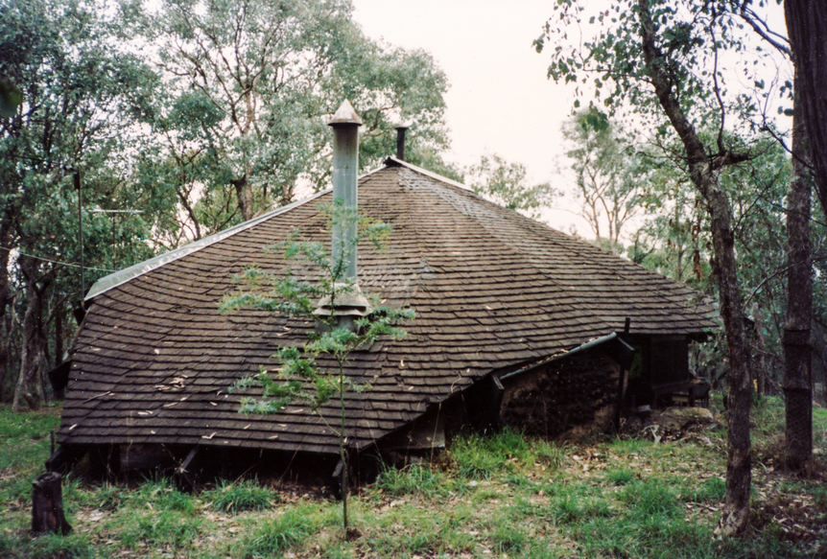  Leon Saper Residence, 60 Dunmoochin Road, Cottles Bridge (HO41). (Source: Victorian Collections; Nearmap 2021) | Built for the well-known potter Leon Saper in c1967, the house is architecturally significant as a work of Morrice Shaw. Shaw was a Modernist architect who worked in the office of Kevin Borland. It is one of the most creative and unusual dwellings built in Victoria and Australia during the 1960s. The house combines the Modernist ideas with the use of mudbrick and recycled materials that are characteristic of the 'Eltham style' architecture that proliferated in the 1950s and 1960s.  The house is noted for its highly individualist expression, which Alistair Knox described as ‘one of the most amazing designs that have occurred in mudbrick building’. The building combines a free-form plan with flowing pisé walls and fireplace under a complex organic roof form. It is the earliest known example in Victoria of a strand of the late twentieth century Organic style.
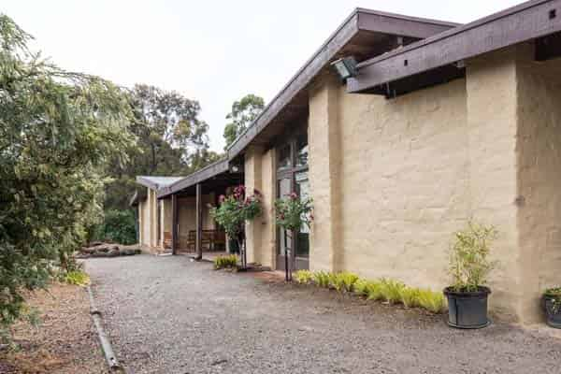  Coller House, 185 Mount Pleasant Road, Eltham (HO136). (Source: T Knox nd) | Coller House, built c1975, is historically significant as an important work by noted designer and builder and Eltham local, Alistair Knox. The house is architecturally significant as a good example of the 'Eltham style' of architecture and landscape design that Knox had developed over the years.
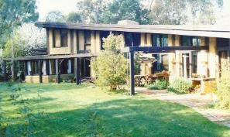  Pittard Residence, 430 Mount Pleasant Road, Research (HO139). (Source: VHD) | Pittard Residence, built 1978-79, is architecturally and historically significant as a particularly innovative example of Alistair Knox's later work. The curved plan and single plane roof rising up over the living area to the double storey end section are of particular note. The house is built from mudbrick.
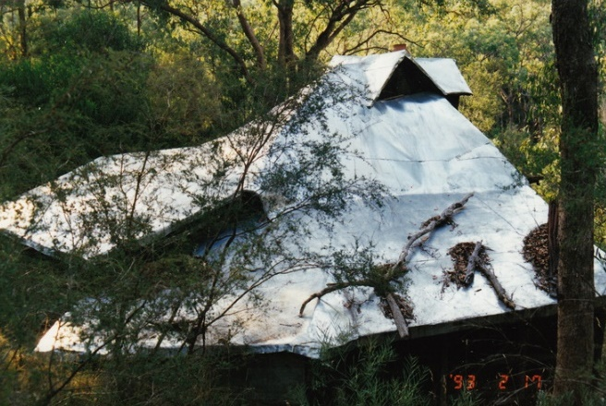  Baker ‘Eltham style’ outbuilding and sculptures, 108 Research-Warrandyte Road, North Warrandyte (HO157). (Source: VHD) | The outbuilding, constructed c1960-1970s, is historically, architecturally and aesthetically significant as a fine, small ‘Eltham style’ building in the Shire of Nillumbik. The outbuilding exemplifies the highly individual and creative structures that were being erected by many around the Shire during that time, and utilises recycled materials and mudbricks. Particularly of note is the organic roof form.

Discussion
57 Thompson Crescent is set apart from the house at 60 Dunmoochin Road, Cottles Bridge, by its more abstract geometry. Designed by Morrie Shaw, of the office of Kevin Borland, 60 Dunmoochin Road features an exaggerated, low-slung shingle roof. Although the house demonstrates a similar rounded form to the subject site, the subject site is set apart as a later version of the style that places greater emphasis on achieving a more geometrically pure form and a less rustic array of materials and textures.
The Coller House is comparable for its use of mudbrick construction. However, unlike the subject site, the Coller House does not follow a has a curved floorplan and is also constructed in mudbrick. The plan of this house, however, does not use the fully circular form is evident at 57 Thompson Crescent, Research. Similarly, the long sweeping roof plane of the Pittard Residence, differs from the that of the subject site with its split form and central peak.
Like 60 Dunmoochin Road, the Baker outbuilding exhibits an organic, broadly circular floorplan. Unlike the subject site, the outbuilding was clearly designed with no intention of producing a geometrically pure form, instead utilising looser organic shapes that responded to its more rustic construction and materials. The use of the building as an outbuilding, rather than a residence, differs from the subject site and likely supported the more experimental form of the building.
The subject site illustrates both a formal preoccupation with pure geometry and an adherence to the material aesthetics made popular as part of both Organic architecture of the late twentieth century and the ‘Eltham style’ championed by Alistair Knox and his contemporaries in earlier decades. It demonstrates the enduring influenced of the ‘Eltham style’ and its nature-centred aesthetic. The subject building’s geometric form, which responds directly to the site topography and earthy materials reflects the influence of Organic architecture. The subject building, with its circular footprint, is a somewhat uncommon example of an ‘Eltham style’ house. Although curved walls and broadly circular forms had been explored elsewhere in the Shire, 57 Thompson Crescent adheres to a purer geometric form. Materially and contextually, however, it reflects key characteristics of the ‘Eltham style’, including the use of timber and mudbrick construction and its integration with its natural bush setting.

STATEMENT OF SIGNIFICANCE

WHAT IS SIGNIFICANT?
The house at 57 Thompson Crescent, Research, most likely built c1984 for the owners Susan Bowles and David Cowan, is significant.
Elements that contribute to the significance of the place include:
- original circular plan form of the house;
- split roof detail and clerestory window;
- central chimney; and
- original fenestrations and pergola.
The later mudbrick building with carport to the southwest of the site is not significant.

HOW IS IT SIGNIFICANT?
The house at 57 Thompson Crescent, Research, is of local representative significance to the Shire of Nillumbik.

WHY IS IT SIGNIFICANT?
The house at 57 Thompson Crescent, Research, exhibits key characteristics of the late twentieth century houses built of earthy materials and reflective of the nature-centred aesthetic. The design of the house combined the Organic idiom of Modernist architecture developed in the 1960s and enduring ‘Eltham style’ influences in the Shire. The house demonstrates this influence in its use of mudbrick and the use of low-cost materials and its affinity with and embeddedness in its natural bushland setting. The use of strong geometry along with the use of natural materials also aligns this house with Organic architecture of the late twentieth century. (Criterion D)

RECOMMENDATIONS
Recommended for inclusion in the Schedule to the Heritage Overlay of the Nillumbik Planning Scheme as an Individually Significant place.
Extent of overlay: To title boundaries
Recommendations for the Schedule to the Heritage Overlay (Clause 43.01) in the Nillumbik Planning Scheme:

Nillumbik Planning Scheme
External paint controls | No
Internal alteration controls | No
Tree controls | No
Outbuildings or fences | No
To be included on the Victorian Heritage Register | No
Prohibited uses may be permitted | No
Aboriginal heritage place | No

Other
N/A

REFERENCES
Advertiser, as cited.
Age, as cited.
Blake, Leslie J (ed) 1973, Vision and Realisation: A centenary History of State Education in Victoria Volume 3, Melbourne, Education Department of Victoria.
Building Permit (BP) for 57 Thompson Crescent, Research.
Butler, Graeme, and Associates 1996, ‘Nillumbik Shire Heritage Review – Environmental History’, Prepared for the Shire of Nillumbik.
Eltham District Historical Society 2000, A Chronology of Known Local Events 1835-early 2000 including those in the Shire of Nillumbik and the former shires of Eltham and Diamond Valley, Eltham District Historical Society Incorporated.
Land Victoria, Certificates of Title (CT), as cited.
Lemon, Andrew 2008, ‘Research’, eMelbourne, School of Historical & Philosophical Studies, The University of Melbourne, https://www.emelbourne.net.au, accessed 23 November 2020.
Nillumbik Parish Plan 1947, Melbourne, Department of Lands and Survey.
Nillumbik Parish Plan 1961, Melbourne, Department of Lands and Survey.
Nillumbik Shire 2020, ‘History of the Shire’, https://www.nillumbik.vic.gov.au/Council/About-the-Shire/History-of-the-Shire, accessed 23 November 2020.
‘Victorian Gold Project: Historic Gold Mining Sites in the St Andrews Mining Division’ 1999, Melbourne, Department of Natural Resources and Environment.
Victorian Places 2015, ‘Eltham North’, Monash University and The University of Queensland, https://www.victorianplaces.com.au/, accessed 10 December 2020.
Weekly Times, as cited.

