10 Caledonia Street, St Andrews

St Andrews General Store and House
Prepared by: Context | Survey date: December 2020
Place type: Commercial, residential | Designer: -
Significance level: Significant | Builder: Not Known
Extent of overlay: To title boundaries | Major construction: 1935
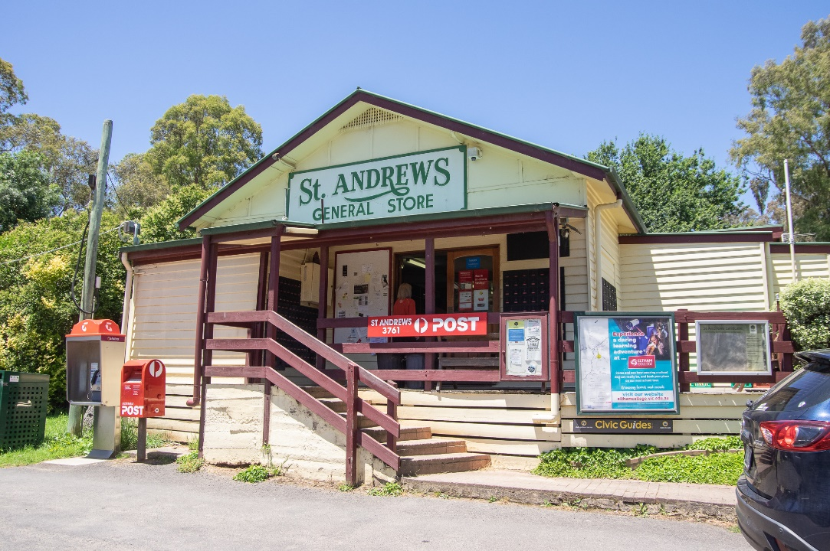
Figure 1. St Andrews General Store and House. (Source: Context 2020)
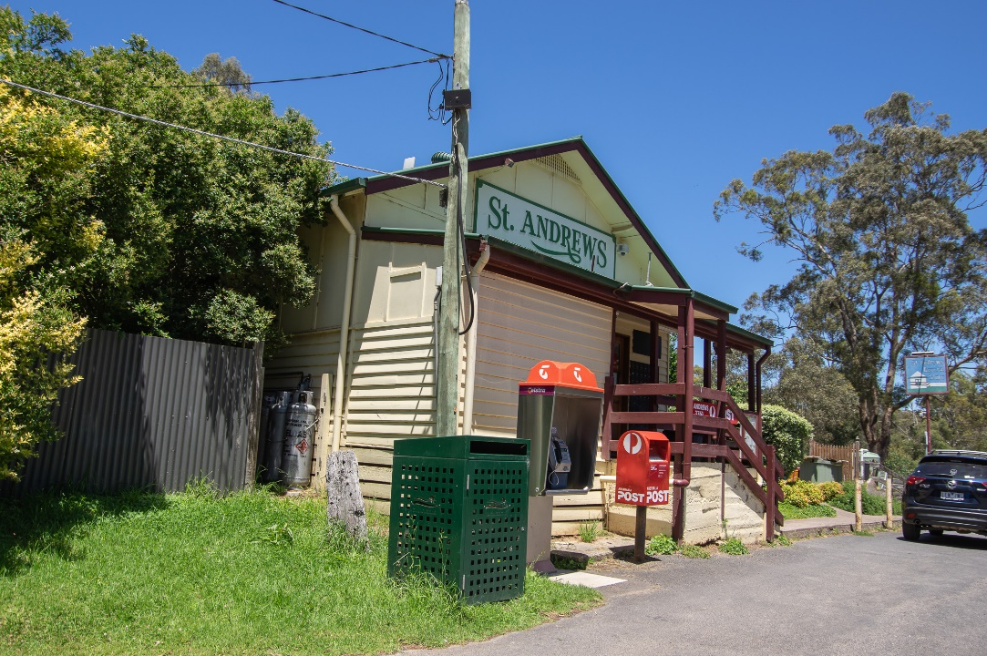
Figure 2. St Andrews General Store and House. (Source: Context 2020)

HISTORICAL CONTEXT
This place is associated with the following historic themes taken from the Nillumbik Shire Thematic Environmental History (2016):
6 BUILDING TOWNS AND SHAPING SUBURBS
6.3 Interwar subdivisions and estates
In the interwar period there were numerous speculative subdivisions throughout the Nillumbik area. These were often marketed as combining possibilities for escape from the city and immersion in the natural values of the area. The introduction of the railway made such speculations possible and they were spurred on by the promise of its electrification. This meant greater frequency of services and therefore greater viability for commuting workers and weekenders. (Mills & Westbrooke 2016:71).
Advertisements for interwar subdivisions in the small towns reveal that they were in large part aimed at a weekender market. In 1924, blocks in the Hurstbridge Railway Estate were advertised as ‘lovely mountain residential week-end holiday lots’, with ‘big timbered blocks’ and ‘pretty quarter and half acre blocks’. A newspaper article breathlessly described its merits. ‘The advantages … are unassailable – nearness to the railway station, commanding extensive and lovely views of the forest and meadow, hill and glen, the very home of various kinds of wattles, with the Diamond Creek in full view, but powerless in its highest floods to do them injury, and the quality of the land suitable for gardens and orchards.’ Four hundred people attended the first auction in November 1924, when 50 of the better blocks of the 160 available were sold. Some buyers bought two or three of the best blocks on Via Meander (now Meander Road), indicating a speculative interest. (Mills & Westbrooke 2016:72).
Most of the housing in these towns in the interwar period, as for the later nineteenth and early twentieth centuries, was still constructed in weatherboard on a timber frame. At Hurstbridge a substantial group of weatherboard cottages and shops along Main Road (Heidelberg–Kinglake Road) remain from this period (HO65–HO79, HO182). They are typically double fronted and set back from the road (HLCD 2008, p. 11). The 1923 Wilkinson House in Diamond Creek, however, was clad in stucco as well as weatherboard (HO184). Another exception was Worlingworth in Eltham, a brick bungalow built in 1920 (HO7). (Mills & Westbrooke 2016:73-74).

LOCALITY HISTORY
St Andrews was part of the Caledonian goldfields, which stretched from St Andrews to Warrandyte (the St Andrews Mining Division), established in 1854 on the country of the Wurundjeri-willam clan of the Woi wurrung people. The settlement was originally called Queenstown, but by 1865 was also known as St Andrews. The presence of large numbers of Scottish miners gave rise to both names ‘Caledonia’ and ‘St Andrews’ (Victorian Places 2015). The place was commonly referred to as ‘St Andrews, Queenstown’.
By 1855 there were 3000 miners in Queenstown, and in 1856 a post office and hotel were established in the settlement. The settlement was located on the road from Melbourne to the goldfields at Woods Point, so it benefited from passing traffic. The town of Queenstown, located on Diamond Creek, was surveyed in 1858 and proclaimed in 1861 (Township of Queenstown 1951; Butler 1996:40). A Church of England school opened in 1858 and was replaced by the Caledonia Common School No. 128, opened in Smiths Gully in 1858. This school, in turn, was replaced by Queenstown State School No. 128 (HO20) built in 1887 (Blake 1973:287). A cemetery (HO163) (in use in nearby Smiths Gully in the 1850s) and a cricket ground were gazetted in 1868, and St Andrews Church of England opened in 1866. A mechanics’ institute opened in 1867 (Butler 1996:40; Victorian Places 2015). The shire’s oldest surviving hotel building, St Andrews Hotel (HO19), was built on the Caledonia goldfields in Queenstown c1860 (Mills and Westbrooke 2017:102).
As gold returns diminished, a series of land Acts introduced in Victoria from 1860 aimed to encourage former gold seekers to take up farming. Although some land leased under the land Acts of 1865 and 1869 saw the establishment of orchards on small blocks of about 20 acres in the St Andrews district, freehold ownership of allotments in the area was not achieved until the land Acts of 1884, 1901 and 1915 (Queenstown Parish Plan 1925).
St Andrews was a part of a substantial area given over to the growing of apples, pears and stone fruit, the main agricultural industry in the Diamond Valley region (the area covered by much of the present Nillumbik Shire) from the 1880s to the 1930s. With its soil and climate suited to the growing of fruit, Diamond Valley formed a significant part of the wider fruit-growing region situated to the north and east of Melbourne in the counties of Evelyn, Bourke and Mornington. Orchards and nurseries were established on the hills and in the gullies of the catchments of Diamond Creek and Arthurs Creek, stretching from the township of Diamond Creek, through Hurstbridge, Cottles Bridge, Arthurs Creek and Panton Hill, to the foot of the Kinglake Ranges at Strathewen and Queenstown (now St Andrews) (National Trust Report, ‘Shaws Cool Store, Cottlesbridge’, B6979, cited in Butler 2006:140).
As part of the expansion of the fruit industry in the area from the 1880s, due to freehold ownership of land facilitated by the land Acts, St Andrews experienced significant growth, and by 1901 the population of the area had increased to 809 (Victorian Places 2015).
In 1881 the population of St Andrews and its associated diggings was 1162. However, by the early 1880s goldmining was in decline (Victorian Places 2015).
In the 1880s some buildings were relocated to what was developing as the centre of town. The Queenstown Mechanics Institute Hall, built in 1883 at Smiths Gully, was moved in 1889 to become St Andrews Hall. It was rebuilt after destruction by fire in 1924 (Reynolds n.d.). The area was mined again during the economic depression of the 1890s when unemployed men were paid by the government to fossick for gold.
The 1903 Australian Handbook described St Andrews, then with a population of 50, including five Chinese residents, as comprising a hotel, State School No. 128, mechanics’ institute, Independent Order of Oddfellows, and Church of England. Two coaches ran daily from Heidelberg. The broader district had a population of 1250 in this year, mostly employed in fruit-growing and mining (Victorian Places 2015).
In 1912, the railway line was extended between Eltham and Upper Diamond Creek, which aided in the transportation of locally grown fruit crops to Melbourne.
Although goldmining had declined in the area, with the advent of technology that allowed deeper exploration, a State-owned gold battery was established in 1919 at nearby Smiths Gully, opposite the Queenstown (St Andrews) Cemetery (Eltham and Whittlesea Shires Advertiser and Diamond Creek Valley Advocate 5 September 1919:3).
In 1920 St Andrews was described as a mining township on Diamond Creek with a state school, church, mechanics’ institute, police station and hotel, with a rail connection to Hurstbridge (Eltham and Whittlesea Shires Advertiser and Diamond Creek Valley Advocate 2 April 1920:4). The St Andrews police quarters were moved to Doncaster East School in 1920 for use as a teacher's residence (St Andrews/Queenstown Historical Society nd).
Increased competition from new fruit-growing areas established in Victoria under irrigation programs after World War I and the impact of the Depression of the 1930s saw many of the district’s orchardists turning to other pursuits such as raising poultry, selling firewood, or supplementing their incomes by working for other landowners or through mining (Nillumbik Shire 2020; ‘Victorian Gold Project’ 1999:14). During the Depression from 1928, men from the city were given a miner’s right and mining sustenance as a form of unemployment relief. In 1931 there were over 200 men camping on Crown land on the Diamond Creek at Queenstown under their miner’s rights (Mills & Westbrooke 2017:33).
In 1935, the St Andrews Post Office was moved to the new general store building erected opposite the Church of England (Advertiser 13 September 1935:2).
Bushfires occurred in the area in 1927, and in 1939, the Black Friday bushfires destroyed parts of Eltham, Warrandyte, Panton Hill, St Andrews, Kinglake and Christmas Hills (Eltham District Historical Society 2000:np).
The town and school name of Queenstown was formally changed to St Andrews in 1952 (St Andrews/Queenstown Historical Society nd).
The area became a favoured locale of musicians and artists from the early 1970s. At their initiative, a Saturday morning market, offering alternative culture, crafts, art and accessories as well as organic vegetables and food, was established on the St Andrews Hall reserve in 1972 and continues to run today.
When a new building was constructed for St Andrews Primary School in 1984, the former school was opened as St Andrews Community Centre (St Andrews/Queenstown Historical Society nd).
Surrounded by a number of bushland reserves, the St Andrews area has been affected by several significant fires over time. During the Black Saturday bushfires of 2009, properties east of the town were destroyed (Victorian Places 2015) and St Andrews Community Centre was established as a relief centre. With funds from the Victorian Bushfire Appeal, the building was redesigned by architect Gregory Burgess, and reopened as Wadambuk Community Centre in 2015. The building is also the home of St Andrews/Queenstown Historical Society (Nillumbik Shire 2015).

PLACE HISTORY
St Andrews General Store and House at 10 Caledonia Street, St Andrews, is located on Crown Allotment 4, Section 2, Queenstown Township, 2 rood allotments purchased by T Mitchell in 1859 (Queenstown Township Plan 1951).
The original Queenstown post office and general store were located in the St Andrews Hotel (St Andrews Primary School Council 1998:136). By 1893, W Atkins was running the Queenstown Post Office Store (Leader 11 February 1893:4).
In July 1935, the Hurstbridge Advertiser reported that
A new grocery store is being built to the order of Mrs N. Rickaby, now of the St. Andrew's hotel. The store is being built opposite the Church of England and is a long wanted addition to the district. A house will also be built on to the shop (Advertiser 26 July 1935:2).
The Queenstown Post Office moved to the building in September of the same year, with D Rickaby appointed postmaster (Figure 3) (Advertiser 13 September 1935:2 and 18 October 1935:3).
The store and post office were owned by the Rickabys until 1938, when the premises were acquired by Albert Fawcett, who employed Ray Rogers and Son in the same year to undertake additions to the building. Fawcett sold the business in 1939, and it was noted in a newspaper report of the day that he would be staying on in the district as he had just built a new house adjoining the store, likely the current residence at 12 Caledonia Street (Figure 3) (Advertiser 18 March 1938:1; 8 April 1938:2; and 3 February 1939:5).
A certificate of title dated 1940 confirms that Albert Fredrick Fawcett was the owner of both Crown Allotment 4 and 5 in that year (CT:V6350 F871).
In 1944, Crown Allotment 4, on which the subject building is located, was sold to storekeeper John Hade. In 1945, Crown Allotment 5, on which Fawcett’s residence stood (12 Caledonia Street), was sold to Edwin Brooks (CT:V6350 F871).
A number of people took over ownership of the store and post office on Crown Allotment 4 in the 1940s and 1950s, including newsagent Geoffrey Tatham in 1947; storekeepers Frank and Rose Eldred in 1950; engineer Alexander Moore in 1950; and accountant Alexander McCutcheon in 1951 (CT:V6699 F612).
By 1954, the configuration of the steps to the entry had changed and appears to have been constructed in timber with diagonal lattice balustrade (Figure 4). This configuration remains extant.
In 1969, Eric and Betty Kerr became the owners. The Kerr family ran the store and post office until 1979, when the McVicars took over ownership. The McVicars sold the store and post office in 1986 (CT:V6699 F612).
An advertisement for the sale of the St Andrews General Store in 1995, by then a milk bar, described the building as a store and two-bedroom modern mudbrick residence on one half acre (Age 11 February 1995:94).
The subject building today houses the St Andrews General Store, an Australian Post outlet, and cafe. A two-bedroom mudbrick residence is located at the rear of the building and is likely to have been constructed after 1968.

Figure 3. St Andrews Post Office and Store, c1930s. (Source: Facebook 2021)
Figure 4. Images of the St Andrews Post Office and Store in 1954, showing Rickaby’s store built in 1935 at 10 Caledonia Street and Fawcett’s house, at 12 Caledonia Street, to the left of the store in the LHS photo. The configuration of the steps have changed by this time. (Source: NAA 1954 In copyright).

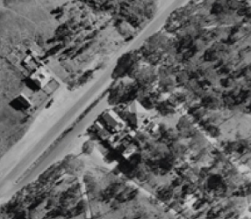
Figure 5. The subject site in 1968. The roof of the rear additions appear different from that of the mudbrick extension. The buildings on the subject site are approximately outlined in orange. (Source: CPO, ‘MELBOURNE 1968 PROJECT’, via Landata)

DESCRIPTION
St Andrews General Store at 10 Caledonia Street, St Andrews, is an interwar shop and residence built in 1935, with a later (post-1968) mudbrick extension to the rear.
Located on the southern side of Caledonia Street, near Waratah Street, the L-shaped site rises to the rear (south) (Figure 5). The footprint of the shop and attached mudbrick dwelling is stepped (Figure 8), but broadly rectangular, sitting snugly in the northern portion of the site with zero setback to Caledonia Street. The building is a single-story gable-roofed weatherboard clad shop. A skillion roofed mudbrick residence has been added to the rear, and is integrated into the shop building. A garden and outbuilding lie behind. The southern portion of the site consists of a gravel driveway and carparking area.
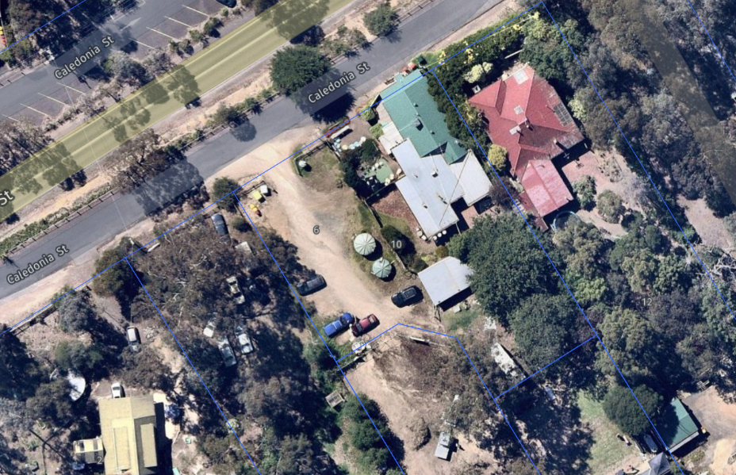
Figure 6. Aerial imagery of the site. (Source: Nearmap 2021)

The primary elevation (north) is elevated above the ground plane and presents a prominent gable frontage to the streetscape. Signage reading ‘St Andrews General Store’ sits within the gable (Figure 7). A shallow skillion roofed verandah supported by simple timber posts protects the entrance and extends around the southeast corner of the building. The northern portion of the verandah is enclosed. Brick paving leads from the south to a concrete, brick steps rising to the verandah and building entrance. An extended section of the verandah projects over the staircase landing. Three slat timber balustrades line the staircase and verandah. Post box slots and a community noticeboard flank the double doorway. A phone box and post box stand on the ground plane, in front of the building to the north.

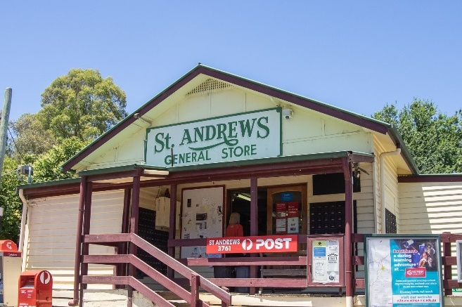  Figure 7. Signage within the gable and other signage such as for Australia Post. (Source: Context 2020) | 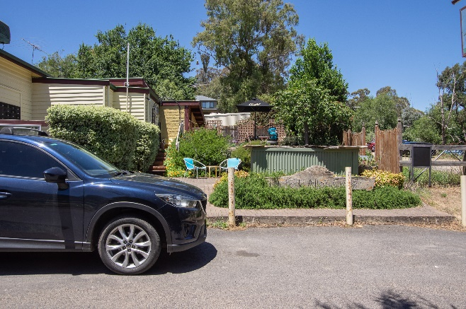  Figure 8. South western edge of the building with paved area and garden beds in front. (Source: Context 2020)

INTEGRITY
10 Caledonia Street, St Andrews, is largely intact with some changes visible to original or early significant fabric. The front shop building retains the single-storey gable-roofed form, skillion verandah and weatherboard cladding construction. The entrance staircase and balustrade are more recent additions but reflect the entry configuration visible in photographs of the building taken in 1954. While the front step configuration is faithful to the 1954 configuration, the extant steps and balustrade themselves are not significant. The building’s retention of its continuous use as a shop and post office enhances the place’s integrity. Overall, the building has high integrity.
The embedded mudbrick residence to the rear of the shop, that is partially visible from the streetscape, is clearly legible as a later addition. It is connected physically but is stylistically different to the main shop building. This does not detract from the integrity of the main shop building.

COMPARATIVE ANALYSIS
By the mid-to-late 1920s, residential development in the outlying townships of current-day Nillumbik, including Hurstbridge, Panton Hill, St Andrew's and Diamond Creek had slowed. With the onset of the Great Depression building activity in Melbourne and its surrounds virtually ceased. A combination of continuing agricultural land use and lack of suburban utilities and the impacts of the Depression (1929-32) meant that development in localities outside the reach of railway lines continued to be slow in the interwar period. Most buildings that appeared in the early twentieth century were modest weatherboard, timber framed structures (Mills & Westbrooke 2016:73-74). As there was limited building activity in the interwar period, there are only a handful of interwar shops listed on the Nillumbik Shire Heritage Overlay. However, early shop buildings are important components of local heritage as they reflect the development of townships and are part of the core of the community.
The St Andrews township is serviced by several buildings: St Andrews State School 128 (HO20); St Andrews Anglican Church (HO21); Weatherboard shop & residence, 85 Burns Street (HO18); St Andrews Hotel (HO19), St Andrews Community Hall (proposed significant in this study), which together form an important scatter of commercial and community buildings defining the centre of the St Andrews township along Burns Street and Caledonia Road.
Below examples of weatherboard shops are listed on the Nillumbik Shire Heritage Overlay.
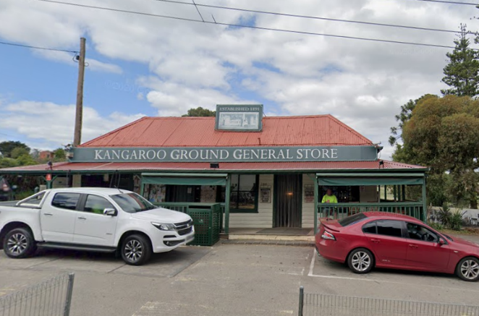  Kangaroo Ground General Store, Post Office, 280 Eltham-Yarra Glen Road, Kangaroo Ground (HO48). (Source: Google Streetview 2020) | The general store, built in the c1900s, is historically significant for its long association with Kangaroo Ground. The store has been an important centre of community life for more than 80 years. Council meetings used to be conducted in the front room of the store at a time when Kangaroo Ground rivalled Eltham as the major centre of the Shire. The general store is one of a group of three well preserved public buildings in the Kangaroo Ground hamlet (including HO46 Presbyterian Church and HO47 Primary (State) school No.2105 and former residence). It is a major focus of Kangaroo Ground which was one of the earliest settled areas of the Shire and which has the character of an English village rather than an Australian settlement. The general store is socially and historically significant because it has served the community since c1900 (VHD).
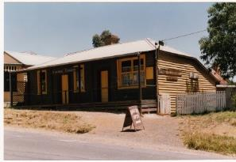  Weatherboard Shop and Residence, 85 Burns Street, St Andrews (HO18). (Source: VHD) | This combined shop and residence built in c1890-1900 is socially and historically significant as one of the two traditional social hubs of St Andrews (HO19 St Andrews Hotel being the other one). In recent decades it has been used for the display of works by local artists, potters and leather/wood workers. The place is historically and aesthetically significant as one of only two examples of a 1890s-1900s combined shop and residence in the area and, in combination with the adjacent St Andrews Hotel, is a major component of the streetscape of St Andrews (VHD).
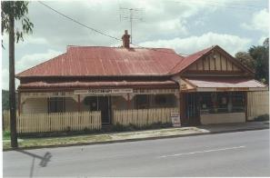  Former Butcher’s Shop and House, 919 Heidelberg-Kinglake Road, Hurstbridge (HO75). (Source: VHD) | The c1913-14 combined shop and residence within the subdivision created by the leading orchardist William Gray, is historically significant. It was constructed immediately after the arrival of the railway in Hurstbridge (1912) and illustrates the growth and change that the arrival of the railway brought to the town. The shop and residence is one of Hurstbridge's most substantial commercial properties, featuring a projecting front gable over the shop and a cast iron decorative verandah, which is rare in Hurstbridge. It is an integral component of a cluster of 1910s and 1920s buildings that gives the centre of Hurstbridge its special character. The building is a rare example of a combined shop and residence in the municipality and illustrates the once common practice of shopkeepers living at their premises (VHD).  It does not appear to be in use as a shop currently.
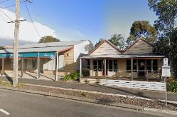  Former Milthorpe Store, 42-44 Main Hurstbridge Road, Diamond Creek (HO259). (Source: Google Streetview 2019) | The c1915 former Milthorpe Store is historically significant for its long association with commercial activities within the township of Diamond Creek. Charles Milthorpe established the store and carrier business c1915 opposite the recently extended railway line and Diamond Creek Railway Station. The Milthorpe family ran the store and carrier from this location until c1960. The former store is an early surviving commercial building in Damond Creek and illustrates the shift of the commercial centre closer to the railway station after 1912 when the line was extended from Eltham to Hurstbridge. The former store was one of the first commercial buildings to be constructed near the railway stations after the line was extended. The former Milthorpe Store is also a partially intact example of an early twentieth century rural store still demonstrating the humble nature of its original construction (VHD).  Today it is used as an opportunity shop.
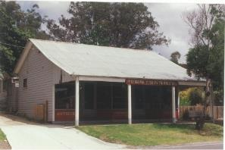  Weatherboard Shop and Dwelling, 956-958 Heidelberg-Kinglake Road, Hurstbridge (HO77). (Source: VHD) | The shop and dwelling (which may originally have been two shops), built c1920, is historically significant because it was constructed within the subdivision created by the leading orchardist, William Gray. It was one of the earliest properties constructed after the arrival of the railway to Hurstbridge (1912) and illustrates the growth and change that its arrival brought to the town. The modest scale of the property reflects the relative poverty of Hurstbridge in the early years of the twentieth century. The shop and dwelling is an integral component of a cluster of 1910 and 1920s buildings that gives the centre of Hurstbridge its special character (VHD).  Today it is used as an opportunity shop.
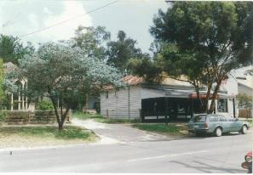  Weatherboard Shop, Corrugated Iron Building and Weatherboard House Behind, 960 Heidelberg-Kinglake Road, Hurstbridge (HO78). (Source: VHD) | The shop and associated house, built c1910-1920, are historically significant because the arrangement of the two (with the shop to the front and the house to the rear) is unique in Hurstbridge. The shop and house were constructed following the completion of the railway line to Hurstbridge (1912) and illustrate the growth and change that its arrival brought to the town. The shop and associated house retained its original/early shopfront and post-supported verandah. The buildings are integral components of a cluster of 1910 and 1920s buildings that gives the centre of Hurstbridge its special character (VHD).  The building is no longer a shop.

Discussion
The St Andrews General Store at 10 Caledonia Street, St Andrews, compares well to the above examples in form, materiality and original function. Of modest timber construction, the St Andrews General Store demonstrates the development of retail outlets during the interwar period and represents the importance of commerce to townships. Many of the examples listed are built prior to the Depression, rendering the St Andrews General Store of further importance as an interwar example of this building type which is poorly represented in the Heritage Overlay.. Like the Former Butcher’s Shop and House at 919 Heidelberg-Kinglake Road, Hurstbridge (HO75), the St Andrews General Store and House is a rare example of a combined shop and residence in the municipality, illustrating the once common practice of shopkeepers living at their premises.
It is also notable for its continuous use as a shop, as some of the comparative examples have been converted to residential use or do not retain their original commercial use. The signage within the gable at 10 Caledonia Street, while not original, makes an important contribution to the streetscape and signifies the commercial use of the place to the public domain.
The St Andrews General Store contributes to the cluster of commercial and community-focused buildings along the main thoroughfares of Caledonia Road and Burns Street which help define the core of the town. It is largely intact on its primary elevation and demonstrates a typical construction method of the interwar period within Nillumbik Shire and contributes to the township’s character in form and function.

STATEMENT OF SIGNIFICANCE

WHAT IS SIGNIFICANT?
St Andrews General Store and House at 10 Caledonia Street, St Andrews, built in 1935 is significant.
Elements that contribute to the significance of the place include:
- Original single-story gable roofed form and scale, and building siting without setback.
- Weatherboard cladding.
The signage, noticeboards and embedded mudbrick dwelling to the rear contributes to the significance of the place.

HOW IS IT SIGNIFICANT?
St Andrews General Store and House at 10 Caledonia Street, St Andrews is of local historical and representative significance to the Shire of Nillumbik.

WHY IS IT SIGNIFICANT?
St Andrews General Store and House at 10 Caledonia Street, St Andrews, is historically significant as it demonstrates commercial retail development within the township during the interwar period. This is enhanced by its continued use as a shop. Signage and noticeboards surrounding the shop have long been in use at this site. They enhance the character of the shop and emphasise its ongoing use as a place for the transmission of community information. St Andrews General Store is also important for its continuing role as a meeting place for the St Andrews community. (Criterion A)
10 Caledonia Street, St Andrews, has representative significance as it demonstrates the interwar shop and residence typology with notable features such as weatherboard cladding, gabled roof form and overall modest construction. Its location on a main street at the centre of the township is also a key characteristic of the type. (Criterion D)

RECOMMENDATIONS
Recommended for inclusion in the Schedule to the Heritage Overlay of the Nillumbik Planning Scheme as an Individually Significant place.
Extent of overlay: To title boundaries
Recommendations for the Schedule to the Heritage Overlay (Clause 43.01) in the Nillumbik Planning Scheme:

Nillumbik Planning Scheme
External paint controls | No
Internal alteration controls | No
Tree controls | No
Outbuildings or fences | No
To be included on the Victorian Heritage Register | No
Prohibited uses may be permitted | No
Aboriginal heritage place | No

Other
N/A

REFERENCES
Advertiser, as cited.
Age, as cited.
Blake, Leslie J (ed) 1973, Vision and Realisation: A centenary History of State Education in Victoria, vol 3, Melbourne, Education Department of Victoria.
Butler, Graeme, and Associates 1996, ‘Nillumbik Shire Heritage Review – Environmental History’, Prepared for the Shire of Nillumbik.
Butler, Graeme, and Associates 2006, ‘Heritage Assessments, Shire of Nillumbik Amendment C13’, Prepared for the Shire of Nillumbik.
Central Plan Office (CPO), Historic Aerial Photography: 1930s to 1990s, as cited, via Landata, https://www.landata.vic.gov.au/, accessed online March-April 2021.
Eltham and Whittlesea Shires Advertiser and Diamond Creek Valley Advocate, as cited.
Eltham District Historical Society 2000, A Chronology of Known Local Events 1835-early 2000 Including those in the Shire of Nillumbik and the former shires of Eltham and Diamond Valley, Eltham District Historical Society Incorporated.
Facebook 2021, ‘St Andrews General Store and Post Office’, https://www.facebook.com/StAndrewsGeneralStore.3761/, accessed online 8 April 2021.
Land Victoria, Certificates of Title (CT), as cited.
Leader, as cited.
Mills, Peter & Westbrooke, Samantha 2017, ‘Nillumbik Shire Thematic Environmental History – Revision 2016’, prepared for Nillumbik Shire Council.
National Archives of Australia (NAA) 1954, St Andrews Post Office, NAA B5919.
Nillumbik Shire 2020, ‘History of the Shire’, https://www.nillumbik.vic.gov.au/, accessed online 23 November 2020.
Nillumbik Shire Council 2015, ‘Nillumbik Heritage Guide’.
Queenstown Township Plan 1951, Melbourne, Department of Crown Lands and Survey.
Reynolds, Pat undated, ‘A Short History of the St Andrews Hall’, Wadambuk St Andrews Community Centre, https://www.standrewscommunitycentre.org/, accessed online 20 November 2020.
St Andrews Primary School Council 1998, A Village Built on Gold: A History to Present Times of St Andrews and District, St Andrews, St Andrews Primary School Council.
Sears’ Studios 1926, ‘Royal Mail coach with passengers, parked outside Post-Office and St Andrew's Hotel, Buggy parked in front. A survival of the good old coaching days at Queenstown, Vict’, State Library Victoria (SLV), accessed online 10 December 2020.
Township of Queenstown 1951, Melbourne, Department of Lands and Survey
‘Victorian Gold Project: Historic Gold Mining Sites in the St Andrews Mining Division’ 1999, Melbourne, Department of Natural Resources and Environment.
Victorian Places 2015, ‘Eltham North’, Monash University and The University of Queensland, https://www.victorianplaces.com.au/, accessed online 10 December 2020.

