Part of 1 Proctor Street, St Andrews

St Andrews Hall
Prepared by: Context | Survey date: December 2020
Place type: Community | Designer: -
Significance level: Significant | Builder: F J Jennings
Extent of overlay: Refer to map | Major construction: 1925
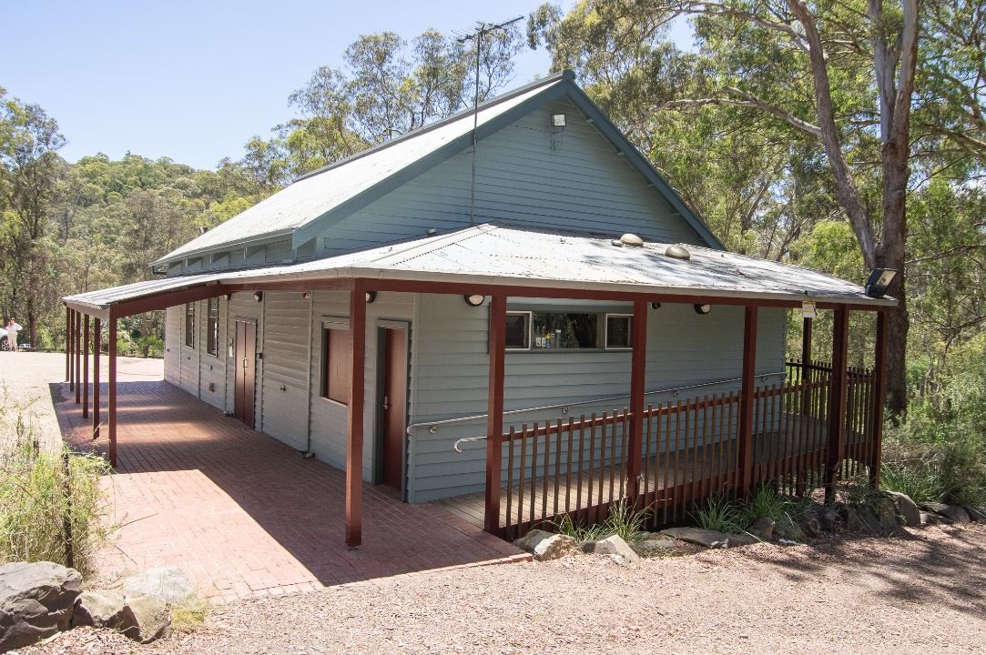
Figure 1. The southern end of St Andrews Hall. (Source: Context 2020)
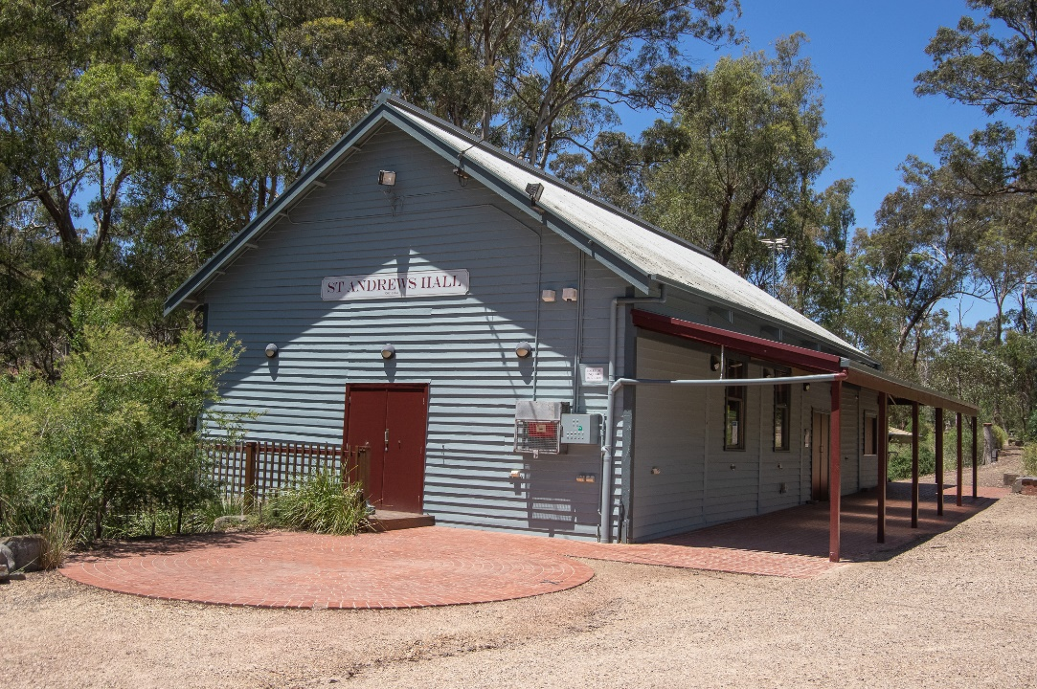
Figure 2. The northern end of St Andrews Hall. (Source: Context 2020)

HISTORICAL CONTEXT
This place is associated with the following historic themes taken from the Nillumbik Shire Thematic Environmental History (2016):
8 BUILDING COMMUNITY LIFE
8.3 Establishing meeting places
In the nineteenth century, the halls of the Nillumbik area usually took the form of a mechanics’ institute and free library. The mechanics’ institute movement started in Scotland in 1900 with the intention of improving the education of working men. Government grants were available from 1860 and from 1887 these funds were directed towards free libraries. (Mills & Westbrooke 2016:103).
By the early twentieth century, the institutes were ‘beginning to die out, or had become more places of amusement’. Existing and renovated halls typically continued to carry the title of mechanics’ institute, but new ones were simply called halls. When a new hall incorporating the earlier Diamond Creek Mechanics’ Hall and Literary Institute was constructed in 1905, the old name was retained. The new hall was among the largest in the area, accommodating 400 people with a lending library of 1,000 books. Like many other important early Diamond Creek buildings, it was destroyed by fire in 1969. (Mills & Westbrooke 2016:104).
When the opening of a hall at Panton Hill was advertised in 1901, it was described both as the Panton Hill Hall and the Panton Hill Mechanics’ Institute. The hall was built on the temporary reserve for ‘a site for a cricket ground and other purposes of public recreation’, which had been gazetted in 1900. (Mills & Westbrooke 2016:104).
First newspaper mentions of a Hurstbridge Public Hall (or Hurstbridge Hall) appear in 1913. Additions were made in 1915. The hall was destroyed by fire and rebuilt in the mid-1950s. By 1915 there were also mentions of a Hurstbridge Mechanics’ Institute and Free Library or Hurstbridge Mechanics’ Hall. This institute was still operating during bushfires in the 1960s. (Mills & Westbrooke 2016:104).
The Plenty Hall (HO248) opened in the midst of the Great Depression, in late 1931 and was soon the venue for fortnightly dances, fundraising balls, tennis club meetings, the Sutherland Homes Dance and Empire Day celebrations. (Mills & Westbrooke 2016:105).
In the austerity period following World War II small communities had scant resources or materials for building a hall when they needed one. In 1948 the Yarrambat community solved the problem by moving a small redundant hall building from Langwarrin to create the Yarrambat Memorial Hall. (Mills & Westbrooke 2016:105).

LOCALITY HISTORY
St Andrews was part of the Caledonian goldfields, which stretched from St Andrews to Warrandyte (the St Andrews Mining Division), established in 1854 on the country of the Wurundjeri-willam clan of the Woi wurrung people. The settlement was originally called Queenstown, but by 1865 was also known as St Andrews. The presence of large numbers of Scottish miners gave rise to both names ‘Caledonia’ and ‘St Andrews’ (Victorian Places 2015). The place was commonly referred to as ‘St Andrews, Queenstown’.
By 1855 there were 3000 miners in Queenstown, and in 1856 a post office and hotel were established in the settlement. The settlement was located on the road from Melbourne to the goldfields at Woods Point, so it benefited from passing traffic. The town of Queenstown, located on Diamond Creek, was surveyed in 1858 and proclaimed in 1861 (Township of Queenstown 1951; Butler 1996:40). A Church of England school opened in 1858 and was replaced by the Caledonia Common School No. 128, opened in Smiths Gully in 1858. This school, in turn, was replaced by Queenstown State School No. 128 (HO20) built in 1887 (Blake 1973:287). A cemetery (HO163) (in use in nearby Smiths Gully in the 1850s) and a cricket ground were gazetted in 1868, and St Andrews Church of England opened in 1866. A mechanics’ institute opened in 1867 (Butler 1996:40; Victorian Places 2015). The shire’s oldest surviving hotel building, St Andrews Hotel (HO19), was built on the Caledonia goldfields in Queenstown c1860 (Mills and Westbrooke 2017:102).
As gold returns diminished, a series of land Acts introduced in Victoria from 1860 aimed to encourage former gold seekers to take up farming. Although some land leased under the land Acts of 1865 and 1869 saw the establishment of orchards on small blocks of about 20 acres in the St Andrews district, freehold ownership of allotments in the area was not achieved until the land Acts of 1884, 1901 and 1915 (Queenstown Parish Plan 1925).
St Andrews was a part of a substantial area given over to the growing of apples, pears and stone fruit, the main agricultural industry in the Diamond Valley region (the area covered by much of the present Nillumbik Shire) from the 1880s to the 1930s. With its soil and climate suited to the growing of fruit, Diamond Valley formed a significant part of the wider fruit-growing region situated to the north and east of Melbourne in the counties of Evelyn, Bourke and Mornington. Orchards and nurseries were established on the hills and in the gullies of the catchments of Diamond Creek and Arthurs Creek, stretching from the township of Diamond Creek, through Hurstbridge, Cottles Bridge, Arthurs Creek and Panton Hill, to the foot of the Kinglake Ranges at Strathewen and Queenstown (now St Andrews) (National Trust Report, ‘Shaws Cool Store, Cottlesbridge’, B6979, cited in Butler 2006:140).
As part of the expansion of the fruit industry in the area from the 1880s, due to freehold ownership of land facilitated by the land Acts, St Andrews experienced significant growth, and by 1901 the population of the area had increased to 809 (Victorian Places 2015).
In 1881 the population of St Andrews and its associated diggings was 1162. However, by the early 1880s goldmining was in decline (Victorian Places 2015).
In the 1880s some buildings were relocated to what was developing as the centre of town. The Queenstown Mechanics Institute Hall, built in 1883 at Smiths Gully, was moved in 1889 to become St Andrews Hall. It was rebuilt after destruction by fire in 1924 (Reynolds n.d.). The area was mined again during the economic depression of the 1890s when unemployed men were paid by the government to fossick for gold.
The 1903 Australian Handbook described St Andrews, then with a population of 50, including five Chinese residents, as comprising a hotel, State School No. 128, mechanics’ institute, Independent Order of Oddfellows, and Church of England. Two coaches ran daily from Heidelberg. The broader district had a population of 1250 in this year, mostly employed in fruit-growing and mining (Victorian Places 2015).
In 1912, the railway line was extended between Eltham and Upper Diamond Creek, which aided in the transportation of locally grown fruit crops to Melbourne.
Although goldmining had declined in the area, with the advent of technology that allowed deeper exploration, a State-owned gold battery was established in 1919 at nearby Smiths Gully, opposite the Queenstown (St Andrews) Cemetery (Eltham and Whittlesea Shires Advertiser and Diamond Creek Valley Advocate 5 September 1919:3).
In 1920 St Andrews was described as a mining township on Diamond Creek with a state school, church, mechanics’ institute, police station and hotel, with a rail connection to Hurstbridge (Eltham and Whittlesea Shires Advertiser and Diamond Creek Valley Advocate 2 April 1920:4). The St Andrews police quarters were moved to Doncaster East School in 1920 for use as a teachers residence (St Andrews/Queenstown Historical Society n.d.).
Increased competition from new fruit-growing areas established in Victoria under irrigation programs after World War I and the impact of the Depression of the 1930s saw many of the district’s orchardists turning to other pursuits such as raising poultry, selling firewood, or supplementing their incomes by working for other landowners or through mining (Nillumbik Shire 2020; ‘Victorian Gold Project’ 1999:14). During the Depression from 1928, men from the city were given a miner’s right and mining sustenance as a form of unemployment relief. In 1931 there were over 200 men camping on Crown land on the Diamond Creek at Queenstown under their miner’s rights (Mills and Westbrooke 2017:33).
In 1935, the St Andrews Post Office was moved to the new general store building erected opposite the Church of England (Advertiser 13 September 1935:2).
Bushfires occurred in the area in 1927, and in 1939, the Black Friday bushfires destroyed parts of Eltham, Warrandyte, Panton Hill, St Andrews, Kinglake and Christmas Hills (Eltham District Historical Society 2000:np).
The town and school name of Queenstown was formally changed to St Andrews in 1952 (St Andrews/Queenstown Historical Society n.d.).
The area became a favoured locale of musicians and artists from the early 1970s. At their initiative, a Saturday morning market, offering alternative culture, crafts, art and accessories as well as organic vegetables and food, was established on the St Andrews Hall reserve in 1972 and continues to run today.
When a new building was constructed for St Andrews Primary School in 1984, the former school was opened as St Andrews Community Centre (St Andrews/Queenstown Historical Society n.d.).
Surrounded by a number of bushland reserves, the St Andrews area has been affected by several significant fires over time. During the Black Saturday bushfires of 2009, properties east of the town were destroyed (Victorian Places 2015) and St Andrews Community Centre was established as a relief centre. With funds from the Victorian Bushfire Appeal, the building was redesigned by architect Gregory Burgess, and reopened as Wadambuk Community Centre in 2015. The building is also the home of St Andrews/Queenstown Historical Society (Nillumbik Shire 2015).

PLACE HISTORY
The 1925 St Andrews Hall at 1 Proctor Street, St Andrews, is located on Crown Allotment A, Section 4A, Queenstown Township, one rood reserved for a Mechanics Institute and Free Library in 1889 (Queenstown Township Plan 1951).
The original building on the subject site was the Queenstown Mechanics Institute and Free Library, which also included a hall, initially built on the land of Mr Harris near Buttermans Track. The building was formally opened on 10 March 1883 by E H Cameron MLA. The celebration was attended by a large audience who was entertained for two hours with songs, readings and recitations. The construction of the building cost £79 (St Andrews Primary School Council 1998:102; Evelyn Observer and South and East Bourke Record 16 March 1883:2).
The Queenstown Mechanics Institute and Free Library building was moved to the subject site in 1889 to be closer to what had become the centre of town. A permit was sought from the Shire of Eltham to remove the railings on the old Queenstown bridge to enable the hall to pass (Reynolds nd). The re-opening of the mechanics institute building on its new site was celebrated with a concert on 2 November 1889 (Evelyn Observer and South and East Bourke Record 8 November 1889:3). The building was also known as the Queenstown Hall. In 1917 a room was added to the rear of the hall (St Andrews Primary School Council 1998:103).
After a fire destroyed the Queenstown Hall in January 1925, a building fund was established to raise monies for the construction of a new hall, and by February 1925 had collected £100, with £120 more required (Argus 29 January 1925:14; Advertiser 27 February 1925:4).
Tenders were called for the supply of materials and construction of a new public hall at Queenstown in February 1925 (Advertiser 13 February 1925:2). By April 1925, the new hall was under construction, with builder F J Jennings of Diamond Creek undertaking the work. The hall was of a simple design, comprising 12 feet high walls built of Baltic pine weatherboard, hardwood floors, and galvanised iron roof. A platform stage and dressing room were built at one end (see Figure 3) (PROV 1925-85, Public Building File).
The hall roof was up in time for the first dance, which was held on the evening of Easter Monday 1925 (Advertiser 17 April 1925:2). A newspaper report of the day described the hall as follows:
It is constructed of the best weatherboards and is roofed with iron. The walls are 12 feet high. The floor is of grooved hardwood, like that of Diamond Creek. The dimensions are 50 feet by 30 feet, which make it 10 feet wider than the old hall, and it will accommodate about 200 people. Provision is made for a 10 feet stage. For the present the walls will not be lined and the ceiling will not be put in, but these will follow when finances justify. The contract price is in the vicinity of £400 (Advertiser 17 April 1925:2).
The hall was officially opened on 6 June 1925 by Eltham Shire councillor H Hewitt, with a large number of people enjoying the musical program and supper. A social club was formed in the same month by the young people of Queenstown, who planned to hold a dance in the hall every fortnight (Advertiser 19 June 1925:2).
A number of functions were held throughout 1925 to raise building funds for the hall. These functions included events held in neighbouring areas such as Hurstbridge, as well as a sports meeting in April 1925 and a dance and social organised in August 1925, both at Queenstown (Advertiser 17 February 1925:4; 17 April 1925:2 and 4 September 1925:2).
The Queenstown Hall was the venue for variety of community activities, including dances, balls, dramas, card games, farewells, church fetes, and meetings.
A plan dated 1952 shows a kitchen, 14 feet by 12 feet, adjoining the hall, which was constructed some time after 1925 (PROV 1925-85, Public Building File).

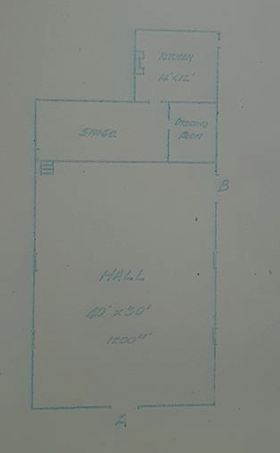
Figure 2. Plan for the Queenstown Mechanics Institute, with kitchen shown at rear, 1952. (Source: PROV 1925-85, Public Building File).

A photo taken at a dance in the 1950s shows the hall still without walls and ceiling lined. The front door resembled a barn door and rough bench seating ran around the walls (Reynolds nd). At this time, there was a dance held in one of the local halls every weekend. St Andrews would be the host one week, then Panton Hill, Hurstbridge, Arthurs Creek and Strathewen would have their turn. The band was made up of local talent (Reynolds nd).
As there was no power in the town, a large iron hoop with hooks for kerosene lanterns was suspended from the ceiling and could be lowered and raised. On some occasions, one of the locals supplied his car battery for lighting. A supper of sandwiches was provided, and a big pot of boiling water hung over the fireplace in the kitchen for tea and coffee (Reynolds nd).
In January 1962 a large fire engulfed St Andrews. Many lost their homes, but the hall, hotel, old church and school were saved. Later that same year the power came to St Andrews and the community celebrated the occasion with a ‘Switch On Ball’ at the hall. By 1964 dances had ceased and regular community gatherings at the hall were a thing of the past (Reynolds nd). By this year, the committee of management had also ceased to function (PROV 1925-85, Public Building File).

Figure 3. St Andrews Hall, c1965. (Source: Reynolds nd)

In 1970, the hall was once more registered with the Department of Health so that it could be re-opened to the public (PROV 1925-85, Public Building File).
In 1972, local artists and musicians established an open-air market on the reserve in front of the hall, with the hall once more becoming a meeting place for the community (Reynolds nd). Moon Dances were held every month and, for a period of time, mothers with children at the primary school screened films for the children and their parents. The hall was also the meeting place for the St Andrews Cub group. At this time, there was still no insulation in the roof and no heating. In summer the doors and the two small high windows on the north wall were opened (Reynolds nd).
A new toilet block with septic tank system was built c1975 (see Figure 4). The toilet block featured adobe walls, a decorative metal finial by Marcus Skipper, and a Colorbond custom orb roof. A letter from Eltham Shire Council in June 1975 that accompanied the plans for the toilet block noted that ‘the residents are to build the toilet block on a voluntary basis and the building has been designed with a view to harmonising with the landscape’ (PROV 1925-85, Public Building File).

Figure 4. Plans showing the proposed toilet block to be built at the rear of the hall, 1975. (PROV 1925-85, Public Building File)

A verandah was added to the hall in the early 1980s (PROV 1925-85, Public Building File).
In 1998 the Hall and Reserve Advisory Committee was created to manage the hall and the surrounding reserve on behalf of Nillumbik Shire and in the 1990s the ceiling was insulated and boxed in (Reynolds nd).
The original septic system was replaced in 2007 with an environmentally sensitive system which recycles the water (Reynolds nd).
In 2008, the two small north facing windows were replaced with expansive glass doors opening onto a deck and the kitchen was updated. A brass plaque on a rock in front of the hall marks the celebration of the completion of the upgrade and landscaping in 2008. The bricks from the old kitchen chimney were saved, and a seat was built with the bricks by volunteers in front of the new kitchen. There is an explanatory plaque on the side of the seat (Reynolds nd).
In February 2009 when the Black Saturday fires devastated the northern area of St Andrews, the hall became the base for emergency services, as it had during the fires in January 1962. Members of the CFA, police and army were all based there for many weeks. For several nights soldiers bedded down on the deck (Reynolds nd).
Many events were held in the hall after the fires to help the community recover: Buddhist monks created a mandala, an Aboriginal dance troop came from the Northern Territory and performed on the brick circle, and musicians offered their support and entertained the community. The play ‘Hero of Queenstown’ was staged in the hall in May 2009 (Reynolds nd).
A few months after the fires, the community was invited to four free film sessions in the hall. They were so popular it was decided to spend some of the Bushfire Recovery funds on a permanent audio-visual system for the hall. A local film society was subsequently formed (Reynolds nd).
After the fire, the Lasting Memories Mosaic Group created a mosaic seat, which was completed in 2012 (Reynolds nd).
In 2013 it was decided to bring the St Andrews Community Centre and St Andrews Hall under the one management committee (Reynolds nd).
In 2015 solar panels were installed on the roof (Reynolds nd).
St Andrews Hall today is also used for yoga, t’ai chi and creative dancing. The hall and its facilities are used to celebrate special occasions such as weddings and birthdays. It continues to be used for community meetings and St Andrews Community Market stallholders make use of the space every Saturday (Reynolds nd).
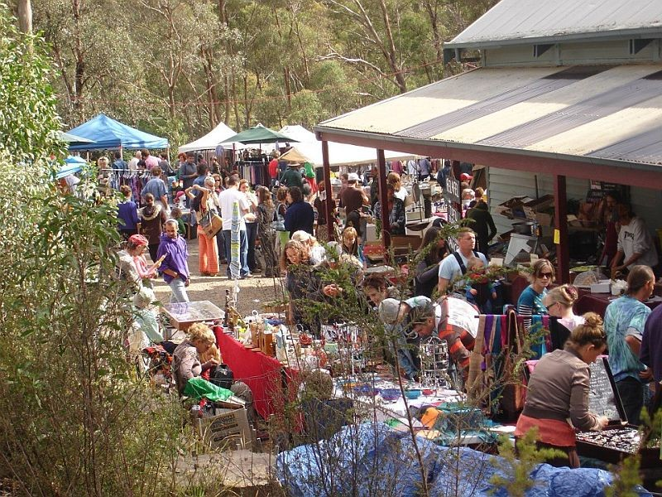
Figure 5. Photograph of the St Andrews Community Market. (Source: localfootconnect.org.ai)

DESCRIPTION
The St Andrews Hall at part of 1 Proctor Street, St Andrews comprises a hall and toilet block. The hall was built in 1925 by FJ Jennings for the Shire of Eltham. The toilet block was constructed c1975.
The St Andrews Hall and more recent toilet block is located on the eastern side of Burns Street, slightly to the south of the Scott Street intersection hugging the western corner of a bushy site (Figure 6). The Old Caledonia Gully runs north-west to south-east through the site, and the land slopes down towards the gully behind the buildings.
The St Andrews Hall building footprint is rectangular with northwest to southeast alignment, and sits to the western edge of the block surrounded by bush and a granitic carpark to the north and western sides. The toilet block with pyramidal roof and, comprising a square footprint, sits on a similar alignment across a driveway south of the hall (Figure 7).

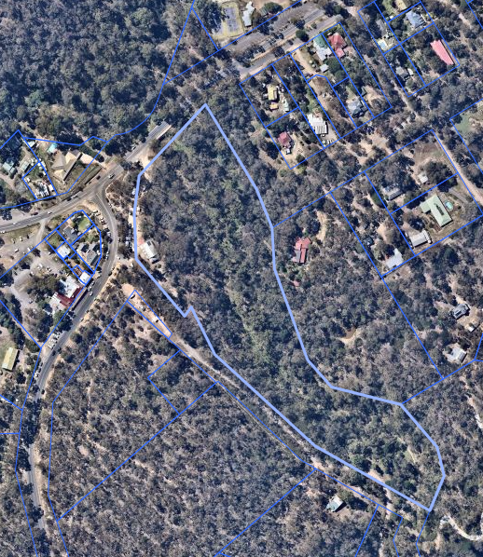
Figure 6. The subject site is highlighted in lighter blue. The hall and toilet block are circled in yellow. (Source: Nearmap 2021)
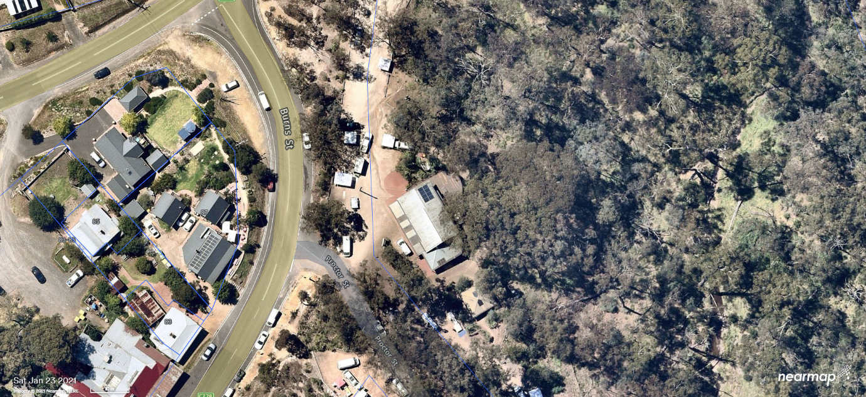
Figure 7. Aerial photograph showing the hall and toilet block, and carpark. (Source: Nearmap 2021)

The St Andrews Hall is of simple vernacular hall design. The simple high pitched gable roof is clad in corrugated iron, eaves have slight overhang with exposed double rafters. The additions to the rear of the building sit under a low-pitched roof which extends beyond the walls to form a verandah supported by simple timber posts (Figure 9). This verandah connects to the verandah to the western side of the building. Red brick paving sits below the western verandah (Figure 10 and Figure 11). The external walls are clad in weatherboards.
Main entrances to the hall are via a double and single doorway on the western elevation, double doorway on the northern elevation. A timber ramp with timber balustrade and metal railing extends along the southern side to a doorway at the rear (Figure 2 and Figure 10).

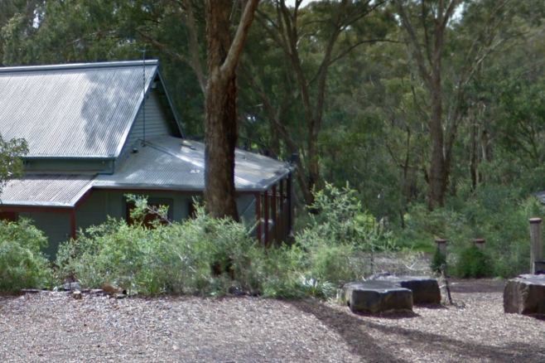  Figure 9. Kitchen addition to the rear of the building. (Source: Google Streetview 2016) | 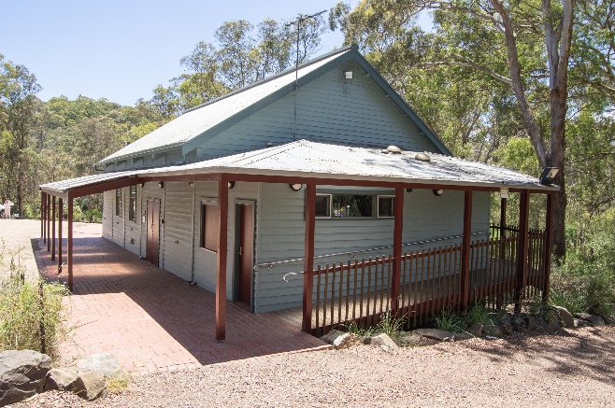  Figure 10. Rear of the hall, including ramp and kitchen addition. (Source: Context 2020)

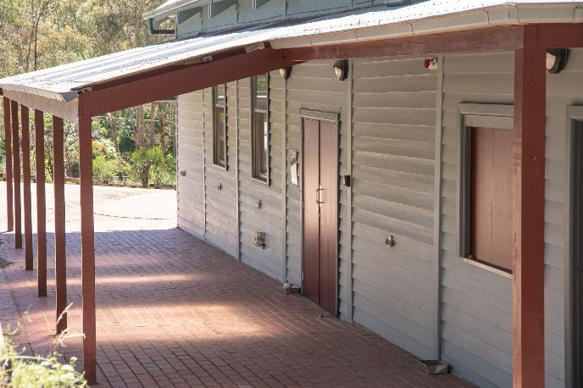  Figure 11. Corrugated iron verandah supported by timber posts over red brick paving. (Source: Context 2020) | 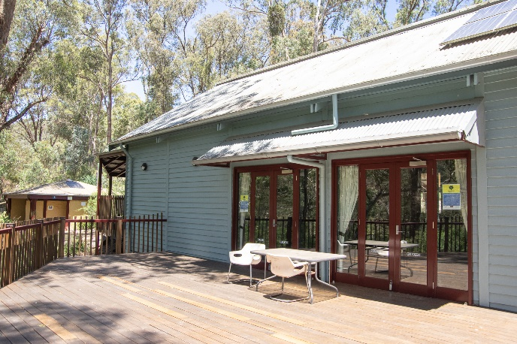  Figure 12. timber decking and row of glazed doors with shallow corrugated awning. (Source: Context 2020)

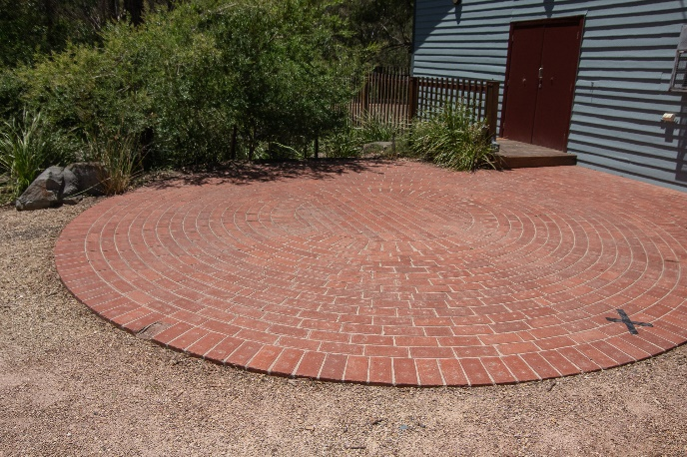  Figure 13. Red brick paving circle at the northern end of the building (Source: Context 2020) | 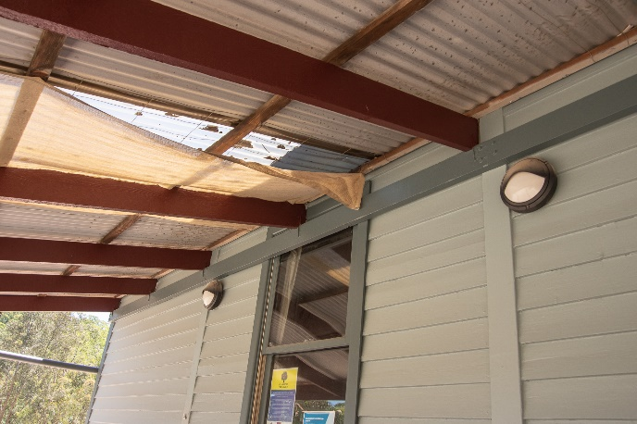  Figure 14. Window, corrugated iron and translucent polycarbonate clad verandah. (Source: Context 2020)

The pyramid roofed mudbrick toilet block is square in footprint with corrugated roof cladding and is located downslope behind a retaining wall (Figure 15).

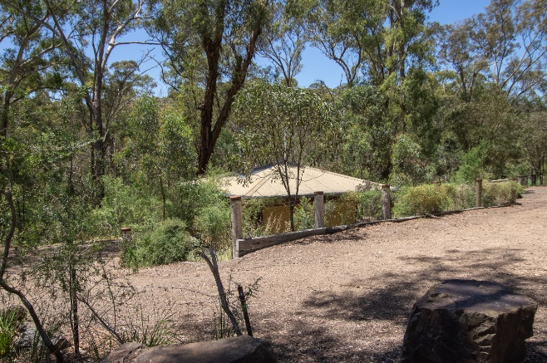  Figure 15. The toilet block sitting below a retaining wall. (Source: Context 2020) | 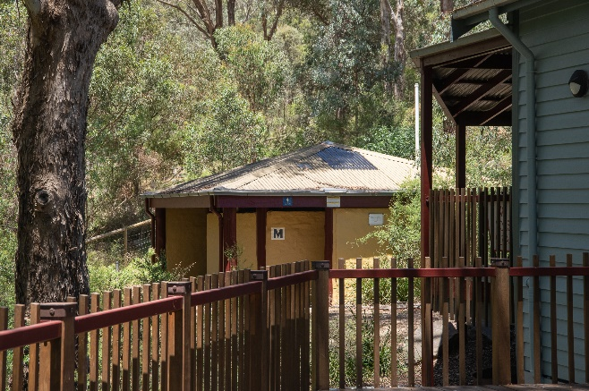  Figure 16. The toilet block viewed from the verandah to the rear of the building. (Source: Context 2020)

A community noticeboard and signage for the St Andrews Market sit beside the road (Figure 17 and Figure 18).
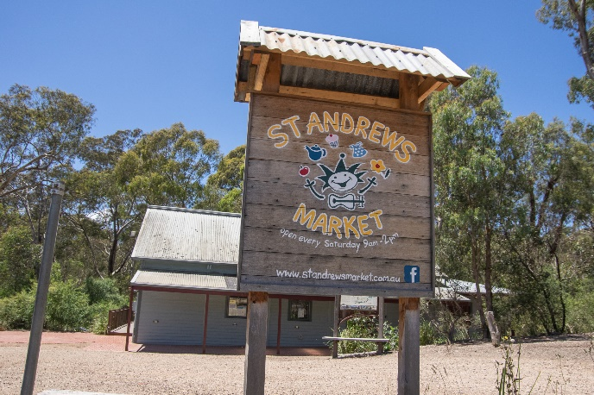  Figure 17. St Andrews Market sign (Source: Context 2020) | 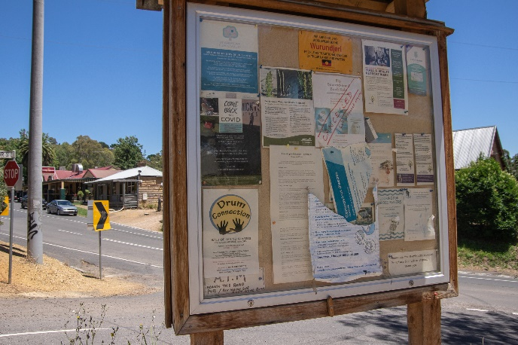  Figure 18. Community noticeboard. (Source: Context 2020)

INTEGRITY
The St Andrews Hall at part of 1 Proctor Street, St Andrews, is generally intact with changes visible to original or early fabric. The hall building retains its original form, with high pitched gable roof. The building also retains its prominence as a local landmark. Windows appear to have been replaced and some fenestrations altered. The addition to the rear (south) is legible as an extension with a different roof pitch.
Additions and extensions support the continuing use of the place as a community hall.
Overall, the building has fair integrity with its early form as an interwar hall remaining legible.

COMPARATIVE ANALYSIS
Halls in townships are important community infrastructure insofar as they are places that facilitate large gatherings of community members. In the nineteenth century, halls in the Nillumbik area typically took the form of mechanics’ institutes and free libraries. The mechanics’ institute movement had emerged in Scotland in 1900 with the intention of improving the education of working men. In Australia, these institutes were constructed with Government funding. From 1860 Government grants were available and from 1887 these were directed to the construction of free libraries (Mills & Westbrooke 2016: 103).
From the twentieth century mechanics institutes were beginning to lose popularity, and some began to be used for other functions more aligned with amusement and recreation. The title of ‘mechanics’ institute’ was typically given to halls whether existing, renovated, or newly constructed.
There are two early halls already listed on the Nillumbik Shire Heritage Overlay. Yarrambat Memorial Hall is outside HO but listed on Victorian War Heritage Inventory (VWHI).
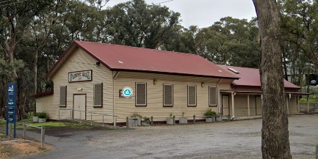  Plenty Hall, 103-107 Yan Yean Road, Plenty (HO248). (Source: Google Streetview) | Constructed in the 1930s, Plenty Hall is significant for its long association with community gatherings, celebration and activities in the Plenty farming area. The hall is one of a group of much valued civic structures in the immediate area (VHD). The hall has a simple rectangular form with a gable roof. Additions are observed at the rear and side elevations.
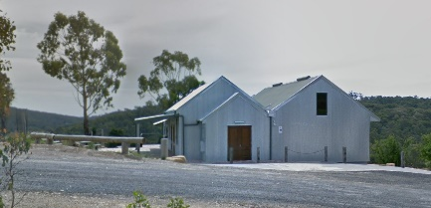  Christmas Hills Mechanics Institute and Free Library, later Harold Muir Hall, 787 Ridge Road, Christmas Hills (HO243). (Source: Google Streetview) | Christmas Hills Mechanics Institute and Free Library, later part Harold Muir Hall is significant as a long-standing public building in the Christmas Hills locality. It is one of the oldest mechanics institutes in the Shire. It also forms part of a significant building group, including the (1st) Daltheith, Former Christmas Hills Post Office Store (HO177) and Christmas Hills War Memorial (also assessed as Individually Significant in this study), each having had a major role in the local community (VHD). The hall has a multi-gable roof with iron cladding. Some changes are visible.

Discussion
St Andrews Hall compares well with other examples of community halls in the Nillumbik Shire Heritage Overlay. Architecturally the hall is of typical simple rectangular, gabled-roofed form and weatherboard construction. St Andrews Hall compares well with the above examples in form and purpose. With its simple form with a gable roof, the subject hall compares particularly well with the Plenty Hall, 103-107 Yan Yean Road, Plenty (HO248), which is still being used for community gatherings, celebration and activities in the Plenty area. Importantly, the hall demonstrates the pursuits and aspirations of communities who sought to provide places of community learning, social interaction and gathering. Like St Andrews Hall, the above HO-listed examples also display some changes.
The St Andrews Hall’s vernacular form with steep pitched gable roof has been retained. Additions are part of its ongoing functionality and the need to accommodate changing community needs. It is tangible evidence of the interwar development of the St Andrews township. It is also important for its legible original form, prominence as a local landmark and association with community gatherings, celebration, and as a base for emergency services and community healing.

STATEMENT OF SIGNIFICANCE

WHAT IS SIGNIFICANT?
The St Andrews Hall at part of 1 Proctor Street, St Andrews, a community hall built in 1925 by F J Jennings, is significant.
Elements that contribute to the significance of the place include:
- original form, high-pitched gabled roof and scale of the hall;
- weatherboard materiality;
- its ongoing use for the St Andrews market for over 40 years; and
- its use as an emergency base and place for community healing

HOW IS IT SIGNIFICANT?
The St Andrews Hall at part of 1 Proctor Street, St Andrews, is of local historic and social significance to the Shire of Nillumbik.

WHY IS IT SIGNIFICANT?
The St Andrews Hall at part of 1 Proctor Street, St Andrews is of historical significance for the association with the development, welfare and advancement of the St Andrews community. It is also historically significant having held the St Andrews community market for over 40 years. The community hall is representative of the vernacular hall form of the early twentieth century. Modest in its construction, and despite later alterations, it remains legible and is a good example of the type. (Criterion A)
The St Andrews Hall at part of 1 Proctor Street, St Andrews is socially significant as the focus of community activities and recreation. St Andrews Hall today is also used for various gatherings, social interaction and learnings, for celebration of special occasions such as weddings and birthdays. It continues to be used for community meetings and St Andrews Community Market stallholders make use of the space every Saturday. (Criterion G)

RECOMMENDATIONS
Recommended for inclusion in the Schedule to the Heritage Overlay of the Nillumbik Planning Scheme as an Individually Significant place.
Extent of overlay: Extent of Heritage Overlay is recommended to allow 10 metres curtilage to the north and east of the buildings and continues the curtilage to the street boundaries to west and south, as indicated by the blue shaded area. Refer to the map below.
Recommendations for the Schedule to the Heritage Overlay (Clause 43.01) in the Nillumbik Planning Scheme:

Nillumbik Planning Scheme
External paint controls | No
Internal alteration controls | No
Tree controls | No
Outbuildings or fences | No
To be included on the Victorian Heritage Register | No
Prohibited uses may be permitted | No
Aboriginal heritage place | No

Other
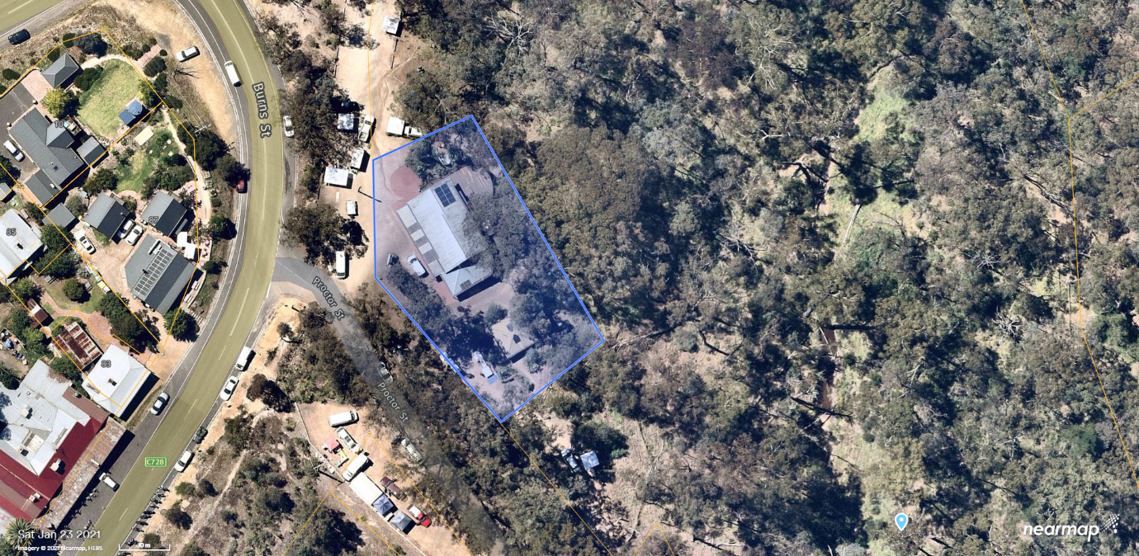
Figure 19. Recommended extent of the Heritage Overlay (blue). (Source: Nearmap 2021)

REFERENCES
Advertiser, as cited.
Argus, as cited.
Blake, Leslie J (ed) 1973, Vision and Realisation: A centenary History of State Education in Victoria Volume 3, Melbourne, Education Department of Victoria.
Butler, Graeme, and Associates 1996, ‘Nillumbik Shire Heritage Review – Environmental History’, Prepared for the Shire of Nillumbik.
Butler, Graeme, and Associates 2006, ‘Heritage Assessments, Shire of Nillumbik Amendment C13’, Prepared for the Shire of Nillumbik.
Eltham and Whittlesea Shires Advertiser and Diamond Creek Valley Advocate, as cited.
Eltham District Historical Society 2000, A Chronology of Known Local Events 1835-early 2000 Including those in the Shire of Nillumbik and the former shires of Eltham and Diamond Valley, Eltham District Historical Society Incorporated.
Evelyn Observer and South and East Bourke Record, as cited.
Local Food Connect n d, ‘St Andrews Community Market’, https://localfoodconnect.org.au/, accessed online May 2021.
Mills, Peter & Westbrooke, Samantha 2017, ‘Nillumbik Shire Thematic Environmental History – Revision 2016’, prepared for Nillumbik Shire Council.
Nearmap, as cited.
Nillumbik Shire 2020, ‘History of the Shire’, https://www.nillumbik.vic.gov.au/, accessed online 23 November 2020.
Nillumbik Shire Council 2015, ‘Nillumbik Heritage Guide’.
Public Record Office of Victoria (PROV) 1925-85, Public Building File, ‘St Andrews Hall Main Road’, VPRS 7882/P1, unit 302.
Queenstown Township Plan 1951, Melbourne, Department of Crown Lands and Survey.
Queenstown Parish Plan 1925, Melbourne, Department of Lands and Survey.
Reynolds, Pat nd, ‘A Short History of the St Andrews Hall’, Wadambuk St Andrews Community Centre, https://www.standrewscommunitycentre.org, accessed online 4 April 2021.
St Andrews Primary School Council 1998, A Village Built on Gold: A History to Present Times of St Andrews and District, St Andrews, St Andrews Primary School Council.
St Andrews/Queenstown Historical Society undated, ‘Historical information’, Wadambuk St Andrews Community Centre, https://www.standrewscommunitycentre.org, accessed online 20 November 2020.
Sears’ Studios 1926, ‘Royal Mail coach with passengers, parked outside Post-Office and St Andrew's Hotel, Buggy parked in front. A survival of the good old coaching days at Queenstown, Vict’, State Library Victoria (SLV), accessed online 10 December 2020.
Township of Queenstown 1951, Melbourne, Department of Lands and Survey
‘Victorian Gold Project: Historic Gold Mining Sites in the St Andrews Mining Division’ 1999, Melbourne, Department of Natural Resources and Environment.
Victorian Places 2015, ‘Eltham North’, Monash University and The University of Queensland, https://www.victorianplaces.com.au/, accessed online 10 December 2020.

