Title: 466 Ironbark Road, Yarrambat
Prepared by: Trethowan Architecture

Address: 466 Ironbark Road, Yarrambat
Name: Former Yarrambat General Store | Survey Date: February 2022
Place Type: House, shop | Architect: Unknown
Grading: Significant | Builder: Unknown
Extent of Overlay: To property boundary | Construction Date: C1877-1885 (house), and 1920s (shop)

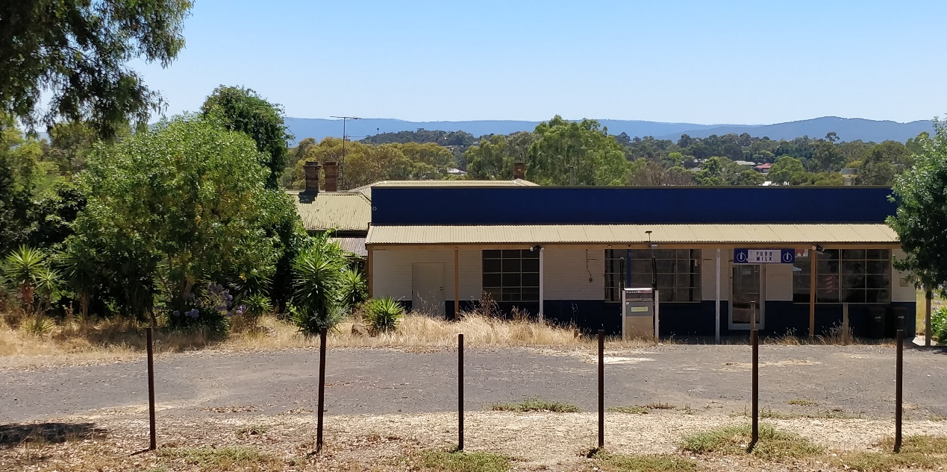

Historical Context
Land to the west of Yan Yean Road, in the Parish of Marong, was sold at Crown land sales between 1840 and the early 1850s (Morang Parish Plan) The gold rushes brought an increase of population to the Diamond Valley and in their wake came the selectors who under the Selection or Land Acts of the 1860s, were able to purchase small holdings of land with the proviso that they improve them by clearing, fencing and building. Yarrambat, originally known as Tanck's Corner had a couple of gold rushes, one before 1860 and the other after 1900. However not enough gold was found to create a thriving township. The town was therefore primarily established by selectors. From the early 1860s commons were set up to allow settlers to graze livestock on Crown Land. The Greensborough Farmers’ Common was gazetted in 1861. The land in the common was described as “mostly Stringy Bark Forest & barren” (Greensborough Farmers’ Common File 907755, Item 21, Unit 892, VPRS242, PROV, Argus, 26 February 1861)

The lots on the north and south sides of Ironbark Road were the first to be taken by selectors Frederick Tanck and Thomas Reynolds in the early 1870s under sections 19 and 20 of the Land Act 1869, and they obtained their grants in the mid-1870s. Tanck’s Corner was a T-intersection where Ironbark Road meets Yan Yean Road. While the first land acts where mainly tailored to selection of blocks of viable farm size, gold miners and their associated service population lobbied for a system allowing small-holdings which would allow food gardens and keeping a horse and cow. Provision was soon made in the land acts for a system of occupation licenses for small areas of Crown land in auriferous areas. The resulting occupation licences on auriferous land, which were limited to twenty acres, were first introduced under Section 42 of the Land Act 1865. As gold was found in the area north of Nillumbik (Diamond Creek) relatively late, in the Tanck’s Corner locality twenty- acre occupation licenses were first taken up under Section 49 of the Land Act 1869. The first Section 49 licenses in the Tanck’s Corner area were taken up from c1883 (‘Greensborough County of Evelyn’, 1884).318 These were close to the eastern edge of the auriferous land, next to Tanck’s and Reynolds’ selections. Further licenses were progressively taken up under Section 65 of the Land Act 1884 over the whole of the auriferous area north of Nillumbik (Mills 2013).

While the occupation licenses did not at first allow for eventual alienation of the auriferous land, under political pressure allowances were made for purchase after a period of lease if it could be shown that mining was unlikely to occur in the future. The first alienations of twenty-acre lots near Tanck’s Corner occurred in the late 1880s, with alienation occurring gradually on the remaining twenty-acre lots into the 1920s (Mills 2013). This process of occupation also eventually led to the demise of the Greensborough Farmers Common, despite resistance by surrounding farmers (Argus, 14 March 1879:3). The Common was officially abolished in 1907 (Victoria Government Gazette, 10 July 1907, No.86 p.3330).

In the broad swathe of over 800 twenty-acre license holdings stretching from Nillumbik (Diamond Creek) to the north-east of St Andrews (Queenstown), the conjunction of these small lots and the hilly and relatively unfertile lands of the auriferous areas was a major stimulus to the establishment of the orcharding industry which was the mainstay of the area’s economy well into the twentieth century. A large proportion of the catchment population of the Tanck’s Creek/Yarrambat population made their living this way. The Tanck’s Corner school, which had opened in 1878 in response to the influx of selectors, closed in 1892, possibly because surrounding land was increasingly being bought for speculation (Butler 1996, p45; Hooper, 1978, p 8). The locals petitioned for reopening, at one stage listing forty-eight children within one-and-a-half miles of Tanck’s Corner (Hooper 1978:33). The reopening in c1900, along with the establishment of postal service and store around the turn of the century, was related to this new and intensive form of settlement.

Many of the people whose names became associated with Yarrambat did not settle there until the 1880s or 1890s. Henry Montague Pepper, with his wife and family, took up their selection in 1889. Thomas Collins, who had lived in Diamond Creek, moved with his wife to Yarrambat to start an orchard in 1886. Another early family, the Stuchbery's, did not select their land, but bought two acres of the Oatlands Estate in 1890. On the banks of the Plenty River, together with their twelve children, they established a market garden and built a house, dairy and stable. The name of the town was officially changed to Yarrambat in 1929. It is unknown why the name was changed however Yarrambat is named from an Aboriginal word meaning "high hills" or "pleasant views".

For a long period of time community life in the township centred on the school, which opened in 1878 on land donated by Thomas Reynolds. Although there was a blacksmith's shop and store at Yarrambat, the school was the only community building until the 1940s, when the fire station was built in 1947 (replaced in 2001) and the Yarrambat Hall in 1948. Parishioners of St Michaels, who met in the school, prior to having a dedicated church of their own, worked from the 1930s to clear land and build their Church. It was officially opened in 1954. The original school building has been moved to Yarrambat Heritage Park (located adjacent to Yarrambat Golf Course).

History
Frederick Tanck was the first purchaser of the land on which this site is situated, and the namesake of Tanck’s Corner, the area now known as Yarrambat. The land was transferred to Margaret Bird on 29 September 1877 (CT: V984 F196757). Margaret’s husband Charles was described variously as a builder and bricklayer (CT: V984 F196757 and Argus 31 May 1878:2). It is possible that he built a brick dwelling at this time. Margaret sold the land to Samuel Jackson in 1879, and when he died in 1885 it was transferred to his wife Ellen Jackson (CT: V1095 F218932). The 1885 Valuation Book for the Greensborough Riding reveals that the property included a four-bedroom brick house with kitchen (VB 1885). The Valuation Book indicates that brick was a very uncommon material for a house at this time. The timeframe for the building of the brick residence on Parcel E7 appears to be the eight years from 1877 to 1885; aligning with Charles Bird’s expertise as a builder and bricklayer.

Up until c1927 the local post office and store were located south of Ironbark Road. From 1927 the Post Office at Tanck’s Corner operated from the thirty-acre lot north of Ironbark Road, purchased by Mr and Mrs Craig in 1922 (CT: V3398 F679494). This corresponds to the date at which the service became a post office rather than a receiving office. In 1931 the post office is described as a separate building on the Craig’s land, fronting Ironbark Road (Advertiser (Hurstbridge) 27 March 1931:2). In 1935 the post-office also became a telephone exchange (Advertiser (Hurstbridge) 7 June 1935:5).

The Craig’s sold the property to the Dowels 1940 (CT: V3398 F679494). With the involvement of Mrs Dowell this post-office store became the terminus of the new bus service from Greensborough in July 1941 (E&WSA 21 February 1941:3; 18 July 1941:1; 21 August 1942:3). The Dowels soon made a number of “improvements”, including introducing a shop to the post office and removing pines and an acacia hedge (E&WSA 25 October 1940:3).

In August 1941 it was reported that Mr L. Dowel had made another improvement in the form of additions to their residence. The store and post office businesses were increasing, with the latter indicated by an increased “allowance”, presumably from the Post Master General’s Department (E&WSA 8 August 1941:1). In 1947 the lot was subdivided into two; the block on which the residence and store are located, was acquired by Ercil Damar Fellowes (CT: V3398 F679494), described as being from Plenty Post Office, Plenty (CT: V7733 F040).

The store building was extended in 1956 and later in 1970 (BP). Examination of the early photo shows that one of these extensions altered the front elevation by replacing timber extensions with a new brick section including a third display window. The site ceased to serve as the Post Office during the latter part of the 20th Century, with the service returning to the south side of Ironbark Road opposite. The site continued to function as a general store.

The house underwent extensive additions in 1987 (adding some 100 sqm metres) (BP) to the original four roomed Victorian house. The additions used modern bricks and some renovations also occurred to the original building, including its re-roofing to match the extension. The entire northern side wall of the original house has been rebuilt.

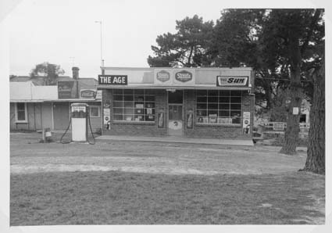
Figure 1: ‘Yarrambat Post Office’ c1950s. The timber section at the west (left of image) has been replaced with another brick bay. The pine trees have also been removed. Source: National Archives photograph, image B5919 2389.

Description & Integrity

House
The house at 466 Ironbark Road is a simple four-roomed brick Victorian Italianate styled structure with a large modern brick extension at the rear (north-east). It has an M-shaped roof to the original four rooms and features a skillion roofed verandah on the front (west) and south elevations supported on timber posts. The roof form and verandah appear to be original with later corrugated metal roof cladding. The house is clad in face-brick, which appears to be a later alteration dating from the same time as the addition. The house features typical details for the period of its construction, including two chimneys, a panelled front door hung in a door case with side and highlights, and double hung timber windows. A second door has been installed to the front room at the south in place of a front window. The plan features a central passage with two rooms accessed from each side. There are no distinctive interior features.

The 1987 addition at the north-east is constructed of brick with a gable roof clad in later corrugated metal (the same as the original residence). It features aluminium windows and a brick chimney constructed to match those of the old house.

The integrity of the house is low, with very limited original details and evidence of the Italianate style. The entire north wall, including windows, is later; the verandah posts, floor and roof are later alterations; a front window has been replaced with a door; the brick wall cladding and corrugated metal roof cladding are both later.

Shop
A covered walkway connects the house to the store, located to the south. The store is a simple brick structure with a skillion roof. The original building dates from c1920s and has been extended twice (1950s and 1970s) to the west and north making a much larger structure. It features a simple verandah running across the front (south) elevation and three sets of large multi-paned windows. The window furthest to the west forms a later addition; the original section is denoted by the central window, door and east window.

The integrity of the shop is compromised by the later additions, although the original form and appearance remain legible. There are no notable architectural features related to the inter-war construction period, or the later alterations.

Site
A driveway at the south-west provides vehicle access to an open parking area and fuel pump in front of the store, and there is a smaller driveway leading to the front (west) of the house. There is a row of mature trees along the street frontage and smaller plantings surrounding the carpark, shop and house. The site is otherwise open to the north, with no additional structures or mature landscaping of note.

The site has been an important social centre in Yarrambat for nearly 100 years. It forms part of a core of commercial and civic functions including the Primary School and St Michaels Church across the road.

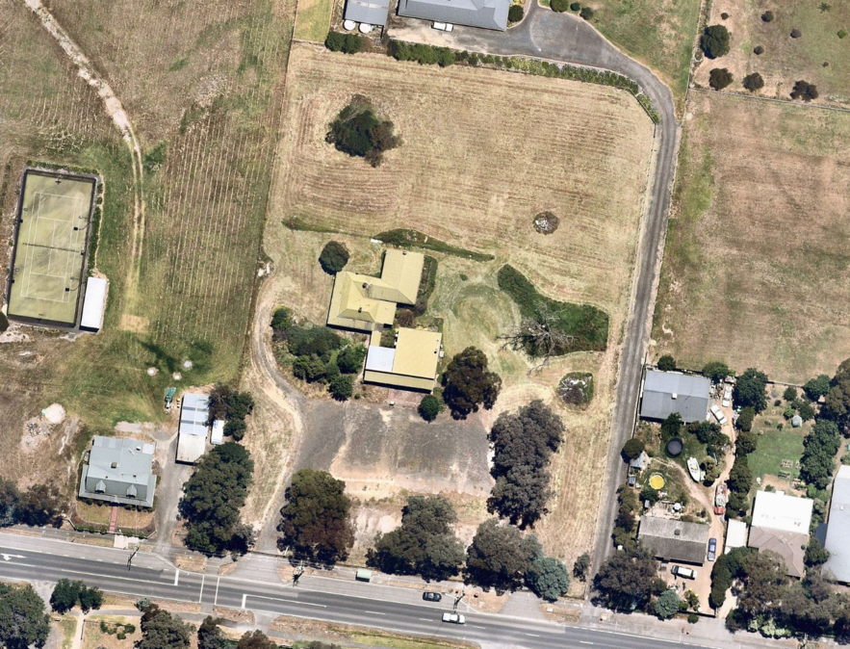
Figure 2: Aerial view of 466 Ironbark Road, Yarrambat (outlined in red) dated 24 December 2021. The house is indicated in yellow and the shop in blue. Source: Nearmap, accessed March 2022.

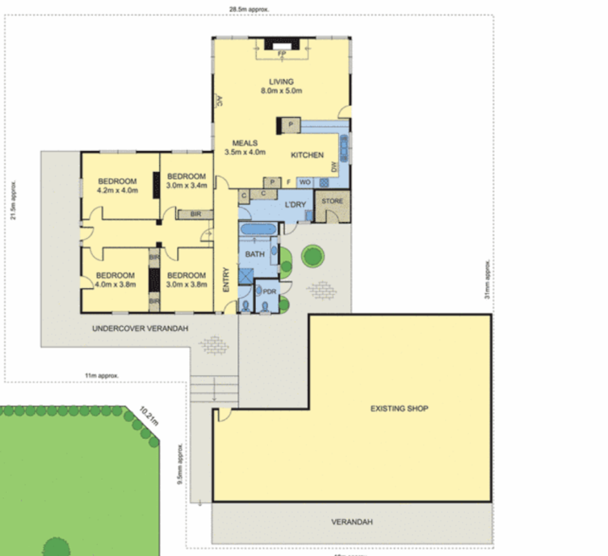
Figure 3: Floor plan showing the original four roomed house (indicated in red) with rear extension and shop. Source: realestatte.com.au

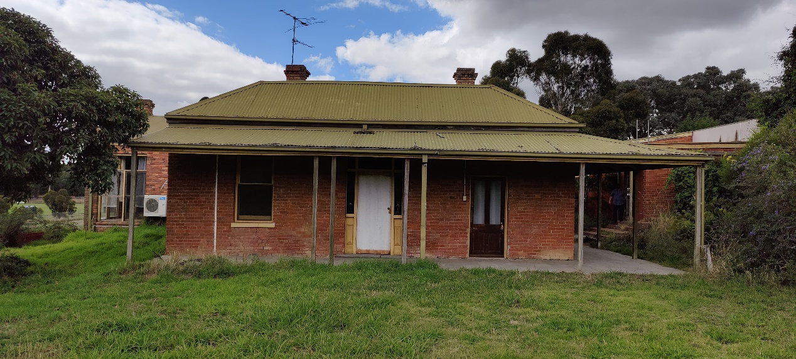
Figure 4: Front (west) elevation of the house. Note the original brick chimneys and the later door at the southern front room. Source: Trethowan Architecture, 2022.

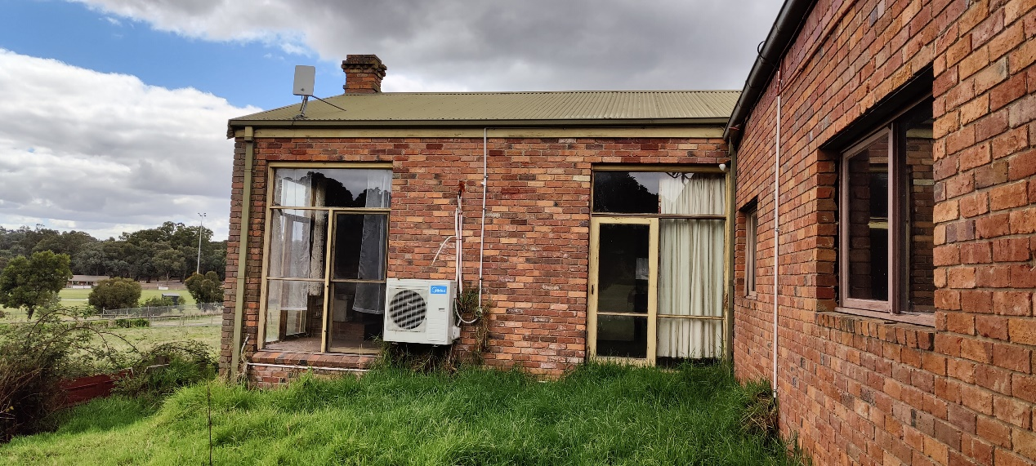
Figure 5: North elevation of the original house, looking east towards the rear extension. Note the matching brick wall cladding and roof sheet between the original and later parts of the house. Source: Trethowan Architecture, 2022.
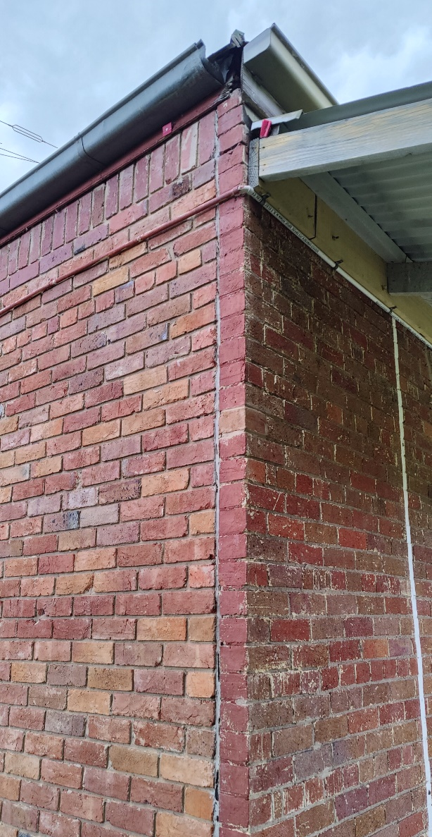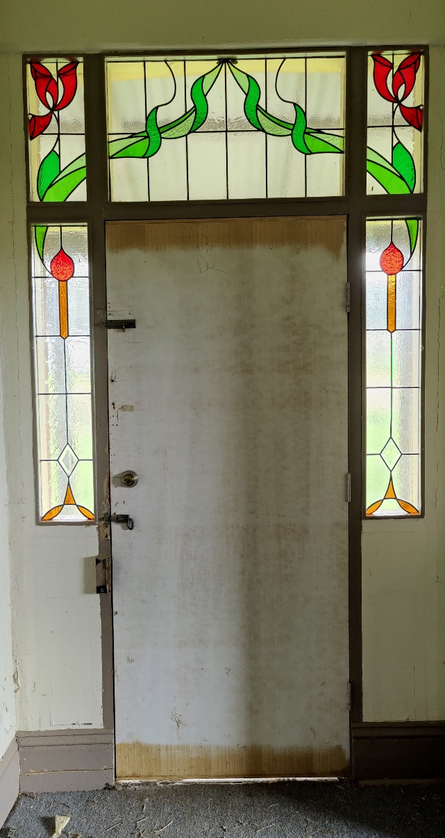

Figure 6: Joint between the new brick north wall (left) and earlier brick west wall. Source: Trethowan Architecture, 2022. | Figure 7: Interior view of front door, with later leadlighting. Source: Trethowan Architecture, 2022.

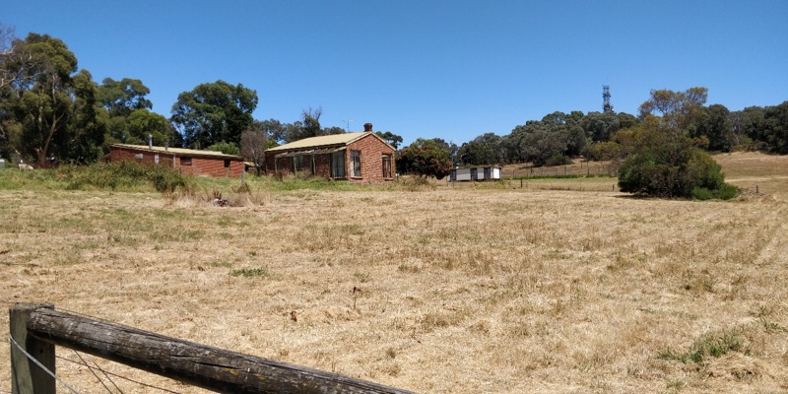
Figure 8: View of the house (right) and store (left) from the north-east. Source: Trethowan Architecture, 2022.

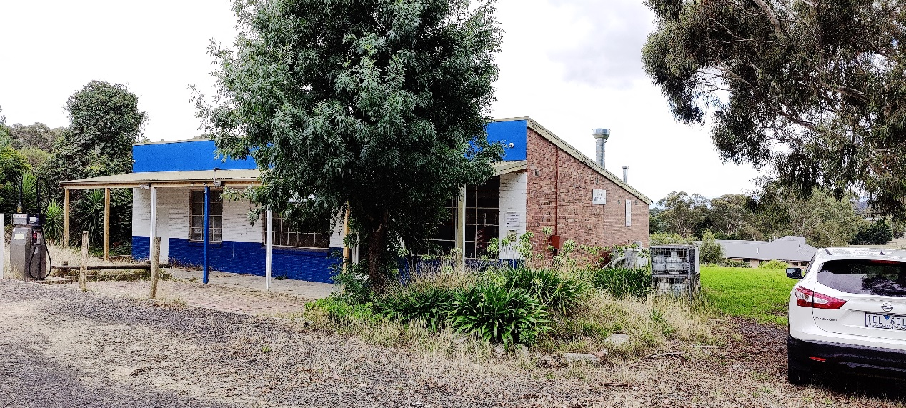
Figure 9: South (front) view of the shop. Note the skillion roof form and verandah. Source: Trethowan Architecture, 2022.
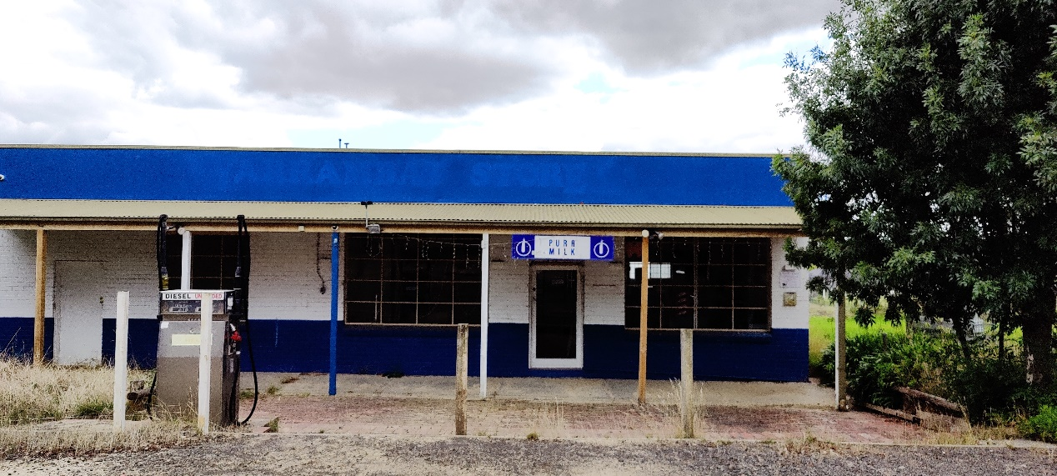
Figure 10: South (front) view of the shop. The original portion is delineated by the door and flanking multi-paned windows, with the later addition to the west (let). Source: Trethowan Architecture, 2022.

Comparative Analysis

The former Yarrambat General Store at 466 Ironbark Road, Yarrambat is a surviving example of a house and adjacent Post Office and shop within Yarrambat. It is located at the historic ‘Tanck’s Corner’ commercial centre nearby to the Yarrambat Primary School, St Michael’s Anglican Church, and the War Memorial Park.

Comparable examples of early mixed use commercial buildings incorporating post offices or attached residences that are included on the Heritage Overlay are as follows:

- Kangaroo Ground General Store & Post Office 280 Eltham-Yarra Glen Road, Kangaroo Ground. (HO48).
- Hurstbridge Post Office – Evelyn Observer Office, 794 Heidelberg-Kinglake Road, Hurstbridge (HO69).
- Former butcher’s shop & house, 919 Heidelberg-Kinglake Road, Hurstbridge (HO75).
- Weatherboard shop & dwelling, 956-958 Heidelberg-Kinglake Road, Hurstbridge (HO77).

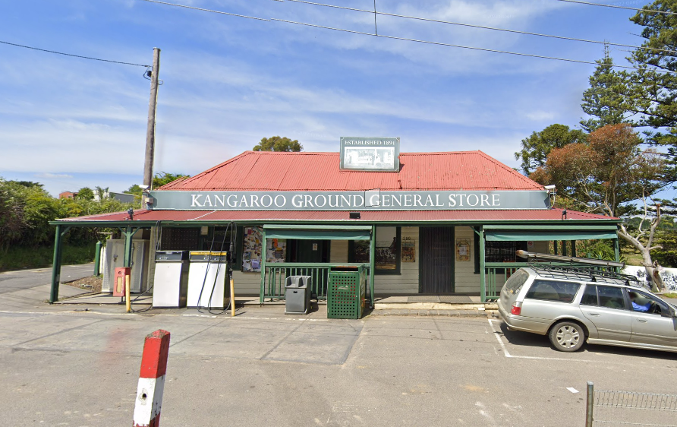  Figure 11. Kangaroo Ground General Store & Post Office 280 Eltham-Yarra Glen Road, Kangaroo Ground. (HO48). | 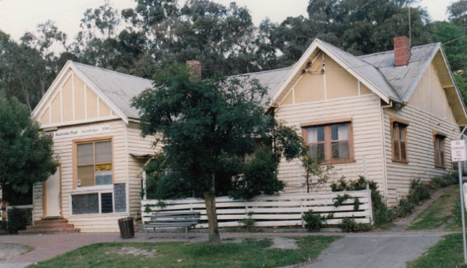  Figure 12. Hurstbridge Post Office – Evelyn Observer Office, 794 Heidelberg-Kinglake Road, Hurstbridge (HO69)
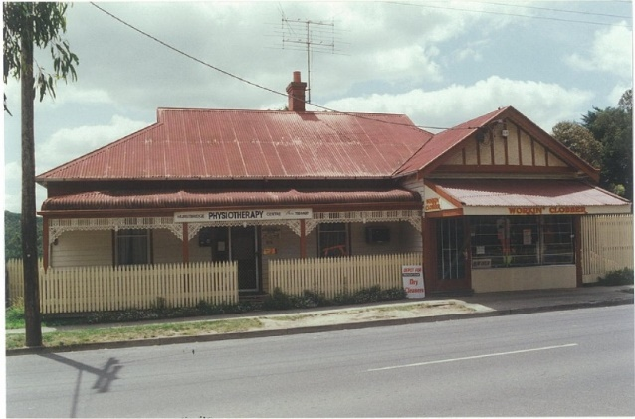  Figure 13. Former butcher’s shop & house, 919 Heidelberg-Kinglake Road, Hurstbridge (HO75) | 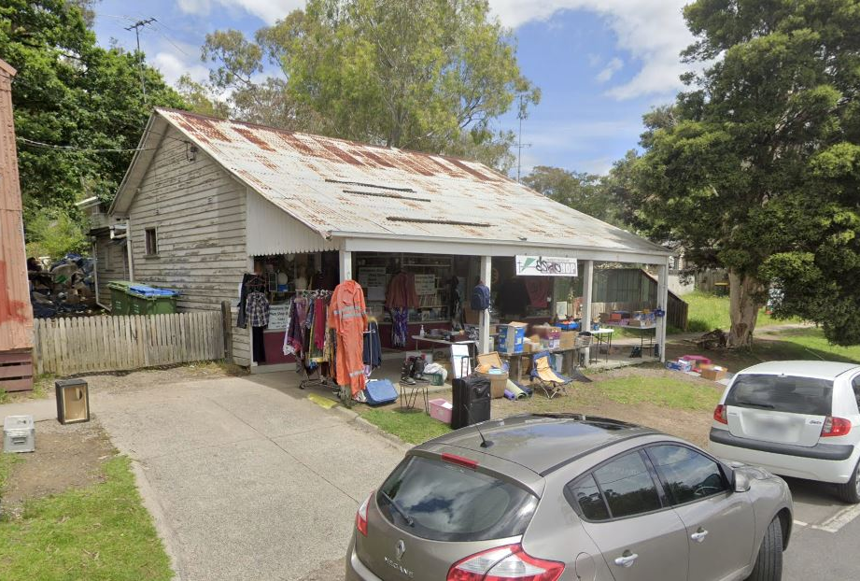Figure 14. Weatherboard shop & dwelling, 956-958 Heidelberg-Kinglake Road, Hurstbridge (HO77)

Kangaroo Ground General Store & Post Office 280 Eltham-Yarra Glen Road, Kangaroo Ground. (HO48) is historically significant as a centre of community and civic life since 1900, including its use for Council meetings. The site is also aesthetically significant as one of few well preserved public buildings in the Kangaroo Ground hamlet.

Hurstbridge Post Office – Evelyn Observer Office, 794 Heidelberg-Kinglake Road, Hurstbridge (HO69) is historically significant as it was constructed for the local newspaper. It is historically and socially significant as it has served as a post office since 1930, and forms part of a group of pre-1950s buildings in the town.

Former butcher’s shop & house, 919 Heidelberg-Kinglake Road, Hurstbridge (HO75) is historically and aesthetically significant as one of Hurstbridge’s most substantial commercial properties and an integral component of a cluster of 1910-1920s buildings in the centre of town. It is a rare example of a combined shop / residence.

Weatherboard shop & dwelling, 956-958 Heidelberg-Kinglake Road, Hurstbridge (HO77) is Historically and aesthetically significant as one of the earliest properties constructed after the arrival of the railway in Hurstbridge, illustrating the growth and change brought to the town. It is an integral part of the cluster of 1910-1920s buildings that characterise the centre of Hurstbridge.

Another comparable property that has been nominated for inclusion on the Heritage Overlay is the former Post Office and General Store at 920 Yan Yean Road, Doreen. It is an example of a 1930s development combining a store and residence and is representative of the early social and commercial centre of the township.

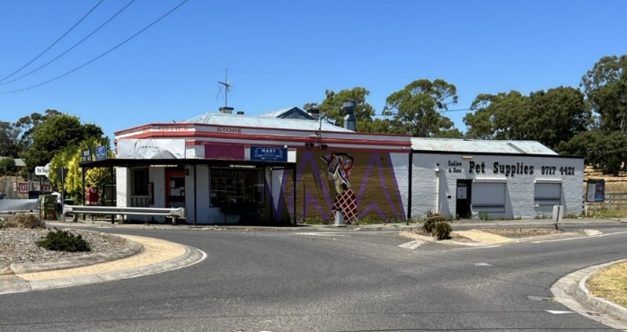
Figure 15. Former Post Office and General Store at 920 Yan Yean Road, Doreen (Recommended for HO)

The former Yarrambat General Store and residence at 466 Ironbark Road is comparable to these places in terms of its historical significance and association with the history of its locality. It is distinctive from these other examples as a brick residence from the Victorian-era, with an attached inter-war shop as well as post office. It is distinctive for the variety of services it provided for the community including the post office, fuel, general merchandise and food. The historic use of the place has ceased and it no longer provides services to the community.

Assessment Against Criteria

Criteria referred to in Practice Note 1: Applying the Heritage Overlay, Department of Planning and Community Development, revised July 2015, modified for the local context.

CRITERION A: Importance to the course or pattern of the Shire of Nillumbik’s cultural or natural history (historical significance).
The former Yarrambat General Store and residence is historically significant to the Shire of Nillumbik as a centre of commercial and civic life since the 1920s, including its former use as the Post Office and local general store. The form of the house and shop demonstrates its original historical identity, layout and use of the place as an early residence and a store in the locality. The house (c.1877) and store (c.1920s) are among the oldest extant structures in the locality of Yarrambat. The house is an early brick house in the area.

CRITERION B: Possession of uncommon, rare or endangered aspects of the Shire of Nillumbik’s cultural or natural history (rarity).
N/A

CRITERION C: Potential to yield information that will contribute to an understanding of the Shire of Nillumbik’s cultural or natural history (research potential).
N/A

CRITERION D: Importance in demonstrating the principal characteristics of a class of cultural or natural places or environments (representativeness).
The form of the house and shop as separate or detached forms is somewhat atypical of general stores and residences in the Shire, that tended to assume a more combined or attached plan.

CRITERION E: Importance in exhibiting particular aesthetic characteristics (aesthetic significance).
Both the residence and shop are heavily altered, with minimal original detailing. Only the footprint, chimneys and general form of the original Victorian-era house remain. There is no remaining evidence of the former Post Office function in the fabric of the shop, which appears as a roadside convenience store. The significance is therefore historical rather than architectural or aesthetic,

CRITERION F: Importance in demonstrating a high degree of creative or technical achievement at a particular period (technical significance).
N/A

CRITERION G: Strong or special association with a particular community or cultural group for social, cultural or spiritual reasons. This includes the significance of a place to Indigenous peoples as part of their continuing and developing cultural traditions (social significance).
N/A

CRITERION H: Special association with the life or works of a person, or group of persons, of importance in the Shire of Nillumbik’s history (associative significance).
N/A

Grading and Recommendations

Recommended for inclusion in the schedule to the Heritage Overlay of the Nillumbik Planning Scheme.

Recommendations for the Schedule to the Heritage Overlay (Clause 43.01) in the Nillumbik Planning Scheme:

External Paint Controls  Is a permit required to paint an already painted surface? | No
Internal Alteration Controls  Is a permit required for internal alterations? | No
Tree Controls  Is a permit required to remove a tree? | No
Victorian Heritage Register  Is the place included on the Victorian Heritage Register? | No
Incorporated Plan  Does an Incorporated Plan apply to the site? | No
Outbuildings and fences exemptions  Are there outbuildings and fences which are not exempt from notice and review? | No
Prohibited uses may be permitted  Can a permit be granted to use the place for a use which would otherwise be prohibited? | Yes
Aboriginal Heritage Place  Is the place an Aboriginal heritage place which is subject to the requirements of the Aboriginal Heritage Act 2006? | No

Identified By

Peter Mills & Samantha Westbrooke

References

Advertiser (Hurstbridge), as cited

Argus, as cited

Eltham & Whittlesea Shires Advertiser (E&WSA), as cited.

Greensborough Parish Plan.

Greensborough Riding Valuation Book 1885, Unit 1 VPRS 3657, PROV.

Land Victoria, Certificates of Title (CT), as cited

Rate Book for Greensborough Riding of Heidelberg Shire for 1892-3, Unit 5, VPRS 2870, PROV.

