Farmhouse, 52 Kurrak Road, Yarrambat
Prepared by: Trethowan Architecture, identified by Samantha Westbrooke

Address: 52 Kurrak Road, Yarrambat
Name: House, Farm. Fmr Golden Wealth Trotting Stud | Survey Date: February 2022
Place Type: Individual Place | Architect: Unknown
Grading: Significant | Builder: Unknown
Extent of Overlay: To property boundaries | Construction Date: c1916-20

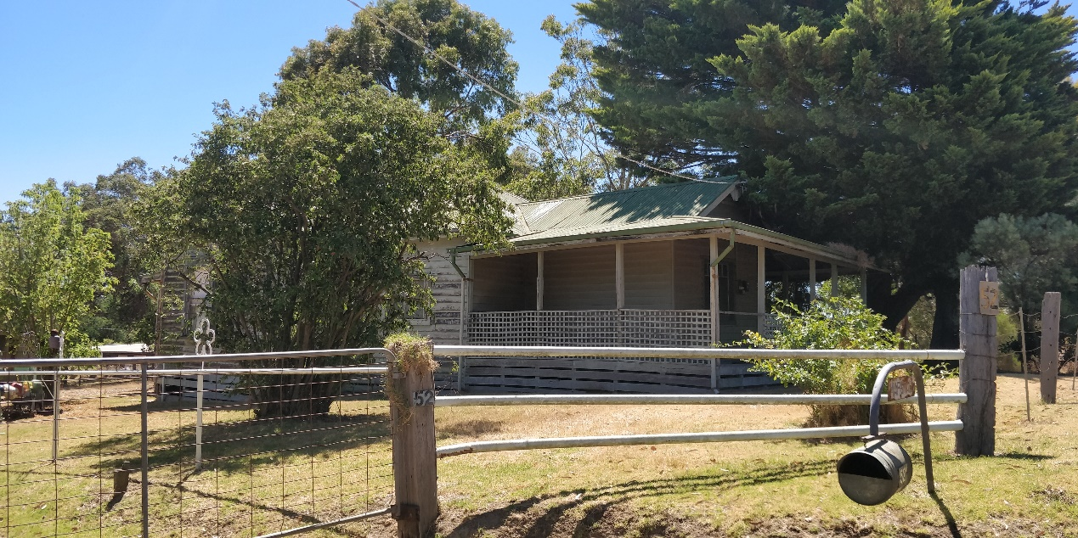

Historical Context

Land to the west of Yan Yean Road, in the Parish of Marong, was sold at Crown land sales between 1840 and the early 1850s (Morang Parish Plan) The gold rushes brought an increase of population to the Diamond Valley and in their wake came the selectors who under the Selection or Land Acts of the 1860s, were able to purchase small holdings of land with the proviso that they improve them by clearing, fencing and building. Yarrambat, originally known as Tanck's Corner had a couple of gold rushes, one before 1860 and the other after 1900. However not enough gold was found to create a thriving township. The town was therefore primarily established by selectors. From the early 1860s commons were set up to allow settlers to graze livestock on Crown Land. The Greensborough Farmers’ Common was gazetted in 1861. The land in the common was described as “mostly Stringy Bark Forest & barren” (Greensborough Farmers’ Common File 907755, Item 21, Unit 892, VPRS242, PROV, Argus, 26 February 1861)

The lots on the north and south sides of Ironbark Road were the first to be taken by selectors Frederick Tanck and Thomas Reynolds in the early 1870s under sections 19 and 20 of the Land Act 1869, and they obtained their grants in the mid-1870s. Tancks Corner was a T-intersection where Ironbark Road meets Yan Yean Road. While the first land acts where mainly tailored to selection of blocks of viable farm size, gold miners and their associated service population lobbied for a system allowing small-holdings which would allow food gardens and keeping a horse and cow. Provision was soon made in the land acts for a system of occupation licenses for small areas of Crown land in auriferous areas. The resulting occupation licences on auriferous land, which were limited to twenty acres, were first introduced under Section 42 of the Land Act 1865. As gold was found in the area north of Nillumbik (Diamond Creek) relatively late, in the Tancks Corner locality twenty- acre occupation licenses were first taken up under Section 49 of the Land Act 1869. The first Section 49 licenses in the Tancks Corner area were taken up from c1883 (‘Greensborough County of Evelyn’, 1884).318 These were close to the eastern edge of the auriferous land, next to Tanck’s and Reynolds’ selections. Further licenses were progressively taken up under Section 65 of the Land Act 1884 over the whole of the auriferous area north of Nillumbik (Mills 2013).

While the occupation licenses did not at first allow for eventual alienation of the auriferous land, under political pressure allowances were made for purchase after a period of lease if it could be shown that mining was unlikely to occur in the future. The first alienations of twenty-acre lots near Tancks Corner occurred in the late 1880s, with alienation occurring gradually on the remaining twenty-acre lots into the 1920s (Mills 2013). This process of occupation also eventually led to the demise of the Greensborough Farmers Common, despite resistance by surrounding farmers (Argus, 14 March 1879:3). The Common was officially abolished in 1907 (Victoria Government Gazette, 10 July 1907, No.86 p.3330).

In the broad swathe of over 800 twenty-acre license holdings stretching from Nillumbik (Diamond Creek) to the north-east of St Andrews (Queenstown), the conjunction of these small lots and the hilly and relatively unfertile lands of the auriferous areas was a major stimulus to the establishment of the orcharding industry which was the mainstay of the area’s economy well into the twentieth century. A large proportion of the catchment population of the Tancks Creek/Yarrambat population made their living this way. The Tanck’s Corner school, which had opened in 1878 in response to the influx of selectors, closed in 1892, possibly because surrounding land was increasingly being bought for speculation (Butler 1996, p45; Hooper, 1978, p 8). The locals petitioned for reopening, at one stage listing forty-eight children within one-and-a-half miles of Tancks Corner (Hooper 1978:33). The reopening in c1900, along with the establishment of postal service and store around the turn of the century, was related to this new and intensive form of settlement.

Many of the people whose names became associated with Yarrambat did not settle there until the 1880s or 1890s. Henry Montague Pepper, with his wife and family, took up their selection in 1889. Thomas Collins, who had lived in Diamond Creek, moved with his wife to Yarrambat to start an orchard in 1886. Another early family, the Stuchbery's, did not select their land, but bought two acres of the Oatlands Estate in 1890. On the banks of the Plenty River, together with their twelve children, they established a market garden and built a house, dairy and stable. The name of the town was officially changed to Yarrambat in 1929. It is unknown why the name was changed however Yarrambat is named from an Aboriginal word meaning "high hills" or "pleasant views".

For a long period of time community life in the township centered on the school, which opened in 1878 on land donated by Thomas Reynolds. Although there was a blacksmith's shop and store at Yarrambat, the school was the only community building until the 1940s, when the fire station was built in 1947 (replaced in 2001) and the Yarrambat Hall in 1948. Parishioners of St Michaels, who met in the school, prior to having a dedicated church of their own, worked from the 1930s to clear land and build their Church. It was officially opened in 1954. The original school building has been moved to Yarrambat Heritage Park (located adjacent to Yarrambat Golf Course).

History

Crown Portion 5 Parish of Morang, 820 acres, was purchased from the Crown by Alexander McKillop in 1840 (Morang Parish Plan). It seems the land had already been subdivided by 1864 (Argus 6 October 1864:1). Between 1875 and 1880 three owners are listed for the land (CT: V770 F907 and CT:V774 F669). It was then further subdivided on several occasions between 1880 and 1906 (CT: V1167 F751 and CT:V3098 F446).

William Henry Dyson, orchardist of South Morang, purchased the land in 1916 (CT: V3125 F918). The house may have been constructed at this point, as it appears to be shown on the 1920 topographic map (Cth Dept. of Defence, 1920).

Walter Marshall, builder of Preston, purchased the land in 1920. When he died in 1927 probate was granted to his wife Mary Harriet and their son Charles Doiley Marshall (CT: V3125 F918). A 1930 topographic map shows the house close to the southeast corner of the lot and orchards over the southern half of the 20 acres (Australian Section, Imperial General Staff, c1930).

When Charles Marshall died in 1949, probate was granted to his son Walter Arthur Marshall (CT: V3125 F918 and Argus 11 January 1949:9). Walter, a clerk, and his brother Ronald Charles Marshall, poultry farmer, both of Yarrambat, owned the land from 1958 (CT: V8198 F:346). The Marshalls branched out into training, driving and breeding horses for harness racing. The Stud was called the Golden Wealth Trotting Stud. A 1974 aerial photograph shows a training track over most of the lot, with two other such tracks on the south side of Brown’s lane; there is no evidence of the orchards shown on the 1930 topographic map (Dept. Crown Lands & Survey, 1974). A sign with the Marshall name still stands at the front of the property.

Description & Integrity

52 Kurrak Road, Yarrambat is a former farm complex located on the north side of Kurrak Road. The c.1916-1920 weatherboard farmhouse is located close of the road, east of a central driveway. A corrugated iron-clad shed is located to the west of the driveway. There are several other large sheds and structures to the rear of the residence and front shed.

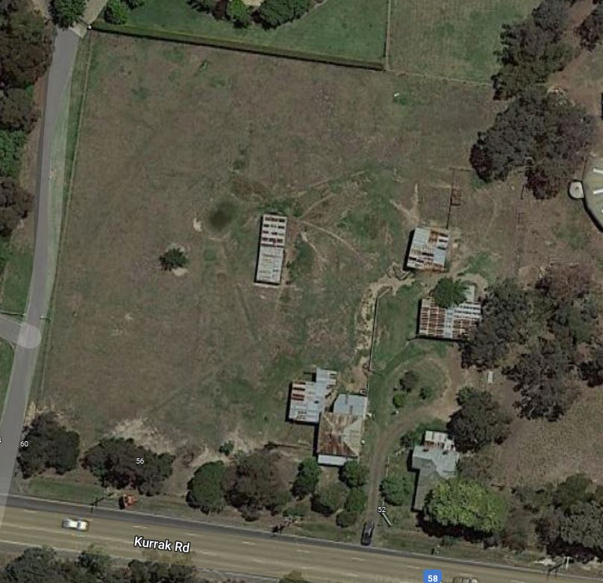
Figure 1: Aerial view of 52 Kurrak Road (indicated in red). The weatherboard residence is indicated in blue, located at the south-east of the site near to the road.

The residence has an L-shaped footprint with a transverse gabled rear wing, a central hipped-roof section, and a projecting gable end towards the front. There is a single window centrally to the front gable, and the entrance is set back to the east. There is a skillion verandah around three sides of this front wing with timber posts and a (later) timber lattice balustrade. There are what appear to be later but early additions to the rear, one with a gable roof and one with a skillion roof. The house is minimally detailed and simply painted in a light grey / blue colour. The house is currently in a state of disrepair, sections of the verandah floor are missing, and the verandah is bowed at the front.

The shed adjacent to the residence at the west side of the driveway has a tall gablet roof, with walls and roof clad in corrugated iron. There are two additions to this shed on the north and the north-west corner. Outbuildings further north into the site are simple, utilitarian shed structures of corrugated iron and no distinguishing detail.

The site is open (likely providing training space for the trotting stud), with some mature trees along the south and east boundaries. The front fence to Kurrak Road is low height, timber post and wire, with a metal lattice gate. A property number sign at the front gate also bears the name ‘Marshall’.
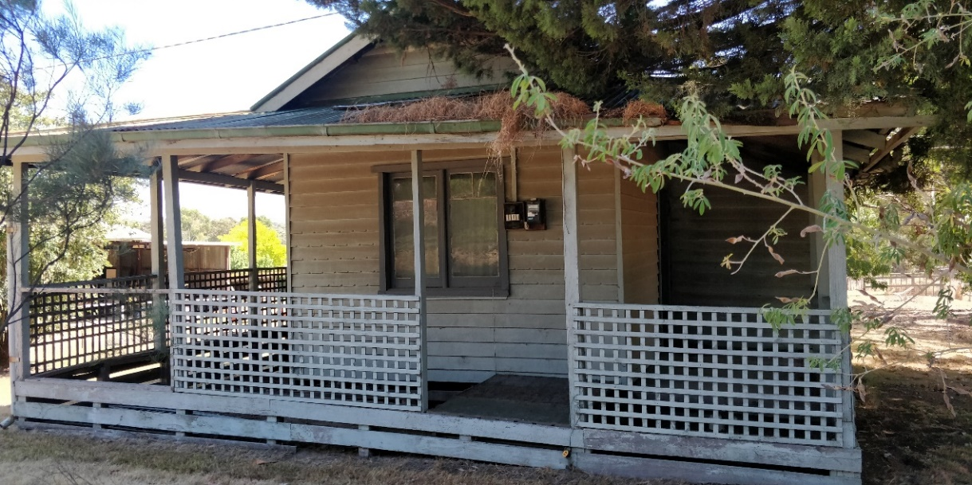
Figure 2: Front of weatherboard house, viewed from the road. Source: Trethowan Architecture, 2022.

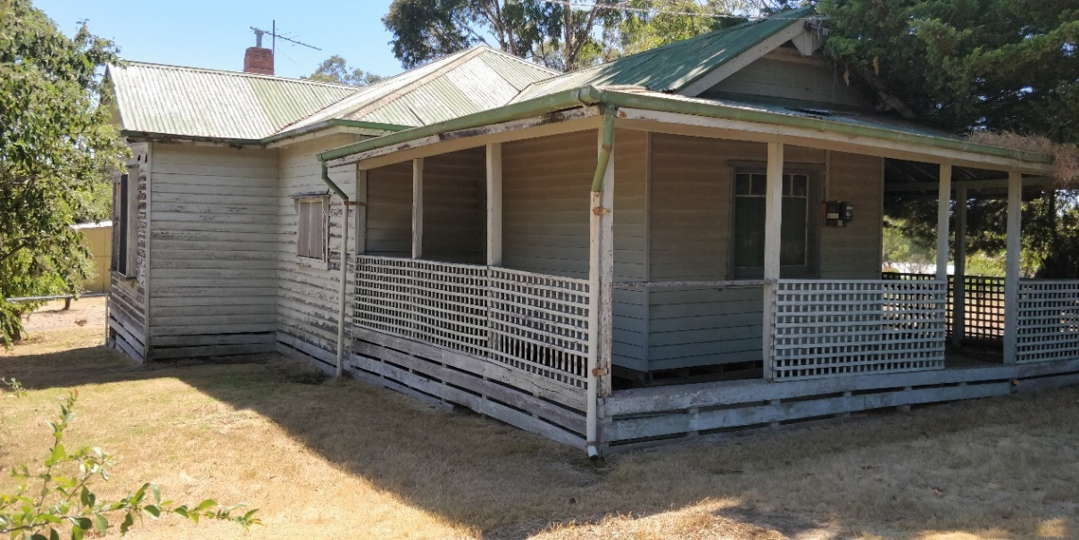
Figure 3: West side of the residence. Source: Trethowan Architecture, 2022.

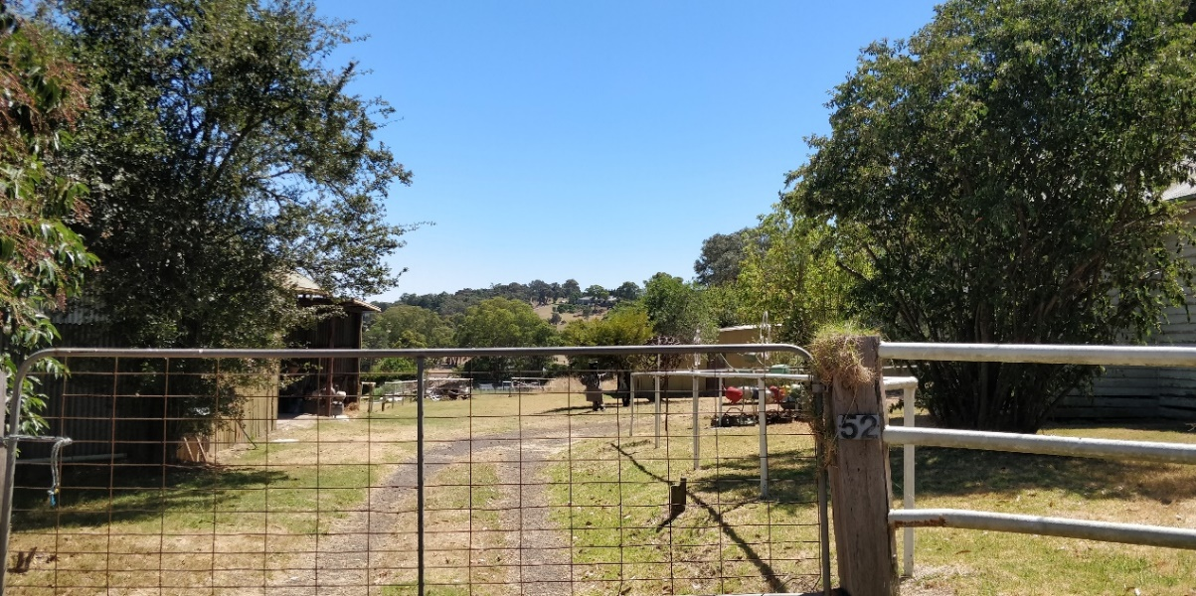
Figure 4: View of the central driveway, looking towards the rear outbuildings. Source: Trethowan Architecture, 2022.

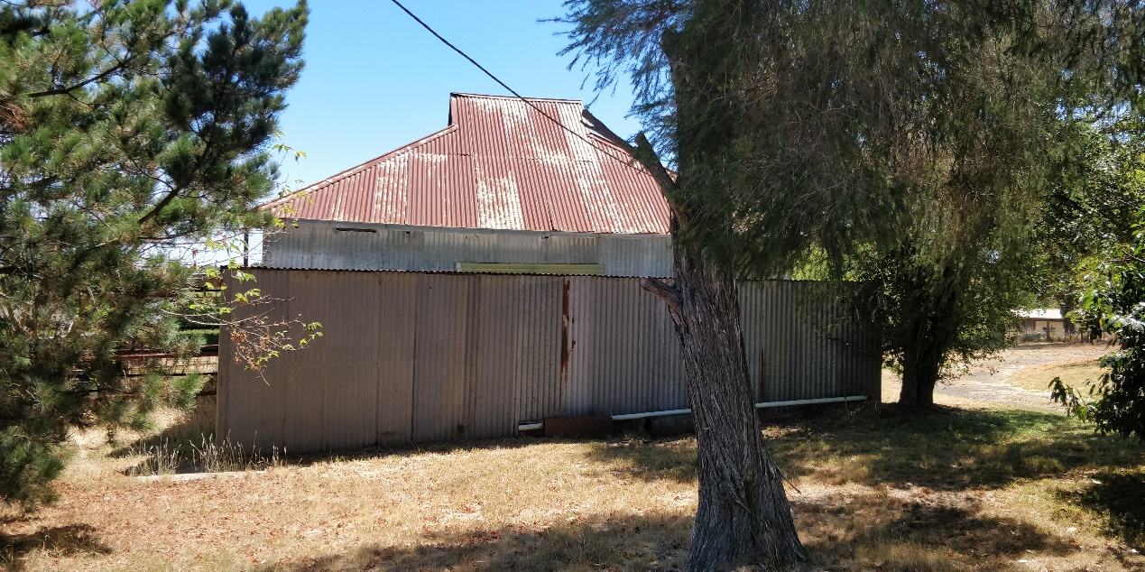
Figure 5: View of the large shed to the west of the central driveway, as viewed from the street. Source: Trethowan Architecture.

Comparative Analysis

52 Kurrak Road, Yarrambat is associated historically with a prominent local family, the Marshalls who established the property in the 1920s and it is still in the same family ownership. The Marshalls were involved in mixed farming practice of orcharding and raising poultry, a common agricultural theme within the interwar period, and later introduced a trotting stud. This interwar period of development in the Shire was identified in the Shire of Nillumbik Heritage Gap Study Framework June 2009 as being a development period under-represented in the Heritage Overlay.

There are other examples of orchard farming properties already on the Heritage Overlay. However, most of these date from the late-nineteenth century when this industry was at its height in the area. Comparable examples include:

- 760 Hurstbridge-Arthurs Creek Road, Arthurs Creek (HO89)
- 14-26 Browns Lane, Plenty (Recommended for HO).

760 Hurstbridge-Arthurs Creek Road, Arthurs Creek (HO89), significant for its association with the MacMillan family of orchardists over a long period of time, and as a pre-1920s weatherboard dwelling in the area. This property also contains pre-1920s outbuildings. 52 Kurrak Road is similar as an orchard farming property with a weatherboard farmhouse. However, the house and outbuildings at 52 Kurrak Road are later. The historical association to orcharding at 52 Kurrak Road demonstrates a different agricultural theme of interwar mixed farming as orcharding alone was not profitable.

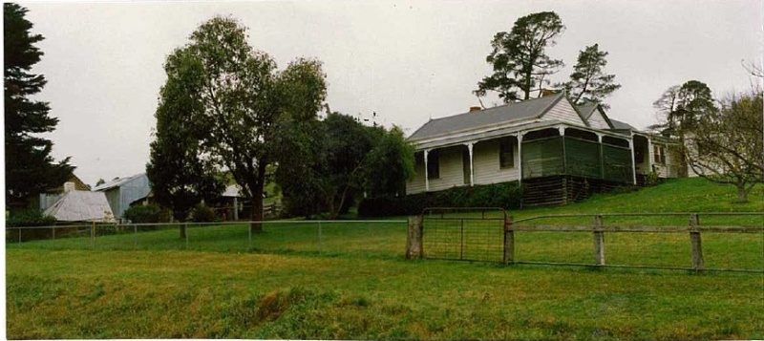
Figure 10: The weatherboard farmhouse at 760 Hurstbridge-Arthurs Creek Road, Arthurs Creek.

14-26 Browns Lane, Plenty is covered by interim Overlay HO270. It is a representative example of an interwar bungalow, originally part of a mixed farming property including orcharding and poultry. The mixed farming use is comparable to 52 Kurrak Road, and is representative of the interwar subdivision and agricultural practices of the area. Often orcharding alone was not financially viable, and farmers began to include other activities. Like 14-26 Browns Lane, the 1920s residence at 52 Kurrak demonstrates the typical single-storey timber construction, asymmetrical form, and wrap around verandah demonstrating styles popular in the earlier (Edwardian) period. 14-26 Browns Lane is distinguished by the more extensive verandah and the bay window with its own skillion roof.

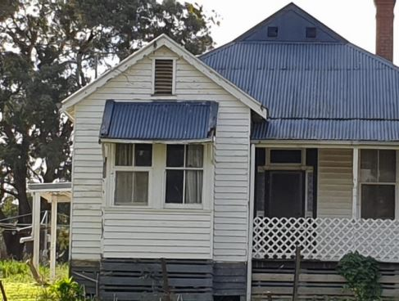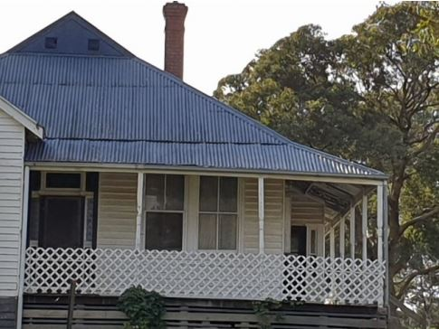
Figure 7: Façade of house at 14-26 Browns Lane, Plenty. Note the box bay window and verandah within the sweep of the main roof including turned timber posts. Source: Citation for 14-26 Browns Lane, Plenty. Prepared by Context, 2021.

Assessment Against Criteria

Criteria referred to in Practice Note 1: Applying the Heritage Overlay, Department of Planning and Community Development, revised July 2015, modified for the local context.

CRITERION A: Importance to the course or pattern of the Shire of Nillumbik’s cultural or natural history (historical significance).
52 Kurrak Road, Yarrambat is historically significant to the Shire of Nillumbik as a representative example of an interwar farmhouse, demonstrating interwar-era mixed farming practices combining orcharding and raising poultry.

CRITERION B: Possession of uncommon, rare or endangered aspects of the Shire of Nillumbik’s cultural or natural history (rarity).
N/A

CRITERION C: Potential to yield information that will contribute to an understanding of the Shire of Nillumbik’s cultural or natural history (research potential).
N/A

CRITERION D: Importance in demonstrating the principal characteristics of a class of cultural or natural places or environments (representativeness).
The farm complex at 52 Kurrak Road, Yarrambat has representative value as a farm house from the 1920s (interwar period) in the Shire, with a modest character. The farmhouse is comparable to other examples of timber farmhouses associated with small mixed farming properties of the period in Nillumbik and retains its original form and main features including weatherboard cladding and return verandah at the front.

CRITERION E: Importance in exhibiting particular aesthetic characteristics (aesthetic significance).
N/A

CRITERION F: Importance in demonstrating a high degree of creative or technical achievement at a particular period (technical significance).
N/A

CRITERION G: Strong or special association with a particular community or cultural group for social, cultural or spiritual reasons. This includes the significance of a place to Indigenous peoples as part of their continuing and developing cultural traditions (social significance).
N/A

CRITERION H: Special association with the life or works of a person, or group of persons, of importance in the Shire of Nillumbik’s history (associative significance).
N/A

Grading and Recommendations

Recommended for inclusion in the schedule to the Heritage Overlay of the Nillumbik Planning Scheme.

Recommendations for the Schedule to the Heritage Overlay (Clause 43.01) in the Nillumbik Planning Scheme:

External Paint Controls  Is a permit required to paint an already painted surface? | No
Internal Alteration Controls  Is a permit required for internal alterations? | No
Tree Controls  Is a permit required to remove a tree? | No
Victorian Heritage Register  Is the place included on the Victorian Heritage Register? | No
Incorporated Plan  Does an Incorporated Plan apply to the site? | No
Outbuildings and fences exemptions  Are there outbuildings and fences which are not exempt from notice and review? | No
Prohibited uses may be permitted  Can a permit be granted to use the place for a use which would otherwise be prohibited? | Yes
Aboriginal Heritage Place  Is the place an Aboriginal heritage place which is subject to the requirements of the Aboriginal Heritage Act 2006? | No

Identified by: Samantha Westbrooke.

References

Argus, as cited.

Australian Section Imperial General Staff, Great Britain, War Office General Staff, c1930, ‘Victoria, Yan Yean Australian Section 1:63,360 topo series’, State Library of Victoria (SLV) Map Collection.

Commonwealth Department of Defence Melbourne, Government Printer, 1920, ‘Victoria, Yan Yean [cartographic material], Australia 1:63,360 topo series’, State Library of Victoria (SLV) Map Collection.

Department of Crown Lands and Survey Victoria, 1974 ‘Yan Yean Photomap’ State Library of Victoria (SLV) Map Collection.

Graeme Butler and Associates, "Nillumbik Shire Heritage Review," (Nillumbik: Nillumbik Shire, 1996),

Eileen Hooper, Centenary Year: Tanck's Corner 1878-1978, Yarrambat 1878-1978 (Yarrambat: Yarrambat State School 1978),

Land Victoria, Certificates of Title (CT), as cited.

Peter Mills, "A History of Twenty-Acre Occupation Licenses on the Auriferous Lands of the Nillumbik Area," (Nillumbik Shire Council, 2013).

Morang Parish Plan

